(bmrn) data completeness listing - dashboard requirements specifications (DRS)

Martin Frigaard

2/16/2021

Table of Contents

Data Completeness Dashboard 2

Document History 2

Change log 2

Purpose 2

Scope 2

Definitions, Acronyms and Abbreviations 2

References 3

Applicable documents/inputs 3

Applicable standards 3

Reference documents 3

OVERALL DESCRIPTION 3

Dashboard/app perspective 4

Dashboard/app functions 4

User characteristics 5

Constraints 5

Assumptions and dependencies 5

DASHBOARD/APP REQUIREMENTS 5

Dashboard/app overview 5

Mockup UI 5

Mockup Server 6

Use case overview 6

Supplementary requirements 9

Functional requirements 9

Non-functional requirements 9

Security requirements 9

APPENDIXES 9

Logical data model 9

**Document Reference:** drs-complete-report-word  
**Owner:** CSM  
**Issue date:** 2021-02-16  
**Version:** 1.10

# Data Completeness Dashboard

This is a dashboard for the data completeness listing (see the example stored in the docs/Fields_DataCompleteness_270302_20210110.xlsx file).

## Document History

Changes to this document should be listed in the Change Log section below:

### Change log

**Version:**  
**Date:**  
**Description:**  
**Modified pages:**

## Purpose

The purpose of this document is to serve as a guide to data scientists, app developers, system administrators, and data engineers who are responsible for the maintenance and deployment of the [**complete-report**] dashboard/app. This document should give the reader all of the information necessary to build, test, and deploy the dashboard/app.

## Scope

The DRS document contains a complete description of the functionality of the [**complete-report**] dashboard. It consists of use cases, functional requirements and non-functional requirements, which, taken together form a complete description of the software.

## Definitions, Acronyms and Abbreviations

**Term:** Listing  
**Definition:** output Excel file from SAS macro. In this dashboard, the listing is the Fields_DataCompleteness_270302_YYYYMMDD.xlsx file.

**Term:** Dataset Name  
**Definition:** Name of source dataset.

**Term:** Field Name  
**Definition:** Abbreviated name for variable in dataset.

**Term:** SAS Label  
**Definition:** Plain language description of measurement

**Term:** Number of Records Expected Without Not Done  
**Definition:** *???*

**Term:** # Data Present  
**Definition:** # Data Present / Total

**Term:** Percentage of Data Present (%)  
**Definition:** # Data Present / Total

**Term:** # Missing  
**Definition:** non-present values

**Term:** Percentage of Missing (%)  
**Definition:** # Missing / Total

**Term:** Condition for Missing  
**Definition:** SAS code for missing values

**Term:**  
**Definition:**

## References

### Applicable documents/inputs

The applicable documents/inputs are inputs to the dashboard/app. Any change to an applicable document or input is likely to impact the dashboard or app.

### Applicable standards

R - [R reference standard](https://cran.r-project.org/manuals.html).

### Reference documents

The reference documents are of interest to the reader of the DRS.

# OVERALL DESCRIPTION

*This section describes the general factors that affect the dashboard/app and its requirements. This section does not state specific requirements. Instead, it provides an overview of those requirements, which are defined in detail in the ‘REQUIREMENTS’ section, and makes them easier to understand.*

The [**complete-report**] dashboard is displays the information contained in the Fields_DataCompleteness_270302_YYYYMMDD excel files, which are distributed via outlook to identified audiences.

### Dashboard/app perspective

The figure below gives an overview of the high level data flow between the [**complete-report**] dashboard and other files and components:

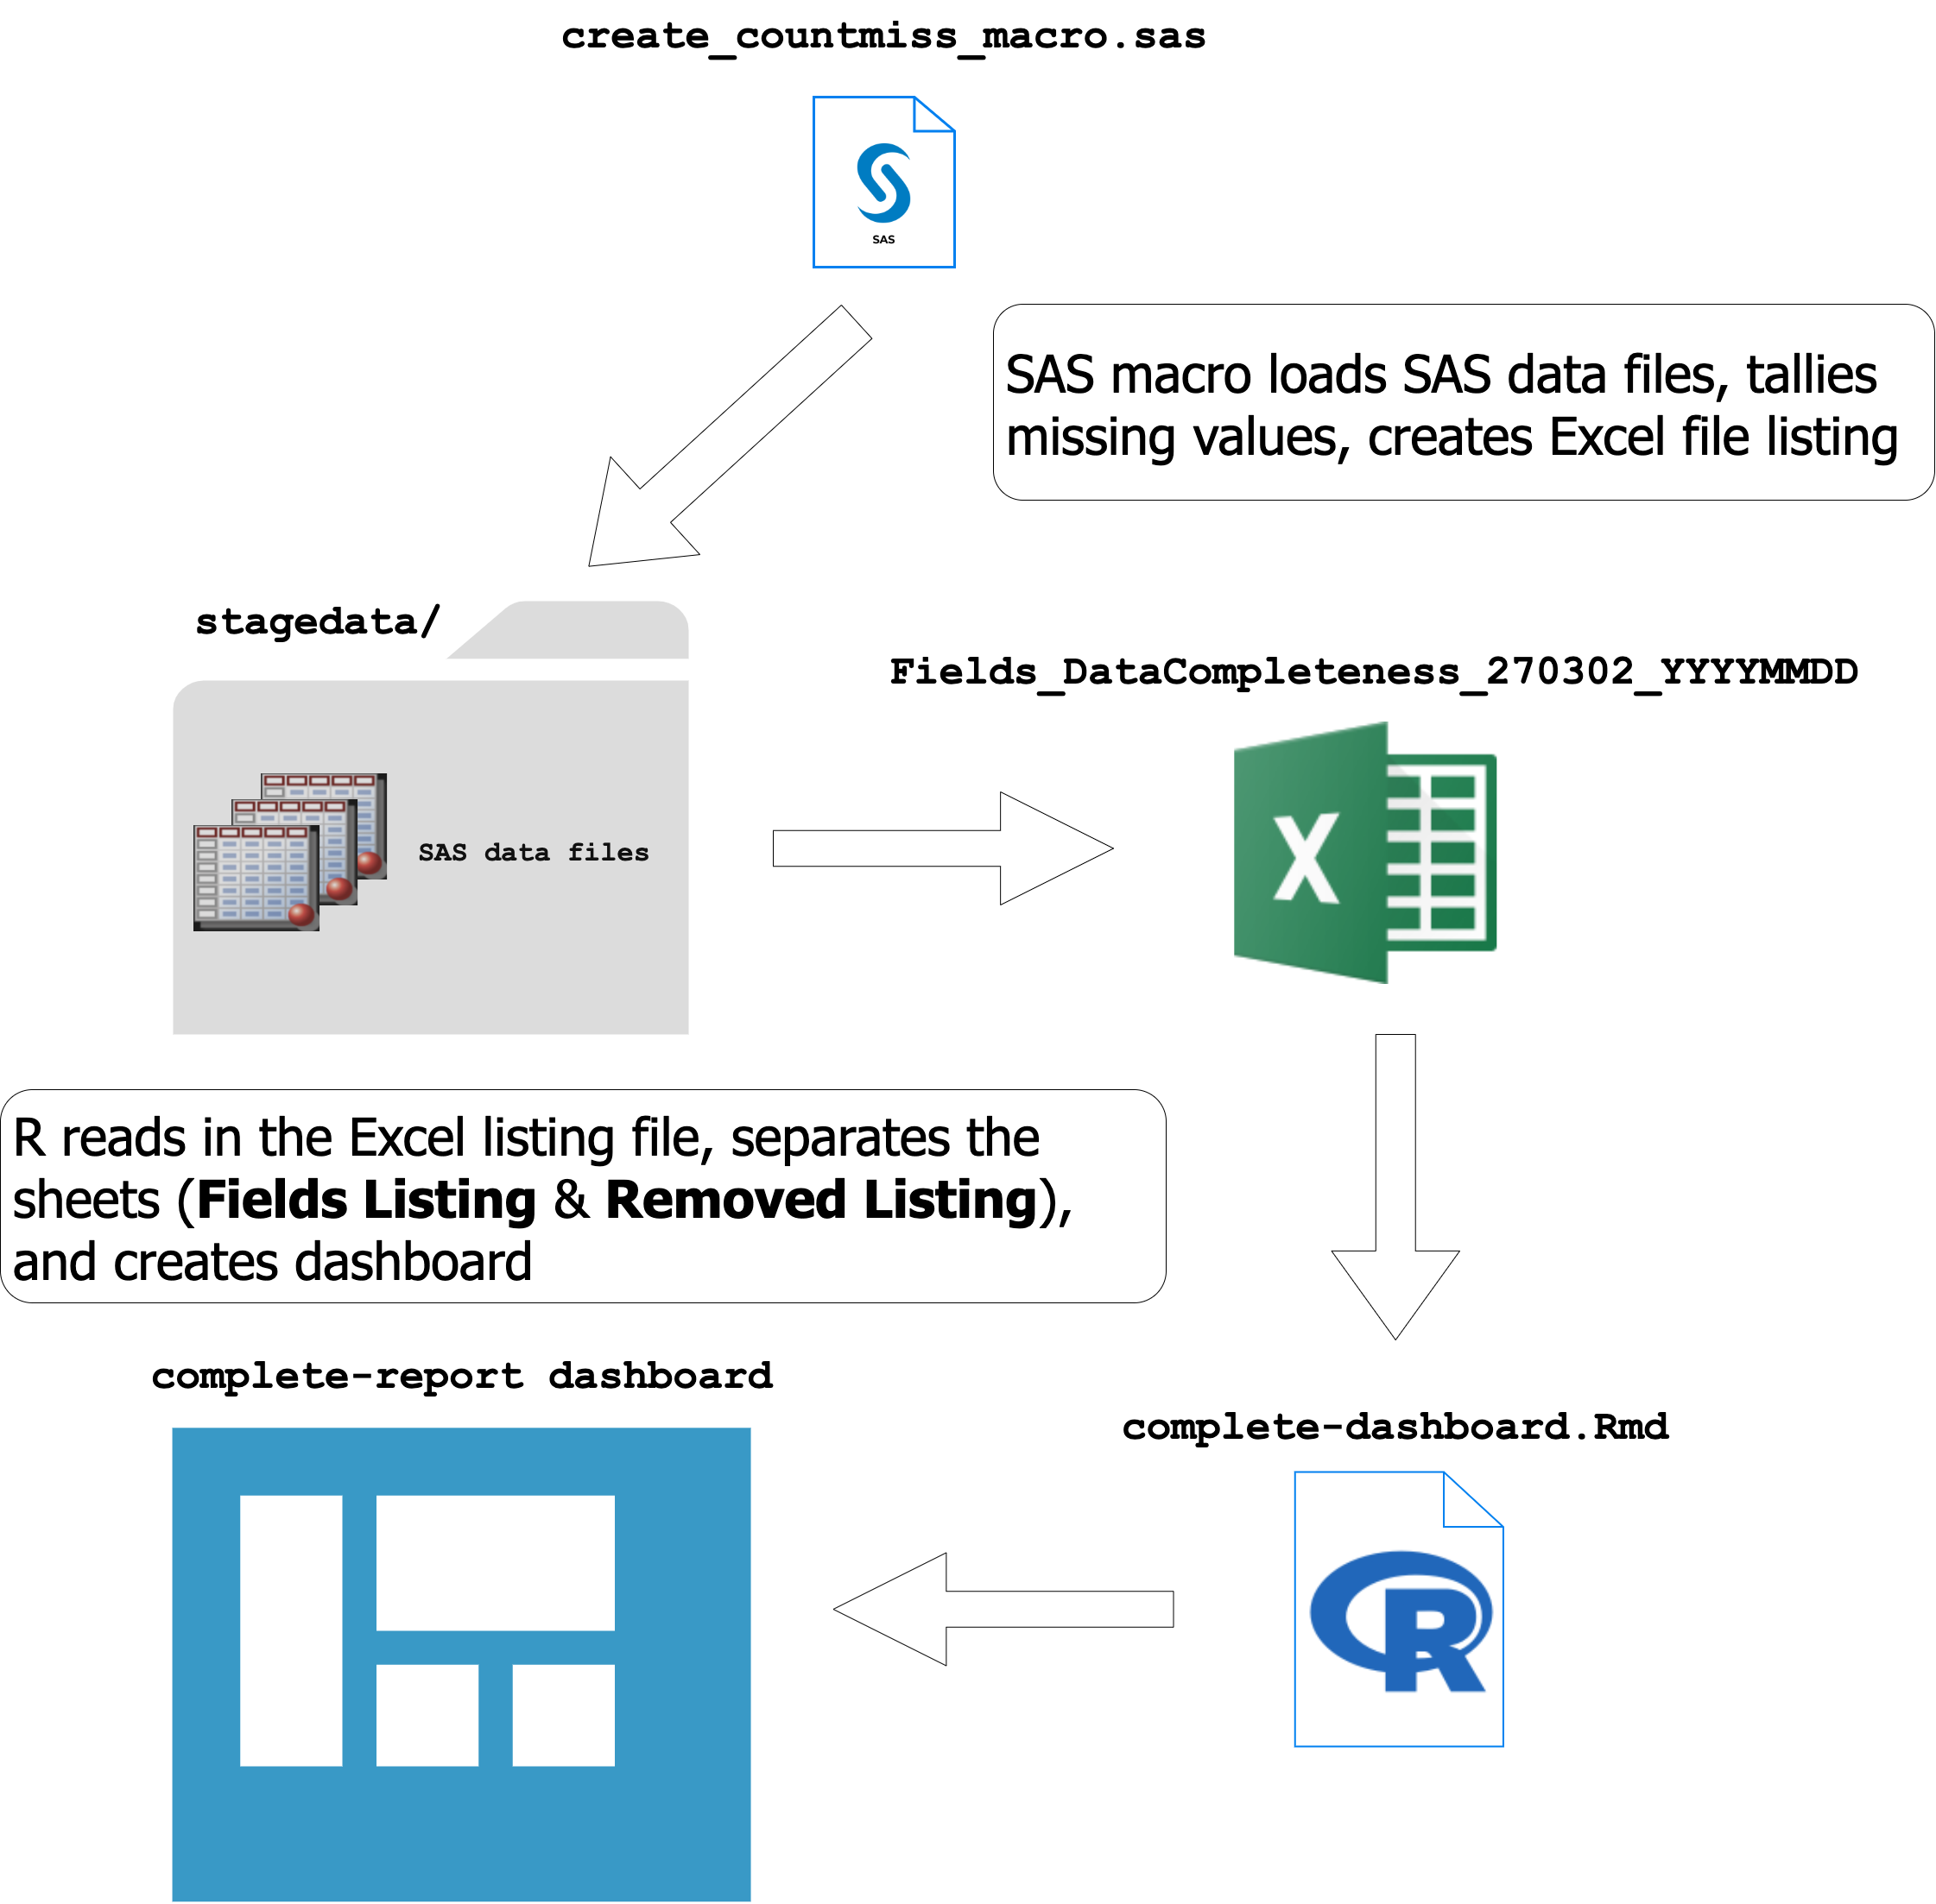

### Dashboard/app functions

The [**complete-report**] dashboard will provide a tabular summary of the completed study measurements by dataset, field, and corresponding SAS label. Users will be able to view both the **Fields Listing** and **Removed Listing** sheets, take notes, and download a .pdf or .docx report.

### User characteristics

The [**complete-report**] dashboard will be made available on the [shiny server]. The target audience is:

* CDM (entire group?)
* Data Managers
* [audience?]
* [audience?]

### Constraints

The dashboard frontend shall be implemented using:

* SAS (calculations and summary report generation)
* Excel (output file from SAS)
* R (Excel file manipulation and shiny display)

### Assumptions and dependencies

* R language (from [CRAN](https://cran.r-project.org/))
* RStudio installed (from [RStudio](https://rstudio.com/))
* Shiny server (from [RStudio](https://rstudio.com/products/shiny/shiny-server/), for deployment)

# DASHBOARD/APP REQUIREMENTS

This section covers the specific requirements and design of the [**complete-report**] dashboard.

## Dashboard/app overview

Below we describe some of the dashboard/application functions.

### Mockup UI

The initial landing page (Fields Listing) is below.

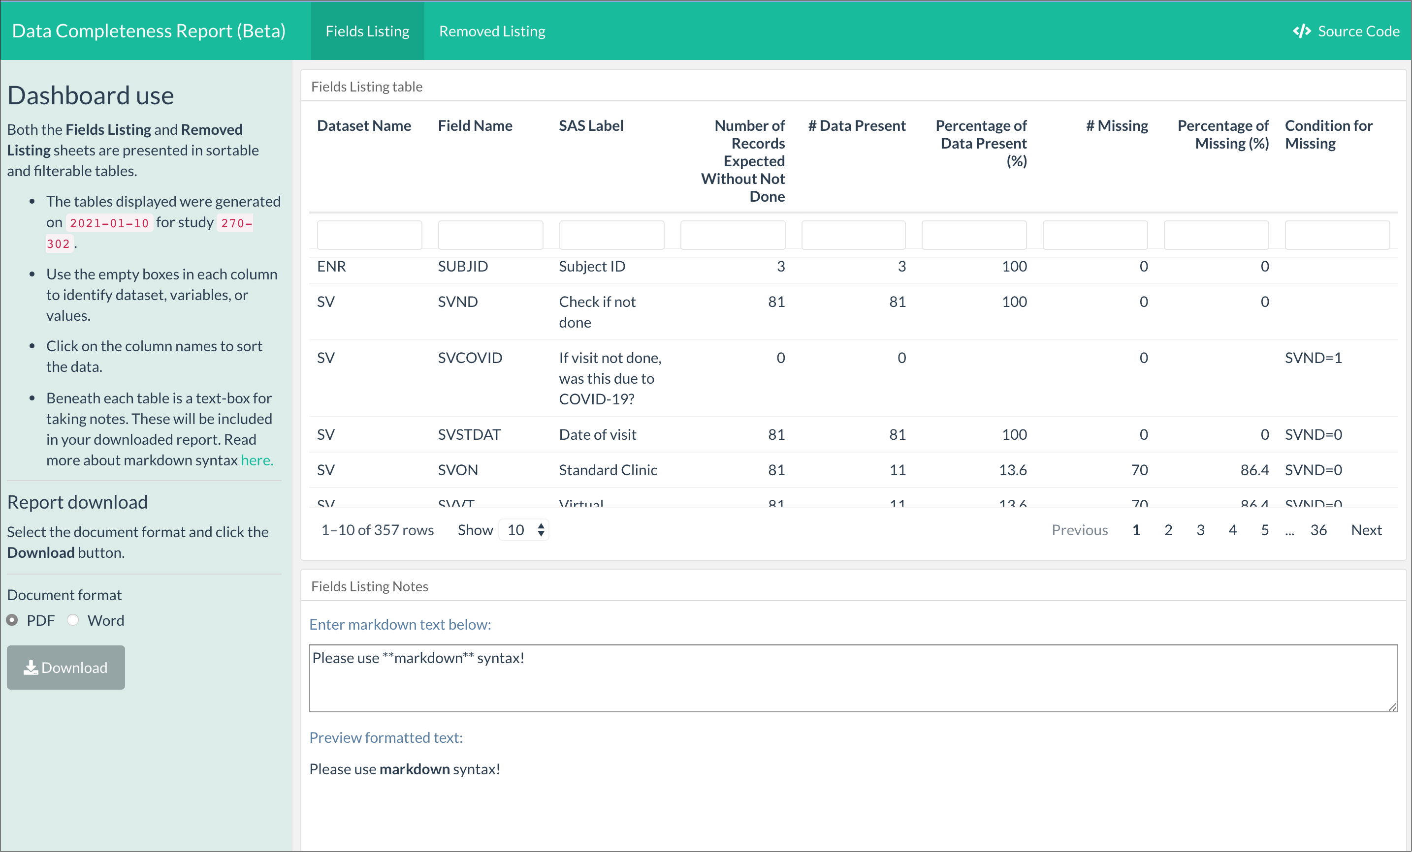

The Removed Listing page is below:

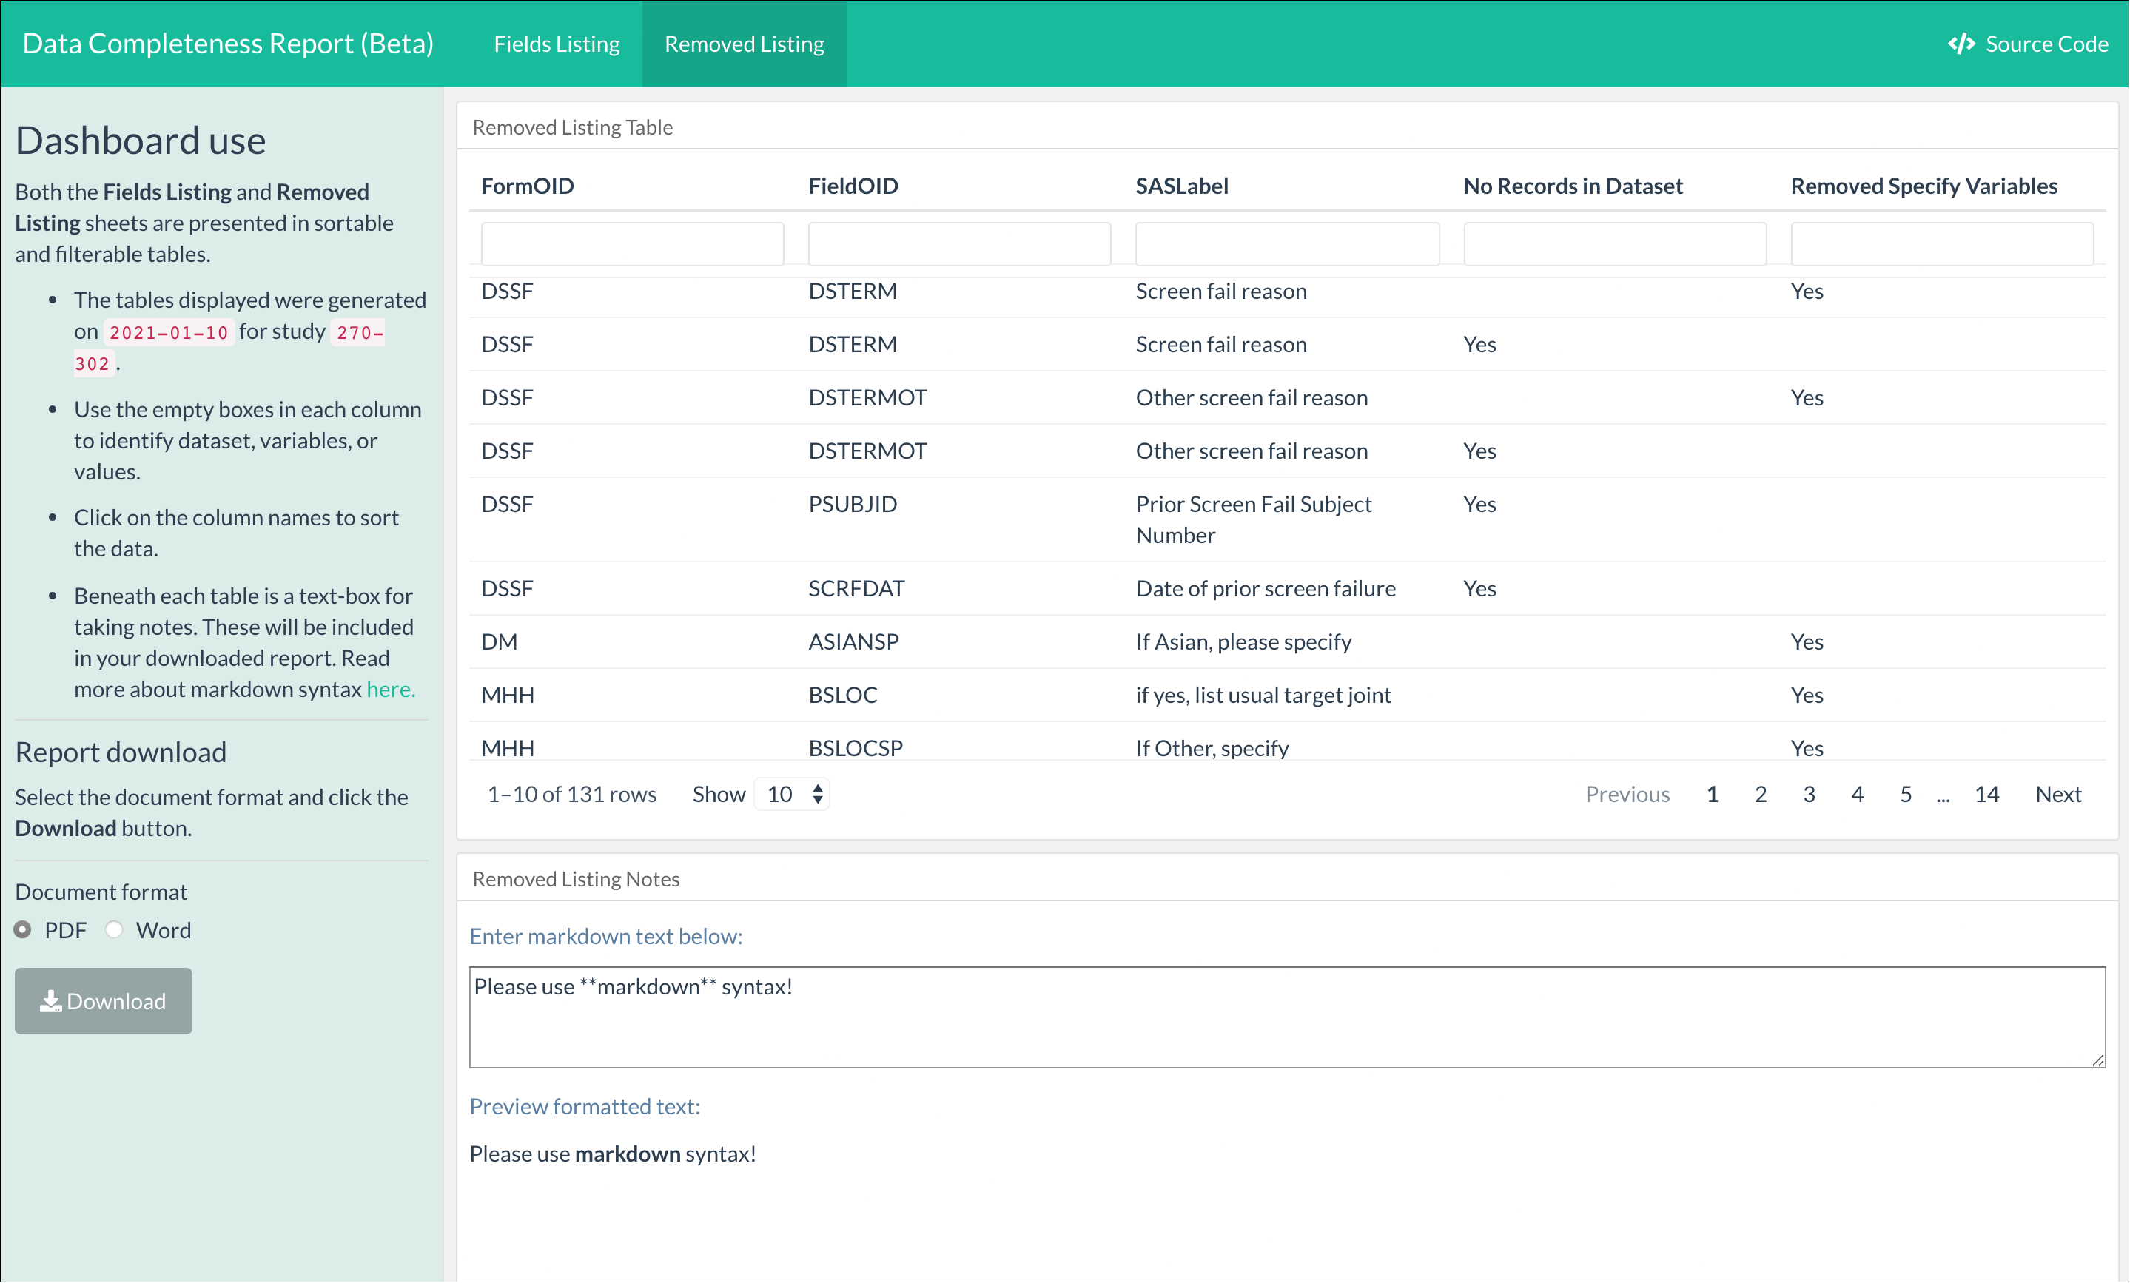

### Mockup Server

*in development*

### Use case overview

Below is an example note for the **Fields listing**:

**CMF** has 200 missing values.   
  
`SAS Label` is `Bleed Visit Number`

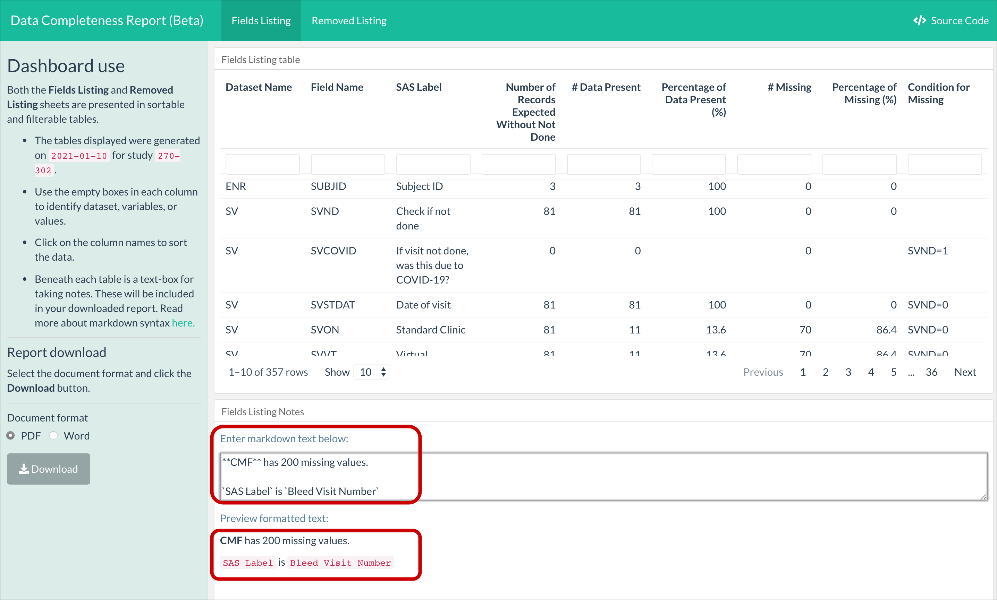

This works in the UI.

Below is an example note for the **Removed listing**:

`DSTERMOT` has been removed.   
  
The `SASLabel` is `Other screen fail reason`

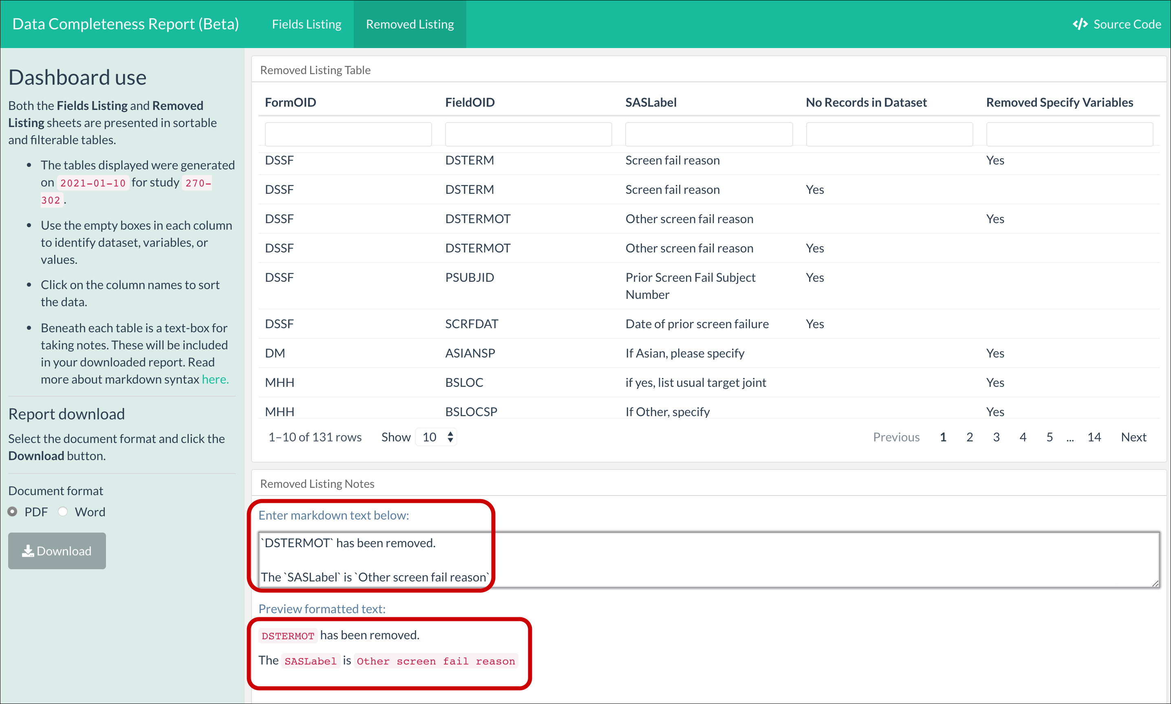

When we click the PDF download file, we see

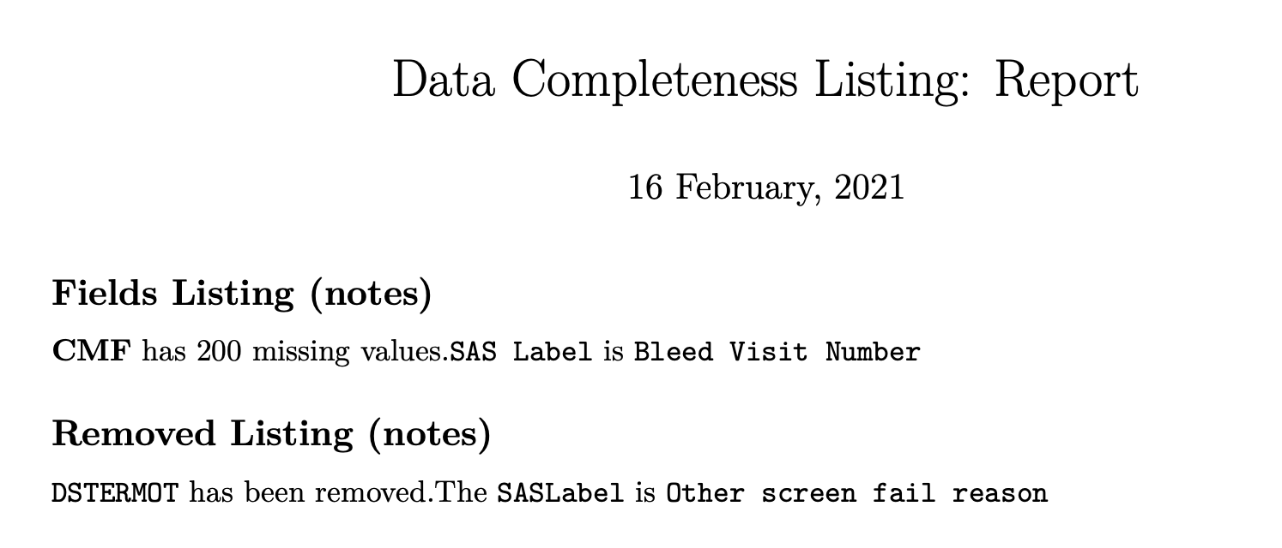

And below is the word output.

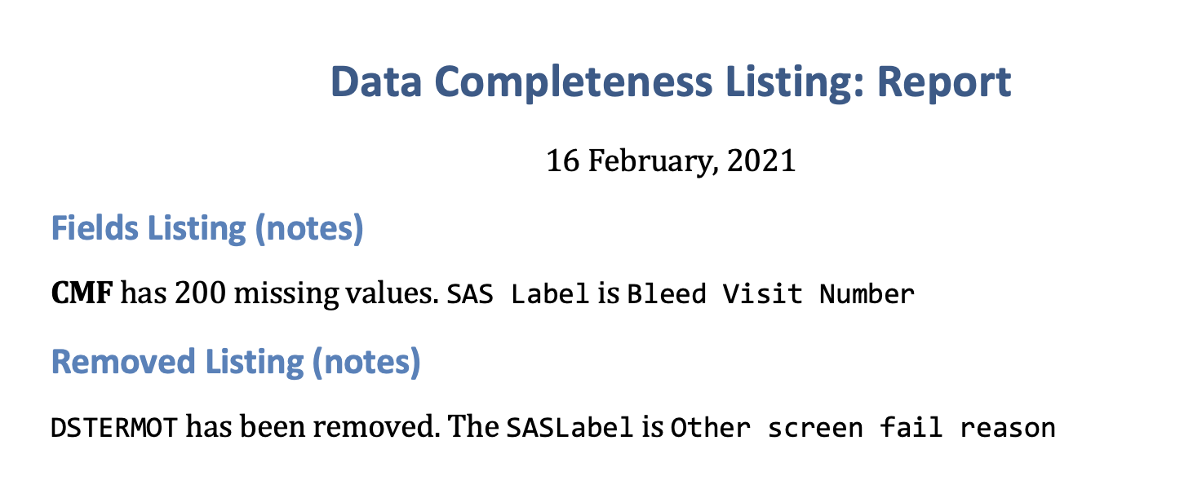

## Supplementary requirements

These are additional inputs, data files, or code that needs

### Functional requirements

The [**complete-report**] dashboard must be displayable by calling it through an URL.

It must be possible to export the data from the [**complete-report**] dashboard.

The two .Rmd files for generating reports (summary_report.Rmd and summary_report_word.Rmd) must be loaded with the [**complete-report**] dashboard.

### Non-functional requirements

Supported browsers: Internet Explorer 9, Firefox 4, Chrome 20, Edge.

### Security requirements

*in development*

# APPENDIXES

## Logical data model

*in development*