Summary Report

19 November, 2020

## Plot 1

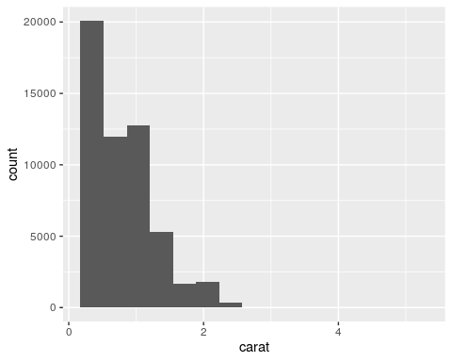

## Note 1

Please use **md** syntax!

## Plot 2

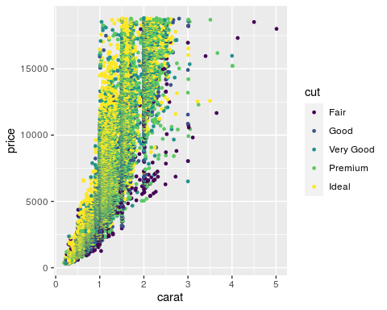

## Note 2

Please use **markdown** syntax!