**MANG3067 Accounting Coursework**

**Merlin Webster – 25603388 – mw16g12**

Choose a technology and explain how it functions:

The technology I will be explaining is the laser diode, and I will be changing the efficiency as my technical parameter.

Laser diodes are used throughout many industries for a wide range of purposes, ranging from laser pointers to fibre optic internet. There are many different designs for laser diodes, each with its benefits and drawbacks. The most basic and fundamental design is a homojunction laser diode.

The basic structure of a diode is two pieces of a semiconductor material placed on top of each other, with each piece of semiconductor material having a separate electrical terminal. A semiconductor can be doped to have many free charge carriers (electrons or holes) by adding impurity atoms to the crystal lattice. This makes it either n-type (free electrons) or p-type (free holes). Impurities are added by firing high velocity atoms at the undoped semiconductor.

A semiconductor has two key energy bands of energy levels which carriers can occupy. These are known as the conduction and valance bands. When no electric field is applied, the conduction band is primarily occupied by free electrons which can flow throughout the device. Similarly, the valance band is occupied by free holes. Carriers in the conduction band have more energy than those in the valance band; this difference in energy levels is know the band gap energy (Eg). The band gap energy is fixed, but varies between different semiconductor materials. When an electron drops from the conduction band to the valance band, it annihilates with a hole, and energy equal to the band gap is released, either as heat or light.

A laser diode has a piece of n-type semiconductor placed on top of a piece of p-type. These p and n-type semiconductors each have different conduction and valance band energies, but the same band gap energy.

When no electric field is applied to the device, this difference in energy levels at the p-n junction prevents the flow of carriers. However, if the device has a forward bias electric field applied to it, the barrier to conduction is decreased and electrons from the n-type semiconductor are able to flow into the p-type. During the operation of a laser diode, an electron drops from the conduction band to the valance band, annihilating with a hole and releasing its energy (Eg) as a photon. The device has mirrors on either end to prevent this photon from escaping. The photon then causes another electron to drop from the conduction band to the valance band, releasing a second photon with the same wavelength and phase. This causes a chain reaction, and soon the laser cavity is filled with laser light. Some of this laser light is allowed to escape the device via a small hole in the mirror. This is where the name ‘laser’ originates from as it is an acronym for ‘light amplification by stimulated emission of radiation’.

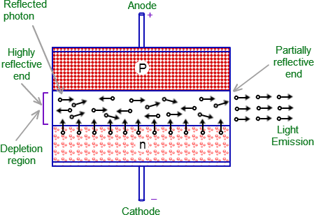

Figure 1: Emission diagram of laser diode. Reproduced from **[1]**.

The wavelength (λ) (and therefore colour) of the laser light is defined by Eg­ via the relationship $λ ∝ \frac{1}{E_{g}}$. The designer of the device chooses a semiconductor material so that it has a desired ­Eg, causing emission of a desired wavelength of light.

The compound semiconductor, Indium Gallium Arsenide (InGaAs), is often used for laser diodes. The doping of the InGaAs can be varied by changing the amount of each element that goes into the compound.

Provide a non-financial engineering measure of performance:

The efficiency of a laser diode is defined by the proportion of energy released as photons, to the proportion added to the device from an external circuit. Excess energy is released as heat. Ideally all of the energy added to the device would be converted to laser light, but this is unrealisable with real designs. The efficiency is therefore a direct measure of the performance.

Homojunction laser diodes are very inefficient, but there are many designs with higher efficiencies. An example of one such design is the double heterojunction laser diode which, uses four semiconductor layers rather than three, and is therefore harder to fabricate. It tends to be the case that the higher the efficiency of a laser diode technology, the more complicated and expensive the design.

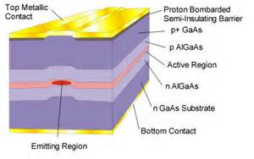

Figure 2: Double heterojunction laser diode cross section. Reproduced from **[2]**.

Exploring the costs of increasing the efficiency of the laser diode:

Direct Costs

The primary direct costs associated with switching to a more advanced laser diode design would be in manufacturing. These would largely be in the cost of new machinery, new materials being used, and the additional labour required to produce the new design.

It is likely that the current fabrication machinery present in the fabrication plant would not be of sufficient quality to produce the new design, and would have to be upgraded or replaced. This would come at a very large financial expense, as fabrication plants must operate a large number of machines in order to produce a financially viable quantity of laser diodes. The unit cost of a laser diode is extremely low compared to that of a fabrication machine and each machine is likely to cost millions of pounds to produce.

In order to further increase laser diode efficiency, higher quality semiconductor materials may have to be used. These would likely be far more expensive than the previous generation of semiconductor materials.

Given that the plant will now be using new machinery, it will be necessary to retrain current staff, or even hire new staff that are more experienced in using higher quality semiconductor materials. These highly skilled staff are likely to require a higher salary.

Indirect Costs

Due to new materials and machinery being used in the manufacturing process, it is likely that many technological advances may need to be made. High research and development (R&D) costs could be incurred. This research would either have to be carried out by current staff, or would be outsourced to a private company or research facility.

The semiconductor fabrication industry is highly competitive. If the research is not conducted quickly, competitors may develop superior technology and gain control of the market before the fabrication plant is complete. This could potentially render the plant obsolete before it is finished. In order to prevent this, large amounts of money would have to be spent on R&D, ensuring that the new fabrication processes are employed quickly enough to remain competitive in the fast growing industry. This will be an ongoing cost, as new technology is always being developed.

It is likely that currently used machinery will require regular maintenance and replacement. The cost of this would not only be in replacing the machines, but in paying additional skilled staff to fit and maintain it.

The cost of required utilities such as electricity and water may also vary over time. These costs will continue throughout the facilities operation.

Administration Costs

Additional managers may need to be hired in order to manage the increased body of staff. Due to their advanced status, they may require a higher wage than that of the regular staff.

Sales and Advertising Costs

It is likely that money will have to be spent on a large advertising campaign in order to show the current client base that the new laser diodes are more efficient and worth spending additional money on.

Break-Even Point

Due to the extremely large investment overheads required to get the new fabrication plant operational, it may take many years for the facility to become profitable. However, provided the facility continues to produce enough laser diodes, and the demand for them does not drop, it will eventually become profitable.

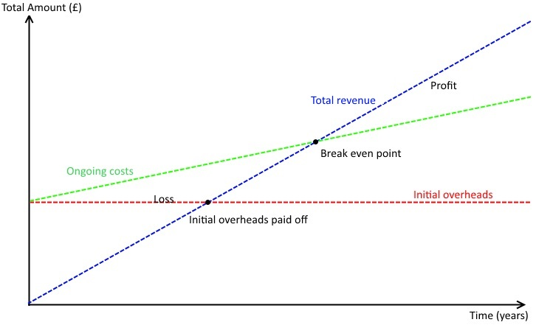

Figure 3: Graph showing time taken for facility to become profitable

The speed at which the break-even point is reached is highly dependent on the quantity of laser diodes being produced.

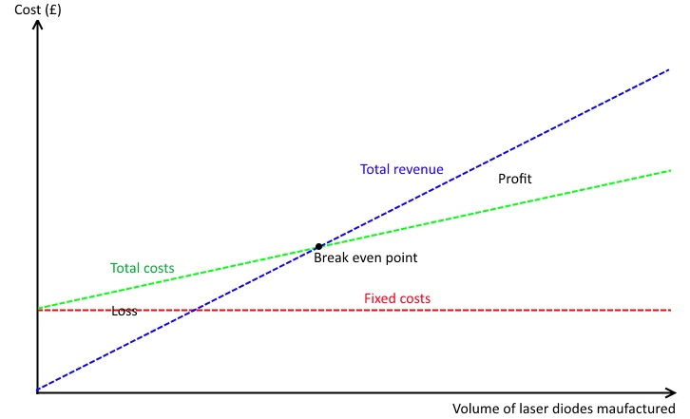

Figure 4: Graph showing how production volume affects break-even point

References:

[1] – Laser diode diagram, www.tutorvista.com, Website: <http://images.tutorvista.com/cms/images/95/laser-diode-working.png>

[2] – Darpa, DAHI Foundaty Technology BAA Overview, Sanjay Raman, Website: <http://www.darpa.mil/WorkArea/DownloadAsset.aspx?id=2147485319>