PROJECT TITLE PROPOSAL

- Name of Proponents:

ARATOC, HAYMEN T.
BANGON,DIANA L.
MIANO,MICCA ELLA L.
MALILA, JOVANIE R.

- Proposed Case Study Title
JD Printing Services Management System

- Area of Investigation
Jose Abad Santos, Koronadal City

- Cited Problems
This study aims to answer the following problems of JD Printing Services Management System.
4.1 Orders and design specifications submitted are not recorded in one system, so staff manually track them, causing missed, or mixed-up orders.
4.2 Production updates are not linked to the order system, so customers and staff can't see real-time progress of an order
4.3 Pick-up or delivery schedules are not connected to the production timeline, so orders sometimes get scheduled before they're actually finished.
4.4 Sales from different product types are not automatically compiled, so staff manually add them together to make one report.
4.5 Printing materials are not properly monitored, so staff manually check and record stock levels, which can cause material shortages and delay.

- Functions of the Proposed System
The proposed JD Printing Services Management System will help the owner and staff manage customer orders, design specifications, production status, pick-up and delivery schedules, price computation, quotation approval. It will also compile sales reports, track best-selling products. The system will provide organized records, reduce manual work, and make daily business work faster.

- Features of the Proposed System
‎Custom Design Order Online – Customers submit their design and order details online.
‎Order Status Tracking – Customers and staff check the current progress of an order.
‎Pick-up/Delivery Scheduling – Staff schedule pick-up or delivery once an order is done.‎
‎Sales Reports – Combines sales from different products into one report.
Inventory Management – Records available printing materials, manages stock in and stock out transactions, monitors stock levels, and provides low-stock alerts.

- Programming Language and Database to be used:
Front End: HTML, CSS, JAVASCRIPT
Back End: PHP, MySQL

- Software Engineering Model to be Used
The Agile Model will be used as the software development methodology for the Shamel Furniture and Decors Management System. Agile is a flexible and iterative approach to system development that focuses on collaboration, adaptability, and continuous improvement throughout the development process.
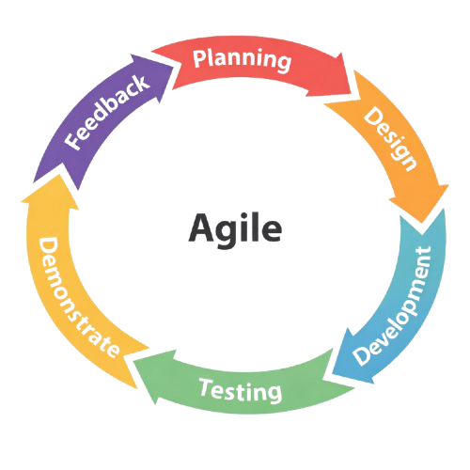

- Reasons for the Choice
‎The development of this system is motivated by the following goals:
‎9.1 To be able to record and manage customer design and order details in one system.
‎9.2 To be able to track the progress of customer orders during production.
‎9.3 To be able to schedule pick-up or delivery based on the completion of customer orders.
‎9.4 To be able to automatically compile sales reports from different product types.
9.5 To be able to record and monitor printing materials.

10.0 Importance of the Study
‎This study is connected to the Sustainable Development Goals (SDGs), especially:
SDG 8 (Decent Work and Economic Growth) – The system helps the printing business run more smoothly, which can help the business grow and give staff more organized and manageable tasks.
SDG 9 (Industry, Innovation, and Infrastructure) – The system brings a modern, digital way of handling orders, pricing, and sales into a business that is usually run manually.
SDG 12 (Responsible Consumption and Production) – Since the system tracks materials and pricing accurately, it can help lessen wasted resources and promote more responsible use of materials in printing production.

11.0 Target Users/ Beneficiaries
• Owner
• Staff
• Customer

