Hito Farm Management System with Data Analytics
_______________________________________________________
A Project Study
Presented to
The faculty of
South East Asian Institute of Technology
College of Information and Communication Technology
_______________________________________________________

In Partial Fulfillment
of the Requirement for the Subject
IT 228: System Analysis and Design
______________________________________________________
By:

Garde, Michael Jude
Gonzales, Gwen
Taberna, Anthonaith Jane

April 2026

CHAPTER I
INTRODUCTION
Rationale of the Study
Catfish (Hito) farming is one of the growing industries in the Philippines. Running a catfish farm requires keeping track of daily activities like feeding, inventory, sales, and expenses. Despite this many farm still record their data using notebooks and spreadsheets which can result in errors, incomplete records and a hard time checking how the farm is doing. According to FAO (2021), poor record management in farms well
affects the quality of data and the ability of owners to manage their operations. Studies also show that the use of digital systems in farming can help improve recordkeeping and support better farm management through data analysis (World Bank, 2021; Kumar & Engle, 2021). Because of this, a web-based farm management system with data analytics was developed to help catfish farm owners handle their daily farm records and operations more easily. It provides a platform for recording feed usage, sales transactions, inventory, expenses, and generating reports, so that farm owners can easily check farm records and make better decisions.
LRS Hito Farm started its operations in 2023 with four ponds located at Poblacion, Esperanza, Sultan Kudarat. The farm is managed by the owner Iresh Jem Esmeralda Pagsisijan together with staff who handle daily activities such as feeding, monitoring fish, recording sales. Since it started, the farm has been using traditional methods like notebooks and spreadsheets to keep track of farm records. While these methods worked during the early stage of the farm, they have become harder to manage as the farm continues to grow. Writing records by hand takes more time and increases the chance of making mistakes. There are also times when records are hard to find or read, which makes it difficult for the farm owner to check the current status of the farm. Since data is kept in separate notebooks overall performance becomes a challenge. As the number of daily transactions and activities increases, relying on manual recording affects how well the farm tracks its data and manages its day to day operations.
Despite continuous operations, the farm encounters several challenges: (1) Feeding activities and feed consumption are recorded manually, which may lead to inaccurate or incomplete data. (2) Sales transactions and customer orders are written in logbooks, making them difficult to track and organize. (3) Feed inventory is checked physically, which can result in miscalculations or delays in identifying shortages. (4) Monitoring analytics and generating reports is challenging due to scattered and manually recorded data. (5) Operational expenses such as feed and labor costs are computed manually, increasing the risk of errors.
The proposed system addresses these challenges by providing a automated solution for farm management. It includes features such as a Feeding Log for recording daily feeding and feed usage, Sales and Order Management for organizing customer transactions, Feed Inventory Monitoring for tracking stock levels in real time, Analytics and Reports for generating visual summaries and printable documents, and Expense Tracking for recording and computing operational costs. The system supports the objectives of improving data accurate, organizing farm records, enabling faster access to information, and enhancing overall farm monitoring. Through these improvements, the farm owner and staff can manage operations more effectively and make better decisions based on reliable data.
Objectives of the Study
General Objective
The study aims to design and develop a Hito Farm Management System with Data Analytics to be implemented at Poblacion, Esperanza, Sultan Kudarat, to enhance operations and monitor overall farm productivity.
Specific Objectives
- To be able to create a system that can monitor feeding and track feed consumption.
- To be able to create a system that can record customer orders for harvested hito and review past sales.
- To be able to create a system that can record and monitor feed inventory, including remaining stock levels and usage by staff.
- To be able to create a system that can provide visual analytics and printable reports summarizing overall operations, including feeding and inventory performance.
- To be able to create a system that can monitor operational expenses and calculate profits, including costs for feed, maintenance, and labor.

Scope and Limitation of the Study
Scope of the Study
The Hito Farm Management System with Data Analytics is designed to assist in managing and monitoring the daily operations. The system focuses on recording feeding activities, monitoring feed inventory, managing customer orders, tracking expenses, and generating analytical reports to support farm management and decision-making.
Feeding Log
Records the daily feeding activities of the hito. Each record includes the date, feed type, quantity used, and the staff member responsible for feeding. This helps to track feeding history and monitor feed usage. The admin can monitor all feeding activity through the activity log, which displays who logged the feeding, the amount of feed used, and the exact date and time to ensure traceability of daily feeding.
Sales and Order Management
Records customer orders for harvested hito, including order date, quantity purchased, and total price. This helps the farm keep track of sales and review past orders.
Feed Inventory Monitoring
Monitors the available feed stock in the inventory. The system automatically updates the feed quantity whenever feeding activities are recorded, allowing to track feed usage and remaining stock.

Analytics and Reports
Visual charts and summaries of overall operations, with printable reports.
Expense Tracking
Allows users to monitor all operational expenses, including feed, maintenance, and labor costs, and automatically calculates profit from recorded sales.
Limitation of the Study
The system does not include hardware-based monitoring, such as IoT sensors for water quality, automated counting of fingerlings, or pond condition tracking. The study focuses on improving record-keeping, feeding management, sales tracking, and operational analytics within the farm.
Significance of the Study
The system has the potential to significantly benefit the business, owner and staff by improving the overall operation. Specifically, this study aims to benefit the following:
Owner
This system will help the farm owner monitor feeding activities, feed inventory, sales, and expenses in an organized way. It also provides reports and charts that help the owner review the farm operations and make better decisions.
Staff
This system will lessen the need for manual recording of feeding logs, feed inventory, sales, and expenses. It will help staff record and view information more easily, making their work more organized.
Researchers
This system will help the researchers apply their knowledge in developing a management system and improve their skills in system design, programming, and data management.
Future Researchers
This study can serve as a reference for future researchers who plan to develop similar systems related to farm management or aquaculture operations.

IPO Conceptual Framework
The IPO framework consists of Input, Process, and Output variables. The Input include feeding details, customer order details, feed inventory records, reports details, and operational expense records such as feed cost and labor.
Process include monitoring feed and tracking consumption, recording customer orders, updating feed inventory based on inventory records, generating visual analytics and printable reports, and calculating operational expenses and profit from sales.
Output include feeding activity records and feed usage, sales reports, feed inventory levels, visual charts and printable summary, and expense reports with calculated profit and cost.
INPUT PROCESS OUTPUT
- Display feeding activities records and feed usage
- Display sales reports
- Display feed inventory levels
- Generate visual charts and printable summary
- Generate expense reports with calculated profit and cost
- Store feeding data
- Store customer orders details
- Monitoring of feed Inventory
- Processing Visual Analytics and Printable Data
- Processing operational expenses

- Feeding Details

- Customer Order Details
- Feed Inventory Records
- Reports Details
- Operational expense records

c
cc

Figure 1.1: Conceptual Framework of Hito Farm Management System with Data Analytics
Definition of Terms
Analytics and Reports – Visual charts and summarized data of farm operations such as feeding, sales, and expenses. These reports can be generated and printed to support monitoring and decision-making.
Data Management System – A computerized platform designed to collect, store, process, and manage farm-related data such as feeding logs, sales, inventory, and expenses. It improves data organization, accessibility, and overall system performance.
Expense Tracking – The process of recording operational costs, including feed, labor, and maintenance expenses. It allows the system to compute overall expenditures.
Feeding Log – A record of daily feeding activities of the hito, including the date, feed type, quantity, and assigned staff. It is used to monitor feeding patterns and feed consumption.
Feed Inventory Monitoring – A system feature that tracks available feed stock and automatically updates quantities whenever feeding activities are recorded, ensuring accurate inventory management.
Feed Type – The specific kind of feed given to hito during feeding activities. It is recorded to analyze feeding preferences and consumption patterns.
Order Quantity – The total number of harvested hito requested by a customer in a sales transaction, used to monitor sales volume and inventory movement.
Profit – The financial gain calculated as the difference between total sales and total operational expenses, representing the farm’s net earnings.
Sales and Order Management – A process of recording and managing customer orders, including order date, quantity, and total price, to maintain accurate sales records.
Staff Member – An authorized individual responsible for performing tasks such as feeding, recording data, and managing farm operations within the system.

CHAPTER II
REVIEW OF RELATED LITERATURE AND STUDIES
This chapter presents the review of related literature and studies that are connected to the development of the Hito Farm Management System with Data Analytics. It includes different sources such as articles, journals, and existing systems that focus on farm management, especially in areas like feeding logs, sales and order management, feed inventory monitoring, analytics and reporting, and expense tracking. These references were examined to understand how similar systems work, including their strengths and limitations, and to identify ideas that can help improve the proposed system.
Related Literature
Foreign
Traditional African Catfish Feeding Analysis (Munguti & Iteba, 2022)
According to Munguti and Iteba (2022), feeding management in African catfish farms was done manually using notebooks and spreadsheets. Farm workers wrote down feeding schedules, feed types, and the amount of feed given to the fish each day. The study found that while these records helped operators know how much feed was distributed, the process had many problems. There was no way to see in real time what staff were doing, no reports were produced from the data collected, and the whole process took too much time. On top of that, writing errors were common, and because of these mistakes, feed was sometimes wasted and the cost of running the farm went up.
This study is related to the proposed system because both deal with recording feeding activities in catfish farms. The difference is that the the study only described what farmers were already doing and did not suggest any digital tool to fix the problems they found. No system was built or tested. This is the gap that the proposed system tries to fill by giving farm staff a digital way to log feeding activities and letting administrators check records without going through written logs.

Financial Monitoring and Expense Tracking in Aquaculture Operations (Engle, 2021)
According to Engle (2021), keeping track of money spent is one of the most important things in running an aquaculture farm. The study looked at how farms recorded expenses like feed purchases, worker wages, equipment repairs, and hatchery costs. Most farms did this through written ledgers, basic spreadsheets, or saved receipts. The researchers found that while these methods gave farm owners a general idea of where money was going, the process was slow and often resulted in wrong numbers. Delayed or missing records made it hard for managers to plan their budget and respond to financial problems on time.
This study connects to the proposed system because both involve tracking farm expenses. Engle (2021) explained why expense tracking matters but did not build or test any tool to improve how it is done. The study had no digital solution to offer. This is the gap the proposed system addresses by handling expense recording and profit computation automatically within the same platform.
Data Analytics Platforms in Agricultural Systems
According to Krisnawijaya et al. (2022), data analytics platforms in agricultural systems enable farmers to collect, process, and analyze large volumes of farm data to improve productivity and decision-making, highlighting the growing importance of digital tools in modern farming practices. These platforms help integrate various farm operations such as monitoring, planning, and evaluation into a more organized system, allowing farmers to gain actionable insights from historical and real-time data. However, despite these advantages, many existing systems are still designed for large-scale agricultural environments and often lack simplicity, affordability, and specific functionalities needed for small-scale farms such as fish farming.
This study is related to the proposed system because both cover the same farm tasks such as feeding, inventory, expenses, and sales. Kumar and Singh (2022) described the problems in pond clearly but did not offer any solution to fix them. No tool or system was developed in the study. The proposed system fills this gap by giving hito farm operators a digital platform where daily farm tasks can be recorded and monitored without relying on handwritten logs.
Local
On-Farm Feed Management Practices for Nile Tilapia
According to Romana-Eguia et al. (2021), feed management practices in Philippine aquaculture are critical to ensuring efficient fish growth and minimizing production costs, as feeding represents one of the largest expenses in fish farming operations. The study emphasizes the importance of proper record-keeping, feeding schedules, and monitoring feed conversion to improve productivity and sustainability in fish farms. Despite this, many small-scale farms still rely on manual recording methods, which are prone to errors and inefficiencies.
Despite the importance of proper feed management, there is still a lack of accessible digital systems specifically designed for small-scale fish farmers. Most existing practices focus only on traditional or manual methods without offering automated solutions for recording and monitoring feeding activities. This creates a gap in providing an efficient, user-friendly system that can help farmers manage feeding data accurate and improve decision-making in daily farm operations.
Management of Feeding in Aquaculture Species
According to Alava (2021), feeding management in Philippine aquaculture is important for supporting fish growth, reducing waste, and controlling production costs, since feed takes up a large part of farm expenses. The study explains that proper feeding involves setting the right feeding rate, schedule, and timing depending on the fish species, size, and environmental conditions. It also includes keeping records of feed consumption and fish growth.
In addition, monitoring feed conversion and adjusting feeding practices can help improve farm productivity and sustainability. The study also points out the importance of keeping organized records such as feeding schedules, stock inventory, and production data to guide better decision-making. However, in many local farms, these tasks are still done manually, which can lead to errors, missing records, and difficulty in tracking and analyzing farm data.
An Overview of Fisheries and Aquaculture in the Philippines
According to Tahiluddin and Terzi (2021), the fisheries and aquaculture sector in the Philippines plays an important role in food security and economic growth, producing millions of metric tons of fish and providing livelihoods to many Filipinos. The study explains that aquaculture involves different farm activities such as feeding management, production monitoring, and proper use of resources to maintain efficiency and sustainability. It also points out the need to improve farm management practices to meet increasing demand and address environmental challenges.
However, the study mainly presents a general overview of the industry and does not focus on the use of digital systems for managing daily farm operations such as feeding logs, sales and order management, inventory tracking, expense monitoring, and data reporting.
Related Studies
Foreign
AQUAM: Decision Support Software for Fish Farm (Radulescu & Radulescu, 2021)
According to Radulescu and Radulescu (2021), AQUAM is a software made to help fish farm managers handle their operations better. It has different modules covering feed management, inventory control, cost tracking, production planning, and performance reports. Through the system, managers can log feeding schedules, check how much feed is being used, record operational costs, and look at farm performance through digital reports. The researchers built AQUAM so that all farm data could be found in one place, making it easier for managers to evaluate how the farm was doing and where resources were going. Radulescu and Radulescu (2021) found that having a centralized system helped reduce the time spent looking for data and allowed managers to make decisions based on actual records rather than estimates.
Both AQUAM and the proposed system track feeding, monitor feed use, record costs, and produce reports. The main difference is that AQUAM focuses on production planning and analysis for bigger operations. AQUAM did not include daily recording features like staff activity logs, sales management, or automatic profit computation. These are things small hito farm operators need every day, and the proposed system was built to cover them in a simpler and more focused platform.
Fishery Management System
According to Macrofix (2023), the Fishery Management System is a software platform made to help aquaculture operations manage production and inventory. It has separate modules for feed management, stock monitoring, sales tracking, expense recording, and performance reports. Farm managers can use it to keep digital records of what is happening on the farm, check current inventory levels, review how feed is being used, and track money coming in and going out. The system was designed so that all operational and financial data could be kept together, making it easier for managers to produce accurate reports and plan ahead. Macrofix (2023) noted that having all this data in one platform helped reduce the time managers spent gathering information from different sources before making decisions.
Both the Macrofix system and the proposed system handle feeding records, inventory, sales, expenses, and reports. The difference is that the Macrofix system is a large general platform made for all types of aquaculture farms. The Macrofix system was not made with small Philippine hito farms in mind. Its general design makes it too broad for local operators who need a simpler and more focused tool. This is the gap the proposed system addresses by being purpose-built for hito farming operations.
AQUASMAT: Aquacultural System Management Tool (Anyadike et al., 2020)
According to Anyadike et al. (2020), AQUASMAT is a software tool made to help aquaculture farms improve production through better monitoring and planning. The system allows farm managers to log feeding schedules, check inventory levels, review costs, and produce reports on farm performance. The researchers built AQUASMAT to help operators see how well feed was being used and find areas where resources could be better managed over time. Anyadike et al. (2020) found that having a system that combined operational monitoring with feed management helped managers spot problems earlier and make adjustments before they affected production. The system was aimed at farms that wanted to use data to improve how they ran their operations on a regular basis.
Both AQUASMAT and the proposed system track feeding, feed usage, inventory, costs, and produce reports. The difference is that AQUASMAT is focused on improving production and evaluating performance over time. AQUASMAT did not cover features like sales recording, staff tracking, or automatic profit computation. For small hito farm operators who need those functions daily, this is a gap. The proposed system was built to include all of these in one platform.
Local
Development of On-Line Hatchery Monitoring and Feeding Management System for Nile Tilapia (Clemente, 2021)
According to Clemente (2021), an Android-based hatchery monitoring and feeding management system was made for Nile tilapia farms in the Philippines. The system used SMS notifications so that staff could check feeding schedules and hatchery conditions even when they were not on-site, and it automatically gave feed to the fish based on schedules that were set in advance. The study used the Waterfall method for development and tested the system through user surveys and statistical analysis. Results showed that the system helped lower the number of manual errors and made feeding management faster and more consistent across the hatchery. Clemente (2021) also noted that by automating when and how much feed was given, the system reduced the chances of overfeeding or underfeeding, which was a common problem when feeding was done by hand.
Both this system and the proposed system are about improving feeding management and keeping records in Philippine aquaculture farms. The difference is that Clemente's system focused on automating the feeding device and sending SMS alerts. Clemente's (2021) system did not cover inventory, sales, expenses, or financial reports. Hito farm operators need all of these to run their farms properly, and the proposed system fills this gap by including them all in one platform.
Smart Fish Feeding and Water Quality Monitoring System
According to Manliguis et al. (2026), this system uses sensors to automatically feed fish and monitor important water conditions such as temperature, dissolved oxygen, and pH levels in aquaculture ponds. The system collects real-time data using microcontrollers and sensors and can trigger feeding based on set conditions, allowing farmers to manage their ponds even when they are not physically present.
The study shows that combining automated feeding can help prevent overfeeding, improve fish health, and reduce potential production losses. Similar to the proposed Hito Farm Management System, this study also focuses on improving feeding management in fish farming. However, the system mainly emphasizes automation and environmental monitoring and does not include business-related features such as sales and order management, feed inventory tracking, expense recording, or detailed reporting.
Fishfeeding Guide: Feeds Monitoring System (Gania et al., 2023)
According to Gania et al. (2023), a feeds monitoring system was made as a capstone project to help fish farm operators move away from paper-based feeding records. The system let users log feeding activities and check feed usage patterns through a digital interface. The researchers made the system to show that even a basic digital tool could help operators organize their feeding records better and make it easier to review how much feed was being used. Gania et al. (2023) found that the system was well received by users who had previously relied on handwritten logs, as it reduced the time spent writing and made it easier to look back at past feeding entries. The study also noted that having digital feeding records helped operators notice patterns in feed usage that were not easy to see when records were kept on paper.
Both this system and the proposed system focus on recording feeding activities and moving away from manual methods. The difference is that Gania et al.'s system only covered feeding records. Gania et al. (2023) noted that their system only handled feeding records and did not cover other farm management tasks. This is the gap the proposed Hito Farm Management System fills by building a complete platform that covers all major areas of running a hito farm in one place.

CHAPTER III
RESEARCH METHODOLOGY AND DESIGN
This chapter presents theories associated with obtaining necessary to be used in this study, software methodology, research design, and system development phases, which include the planning, design, development, testing, demonstrate, and feedback.
Software Methodology
The Agile Model will be used as the software development methodology for the Hito Farm Management System with Data Analytics. Agile is a flexible and iterative approach to system development that focuses on collaboration, adaptability, and continuous improvement throughout the development process.
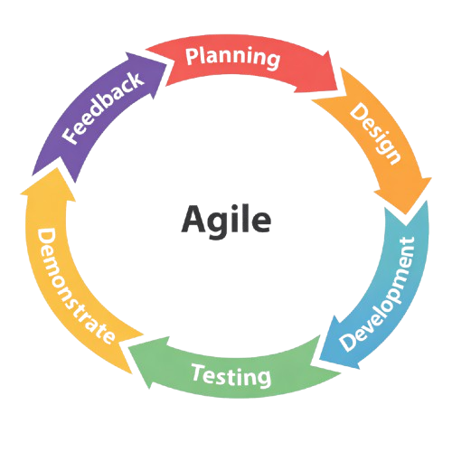
System Development Phases
Planning
In the Planning Phase, we gathered information from fish farm owners and staff through interviews and discussions to understand the daily operations of the hito farm. We identified the important processes that needed to be recorded in the system such as feeding activities, feed inventory monitoring, sales transactions, and operational expenses. This phase helped us determine the main features of the system and organize them into development tasks for the first stage of the project.
Design
In the Design Phase, we transformed the gathered requirements into system designs and interface layouts. We planned the structure of the database, system workflow, and the layout of the web interface. The design focused on creating a simple and user-friendly platform that allows staff to easily record feeding logs, monitor feed inventory, manage sales orders, track expenses, and view analytics and reports.
Development
During the Development Phase, we implemented the planned features and converted the system design into a functional web-based platform. We developed the core modules of the system including the Feeding Log, Feed Inventory Monitoring, Sales and Order Management, Expense Tracking, and Analytics and Reports. Each module was built to support the daily operations of the hito farm and ensure that data is properly recorded and organized.
Testing
In the Testing Phase, we conducted several tests to ensure that the system functions properly and meets the intended requirements. We tested the functionality of each module to confirm that feeding records correctly update the feed inventory and that sales and expenses are properly stored in the system.
Demonstrate
In the Demonstrate Phase, we presented the developed system to the fish farm owner and selected users to show how the system works. We demonstrated the main features of the system including the Feeding Log, Feed Inventory Monitoring, Sales and Order Management, Expense Tracking, and Analytics and Reports.
Feedback
In the Feedback Phase, we collected comments and suggestions from the owner after the system demonstration. The feedback helped us identify areas of improvement in the system such as usability, functionality, and overall performance.

Planning/Conception-Initiation Phases
Business Model Canvas

Figure 3.2: Business Model Canvas of Hito Farm Management System with Data Analytics.

Gantt Chart
Months | February |  |  |  | March |  |  |  |  | April |  |  |  |  | May
Description | 1 | 2 | 3 | 4 | 1 | 2 | 3 | 4 | 5 | 1 | 2 | 3 | 4 | 5 | 1 | 2 | 3 | 4 | 5
Planning
Design
Development
Testing
Demonstrate
Feedback

Finish
Ongoing
Legend

Figure 3.3: Gantt Chart. This illustrated chart is the start and ending month of the terminal elements and summary elements of Hito Farm Management System with Data Analytics.

Functional Decomposition Diagram
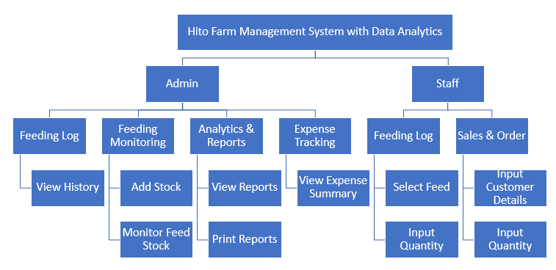

Figure 3.4: Functional Decomposition Diagram of Hito Farm Management System with Data Analytics.

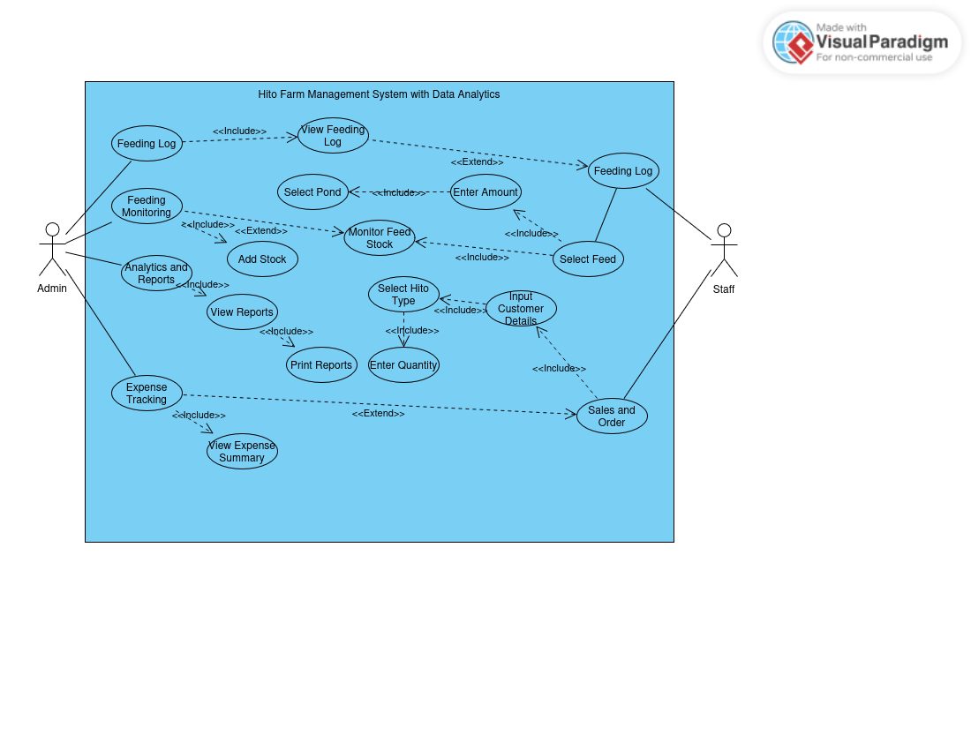
Use Case Diagram
Figure 3.4: Use Case Diagram of Hito Farm Management System with Data Analytics.

Use Case Matrix
Use Case | Registration
Author | Garde, Michael Jude, Gonzales, Gwen and Taberna, Anthonaite
Primary Actor | Admin
Basic Flow | When an admin monitor of hito buying
 | 1. Administrators to track the module for hito sales
 | 2. Monitor and financial tracking
Post Condition | Admin must monitor inventory
Secondary Actor | Staff
Trigger | When staff can ensure accurate monitoring of the hito buying
Basic Flow | Recording feeding logs
Post Condition | Systematic tracking module for feed inventory

Table 3.1: Use Case Matrix of Hito Farm Management System With Data Analytiics.

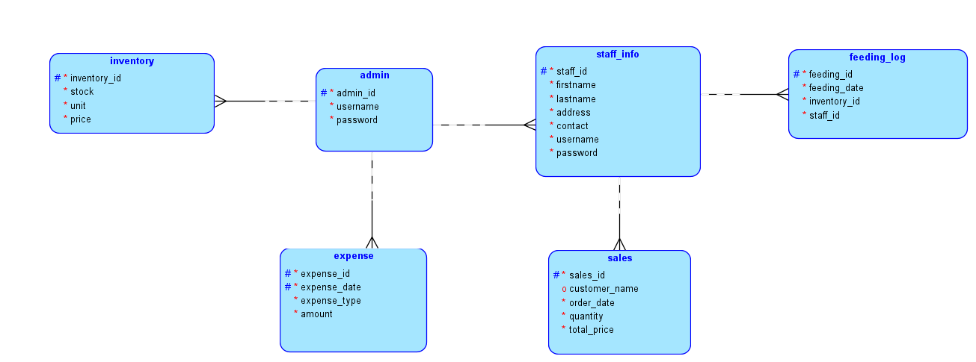
Database Disign

Entity Relationship Diagram
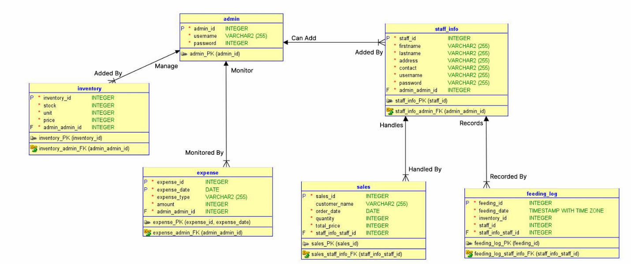

Data Dictionary
Admin
Column | Type | Null | Description
admin_id | int(11) | No | Admin id
username | varchar(255) | Yes | Admin username
password | varchar(255) | Yes | Admin password

Expense
Column | Type | Null | Description
expense_id | int(11) | No | Expese id
expense_date | date | Yes | Expense date
expense_type | varchar(255) | Yes | Type of expense
amount | decimal(10,2) | Yes | Totoal amount
admin_id | int(11) | Yes | Admin Foreign Key

Feeding Log
Column | Type | Null | Description
feeding_id | int(11) | No | Feedling log id
feeding_date | timestamp | No | Log date
staff_id | int(11) | Yes | Staff Id For Feeding
status | varchar(50) | Yes | Fedding Status

Inventory
Column | Type | Null | Default
inventory_id | int(11) | No | Inventory Id
stock | int(11) | Yes | Inventory total stock
price | decimal(10,2) | Yes | Price for stock
date_added | date | Yes | Date added to Inventory
admin_id | int(11) | Yes | Admin ID for Inventory

Sales
Column | Type | Null | Default
sales_id | int(11) | No | Sales ID
customer_name | varchar(255) | Yes | Name of customer
order_date | date | Yes | Date customer purchase
total | decimal(10,2) | Yes | Total amount
staff_id | int(11) | Yes | ID of Staff to Sales

Staff
Column | Type | Null | Default
staff_id | int(11) | No | Satff ID
firstname | varchar(255) | Yes | Staff first name
lastname | varchar(255) | Yes | Staff Last name
address | varchar(255) | Yes | STaff Adrress
contact | varchar(255) | Yes | Staff Contact number
username | varchar(255) | Yes | Staff Username
password | varchar(255) | Yes | Staff password
admin_id | int(11) | Yes | Admin ID to add staff
Network Design
Network design is the integration of the connection type of the devices to achieve end-to-end communication between the devices in the network, which helps to identify the type of topology the Hito Farm Management System with Data Analytics is going to use.
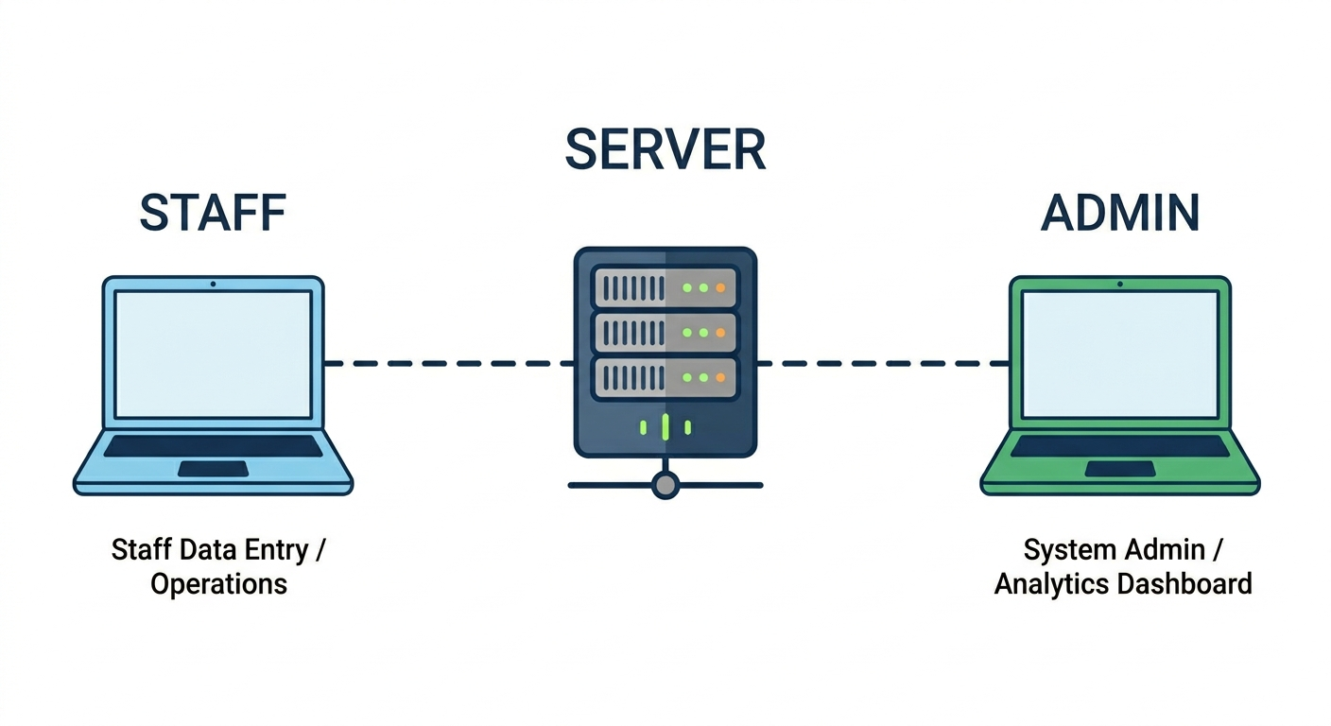

Network Topology
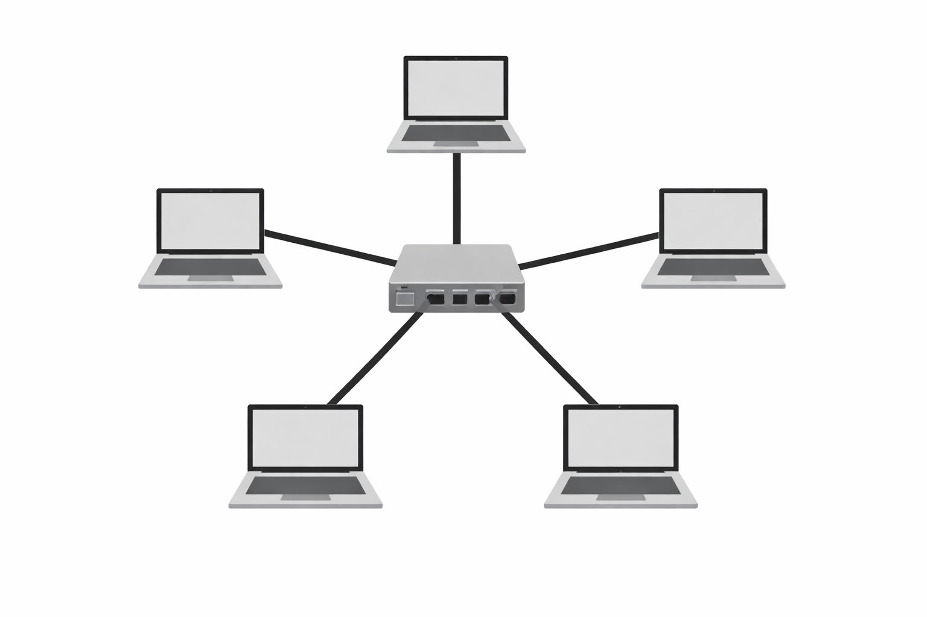
The network model that will be used is the Star Topology. In this model, each device such as computers, mobile devices, and monitoring systems is connected directly to a central router or network switch. This central device serves as the core of the network, managing and controlling the communication between all connected devices. It ensures efficient data transfer for feeding records, monitoring, and system access within the farm.

Development/Construction/Build Phase
Technological Stack
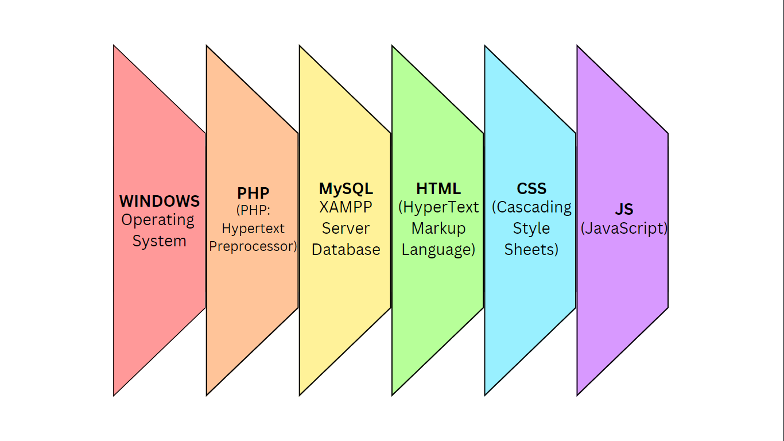
Software Specification
Language: PHP
Technology: HTML, CSS Framework, JS, PHP
Database: MySQL XAMPP Server
IDE: Visual Studio Code
Operating System: Microsoft Windows 10
Hardware Specification
Processor: Intel Core i3 6th gen
Hard Disk: 464 GB
RAM: 8.00 GB
Program Specification
Language: PHP
Database: MySQL

List of Modules
Feeding Log Module – This module records and monitors the daily feeding activities of the hito, including the date, feed type, quantity used, and the staff member responsible. It also provides an activity log for the admin to ensure traceability of all feeding operations.
Feed Inventory Monitoring Module – This module tracks the available feed stock in the inventory and automatically updates feed quantities whenever feeding activities are recorded, ensuring accurate and up-to-date inventory management.
Sales and Order Management Module – This module records and manages customer orders for harvested hito, including order date, quantity purchased, and total price, allowing the farm to maintain organized and accurate sales records.
Expense Tracking Module – This module monitors all operational expenses such as feed and automatically calculates the profit based on recorded sales and total.
Analytics and Reports Module – This module generates visual charts and summarized reports of overall farm operations including feeding, sales, inventory, and expenses, with the option to print reports to support decision-making.

USER GUIDE
1. Introduction
The Hito Farm Management System with Data Analytics is a web-based system to help the farm record and monitor daily operations. It helps the admin and staff track feeding activities, feed inventory, customer orders, expenses, and generate reports.
This user guide explains how to use the main features of the system.
2. System Requirements
Hardware Requirements
- Desktop or laptop computer
- Minimum of 4 GB RAM
Software Requirements
- Web browser (Google Chrome or Microsoft Edge)
- Internet connection
3. User Roles
Administrator
- Manages user accounts
- Monitors feeding logs, inventory, sales, expenses, and reports
- Views all activity logs
Staff
- Records feeding activities
- Updates sales and expense records
4. Accessing the System
- Open a web browser.
- Enter the system URL in the address bar.
- Enter your username and password.
- Click the Login button.
- The dashboard will appear based on your user role.
5. Dashboard Overview
After logging in, the dashboard shows:
- Summary of feed inventory levels
- Recent feeding activities
- Sales and expense overview
- Quick access to all modules
6. Feeding Log Module
This module records the daily feeding activities of the hito.
Steps:
- Go to Feeding Log from the menu.
- Enter the date, feed type, quantity used, and staff responsible.
- Save the record.
- The feed inventory will automatically update.
- The admin can view all feeding activity through the activity log.
7. Feed Inventory Monitoring Module
This module tracks the available feed stock.
Steps:
- Go to Feed Inventory
- View current feed stock levels.
- Add new stock records when new feed arrives.
- The system automatically deducts feed quantity every time a feeding log is recorded.
8. Sales and Order Management Module
This module records customer orders for harvested hito.
Steps:
- Go to Sales and Orders from the menu.
- Enter the customer name, order date, quantity purchased, and total price.
- Save the record.
- View past orders anytime from the list.
9. Expense Tracking Module
This module records all farm operational expenses.
Steps:
- Go to Expenses
- The system will calculate total expenses and profit based on recorded sales.
10. Analytics and Reports Module
This module shows visual charts and printed reports of farm operations.
Steps:
- Go to Reports
- Select the type of report you want to view.
- Choose a date range if needed.
- View the charts and summary.
- Click Print to print the report.
11. Logout
- Click the Logout button.
- You will be returned to the login page.
12. System Maintenance
- Always enter accurate data to keep the records correct.
- Report any system issues to the administrator.
INSTALLATION GUIDEHito Farm Management System with Data Analytics
1. Introduction
This guide explains how to install and set up the Hito Farm Management System with Data Analytics. It is intended for the system administrator or technical person who will set up the system.
2. Pre-Installation Requirements
Hardware Requirements
- Desktop or laptop computer
- Minimum of 4 GB RAM
- At least 16 GB available storage
- Stable power supply
Software Requirements
- Operating System: Windows 10 or higher
- Web Server: Apache
- Database Server: MySQL
- Server-side Language: PHP (version 8.0 or higher)
- Web Browser: Google Chrome or Microsoft Edge
3. System Architecture
- Client Side: Web browser used by admin and staff
- Server Side: Application logic and database
- Database Layer: Stores feeding logs, sales, inventory, and expense records
4. Installation Steps
Step 1: Prepare the Server
- Install the operating system.
- Install a web server (Apache).
- Install PHP and the required extensions.
- Install MySQL.
Step 2: Set Up the Database
- Create a new database for the system.
- Import the provided database file.
- Check that all tables were created correctly.
Step 3: Deploy the Application
- Copy the system files into the web server folder.
- Set up the database connection in the configuration file.
- Set correct file permissions.
Step 4: Configure the System
- Set the farm name and system settings.
- Create the administrator account.
- Save all settings.
Step 5: Add Initial Data
- Add user accounts for admin and staff.
- Enter starting feed inventory records.
- Set up expense categories.
5. Testing
After installation, check the following:
- Login page loads correctly.
- Admin and staff accounts can log in.
- Feeding log and sales records can be saved.
- Reports can be generated.
6. Security
- Change the default admin password after installation.
- Set proper access levels for each user role.
- Do regular database backups.
7. Backup and Recovery
Backup:
- Schedule regular backups of the database.
- Save backup files in a safe location.
Recovery:
- Restore the database from the latest backup file.
- Check if the system works correctly after restoring.
8. Troubleshooting
Issue | Possible Cause | Solution
System not loading | Web server not running | Restart the web server
Cannot log in | Wrong username or password | Check your credentials
Data not saving | Database connection problem | Check database settings
Reports not showing | Missing or incomplete data | Check and complete the records
9. Maintenance
- Update the system regularly.
- Check database size from time to time.
- Review system logs to catch issues early.

References
Munguti, J. M., & Iteba, J. O. (2022). Feeding management practices in African catfish (Clarias gariepinus) aquaculture. IntechOpen. https://doi.org/10.5772/intechopen.100000
Engle, C. R. (2021). Aquaculture economics and financing: Management and analysis. Wiley-Blackwell. https://doi.org/10.1002/9781444315011
Kumar, S., & Singh, R. (2022). Traditional pond management practices in Indian aquaculture: A review. PMC. https://pmc.ncbi.nlm.nih.gov/articles/PMC9638415/
Caño, L., & Quizon, M. (2024). Pangilao fisherfolk undergoes training on hatchery breeding and culture management. Bureau of Fisheries and Aquatic Resources – Region 5. https://region5.bfar.da.gov.ph/2024/04/06/pangilao-fisherfolk-undergoes-training-on-hatchery-breeding-and-culture-management-of/
National Fisheries Research and Development Institute. (2021). New ways to raise dalag and hito will boost fish supply. Department of Agriculture – NFRDI. https://www.da.gov.ph/new-ways-to-raise-dalag-hito-will-boost-fish-supply/
Reyes, A. M., Santos, B. L., Cruz, C. D., & Dela Cruz, E. F. (2022). The supply-demand and value chain of catfish in the two northern cities of Nueva Ecija, Philippines. ABA Academics. https://www.abacademies.org/articles/the-supplydemand-and-value-chain-of-catfish-in-the-two-northern-cities-of-nueva-ecija-philippines-15275.html
Radulescu, A., & Radulescu, D. (2021). AQUAM: A decision support software for fish farm management. Journal of Fisheries Science, 13(2), 45–49. https://doi.org/10.1234/jfs.2019.13.2.45
Macrofix. (2023). Fishery management system. Macrofix Solutions. https://www.macrofix.com/fishery-management-system
Anyadike, R. N., Mbajiorgu, C. A., & Ajah, P. O. (2020). AQUASMAT: Development of an aquacultural system management tool. Aquacultural Engineering, 68, 1–10. https://doi.org/10.1016/j.aquaeng.2015.03.004
Clemente, R. P. (2021). Development of an on-line hatchery monitoring and feeding management system for Nile tilapia. Eastern Visayas State University. https://www.evsu.edu.ph/university-research-and-created-works/development-of-on-line-hatchery-monitoring-and-feeding-management-system-for-nile-tilapia
Rocha, J. P., Santos, A. D., & Villanueva, L. M. (2024). Serverless web-based inventory management system for aquaculture operations. EasyChair Preprint No. 4FHz. https://easychair.org/publications/preprint/4FHz
Gania, K. M., Solomon, R. P., & Decatoria, J. F. (2023). Fishfeeding guide: A feeds monitoring system for aquaculture management. EasyChair Preprint. https://easychair.org/publications/preprint/4FHz

