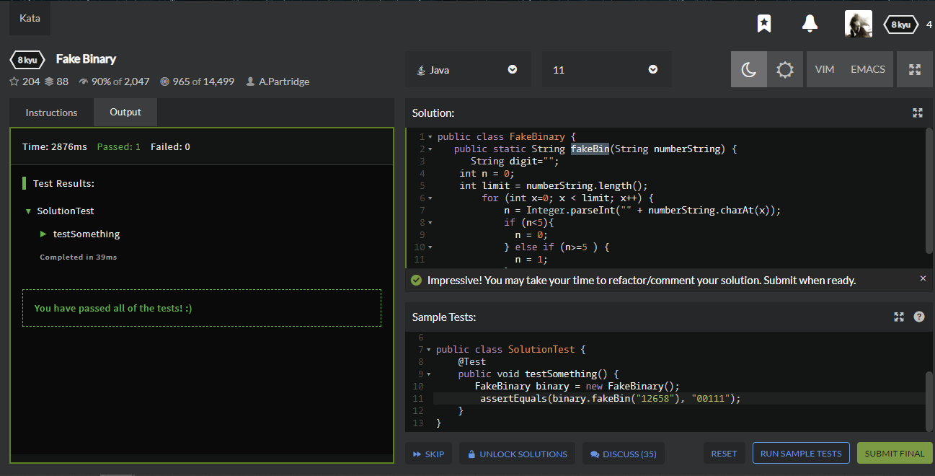

**public** **class** FakeBinary {

**public** **static** **void** main(String[] args) {

String numberString = "125789";

String result= *fakeBin*(numberString);

System.***out***.println(result);

}

**public** **static** String fakeBin(String numberString) {

String digit="";

**int** n = 0;

**int** limit = numberString.length();

**for** (**int** x=0; x < limit; x++) {

n = Integer.*parseInt*("" + numberString.charAt(x));

**if** (n<5){

n = 0;

} **else** **if** (n>=5 ) {

n = 1;

}

digit = digit + n;

}

**return** digit;

}

}

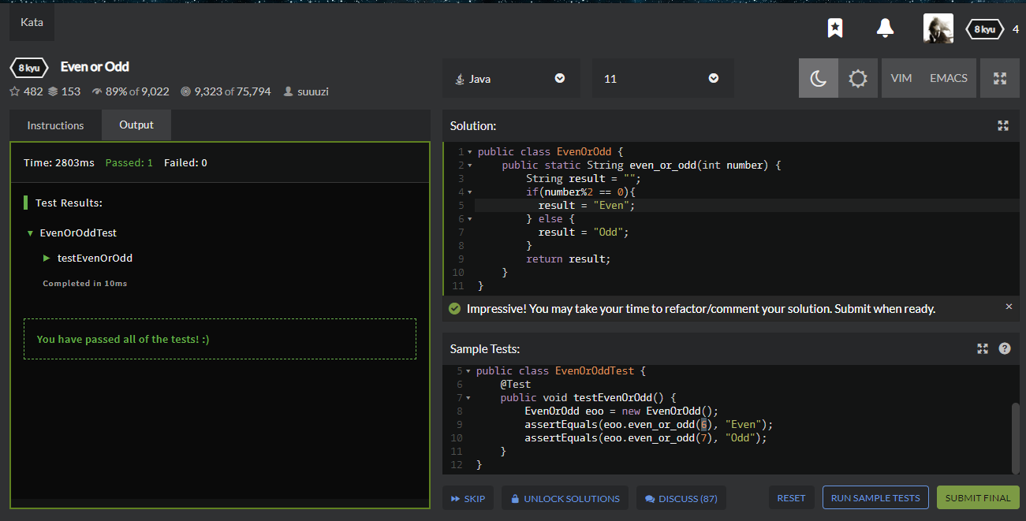

**public** **class** EvenOrOdd {

**public** **static** **void** main(String[] args) {

String result = *even_or_odd*(5);

System.***out***.println(result);

}

**public** **static** String even_or_odd(**int** number) {

String result = "";

**if**(number%2 == 0){

result = "Even";

} **else** {

result = "Odd";

}

**return** result;

}

}

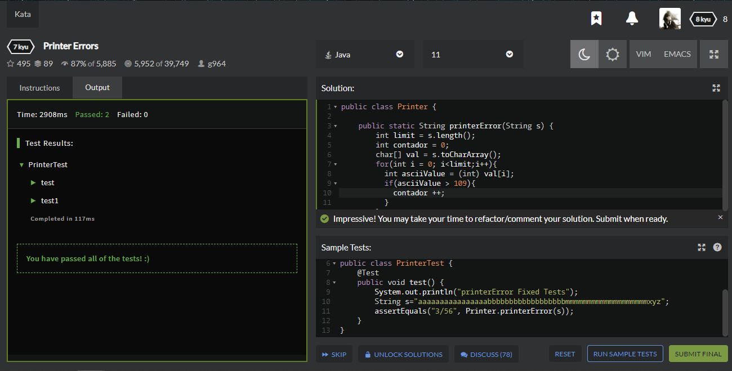

**public** **class** Printer {

**public** **static** **void** main(String[] args) {

String s = "kisdhifbgsodfasiovy";

String result= *printerError*(s);

System.***out***.println(result);

}

**public** **static** String printerError(String s) {

**int** limit = s.length();

**int** contador = 0;

**char**[] val = s.toCharArray();

**for**(**int** i = 0; i<limit;i++){

**int** asciiValue = (**int**) val[i];

**if**(asciiValue > 109){

contador ++;

}

}

**return** (contador+"/"+limit);

}

}

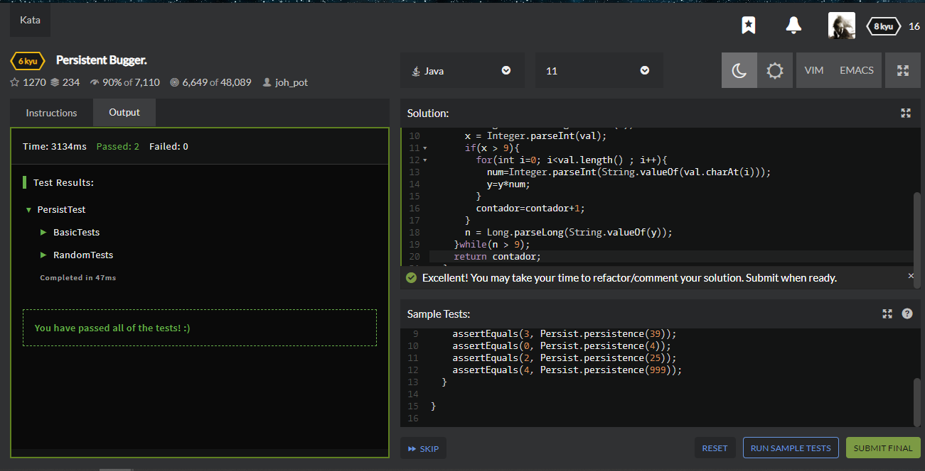

**public** **class** Persist {

**public** **static** **int** persistence(**long** n) {

**int** num;

**int** x;

**int** y =0;

**int** contador = 0;

**do**{

y = 1;

String val = String.*valueOf*(n);

x = Integer.*parseInt*(val);

**if**(x > 9){

**for**(**int** i=0; i<val.length() ; i++){

num=Integer.*parseInt*(String.*valueOf*(val.charAt(i)));

y=y*num;

}

contador=contador+1;

}

n = Long.*parseLong*(String.*valueOf*(y));

}**while**(n > 9);

**return** contador;

}

}