On the Origin of Citations

Michael Gebhardt

September 15, 2015

# Load the Data

## Using 'read.delim'

counts_raw <- read.delim("data/counts-raw.txt.gz")  
counts_norm <- read.delim("data/counts-norm.txt.gz")

# Data Exploration

### What's the distribution of authors in all articles of our data set?

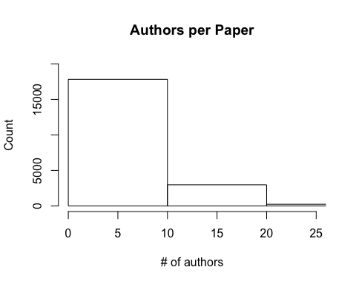

### How popular are articles on Facebook?

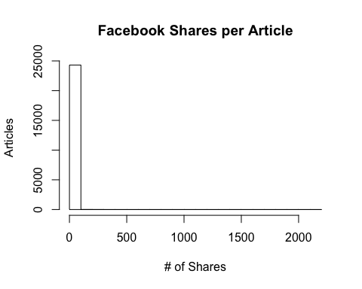

The average number of Facebook Shares per article in the data set is **0.6524187**.

The maximum number of Facebook Shares for the dataset is 2145.