# ellen_clock

Python 3.6.10 |Anaconda, Inc.| (default, Jan 7 2020, 21:14:29)

[GCC 7.3.0] on linux

# Intentional Binding Task

## Task definition

* The procedure for this task was based on that described by Moore et al., (2010). In the task, participants sat in front of a computer screen displaying a clock face (7 cm in diameter) with a single hand.
* The clock was marked with the conventional intervals (e.g. 5, 10, 15, etc, through to 60).
* The hand rotated at one revolution every 2560 ms, init position = 0
* The clock hand continued to rotate for a random length of time after the tone (between 1500 ms and 2500 ms) after the button was pressed
* The [conditions] were presented in [blocks], such that the participants always estimated either the action times only, or the tone times only. There were a total of four conditions in the Intentional Binding task, and each condition was preserved in a block. The four blocks were presented in randomised order [but maybe not randomised this time], and each block consisted of 20 trials.
  + There were four [blocks] in the task: two action–effect (agency) conditions and two baseline conditions
* [instruct] not to only to provide responses that were multiples of five according to the numbers displayed: yield a response in {1,2,3,…,58,59,60} instead of in {0,5,10,15,…,45,50,55,60}
* [return] the mean error between estimated and actual times was calculated for each condition.

## Table of conditions

|  |  |
| --- | --- |
| baseline action | action-effect action |
| baseline tone | action-effect tone |

* Baseline action: spoken response is a clock-time estimate for the keypress.
* Baseline tone: spoken response is a clock-time estimate for the tone.
* Action-effect action: spoken response is a clock-time estimate for the keypress (where a tone is played just after the keypress).
* Action-effect tone: spoken response is a clock-time estimate for the tone (the tone that occurred just after the keypress).

## Procedure for each of the 4 conditions

### baseline action

* The rotation of the clock hand was initiated by kb
* participant presses mac key whenever they like and this is the time stamp they are indicating when they respond.
  + Also init listener.
* response is an estimate of what number the clock hand was pointed at at the time of the kb press, given as a time-stamped voice response
* wav file close
* repeat trial

### baseline with tone

* The rotation of the clock hand was initiated by kb
* [tone] tone (1000 Hz, 75 ms duration) occurs at [some, tbc, min.max] duration since clock init.
  + Also init listener.
* response is an estimate of what number the clock hand was pointed at at the time of the [tone], given as a time-stamped voice response
* wav file close
* repeat trial

### action-effect tone condition

* The rotation of the clock hand was initiated by kb
* participant presses mac key whenever they like and this is the time stamp they are indicating when they respond.
* [tone] tone (1000 Hz, 75 ms duration) occurs at [250 ms] duration since [kb press].
  + Also init listener.
* response is an estimate of what number the clock hand was pointed at at the time of the [tone], given as a time-stamped voice response
* wav file close
* repeat trial

### action-effect action condition

* The rotation of the clock hand was initiated by kb
* participant presses mac key whenever they like and this is the time stamp they are indicating when they respond.
* [tone] tone (1000 Hz, 75 ms duration) occurs at [250 ms] duration since [kb press].
  + Also init listener.
* response is an estimate of what number the clock hand was pointed at at the time of the [kb press], given as a time-stamped voice response
* wav file close
* repeat trial

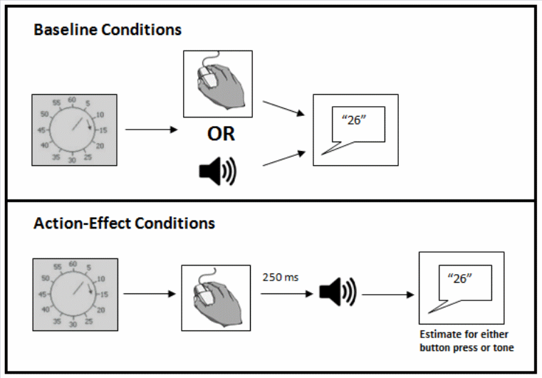

Conditions

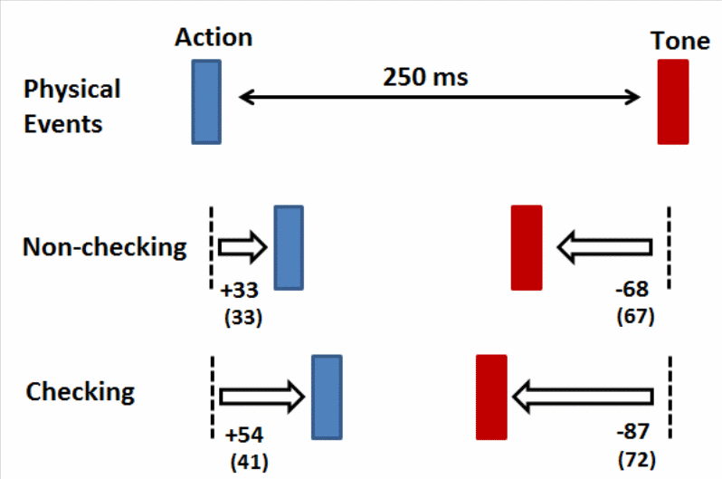

Results example