**EMSA Practical Report: Resubmission**

***The Other-Race Effect in Face Recognition***

Students are required to submit a 1500-word practical report. This report is the same as the SIT (and In-Year Retrieval) assignment. A lot of effort was put into providing detailed constructive feedback on all reports. Students should review their previous submission to check and follow feedback carefully.

The Discussion Forum contains a lot of information relating to the assignment. There have also been multiple Brightspace announcements relating to the assignment (i.e., what is required to pass, what types of tests will need to be conducted, how to follow feedback).

**Report details:**

The following information relates to what is expected in the assignment. It details the specific tests that are required to be run, and how students will be able to pass the assignment.

**ASSIGNMENT TEMPLATE:**

All students have been notified that they **SHOULD** use the **Assignment Template** provided to them on Brightspace. This template is a fill-in-the-blanks document and is designed to ensure they submit a report with the necessary sections and in the correct format (the document is in APA format).

The assignment template starts with the assignment front cover sheet – which students should fill in. If they don’t, please mention this within the feedback section to take note of for future assignments.

In this template, there are sections which are in blue (see image below). All blue writing should be deleted prior to the submission. This includes the entire Introduction section.

If a student does not use the template, then it is likely that they are missing sections, or the formatting is not correct throughout. Please make a note of this in the written feedback. If they are missing sections/content, then this will be addressed in the marking of specific sections of the report.

**WORD COUNT:**

This assignment is a 1500-word practical report. The word count includes:

* Abstract
* Abstract Keywords
* Method
* Results
* Discussion
* Headers
* Sub-Headers
* Figure/Table Headings

The word count does NOT include:

* Cover page
* Title
* Introduction (this should be deleted prior to submission)
* Tables
* Figures
* Tables/Figures Titles
* References
* Appendices

If the word limit is exceeded (even by one word), 10 marks will be deducted from the grade. You should highlight this within the feedback and inform the student to take note of the word limit on future assignments.

**INTRODUCTION SECTION:**

Since this is the students’ first empirical report, the Introduction was written for them. This should provide them with an overview of the research topic and why this is an important piece of research to explore. The introduction also includes some citations that students can use in their Discussion section:

* Meissner & Brigham, 2001; Zhao et al., 2014; Wright et al., 2003; Hancock & Rhodes, 2003; Fioravanti-Bastos et al., 2014; Wong et al., 2020; Wong et al., 2013.

Students are informed that they **MUST delete the Introduction section prior to submission** to avoid a high similarity percentage.

The study aims and hypotheses are provided to students in the Introduction section in the Template.

**ASSIGNMENT TASK:**

The assignment investigates how contact with other races can affect other-race recognition (i.e., how accurate we are at recognising faces from other races).

Students are given two research questions:

* Are Caucasian people better are recognising Caucasian faces than Chinese faces?
* Is there a relationship/association between the time living in East Asia and the recognition of Chinese faces?

Students were provided with the data. This data contained responses from 50 British Caucasian participants. These participants were first asked the following question:

* How long (in months) have you stayed in these South Asian countries (If you have not lived in South-Easy Asia, please leave as ‘0 month’).

Following this question, participants were then given a face recognition task. This task consists of two stages: the learning and the recognition stages. During the learning stage, participants must learn several faces – half of them were Asian and the other half were Caucasian faces. During the recognition stage, the learnt faces are now intermixed with new faces, that were either Asian or Caucasian faces. Participants had to decide if the faces shown here were those previously learnt. For more detailed description of the experiment, please refer to the Student Guide.

**WHAT STUDENTS ARE EXPECTED TO DO AND FIND:**

Students NEED to:

* Complete all necessary sections of the empirical report: Abstract, Method, Results, Discussion, References, Appendices.
* RQ1: Compare the participants recognition accuracy for Caucasian and Asian faces. They should use a Paired -samples t-test (also known as within-subjects or repeated measures t-test).  
  + In brief, the Caucasian participants were found to be better at recognising their own-race faces (RQ1).
* RQ2: Determine if there is an association/relationship between accuracy for Asian faces and duration stayed in South-East Asia. They should use a correlation. **VIP:** Depending on the version of JASP used, students will either find a significant or not significant p-value when testing normality. As such, students may use either a Pearson’s r or Spearman’s rho test here. However, they should choose the correct correlation test depending upon their normality test.  
  + In brief, those who spent more time staying/living in South-East Asia were also better at recognising Asian faces (i.e., more time spent = higher accuracy; RQ2).
* Overall, the study provides further support for the other-race effect. It also provides evidence that this effect is modulated by experience/contact with race of face (i.e., better recognition of other-race faces due to more contact, therefore reducing the differences in accuracy compared to recognising own-race faces).

**TITLE:**

The Title should convey exactly what the report is about. Ideally, this should include the IV (other-race effect contact) and the DV (face recognition). Ideally, the Title will be concise (10-12 words), but if they do expand then it should be as a correlational experience. Some examples are below:

* *Impact of cross-cultural contact on other-race effect*
* *Contact and its influences on face recognition in Western society*
* *Role of contact in the other-race effect: A correlational study*
* *An investigation into the other-race effect on face recognition*

**ABSTRACT:**

The Abstract should be around 120-150 words. The Abstract should:

* Provide an overview of a key study or theory which underpins the research project. This study is based on an older piece of research showing that face recognition is better for own-race faces than other-race faces, and how contact may be a contributing factor. Citations from the following are acceptable (Hancock & Rhodes, 2008; Meissner & Brigham, 2001; Wright et al., 2003; Fioravanti-Bastos et al., 2014; Zhao et al., 2014; Wong et al., 2021)
* A summary of what they did
* A summary of what they found
* A summary of what it means (i.e., interpretation of the findings).

**INTRODUCTION:**

As stated above, students were given the Introduction in the Template. They SHOULD delete this.

In essence, there should be no Introduction section. If, however, students leave the word ‘Introduction’ or put the project aim or hypotheses under this section, then please do not penalise.

**METHOD SECTION (30%):**

The Method section should have **four different subsections**.

**DESIGN**

RQ1: The first research question (recognition of own-race faces better than other-race faces) was a within-subject / repeated measures design. The IV was race of faces (Caucasian / White + Asian / Chinese) and the DV was face recognition accuracy (or percentage of correct faces).

RQ2: The second research question (does contact affect recognition of Chinese faces?) was a correlational design. This design was used to examine the association/relationship between the variables (1) contact / time spent in Asia, and (2) recognition of Chinese faces.

* Design **must** state repeated measures and/or correlational design.
* Please state when student incorrectly provides IV/DV for RQ2. Correlational designs do **not** have an IV/DV. They just have co-occuring variables.

Examples:

*“To examine the first research question, a within-subjects /repeated measures design was used. The IV was race of faces (Caucasian or Asian) and the DV was face recognition accuracy.”*

*“To investigate the second research question, a correlational design was used. We examined the relationship between time spent in Asia and recognition of Chinese faces.”*

Hypotheses:

Students are asked to provide hypotheses for the research questions. They can put this anywhere within their report (i.e., where the Introduction usually goes), though it is best placed in the ‘Design’ subsection of the Method section.

As there are two research questions, there are two alternative hypotheses and two null hypotheses. Be aware of use of language in the hypotheses.

RQ1:

**Alternative:** *We hypothesise that White British participants will demonstrate better recognition of faces from their own racial group (own-race) compared to faces of other racial or ethnic groups (e.g., Asian or Chinese faces).*

**Null:** *We hypothesise that there will be no significant difference in the recognition of own-race faces and faces from other racial or ethnic groups (e.g., Asian or Chinese faces) by White British participants.*

RQ2:

**Alternative:** *There will be a positive association between the amount of time individuals have lived in South-East Asia and their ability to recognise Chinese faces.*

**Null:**  *There will be no association between the amount of time individuals have lived in South-East Asia and their ability to recognise Chinese faces.*

**PARTICIPANTS**

Students should report here information about the participants in the research. This includes, how many people, gender (ideally a breakdown of gender), and mean age. They have been told to write this section *as if* they had collected the data. Generally, students should include the following:

* 50 British Caucasian Psychology Students from Bournemouth University.
* 25 males, 25 females
* Mean age: *M* = 20.14, *SDAGE = 2.21* (should **not** be marked down if include decimal point or not but **must** include the unit in ‘years’ for both Mean and SD).
* Note that students should provide age for males and females separately (descriptive statistics for ALL participants and Gender breakdown are below).

Examples:

*This study included 50 British Caucasian Psychology students (25 males, 25 females) from Bournemouth University, with a Mean age of 20 years (SD = 2 years). All participants provided informed consent prior to the experiment.*

*50 British Caucasian Psychology students (25 males and 25 females) from Bournemouth University with a Mean age of 20.14 and a Standard Deviation Age of 2.21 years were recruited. The Mean age of Males was 20.16 years (SD = 2.90 years). The Mean age of Females was 20.12 years (SD = 1.27 years).*

* Participants subsection **must** contain some descriptive statistics (Mean and Standard Deviation) of the 50 Caucasian participants.

**MATERIALS**

This section **must** include the one question asked to participants (e.g., *A pre-screening questionnaire was given, asking participants the following question: “How long (in months) have you stayed in these South-Asian countries?”).*

The Materials subsection **must** include description of the stimuli used. It should include **most** of the details below:

* 21-inch screen used
* Obtained from University of Nottingham Malaysia Face Lab (Wong et al., 2021)
* Number (and race) of faces: 24 faces (12 Caucasian, 12 Asian)
* Size: 200 pixels (width) × 250 pixels (height)
* Gender of faces: all male faces
* Faces were cropped so that only internal facial features were retained.

**Bonus** if they include any of the following:

* Experiment was conducted on Testable (Rezlescu et al., 2020).
* Included an example of stimuli (figure) in appendix.
* Only male faces were used because people perform equally well with male faces whereas women show a recognition advantage over female faces (Lewin & Herlitz, 2002).

Some students might include an image of the stimuli (or mention that the stimuli can be found in the Appendix section). This is good practice, and you should provide positive feedback for including an example of the stimuli in the report.

* Materials subsection **must** mention that a face recognition task was employed, wherein both Caucasian and Asian faces were displayed/shown.

**PROCEDURE:**

This section **should** provide a chronological account of what was done. This section **should not** include data analysis or anything that has already been mentioned above. Students **should** include details relating to:

* How many faces presented during learning and recognition stage (specifically, in each block).
* How many of these faces were Caucasian and Asian.
* How long faces were presented.
* What the response key was (i.e., ‘Q’ for yes + ‘P’ for no).
* Participants were debriefed.
* Bonus if student includes the text in **bold** below (as this would indicate they ran the study on themselves as requested).

“*All participants were provided informed consent prior to participation. Participants sat in front of a PC equipped with a 21-inch screen at approximately a distance of 70 cm. Following the pre-test question, participants were given the main task.* ***There are two blocks for the main task. Each block contains two stages: learning and recognition stage****. In each block during the learning stage, participants were presented with a set of six unique faces to learn (three Caucasian, three Asian faces).* ***Faces were presented sequentially/individually****, each for one second. Accordingly, during the recognition stage, participants were presented with the six learnt faces intermixed with six new faces (total of six Caucasian and six Asian faces). In this stage, participants must decide if they have seen these faces during the earlier stage, or not. Each face was presented for 0.5 seconds, followed by a blank screen until a response was given* ***(‘Q’ for yes and ‘P’ for no)****.* ***A new face will appear once a response has been given.******The order of the faces in both stages were randomized for each participant****. Participants were debriefed at the end of the study.* ***The whole session took approximately 10 minutes.***”

* Procedure subsection **must** mention that six faces were learnt, and that participants had to recognise them among six other novel faces (12 faces in total) in the later stage. This section should explain how the study was conducted, step-by-step, in a chronological manner, so that readers can replicate exactly how the experiment was conducted.

**JASP VERSION:**

Students have been asked to state which version of JASP they have used in their analysis. There are three versions (V.17, V.18, V.19) they have access to. They **should** state this somewhere in the Method section or Results section. Please do not penalise if they do not add this. It is purely to ensure we are aware of what version JASP they use as this will determine if their choice of test in RQ2 (correlation) is a Pearson’s r or Spearman’s rho correlation.

**WEIGHING THE METHOD SECTION:**

This section is worth 30% of their assignment. Students were told to run the experiment on themselves. **Bonus marks** (those highlighted above in **bold**) are for information they would know **only if** they ran the experiment as requested.

Students must have 4 sub-headings in this section (this was provided to students in the template already). Each subsection should be described in paragraphs (see examples above) and not in bullet point format.

Some students might also add an Ethics subsection and state how participants were informed of the study (i.e., Participant Information Sheet), provided informed consent (i.e., Participant Consent Form) and were debriefed at the end (i.e., Debrief Form). Do **not** penalise for a 5th subsection. In fact, you should use your judgement and if included, this should go towards the bonus marks calculation.

**RESULTS SECTION (40%):**

The Results section should begin with a **summary** of their findings and/or referred to **Tables or Graphs** (unless different information is presented in each). Some students may also start with an outline/reminder of the project aims/hypotheses. Students were provided with the following instructions:

**Note:** JASP output (i.e., anything produced in JASP should be included in the Appendix section). In the Results section, students should include APA formatted Tables/Figures based on the JASP output.

Students are not told which (significance) test to use, so their choice should be followed by a clear justification of which is appropriate. Bonus if they use correct error bars (95 CI) and reported them correctly for Figure/Graph (see *Note*):





As a **minimum**, students should report:

* A description of the results for each question (see below). Students may split their Results section into two halves: RQ1 and RQ2 for ease of reading.
* **Data Assumptions:** For both RQ1 and RQ2, students should check for normality (e.g., Shapiro-Wilk test). Please note, during the lectures, students were informed that t-tests are quite robust to normality violations – which they might state.

**Assumptions:**

For RQ1: The normality assumptions are met – irrespective of JASP version used.

For RQ2: The normality assumptions are dependent upon version of JASP used. **All versions are ok to use – however, students should follow the correct statistical test depending upon the results of their normality test** (see below).

RQ1:

Students should use a Paired samples t-test. Data output:

* **Paired samples (repeated-measures) t-test** **for RQ1:** Findings show that participants recognise own-race (White) faces more accurately than other-race (Asian) faces. Below are some examples:
  + “*A within-subjects/paired sample t-test showed there was a significant difference between the recognition accuracy for own-race (Caucasian) faces (M = 77.35, SD = 12.07) and other-race (Asian) faces (M = 57.83, SD = 15.45), t(49) = 9.463, p < .001.*”
  + “*Our analysis revealed that the mean accuracy for own race (Caucasian) faces was 77.35% (SD = 12.07),* *and the mean accuracy for other-race (Asian) faces was 57.83% (SD = 15.45). A within-subjects/paired sample t-test showed the differences were statistically significant, t(49) = 9.463, p < .001.*”
  + Extra points if students report and interpret **effect sizes** (written after the p-values, e.g., *t(49) = 9.463, p < .001, d = 1.338*). Ideally, they should also relate Cohen’s *d* values to whether the effect is small or large: .2 = small effect, .5 = medium effect and .8 = large effect size. This is not applicable for the second research question involving correlation.

RQ2:

Students should use a Correlation test. Depending upon the version of JASP used (please see below), the test for normality (Shapiro-Wilk) is violated / not-violated.

* **If this test is violated (i.e., p < .05) then students should use a Spearman’s rho correlation (as data is not normally distributed).**
* **If this test is not violated (i.e., p > .05) then students should use a Pearson’s r correlation (as the data is normally distributed).**

For JASP Version 17 and 18, students will likely see that the Shapiro-Wilk test is not significant (i.e., data is normally distributed / does not violate normality) and should compute a Pearson’s r correlation.

For JASP Version 19, students will likely see that the Shapiro-Wilk test is significant (i.e., data is not normally distributed / data does violate normality) and should compute a Spearman’s rho correlation.

Version 17 + 18 (Shapiro-Wilk not violated = Pearson’s r Correlation):

Version 19 (Shapiro-Wilk is violated = Spearman’s rho correlation):

* **Pearson’s correlation for the RQ2 (Version 17 + Version 18):** Findings show that duration stayed in SEA is significantly associated with recognition of Chinese faces. The Shapiro Wilk test is not significant – indicating that the data does not violate normality.  
  + “*A Pearson’s correlation coefficient showed there was a significant positive association/correlation between the recognition accuracy for other-race/Chinese faces and duration stayed in South-East Asia, r(48) = .609, p < .001.*”
* **Spearman’s rho correlation for RQ2 (Version 19):** Findings show that duration stayed in SEA is significantly associated with recognition of Chinese faces.   
  + “*A Spearman’s rho correlation coefficient showed there was a significant positive association/correlation between the recognition accuracy for other-race/Chinese faces and duration stayed in South-East Asia, r(48) = .641, p < .001.*”

Please note, students may forget to include the JASP version in their report. If this is the case, you should not penalise them if they choose either test (Pearson’s r OR Spearman’s rho). **However, they should make it clear why they chose this specific correlation test (i.e., the normality test being violated or not).**

**WEIGHING THE RESULTS SECTION:**

This section is worth 40% of their assignment. If students fail to report their analyses correctly **(*must contain those underlined above* + values should be the same)**, then they will be marked down.

Some students might do additional analysis and examine the relationship between ORE (difference between accuracy for own/other-race faces) and contact. If so, remind the student that this was **not part of the research question, but do not mark them down.** Some students might also try gender breakdowns in the Results section. If this is in addition to what they have been asked, **do not mark them down.**

**Reminder:** A large portion of their coursework marks are in the Results section (40%). Use your judgement with marking based on the information above and the information provided by the student. Tables must **not** be JASP output in the Results section. JASP output **must** go in the Appendix. Only APA formatted Tables/Figures should go in the Results section.

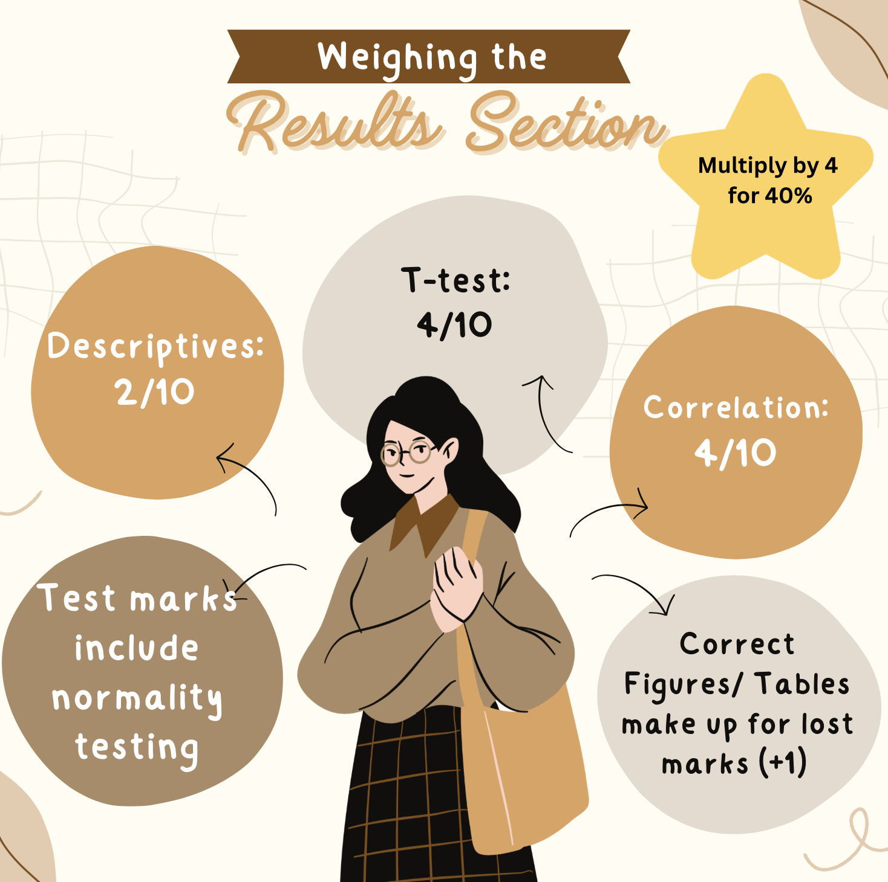

**DISCUSSION SECTION (30%):**

The Discussion section should begin with reiteration of the research question, and the hypotheses (which they may put before or in the Method section).

* “*The aim of the current study was to…, we hypothesise that…*”

Importantly, students must summarise the findings and link these back to their hypothesis and previous studies included in the introduction. **Students should answer the research questions based on their findings and provide support to the implications of previous studies**.

* E.g., “*We found that face recognition of own-race faces is better than other-race faces. Furthermore, our findings also revealed that more contact with other races indeed increases face recognition accuracy for other-race faces (Meissner & Brigham, 2001). These findings support/are consistent with the assumption that the face processing system is shaped by the interaction with the environment, specifically, experiences with other-race faces modulates the other-race effect (Zhao et al., 2014).”*

The students should also consider and evaluate the limitations, this might include improvements to the method:

* The other-race effect/contact may not be universal to other cultures, e.g., these findings may not be applicable in Asian participants etc.
* Ecological validity, e.g., in real-life scenarios, faces are not cropped, and we can identify others using external features as well etc.
* Encouraged more thoughtful criticism rather than general comments such as ‘cannot be generalised because tested on undergraduates’, ‘small sample size’ etc.

Bonus marks if they can provide counter arguments as to why they found what they found, but previous study found no such effect, e.g., Wong et al. (2023).

* “*As the social contact questionnaire was vague, wherein it did not separate past experience from current experience participants had with other-race people, it remains possible that the malleability of the other-race effect is determined by the age at which experience with another racial group begins*.”

Future research should reflect some considered ideas about the study and how it might be further developed. For example, the current research included only Caucasian samples, it would be great if future studies can examine ORE and contact by sampling multiple races and make such comparisons.

The final paragraph should conclude the entire study.

* “*In conclusion, our studies found that Caucasians were better at recognizing own-race than other-race faces (i.e., the other-race effect), and this other-race effect is modulated by contact/experience with other-race faces*.”

**WEIGHING THE DISCUSSION SECTION:**

The Discussion section should include an interpretation of the results, some discussion of the implication of the research and its findings and connect to previous studies/literature/theory. The Discussion section should also include a discussion of the study limitations, future directions, and a conclusion.

Students are new to writing an empirical report and may struggle to link their findings to other research. It is likely that most students will refer to the research stated in the provided Introduction (which they should delete). Some students may explore other research (i.e., more recent research). Take this into account when reading the Discussion section. We should positively mark for effort (with feedback on how to improve) rather than penalise for effort which might not be 100% correct.

