ME 557 Final Project

Yuanfen Chen, Michael Hoefer, Nigel Lee, Hsiang Sing Naik (Marcus)

3D Pacman

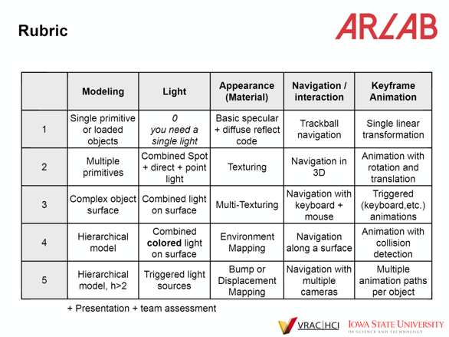

**Modeling - 3 points - complex object surface**

The two diamonds (dia1 and dia2) are instances of the GLDiamond class (in GLDiamond.cpp/.h), which extends the GLObject class.

void GLDiamond::make_Dia contains the vertices

The draw function uses triangle fan and triangle primitives

**Light - 5 points - triggered light sources**

GLSphere3D* sphere_blue has a spotlight on top and there is a direct light that changes (Triggered) based on the direction pacman is moving. This happens in the main render loop (switch (lightsource_flag)) and then the light_source_direct1 direction changes.

Lightsource_flag is updated in the control’s callback function at the top of the main file, based on the direction pacman is facing. The light is red and the sphere is blue, so it looks purple.

**Appearance (material) - 5 points - displacement mapping**

The displacement mapping happens on the GLPlane3D* plane.

The appearance is created using GLMultiTexture* texture_maze, using a color gradient and the tile texture. The tiles are distorted. The shaders used are noisemap.vs and noisemap.fs.

There is environment mapping on Pacman (loadedModel2) using spherical_mapping.vs and spherical_mapping.fs.

The texture.cpp is modified to make the environment mapping and displacement mapping compatible. (Previously the texture was overwritten). Environment mapping uses texture unit 0 and displacement mapping uses texture unit 1 and 2.

**Navigation/Interaction - 4 or 5 points (Navigation along a surface + multiple cameras)**

Pacman moves forward with “W,” rotates 90 degrees with “A” and “D” and rotates 180 degrees with “S.”

The keyboard_callback function contains the navigation logic. The current direction is stored in currentDirection and the camera changes accordingly. The ray intersection test is computed between pacman (loadedObject2) and the maze(loadedObject1). This ensures pacman cannot move through walls. For the spheres/diamonds, coordinates are stored and compared to pacman’s current location.

Pressing “2” moves to the birds eye view that allows click to rotate and hold right click to zoom.

**Total: 18 points**