ME 557

10/8/2015

By: Michael Hoefer, Anupu Prudhivi, and Hsin Miao Lee

During the whole process with changing coding which is provided by professor, we found out there are couple parameters are important for giving us the correct light sources to the sphere.

There are several parameters we can vary which depends on what lights we would like to see on the spheres. For example:

* **light position and cone direction:**

The position and direction of a spotlight will determine which surfaces are illuminated.

For sphere three, having the spotlight in a low position will shine light on the lower part of the sphere (y = -5). Setting y = 0 moves the spotlight up. In the first case, the cone direction is constant between the two, but can be changed to alter the direction of the shining light.

Moving the cone direction to the right (setting x = 1 instead of x = 0) results in the light shining only on the right side of the sphere.

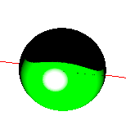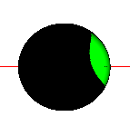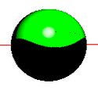

* **ambient intensity**:-Ambient intensity controls the amount of light that reflects on the material of the object, coming from the general world (no specific light source position). When ambient light is set to zero, the “dark side” of the sphere appears black. When the intensity is set to 0.3, the entire sphere is illuminated. When the intensity is changed to -1.0, strange things happen.
* 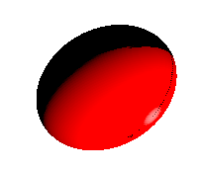
* 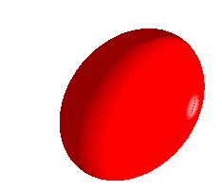
* 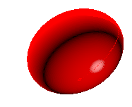
* **specular intensity**: Specular intensity controls the amount of light that comes from a spotlight. Specular intensity of 1 (on the left) vs specular intensity of 15 (on the right). Notice the white highlight is stronger and larger.
* 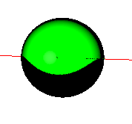

-

* **diffuse intensity**: Diffuse intensity controls the intensity of the light reflecting from the material. Increasing the diffuse light intensity makes the material brighter. The left object has a diffuse intensity of 0.1, versus a diffuse intensity of 1.0 on the right.

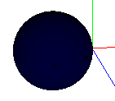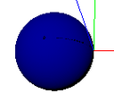

-

* **attenuation coefficient**: as the object gets further from the light, the brightness decreases. The attenuation coefficient determines how quickly light fades with distance. As the coefficient increases, the light fades faster. On the left, the attenuation coefficient is zero. On the right, the coefficient is 0.5. Notice how the light fades much faster on the left.

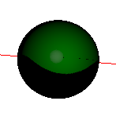

-

However, there are other factors will affect how does light look like on the sphere, such as the distance between light source and sphere and the angles between light source and sphere.

When all the parameters were modified, this was the final result.

