ME 557 HW 4

Yuanfen Chen, Michael Hoefer, Marcus Naik

Problem 1: Investigate different blending modes

We were required to blend three different types of images (Landscape, Color gradient, and animal/human) together to produce an image consisting elements of each image. The three images we used are shown below:

Eagle Nebula (Landscape)

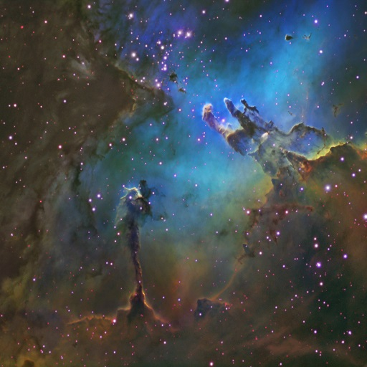

Color Gradient

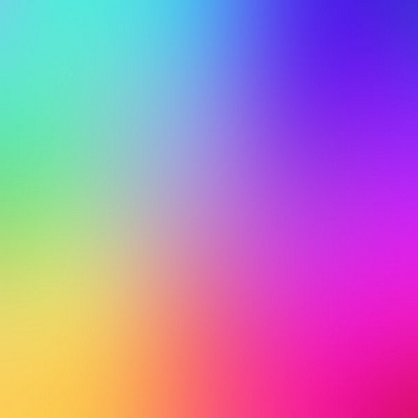

Penguin (Animal)

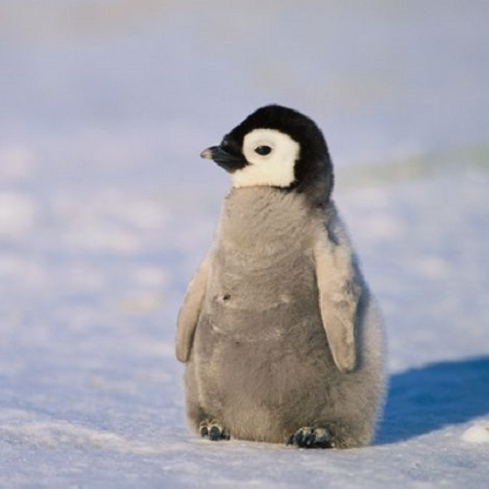

The first blending mode we tried was using a combination of addition and multiplication, with the following formula:

**color = (gradient*0.5)*landscape + penguin;**

This resulted in the image below, where the penguin image stands out significantly (due to adding instead of multiplication). The gradient and landscape are less visible because of the 0.5 scalar.

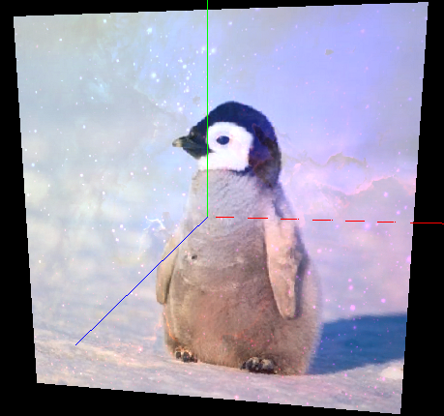

Our next blending mode was a simple addition. At first, we had no scalar multipliers on the textures and the image appeared white, shown below.

**color = 0.1 * pass_Color + tex_gradient + tex_landscape + tex_penguin;**

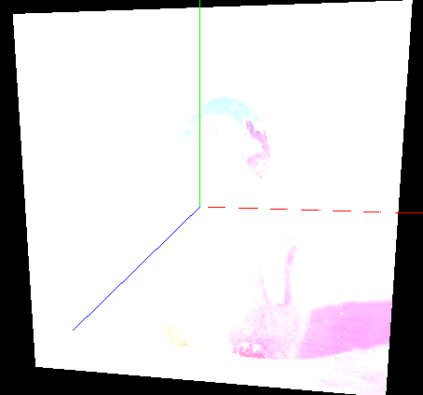

To give the image more clarity, we divided each color intensity by 2 with the following blend mode:

**color = 0.1 * pass_Color + 0.5*tex_gradient+0.5*tex_landscape +0.5*tex_penguin;**

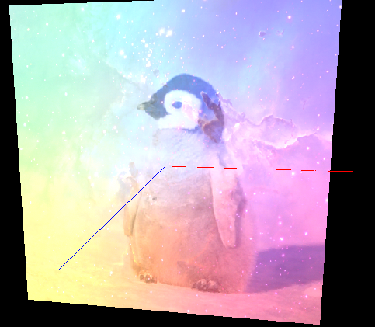

We changed the scaling factors to get the image below:

**color = 0.1 * pass_Color + 0.5*tex_gradient+0.6*tex_landscape +0.7*tex_penguin;**

This made the gradient less visible. The multiplier seems a bit high because the image is more washed out.

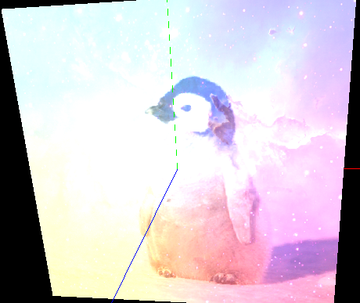

We tried removing the scaling factor on the pass_color of the primitive, which yielded an even brighter image. This makes sense, as the color of the primitive is set to white (1,1,1).

**color = pass_Color + 0.5*tex_gradient+0.6*tex_landscape +0.7*tex_penguin;**

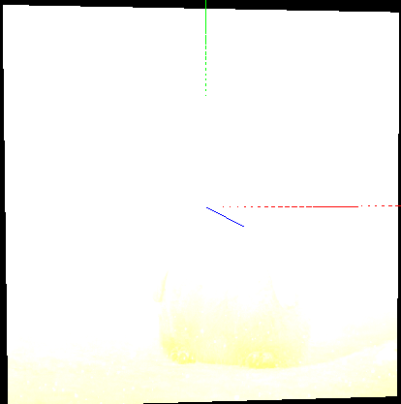

Our third blend mode was pure multiplication, which provides a good combination of landscape, gradient, and penguin. Using multiplication ensures that the color values remain lower than any single texture value by itself, so there is no issue with washing out the colors. The image appears darker because the RGB values are all less than one, so multiplication results in less intensity.

**color = tex_landscape * tex_gradient * tex_penguin;**

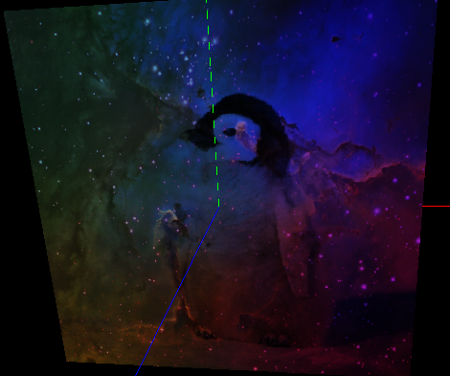

To increase the brightness, we added in some of the pass_Color of the primitive (white)

**color =pass_Color*0.1 + tex_landscape * tex_gradient * tex_penguin;**

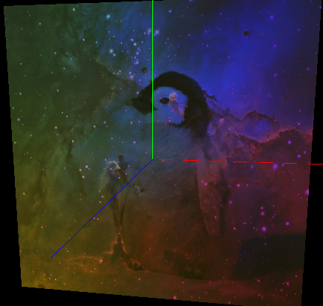

Next, we experimented with adding and subtracting single color channels of the color gradient. This made the picture brighter in the blue areas and darker in the red areas.

**color =pass_Color*0.1 + tex_landscape * tex_gradient * tex_penguin +0.4* tex_gradient.b - 0.4*tex_gradient.r;**

