1. Abstraction - I will do

Youtube has become a prominent media which has tons of video contents in different categories. Youtube is now pulling in over 1.8 billion users every day. youtube having thousands of trending videos in different countries every day. a lot of people are making a good amount of income from their youtube channels. Since it became a highly influencing social media, people are using this platform as a powerful tool for sharing their thoughts and many more. Here we are analysing US trending videos dataset in order to find correlations between trending videos’ properties. By doing this we can come up with some common features in all youtube trending videos in the US, using this output information from our analysis we can give some meaningful suggestions to the people who are uploading videos on youtube. We believe by applying our findings, a YouTuber can increase the view count of the video.

1. Introduction - 1.5 page

* What is youtube
* How it’s important in data today life
* Youtube all statistics
* Youtube impact on society
* How people make a business out of it
* How it going to be in future
* Elaborate our choice why we have selected this youtube data analysis

Start from here

1. Motivation

* Why we are conduction this analysis
* What are the benefits we are getting out of it
* How useful this research
* What can we do from this output
* Some points from section 2(introduction)

1. Data processing analysing - I am going to do this

* About the dataset we have - overview of the data set used
* How we cleaning the data
* How handling missing values
* What are columns
* From - To date dataset
* Pic of the data set from jupyter notebook

We selected a well-structured dataset for this research from keggle, Our dataset has been titled as Trending Youtube Videos there are hundreds of videos which was trending during that particular day and also they have separated these datasets with different regions for analysis purpose we have selected US youtube trending videos dataset so that we can be focused on a single region. When we are looking at the dataset we only have data from 2017 November to 2018 June unfortunately. Apart from this, the dataset contains 40950 rows and 16 columns. Columns names are video_id, trendin_date, title, channel_title, category_id, publish_time, tags, views, likes, dislikes, comments_count, thumbnail_link, comments_disabled, ratings_disabled, video_error_or_removed, descriptions. Each column contains different types of data, some of the columns’ data we are using for our analysis purpose some of them are not.

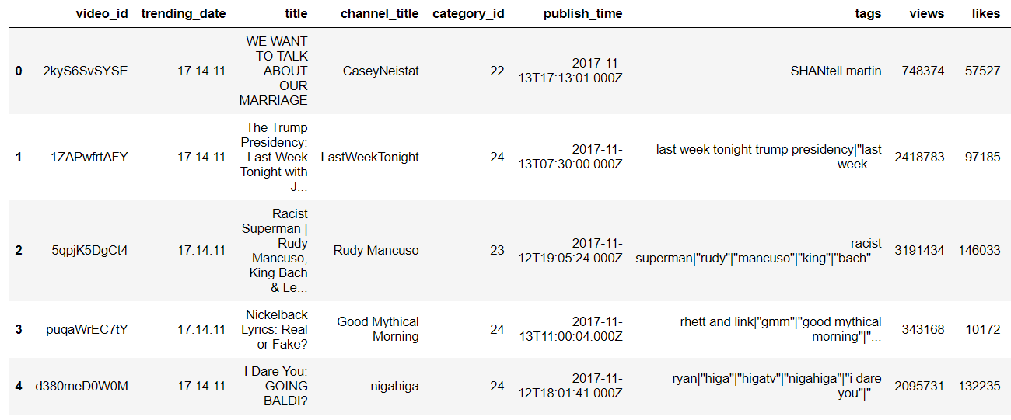

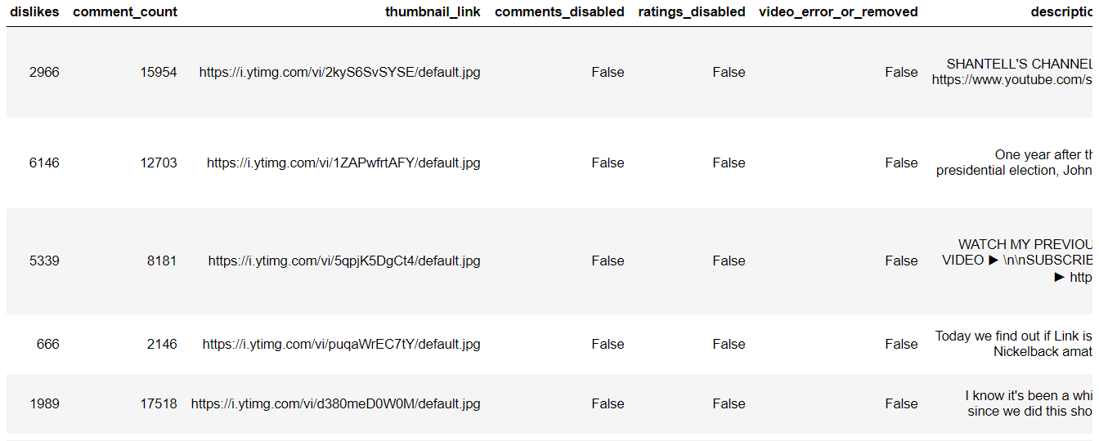

This is our dataset in fig- showing. In this dataset, we have identified some issues here we listing those issues

1. Trending_date column contains a date which not well-formatted
2. Category_id column contains different category id but not the category name
3. We don’t need some of these columns for our analysis
4. We need some extra columns of data for further analysis.

We cleaned our dataset in order to overcome these issues we have mentioned above

1. We have to format our trending date column as a pandas DateTime formate. For this, we have used *pandas.to_datetime()*, here our output shows in fig-

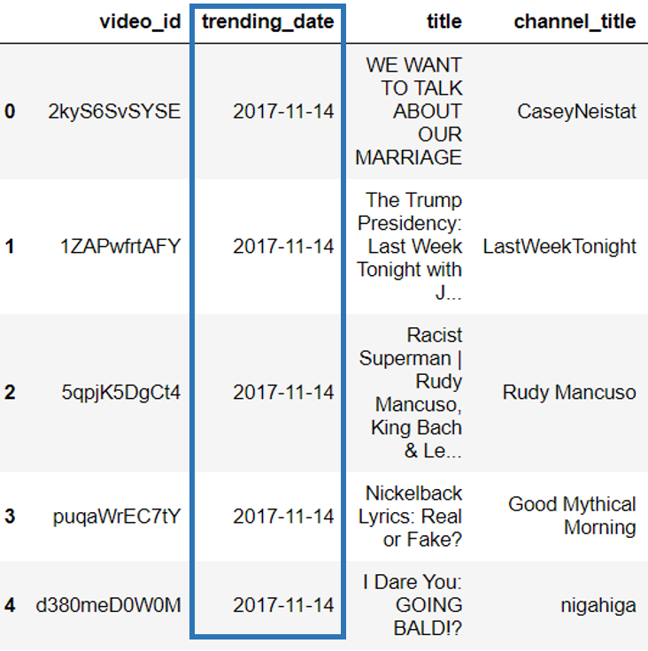

1. Category_id column only contains videos’ category ids only for analysis purpose we need category name and we have to map that name with this id all over the dataset. For this purpose, we have created a new CSV file which contains all the category then after we have mapped that file with our dataset.

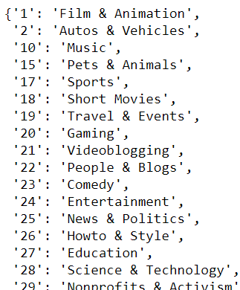

fig - shows our category id and name dataset after we mapped with our dataset it show like this in fig-

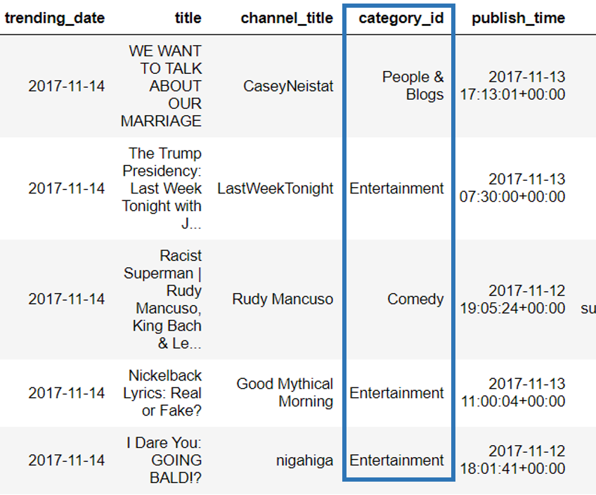

1. Finally, we have removed unwanted columns which are not needed for our analysis purpose, these the list of columns we have removed thumbnail_link, comments_disabled, ratings_disabled, video_error_or_removed, description. But we didn’t remove video_id, title, channel_title, tags columns for our future analysis purpose. After removing all these the dataset showing like this in fig-

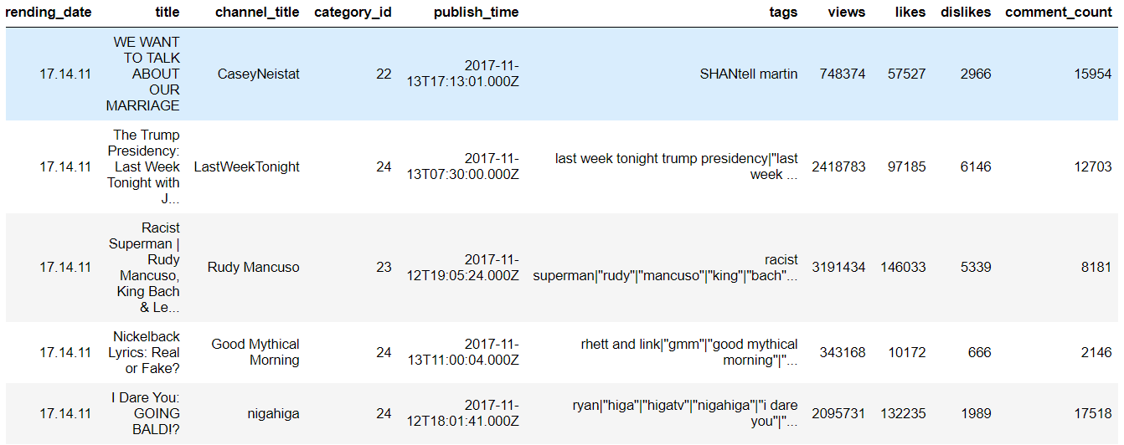

1. Apart from these columns which already came up with dataset we have created some new columns with other existing data for our further analysis purpose, these columns have been created whenever they needed for the particular analysis purpose. These are columns we have created publishing_day, publishing_hour and pulishing_month. Here in this fig- shows those created columns.

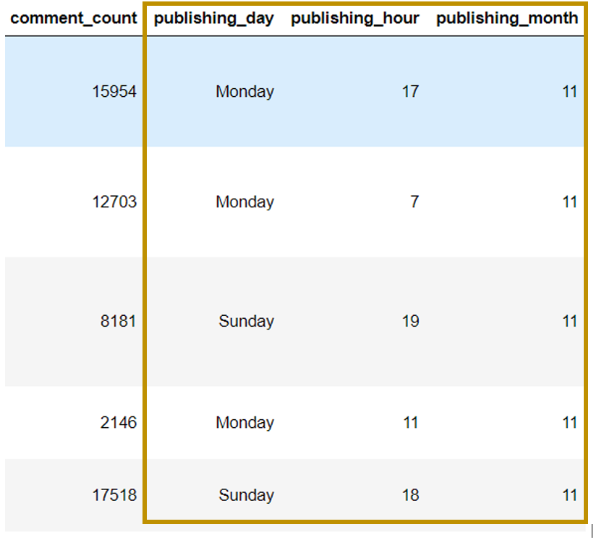

1. Methodology - I am doing

* correlations / let’s take any 2 variables
* Descriptive analysis
* Predictive analysis

In this paper, we are conducting a study on trending YouTube videos’ properties in order to find some meaningful insights.

We have used the Pearson Correlation Coefficient for finding the correlations between videos’ views, like, dislike and comments_cout.

What is the Pearson Correlation Coefficient

Pearson Correlation coefficient used to find the linear correlations or association between two variables, it can take a range of values from +1 to -1 if it’s 0 then there is no relationship between them. A value greater than 0 indicates a positive association and a value less than 0 indicates a negative association. It indicates the strength of the relationship.

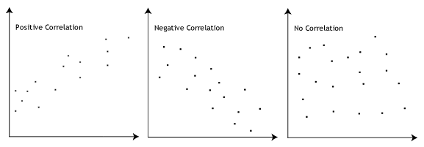

Here we are finding Pearson correlations coefficient between these views, like, dislike and comments_cout property of training videos so that we can identify an impact on one variable in another using this below formula.

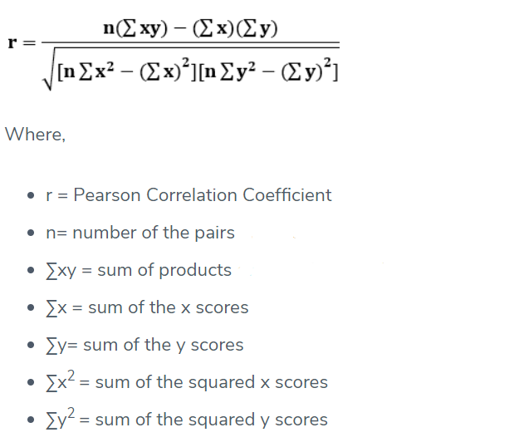

Apart from this correlations coefficient analysis, we can have some different analysis as well for finding more insights so this purpose.

* trending videos’ category with its views and likes
* Which day of the week most of the trending videos had been uploaded
* Which time in a day most of the trending videos had been uploaded

1. Results and Conclusion

We found the Pearson correlations coefficient between columns views, like, dislike and comments_cout here our output shows in fig -

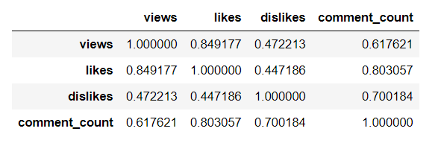

From the above table, views-likes showing the highest Pearson correlations coefficient value, after this views-comments_count showing second-highest value but views-dislikes showing the least value. So that we can come up with the conclusion likes column having the most impact on views column apart from the other two properties of the video. This result giving a clear view that if any video becomes a trending it mostly depends on how people like that video. If any video satisfying audience then it will become a trending one. Apart from this finding, we can come up with one more, If we look at comment_count-likes and comment_count-dislike we can identify both are having a nearly same value it’s indicating that whether people like it or not they are giving their opinion. Apart from this above table, we can come up with this below pairplot.

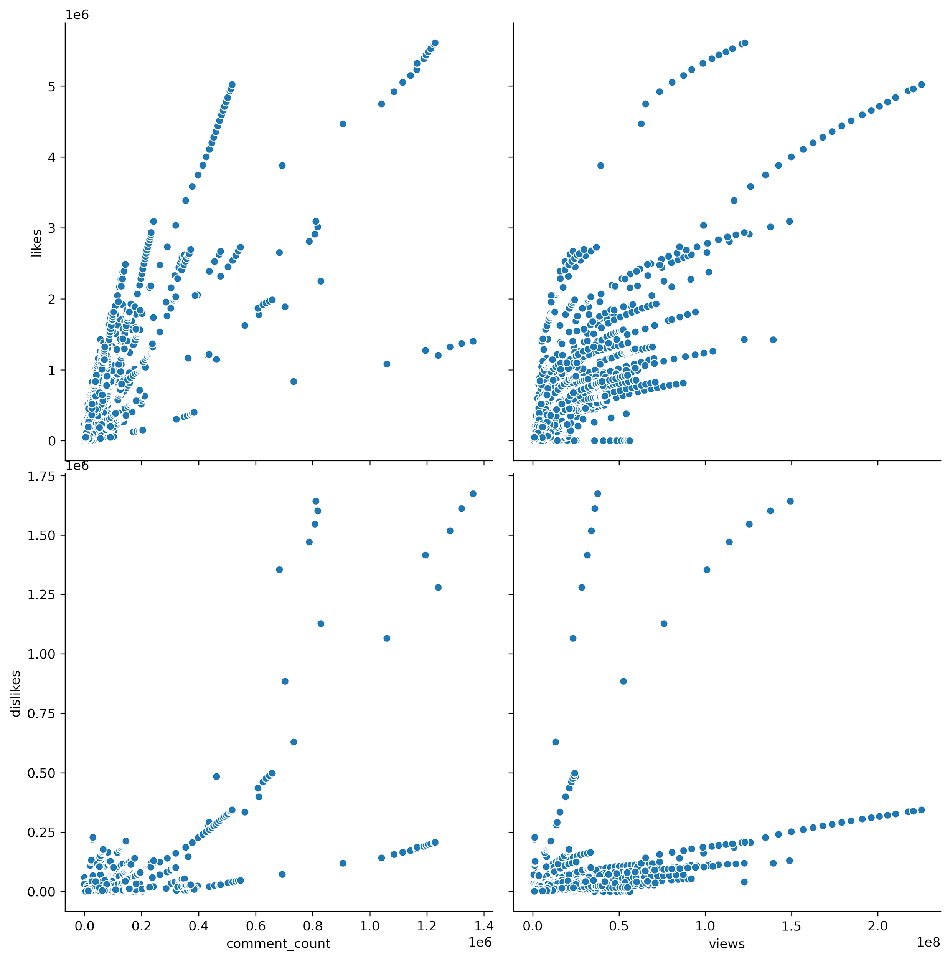

We have analysis the video category with views and likes so that we can get some more details with videos category which category video gets more views and likes we plotted these details in this below diagram.

1. 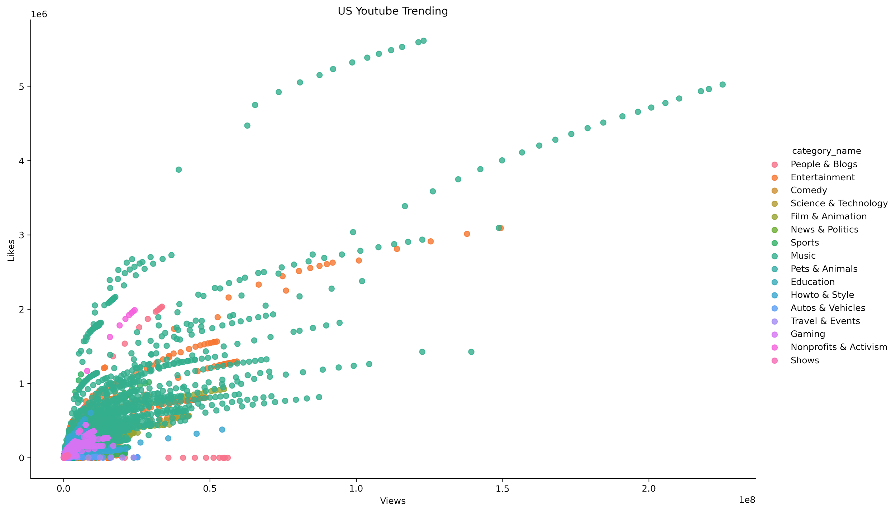
2. Above plot, we can see that most people viewed and liked entertainment videos. To compare between different video category we came up with this below chart.

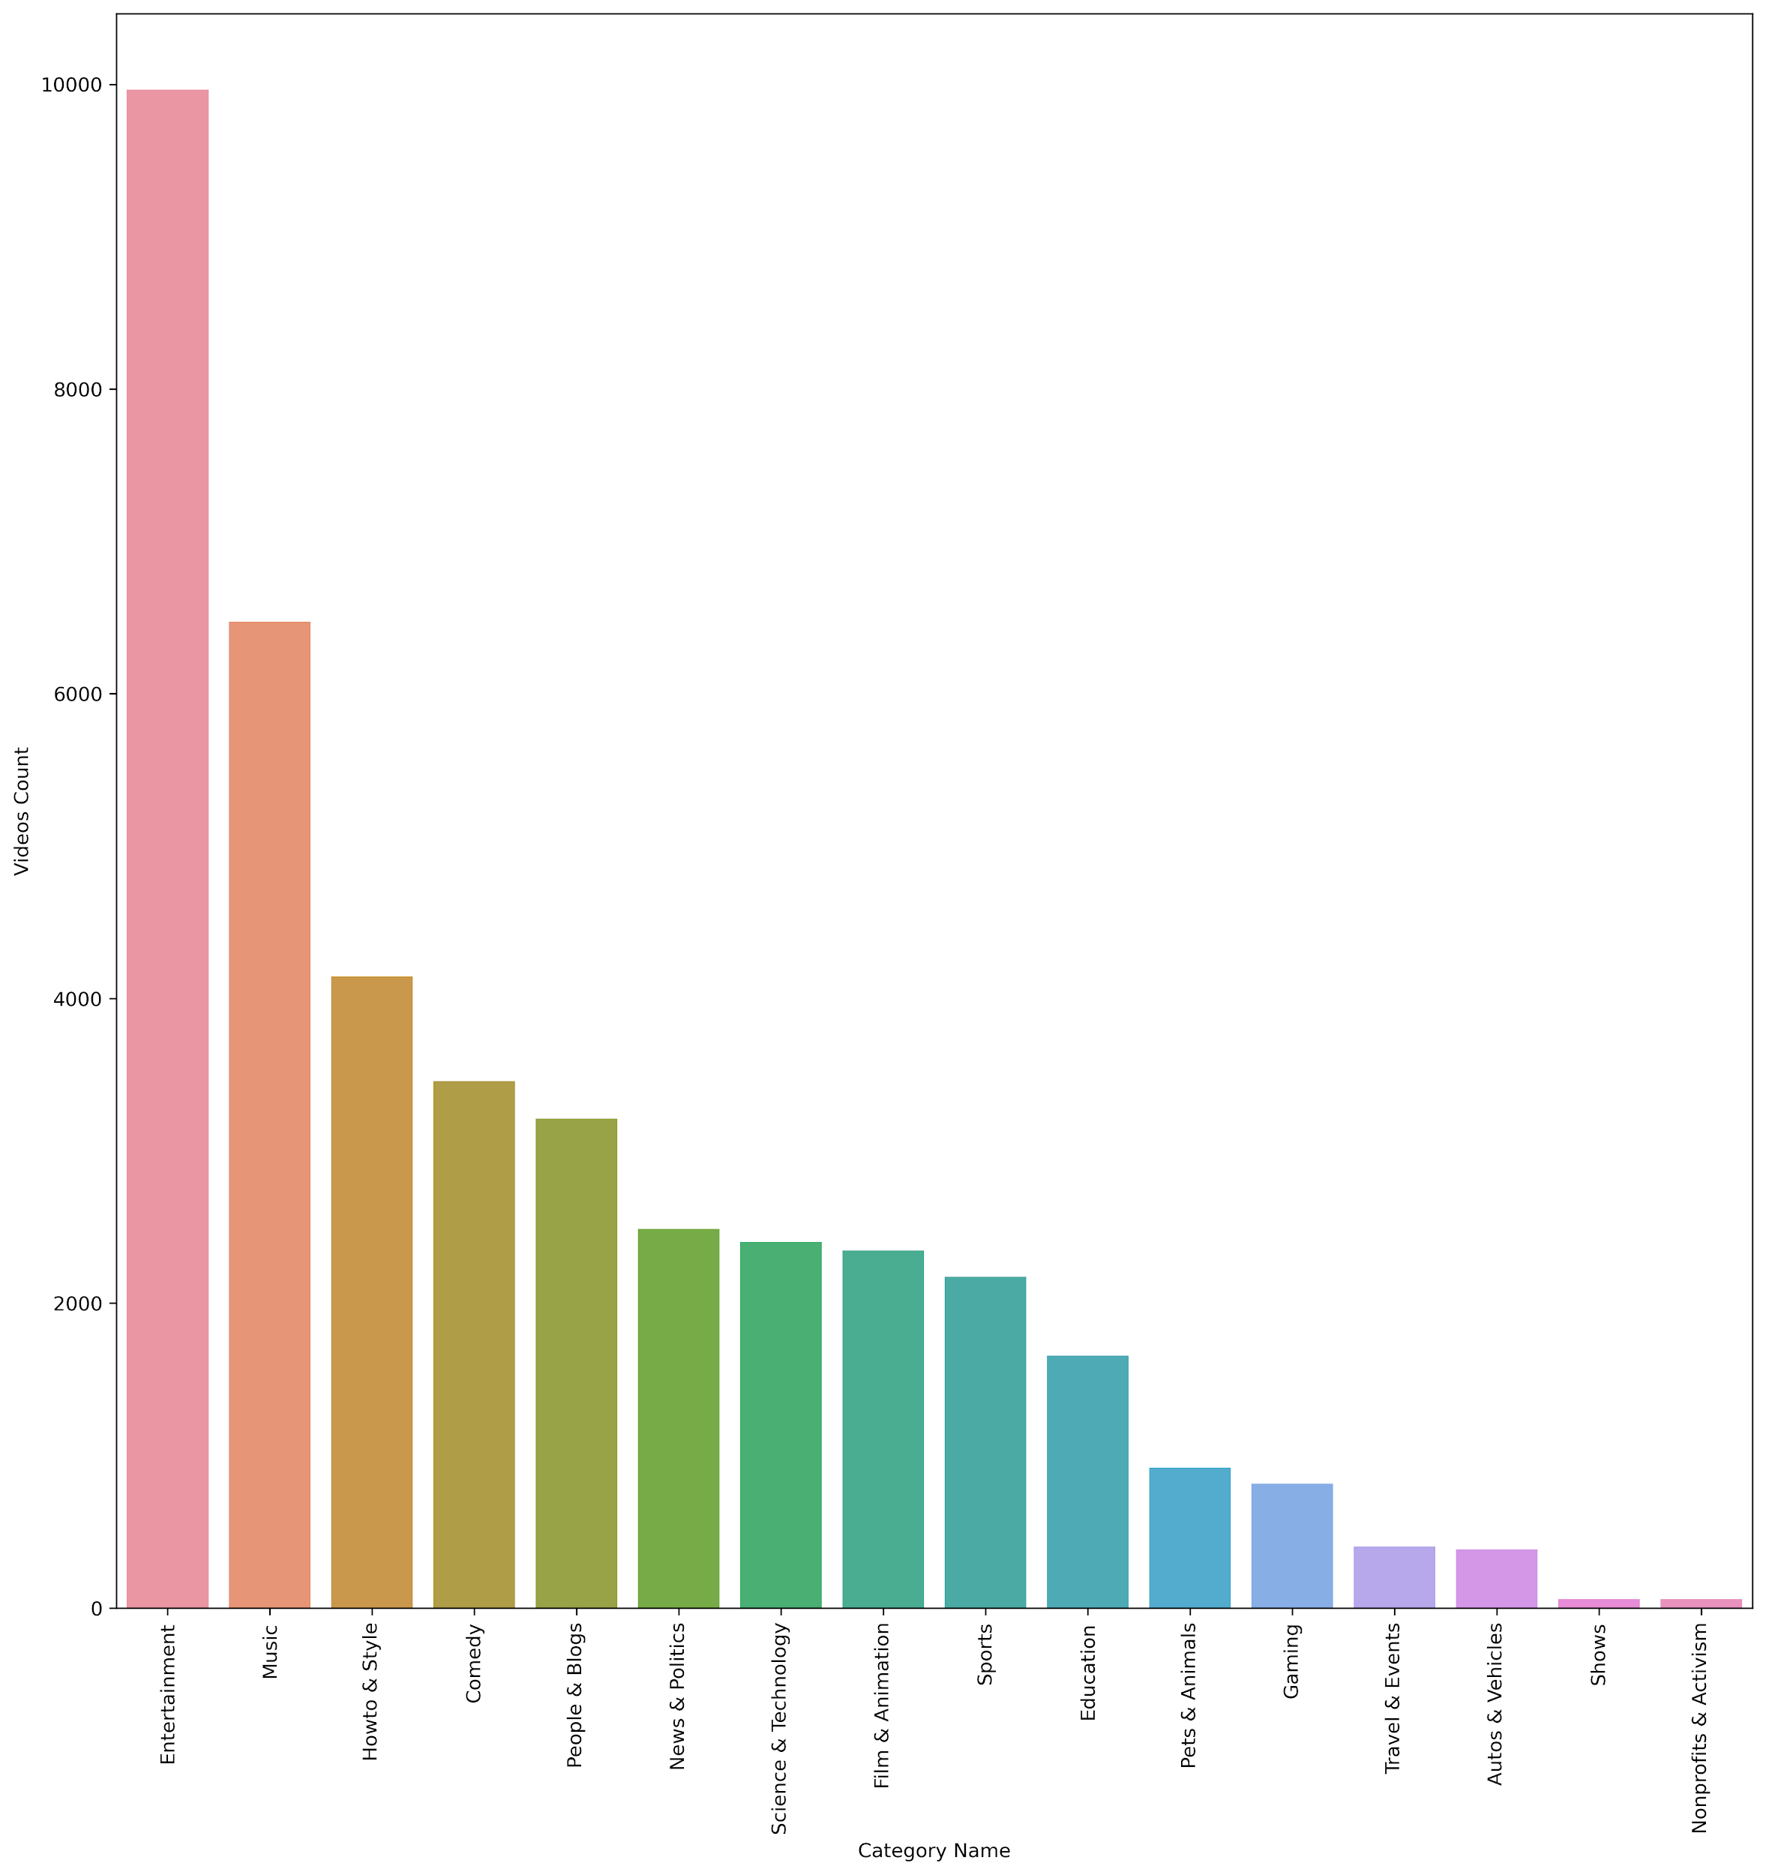

From the above chart, we can see the Entertainment category having the highest trending videos. Here we have noticed one more thing is entertainment having more than four times of education videos.

Furthermore, we came up with some different analysis parts, we have find each video published day of the week and get the total count for each day and plot it on a bar chart, here the below image showing the figure

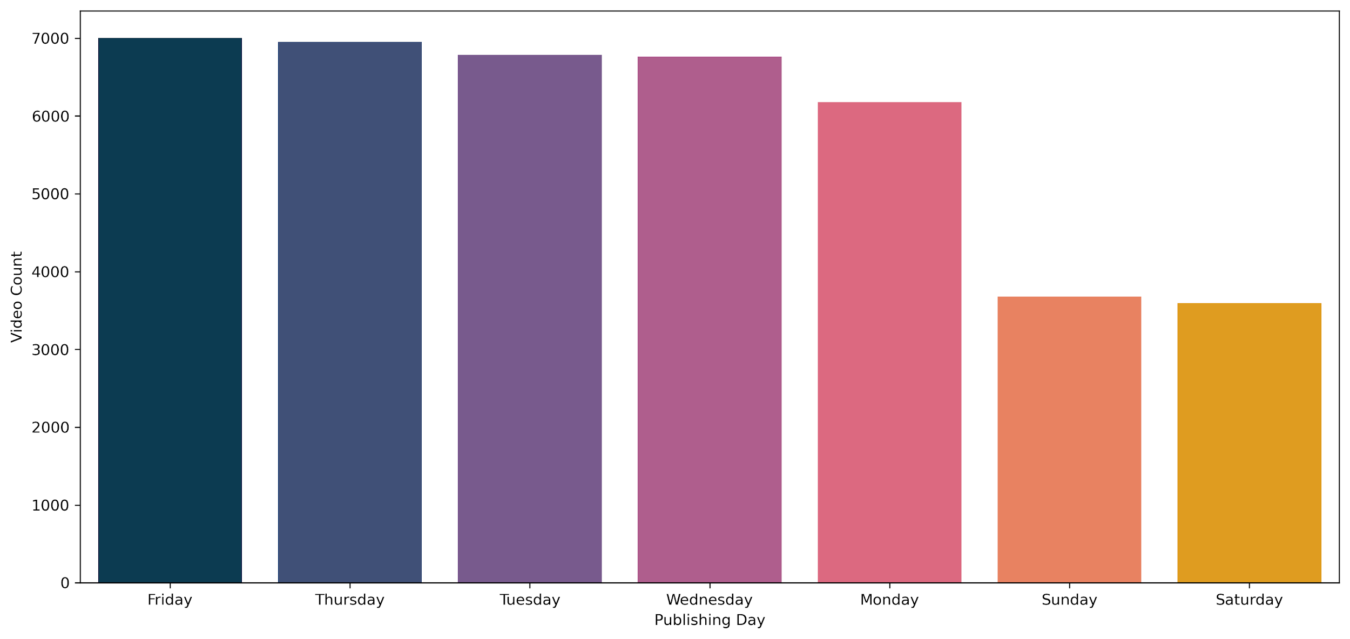

From this chart, we can see that most of the trending videos have been uploaded on Friday and the least amount of video has been uploaded on Saturday. There might be some different reasons for this insight Friday people getting off from work and having more free time during weekends so they are watching and spending more time on YouTube. After this, we came up with another analysis that we found the total count of publishing hour and we plotted into a bar chart.

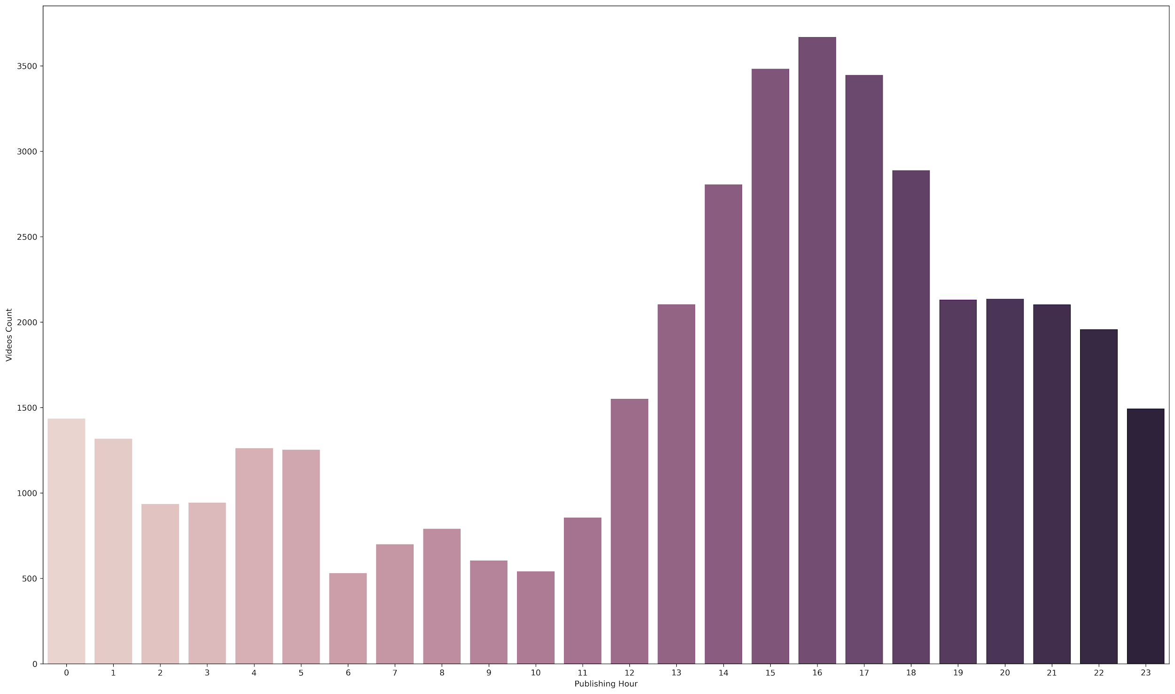

From the above bar chart, we can clearly identify most of the trending videos have been uploaded during 3 PM to 5 PM.

All these above analysis and finding are telling a lot of information about US YouTube trending videos. After all these findings we can make a good decision about how to make our video as a trending video. Since YouTube became a good source of income and influencing, media people are making a ton of videos every single day. We can help a YouTuber to make their video a trending one we can tell them you have to upload a video on this day, this time and this category. Apart from this, we can say a video became a trending one when people like that video it’s all about audience satisfaction.

1. Acknowledgement
2. Future work
3. References