**ODATA IN SAP**

**🧠 1. What is OData and Why It’s a Game-Changer for SAP Developers**

Let’s start with a truth: **SAP data is valuable, but it’s trapped** inside tight systems. OData is how we *unlock* that data and make it useful to the outside world.

**So, what exactly is OData?**

* **Open Data Protocol**, designed by Microsoft.
* REST-based API model — built on HTTP, supports JSON/XML.
* Allows clients (apps, mobile, external systems) to interact with backend systems like SAP.

**Why should an ABAP developer care?**

Because SAP is moving toward **modular, API-first design**. Fiori, mobile apps, cloud platforms, and integrations all rely on it.

Because if you're still stuck in classic report programming, you're missing the real action—modern SAP runs on services, not just screens.

**Without OData**, SAP is a walled garden.  
**With OData**, it becomes a player in the modern tech ecosystem.

✅ *“You’re not just writing code in SAP anymore — you’re building APIs, microservices, and front-end-ready data pipelines.”*

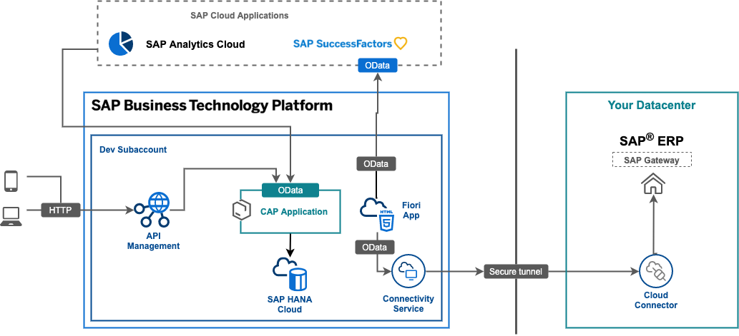

**🔧 2. Inside SAP: How ABAP and SEGW Power OData**

SAP doesn’t expose OData automatically. You, the developer, do it using a tool called **SEGW** — Service Gateway Builder.

Here’s what happens under the hood:

**SEGW Project:**

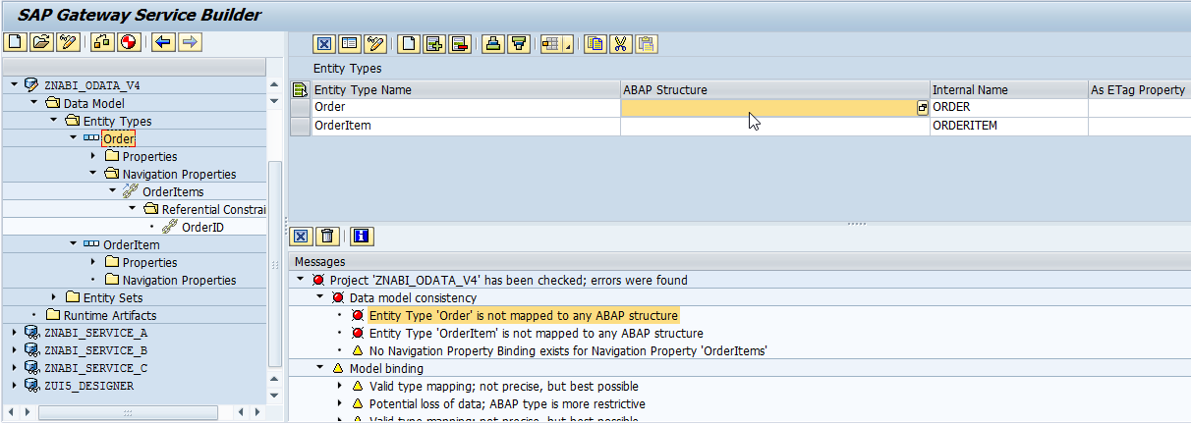

Think of it like an API design studio. You define:

* **Entities** → Your data model (table structures)
* **Associations** → Relationships between entities
* **Metadata** → Automatically created via MPC (Model Provider Class)
* **Runtime Logic** → You implement via DPC (Data Provider Class)

**What gets generated:**

| **Class** | **Role** |
| --- | --- |
| ZCL_<proj>_MPC_EXT | Controls metadata |
| ZCL_<proj>_DPC_EXT | You write logic here — selects, inserts, updates |

📌 *Why do we use the _EXT classes?*  
Because SAP regenerates the base classes when you regenerate the project. So _EXT protects your custom logic from being wiped.

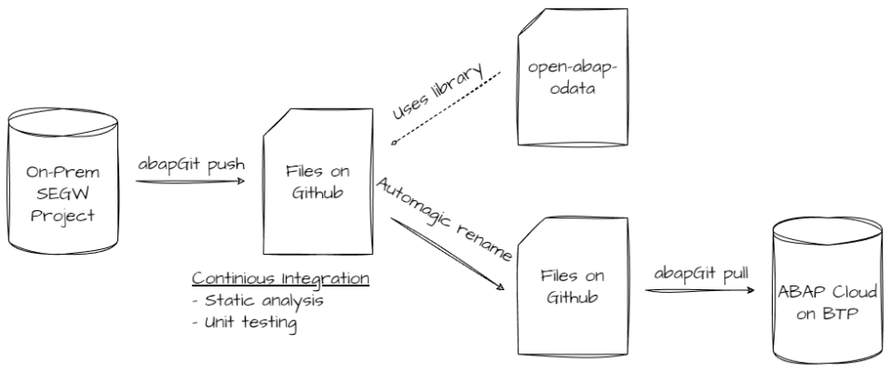

**🛠️ 3. Building Your First OData Service in SEGW (Step-by-Step)**

Let’s say your business wants a UI5/Fiori app that displays student info. Data is in table ZSTUDENT. Here's how to expose it.

**✅ Step 1: Create SEGW Project**

* TCode: SEGW
* Click "Create Project"
* Give a project name like ZSTUDENT_ODATA
* Assign package + transport request

📌 *This project is your OData backend. All modeling happens here.*

**✅ Step 2: Define the Entity**

* Right-click Data Model → Import → DDIC Structure
* Enter structure/table: ZSTUDENT
* System pulls the fields as properties

Select the primary key (e.g. STUDENT_ID) — it’s mandatory. Without a key, OData won’t function.

📌 *Each Entity = one API resource. Think of it like a REST route.*

**✅ Step 3: Generate Runtime Artifacts**

Click the wand icon. SAP now creates:

* ZCL_ZSTUDENT_ODATA_DPC_EXT → Write your logic here
* ZCL_ZSTUDENT_ODATA_MPC_EXT → Optional: annotate metadata here

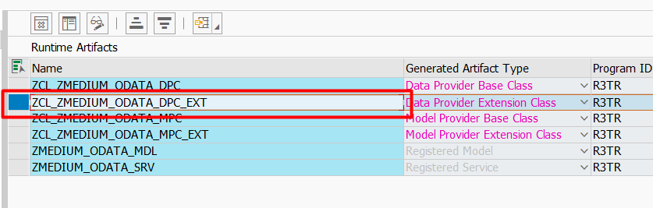

**✅ Step 4: Register Service**

* TCode: /IWFND/MAINT_SERVICE
* Click “Add Service”
* System Alias: usually LOCAL
* Activate it

You’ll now be able to hit the URL:

/sap/opu/odata/sap/ZSTUDENT_ODATA_SRV/StudentSet

Test it in /IWFND/GW_CLIENT or even in your browser.

**🧪 4. Redefining CRUD Methods: Your ABAP in Action**

Once you define the entity, you write logic to fetch, insert, or update data. Here's how:

**🔹 GET_ENTITYSET – fetch all students**

METHOD studentset_get_entityset.

SELECT * FROM zstudent INTO TABLE @et_entityset.

ENDMETHOD.

Behind the scenes, this maps to:

GET /StudentSet

**🔹 GET_ENTITY – fetch by key**

METHOD studentset_get_entity.

DATA ls_student TYPE zstudent.

SELECT SINGLE * FROM zstudent

INTO @ls_student

WHERE student_id = @iv_student_id.

MOVE-CORRESPONDING ls_student TO er_entity.

ENDMETHOD.

**🔹 CREATE_ENTITY – add a student**

METHOD studentset_create_entity.

DATA ls_input TYPE zstudent.

io_data_provider->read_entry_data( IMPORTING es_data = ls_input ).

INSERT zstudent FROM @ls_input.

ENDMETHOD.

Same way, you can redefine UPDATE_ENTITY, DELETE_ENTITY.

📌 *Important: Handle exceptions properly. Use mo_context->get_message_container( ) to return errors back to client.*

**🎯 5. Filters, Sorts, and Pagination — No Custom Logic Needed**

One of the best things about OData: you don’t need to write separate endpoints for filtering, sorting, or limiting data.

Examples:

/StudentSet?$filter=City eq 'Pune'

/StudentSet?$orderby=Name

/StudentSet?$top=10&$skip=20

You handle these via:

DATA(lo_filter) = io_tech_request_context->get_filter( ).

These values come from the client request and let you build dynamic SQL.

💡 *With little effort, you give your frontend team exactly what they need.*

**🔗 6. Associations, Navigation, and Deep Entities**

In real business cases, data is relational. Students belong to courses, employees to departments.

You define this in SEGW:

* Create **Associations** between entities
* Define **Navigation Properties**

This enables URLs like:

/StudentSet('101')/Courses

To handle this, you implement:

studentset_get_expanded_entityset

📌 *Deep Entity = Nested JSON. This is key for Fiori Smart Templates.*

**⚠️ 7. Common Mistakes and Debugging Tips**

| **Mistake** | **Fix** |
| --- | --- |
| No response in browser | Forgot to register service |
| Changes not visible | Metadata cache not cleared |
| Code not triggered | Wrote logic in base class instead of _EXT |
| CSRF error in POST | Need to fetch X-CSRF-Token first |
| Empty data returned | Forgot to implement SELECT properly |

**For debugging:**

* Use /IWFND/GW_CLIENT
* Set breakpoints in DPC_EXT methods
* Log input data using WRITE or MESSAGE

Use:

<URL:-> /sap/opu/odata/sap/ZSTUDENT_ODATA_SRV/$metadata?sap-cache-clear=true

...to clear metadata issues.

**🌍 8. Consuming OData: Postman, React, Fiori**

Once service is up, it’s just an API. Anything can use it.

**➤ Postman:**

* Headers: X-CSRF-Token: Fetch (for POST/PUT)
* Content-Type: application/json
* Body: Raw JSON

**➤ React Frontend:**

useEffect(() => {

fetch("/sap/opu/odata/sap/ZSTUDENT_ODATA_SRV/StudentSet")

.then(res => res.json())

.then(data => setStudents(data.d.results));

}, []);

**➤ Fiori/UI5:**

ODataModel auto-binds to your service:

this.getView().setModel(new sap.ui.model.odata.v2.ODataModel("/sap/opu/odata/sap/ZSTUDENT_ODATA_SRV/"));

📌 *You now bridge SAP to the web world. Respect.*

**🚀 9. CDS + Annotations: Modern Way of OData**

Newer SAP systems support exposing data without SEGW.

Here’s how:

@OData.publish: true

define view ZCDS_STUDENT as select from zstudent {

key student_id,

name,

age,

city

}

This view is immediately available as an OData service.  
You just register it in /IWFND/MAINT_SERVICE.

Add annotations for Fiori:  
@UI.lineItem: [{ position: 10, value: name }]

📌 *CDS + OData = Clean, fast, and preferred in RAP-based development.*

**⚙️ 10. Advanced Techniques & Pro Dev Tips**

* Handle $batch calls → Combine multiple operations into one HTTP call
* Add custom error messages using mo_context->get_message_container( )
* Implement soft deletes instead of hard DELETE
* Use associations + deep insert for complex nested forms
* Secure using AUTHORITY-CHECK for data-level access control
* Monitor with /IWFND/ERROR_LOG and /IWFND/APPS_LOG

**✅ Recap Table (Condensed Wisdom)**

| **Topic** | **Benefit** | **Pro Tip** |
| --- | --- | --- |
| SEGW + DPC | Full control | Use _EXT classes only |
| CDS + OData | Clean & fast | RAP-ready |
| Filtering | No extra logic | Use dynamic WHERE |
| Navigation | Relational data | UI5 loves this |
| CSRF & Errors | Client compatibility | Token handling is a must |

**✋ Final Thoughts**

OData is not “just another SAP topic”.  
It’s the **gateway**. You master OData, you control how SAP talks to the outside world — Fiori, APIs, partners, mobile apps — you own all of it.

And that makes you more than just an ABAP developer — it makes you a system integrator.

**📎 Want More?**

* SAP Help - OData Guide (<https://help.sap.com>)
* Postman OData collection examples (<https://www.postman.com>)
* GitHub repo with sample ABAP logic — coming soon 😉