Michael Ingram

**Linear Mixed Effects Models**

Math 6338 Final Project

**Introduction**

Linear Mixed Effects Models came about from problems arising in biology where observations are taken from clusters of related units or repeated measurements are taken from related units. A Linear Mixed Effects Model is a model with both fixed and random effects. They are specifically used for when the independence assumption of ordinary least squares regression is violated from the dependence of observations taken from repeated measurements or within clusters. Some of the earliest papers on linear mixed effects models are Ronald Fishers "The correlation between relatives on the supposition of Mendelian inheritance" published in 1918 and Henderson et al. "The Estimation of Environmental and Genetic Trends from Records Subject to Culling" published in 1959 both of which are from the areas of genetics. In the last few decades research has increased in the areas of linear mixed effects model and today they are used frequently in the fields of genetics, biology, ecology, social sciences, econometrics and problems that are longitudinal in nature.

**Case Study Description**

For this project, the case study I analyzed was a study on a person’s reaction time in sleep deprivation. This study titled “Patterns of performance degradation and restoration during sleep restriction and subsequent recovery: a sleep dose-response study” was published in the Journal of Sleep Research in 2003. In the study the 18 subjects were given a normal night of rest (8 hours) the first night and their average reaction time for a series of test was recorded the next day. The first observation with normal night’s sleep was recorded as Day 0. For the next 9 days, subjects were limited to 3 hours of sleep a night and the following day the same tests for their reaction was averaged and recorded. The data set itself contained 180 observations, with 18 subjects and 10 observations for the 10 days they participated in the study. The response variable, reaction time, was measured in milliseconds. The fixed effect predictor variable for the model is Days and ranges from 0 to 9. The predictor variable and random effect for our model is Subject and subjects were numbered 308, 309 310, 330, 331, 332, 333, 334, 335, 337, 349, 350, 351, 352, 369, 370, 371, 372. The goal of this analysis is to accurately model the effect of sleep deprivation on the number of days a subject goes without sleep.

**Model and Methods**

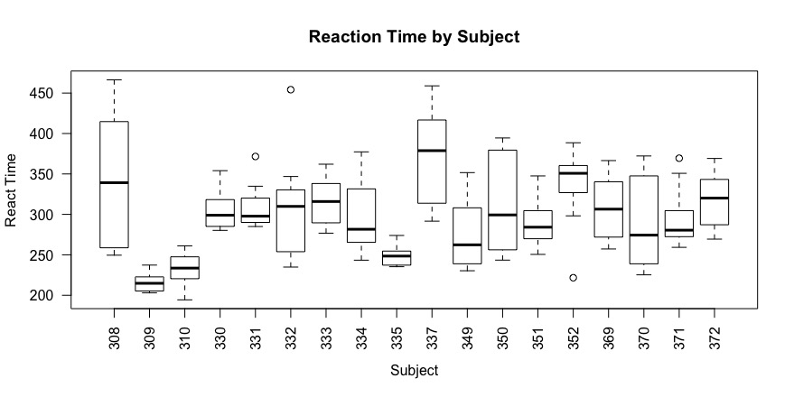The first questions that comes to mind with this data set is why us a linear mixed effects model? Why not just model Reaction vs. Days with an Ordinary Least Squares regression model? Although you can fit an ordinary least squares regression model to this data set, there is a big problem in the assumptions made in linear regression. One of the most important assumptions of linear regression is independence of the error term. The problem with the sleep study data set is that multiple observations are taken from each subject. This violates the assumption of independence. We can visualize the problem graphically from figure 1, a box plot of Reaction Time vs. Subject.

**Figure 1.** Box Plot of Reaction Time by Subject

The plot shows the range of different reaction times for each subject as well as the mean. Notice that the mean and range are different for every subject. Figure 2 shows another way to visualize the independence problem in our data.

**Figure 1.**

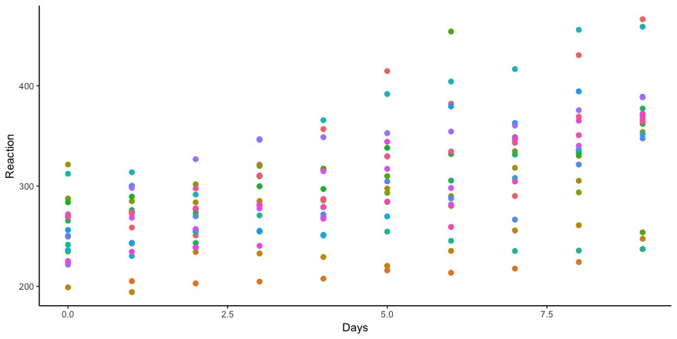

**Figure 2.** Scatter Plot of Reaction vs. Days by Subject

Here each dots’ color corresponds to the subject the observation belongs to. Some obvious trends appear such as the subject corresponding to orange are all near the 200 reaction time range and the subject corresponding to purple dots are all near the 350 reaction time range. This graph also clearly shows that fitting one linear regression line through this data set will not account for the variation very well.

One solution for this would be to fit a regression model for each subject. This would result in 36 parameters being estimated (slope and intercept for 18 subjects) and each sample size would be reduced from 180 to 10. In addition, the chance of a Type I error occurring would increase since you would have to implement so many comparisons. The better solution to this problem is to fit a linear mixed effects model. This project covers two of the most basic types of linear mixed effects models, the random intercept model and the random intercept and random slope model. This list is by no means exhaustive as there are countless number of linear mixed effects models out there but these two are often a good place to start.

Random Intercept Model

To account for the differences in each subject, I fit a model that assigns a random intercept to each subject. This is known as a linear mixed effects model with random intercepts.

In R, I would use the lme4 package. For the sleep study data set our fixed effects will be days which range from 0 to 9. The random effect will be subject to account for the variation between different subjects. In R, the structure of the model to fit a random intercept linear mixed effects model to the sleep study data is shown below:

$$lmer(Reaction Time \sim Days+\left(1 | Subject\right), data= sleepstudy)$$

This is quite similar to fitting an ordinary least squares linear regression model but the main differences are that you use lmer instead of lm and the (1|Subject) notation to indicate a random intercept for each subject. One thing to note is that a random effect will always categorical. It doesn’t make sense to use a continuous random effect because you are trying to group. Mathematical notation and model specific assumptions for the random intercept model is show below:

$$Y_{ij}=b_{0}+b_{1}x_{ij}+γ_{i}+ϵ_{ij}$$

$$for i∈\left\{1, …, n\right\} and j∈\{1,…, m_{i}\}$$

$$Y_{ij} ∈R is the response \left(Reaction Time\right) for the j^{th} measurement of i^{th} Subject$$

$$b_{0 } ∈ R is the fixed intercept for the Regression Model$$

$$b_{1} ∈ R is the fixed slope for the Regression Model$$

$$x_{ij} ∈ R is the predictor for the j^{th} measurement of Subject i$$

$$γ_{i}\sim iid N\left(0, σ_{γ}^{2}\right) is the random intercept for the i^{th} Subject$$

$$ϵ_{ij}\sim iid N\left(0, σ_{ϵ}^{2}\right) is a Gaussian Error Term$$

Assumptions:

1. Relationship between X and Y is linear.
2. $x_{ij}$ and $Y_{ij}$ are observed Random Variables.
3. $γ_{i}\sim iid N\left(0, σ_{γ}^{2}\right)$ is an unobserved Random Variable.
4. $ϵ_{ij}\sim iid N\left(0, σ_{ϵ}^{2}\right)$ is an unobserved Random Variable.
5. $γ_{i}$ and $ϵ_{ij}$ are independent of one another
6. $b_{0 }$ and $b_{1}$ are unknown constants.

$\left(Y_{ij} | x_{ij}\right)\sim N\left(b_{0}+ b_{1}x_{ij}, σ_{Y}^{2}\right) where σ_{Y}^{2}= σ_{γ}^{2}+ σ_{ϵ}^{2}$

Random Intercept and Slope Model

While we account for baseline differences between subjects with a random intercept model, we do not account for the effect of days on each subject. This is seen in the random intercept model by the same slope estimation for each subject. However, physically it does make sense that days would have an effect on each subject. The subjects were not living in a vacuum, so other factors throughout their day most likely had an effect on the subject. To account for this in the model we add a random slope. In R, the model structure used to fit a random intercept and slope is shown below.

$$lmer(Reaction Time \sim Days+\left(Days | Subject\right), data=sleepstudy)$$

The difference from our previous model is the random effect now looks like (Days|Subject) since we want to consider days effect on subjects. Mathematical notation and model specific assumptions for the random slope and intercept linear mixed effects model is shown below.

$$Y_{ij}=b_{0}+b_{1}x_{ij}+γ_{i0}+γ_{i1}x_{ij}+ϵ_{ij}$$

$$for i∈\left\{1, …, n\right\} and j∈\{1,…, m_{i}\}$$

$$Y_{ij} ∈R is the response \left(Reaction Time\right) for the j^{th} measurement of i^{th} Subject$$

$$b_{0 } ∈ R is the fixed intercept for the Regression Model$$

$$b_{1} ∈ R is the fixed slope for the Regression Model$$

$$x_{ij} ∈ R is the predictor for the j^{th} measurement of Subject i$$

$$γ_{i0}\sim iid N\left(0, σ_{0}^{2}\right) is the random intercept for the i^{th} Subject$$

$$γ_{i1}\sim iid N\left(0, σ_{1}^{2}\right) is the random slope for the i^{th} Subject$$

$$ϵ_{ij}\sim iid N\left(0, σ_{ϵ}^{2}\right) is a Gaussian Error Term$$

Assumptions:

1. Relationship between X and Y is linear.
2. $x_{ij}$ and $Y_{ij}$ are observed Random Variables.
3. $γ_{i0}\sim iid N\left(0, σ_{0}^{2}\right)$ and $γ_{i1}\sim iid N\left(0, σ_{1}^{2}\right)$ are unobserved Random Variables.
$\left(γ_{i0},γ_{i1}\right)\sim iid N\left(0,Σ\right) where Σ= \left(\begin{matrix}σ_{0}^{2} & σ_{01} \\ σ_{01} & σ_{1}^{2}\end{matrix}\right)$

4. $ϵ_{ij}\sim iid N\left(0, σ_{ϵ}^{2}\right)$ is an unobserved Random Variable.
5. ${(γ}_{i0}, γ_{i1})$ and $ϵ_{ij}$ are independent of one another
6. $b_{0 }$ and $b_{1}$ are unknown constants.

$\left(Y_{ij} | x_{ij}\right)\sim N\left(b_{0}+ b_{1}x_{ij}, σ_{Y_{ij}}^{2}\right) where σ_{Y_{ij}}^{2}= σ_{0}^{2}+2σ_{01}x_{ij}+ σ_{1}^{2} x_{ij}^{2}+σ_{ϵ}^{2}$

Checking Model Assumptions

In addition to the model specific assumptions stated above, a linear mixed effects model is still a linear regression model, so it is good to check for homogeneity of variance, normality, influential points and collinearity. Fortunately for this data set, there is only 1 fixed effect and so the checking of collinearity is not needed. If there was more than one fixed effect present collinearity would be something to check for using variance inflation factors as you would in ordinary least squares. Figure 3 and 4 below are Residual vs. Fitted Value plots for the random intercept model and random slope and intercept model, respectively. These plots test for the homogeneity of variance for the models and ideally, they should show an even spread with no visible pattern. From looking at figures 3 and 4 they do not look to have any visible pattern and a fairly even spread of points and so the homogeneity of variance assumption for both models looks to be satisfied.

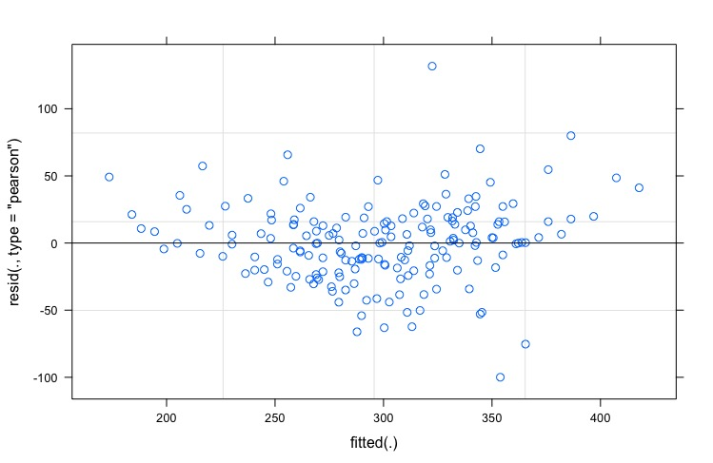

**Figure 3.** Plot of Residual vs. Fitted Value for Random Intercept Model

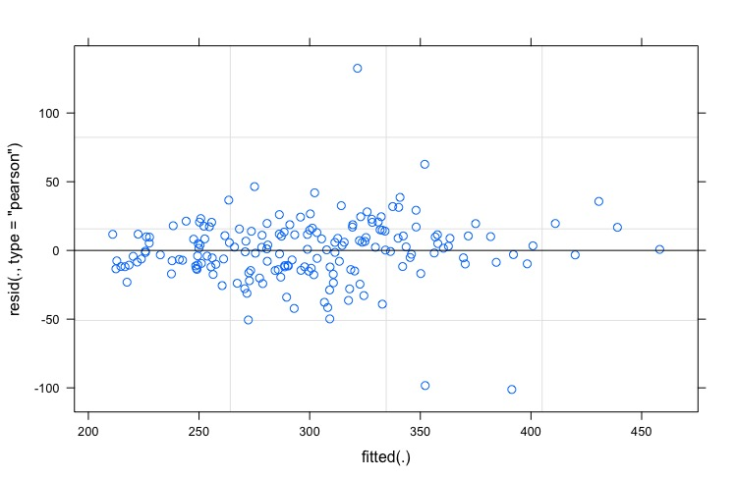

**Figure 4.** Plot of Residual vs. Fitted Values for Random Slope and Intercept Model

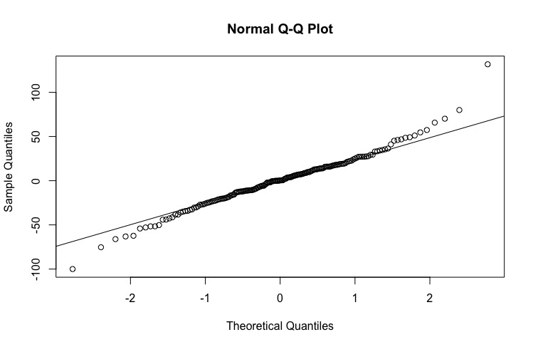 Figure 5 and 6 are QQ plots for the random intercept and random slope and intercept models, respectively. These plots are a way to diagnose problems with normality and ideally all the points in the plot should fall on the line. In both figures, the majority of points do fall on the line except for the head and tails. While this is not ideal, it is not a big enough problem to fail the normality assumption. Moreover, it means that influence and outliers should be looked into to see if there is a problem.

**Figure 5.** QQ Plot Random Intercept Model

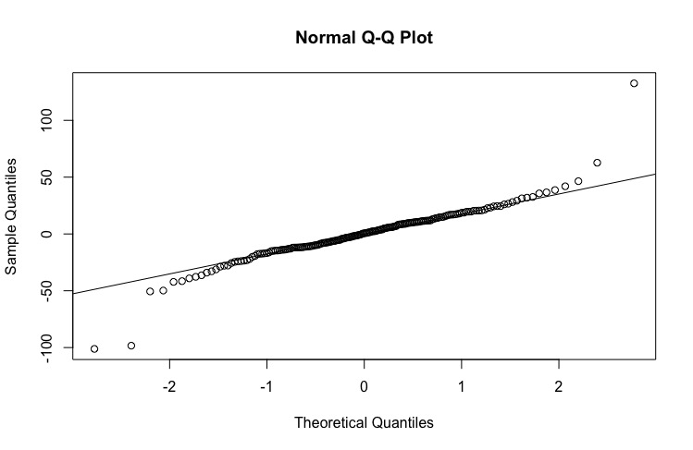

**Figure 6.** QQ Plot Random Intercept Model

Figure 7 is an influence index plot that is meant for visualizing influence and outliers in the data. The figure contains 4 plots that show Cook’s Distance, Studentized Residuals, Bonferroni P-Values and Hat Values by observation number. This figure shows two observations, 57 and 60, that stand out in the Cook’s Distance, Studentized Residuals and Bonferroni P-Values plots. Further investigation into these observations show that they belong to the same subject, 332. Observation 57 is particularly of interested because on Day 6 the subjects average reaction time was 454.1618 milliseconds. This is extremely large compared to the subject previous day 309.9976 milliseconds and following day 346.8311 milliseconds. Observation 60 belonged to Day 9 of the same subject and was 253.8644. milliseconds. The problem with this observation looks to be just an offshoot of the problem with observation 57, subject 332’s Day 6 observation. By Day 9, the subject’s reaction time has returned to levels similar to when he started. While the two observations are definitely outliers, their Cook’s distance values are still relatively small and are not influential enough to warrant removal.

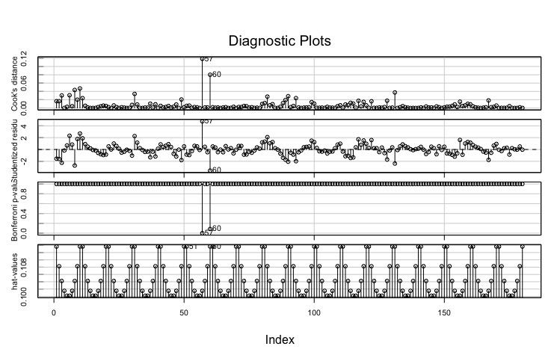

**Figure 7.** Influence Plot of Cook’s Distance, Studentized Residuals, Bonferroni P-Values and Hat Values by Observation

Significance of Effects

In linear mixed effects models, it is always good to test the significance of each of the predictors in the model. While this case study it is a simple 2 level model, it becomes increasingly important to test for the significance of effects when you have multiple fixed effects, random effects, levels and interaction terms. In order to test for significance of fixed effects, the statistical test to run include Wald Test, Likelihood Ratio Test and Parametric Bootstrap, with Likelihood Ratio Test and Parametric Bootstrap generally preferred to Wald tests.

When testing for significance of the random effects, the statistical test to use are a Restricted Likelihood Ratio Test or Parametric Bootstrap. Using a likelihood ratio test on a linear mixed model requires that the random effects of the models you are comparing are the same. You cannot compare two models with differing random effects such as a random slope to a random slope and intercept model. In order to compare random effects, the Restricted Likelihood Ratio Test is used. In R, this is performed with the “RLRsim” package. See the package for more information regarding this statistical test. Although there are many methods to test for significance, in this project I compute likelihood ratio tests for fixed effects and restricted likelihood ratio tests for random effects. Mathematically, the likelihood ratio test is presented below:

$$LRT: D= -2 ln\left(\frac{L\left(M_{o}\right)}{L\left(M_{1}\right)}\right)=2\left[LL\left(M_{1}\right)-LL\left(M_{0}\right)\right] where D\sim χ_{k}^{2}$$

$$M_{0}:A Null Model with p Paramters$$

$$M_{1}:The Alternative Model with q=p+k Paramters$$

One thing to note is that there are two types of maximum likelihood estimation used to estimate the fixed effect (**b**) and variance components ( $σ^{2} and Σ)$ of a linear mixed effects model. The standard maximum likelihood estimation underestimates the variance components. While the restricted maximum likelihood (REML) provides more consistent estimates. By default, R and most software packages use REML to estimate the coefficients. However, when performing a likelihood ratio test or restricted likelihood ratio test, it is required to use the standard maximum likelihood estimate to estimate the coefficients of the linear mixed effect model.

Now that the theory behind the linear mixed effects model and corresponding statistical test have been discussed, as well as the assumptions for homogeneity of variance, normality, collinearity and influential observations checked and satisfied, let’s move on to the analysis and results of the two linear mixed effects model.

**Analysis and Results**

Random Intercept Model

Running the linear mixed effects in R is similar to an ordinary least squares model. After fitting the model with the structure as described in the methods section, running the summary of the lmer object should output the results. While the summary of a lmer object shows a lot of information, let’s focus on summary output for random effects only. Table 1 shows just the information about the random effects shown in the summary output.

**Table 1**

|  |  |  |  |
| --- | --- | --- | --- |
| **Random Effects Summary from Random Intercept Model** | | | |
| Groups | Name | Variance | Standard Deviation |
| Subject | (Intercept) | 1296.9 | 36.01 |
| Residual |  | 954.5 | 30.90 |

The random effects summary shows the variance explained by the model for the random effect, Subject, as well as the residuals. The residuals are the $ϵ$ part of our linear mixed effects model. That is the variance not explained by the model or by the random effect subject. Notice that the variance of the random effect accounts for $\frac{1296.9}{954.5+1296.9}=57.6\%$ of the total variance remaining after the variance explained by the fixed effect, Days, is accounted for. More specifically, the differences between subjects account for 57.6% of the variance.

**Table 2**

|  |  |  |
| --- | --- | --- |
| **Coefficients of Random Intercept Model** | | |
| Subject | Intercept | Days (Slope) |
| 308 | 292.04 | 10.47 |
| 309 | 173.84 | 10.47 |
| 310 | 188.53 | 10.47 |
| 330 | 255.80 | 10.47 |
| 331 | 261.58 | 10.47 |
| 332 | 259.60 | 10.47 |
| 333 | 267.85 | 10.47 |
| 334 | 248.42 | 10.47 |
| 335 | 206.29 | 10.47 |
| 337 | 323.32 | 10.47 |
| 349 | 230..29 | 10.47 |
| 350 | 265.47 | 10.47 |
| 351 | 243.57 | 10.47 |
| 352 | 287.65 | 10.47 |
| 369 | 258.42 | 10.47 |
| 370 | 245.07 | 10.47 |
| 371 | 248.12 | 10.47 |
| 372 | 269.45 | 10.47 |

Table 2 shows the coefficients for the random intercept model. Notice that each subject has a different intercept but the same slope to help account for differences between subjects. Table 3 shows the parameters estimates for fixed effects only portion of the summary output in R.

**Table 3**

|  |  |  |
| --- | --- | --- |
| **Fixed Effects Summary from Random Intercept Model** | | |
|  | Estimate | Standard Error |
| Intercept | 251.41 | 9.51 |
| Days | 10.47 | 0.80 |

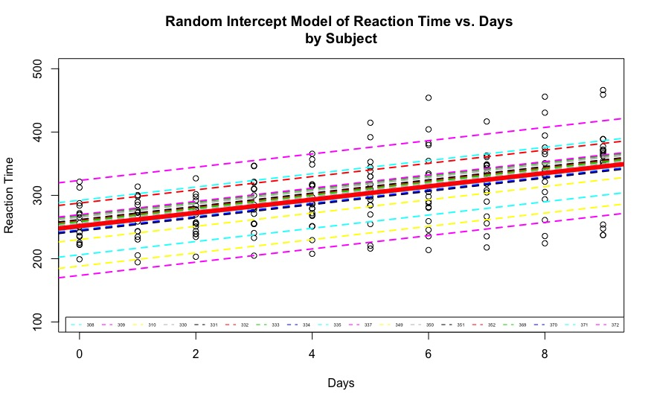Putting it all together we can view the random intercept linear mixed effect model graphically in Figure 8. The thick red line corresponds to Table 3, the fixed effects portion of the model. The other colored dashed lines correspond to each individual subject (Table 2). Figure 8 visually shows that the linear mixed model with random intercept accounts for the differences between each subject and helps account for the variance in the data better than a simple linear regression model would.

**Figure 8.** Random Intercept Linear Mixed Effects Model of Reaction Time vs. Days by Subject

Random Slope and Intercept Model

Table 4 shows the summary for the random effects portion of the random slope and intercept model.

**Table 4**

|  |  |  |  |
| --- | --- | --- | --- |
| **Summary of Random Effects from Random Slope and Intercept Model** | | | |
| Groups | Name | Variance | Standard Deviation |
| Subject | Intercept | 565.52 | 23.78 |
|  | Days | 32.68 | 5.72 |
| Residual |  | 654.94 | 25.59 |

Table 4 is very similar to our random effects summary from the random intercept model, Table 1, but now you can see the variance for subject is broken into both a random slope and random intercept. $\frac{565.52+32.68}{565.52+32.68+654.94}=53.5\%$ of the total variance remaining after accounting for fixed effects is explained by subject. This is fairly similar to what was achieved with the random intercept model. The differences between subjects account for $\frac{565.52}{565.52+32.68+654.94}=45.1\%$ of the variance and $\frac{32.68}{565.52+32.68+654.94}=10.38\%$ of the variance comes from the effect of days on subjects.

Now let’s take a look at the fixed effects from the random slope and intercept model. Table 5 shows the summary of the fixed effects.

**Table 5**

|  |  |  |
| --- | --- | --- |
| **Summary of Fixed Effects from Random Slope and Intercept Model** | | |
|  | Estimate | Standard Error |
| Intercept | 251.41 | 6.632 |
| Days | 10.467 | 1.502 |

As you can see, the summary of the fixed effects has not changed at all from the previous random intercept model. This is because we have only changed the random effects in the model not the fixed effects. Figure 9 below shows the final results of the random slope and intercept model. This figure is similar to Figure 8 but now each subject has a different slope. Graphically, this fits our data points better than having the same slope for each subject. 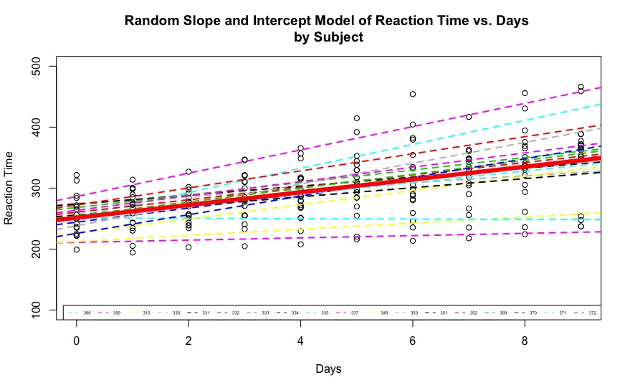

**Figure 9.** Random Slope and Intercept Linear Mixed Effects Model of Reaction Time vs. Days by Subject

Testing for Statistical Significance

Table 6 shows the results of the likelihood ratio test for statistical significance of fixed effect, Days. For the random intercept model, we are testing:

$$M_{0}:lmer\left(Reaction Time \sim 1+\left(1 | Subject\right)\right)$$

$$M_{1}:lmer\left(Reaction Time \sim Days+\left(1 | Subject\right)\right)$$

The results in Table 6 show that with a p-value of <2.2e-16, it is significant to include Days in the model. For the random slope and intercept model, we are testing:

$$M_{0 }:lmer(Reaction Time \sim 1+\left(Days\right|Subject))$$

$$M_{1}:(Reaction Time\sim Days+\left(Days | Subject\right))$$

The results in Table 6 show that a with a p-value of 1.22e-6, the likelihood ratio test indicates that including Days is as a fixed effect is significant to the model. Notice that in both likelihood ratio tests, the models compared to each other always have the same random effect.

**Table 6**

|  |  |  |
| --- | --- | --- |
| **Likelihood Ratio Test for Significance of Fixed Effects** | | |
| Model | Test Statistic | P-Value |
| Random Intercept | 116.46 | <2.2e-16 |
| Random Slope | 23.537 | 1.22e-6 |

Table 7 shows the results for the Restricted Likelihood Ratio Test. This is the test used to test for the significance of the random effects in the model. This is very similar to the likelihood ratio test except that we do not need to have the same random effects to compare. For the Random Intercept Model, we are testing:

$$M_{0}:lmer\left(Reaction Time \sim Days\right)$$

$$M_{1}:lmer\left(Reaction Time \sim Days+\left(1 | Subject\right)\right)$$

For the Random Slope and Intercept Model, we are testing

$$M_{0}:lmer\left(Reaction Time \sim Days+\left(1 | Subject\right)\right)$$

$$M_{1}:lmer(Reaction Time \sim Days+\left(Days\right|Subject))$$

Table 7 shows that the results for the restricted likelihood ratio test report a p-value of <2.2e-16 for both the random intercept model as well as the random slope and intercept model. This means that for the random intercept model test it is significant to include a random intercept over the model without and for the random slope model it is significant to include a random slope and intercept over just a random intercept. In a more general sense we can say that the results of the restricted likelihood ratio test indicate that the random slope and intercept model is statistically significant over the random intercept model.

**Table 7**

|  |  |  |
| --- | --- | --- |
| **Restricted Likelihood Ratio Test for Statistical Significance of Random Effects** | | |
| Model | RLRT Test Statistic | P-Value |
| Random Intercept | 107.2 | <2.2e-16 |
| Random Slope | 47.796 | <2.2e-16 |

**Discussion**

Comparing and contrasting the two linear mixed effects models we can see that in this case the random slope model is preferred. Visually we can see that the random slope model provides a lot more insight into each specific subject. While most subject’s reaction time increased as days increased, there was one subject who actually had a decrease as days increased. This information was captured by the random slope model but not by the random intercept. Furthermore, there is a trend where the subject who started with the fastest reaction time tended to have little to no change as opposed to those who started with a slower reaction time tended to get worse. Although this can be seen from both models, it is interesting to see how the rates of the subject’s reaction time change over time.

There are few applications and many ways to go further with this analysis. One specific application would be for searching for job candidates for jobs that require a quick reaction time under stressful hours. For example, if the military was interviewing candidates for the Navy Seals a reaction time vs. sleep deprivation model would be valuable. A Navy Seal’ candidate would be required to have a good reaction time at the start and be able to relatively maintain that rate under days of reduced sleep. By using the random slope model, it would be possible to identify candidates who fit that description.

Similarly, a more civilian application would be identifying good candidate for a truck driver position. Truck drivers often have to drive long hours across the country but need to be able to maintain a good reaction time to not get into an accident. While the military might be able to conduct a 10-day sleep deprivation test for candidates, it is costly and perhaps borderline unethical for a truck company to conduct a 10 day sleep deprivation test. However, using either of the mixed effects model we can get a reasonable approximation for how a candidate’s reaction time will behave over time given just the first few days of data a truck company might be able to test.

I could have taken this analysis further by modeling with a random polynomial slope. For example, subject 332, who was mentioned previously as having reaction times in the four hundred millisecond range on day 6 and then back down to around 250 milliseconds on day 9, might have benefitted from modeling with a polynomial slope. However, as with most statistical models, it is important to not add complexity to the point where you are overfitting. This comes back to an important point that while in this simple case study the random slope model was preferred over the random intercept model, this is not always the case. Many times, a random intercept model is good enough and so background knowledge is key element to successful linear mixed effects models.

**References**

Czado, Claudia. "Lecture 10: Linear Mixed Models (Linear Models with Random Effects)." Accessed December 12, 2018. http://www2.stat.duke.edu/~sayan/Sta613/2017/lec/LMM.pdf.

Fisher, R. A. "XV.—The Correlation between Relatives on the Supposition of Mendelian Inheritance." *Transactions of the Royal Society of Edinburgh*52, no. 02 (1919): 399-433. Accessed December 12, 2018. doi:10.1017/s0080456800012163.

Hajduk, Gabriela K. "Introduction to Lienar Mixed Effects Models." Coding Club. March 15, 2017. Accessed December 12, 2018. https://ourcodingclub.github.io/2017/03/15/mixed-models.html.

Helwig, Nathaniel E. "Linear Mixed Effects Regression." University of Minnesota Department of Statistics. January 04, 2017. Accessed December 12, 2018. http://users.stat.umn.edu/~helwig/notes/lmer-Notes.pdf.

Henderson, C. R., Oscar Kempthorne, S. R. Searle, and C. M. Von Krosigk. "The Estimation of Environmental and Genetic Trends from Records Subject to Culling." *Biometrics*15, no. 2 (1959): 192. doi:10.2307/2527669.

Magnusson, Kristoffer. "Using R and Lme/lmer to Fit Different Two- and Three-level Longitudinal Models." R Psychologist Full RSS. Accessed December 12, 2018. https://rpsychologist.com/r-guide-longitudinal-lme-lmer.

"Mixed Models: Testing Significance of Effects." Legal Studies Program. March 23, 2016. Accessed December 12, 2018. https://www.ssc.wisc.edu/sscc/pubs/MM/MM_TestEffects.html.

Scheipl, Fabian, Sonja Greven, and Helmut Kuchenhof. "RLRsim: Testing for Random Effects or Nonparametric Regression Functions in Additive Mixed Models." R-Project.org. August 13, 2008. Accessed December 12, 2018. https://www.r-project.org/conferences/useR-2008/slides/Scheipl Greven Kuechenhoff.pdf.

University of Bristol. "Centre for Multilevel Modelling." A Short Biography of Elizabeth Blackwell | Elizabeth Blackwell Institute for Health Research | University of Bristol. November 12, 2014. Accessed December 12, 2018. http://www.bristol.ac.uk/cmm/learning/videos/random-slopes.html.

Winter, Bodo. "A Very Basic Tutorial for Performing Linear Mixed Effects Analyses." Accessed December 12, 2018. http://www.bodowinter.com/tutorial/bw_LME_tutorial2.pdf.

**R Package Citations**:

Douglas Bates, Martin Maechler, Ben Bolker, Steve

Walker (2015). Fitting Linear Mixed-Effects Models

Using lme4. Journal of Statistical Software, 67(1),

1-48. doi:10.18637/jss.v067.i01.

Edsel A. Pena and Elizabeth H. Slate (2014). gvlma:

Global Validation of Linear Models Assumptions. R

package version 1.0.0.2.

<https://CRAN.R-project.org/package=gvlma>

John Fox and Sanford Weisberg (2011). An {R}

Companion to Applied Regression, Second Edition.

Thousand Oaks CA: Sage. URL:

<http://socserv.socsci.mcmaster.ca/jfox/Books/Companion>

H. Wickham. ggplot2: Elegant Graphics for Data

Analysis. Springer-Verlag New York, 2016.

Scheipl, F., Greven, S. and Kuechenhoff, H. (2008)

Size and power of tests for a zero random effect

variance or polynomial regression in additive and

linear mixed models. Computational Statistics & Data

Analysis, 52(7):3283--3299.

**Appendix**

library(lme4)

## Loading required package: Matrix

## Load Data and EDA/Check Assumptions  
sleepDat<-sleepstudy  
hist(sleepDat$Reaction)

hist(sleepDat$Days)

sleepMod1<-lm(Reaction~Days + Subject, sleepDat)  
par(mfrow=c(2,2))  
plot(sleepMod1)

library(gvlma)  
gvlma(sleepMod1)  
library(car)

## Loading required package: carData

influenceIndexPlot(sleepMod1)

vif(sleepMod1)  
  
par(mfrow=c(1,1))  
  
library(ggplot2)  
ggplot(sleepDat, aes(x = Days, y = Reaction, colour = Subject)) +  
 geom_point(size = 2) +  
 theme_classic() +  
 theme(legend.position = "none")

## Possible Influence/outliers, independence assumption is violated, homoscedasity may be violated. Going to try linear mixed effects models to see if they will fix the assumptions.

DayCol<-sleepDat$Days  
ReactCol<-sleepDat$Reaction  
plot(DayCol, ReactCol)

## Now build linear mixed effects models  
## Random Intercept first  
sleepMod2<-lmer(Reaction ~ Days + (1|Subject), sleepDat)  
summary(sleepMod2)  
coef(sleepMod2)  
  
  
## Random Slope Model  
sleepMod3<-lmer(Reaction ~ Days + (Days|Subject), sleepDat)  
summary(sleepMod3)  
coef(sleepMod3)  
  
  
  
## Plotting Mixed Effects Models  
## Random Intercept Model  
fixParam<-fixef(sleepMod2)  
  
randParamVector<-coef(sleepMod2)[["Subject"]][["(Intercept)"]]  
SubjectVector<-levels(sleepDat$Subject)  
  
plot(Reaction~Days,data=sleepDat,ylab="Reaction Time",xlab="Days", ylim=c(100, 500), main="Random Intercept Model of Reaction Time vs. Days \nby Subject")  
subNum<-unique(sleepDat$Subject)  
for(i in 1:18){  
abline(a=randParamVector[i], b=fixParam[2],col=(20+i),lty=2,lwd=2)  
  
}  
abline(fixParam,lwd=6,col="red")  
legend("bottomright", legend=SubjectVector,  
 col=21:38, lty=2, cex=0.375, horiz=TRUE)

## Random Slope Model  
fixParam<-fixef(sleepMod3)  
  
randParamVector<-coef(sleepMod3)[["Subject"]][["(Intercept)"]]  
fixParamVector<-coef(sleepMod3)[["Subject"]][["Days"]]  
  
plot(Reaction~Days,data=sleepDat,ylab="Reaction Time",xlab="Days", ylim=c(100, 500), main="Random Slope and Intercept Model of Reaction Time vs. Days \nby Subject")  
subNum<-unique(sleepDat$Subject)  
for(i in 1:18){  
abline(a=randParamVector[i],b=fixParamVector[i], col=(20+i), lty=2, lwd=2)  
  
}  
abline(fixParam,lwd=6,col="red")  
legend("bottomright", legend=SubjectVector,  
 col=21:38, lty=2, cex=0.375, horiz=TRUE)

## Likelihood Ratio Test  
##Random Intercept Model Fixed Effect Significance  
sleepMod2<-lmer(Reaction ~ Days + (1|Subject), sleepDat, REML = FALSE)  
sleepMod2.Null<-lmer(Reaction ~ 1 + (1|Subject),sleepDat,REML = FALSE)  
  
anova(sleepMod2.Null, sleepMod2)  
## Chi-Sq:116.46, Df=1, p-value:2.2e-16  
## Days is significant for the model  
  
## Likelihood Ratio Test  
## Fixed Effect Model Random effect Significance  
sleepMod2<-lmer(Reaction ~ Days + (1|Subject), sleepDat)  
library(RLRsim)  
exactRLRT(sleepMod2)  
  
## P-Value <2.2e-16 is evidence the random effect is non zero  
  
## Likelihood Ratio Test  
## Random Slope Model  
sleepMod3<-lmer(Reaction ~ Days + (Days|Subject), sleepDat, REML = FALSE)  
sleepMod3.Null<-lmer(Reaction~1 + (Days|Subject), sleepDat, REML=FALSE)  
sleepMod3.RanNull<-lm(Reaction~Days, sleepDat)  
  
anova(sleepMod3.Null, sleepMod3)  
## Chi-Square: 23.537, Df=1, P-Value:1.226e-06  
## Days is significant in the model  
  
## Restricted Likelihood Ratio Test  
## Random Slope Effect test for significance  
  
sleepMod2<-lmer(Reaction ~ Days + (1|Subject), sleepDat)  
mA <- update(sleepMod2, .~. + (0 + Days|Subject))  
mSlope <- update(mA, .~. - (1|Subject))  
exactRLRT(mSlope, mA, m0=sleepMod2)  
  
  
  
## Checking assumptions  
plot(sleepMod1)

library(car)  
influenceIndexPlot(sleepMod1)

plot(sleepMod2)

qqnorm(resid(sleepMod2))  
qqline(resid(sleepMod2))

plot(sleepMod3)

qqnorm(resid(sleepMod3))  
qqline(resid(sleepMod3))