I've built a containerized Python WebSocket service for an Air Force logistics use case. It provides a foundation for streaming logistics events in near real time, including aircraft readiness, parts inventory, maintenance work orders, and transportation status.
Download the project
Download the complete Air Force Logistics WebSocket project
The ZIP contains the Python application, Dockerfile, Docker Compose configuration, sample client, tests, and setup documentation.
1. Architecture
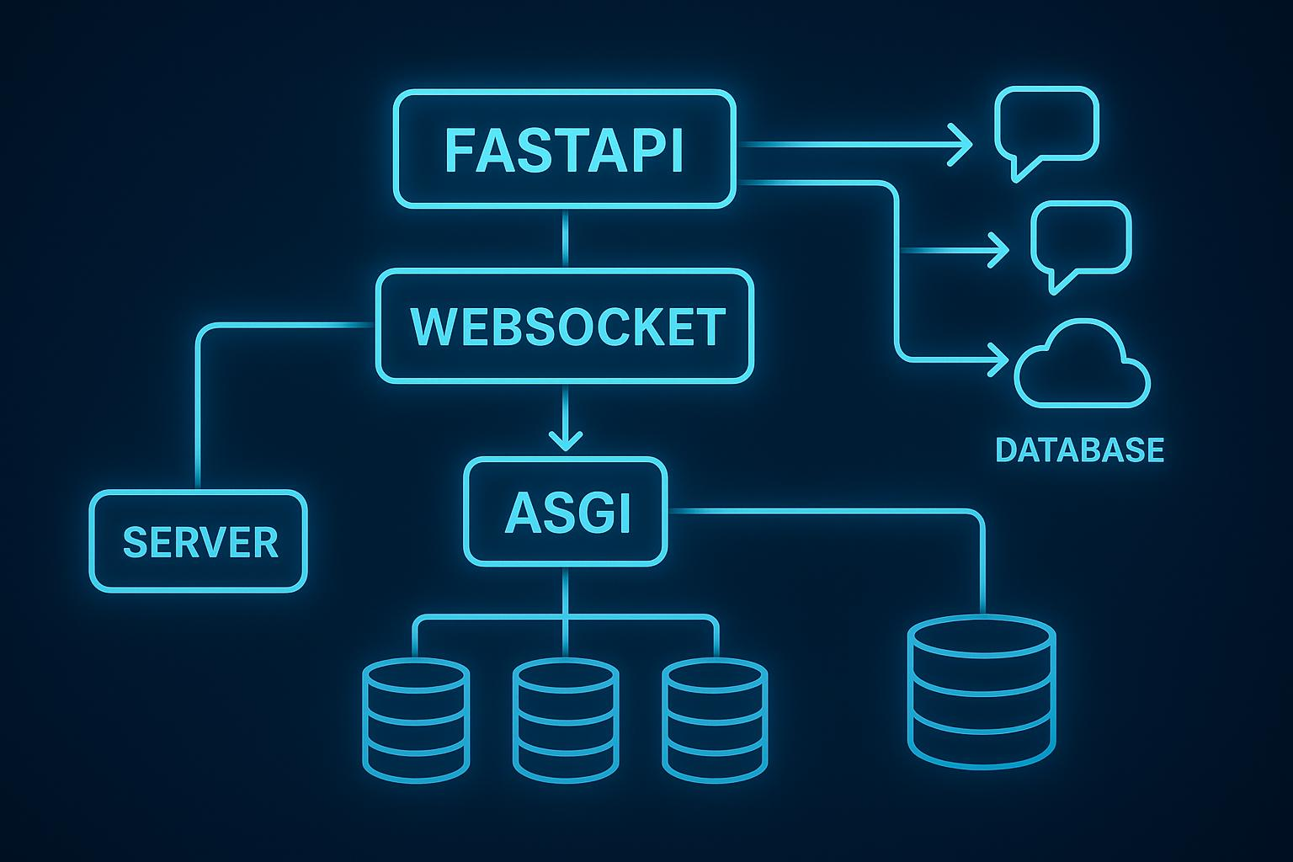
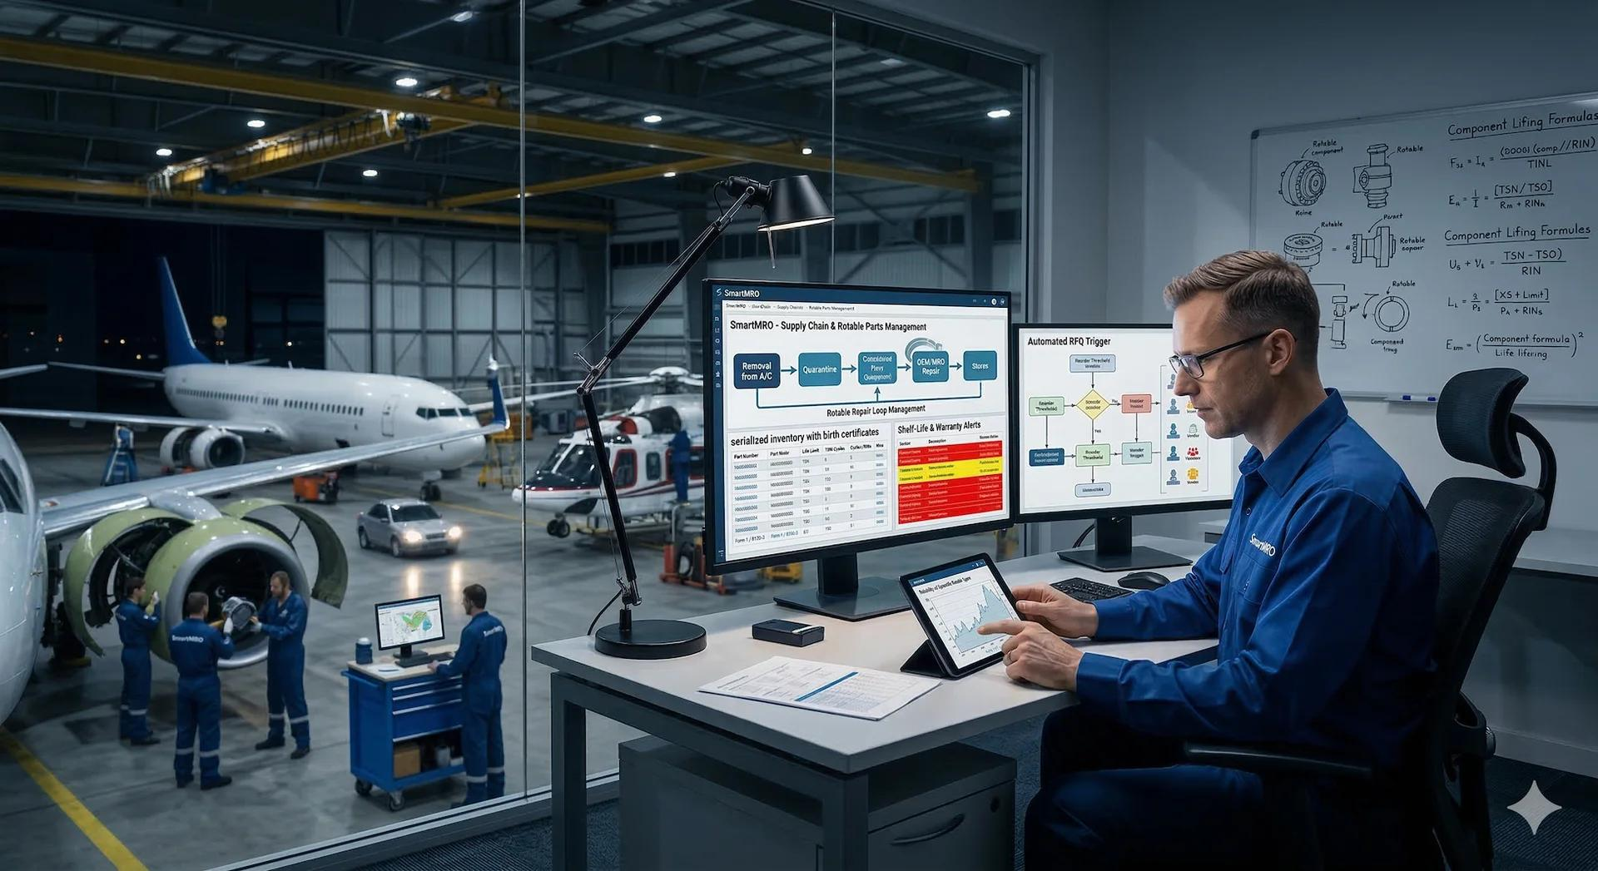
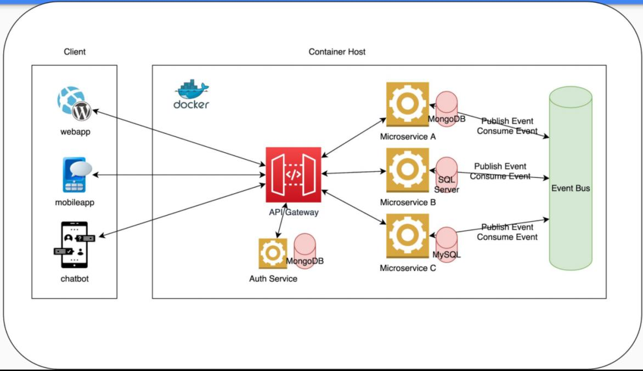
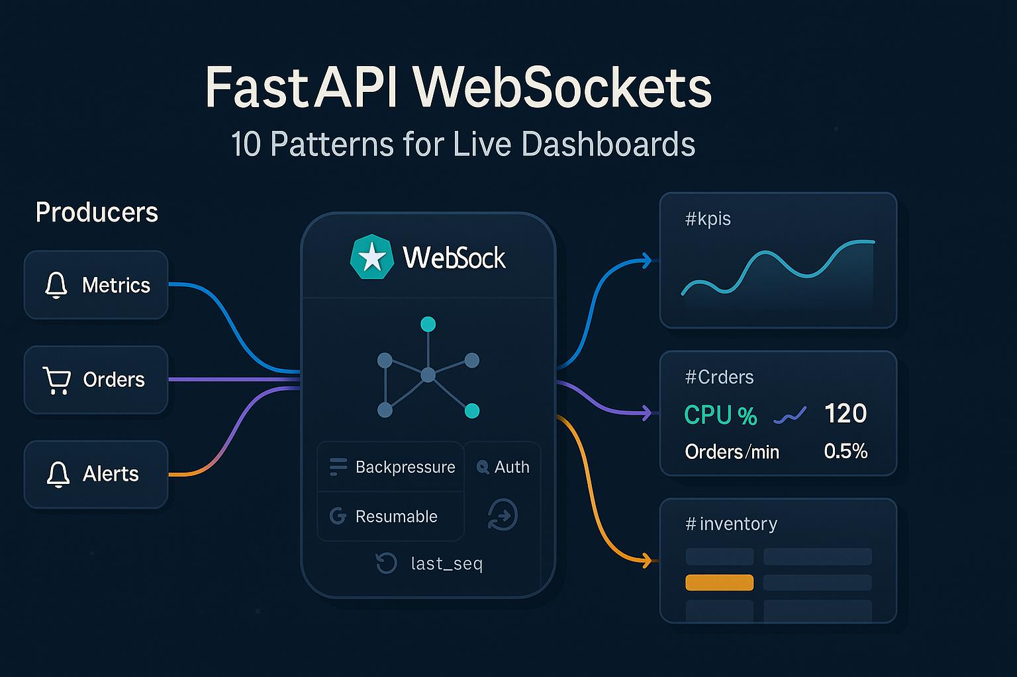
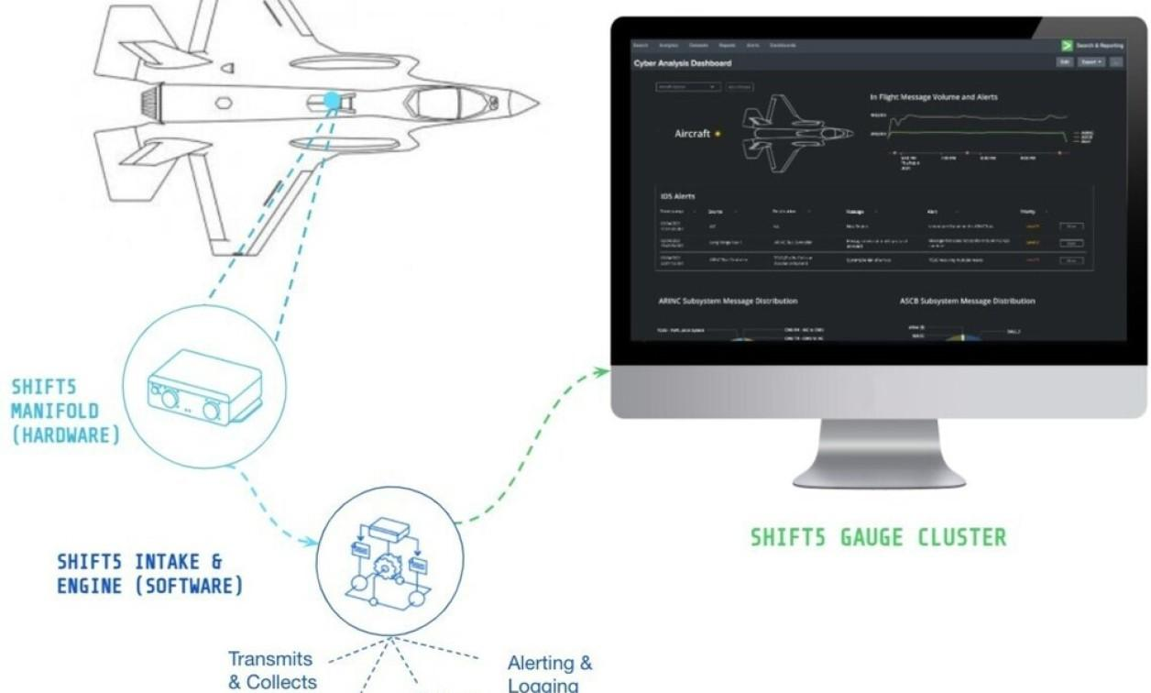
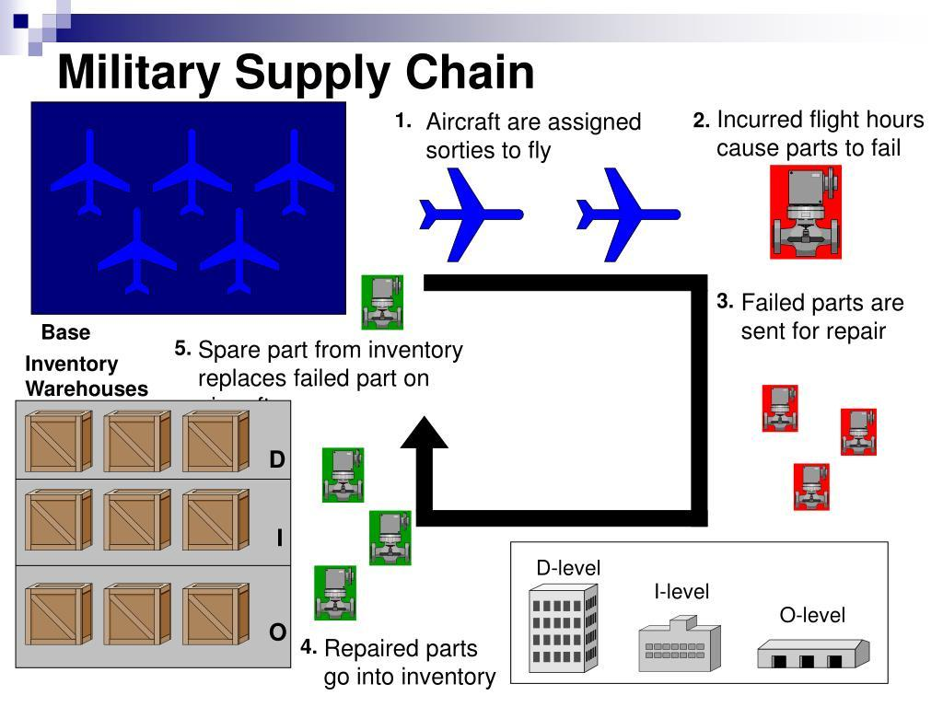
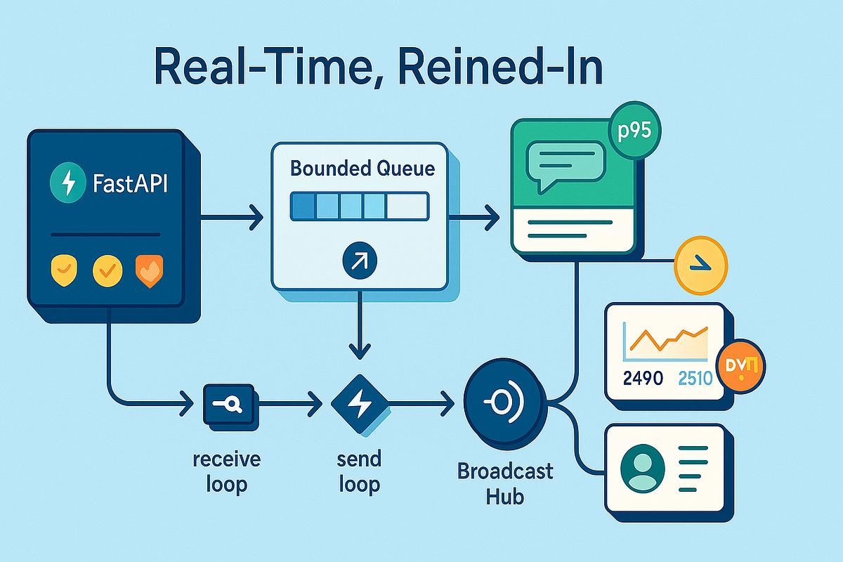
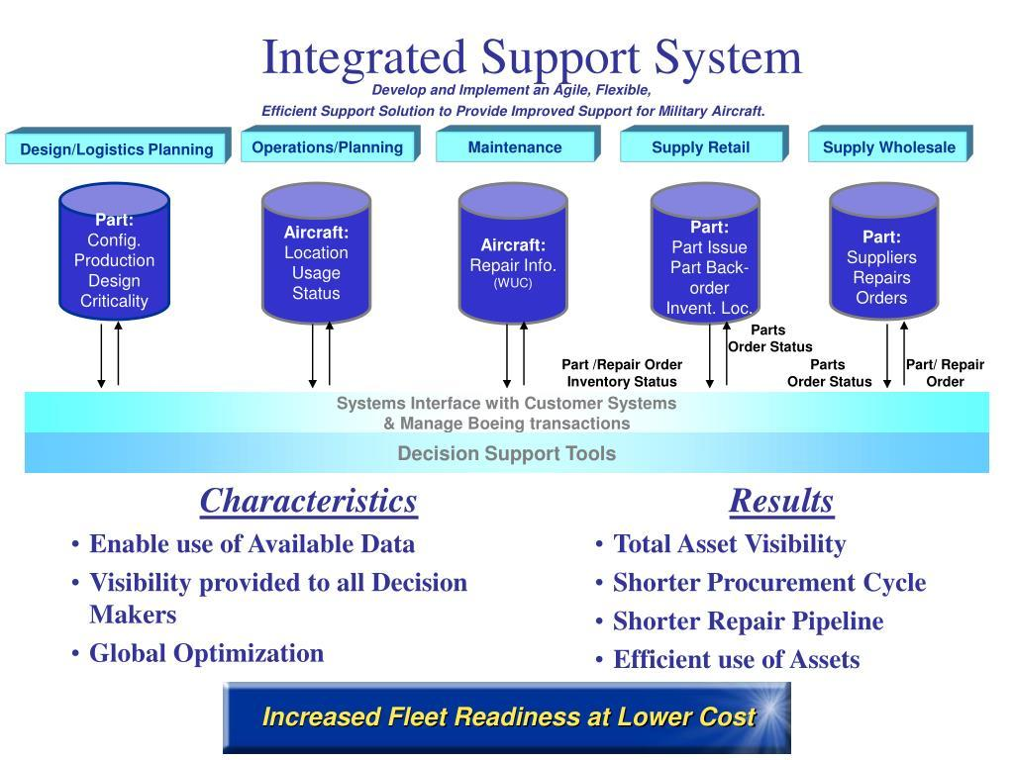
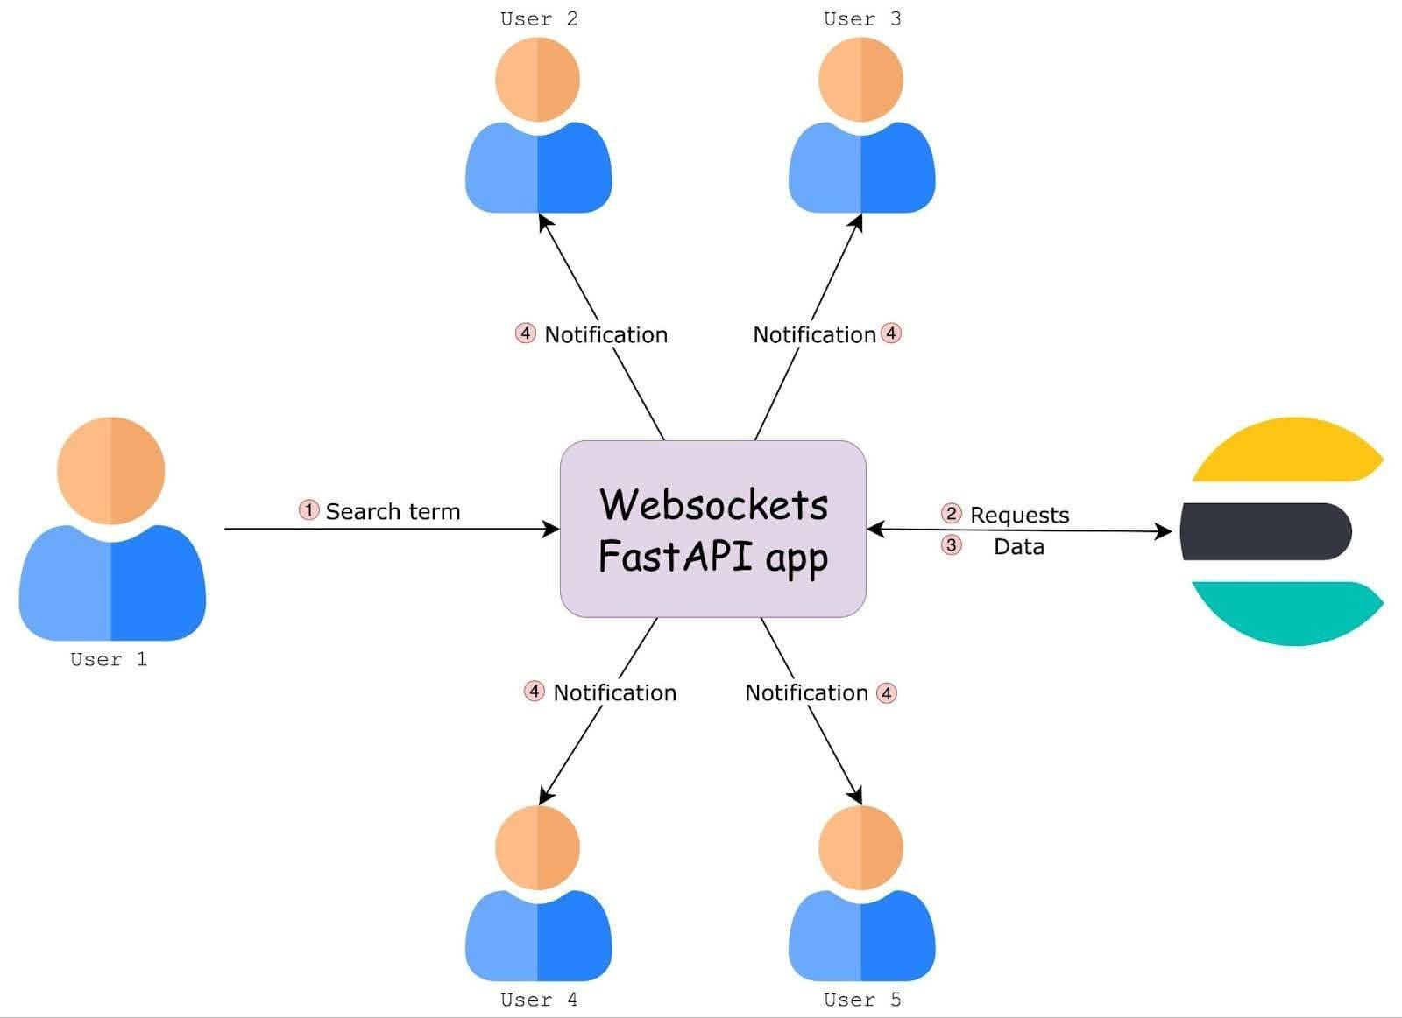
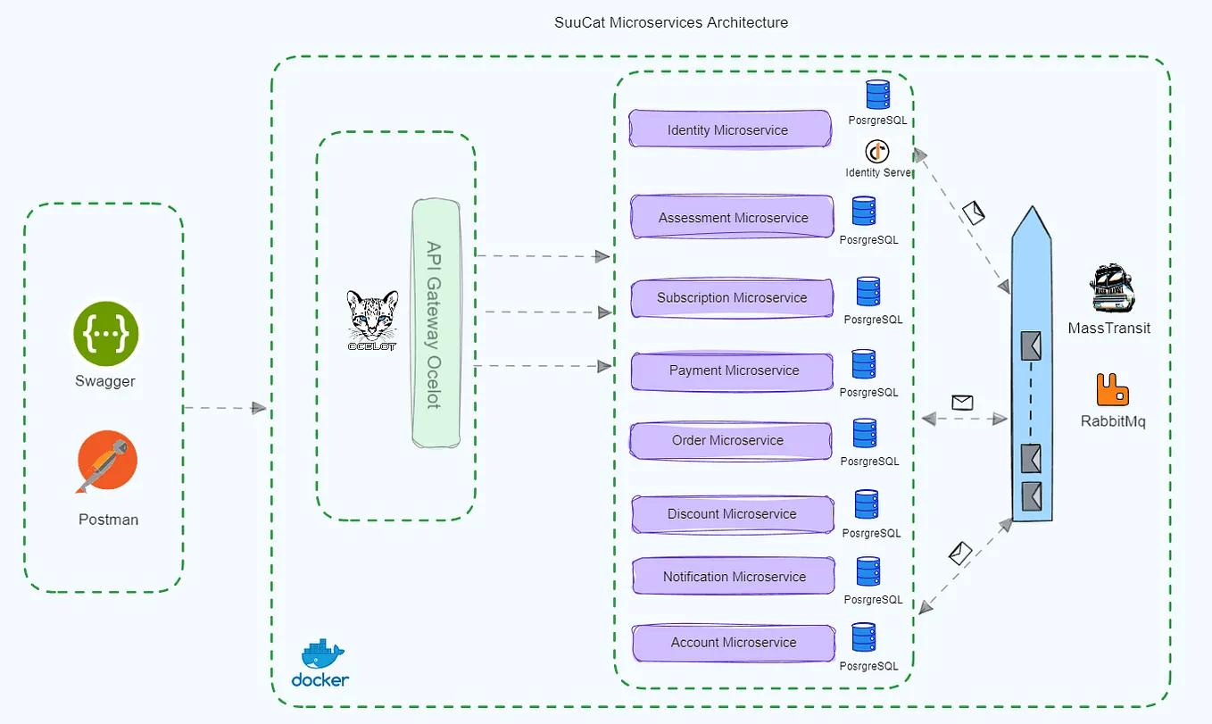
The service uses Python and FastAPI to stream events to connected applications.
AIR FORCE LOGISTICS DATA SOURCES
┌──────────┬──────────┬──────────┐
│ Aircraft │ Inventory│Maintenance│
│ Readiness│ / Parts │ Work Orders
└─────┬────┴────┬─────┴────┬─────┘
│ │ │
▼ ▼ ▼
┌──────────────────────────────┐
│ Python Logistics Event Engine│
│ │
│ • Event generation │
│ • JSON normalization │
│ • Topic filtering │
│ • Timestamping │
└──────────────┬───────────────┘
│
▼
┌──────────────────────────────┐
│ FastAPI WebSocket Service │
│ │
│ Docker Container │
│ WebSocket: /ws/logistics │
│ REST: /api/logistics/snapshot│
│ Health: /health │
└──────────────┬───────────────┘
│
Persistent WebSocket
│
┌──────────────┼───────────────┐
▼ ▼ ▼
Logistics Maintenance Analytics /
Dashboard Applications AI Applications
Important: The initial implementation generates synthetic demonstration data. It does not connect to actual Air Force systems or contain operational logistics data.
2. What the service does
The application supports four logistics event categories.
Topic | Example event | Potential Air Force application
readiness | Aircraft readiness updated | Monitor mission-capable status
inventory | Spare part inventory updated | Identify parts below reorder thresholds
maintenance | Work order status changed | Monitor maintenance backlogs
transport | Shipment status updated | Track logistics shipments and estimated arrival
For example, an inventory event might look like this:
{
"event_type": "inventory.stock.updated",
"topic": "inventory",
"classification": "UNCLASSIFIED//SYNTHETIC DEMO DATA",
"data": {
"part_number": "DEMO-PN-2002",
"description": "Avionics cooling fan",
"on_hand": 3,
"reorder_point": 5,
"reorder_recommended": true,
"location": "DEMO-BASE-B"
}
}
A connected application receives the event as soon as the service generates it.
This allows multiple consumers to receive updates without repeatedly polling a REST API.
3. Technology stack
Component | Implementation | Purpose
Programming language | Python 3.12 | Application logic
Web framework | FastAPI | HTTP and WebSocket endpoints
Web server | Uvicorn | Application runtime
Messaging | WebSocket | Persistent, bidirectional client connections
Data format | JSON | Logistics event representation
Containerization | Docker | Portable application deployment
Orchestration | Docker Compose | Local deployment and configuration
Testing | Pytest | Basic API tests
The application is configured to run as a non-root user inside a container, with a read-only root filesystem and dropped Linux capabilities.
These are useful baseline hardening measures, but they do not establish compliance with DoD security requirements.
4. Run the application
Step 1: Extract the ZIP
Extract air_force_logistics_websocket.zip to your development machine.
Open a terminal in the extracted project directory.
Step 2: Build and start the container
Run:
docker compose up --build -d
Check the container:
docker compose ps
View its logs:
docker compose logs -f logistics-ws
Step 3: Test the REST endpoints
Check service health:
curl http://localhost:8000/health
Retrieve the baseline logistics snapshot:
curl http://localhost:8000/api/logistics/snapshot
You can also open the interactive API documentation:
http://localhost:8000/docs
Step 4: Connect a WebSocket client
The project includes client.py.
Install the Python dependencies in a virtual environment and run:
python client.py
The client connects to:
ws://localhost:8000/ws/logistics
It then receives a stream of synthetic logistics events.
The default event interval is three seconds.
5. Filter the events you receive
One useful feature is the ability for clients to subscribe to particular event topics.
For example, a maintenance application might send:
{
"action": "subscribe",
"topics": [
"maintenance",
"inventory"
]
}
The service then sends that connection only maintenance and inventory events.
A readiness dashboard could subscribe to:
{
"action": "subscribe",
"topics": [
"readiness"
]
}
The service also supports a simple ping/pong interaction for connection checks.
6. How I would extend this for an Air Force logistics data fabric
For your broader logistics integration use case, I would evolve this demonstration into the following architecture.
Layer | Recommended capability | Role
Source systems | ERP, maintenance, supply, transportation | Provide authoritative logistics data
Integration | Existing APIs, adapters, event consumers | Retrieve and normalize source data
Event backbone | Kafka or an approved messaging platform | Buffer and distribute events
API gateway | Kong or an approved gateway | API access, routing, and policy enforcement
WebSocket service | Python/FastAPI | Stream authorized events to clients
Data processing | Python and rules-based analytics | Detect shortages and readiness changes
Observability | Prometheus and Grafana | Monitor service health, traffic, and latency
Security | Approved ICAM, RBAC/ABAC, TLS, audit logging | Control access and protect data
Consumer applications | Dashboards, planning tools, analytics | Present logistics information to users
Example operational workflow
Imagine a maintenance system records a shortage of a required component.
- An integration adapter detects the inventory change.
- The event is normalized into a common logistics schema.
- The event is published to a messaging platform.
- The Python service receives it and determines which authorized subscribers should receive it.
- A maintenance dashboard receives the update over WebSocket.
- A downstream analytics service evaluates the shortage's potential effect on aircraft availability.
The current project implements the WebSocket service and synthetic event generation. The source-system integration, durable messaging, authorization policies, and readiness-impact analysis would be additional development.
One important distinction: WebSocket provides a communication channel, not a durable message queue. This demonstration does not guarantee delivery to disconnected clients or replay missed events. A production implementation should use a durable messaging layer when those capabilities are required.

7. Recommended next step
Given the Air Force logistics integration scenario, I would recommend evolving this into a Kong + Python WebSocket + Kafka + Prometheus/Grafana demonstration.
That would let you demonstrate:
- Kong: API access and routing policies.
- Python WebSocket service: Real-time event delivery to applications.
- Kafka: Durable event distribution and replay.
- Prometheus/Grafana: Connection counts, event throughput, latency, and service health.
- Logistics event schemas: Standardized inventory, maintenance, transportation, and readiness messages.
- Security integration: An architecture for approved ICAM, topic-level authorization, and audit logging.
The result would be a more complete prototype for demonstrating how legacy logistics data can be transformed into real-time, reusable services without requiring every consumer to integrate directly with every source system.

