# Site Flow and Sketches

## Step 1: Competitive Analysis

|  |  |
| --- | --- |
| Competitor Site 1: <site name here> URL: Spotify.com AnalysisWhat is good about this site?  1. I have my own playlist of songs 2. There’s a wide variety of new genres to explore 3. I can see what my friends are listening to  What is bad about this site?  1. Some artists aren’t on Spotify 2. You have to pay for Spotify premium 3. Spotify doesn’t have popular remixes that can be found on other sites like SoundCloud. | Competitor Site 2s: <site name here> URL: Netflix.com AnalysisWhat is good about this site?  1. Recommendations for shows 2. I can resume a show or movie at anytime 3. There’s a wide variety of new releases  What is bad about this site?  1. You have to pay for a subscription 2. Netflix doesn’t have a very good variety of new releases 3. Netflix doesn’t allow users to stream on-going shows |

### Competitor 1 Pages

#### Page (or Screen) where you ask “What should I do tonight?”

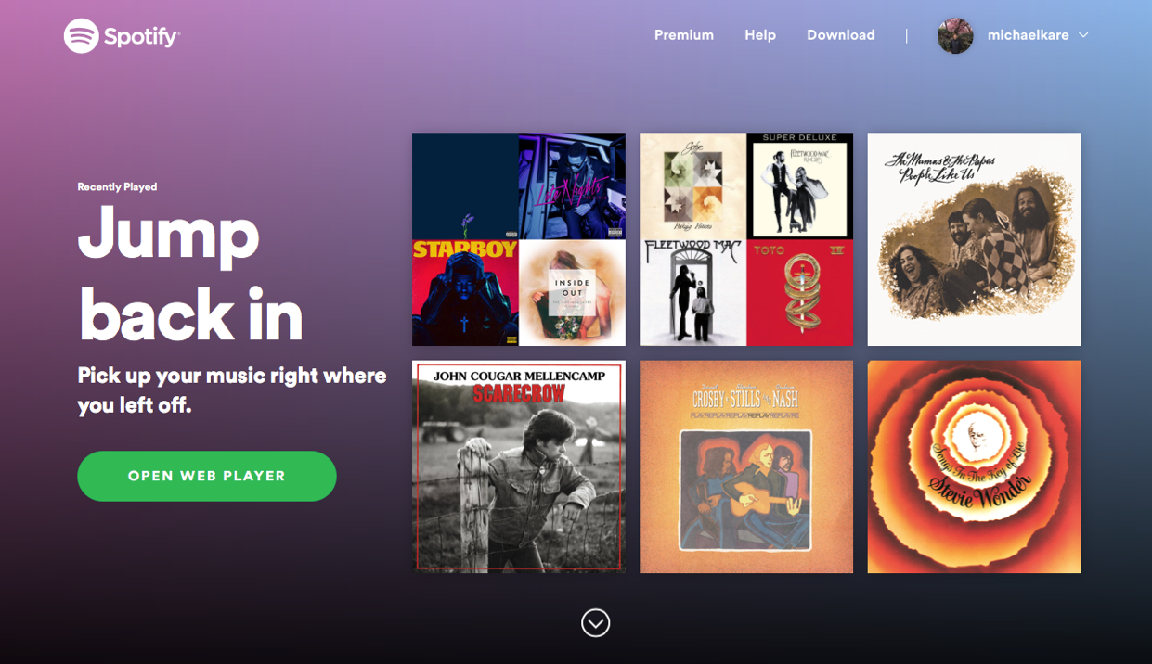

#### Pages (or Screens) look for the answer

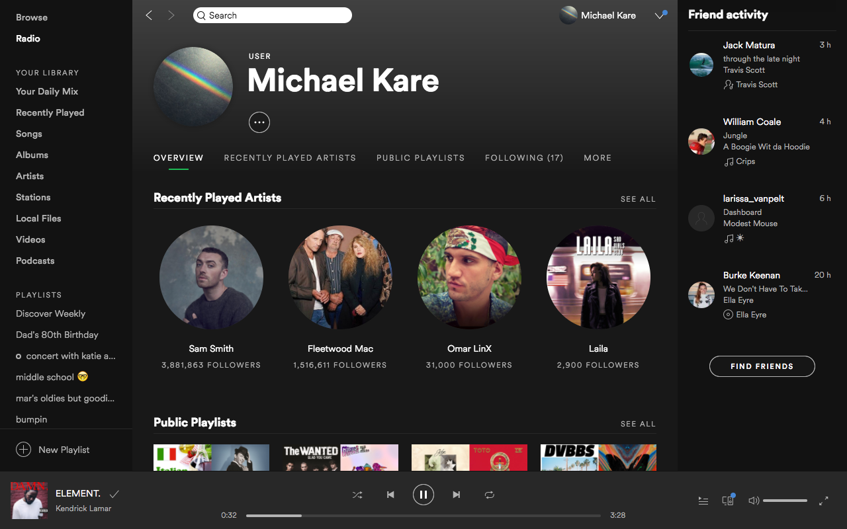

#### Page where you get an answer

### ../Desktop/Screen%20Shot%202017-10-18%20at%202.25.00%20PM.png

### Competitor 2 Pages

#### Page (or Screen) where you ask “What should I do tonight?”

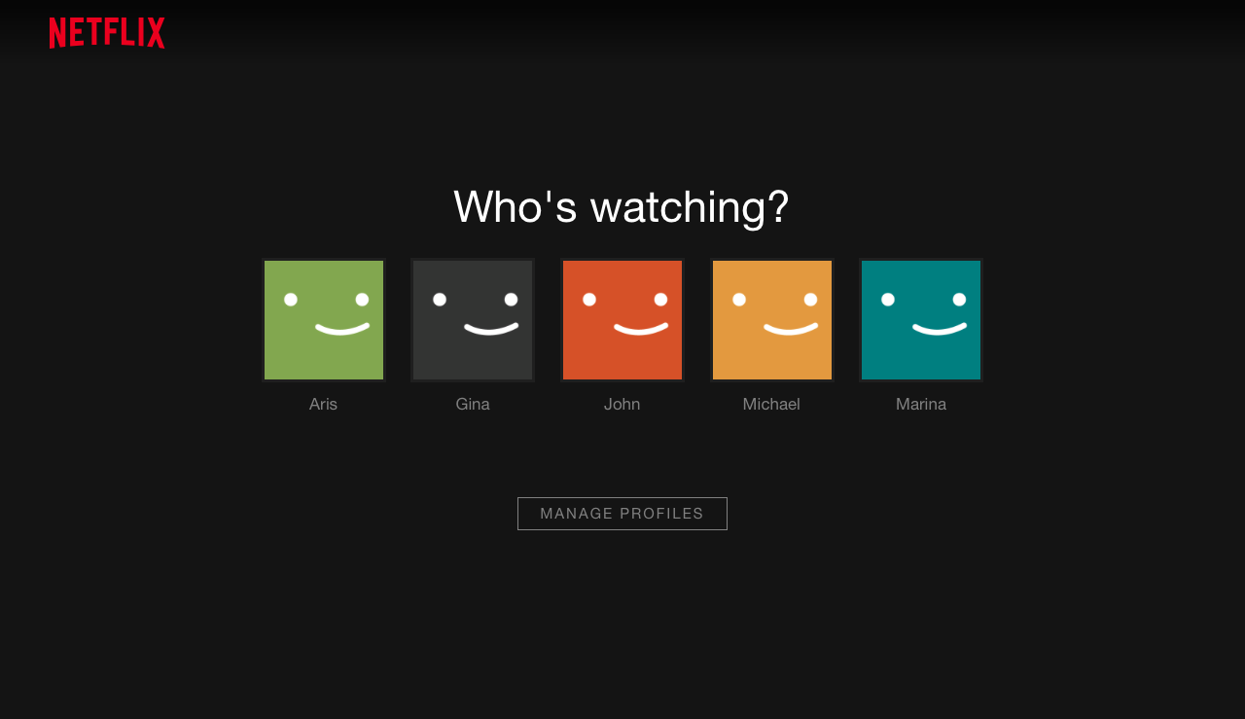

#### Pages (or Screens) look for the answer

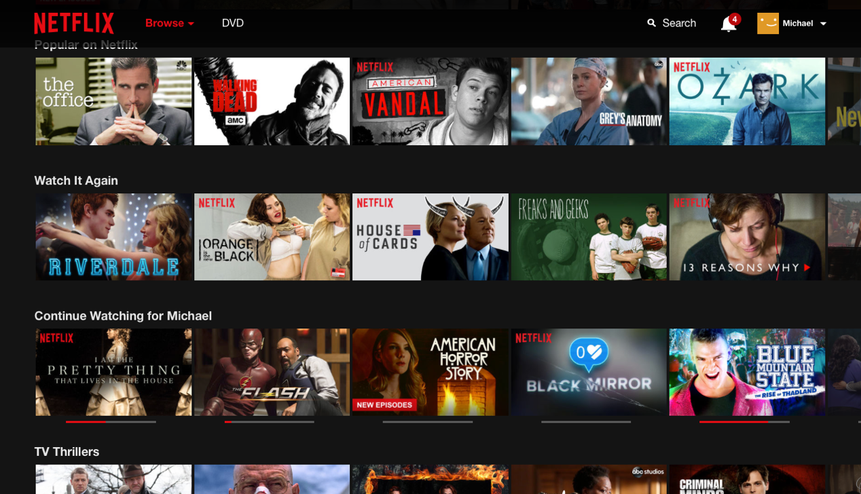

#### Pages (or Screens) look for the answer

#### ../Desktop/Screen%20Shot%202017-10-18%20at%202.36.09%20PM.png

## Step 2: Sketch One Competitor Flow

### Favorite Competitor: Page Flow Sketch

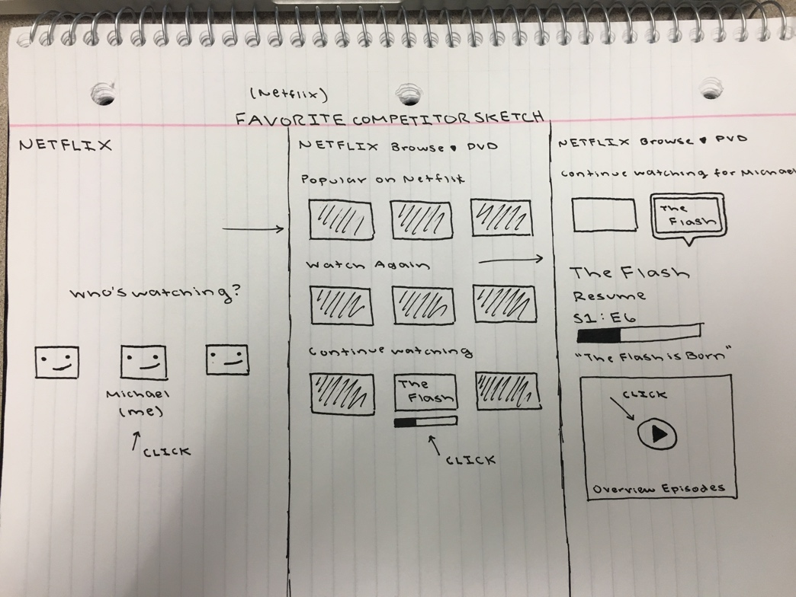Pages sketched as boxes for the flow between pages (or screens) where you ask “What should I do tonight?”, look for the answer, and get an answer. Arrows drawn between the boxes show how the pages are connected by clicks. Inside the page boxes details include:

## 

## Step 3: Sketch YOUR Flow

### My Site Name

Freegamesbuzz.com

#### Sketch of My Page Flow

Pages sketched as boxes for the flow between pages (or screens) where you ask “What should I do tonight?”, look for the answer, and get an answer. Arrows drawn between the boxes show how the pages are connected by clicks. Inside the page boxes details include:

