Library Investment and Local Business Formation:
A Difference-in-Differences Analysis of Chicago Public Library Branches
Minjoo Kim
Independent Research Project — University of California, San Diego
During my research on restorative environments in Dr. David Kirsh's XR Interactivity Lab, I frequently encountered libraries as examples. Libraries were often quiet, well-designed, and open to anyone, serving as restorative spaces that support cognitive recovery from mental fatigue and stress. My research mainly examined the cognitive dimension of restorative architecture. Beyond the cognitive effects, this project brings an economic perspective on this topic: if libraries function as genuine neighborhood anchors, would that anchoring effect lead to measurable local economic activity? To test this, I specifically examined the rate of new business formation near the libraries once a branch opened or was renovated.

1. Motivation and Research Question
Libraries have a subtler anchoring effect on local business formation compared to large employers or transit stops. Any effects should happen through indirect channels such as a signal that public investment was made to the neighborhood, increased foot traffic from regular patrons, and new residents in co-located affordable housing as part of the same development. Three of the seven branches I examined — Independence, Little Italy, and Northtown — were built as part of exactly this kind of mixed-use development. Whether these channels produce a detectable effect is something only data can answer.
This project asks: does the opening or major renovation of a Chicago Public Library branch cause a detectable change in the rate of new business formation in the surrounding area?
I chose new business formation as the outcome variable deliberately. Tracking nearby property values would be a natural way to measure the economic effects of public libraries; however, this risks conflating the library's effect with broader neighborhood gentrification, making it difficult to know if the new library is a cause of increase. New business formation would be a broader proxy for local economic productivity, as it is farther from pure real-estate appreciation but still close to the tangible economic vitality that these public investments claim to support.

2. Data
I used two datasets for this analysis. First, I got new business activity data from the City of Chicago's Business Licenses dataset. I gained access through Chicago's open data API using Python's sodapy client. Second, I got library locations and identifying information data from the Chicago Public Library Locations dataset, which lists all 81 branches operating across the city.
For the treatment, I started with all 81 branches, but most did not have a clean, datable “start” event. To ensure validity, I narrowed down to branches that had a documented and verifiable opening or major renovation date using Chicago Public Library's official history page, press releases, and verified news coverage (Table 1). I chose to work with fewer branches with strong sources over more branches with weak sourcing.
Table 1. Treatment events and dates for the seven library branches included in this analysis
Branch | Event | Date
Richard M. Daley | New branch opening | July 8, 2011
West Loop | New branch opening | January 17, 2019
Independence | New branch opening (co-located affordable housing) | January 22, 2019
Little Italy | New branch opening (co-located affordable housing) | January 22, 2019
Northtown | New branch opening (co-located affordable housing) | March 5, 2019
Legler Regional | Reopened after major renovation | June 2019
Altgeld | New branch opening (co-located affordable housing) | November 9, 2020

To construct the outcome, I filtered business licenses to application_type = 'ISSUE' only, which excludes renewals and isolates genuine new business formation. Then, I built spatial buffers (0.25mi, 0.5mi) around each library using a server-side spatial query (within_circle()), rather than downloading everything and filtering locally. I then aggregated license counts to quarterly totals per library, per radius. Lastly, I explicitly filled gap quarters (no license activity) with zero rather than leaving them missing, so that the regression reads these periods as a true zero rather than missing data.
The panel I got included a time span of 2005Q1–2026Q2 with 14 panel units (7 branches × 2 radius specs) and 1,204 total observations. Stata confirmed this panel as “strongly balanced,” which means every unit was present in every time period without gaps.

3. Empirical Strategy
I chose to conduct a Difference-in-Differences (DiD) analysis because it compares each library to itself over time. This differenced out permanent neighborhood characteristics (walkability, density, historical character, etc.) that do not change and would introduce a bias to simple comparison. This design relies on repeated observations of the same 14 units over 86 quarters.
On the other hand, a two-way fixed effects analysis (TWFE) is inadequate for this project because branches were treated in different years, and every branch in the sample is eventually treated — meaning no group remains untreated to serve as a clean comparison. Recent economic literature (Callaway & Sant'Anna 2021, among others) has shown that TWFE can produce biased estimates specifically in this kind of staggered-adoption setting, since units that are already treated can end up serving as improper “controls” for units treated later. I still ran a TWFE as a first look, but treated this as a preliminary, not a primary, result.
For the primary specification, I used the estimator developed by Callaway and Sant'Anna (2021), implemented in Stata. I used the csdid command and independently cross-checked in R using the did package. This way, I estimated a separate average treatment effect for each treatment cohort, grouped by the quarter in which a branch was treated, rather than producing a single pooled treatment effect. I used libraries that had not yet been treated at a given point in time as the comparison group, since already-treated libraries could no longer serve as a valid untreated baseline. These group-time effects can then be aggregated into a single overall estimate or into an event-study format that shows how the effect evolves before and after treatment.
In this design, there is an underlying parallel trends assumption: without treatment, business formation near libraries that were treated later would have a similar trajectory to libraries that had already been treated or had not yet been treated at that point. I checked this assumption indirectly by examining the trends of treated and comparison libraries before treatment occurred. This test is in the Results section, where I use event-study estimates for the pre-treatment period.

4. Results

Main Estimates
I first used a standard two-way fixed effects regression for a preliminary check. The coefficient on the post-treatment indicator was -1.90 (p = 0.118), meaning no statistically significant effect. However, I didn't treat this as a primary result because this design has staggered treatment timing and no permanently untreated comparison group. Instead, I used the Callaway and Sant'Anna estimator described in the previous section. Through the analysis, I got a resulting average treatment effect on the treated of 0.118 (SE = 1.35, p = 0.931), which is small in magnitude and not statistically distinguishable from zero. Therefore, there is no evidence that library openings or renovations caused a detectable change in new business formation in nearby areas.
Figure 1. Event-study estimates of the effect of library treatment on new business formation, by quarter relative to treatment
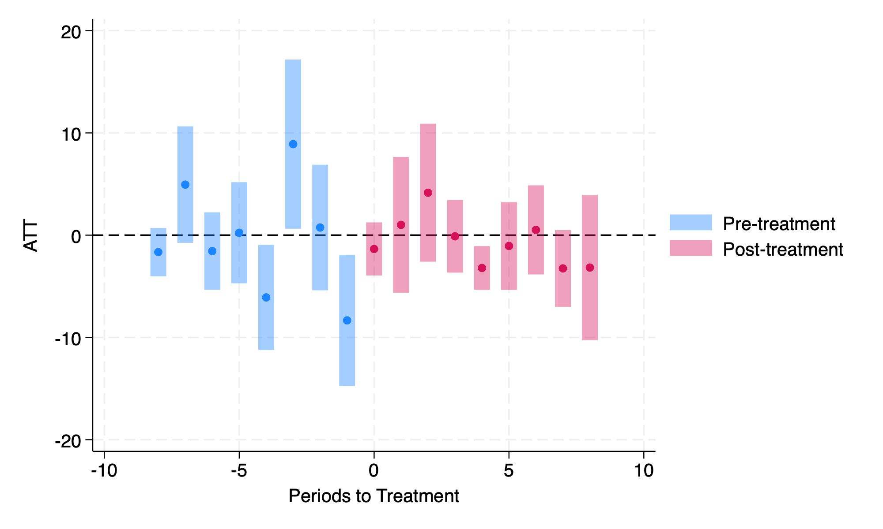
Figure 1 shows the event-study estimates by quarter relative to the treatment. There is no visible jump in new business formation at the treatment quarter, and the point estimates on both sides of treatment sit close to zero with wide, overlapping confidence intervals. This pattern is consistent with the null result mentioned above: business formation near treated libraries does not appear to shift meaningfully around the time of treatment.

Robustness: Radius Specification
I re-estimated the model separately for the 0.25 mile and 0.5 mile radius specifications to check whether this result would differ depending on the specific choice of geographic buffer. For both distances, the estimated effect was small and statistically insignificant (ATT = 0.118, p = 0.931 at 0.25 miles; ATT = 0.831, p = 0.741 at 0.5 miles). This consistency suggests that the result is not affected by any single buffer choice.

Pre-Trends
The parallel trends assumption mentioned in the previous section can be examined by assessing the pre-treatment estimates directly. The average pre-treatment effect was statistically significant (p = 0.043) in the entire event-study window, which looked like a problem at first. This suggested that the library groups might have already been behaving differently before treatment occurred. Once I restricted the window to the 8 quarters immediately before and after treatment, which is the range most relevant to this design, no individual pre-treatment quarter had a statistically significant estimate. I include both findings here, not just the favorable one, since the initial concern was real in the data; it simply disappeared once I looked at the more relevant time window.

Independent Cross-Check
To check that this result is not because of a coding error, I reran the same analysis in R using the did package, which Callaway and Sant'Anna released with their 2021 paper. The R estimate (ATT = 0.112) was almost identical to the Stata estimate (ATT = 0.118), which confirms the null finding across two different implementations of the same estimator.

5. Limitations
There are several limitations in this analysis. First, the design is only based on 14 panel units for cluster-robust inference, which is well below the 30 to 50 clusters typically recommended for reliable standard errors. This is an inherent constraint of studying a small number of treated libraries. Second, I couldn't get a separate treatment effect for the Altgeld cohort using the Callaway and Sant'Anna estimator because there was too little variation in the single-branch cohort, and it was difficult for the estimator to isolate its effect from noise.
I chose the 0.25 and 0.5 mile radii to define library-adjacent businesses based on a reasonable approximation of a five- to ten-minute walk, rather than a specific formula or prior study establishing an optimal distance. A different radius choice could plausibly have produced a different result.
The fact that this analysis measures new business formation is also worth mentioning: it's focused on whether a license was issued rather than whether businesses survive or succeed. The null result I got doesn't mean that libraries have no economic effect — they could still influence whether nearby businesses survive and grow, but this was not measured in this project.
To test this question more properly in the future, I would want a bigger set of libraries across multiple cities and more years of data after treatment, since several of the libraries only have a short post-treatment window.

6. Conclusion
Taken together, there was no evidence that library branch openings or renovations caused a detectable change in new business formation nearby. This result was consistent across two radius specifications and two independent statistical implementations. However, this shouldn't be understood as evidence that libraries have no economic value in neighborhoods: only that this particular channel, in this data, and over this time window, did not produce a measurable effect. A study spanning multiple cities, with more treated branches and longer post-treatment windows, would better detect a smaller or slower-developing effect than what this project could test.

References
Callaway, B., & Sant'Anna, P. H. C. (2021). Difference-in-differences with multiple time periods. Journal of Econometrics, 225(2), 200–230.

