Weekopdrachten Software Engineering
Ad-ICT zuyd hogeschool
Nathalie Koeman - 2406365
2026
Inhoud
Week 1 1
Week 2 3

Week 1

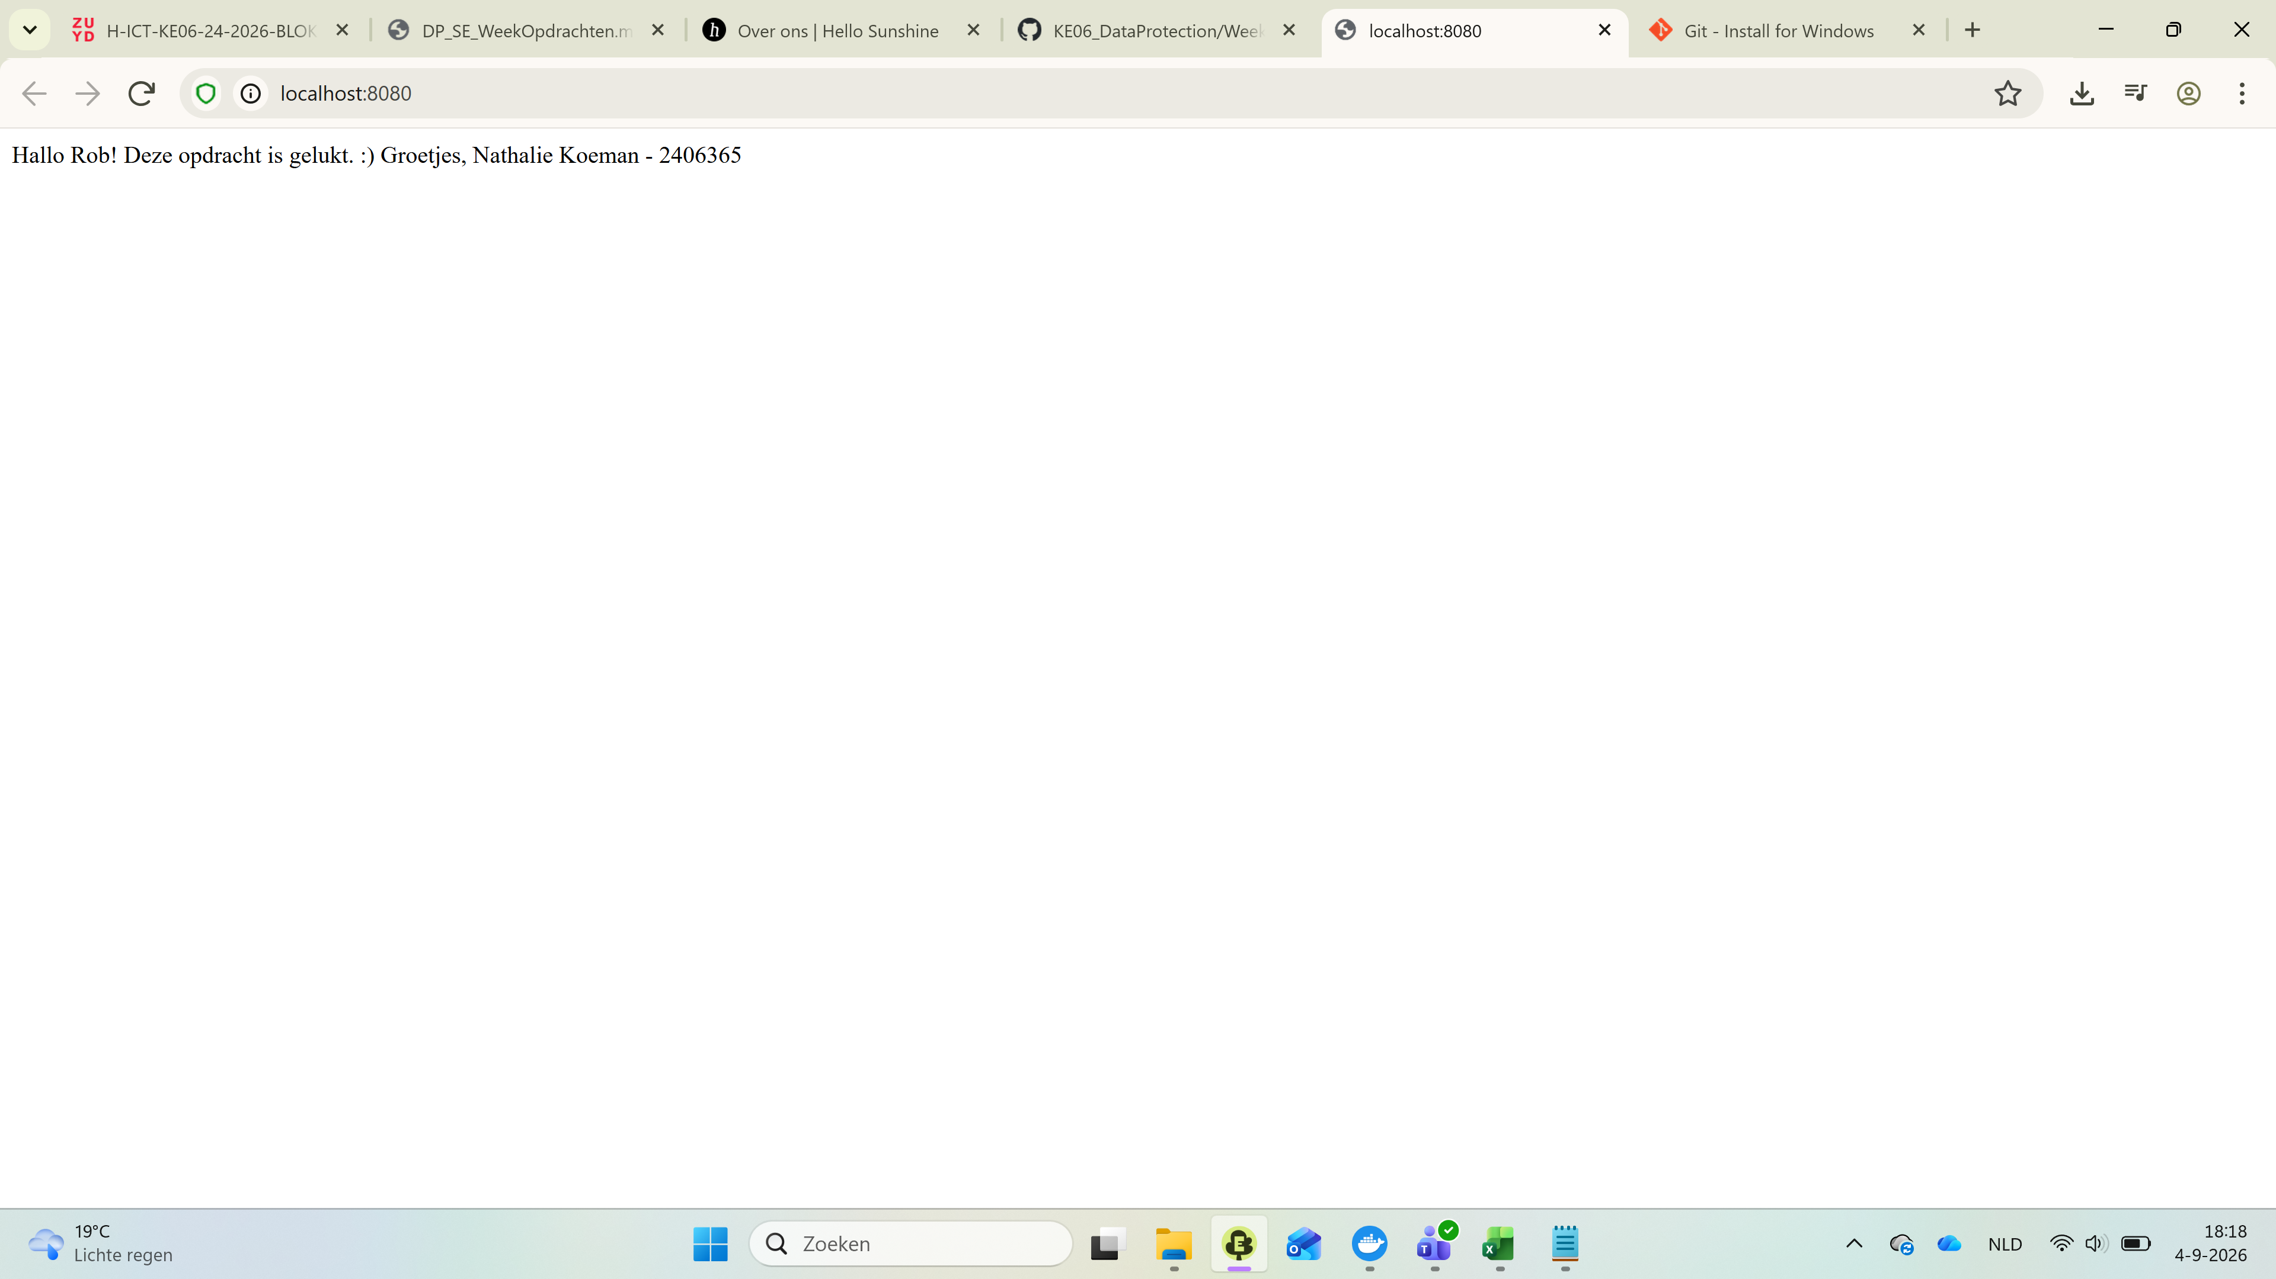
Figuur 1: Screenshot HTML pagina met aangepaste inhoud
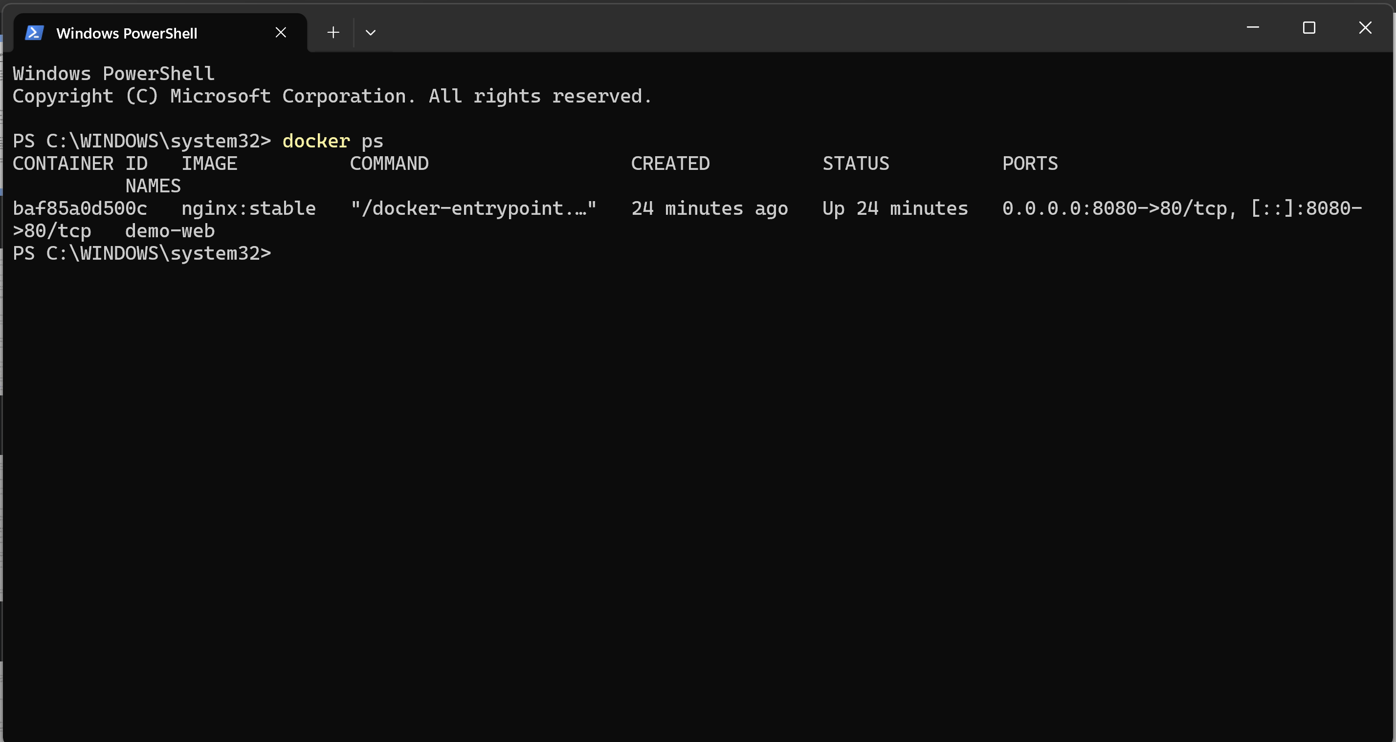
Figuur 2: Screenshot terminal commando ‘docker ps’

Week 2

