Capstone Project: Understanding Consumer Spending Depending on the State of the United States Economy

Michael Lawlor
Department of Computer Information Systems, Mesa Community College
CIS 480: Data Analytics and Programming Capstone
Dr. Kazuaki Kashihara
May 1, 2026

Introduction and Rationale
Topic
It is common to hear phrases such as “during times of economic recession/crisis, luxury spending increases” used often in conversations regarding the state of the economy. Therefore, this capstone project aims to investigate the validity of these types of claims by analyzing spending habits during distinct, significantly varying, snapshots of the United States economy.
Relation and Meaningfulness
This is related to data analytics and programming by its ability to be analyzed using the practices utilized throughout this program. Analytical methods involving relational data are most relevant in this case such as Pandas or SQL as we are trying to analyze correlation and cause and effect. Predictive models in Sci-kit learn may also be built to predict spending habits under specific conditions. Pandas is used for this project for its ability to easily work with CSV data and apply that data to predictive modeling.
Economic and financial analysis is overall an interesting topic. The Black-Scholes mode, for example, is widely regarded as inspirational work in the field of mathematics and data science. By better understanding money, awareness is gained related to how it should be managed. It is a skill applicable not only to professional environments but also to personal life.
Broad Significance
In terms of real-world applications, a company may find this analysis valuable to better understand consumer practices and how they interact with their products. They can use the results to form an objective, actionable, plan for their target audience under various economic conditions. Even more broadly, any curious individual could find this information interesting.
Research Objective and Questions
Primary Objective
The primary objective of this project is to better understand the spending habits of consumers under various economic conditions. Additionally, correlations between spending habits of types of goods and metrics of economic prowess are investigated to gain a better understanding of the relation between economy and behavior. With this information, stakeholders will be able to form an objective, actionable plan on how to better interact with a consumer market under certain circumstances.
Research Questions
- How does the state of an economy defined by appropriate metrics correlate with consumer spending?
- How do consumers allocate their spending during periods of lesser, moderate, and greater economic conditions?
- What metrics are recognized as indicators of the state of the economy?
- How do these economic indicators correlate with each spending category?
- How does consumer behavior change as the state of the economy changes?
Regression Model
Predictive models are applicable and are used to form predictions of consumer spending using economic indicators. Three regression models are built and tested for accuracy to determine which algorithm suits the data best. These models include linear regression, second-degree polynomial regression, and third-degree polynomial regression.
Preliminary Data Sources and Scope
Primary Data Source
The Federal Reserve Bank of St Louis (FRED) is the primary source of data. It features the most accurate and well-maintained data on consumer spending in the United States. The geographic level of the data encompasses the entirety of the United States. It would be preferred to analyze the data at a state geographic level to account for the influence of state governments. However, doing so would require sourcing the data from less credible sources, compromising the integrity of the data and by extension, the entire analysis.
Other Data Sources
While the FRED is an excellent source of economic data tailored towards consumer spending, other sources are more reliable for economic indicators. Sourcing this data from its primary source is ideal especially considering the case of some economic indicators being reported from different sources that determine their value differently. This leads to discrepancies between their data and the agency responsible for reporting that indicator. This is relevant specifically for economic indicators such as the Consumer Confidence Index (CCI).
Feasibility and Next Steps
Feasibility
With consistent effort put towards the project and given the timeframe in which the entire project needs to be completed, it is reasonable to expect this project to be feasible. All the FRED data is readily and reliably available to the public. Critical, time-consuming tasks can be completed early in the project cycle allowing for a streamlined workflow. This project aims to provide answers to specific questions of varying complexity. While the initial scope is relatively substantial, concepts can be expanded upon or condensed if necessary.
Next Steps
The project will go into the hypothesis testing stage. Research will be done to determine metrics that are used to determine economic status, specific datasets will be collected that are relevant to these metrics, and tests will be conducted to determine which features are correlated to components of consumer spending. This will be accomplished by defining and testing a null hypothesis utilizing proper statistical analysis to reject or fail to reject the hypothesis. Once significant metrics have been objectively determined using hypothesis testing, the project can then proceed into further stages.
Literature Review
Working With Economic Indicators: Interpretation and Sources
The different economic indicators and what economic conditions they are associated with is overwhelmingly numerous. Because of the broad usage of this term, it is difficult to determine which indicators should be used when forming an analysis. This book, found on the Maricopa Community College online library, serves as an excellent introduction to economic indicators and which ones are relevant to this research question. The authors organized metrics that serve as indicators by the type of economic condition they may project such as interest rates, prices, resource utilization, or most relevant to this case, economic activity.
When the classic indicator, gross domestic product (GDP), is discussed, the book introduces the concept of the business cycle. While the U.S. GDP increases by a stead 3-4% annually (Stengel & Chaffe-Stengel, 2012), the exact GDP fluctuates throughout the year due to seasonality. This introduces a key problem for this study. The time data was collected or the timeframe it represents may need to be considered depending on how significant the seasonality of the metrics are. Generalizing the data by year may be a simple solution that allows this project to remain within scope.
The book also introduces two interesting metrics namely the consumer confidence index (CCI) and the consumer sentiment index (CSI). The CCI highlights what randomly selected U.S. households think about business conditions, job prospects, and household income while the CSI highlights what the respondent thinks about whether their household is better off now than a year ago, whether the next twelve months will be good or bad economic times, if there will be periods of unemployment during the next five years, and if now is a good time buy big ticket items (Stengel & Chaffe-Stengel, 2012). These indicators may provide a credible method of bridging the gap between the objectivity of the state of an economy or consumer spending and the perception of the consumers in the respective economy. This may provide valuable insight into why potential discrepancies between consumer spending and GDP exist during certain periods after analysis.
Consumer Spending During Unemployment: Positive and Normative Implications
Due to unemployment rate being commonly referred to as a key economic indicator and its distinction from GDP, its potential implications for consumer spending should be considered. This paper from the National Bureau of Economic Research highlights this concern comprehensively. Most relevant to this project, they show that spending drops drastically due to the large predictable decrease in income near the exhaustion of unemployment insurance (Ganong & Noel, 2019). Additionally, they analyzed the decreased spending post unemployment insurance exhaustion is significantly smoother with longer periods of unemployment insurance benefits when compared to raising unemployment insurance benefit levels (Ganong & Noel, 2019).
The displayed relevance of unemployment and consumer spending implies a need to consider whether GDP, unemployment rate, or both should be used as economic indicators for this project. Further research or analysis would be required to determine which economic indicator is more related to consumer spending and the state of an economy, however conducting an analysis personally raises concerns with increasing the scope of the project.
Okun’s Law: Fit at Fifty?
In an effort to reduce dimensions and by extension reduce research hypotheses, the relationship between GDP and unemployment was investigated to determine the potential redundancy of including both economic indicators in this analysis. This paper by the National Bureau of Economic Research investigates how well Okun’s law aligns with the unemployment movements in the United States since 1948. Okun’s law is an empirical relationship between GDP and unemployment in post-war data that states every one percent decrease in unemployment increases GDP by three percent (Institute for New Economic Thinking, n.d.). The paper confirms Okun’s law maintains a stable relationship across multiple countries and accounts stating the law did not fit are flawed.
In other words, because Okun’s law establishes a strong inverse relationship between unemployment and GDP, including both features is redundant. This paper provides the empirical research necessary to ensure that reducing the dimensions of the data used for this analysis does not remove too much significantly important information.
Synthesis
Synthesis can be drawn from the information provided by this literature review connecting them to GDP, Unemployment, Consumer Confidence, GDP Growth, and Consumer Spending Behavior. ‘Working With Economic Indicators: Interpretation and Sources’ highlights statistics that are regarded as the most accepted indicators of economic conditions. The findings discussed in ‘Consumer Spending During Unemployment: Positive and Normative Implications’ strongly suggest people’s spending changes depending on their personal financial stability, which may be generally influenced by the state of the economy. ‘Okun’s Law: Fit at Fifty?’ demonstrates the relationship between GDP Growth and unemployment, showing how personal financial conditions are related to the state of the economy. With these pieces of literature, and ecosystem between the overall economy, and consumer personal finances is established relating to GDP, unemployment, consumer confidence, and consumer spending behavior.
Hypothesis Development
Hypothesis 1
This two-tailed hypothesis intends to provide evidence for how the most universally accepted metric for state of the economy, GDP Growth, effects overall consumer spending. This begins the series of tests needed to form a better understanding of how consumer spending changes depending on the objective state of the economy. (H0₁) Overall consumer spending in the United States, defined by Personal Consumption Expenditures (PCE), has no significant change based on United States GDP growth. (H1₁) Overall consumer spending in the United States, defined by PCE, experiences significant change with shifts to United States GDP Growth.
Hypothesis 2
This set of two-tailed hypothesis intends to provide evidence for how consumer spending on various spending categories, in this case food, durable goods, and services, changes with GDP Growth. This allows for the formation of a more comprehensive overview of the overall spending habits of consumers depending on the state of the economy. (H0₂a) Consumer spending on food, defined by PCE: Food, experiences no significant change as GDP Growth changes. (H1₂a) Consumer spending on food, defined by PCE: Food, experiences significant changes as GDP Growth changes. (H0₂b) Consumer spending on durable goods, defined by PCE: Durable Goods, experiences no significant change as GDP Growth changes. (H1₂b) Consumer spending on durable goods, defined by PCE: Durable Goods, experiences significant change as GDP Growth changes. (H0₂c) Consumer spending on services, defined by PCE: Services, experiences no significant change as GDP Growth changes. (H1₂c) Consumer spending on services, defined by PCE: Services, experiences significant change as GDP Growth changes.
Hypothesis 3
This two-tailed hypothesis intends to provide evidence for how overall consumer spending changes as an economic indicator used to measure consumers’ perception of the economy changes. For this analysis, the Conference Board CCI is used. This begins the short series of tests needed to form a better understanding of how consumer spending changes depending on consumers’ perception of the economy. (H0₃) Overall consumer spending, defined by PCE, has no significant change based on Conference Board CCI. (H1₃) Overall consumer spending, defined by PCE, experiences significant change with shifts to Conference Board CCI.
Hypothesis 4
This final two-tailed hypothesis intends to provide evidence for how consumer spending on various spending categories, in this case food, durable goods, and services, changes with shifts to the Conference Board CCI. This allows for the formation of a more comprehensive overview of the overall spending habits of consumers depending on consumers’ perception of the economy. (H0₄a) Consumer spending on food, defined by PCE: Food, experiences significant change as Conference Board CCI changes. (H1₄a) Consumer spending on food, defined by PCE: Food, experiences significant changes as Conference Board CCI changes. (H0₄b) Consumer spending on durable goods, defined by PCE: Durable Goods, experiences no significant change as Conference Board CCI changes. (H1₄b) Consumer spending on durable goods, defined by PCE: Durable Goods, experiences significant change as Conference Board CCI changes. (H0₄c) Consumer spending on services, defined by PCE: Services, experiences no significant change as Conference Board CCI changes. (H1₄c) Consumer spending on services, defined by PCE: Services, experiences significant change as Conference Board CCI changes.
Data Collection Strategy
Data Sources
The Federal Reserve Bank of St. Louis Economic Data (FRED), the Bureau of Economic Analysis and Investing.com, a secondary source of the data from the Conference Board, are the sources of data for this analysis. The FRED is the primary source of data relating to consumer spending by categories: food, durable goods, services, and the total. The Bureau of Economic Analysis (BEA) provides a comprehensive view of GDP growth. Lastly, Investing.com provides data on the CCI as published by the Conference Board.
Justification for Source Selection
The FRED is maintained by the Federal Reserve Bank of St. Louis by compiling data from U.S. federal statistical agencies such as the Bureau of Labor Statistics, the BEA, and the Census Bureau (Federal Reserve Bank of St. Louis, 2026) making it a credible source. It also shows consistent and methodological transparency valuable when compiling several related measures for comparative analysis.
The BEA is the government agency responsible for reporting GDP and GDP growth at the start of each quarter (U.S. Bureau of Economic Analysis, n.d.). Therefore, the BEA acts as the primary source for this metric. As a result, other credible agencies reporting GDP or GDP growth must originally source their data from the BEA, making the BEA the best source for this data.
In parallel to the BEA, the Conference Board is the independent agency responsible for reporting CCI (The Conference Board, 2026). They are a globally respected research organization that produces metrics widely regarded as leading economic indicators such as the Leading Economic Index, Employment Trends Index, and of course CCI. They are the primary source for consumer confidence data. While it is preferable to source CCI data from the Conference Board, accessing their database comes with complications that do not make this a reasonable option. For this reason, a third party that directly sources its data from the Conference Board is used to source the CCI data used for this analysis, namely Investing.com. The data provided by Investing.com has been verified with multiple articles published by the Conference Board reporting the monthly CCI to ensure it’s accuracy.
Geographic and Temporal Scope
The data collected from the FRED, BEA, and Investing.com encompasses the entirety of the United States. The research question demands the analysis of overall economic trends to determine how people generally change their spending habits relative to the state of the economy. While a more acute analysis at the state geographic level would facilitate a more specific overview, these agencies provide the required data either federally exclusively in the case of categorized consumer spending or the metrics they report are delivered the most confidently at the federal level. Despite this, the insights gained by the resulting model should still be applicable when predicting spending habits in a more localized economy given the respective localized metrics.
The temporal scope of these metrics conflict due to the difference in reporting times between GDP growth and CCI. The BEA reports GDP growth on the first day of the following quarter while the Conference Board reports CCI on the first Tuesday of each month. This can be partially remedied by forming the best estimate possible by analyzing personal consumption expenditures (PCE) monthly and associating each PCE with the GDP growth period their date falls under. Additionally, all the years included in the BEA’s January 1, 2026, report will be analyzed to create a dataset robust enough to derive meaningful connections. This consists of the years 2022 through 2025 inclusive. This is sufficient for this analysis as it describes the modern audience while consisting of a sufficient enough amount of data to derive insights. This timeframe also eliminates the unexpected fluctuation in the economy witnessed during the height of the COVID-19 pandemic.
Data Types and Variables
From the FRED, monthly data on four PCE measures is collected. This includes the overall PCE, as well as PCE: Food (PCEF), PCE: Durable Goods (PCEDG), and PCE: Services (PCES). The tables published in the BEA’s January 1, 2026, report is collected to provide quarterly data on U.S. GDP growth. Lastly, due to complications with collecting data directly from the Conference Board’s online database, a credible secondary source is used to collect data on the Conference Board CCI. Each of these six variables described (PCE, PCEF, PCEDG, PCES, GDP Growth, and CCI) are all continuous numeric variables.
Data Cleaning and Integration Plans
The most concerning problem that was encountered when merging each feature is the date associated with each value. In an effort to allow all the metrics to coexist under a single timeline, the value of GDP growth is assigned to each FRED observation based on the date in which the FRED observation was recorded. For example, the value for GDP growth for Q3 2025 was 4.4% which encompasses a date range of 07-01-2025 through 09-30-2025 (U.S. Bureau of Economic Analysis, 2026a). Therefore, any FRED observations within that date range has a GDP growth value of 4.4 associated with them. This results in the best possible estimate for the GDP growth rate during that period while resolving timing conflicts. No missing values or formatting issues were encountered as all data sources provided complete information and consisted of continuous numeric values.
Modeling Strategy
Model Type
To answer the research questions, a combination of methods including descriptive analytics and predictive modeling is utilized. The relationships between each PCE and GDP growth/CCI is analyzed to form an understanding of how these economic indicators correlate if not influence consumer spending habits. Regarding predictive modeling techniques, three models are created and evaluated to determine which makes up the best representation of the data. These model types include linear regression, second-degree polynomial regression, and third-degree polynomial regression.
Justification for Model Selection
Since all of the features included in the study consist of continuous values, a regression model is most appropriate. The categorized PCE, GDP growth, as well as CCI are all measured on a continuous scale. Classification models would not be applicable due to the lack of categorical or binary values being present. While models such as ARIMA, AR, and MA are often used in time series data like most instances of economic data, the purpose of this analysis does not require them. ARIMA requires mean and variance to be constant over time, while AR and MA are relevant to pattern recognition relevant to signal analysis. The data does not fulfill the criteria of any of these common time series algorithms. Additionally, ARIMA, AR, and MA analyze time dependent patterns while linear and logistic regression estimate entity dependent patterns such as in this case.
Independent Variables and Features
For this analysis, the independent variables (X) consist of GDP growth and CCI while the dependent variables (y) consist of PCE, PCEF, PCEDG, and PCES. This is because this analysis aims to understand how consumers naturally allocate their expenses as the state of the economy changes. The values that are being predicted are the PCE categories while the values being used to form these predictions are GDP growth and CCI. Each of the model’s performances are evaluated using evaluation metrics relevant to regression analysis. These include R-squared, RMSE, and MAE.
Research Question and Hypothesis Connection
The visualizations presented through a Microsoft Power BI dashboard are specifically designed to answer the research questions and address each hypothesis. To demonstrate this, each report page is showcased to highlight how each visualization corresponds directly to the hypotheses and research questions. Figure 1 contains a screenshot of the first page of the Power BI dashboard.
Figure 1
First page of Power BI Dashboard, “GDP Growth versus Consumer Confidence”.
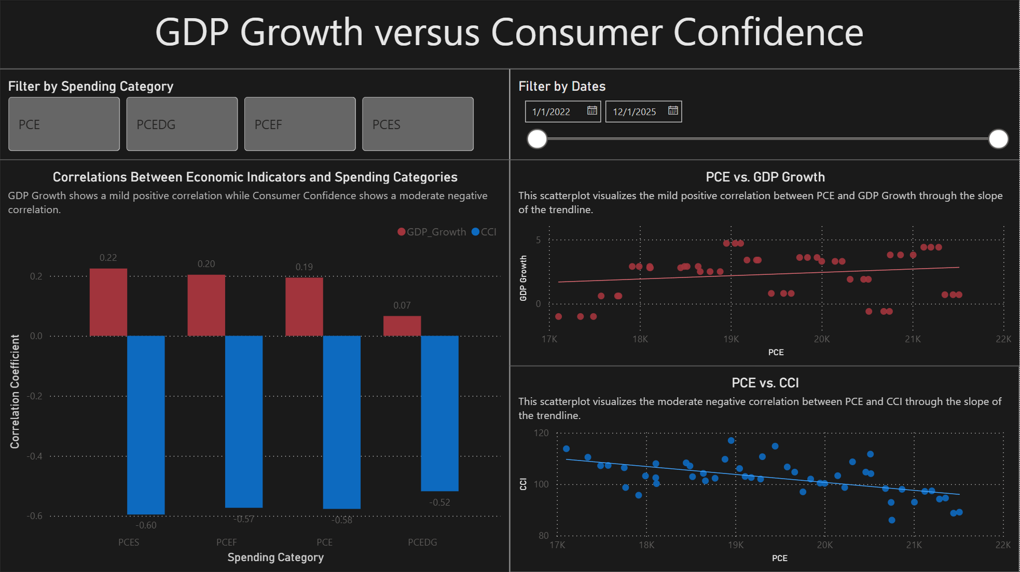
The visualizations in figure 1 intend to answer the research questions “How does the state of an economy defined by appropriate metrics correlate with consumer spending?”, “How do consumers allocate their spending during periods of lesser, moderate, and greater economic conditions?”, “How do these economic indicators correlate with each spending category?”, and “How does consumer behavior change as the state of the economy changes?”. The visualization titled “Correlations Between Economic Indicators and Spending Categories” directly answers the research questions “How does the state of an economy defined by appropriate metrics correlate with consumer spending?” and “How do these economic indicators correlate with each spending category?” by showing the correlation coefficient of each spending category in an accessible clustered column chart. With use of the “Filter by Dates” slicer and the scatterplots titled “PCE vs. GDP Growth” and “PCE vs. CCI” the research questions “How do consumers allocate their spending during periods of lesser, moderate, and greater economic conditions” and “How does consumer behavior change as the state of the economy changes?” is provided supporting information where it is comprehensively addressed in the following pages.
Figure 2
Second page of Power BI Dashboard, “Overall Consumer Spending and Economic Indicators”
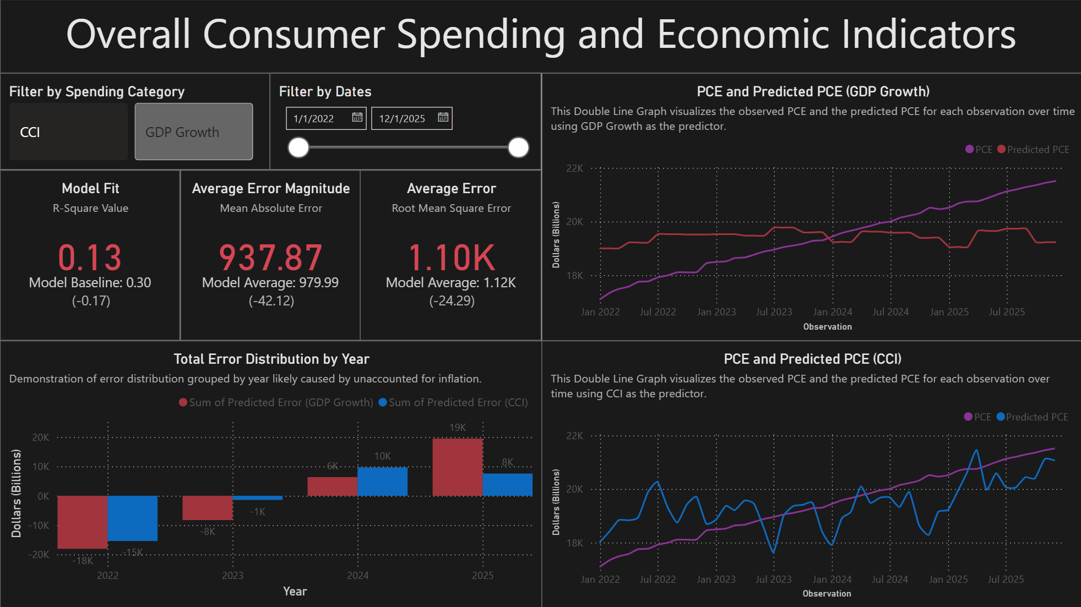
Note. Analyzes the measure, Personal Consumption Expenditures.
Figure 3
Third page of Power BI Dashboard, “Durable Goods Spending and Economic Indicators”
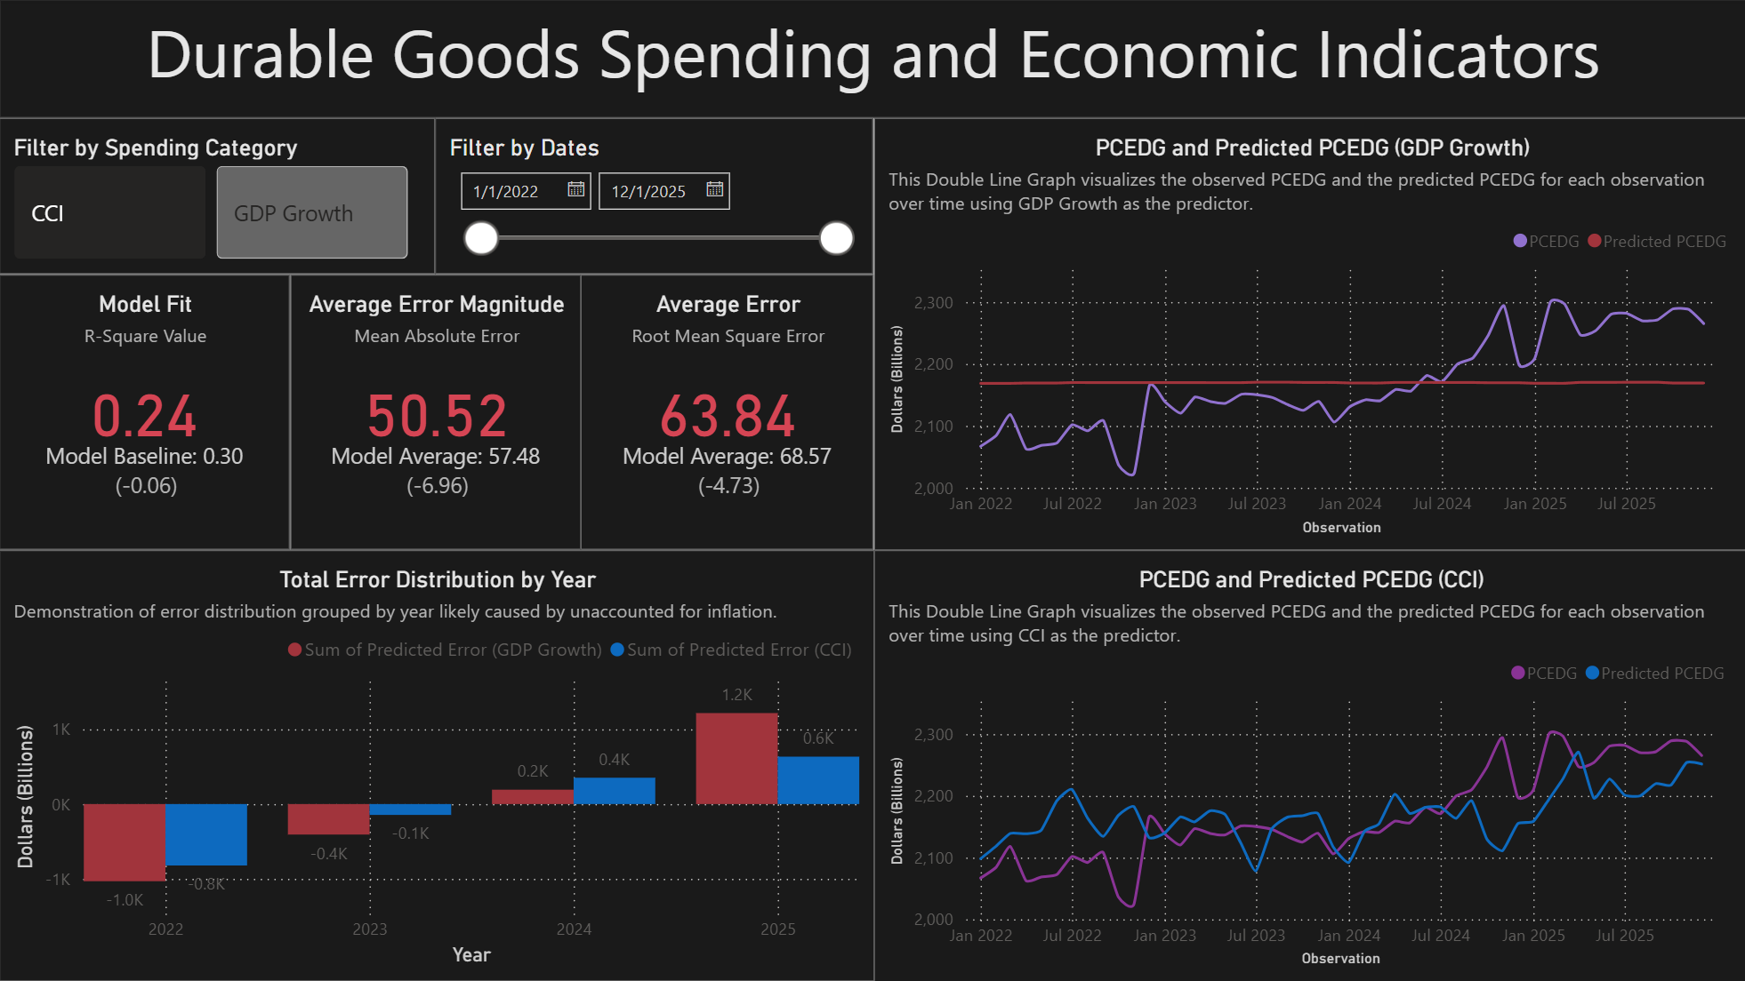
Note. Analyzes the measure, Personal Consumption Expenditures: Durable Goods.

Figure 4
Fourth Page of Power BI Dashboard, “Food Spending and Economic Indicators
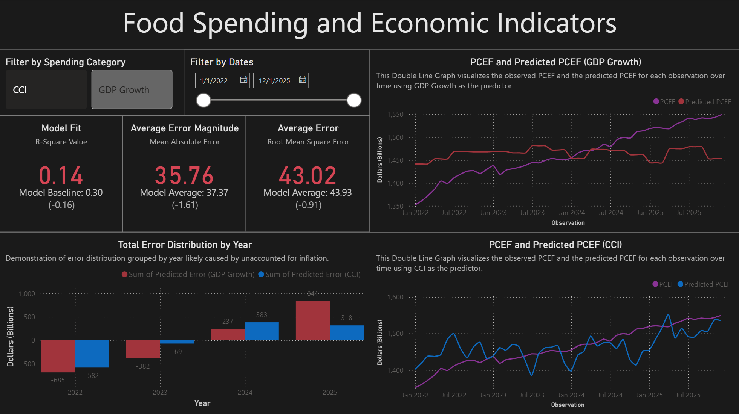
Note. Analyzes the measure, Personal Consumption Expenditures: Food.

Figure 5
Fifth and final page of Power BI Dashboard, “Service Spending and Economic Indicators”
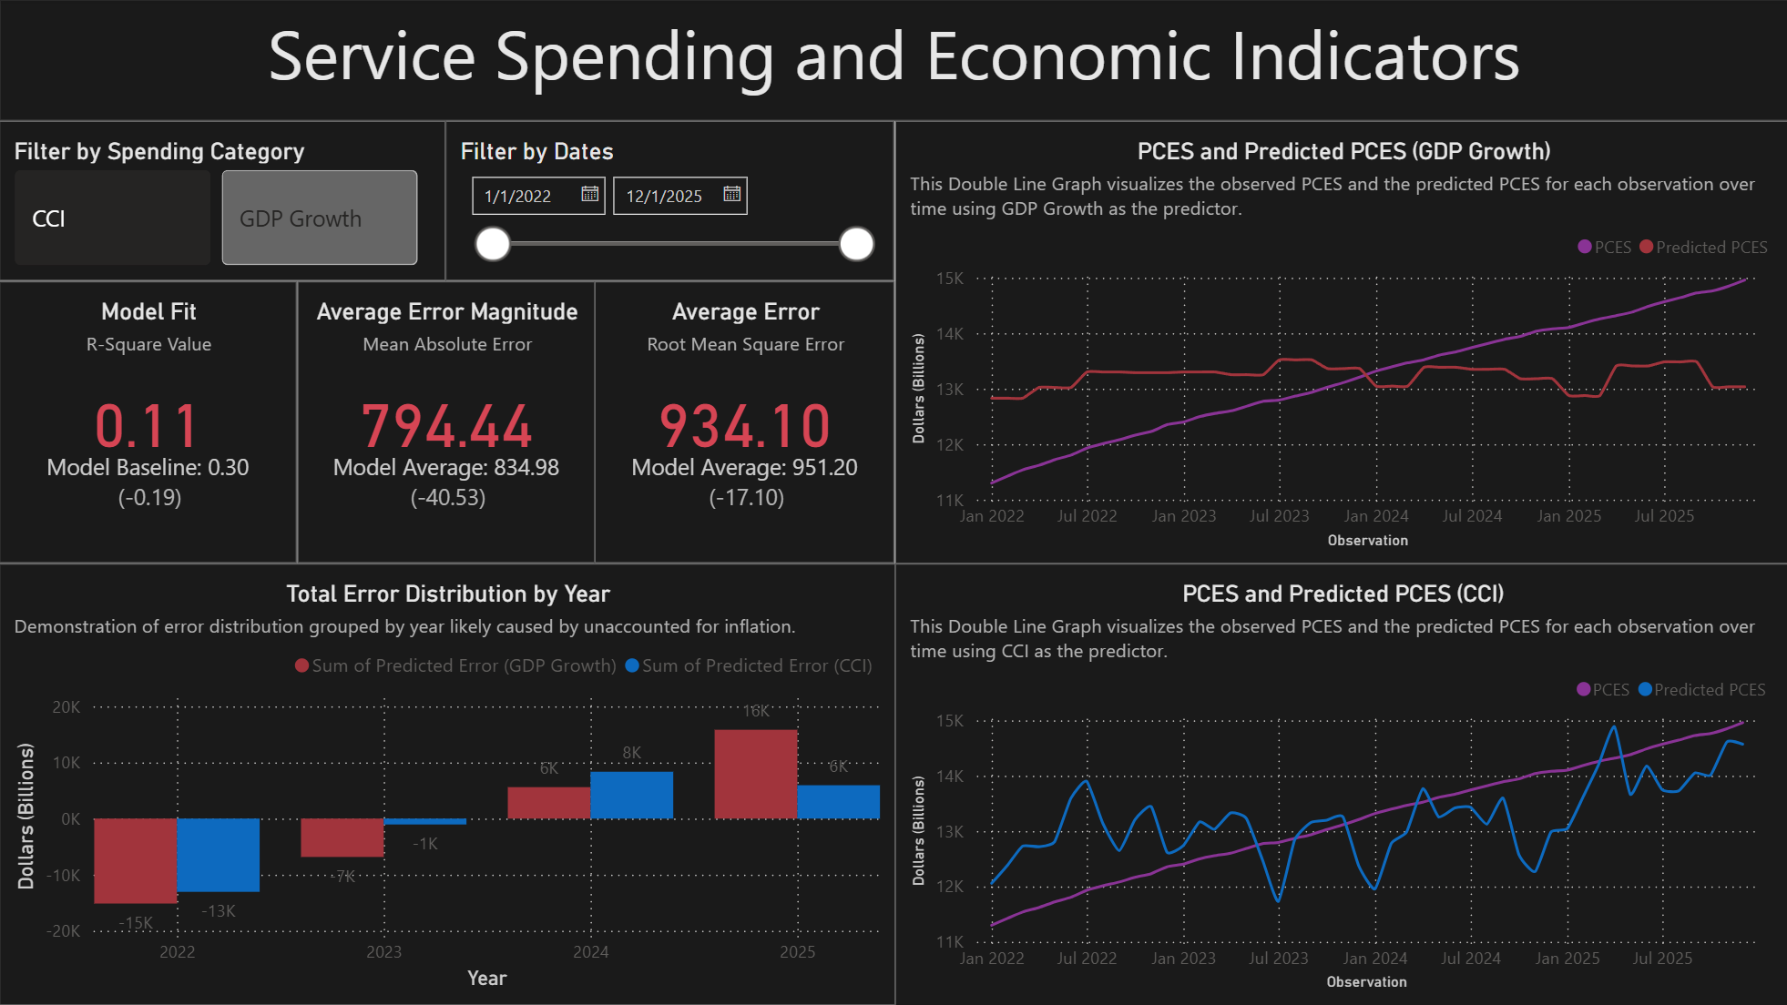
Note. Analyzes the measure, Personal Consumption Expenditures: Services.
These figures provide comprehensive insight into the remaining unresolved researched questions, as well as the hypotheses. Specifically, the research questions “How do consumers allocate their spending during periods of lesser, moderate, and greater economic conditions?” and “How does consumer behavior change as the state of the economy changes?” are supplied with the supporting details needed to fully answer them through the use of the double line charts on each page. As for the null hypotheses, figure 2 visualizes the results of the null hypothesis test for hypotheses H01 and H03. Respectively, figure 3 visualizes hypotheses H02b and H04b; figure 4 visualizes hypotheses H02a and H04a; and figure 5 visualizes hypotheses H02c and H04c. These results of these hypothesis tests are demonstrated numerically through the key performance indicator (KPI) cards and the double line charts.
Chart or Feature Selection
Clustered Column Charts
Clustered column charts serve as an excellent method for comparing summarized data over time (e.g. figures 2-5) and for comparing values directly between two categories (e.g. figure 1). In these instances, clustered column charts are used to compare the correlations between GDP Growth and each spending category with the correlations between CCI and each spending category.
Scatterplots
In reference to figure 1, scatterplots are used to visualize the correlation between PCE and GDP Growth and the correlation between PCE and CCI. These scatterplots serve as supporting visuals to the clustered column chart that demonstrates these correlations more directly. Additionally, a trend line is added to each scatterplot to better visualize the correlation through the slope of the trend line.
Double Line Charts
The double line charts utilized throughout the dashboard are used to emphasize how the data changes as time passed. As each row represents a reasonably similar passage of time between each observation, a double line chart becomes an appropriate choice for comparing two values as time passes. This is relevant for the comparison of each category of consumer spending with each economic indicator investigated (e.g. figures 2-5).
KPI Cards
The KPI cards featured throughout figures 2 through 4 add a descriptive element to the dashboard that is difficult to demonstrate with other visualization strategies. They allow for an interactive method of displaying summary statistics such as model fit, mean absolute error, and root mean square error (e.g. figures 2-5).
Slicers
Slicers enhance the interactivity of the dashboard while also improving the granularity of insights that can be derived from each visualization. On each page of the dashboard, a button slicer is added to sort by relevant categorized data, and a date slicer is added to filter time-based visualizations such as the double line charts to visualize specific date ranges in more detail (e.g. figures 1-5)
Data Structure and User Experience
Data Fields in Each Visualization
The clustered column charts feature a comparison between GDP growth and consumer confidence on the y-axis. This comes in the form of a comparison between correlations and spending category on the x-axis (e.g. figure 1) or the comparison between the sum of predicted error and year (e.g. figure 2-5). The scatterplots each feature the respective economic indicator on the y-axis and PCE on the x-axis. Each of the double line charts feature the true and predicted value of the respective spending categories on the y-axis and the observations on the y-axis (e.g. figures 2-5). Lastly, the KPI cards feature the values of r-square, mean absolute error, and root mean square error for both the CCI and GDP Growth models. The target value for the Model is set to .3 to align with the expected results of a combination of macroeconomics, human behavior, and noisy data. Meanwhile, mean absolute error, and root mean square error have their target value set to the average between the results from the CCI and GDP Growth models to clearly demonstrate which performed better and by how much (e.g. figures 2-5).
Influence of Data Structure
The continuous and temporal nature of the data influenced chart design by justifying the use of time summary tables and line charts. This additionally incentivized the implementation of the date slicer (e.g. figures 2-5). Meanwhile, the categorical nature of the spending categories influenced the used of column charts (e.g. figure 1) for summarization and incentivized the inclusion of button slicers (e.g. figures 1-5).
Interactivity and User Experience
Button slicers used as categorical filters are implemented to allow the user to focus on the data that is relevant to their analysis. This allows the user to reduce the informational noise caused by the presentation of unnecessary information. More importantly for the purposes of this analysis, the date slicer allows users to analyze the data within the timeframe that is relevant to them. This allows them to gain unique insights that are not immediately present through summary statistics.
In an effort to increase accessibility, alt text is provided for the description of each visualization. Additionally, each page of the dashboard has a layout designed for mobile presentation. This gives more users the ability to use the dashboard and access it through their preferred method.
Summary of Hypotheses and Results
Hypothesis 1
The null hypothesis, H01, is not rejected by the analysis due to the weak correlation between GDP growth and the underperforming R-sqaure score found during model evaluation.
Hypothesis 2
The null hypothesis, H02a, is not rejected by the analysis for similar reasons as H01. While performing slightly better, the model fit is still far below the baseline established during testing while experiencing a similar correlation.
The null hypothesis, H02b, is not rejected by the analysis. PCEDG is the worst performing spending category when evaluated by GDP Growth. The correlation approaches zero and the R-square score is zero.
The null hypothesis, H02c, is not rejected by the analysis. The overall performance of PCES is comparable to PCE boasting slightly higher correlation but a slightly lower R-square score.
Hypothesis 3
The null hypothesis, H03, is rejected by the analysis. Conference Board CCI boasts a moderately strong relationship to spending which is high in the field of macroeconomics. While the R-square score does not reflect CCI as being a strong predictor of consumer spending, this may be due to a lack of verification using varied random states.
Hypothesis 4
The null hypothesis, H04a, is rejected by the analysis. PCEF performed slightly better across both correlation and R-square score than PCE, establishing clear relationship.
The null hypothesis, H04b, is rejected by the analysis. This is arguably the best performing test. While the correlation between PCEDG and Conference Board CCI was significantly lower, the model fit nearly met the baseline.
The null hypothesis. H04c, is rejected by the analysis. PCES has the strongest correlation with CCI while still only performing slightly lower during linear modeling.
Project Summary and Reflection
Key Findings
Overall, consumers’ perception of the economy appears to be a significantly better indicator of consumer spending than objective state of the economy. This is reinforced by the universally accepted metric for consumers’ perception of the economy, Conference Board CCI, significantly outperforming the universally accepted metric for the objective state of the economy, GDP Growth. This analysis additionally reinforced the understanding of how consumers allocate their spending depending on how they both perceive and how the state of the economy is defined by economic indicators.
Major Challenges
Throughout the process of developing this project, several challenges were encountered. The most critical identifiable issue was the problems not taking inflation into account caused. There was an observable ramp in consumer spending that appeared independent to the economic indicators likely caused by a combination of inflation and consumer culture. Additionally, sourcing consumer confidence data directly from the Conference Board proved challenging due to its inaccessibility.
Lessons Learned
These challenges teach valuable lessons related to data analytics. It serves as a case study in ensuring there is a comprehensive understanding of the data, especially in complex fields such as macroeconomics, before beginning analysis. Otherwise, there may be other unexpected contributing factors to the data that will hinder the final results. The process of working on this project also shows the importance of evaluating the feasibility of data collection before committing to it.
Personal Development
This project provided excellent experience for personal development. It has provided an opportunity to work with advanced data in an unfamiliar, complicated, and challenging context. Plans to build upon these discoveries in future data analytics work involve taking into account additional factors as soon as possible to avoid an unreasonably reversable scenario such as this case regarding the unaccounted-for linear coefficient.
Real-World Implications
Practical Impact
This analysis has proven to have a significant real-world impact. PCEDG has a significantly lower correlation between both GDP Growth and CCI than other spending categories implying consumers may purchase durable goods out of necessity rather than out of luxury. Meanwhile, the higher correlation of PCEF and PCES suggests that people tend to spend more on food and services when they perceive the economy is in a good state. This implies consumers may be more willing to spend more on goods and services, considered luxuries, when they are more secure about the economy, they exist in and by extension their own personal finances. More studies would need to be conducted to ensure the validity of these scenarios.
Additionally, this analysis reinforces the findings of prior economists. Unintuitively, the phrase “during times of economic recession/crisis, luxury spending increases” is validated. The two categories, PCES and PCEF, can be justifiably determined as luxury as services are rarely a necessity and any supplemental spending on food is a luxury. Meanwhile, PCEDG can be argued to consist primarily of essential spending. The significantly stronger negative correlation between PCES/PCEF and CCI and GDP growth compared to the weaker negative correlation between PCEDG and CCI and GDP growth heavily suggests this statement is true.
Real World Problems
There are many real-world problems that can be addressed with the use of the results of this analysis, especially in fields involving macroeconomics, consumer behavior, or personal finances. A large-scale retail business that sells products considered a luxury may find the results of this analysis useful when exploring consumer behavior to optimize their marketing strategy. More humbly, an individual consumer might find the concepts explored beneficial to their personal awareness. Lastly, financial analysts may find this analysis useful as a cautionary case study of how consumers may poorly manage their money in the event of perceived economic distress.
Societal Issues
These findings relate to everyday societal issues by addressing the common concerns consumers have regarding the perceivably declining state of the economy and the effect this has on their personal quality of life. While not explicitly expressed through reporting, issues regarding income disparities and public policy in the form of data privacy are also relevant to this project. By extension of the concepts explored during this project, the findings can be used as supporting details in discussions relating to these topics.
How This Analysis Addresses these Challenges
This analysis addresses the challenges of personal quality of life by bringing facts of the spending habits of consumers during times of economic hardship to the forefront of discussion. By spreading awareness of potential problems that affect certain individuals, those individuals may make the conscious decision to avoid making poor financial decisions. This ties into the issue of income disparity. A person of lower financial status would be more greatly affected by unnecessary luxury spending during times of economic hardship than someone of higher financial status. As for public policy, this analysis brings concerns regarding data privacy. It demonstrates how businesses could potentially take advantage of certain consumers more prone to luxury spending depending on how those consumers perceive the economy.

References
Ball, L. M., Leigh, D., & Loungani, P. (2013). Okun’s law: Fit at fifty? National Bureau of Economic Research. https://www.nber.org/system/files/working_papers/w18668/w18668.pdf
Federal Reserve Bank of St. Louis. (2026a, March 13). Personal consumption expenditures: Durable goods. FRED. https://fred.stlouisfed.org/series/PCEDG
Federal Reserve Bank of St. Louis. (2026b, March 13). Personal consumption expenditures. FRED. https://fred.stlouisfed.org/series/PCE
Federal Reserve Bank of St. Louis. (2026c, March 13). Personal consumption expenditures: Food. FRED. https://fred.stlouisfed.org/series/DFXARC1M027SBEA
Federal Reserve Bank of St. Louis. (2026d, March 13). Personal consumption expenditures: Services. FRED. https://fred.stlouisfed.org/series/PCES
Franco, L. (2022a, January 25). January consumer confidence moderates following three months of gains. The Conference Board. https://www.conference-board.org/publications/US-Consumer-Confidence_Jan22
Franco, L. (2022b, February 1). Consumer confidence declined for second consecutive month in February. The Conference Board. https://www.conference-board.org/topics/consumer-confidence/Consumer-Confidence-Feb22
Ganong, P., & Noel, P. J. (2019). Consumer spending during unemployment: Positive and normative implications. National Bureau of Economic Research. https://www.nber.org/system/files/working_papers/w25417/w25417.pdf
Institute for New Economic Thinking. (n.d.). Arthur M. Okun, 1899–1980. The History of Economic Thought. https://www.hetwebsite.net/het/profiles/okun.htm
Investing.com. (2026, March 31). United States CB consumer confidence. Economic Calendar. https://www.investing.com/economic-calendar/cb-consumer-confidence-48
Mataloni, L., & O’Connell, C. (2026, March 13). GDP news release. U.S. Bureau of Economic Analysis. https://www.bea.gov/sites/default/files/2026-03/gdp4q25-2nd.pdf
Stengel, D. N., & Chaffe-Stengel, P. M. (2012). Working with economic indicators: Interpretation and sources. Business Expert Press.
Stickler, M., Baffes, J., Kaushik, S., & López-Calva, L. F. (2026, January 12). World Bank open data. World Bank. https://data.worldbank.org/
The Conference Board. (2026, March 1). US consumer confidence. https://www.conference-board.org/topics/consumer-confidence/
The Conference Board. (n.d.). The Conference Board Data Central. https://data-central.conference-board.org/
U.S. Bureau of Economic Analysis. (2026a). GDP (second estimate), 4th quarter and year 2025: Real gross domestic product and related measures. https://www.bea.gov/sites/default/files/2026-03/gdp4q25-2nd.pdf
U.S. Bureau of Economic Analysis. (2026b, March 13). Gross domestic product. https://www.bea.gov/data/gdp/gross-domestic-product
U.S. Bureau of Economic Analysis. (n.d.). Gross domestic product. https://www.bea.gov/resources/learning-center/what-to-know-gdp
U.S. General Services Administration. (2026, January 29). Data.gov. https://data.gov/

