Statistics: The Science of Decisions Project Instructions

**Background Information**

In a Stroop task, participants are presented with a list of words, with each word displayed in a color of ink. The participant’s task is to say out loud the *color of the ink* in which the word is printed. The task has two conditions: a congruent words condition, and an incongruent words condition. In the *congruent words* condition, the words being displayed are color words whose names match the colors in which they are printed: for example RED, BLUE. In the *incongruent words* condition, the words displayed are color words whose names do not match the colors in which they are printed: for example PURPLE, ORANGE. In each case, we measure the time it takes to name the ink colors in equally-sized lists. Each participant will go through and record a time from each condition.

Questions For Investigation

As a general note, be sure to keep a record of any resources that you use or refer to in the creation of your project. You will need to report your sources as part of the project submission.

1.

What is our independent variable? The independent variable is the Congruent and Incongruent words.

What is our dependent variable? The dependent variable is the time it takes to name the ink colors.

2.

What is an appropriate set of hypotheses for this task?

Null hypothesis: The time for Congruent and Incongruent words will be equal.

Alternative hypothesis: The results of the Incongruent will be significantly longer.

What kind of statistical test do you expect to perform? I will perform a T-Test.

Justification: Because both the Congruent and Incongruent words are tested on the same people, a T-Test is appropriate.

Now it’s your chance to try out the Stroop task for yourself. Go to [this link](https://www.google.com/url?q=https://faculty.washington.edu/chudler/java/ready.html&sa=D&ust=1499741123678000&usg=AFQjCNGeMXJUNrj-CKxuqPZNQgWH-ZH3Lg), which has a Java-based applet for performing the Stroop task. Record the times that you received on the task (you do not need to submit your times to the site.) Now, download [this dataset](https://www.google.com/url?q=https://drive.google.com/file/d/0B9Yf01UaIbUgQXpYb2NhZ29yX1U/view?usp%3Dsharing&sa=D&ust=1499741123678000&usg=AFQjCNEq-7lZG6TFA77_BzMqnns9lQY1zQ) which contains results from a number of participants in the task. Each row of the dataset contains the performance for one participant, with the first number their results on the congruent task and the second number their performance on the incongruent task.

3.

|  |  |  |  |  |  |  |
| --- | --- | --- | --- | --- | --- | --- |
| t- | | | |  | | |
|  |  |  |  |  |  |  |
|  | *Congruent* | *Incongruent* |  |
| Mean | 14.051125 | 22.01591667 |  |
| Variance | 12.66902907 | 23.01175704 |  |  |  |  |
| Observations | 24 | 24 |  |  |  |  |

Report some descriptive statistics regarding this dataset. Include at least one measure of central tendency and at least one measure of variability.

4. Provide one or two visualizations that show the distribution of the sample data. Write one or two sentences noting what you observe about the plot or plots.

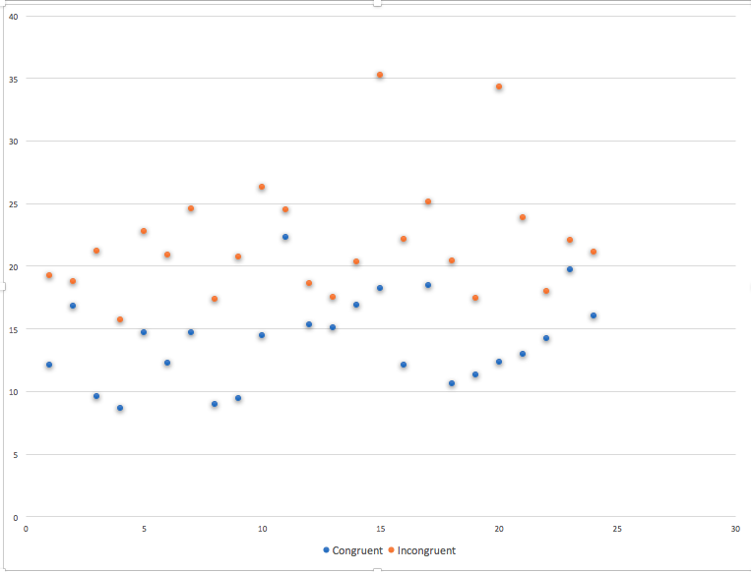

Both visualizations show a longer response time for Incongruent words. I believe this will be confirmed with the T-Test.

5. Now, perform the statistical test and report your results. What is your confidence level and your critical statistic value? Do you reject the null hypothesis or fail to reject it? Come to a conclusion in terms of the experiment task. Did the results match up with your expectations?

|  |  |  |
| --- | --- | --- |
| t-Test: Two-Sample Assuming Unequal Variances | |  |
|  |  |  |
|  | *Congruent* | *Incongruent* |
| Mean | 14.051125 | 22.01591667 |
| Variance | 12.66902907 | 23.01175704 |
| Observations | 24 | 24 |
| Hypothesized Mean Difference | 0 |  |
| df | 42 |  |
| t Stat | -6.532250554 |  |
| P(T<=t) one-tail | 3.40518E-08 |  |
| t Critical one-tail | 1.681952357 |  |
| P(T<=t) two-tail | 6.81036E-08 |  |
| t Critical two-tail | 2.018081703 |  |

Based on the results of this test, it fails to reject the null hypothesis. The results were in line with my expectations.