OOPS Project

Developer name: Mohamed Jamal

Core concepts that were used in the project is:

* Data structures such as arrays.
* Sorting files.
* Searching files.
* Filesystems for creation and deletion.
* Handling exceptions.

Application features:

* Display all the files in the directory in an ascending order.
* Menu to navigate through the application with options such as: add, delete, and search files.
* Close the application at any time.

The application was done in three sprints, the first sprint for sprint planning and preparing. Next, two sprint for developing and testing the application. Moving on to the first sprint we planned the flow of the development and how we are approaching the project. Furthermore, we developed the menu first that will be displayed to the user. Then we started implementing methods for each option in the menu. We also thought it would better if we dedicated a specific directory for file creation, searching, etc. we used algorithms to sort the files in an ascending order. In addition, we created the option to exist the application if desired. Finally, we tested the application and added a bit of changes.

Below you will find screenshots of the application:

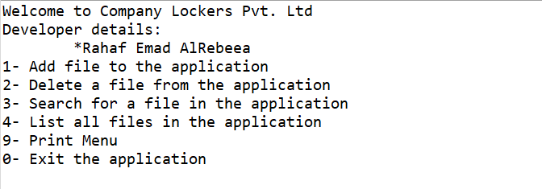

The above screenshot displays the welcome menu and the options where the user can navigate it.

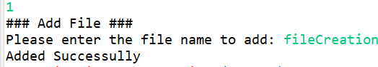

This screenshot shows the file creation process, the user has to enter the name of the file and it will create it and display a successful message.

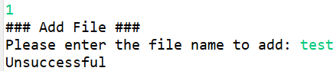

If a file exist, unsuccessful message will be displayed.

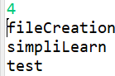

This option list all the file in an ascending order to the user and as you can see the fileCreation file is created.

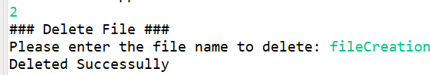

In this screenshot the deletion is displayed, the user has to type the file name and it will be deleted.

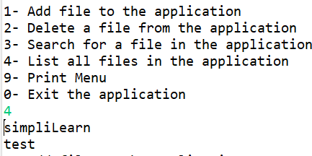

This screenshot shows that the fileCreated has been deleted.

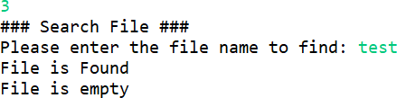

Above is the screenshot of searching a file, the user will type the file they want to search. And it will show if the file is available or not and the content of the file if found.

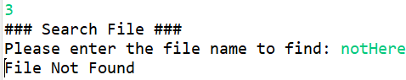

This is the FNF message in case a file is not found.

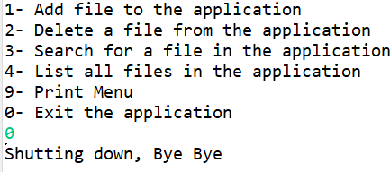

This is the last option if the user wants to quit or exit the application.

This is the link to github: <https://github.com/mjmaahs/oop-intro>

To conclude, this project will help the company digitize their products and help them with their work. It is developed in a way to make their life easier as it is user-friendly and easy to learn.