Virtual Machine Based Rootkit Detection
Description and Analysis of VM Based Rootkit Attacks and Detection

Prashanta Gyawali, Rachel Pekarek, Michael Malkowski
Department of Math and Computer Science
South Dakota School of Mines and Technology
Rapid City, SD

Abstract—This electronic document is a “live” template and already defines the components of your paper [title, text, heads, etc.] in its style sheet. *CRITICAL: Do Not Use Symbols, Special Characters, or Math in Paper Title or Abstract. (Abstract)
Keywords—component; formatting; style; styling; insert (key words)

Introduction
Virtual Machines simulate a machine (abstract or real) that is typically different from the target machine it is being simulated on. Virtual machines can emulate the computer architecture and functions of a real world computer without extra hardware. This power and convenience has caused virtual machine applications to become increasingly more popular. This virtualization, however, may bring some new security risks to the table. Rootkits are a type of malicious software that is activated before the operating system each time a system is booted up. With the rise of virtual machine usage, virtual machine based rootkits (VMBRs) have also come into play. VMBRs, like regular rootkits, may install hidden files, processes, user accounts, or other malicious data on a system. However, it does this on a separate OS, making it virtually invisible to the target OS and its anti-malware applications. This paper will evaluate some existing virtual machine rootkits and proposed defenses against them. It will also provide new insight on tactics for virtual machine rootkit defense.

Virtual Machines
A virtual machine (VM) creates a completely isolated operating system on one computer that will execute programs just like a physical computer. VMs can be categorized into two different types: virtualized VMs and emulated VMs. The following section will compare and contrast the two different types of virtual machines.

Virtualized VMs
A virtualized VM, also known as a process virtual machine, is the faster of the two VMs. This is mainly due to the fact that the virtualized VM uses the same hardware as the host computer. There is one catch. The virtual machine’s hardware requirements must match the host’s provided set of chips.

Emulated VMs
An emulated VM, also known as a system virtual machine, is the second of the two types of VMs. This type of VM provides a better separation between the guest OS and the host OS. This separation provides a layer of indirection and translation that allows for the host to provide a type of chipset. Although this layer of indirection helps separate the VM from the hardware of the host, it is significantly slower that its counterpart.
Identify applicable sponsor/s here. If no sponsors, delete this text box (sponsors).

VMBR Installation
In order for a virtual machine rootkit to be installed, it must first obtain root privileges – or access to kernel mode. This is not a trivial task, but it can be done by exploiting a remote vulnerability, booting from a bad CD-ROM/DVD, or via malicious software installed with root privileges. Corrupt vendors could also sell this kind of information or exploit it themselves after selling the hardware to a paying customer. This root access allows the attacker to install the VMBR in persistent storage (typically disk). Microsoft used the following tactics in the installation of their subVirt VMBR: “When the target system is Windows XP, we store the VMBR state in the beginning of the first active disk partition. We relocate the data that was in these disk blocks to unused blocks elsewhere on the disk. When the target system is Linux, we disable swapping and use the swap partition to store persistent VMBR state. Both these installation procedures leave most of the target’s data in its original location on disk.” [1]
Root access is also necessary to modify the system boot records, which can allow the VMBR to run before the target OS. This modification can be done during the final stages of system shutdown when it won’t be detected by anti-malware applications that have already shut down. Installation of the rootkit will also happen in this phase of shutdown after the boot sequence has been modified. The boot sequence modification is OS Platform specific. On Windows XP it can be done in a LastChanceShutdown Notification event handler that uses the low-level disk driver to copy the modified boot sequence and bypass the file system layer. On Linux, the boot sequence can be modified in user-mode by changing the shutdown scripts so that the installation code runs after all other applications shut down, before the system shuts down entirely.
The installation places the target OS disk space onto a virtual disk. Once the boot sequence has been modified during the final stages of shutdown and the VMBR is installed, the rootkit will run before the target OS during the next system startup. The VMBR must translate the virtual disk to the equivalent location on physical disk. Microsoft’s subVirt modifies the VMM’s disk virtualization module on Windows VirtualPC and the hard-drive block device in Linux for VMware. At this point the VMBR has a very discrete control over the system.

Forms of attack
King and Chain [1] have categorized the malicious services into three types: those that need not interact with the target system at all, those that observe information about the target system, and those that intentionally perturb the execution of the target system. Spam relays, distributed denial-of-service zombies and phishing web servers are the example of the first category. Since these services are run in the attack OS they are never exposed to the target OS. The second type of VMBR monitor the hardware-level data like keystrokes or network packets. They modify the VMM’s device emulation software. This change does not affect the virtual device presented to the target OS. An interesting example about network cards is presented by the authors in [1]. The other form of attack these rootkits can launch is termed virtual-machine introspection. Using this technique malicious service can reconstruct the data and abstractions from the target system. An example about SSL write call is presented by authors in [1]. The third class VMBR will directly modify the data entering and outgoing from the target system. VMBR can directly interfere with the network data or email messages.

Maintaining Control Over the System
One of the main objectives of a rootkit is to maintain control over the system. A rootkit also aims to remain hidden from not only the computer user, but also any form of detection from the computer itself. This following section will discuss the methods on how a rootkit can achieve these goals.

Control
A rootkit can maintain control over a system by allowing the rootkit administrative privileges, also known as ‘root’ access, to the program.

Stealth
One main attributes of a rootkit is to have the ability to not be detected by either human or OS. There have been cases where a rootkit actually manipulated an antivirus’ code so that it left the antivirus useless. This is what makes a rootkit so dangerous and so persistent. By allowing the rootkit to go undetected and granting itself root access, the rootkit may do whatever it pleases. This type of control is more difficult in a virtual machine environment, but rootkits have adapted.

Defending against VMBR
King et. al[1] have categorized the detection techniques into two types; first where the detection system is running below the VMBR and second where the detection system is running above the VMBR(i.e., within the target system).

Security software below the VMBR
Detectors running below VMBR can read physical memory or disk and look for signatures or anomalies that indicate the presence of VMBR, such as a modified boot sequence. One of the ways to gain control below the VMBR is to use secure hardware that can run low-layer security software beneath a VMBR. A few of these detectors (Hooksafe and Paladin) will be described in the following section, section VII and the Paladin detector in further detail in section VIII.
Another way around to get control below VMBR is to boot from a safe medium such as CD-ROM, USB drive or network boot server. One problem with this could be that VMBRs can avoid booting from safe medium by emulating system shutdowns and reboots. Thus it would be wise to unplug the system before rebooting. As for detection, it is important to remember that in order to survive physical reboots, persistent storage must be used. If there is abnormal availability of these resources, a VMBR could be installed on the machine. [3]

The third way to gain control below the VMBR is to use a secure VMM. King et. al[1] implemented an enhanced version of secure boot which can prevent VMBR installation. The goal of their secure boot system was to provide attestation for existing boot components such as disk’s master boot loader and also to allow legitimate updates of these components. There are other secure VMMs available that aid in the prevention of VMBR attacks. These will also be described in the following section.

Run detection within virtual machine on target
King et. al [1] suggested a few methods of detecting a VMBR within the target OS that were somewhat elementary in nature. These suggestions included looking for excess CPU overhead using clock that can’t be manipulated by rootkit and looking for excess memory usage. [1] As indicated in the previous section, manipulation of the outputted clock times, CPU usage, and memory usage on a system are two ways in which a VMBR can hide its presence and maintain control of the system. This is why using a clock to measure the CPU usage must be out of the control of the machine. However, even if there is an external method of measurement, these methods of detection are likely to produce erroneous interpretations. Critics, on the other hand, insist VMBRs attempting to hide their presence with these manipulations will only make themselves more noticeable, and therefore can be easily detected from within the target OS.

Another approach suggested by King et. al is the detection of abnormalities in I/O device usages when the system doesn’t already have a VMM present on their machines. Existing VMMs value functionality over transparency and virtual hardware is fundamentally different than underlying physical hardware. [3] Detecting differences such as I/O paravirtualization and the inability to execute non-virtualizable instructions like SIDT, SGDT, and SSL can give away the presence of a VMM and a VMBR from within the target OS running on top of the VMM. The following section will describe existing implementations of some secure VMMs and VMBR detectors.

Existing Detectors
There are many existing rootkit detectors, but only a small handful can detect a VMBR. Hooksafe is one such detector. It works by protecting kernel hooks from rootkit attacks by monitoring write access hooks. Hooks are blocks of code that intercept events, function calls, or messages. There are many hooks (thousands) in a Linux system but most of them are read access only. Hooksafe utilizes a hook indirection layer that regulates and limits access to hooks in the kernel. This regulation allows the system to identify rootkit attacks and the owner of the system to regain control [4].

Another detector is SecVisor. SecVisor is a relatively simple hypervisor based mechanism. It protects the integrity of code in OS kernels by preventing unauthorized modifications to the code via a user specified approval policy. The problem with this strategy is that it leaves much of the responsibility to the user, who may or may not have a good understanding of their system or the policies they should put in place.

NICKLE is a system that uses a VMM to restrict access to the kernel space, thereby stopping unauthorized kernel code execution in unmodified guest operating systems. NICKLE utilizes the VMM based memory shadowing scheme and disallows guest OS kernels from accessing shadow memory. Any time an instruction is executed in kernel space during runtime the instruction is retrieved from shadow memory. Shadow memory instructions are authenticated and therefore can be compared to VMBR corrupted instructions to detect the presence of the VMBR. The following diagram illustrates the NICKLE system. [4]

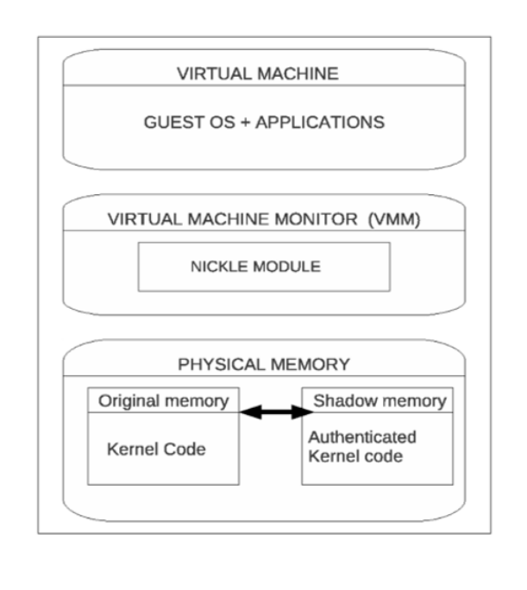
Figure x. NICKLE Implementation

Automated rootkit detection has been made possible by Paladin. This detector uses Virtual Machine technology to detect and contain rootkit attacks. It puts in place file and memory access control policies that protect parts of memory that are prone to VMBR attack. Paladin utilizes dependency trees that track process-file relationships. VMBR attacks can be contained using detection based on this tree when an access control policy has been violated. The automation of Paladin makes it extremely appealing in that it can detect and contain VMBR attacks very quickly. The implementation of Paladin will be discussed in detail in the following section, section VIII.

Implementation of Defense System- Paladin
Baliga et. al [2] proposed a solution for real-time automated detection and containment of rootkit attacks. They developed a prototype using VMware Workstation to illustrate the solution.

Approach
Paladin system identifies and counters hiding behavior of rootkits using combination of three mechanisms: Prevention and Detection, Tracking and Containment.

Prevention and Detection
Baliga et al[2] have presented ways to prevent the VMBR from being installed. Their idea is mainly based around access control policies. File access control policies protect the system utilities from being replaced by their trojaned counterparts. Memory access control policies protect the kernel code and data structures from being overwritten in memory.

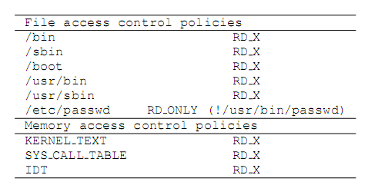
Figure 1. Sample policies for Paladin
Figure shows a sample policy file used by their system. Several directories are made non-writable. Several directories are made non-writable. These policies can be tailored as per the system requirement. Figure 1. shows that the program /usr/bin/passwd is allowed to write into /etc/passwd which is readonly to other programs. Memory access control policies include protecting the kernel system call table, the interrupt descriptor table and the kernel text. Certain legitimate applications may need to write into kernel memory or hook to certain protected areas. Only these applications can be allowed exclusive access to these areas. These applications, in turn, need to be protected on disk by using appropriate access control policies to prevent rootkits from modifying these.
Since attacking the Guest OS does not give access to the VMM, the VMM can enforce the access control policies without itself being compromised [2].

Tracking
The tracking system keeps track of files created by different processes. It generates a dependency tree by maintaining parent-child relationships between processes. The dependency tree is further used by containment algorithm to identify possible malicious processes.

Containment
Containment is required to stop immediate ongoing damage as soon as a violation of the access control policies is detected. Containment can be effective in stopping a damage when a virus or worm accompanies the rootkit. The containment algorithm tracks possible malicious process by referring to the information dependency tree.
A Process Resident Set (PRS) is defined as the set of process that needa to be always running in the system. Process such as init, login and other system daemons that are usually always present on the system fall under PRS.
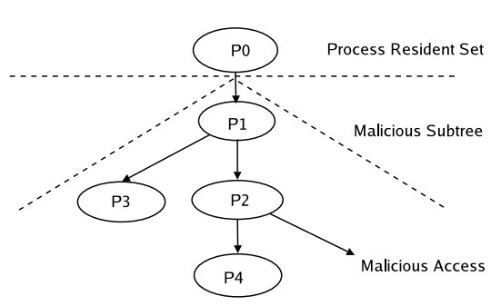
Figure. 2. Automated containment of Paladin
Figure 2 shows process P2 performing malicious access. P2 is identified as the offending process. The system automatically identifies the subtree that is considered malicious using the information in the dependency tree. A path is tracked back from P2 to the root of the dependency tree till a process I the PRS is encountered. In this case, P0 belongs to the ORS and hence, O2 becomes the root of the subtree identified as malicious. All process identified in this subtree are considered malicious and will be killed by the system.

Design and Implementation
Paladin comprises of several components like the modified form of VMware Workstation, Paladin App, the driver and the database. VMApp and the VMM are a part of the VMware are a a part of the VMware Workstation software.

Acknowledgment (Heading 5)
May or may not need this.

References
The template will number citations consecutively within brackets [1]. The sentence punctuation follows the bracket [2]. Refer simply to the reference number, as in [3]—do not use “Ref. [3]” or “reference [3]” except at the beginning of a sentence: “Reference [3] was the first ...”
Number footnotes separately in superscripts. Place the actual footnote at the bottom of the column in which it was cited. Do not put footnotes in the reference list. Use letters for table footnotes.
Unless there are six authors or more give all authors’ names; do not use “et al.”. Papers that have not been published, even if they have been submitted for publication, should be cited as “unpublished” [4]. Papers that have been accepted for publication should be cited as “in press” [5]. Capitalize only the first word in a paper title, except for proper nouns and element symbols.
For papers published in translation journals, please give the English citation first, followed by the original foreign-language citation [6].

- [1] S T. Young and Peter M. Chen, “SubVirt: Implementing malware with vitual machines”
- [2] A. Baliga and L.Iftode, “Automated Containment of Rootkits Attacks”
- [3] vmm_detection_hotos07.pdf
[4] rootkit_survey.pdf

