Mponane Mankgane, Bonolo kwadi, thobile sibiya

Gametopia 2024

Bridgett

A Bridge Engineering game

October 15, 2024

Background and Motivation 2

Problem Statement 2

Approach 2

Timeline 3

UML Use Case Diagram 4

UML Use Class Diagram 5

References 5

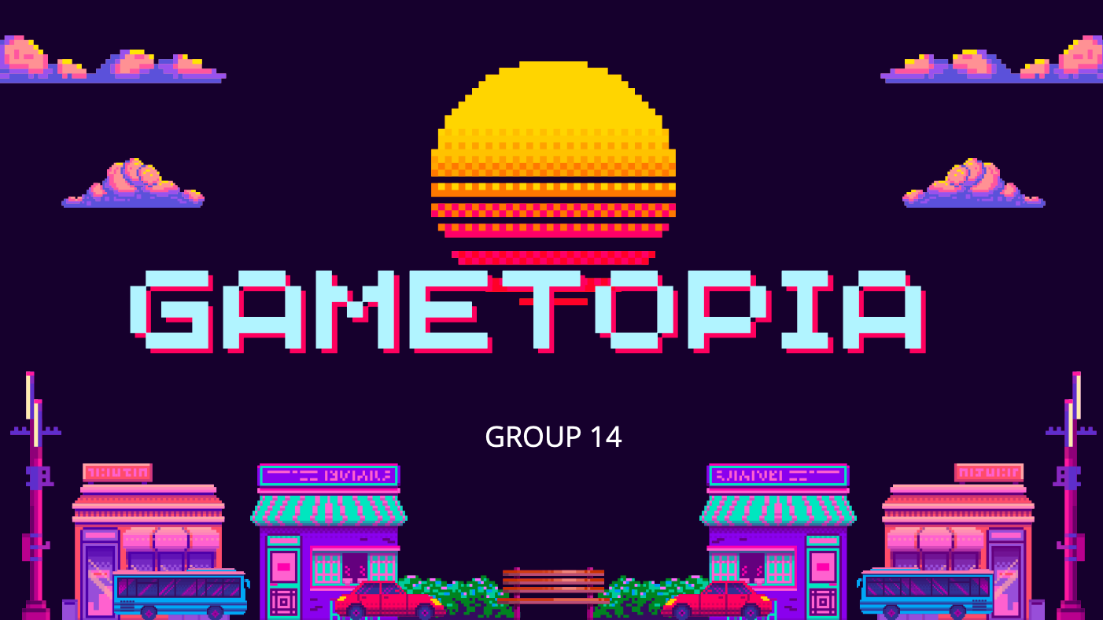

## **Background and Motivation**

The bridge engineering game is a moderately complex game that is played with a pen. A single player uses the pen to design a bridge that will be strong enough to hold and carry a load over a distance.[1] The player has to use the pen to draw straight, continuous lines that will represent the parts of the bridge that they are engineering. Once the player has used up all the available resources (parts, money, labour, etc.) or feels confident with the design of their bridge, they have to build the bridge and test it by letting a load cross over it. If the bridge holds, and the load reaches the safety point (crosses over safely), he/she wins.[2] Points/earnings will be granted as money that the player can use for a wide variety of things.

This version of a bridge building game, Bridgett, will not only test the player’s problem-solving skills, but also business management skills. We introduce a feature that will prompt the player to create a construction company that will be based in a region specified by the player. Once his/her company has been established, the user will have to manage the day-to-day operations of the company by utilizing its resources to construct bridges in the selected region.

This variation or feature from our version will enhance the game’s distinct difficulty levels by testing business and problem-solving thinking in civil engineering.

## **Problem Statement**

The aim of this version of bridge engineering is to build a bridge that will hold and carry a certain load across it, using limited resources. Bridgett has moderate complexity that is dependent on the features of it. Adding features will increase the game’s attractiveness, complexity, and depth for civil engineering use and entrepreneurship.

## **Approach**

This project aims to implement a bridge engineering game in Java with the following milestones: Firstly, is to code a data structure that will contain two-point coordinates representing a straight line on a plane (perhaps an array of “sub-arrays”). Next is to code another data structure (Pen) that will generate these two-point coordinates. Only a single player can play this game at a time, therefore the player will generate the two-point coordinates using Pen, and the program will register each coordinate (with additional data structures). A scoreboard or resources data structure can hence be implemented to make the game more fun and complex. A simple graphical user interface (GUI) will be implemented to improve the game’s attractiveness, provide a bridge designing canvas and a work area for the player, and allow and enhancement features to increase the complexity of the game. Finally, the project will be presented for assessment in the form of GitHub code and Project Document, which will include the revision and extension of this proposal. These extensions will include the steps through the software development life cycle that GameTopia has followed, and a visual guide that acts as a demo of the game, explaining each frame of the game from start to end. [3]

## **Timeline**

[4]

## **UML Use Case Diagram**

[5]

Bridgett (Game-Play)

Player 1

## **UML Use Class Diagram**

## **References**

[1] WTWH (2024). *Bridge Designer.* Retrieved from Engineering: <https://www.engineering.com/games/bridge-designer/>

[2] BoomBit (2016). *Build a Bridge! Ninetendo switch.* Retrieved from NINETENDO FANDOM: <https://nintendo.fandom.com/wiki/Build_a_Bridge>!

[3] Rhodes University (2024). CSc102 2024. Retrieved from RUConnected: <https://ruconnected.ru.ac.za/course/view.php?id=6649#section-18>

[4] Wikipedia (2024). Gantt chart. Retrieved from Wikipedia: <https://en.wikipedia.org/wiki/Gantt_chart>

[5] Lucid Software Inc. (2024). UML Use Case Diagrams. Retrieved from: <https://www.lucidchart.com/pages/uml-use-case-diagram>