**Written Report:**

In my shiny application, I delved into data from the 2024 March Madness tournament, examining teams’ offensive and defensive statistics alongside their win probabilities against Division 1 teams. Additionally, I analyzed another dataset spanning from 1985 to 2019, detailing tournament winners and losers for each playoff round, including score results over the years. My analysis revealed that in the 2024 March Madness tournament, teams with higher two-point percentages and lower defensive two-point percentages tended to achieve more success. I also observed that in the first round of playoffs from 1985 to 2019, most games had score differences below 20 points, with only one game exceeding a 50-point difference. The subsequent rounds generally featured score differences below 30 points, except for the Final Four, where one game in 2016 saw a 44-point difference, with Villanova defeating Oklahoma 95 to 51. Furthermore, only one winning team in these years scored over 100 points in the Final game.

The data being used in my shiny application is on this past March Madness tournament, 2024 playoff, along with tournament results from each playoff round starting in the year 1985, when the league officially switched over to 64 team format, all the way to 2019, where it contains each results of every playoff round, including the winning/losing team, winner/loser score, along with a calculated difference in the two scores, to look at score variation among between the competing teams.

For the March Madness ’24 dataset, I am interested in exploring a comparison table where you could stack multiple teams on top of each other and compare defensive or offensive stats to see which teams are expected to put up more points or prevent points from being scored on the defensive end. More specifically, this dataset will contain the team’s rank in the tournament, their playoff seed, team name, the conference they play in, and number of games played (an indication of how far the team made it). Adjusted offensive and defensive efficiency is the number of points allowed/scored per 100 possessions against average Division One offense/defense. Barthag is a power Rating measured by a team’s chance to beat an average Division I team. EFG% and EFGD% represent the effective field goal percentage scored/allowed—offensive and defensive rebound rate, measured as a percentage. FTR and FTRD represent the free throw rate on offense and defense and are measured by free throws attempted per field goal. There is an offensive and defensive measurement for two- and three-point percentages, one for how many scored and the other for points allowed. Adjusted tempo is an estimate of tempo (determined by possessions per 40 minutes) against a team playing at an average Division One tempo. Finally, wins above the bubble (WAB) mark the cut-off between making the tournament or not. The primary purpose of using this data is to explore what factors impact teams, specifically to recognize what makes a team more successful when playing in the tournament.

For the data covering tournament results from 1985 to 2019, I am interested in finding any trends in the winning/losing scores as well as differences in the scores between compete, as well finding any score records in the tournament, particularly in the fifth and sixth round of playoffs(final two rounds). This dataset will contain the year, playoff round number, playoff seed number for both teams one and two, scores for both teams, and names of both teams differentiated between one and two, then mutate the data to make a column for teams with winning and losing scores, names for each game,  and lastly a column representing the difference between the score of the winning and losing team. I will use my shiny application, a user-friendly and intuitive platform, to produce plots of each  playoff round. The user can easily adjust the round, year, and region filters for desired outputs, empowering them to conduct their own analyses and explore the data in depth. This will allow the user to easy identify any games that seems to be an outlier, which would be evidence of a high-score record, if the point is found on higher y-values.

Now looking more in depth with the data using the application, looking at the final four teams for the 2024 march madness data, Connecticut, Alabama, Purdue, and North Carolina State. More specifically I will be looking at how their offensive and defensive stats compare to one another and see if any inferences can be made based on the result of the tournament.

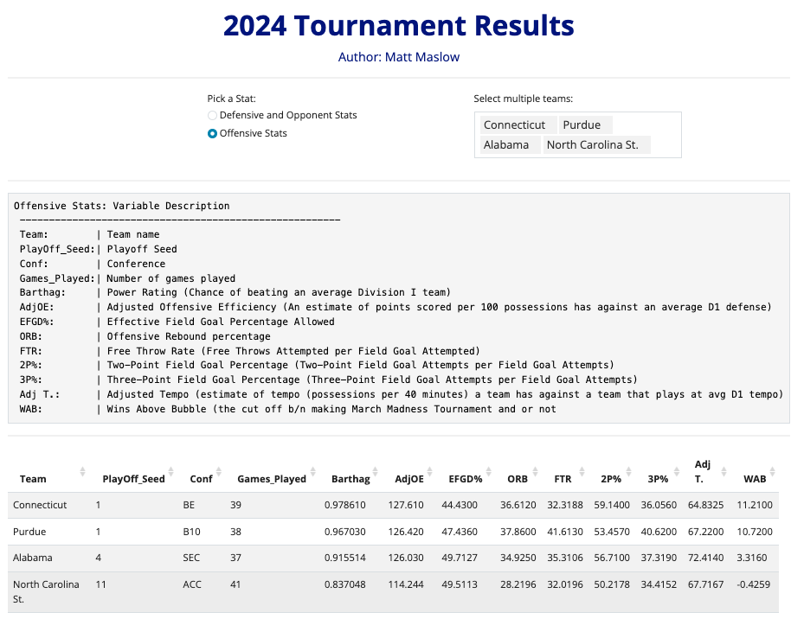

Starting with the base statistics, Connecticut and Purdue are both ranked a one-seed, while Alabama is four, and NC State is 11th. It is clear, that NC State are considered the underdogs as they are seated significantly higher compared to the rest, would be most likely the result of an upset. In addition to the playoff seed, the team’s Barthag rating would compare similarly where Purdue and Connecticut are 0.97ish while Alabama is 0.92 and NC State 0.84, which assesses the team’s probability of beating a division one team. In the 2024 tournament, Connecticut beat Alabama in the final four, and this can be supported with the fact Connecticut has a higher over adjusted offense efficiency, two-point percentage, and offensive rebound, implying that Connecticut has the overall stronger offense compared to Alabama. Like that game, Purdue and NC State had a similar result, leaving the two one seeds to face in the championship. While Purdue may have the higher offensive rebound rate and better percentage from outside of the arc, Connecticut still has the stronger offensive efficiency along with the better two-point percentage which is the more common basket to be made in a game. In the end, Connecticut does beat Purdue and stays in the lead the whole time, which shows that their offensive statistics could prove to be stronger/better combination. However, to fully grasp a perspective on how a team might have been more successful than others, we will have to look at the defensive half of the game too.

Alabama (Playoff Seed: 4, Conf: SEC) They had a decent Barthag rating, indicating strong overall performance. - Their adjusted offensive efficiency (AdjOE) was high, suggesting they were efficient in scoring. - Effective Field Goal Percentage (EFGD%) was average, neither exceptionally good nor bad. - They were average in offensive rebounding (ORB) and free throw rate (FTR). - Their two-point shooting percentage (2P%) was decent, but their three-point shooting percentage (3P%) was slightly below average. - Their adjusted tempo (Adj T.) was high, indicating a fast-paced style of play. - With a positive WAB (Wins Above Bubble), they were considered to be performing better than expected.

Connecticut (Playoff Seed: 1, Conf: BE) They had a high Barthag rating, indicating strong overall performance. - Their adjusted offensive efficiency (AdjOE) was high, suggesting they were efficient in scoring. - Effective Field Goal Percentage (EFGD%) was decent. - They had a low offensive rebounding rate (ORB) but a high free throw rate (FTR). - Both their two-point and three-point shooting percentages were above average. - Their adjusted tempo (Adj T.) was moderate. - With a significantly positive WAB, they were performing exceptionally well compared to expectations.

North Carolina State (Playoff Seed: 11, Conf: ACC) They had a lower Barthag rating compared to other teams, indicating a slightly weaker overall performance. - Their adjusted offensive efficiency (AdjOE) was lower than the other teams. - Effective Field Goal Percentage (EFGD%) was decent. - They had a moderate offensive rebounding rate (ORB) but a low free throw rate (FTR). - Their shooting percentages were average. - Their adjusted tempo (Adj T.) was moderate. - With a negative WAB, they were considered to be performing below expectations.

Purdue (Playoff Seed: 1, Conf: B10) They had a high Barthag rating, indicating strong overall performance. - Their adjusted offensive efficiency (AdjOE) was high, suggesting they were efficient in scoring. - Effective Field Goal Percentage (EFGD%) was decent. - They had a high offensive rebounding rate (ORB) and free throw rate (FTR). - Both their two-point and three-point shooting percentages were above average. - Their adjusted tempo (Adj T.) was moderate. - With a significantly positive WAB, they were performing exceptionally well compared to expectations.

Connecticut and Purdue had the highest Barthag ratings and significantly positive WAB, indicating they were the strongest teams overall. - Alabama and Purdue had high adjusted offensive efficiency, suggesting they were efficient in scoring. - Connecticut had a notably high free throw rate (FTR), which could have given them an advantage in close games. - North Carolina State had a lower Barthag rating and a negative WAB, indicating they were the weakest team among the four. - Connecticut and Purdue had higher playoff seeds (1), suggesting they were expected to perform well, which aligns with their strong defensive stats. - Ultimately, the results of the tournament might have ended with Connecticut or Purdue as the champions due to their strong defensive performances, efficient scoring, and higher-than-expected performance compared to their seeds.

(5 points) a concluding section describing future work that you would complete if you had more time as well as any limitations to your visualizations.