**AIRLINE TICKET RESERVATION**

1. **Introduction**

In today’s airline industry users or customers can reserve seat or book flight as long as they are connected to internet. The innovation of technology has made travelling in the air easier for customers with airline reservation system. Thousands of people flock the airline industry these days so that they can arrive their destination within a short period of time. Through this airline reservation system, customers can reserve seat, book flight and set the date if their departure and arrival using the internet. Customers can choose the place they want to go here in the Philippines. This system contributed to fundamental changes in the structure of the industry. The places available in this system are Bacolod, Batanes, Cebu, Davao, and Palawan. In the database, the flight schedule on different routes and aircraft seating capacity is stored. Along with their deposits and their accounts. The system ensures the security of the customers. The airline reservation system take pride in monitoring, administration and maintenance of the database environment using MySQLite.

1. **Objectives**

The objectives of this system are:

1. To help the customers in reserving air tickets through online system
2. To implement the airline reservation system to the best satisfaction of the customer
3. Use database MySQLite to facilitate this process

The normal process of this system is to fill the data and then process the data which used to cause a lot of inconvenience to both the administrator and customers. In using databases, the reservation of airline tickets will be facilitated. The airline reservation system can be presented in views of the different involved with it. These are the administrator and customer.

1. **Functions**
2. **Administrator Page**

The administrator is the one responsible for managing and monitoring the system. The administrator must do the following:

* Choose the date to check available flights
* By choosing the displayed flight number, the administrator may now be able to view the flight details of the customer
* Check the number of reservations per flight
* Schedule of all flights
* List and status of passengers such as the location, departure, arrival, price, and available seats

1. **Index Page**

* Login the username and password
* If no account yet, choose signup

1. **Customer Sign Up**

* The customer must fill up the following details such first name, last name, email address, username, password, date of birth, gender, and contact number
* The customer can either signup or cancel

1. **Booking a Flight**

The customer needs to know the following information:

* Choose the number of passengers
* Choose if the passenger is adult, child, or infant

1. **Customer Login**

Page wherein the customer will be able to login in the system.

1. **Flight Departure**

The customer may:

* Choose the date of flight
* Choose the flights available from the day that the user has chosen

1. **Flight Return**

Customer may choose the flight they want to return.

1. **Payment Section**

This is the section that the customer will see how much they are going to pay. They can either choose what type of method they are going to take action.

1. **Database**
2. **Architectural Design**

The architecture of Airline Ticket Reservation is based on the three-tier architecture. This mainly consists of three layers namely:

* Presentation Tier
* Business Tier
* Data Access Tier

A picture containing object

Description generated with very high confidence

The presentation layer is the topmost layer of the application and it is responsible for the user interface of the application which deals with the presentation of data to the user. The business logic layer is the middle layer of the application and the business logic for the Airline Ticket Reservation would be present here. It is responsible for the information exchange between the user interface and the database. The database layer is the final layer of the application. All the data related to the system is stored and retrieved from here.

1. **Graphical User Interface**

**Admin UI**

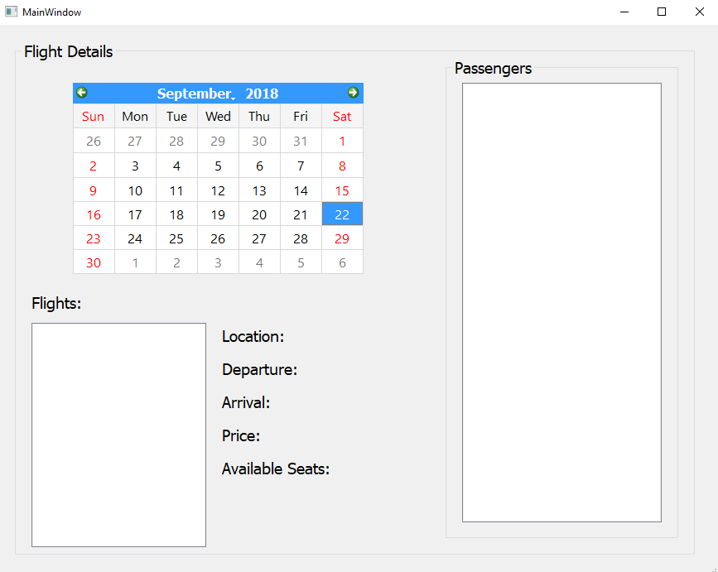

This user interface has the function where the admin can see the flight details of the customer. First, the admin will choose the date then the passengers will pop on the right part of the interface. The admin will then choose a passenger and the flight details will show up.

**Login UI**

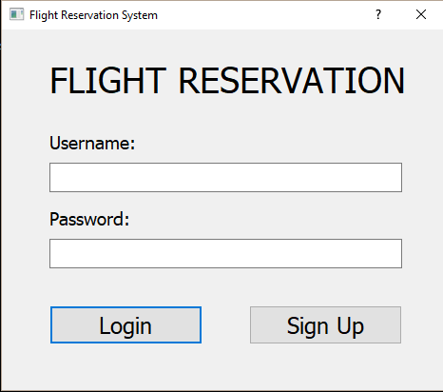

This is where the customer will login or signup. Once the admin login, the admin page will pop up as seen in the first picture wherein the admin can see the flight details of the customer. Once the user chose the signup, the customer signup user interface will pop up wherein the user must answer the given details.

**Customer Sign Up UI**

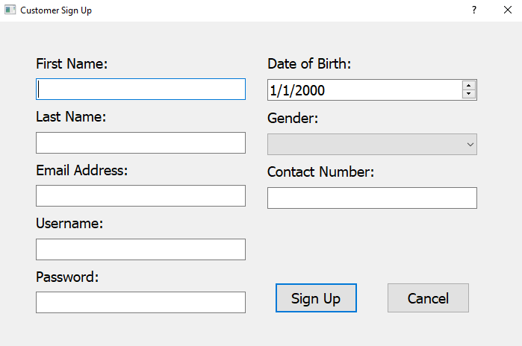

This is the customer signup user interface wherein once the user chose the signup in the login page, the given details such as the full name, email address, username, password, birthday, gender, and contact number must be answered.

**Book a Flight**

1. **Use Case Diagram**

**A picture containing text, map

Description generated with very high confidence**

For the Use Case Diagram of the system, the whole system is seen. It contains use cases and actors outside the box. The system name is Airline Ticket Reservation. As you can see, the ovals represent the system’s function. These functions are search for the available flight, find matching flight, reserve ticket, and login/sign up site. The actor of the system is the customer. The customer is the one who uses the functions except for finding the matching flight. Search engine is the one responsible to find a matching flight.

1. **Class Diagram**

The class diagram of the Airline Ticket Reservation project would be as follows:

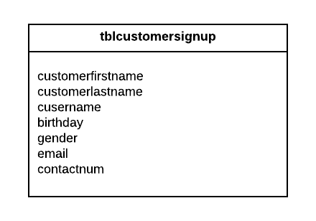

The attributes for the customersignup are Cusername which is unique, customer first and last name, gender, birthday, email address and contact number. The functions that the customer would be able to perform are signup or cancel the signing up.

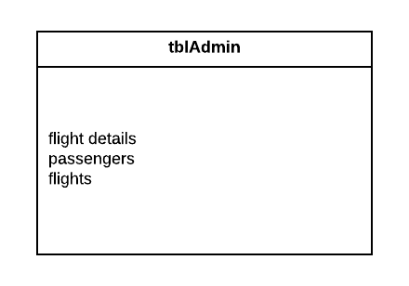

The attributes for the admin are flight details, passengers, and flights wherein the admin can see the information or details of the chosen passenger in the specific date. The function that the admin would be able to perform is to search the passenger’s details.

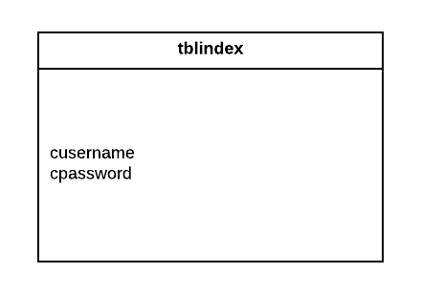

The attributes for the index are the username and password wherein the actor will put the username and password to be able to login in the system. Also, the actor can also choose to signup if no account is existing.

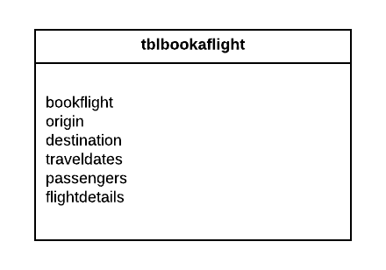

In booking a flight section, the actors can choose whether round trip or one-way, put the origin place and destination, select a travel date, who are the passengers and the actors will put how many adults or children, and then the flight details will be seen in the text box.

1. **Test Case Diagram**

|  |  |  |
| --- | --- | --- |
| **TEST CASE #** | **DESCRIPTION** | **RESULTS/COMMENTS** |
| TC # 1 | User Login |  |
| TC # 2 | User Registration |  |

1. **Partial Codes**
2. **Sprint 1**

* Admin.py

1. **Sprint 2**
2. **Sprint 3**
3. **Errors Encountered**

|  |  |
| --- | --- |
| Date | Error |
| 9/20/18 | * Failed to upload the document (Gantt Chart) under the Documentation folder in the Github. The file was already reuploaded inside the folder. |
| 9/21/18 | * The title of our project did not match with the system name in the use case diagram. |
| 9/22/18 | * At first, we failed to download the pyqt5 on the path environment because the command prompt is not in the administrator. |
| 9/23/18 | * No errors |
| 9/24/18 | * No errors |
| 9/25/18 | * At first, we were unable to convert the ui to python because of the wrong command. |

1. **Recommendation**
2. **Conclusion**