BookRecycle

Michael Josh Bauzon, Xiaowen Fang

Heuristic Violations

**Violation 1**

(H2: Match between system and the real world)

In textbookPosting.html and createPosting.html, we don't use user's language for labels of user input.

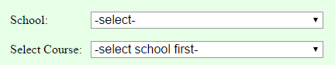

Figure 1. textbookPostings.html

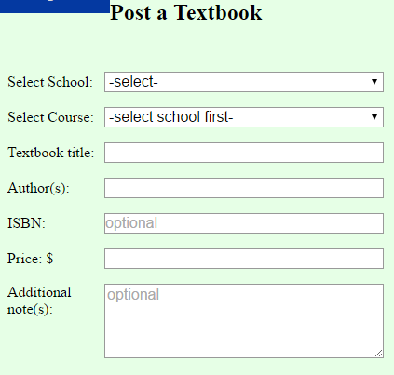

Figure 2. createPosting.html

For the input for user to select their school, we should change the labels of input from “School/Select school” to “Your school” or “Find a school”. Or other more understandable instructions.

**Violation 2**

(H4: Consistency and Standards)

At textbookPosting.html, the outcome format is not consistent.

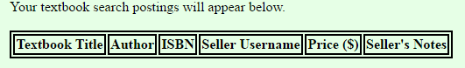

Figure 3. Attributes row before searching postings.

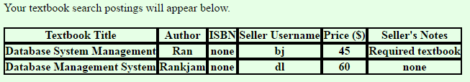

Figure 4. Attributes row of searching outcome.

The border of attributes row differs before and after searching, which should be the same.

**Violation 3**

(H5: Error prevention)

At index.html, user should only upload image file but actually user can upload any kind of files.



Figure 5. User profile picture on homepage when user uploads an image file.

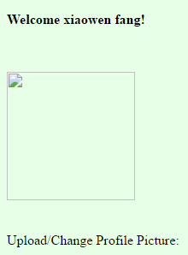

Figure 6. User profile picture on homepage when user uploads a non-image file.

User should always upload image file for their profile picture.

**Violation 4**

(H6: Recognition rather than recall)

User needs to recall username rather than recognize existing username when searching user's information.

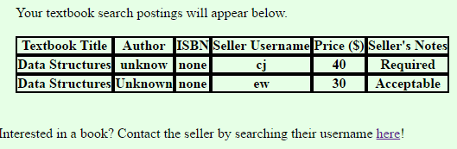

Figure 7. Textbook Postings. User cannot get seller’s information immediately.

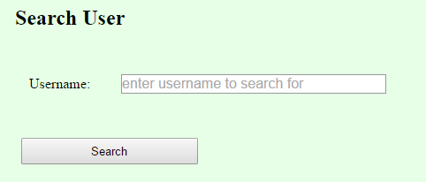

Figure 8. User have to search seller’s information on another page.

User should get seller’s information immediately with one click.

**Violation 5**

(H10: Help and documentation)

User should be allowed to sort outcome by attributes value they are interested (like Price).

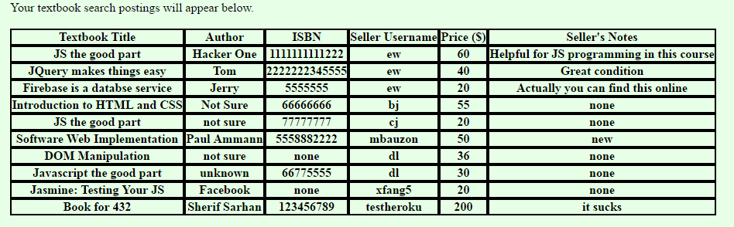

Figure 9. User cannot sort textbook by price.

**Violation 6**

(H8: Aesthetic and Minimalist design)

Too much un-needed information on webpage.

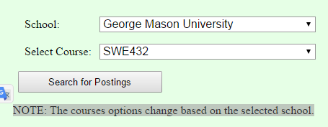

Figure 10. User knows that courses options change based on different schools.

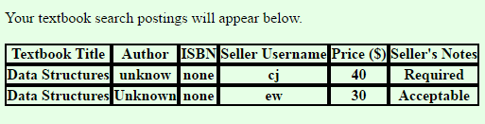

Figure 11. Users know where the outcome appears once they see it.

We should delete such useless guidance.

**Violation 7**

(H4: Consistency and Standards)

Navigate bar is not consistent between different pages.



Figure 3. Navigate bar on index.html (home page).

Capture.PNG

Figure4. Navigate bar on other pages.

We should make the navigate bar consistent among each page.

Changes

**Changes to Violation 1**

Changed labels of user input to more user-understandable language.

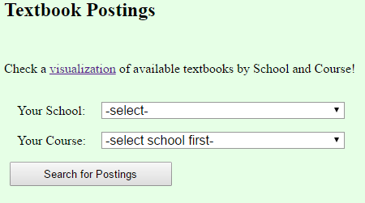

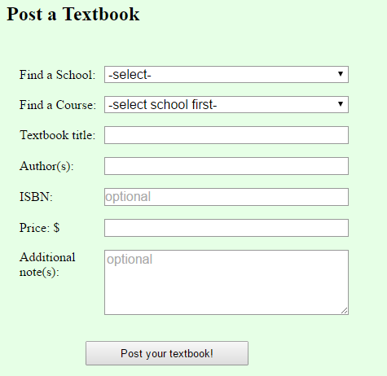

**Changes to Violation 2**

Updated code to be consistent with formatting the table when modified. Format of table before searching and after searching for a textbook is now the consistent.



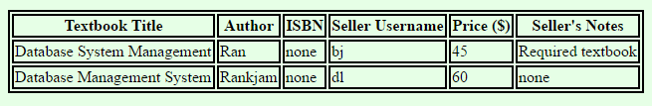

**Changes to Violation 3**

Updated file input form so it only accepts image files. Added code to handle when user forces to upload non-image file.

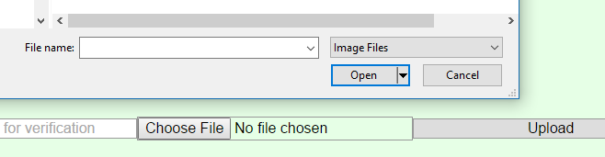

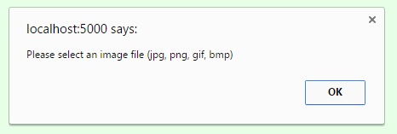

**Changes to Violation 4**

Added a functionality so that when a user clicks on a row posting result, it will immediately show the seller’s contact information on the same page.

