BECAUSE

COMMUNICATION

*ISN’T*

OPTIONAL

Let’s face it, whether it’s verbal or non-verbal – communication *isn’t* optional.

Developing and honing this important skill, along with the other skills you gain with

Toastmasters, will give you the confidence to:

* Excel at job interviews
* Give powerful business presentations
* Effectively teach classes or training sessions
* Lead successful seminars
* Present persuasive opening arguments, summations or cross examinations
* Give humorous, informative or special occasion speeches

Whatever the case may be, Toastmasters is the answer. Visit a meeting today and start taking

advantage of all that Toastmasters has to offer.

**To find out more please contact**:

WHERE LEADERS ARE MADE

Item 113

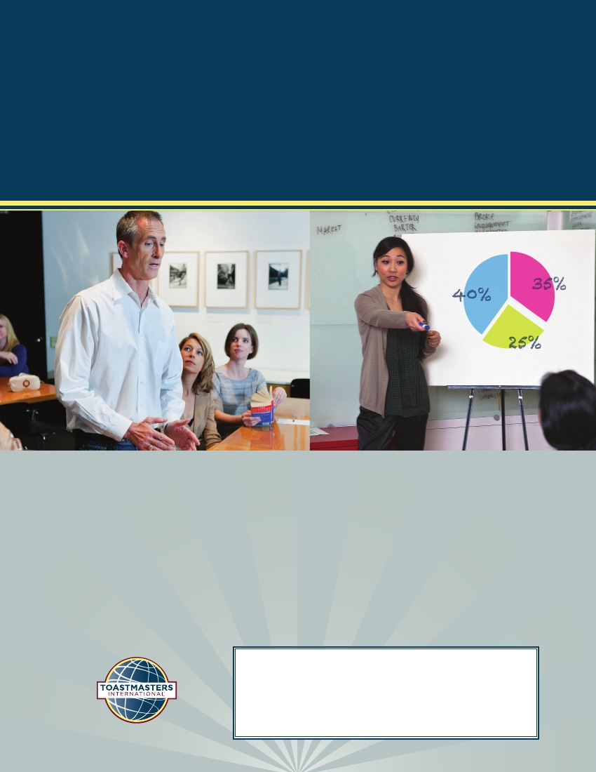

Toastmaster Club  
Contact Name Phone:   
Email &/or Web Address