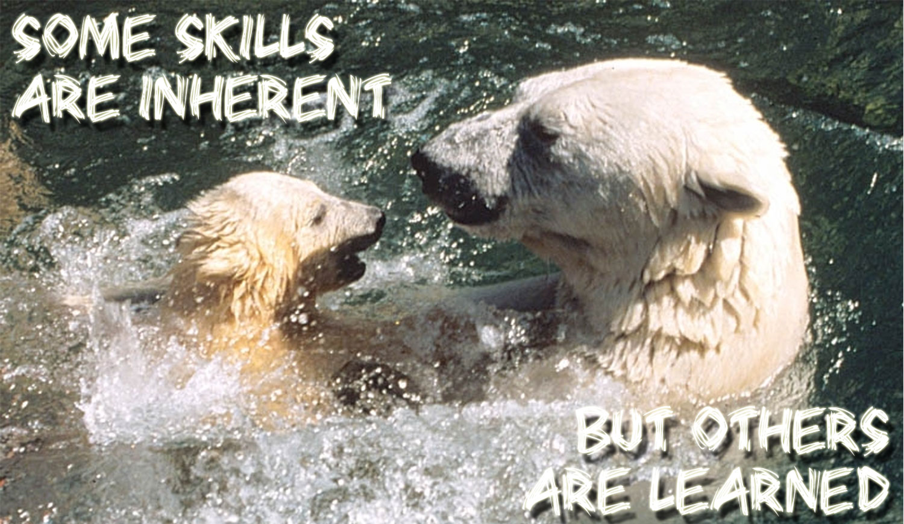

Public speaking is one of those learned skills.

Want to improve your aptitude behind a podium/microphone, in front of a classroom, leading a meeting, or discussions in your boss’s office?

Toastmasters is a safe, fun proven method to develop your communication skills. It’s helped thousands of people around the world already.

So why don’t you give it a try?

So why don’t you contact us today and start your journey

Contact: Club Name

Contact person  
 email address  
 Phone: