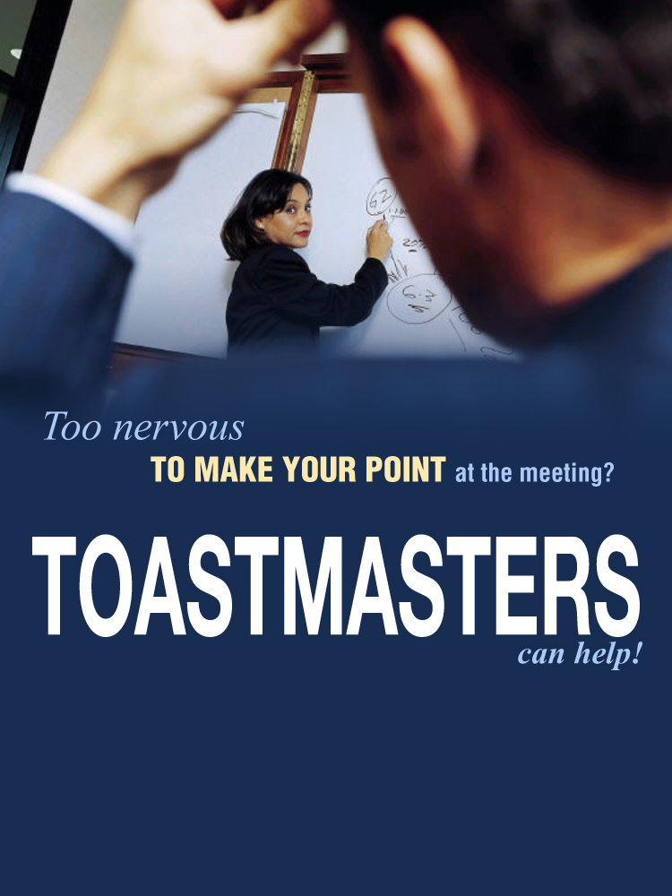

Toastmasters Club Name

**Day • Time**

**Venue**

**Call 0800 PEOPLE or visit www.toastmasters.org.nz for more information**