**Search Engine Optimisation in other words  
- How to Get Ranked Number 1 on Google?**

This is a question that every website owner wants to know, and why – because here are the cold hard facts.

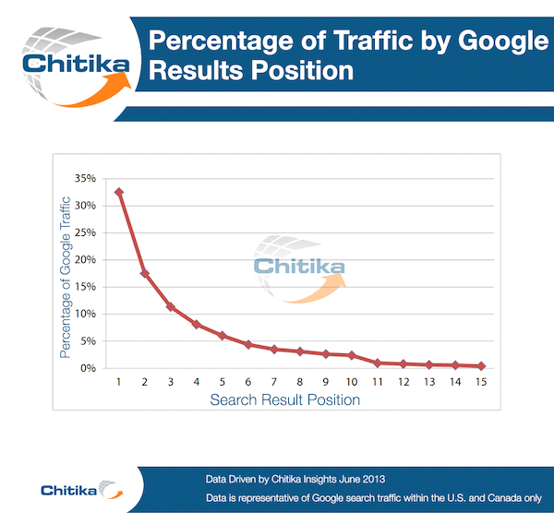

The club website that ranks number one on Google will attract 32.5% of the average traffic share, number two 17.6%, number three 11.4% and it drops away rapidly to 10th place which attracts only 2.4%. After that, if your club website is not on the front page of Google then sadly prospective guests are just not viewing it.

**So how do you get to number one?**

Here we go: In order to comprehend what you have to do to get to number one on Google, you really have to understand two different things.

First, you need to understand what factors Google uses to determine which page should rank there. Then you have to understand the reason behind why the page that is ranking there right now is ranking that high. So it really boils down to understanding Google and understanding your competition.

**Understanding Google Rankings**

I am not going to claim that I know every last detail about Google’s ranking algorithm. I certainly do not. Neither does anyone else who doesn’t work very high in the Google algorithm engineering team.

But what I can share with you are the most important factors for getting a page to rank highly.

It’s important at this point to stop for a moment and consider what Google is trying to do by ranking the search results the way that they do. They are trying to provide the searcher with exactly what he or she is looking for. They are trying to show the searcher the most relevant pages Google can possibly find. Whenever possible, Google also wants to show the searcher the most popular pages on those topics. And, they want those pages to be of reasonably high quality.

If you want your page to rank highly, then you must convince Google that your page is highly relevant for that search phrase, your page & your website are popular and your page is of a high quality.

More relevant = higher rankings

More popular = higher rankings

Maintaining high quality usually = high rankings

The 6 Most Important Factors   
You Can Influence That Google   
Uses To Determine Rankings

1. **Page Title –** Make sure that you include the words that people will search for in your page title. As an example Christchurch Toastmasters Club sits at number one on Google purely becausepeople search for Toastmasters Christchurch and this name is the closest match to it. Yet following this training many clubs have now added words to the end of their page title to cash in on this. I.e., Spreydon Toastmasters Club, have changed their page title to Spreydon Toastmasters Club Christchurch and as a result they have leapt up the rankings. So consider what people search for & then adapt your page title to suit.
2. **Words on the page** – The second thing you have control over that makes a huge difference are the words on the page. Search engines can read words pretty easily. If you have a page with at least several hundred words on it, then it is pretty easy for a search engine to tell what that page is about. Google simply counts the number of times each important word or each important phrase appears. The more times a word or phrase appears, the more likely Google is to think that the page is about that word or phrase. For instance, if the phrase “Christchurch Toastmasters” is mentioned several times in different spots on your webpage, then Google reasons that the page is more likely to be about Christchurch Toastmasters and elevates it because of relevance.
3. **Create a You Tube Video** of your meeting. Google is always monitoring the quality of your website and it looks favorably on video. So why don’t you film part of one of your meetings, post it on You Tube and then put a link to it from your website. Not only does Google like this, but your potential guests also love it, as it removes some of the unknowns before they make a visit. They know what the room looks like, what some of the people look like, and they can see how many people are at your meetings. Wouldn’t it have been easier if you had known these things before you walked into your first meeting?
4. **Number of Hits/Clicks/Visits -** Google monitors your traffic flow to see how many clicks your site receives, and checks whether visitors then move on to another site or they have found what they are looking for on your site. So knowing this, then let’s fool Google. Why send out your clubs forward planners etc. via email? Instead have a members’ only part of your website, where your members go to check the forward planner. To Google this appears as visitors checking out your site and finding what they want.
5. **Domain Links** - The number and quality of links pointing to your website as a whole matters to Google. They consider a website to be more link popular if it has more links pointing to its pages. Your website earns a reputation by earning links. You want links from other reputable sources because that improves your own reputation. The more reputable the websites are that link to your website makes a huge difference in how well the pages on your website tend to rank. Generally you are better off getting at least one link from as many different trustworthy websites as possible.
6. Avoiding **Google’s quality filters** that filter out low quality pages and low quality websites. It's time for some honesty here, how long is it since you updated your website? Google frowns upon "stale" websites, as they consider the content to be out of date. So why not post a photo from your last meeting, a summary of your last meeting, or some recent achievement by a member. You don't need to be making radical changes weekly, you just need to be adding information regularly.