COMMUNICATE

**WITH CONFIDENCE?**

DO YOU

From public speaking, presentations to general

conversations, Toastmasters will strengthen your

communication skills and boost your confidence.

For more information contact:

WHERE LEADERS ARE MADE

Item 116

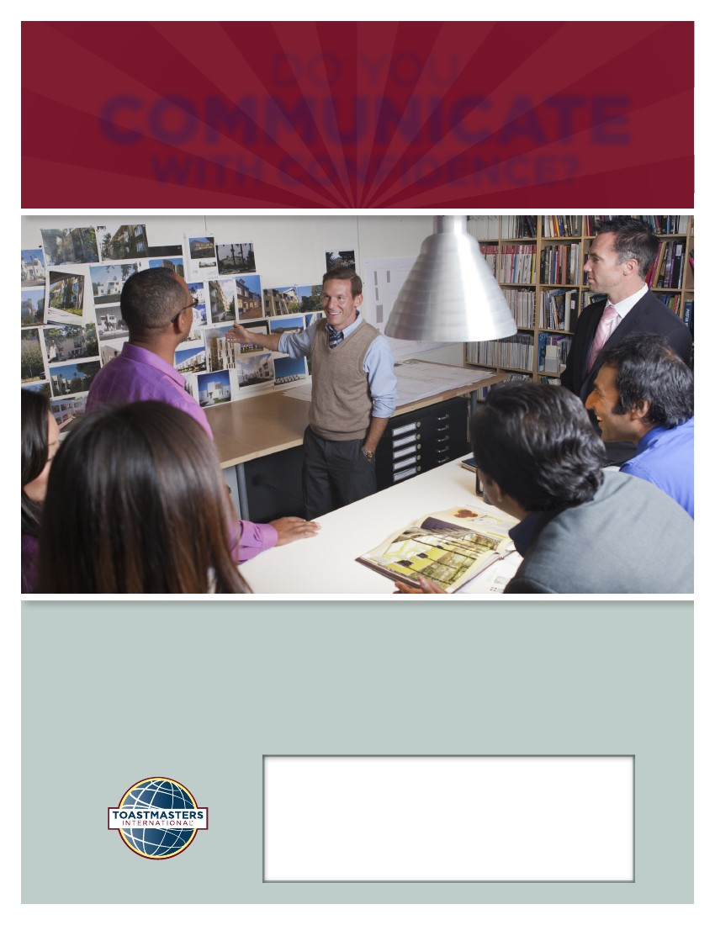-

Toastmaster Club  
Contact Name Phone:   
Email &/or Web Address