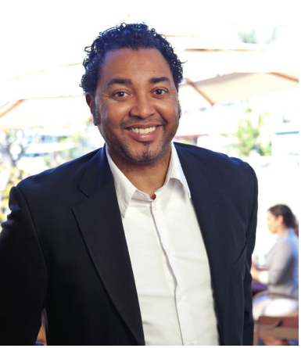

“Toastmasters is the best and least expensive personal improvement class you can go to. Anybody who begins and sticks with it for any length of time ends up a better speaker. As a result, they build confidence and are able to do their jobs better.”

**Better** **Speakers** **and** **Leaders**

Toastmasters is the best way for anyone - whether a working professional, student, stay-at-home parent or retiree - to improve his or her communication and leadership skills. Members overcome the fear of public speaking and learn skills that aid them in becoming more successful. Toastmasters creates better listeners and stronger team members and leaders who can comfortably give and receive constructive evaluations.

**About** **Toastmasters** **International**

Toastmasters International is a non-profit educational organisation that teaches public speaking and leadership skills through a worldwide network of clubs.

**For more information please Contact**

**Name Toastmasters Club**

**Person**

**Email**

**Phone:**

*Adapted TM Item 124*

Headquartered in Rancho Santa Margarita, California, the organization has more than 280,000 members who belong to 13,500 clubs in 116 countries. Since 1924, Toastmasters International has helped people of all backgrounds build confidence as speakers and leaders.

**Joining** **Toastmasters**

Joining a Toastmasters club is easy. A listing of clubs by geographic area can be located on the Toastmasters website at **www.toastmasters.org/find**. Visitors to the website can select the most convenient club, attend a meeting and apply for membership. (Applicants must be 18 or older.) New clubs can be started with permission and assistance from Toastmasters International.

Linda Lingle

Former Governor of Hawaii

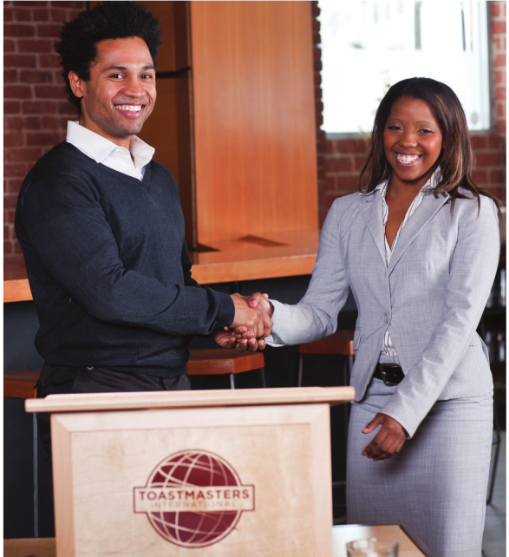

Toastmasters Tools

Upon joining a Toastmasters club, each new member receives manuals and resources about how to become a better speaker and a more confident leader. Members also have access to a wide variety of books and educational resources. In addition, they receive the award-winning Toastmaster, a monthly magazine with the latest insights about speaking and leadership techniques.

**With Toastmasters, the potential is unlimited.**

**Community Benefits**

Toastmasters helps many members in their community-service activities. Using the skills developed in Toastmasters, members have become more active in business, church, service and charity organizations. Toastmasters are able to organize activities, conduct meetings and speak in public as their organizations’ representatives. Some even become active in local, state or national government.

Toastmasters produces results. Around the world more than four million men and women of all ages and occupations have benefited from Toastmasters training. Thousands of corporations, community groups, universities, associations and government agencies currently use Toastmasters training.

 Give better sales presentations

 Hone their management skills

 Work better with fellow employees

 Develop and present ideas more effectively  Offer constructive criticism

 Accept feedback more objectively

**Company Benefits**

A company’s success depends on Communication. Employees interact with their colleagues and customers to exchange ideas, messages and information. How well they communicate and share their ideas can determine whether a company grows into an industry leader

or is mired in mediocrity. At a very reasonable

cost, Toastmasters teaches employees to become better presenters and leaders

 Present prepared speeches

Two or more members present

speeches based on projects from manuals in

Toastmasters’ proven communication and leadership

ship programs. Projects cover topics such as speech

organisation, vocal variety, language, gestures and

persuasion.

 Offer constructive evaluation

Every speaker is assigned an evaluator who points out speech strers suggestions for

improvement.

 Conduct meetings

Members learn how to plan and  
conduct meetings

 Give impromptu speeches

Members present one-to-two-minute,

impromptu speeches about assigned

topics

How Toastmasters Works

At Toastmasters, members learn by speaking to groups and working with others in a supportive environment. A typical Toastmasters club is made up of 20 to 30 people who meet once a week for approxi-mately an hour. Each meeting gives members several opportunities:

**Toastmasters** **and** **Leadership**

Leadership takes practice. In Toastmasters, members learn leadership skills by organizing and conducting meetings and completing projects in manuals. Projects address skills such as listening, planning, motivating, and team building and give

members the opportunity to practice them. Just as Toastmasters members improve communication by speaking, they learn leadership skills by leading.