 | 

RFID Technology for Ultrasound Project

Final Report

June 6, 2008

ECE 08.5 Team Members
Riley Higa
Andrew Kurniadi
Min Kyeong Lee
Mark John Merin
Robert Nguon

Science and Engineering Project Center
School of Science and Engineering
Seattle University
June 6, 2008

Mr. Dale Chermak
Mr. Matthew Rieger
Philips Healthcare
22100 Bothell Everett Highway
P.O.Box 3003 98041-3003
Bothell, WA 98021-8431

RE: Seattle University RFID Technology for Ultrasound Project

Dear Mr. Chermak and Mr. Rieger:

We are submitting to you and Philips Healthcare a design of an RFID system for tracking patient data. Our plan meets all of the specifications and requirements stated by Philips Healthcare to incorporate an RFID system to automate data entry on ultrasound machines. The purpose of the project is to have a secure system of tracking patient data and to speed up the data entry process.

Our design includes an RFID system that has an operating frequency of 13.56 MHz which according to our research is the trend that current technology is following. It is also the most widely used RFID operating frequency in hospital applications.

It has been a pleasure working with you and Philips Healthcare.

Sincerely,

Seattle University Design Team ECE 08.5

Riley Higa Andrew Kurniadi

Min Kyeong Lee Mark John Merin

Robert Nguon

Cc: Dr. Robert Heeren, Seattle University Faculty Advisor

RFID Patient Data Project

Project Sponsor
Philips Healthcare

Liaison Engineer
Mr. Dale Chermak
Mr. Matthew Rieger

Engineering Design Team ECE 08.5

Seattle University Project Engineers
Riley Higa
Andrew Kurniadi
Min Kyeong Lee
Mark John Merin
Robert Nguon

Faculty Project Advisor
Dr. Robert Heeren

Electrical Engineering Senior Design Coordinator
Dr. Alvin Moser

Science and Engineering Project Center Director
Mr. Jeff Gilles

June 6, 2008

EXECUTIVE SUMMARY

Philips Healthcare asked us to implement a system to automate the patient data entry process at ultrasound clinics and hospitals. The solution to this is RFID (Radio Frequency Identification) technology. Basically, through the use of an RFID reader/writer, hospitals will be able to wirelessly secure and retrieve patient information on hospital bracelets. This would allow hospitals and clinics to process patients faster and at the same time provide a higher level of convenience for staff members.

ABSTRACT

With RFID technology a quickly growing trend, Philips Healthcare asked us to develop an RFID solution for patient data entry on their ultrasound machines. The following report details the research and design of an RFID reader/writer using the Texas Instruments MSP430 microcontroller, Texas Instruments TRF7960 RFID Reader IC, and the FTDI UM232R USB-to-Serial conversion device. In addition, encryption and compression algorithms were implemented for securely storing patient data onto an RFID tag. The source-code for the software to interface with the RFID reader and writer is provided.

ACKNOWLEDGMENTS

Dale Chermak and Matthew Rieger, liaison engineers from Philips Healthcare, thank you for sponsoring this senior design project and donating the necessary funds and equipment. You both have been very supportive and accommodating throughout the design process this year.

Dr. Alvin Moser, the Electrical Engineering Senior Design coordinator, thank you for your leadership, management, and support throughout our senior design process.

Dr. Robert Heeren, our faculty advisor, thank you for your guidance and support.

Diannie Ran, of the Seattle University Project Center, thank you for your help and support throughout the year.

Jeff Wilhite, the Machine Shop Manager, thank you for assisting us in the cutting and drilling of our printed circuit boards and for manufacturing our RFID reader/writer case.

Jim Howard, a fellow electrical engineering student, thank you for teaching us how to solder properly and for your numerous tips and pointers throughout the school year.
Table of Content

EXECUTIVE SUMMARY 4
ABSTRACT 5
ACKNOWLEDGMENTS 6
I. Introduction 9
A. Background 9
B. Statement of Problem 9
II) Solving the Problem 10
III) Hardware 10
A. Overview 10
B. Implementing with the FTDI UM232R USB-to-UART Module 11
C. Implementing with the MSP430F169 Microcontroller 12
D. Implementing with the TRF7960 RFID Reader Chip 12
E. RFID Antenna Design 13
IV. Coding the MSP430F169 Microcontroller 16
A. UART Implementation 16
B. RFID Implementation 17
V. Software for PC 18
A. Overview 18
B. Encryption 19
C. Serial Port Implementation 20
VI) PCB 20
VII) Results 21
VIII) Conclusions 21
IX) References 23
IX) Appendix 25
Appendix A: Statement of Work 25
Appendix B: Student Resumes 28
Appendix C 34
A) Hardware Components Used 34
B) Schematic of Current Design 36
C) Encryption Algorithms Introduced 37
D) Data Compression Introduced 38
E) MSP430F169 Microcontroller Source Code 39
F) Software Source Code 64

Table of Figures

Figure 1: Project Deliverables 10
Figure 2: UM232R and Microcontroller Connection Reference 11
Figure 3: TRF7960 and MSP430 Connection Reference 13
Figure 4: Designed Antenna Schematic on PCB 13
Figure 5: Antenna Schematic 14
Figure 6: Charge Level Indicator Modification on a RFID Tag 15
Figure 7: Spectrum Analyzer Screen 15
Figure 8: Completed Antenna 16
Figure 9: GUI Window of RFID Software 18
Figure 10: Finished Prototype 20
Figure 11: RFID tag for storing patient data 34
Figure 12: TRF7960 RFID Reader Chip 34
Figure 13: MSP430F169 Microcontroller Development Board 35
Figure 14: UM232R USB-to-Serial Conversion Device 35
Figure 15: How DPAPI Exists Within the OS and How Data Gets Encrypted 38

I. Introduction

Philips Healthcare seeks a solution to speed up the data entry process on Ultrasound machines. They have requested an RFID system that tracks patient data in a secure manner.

A. Background

Philips Healthcare is a company dedicated to the advancement of healthcare technology. Currently, in ultrasound exams, the sonographer must input patient data into the ultrasound machine by hand via the built-in keyboard. This is a time consuming and error prone process. As a result, Philips Healthcare wishes to design an RFID system that would allow the sonographer to read patient data from RFID tags and avoid duplicate data entry.

B. Statement of Problem

Ultrasound examinations are currently being conducted by specialized clinics and hospitals. These facilities wish to decrease the time it takes to do an examination. As an ultrasound machine supplier, Philips Healthcare wants to solve the problem by using RFID technology. The design consists of three main components, an RFID writer, RFID reader, and a bracelet containing an RFID tag to store patient data. The design needs to be able to perform four major functions as shown in Figure 1.

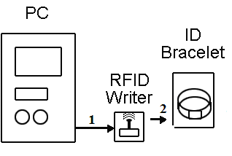

1) Enter Patient Data through a special windows application on a PC and communicate with the RFID writer
2) Write Patient Data to the RFID tag on an ID bracelet

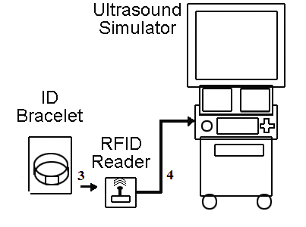
3) Read Patient Data from the RFID tag on the ID bracelet
4) Display Patient Data through a special windows application on the Ultrasound Simulator

Figure 1: Project Deliverables

The bracelet has an RFID chip capable of storing 256 bytes of data. Due to the sensitive data stored on the bracelet, a means of encryption was also implemented to protect the data.

II) Solving the Problem

The RFID reader and writer was designed using current available technology on the market. Software was also developed to interface with the RFID reader/writer to be able to write/read specific data on the RFID tags. In addition, Philips Healthcare specified that this software needed to be compatible with Windows XP. This was convenient because it was also the operating system of the design lab workstation computers and the ultrasound simulator (also a PC). To keep the confidentiality of the data stored on the RFID tags, encryption methods were implemented to protect the patient’s data.

III) Hardware

A. Overview

Building the RFID reader/writer required the use of a Texas Instrument TRF7960 RFID Reader IC, a Texas Instrument MSP430F169 microcontroller, and an FTDI UM232R USB-to-UART conversion device. Due to the TRF7960 being capable of reading and writing, the same design was used for both the reader and writer. Encryption was not implemented in hardware because it would be inconvenient and expensive to update hardware devices with new encryption algorithms. Therefore, encryption methods were implemented on software level.

B. Implementing with the FTDI UM232R USB-to-UART Module

The UM232R device is used for communication between the microcontroller and the computer. Fortunately, the drivers were provided by the manufacturer. Even though the module is connected to the PC through a USB port, it is simulated as a COM serial port. This allowed convenient communication between the microcontroller and the computer.
Both the microcontroller and the UM232R device natively support UART communication and so it was very simple to connect these two components together (see Figure 2). No programming was necessary for the UM232R. However, programming of the microcontroller was necessary to handle the data coming in from the computer. For the final design, handshake pins (RTS# and CTS# pins) were not used because they were not needed. The microcontroller will only expect UART communication with the UM232R.
The capabilities of the UM232R are that, it can be powered by the USB port on a PC and can also power up other components by supplying 3.3 or 5 volts. (see Figure 2).Therefore, an external power supply is not necessary since all components can be powered through USB.

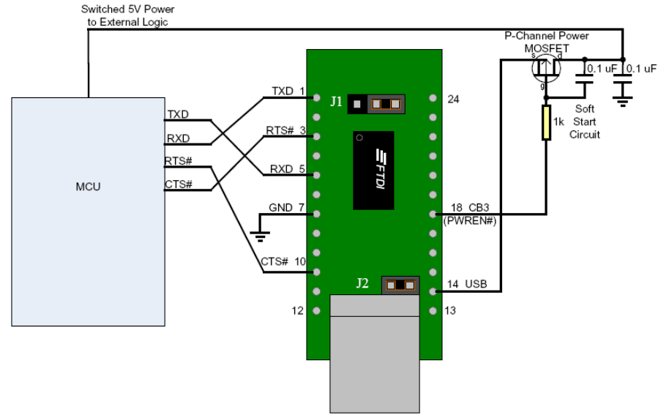

Figure 2: UM232R and Microcontroller Connection Reference

By default, the EEPROM is set to have a maximum draw current from the USB port of 100 mA. We had to update the EEPROM using FTDI’s software, MPROG2, to allow up to 450 mA of draw current from the USB port. This was needed to power up our TRF7960 RFID chip. Despite changing this characteristic, we are still within the USB standards of drawing up to 500 mA of current.

C. Implementing with the MSP430F169 Microcontroller

The MSP430F169 microcontroller performs all the data handling in our RFID read/write system. For our project, it processes commands and data from the PC and the TRF7960 RFID reader chip. To program our microcontroller, we purchased a development board and downloaded IAR Embedded Workbench, a coding development software recommended by Texas Instruments.
The microcontroller supports UART functionality which is used to communicate with the PC simply with the aid of a USB-UART device. For communicating with the RFID reader chip, it involves a direct 8-bit parallel data line, a shared system clock, a data trigger clock, and an interrupt line connection between the two components. Because the MSP430F169 only supports up to an 8 MHz clock and the RFID Reader chips runs at 13.56 MHz, the reader chip must be set to a lower clock frequency to ensure stable communication. To allow compatibility between the two components, we chose 6.78 MHz to be the shared system clock. For serial communications with the PC, we also had to calculate the conversion of our system clock to the desired baud rate. We chose a baud rate of 4800 because we found the error rate to be minimal at only 0.04% with the help of an online baud rate conversion tool.
Before using the reader chip, it must first be initialized through a set of commands by the microcontroller. Some of these items include setting up the shared system clock, turning on the transmit/receive functions, and configuring the ISO mode to match the ISO protocols of our RFID tags. Because the TRF7960 chip can’t be programmed directly, the initialization part must be carried out through the microcontroller every time the RFID system is turned on.
According to the MSP430F169 datasheet, the microcontroller needed about 3V to be powered. Taking advantage of UM232R capability to supply power, the microcontroller was powered with the 3.3V output pin on the UM232R.

D. Implementing with the TRF7960 RFID Reader Chip

The TRF7960 RFID reader chip performs all the necessary functions of reading from and writing to an RFID tag. However, an external antenna needed to be designed so that the reader chip can actually physically read and write from a tag.
The design has the reader chip connected to the MSP430F169 with 8 data lines, an interrupt line, a data clock line, and a system clock line. This is shown in Figure 3. It is possible to send data using SPI mode (Serial Peripheral Interface) using only three lines instead of eight. However based on our research, implementing an 8-bit parallel bus is much simpler and easier to understand.
.
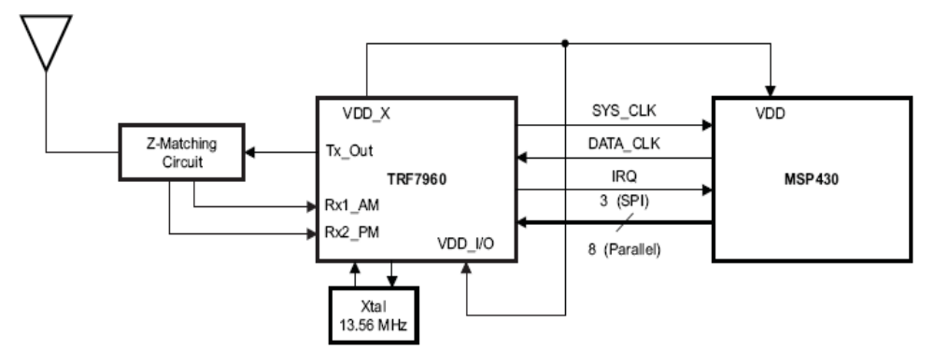

Figure 3: TRF7960 and MSP430 Connection Reference

Before our reader chip can write or read from a tag, an antenna and a 50Ω Z-matching circuit had to be designed. It is very important that the total antenna circuit load is 50Ω and tuned to 13.56MHz for it to work correctly. If the antenna circuit is not at the right impedance or untuned, the reader chip will not be able to detect any RFID tags.

E. RFID Antenna Design

The antenna design was based off of Texas Instrument’s HF Antenna Cookbook. The cookbook provided us with an antenna drawing, shown in Figure 4, to be ironed onto a copper board. After the ink had transferred to the copper board, we dipped the board into an etching solution for twenty minutes to make our antenna. The antenna was measured to be 50mm by 30mm with a trace width of 0.031 inches and a trace spacing of 0.047 inches.

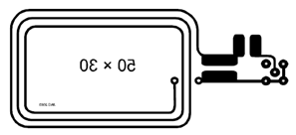

Figure 4: Designed Antenna Schematic on PCB

To give a clearer representation of what the pads in Figure 4 represent, a schematic of the antenna and the matching circuit is given below in Figure 5.

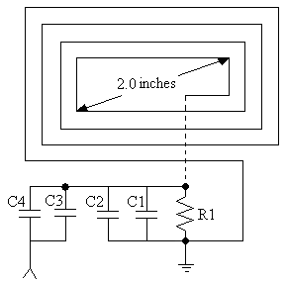

Figure 5: Antenna Schematic

A rule of thumb is that the expected read range of an antenna is twice the antenna’s inner diagonal measurement. For example, to get a read range of 4.0 inches, the antenna diagonal needs to be approximately 2.0 inches. To maximize the communication between the tag and the antenna, they both need to have the same quality factor value, also known as Q. To calculate the ideal quality factor of the tag, Q_{T}, the equation given below was used. The fundamental frequency f_{o} is 13.56 MHz, and the message frequency f, of the tag is 423.75 KHz. The message frequency is doubled in order to get the bandwidth which is 847.5 KHz.
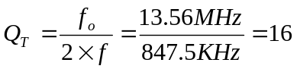

The cookbook recommended a 10k Ω resistor, and 148 pF capacitor be attached across the parallel pads. Then, connected in series would be a 31 pF capacitor.
In theory, the values of the resistor and the capacitors are supposed to give a nice single peak at 13.56 MHz in the antenna’s frequency response. However, in the real world, it gives two peaks due to magnetic coupling; one on the left side and one on the right side of 13.56 MHz. The best way to fix this problem is to tune the value of the capacitors on the matching circuit. Instead of using the fixed value of two capacitors 148 pF and 31 pF, two variable capacitors were used.
The value of the resistor is R1 = 10 KΩ, and the values of the capacitors are C1 = 120 pF, C2 = 0 to 30 pF variable, C3 = 10 pF, and C4 = 0 to 30 pF variable as shown in Figure 5.
We had trouble tuning the antenna correctly because we had no means of measuring RF power of our antenna. However, we discovered a reasonable method using a signal generator and a spectrum analyzer that was available to us in our laboratory. First we had to find a way to measure the charge level of a tag. In Texas Instruments’ HF Antenna Design Notes, they showed us a way to do that. First we had to remove the IC chip from the tag and solder components as shown in Figure 6.

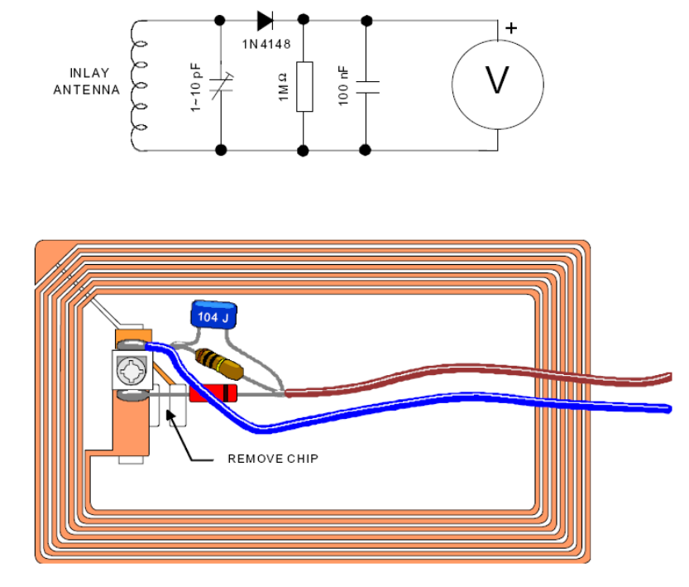
Figure 6: Charge Level Indicator Modification on a RFID Tag

We needed to tune the antenna to allow maximum power transfer to the RFID tag. This was done by measuring the charge level of the tag. The antenna was connected to a signal generator outputting a sine wave at 13.56 MHz. Then the tag was connected to a spectrum analyzer and placed roughly an inch from the top of our antenna to simulate transmitting and receiving. We know when the antenna is tuned when the charge level of the tag is at its maximum. The following figure displays roughly what was shown on the spectrum analyzer.

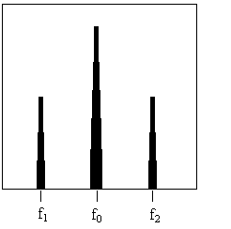

Figure 7: Spectrum Analyzer Screen

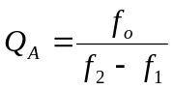

As mentioned previously, f₀ is 13.56 MHz and the tag has a frequency of 423.75 KHz. Using the equation above, we have to make sure that f₂-f₁ is as close to 847.5 KHz as possible which is twice the tag frequency. This adjustment is done by adjusting the variable capacitors.
In the end, the closest we could get the bandwidth to be was 700 KHz. This meant that f₁ was 13.9 MHz, and the value of f₂ was 13.2 MHz. Our Q factor was calculated to be 19 as shown below.

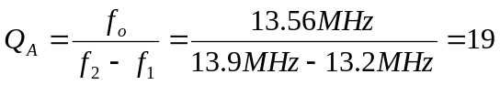

Since the quality factor of the antenna, Q_{A} = 19, is very close to the quality factor of the tag, Q_{T} = 16, we can confirm that our tuning values of the variable capacitors were good, and our antenna gave good performance in the real word, not only in the theory. Our completed antenna is shown below in Figure 8.

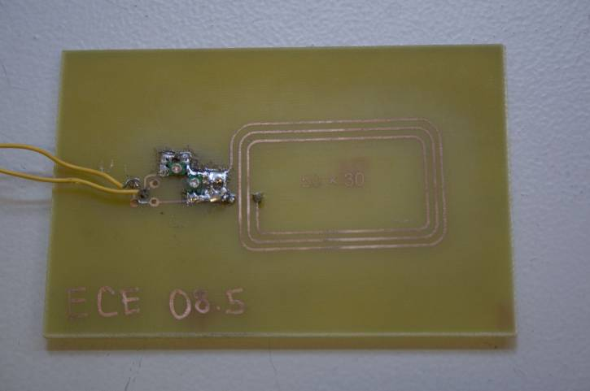

Figure 8: Completed Antenna

IV. Coding the MSP430F169 Microcontroller

A. UART Implementation

To understand how UART works, the concept of baud rate and clock must first be understood. The clock can be thought of as the rate at which information is processed. The baud rate can be thought of as the rate at which information is transmitted or received. Therefore, the clock rate has to be significantly higher than the baud rate. Research has shown that the clock rate should ideally be sixteen times greater than the baud rate. If this standard is not followed, faulty transmission would occur. The clock rate for the project was chosen to be 6.78 MHz and the baud rate chosen to be 4800 bps. This combination yielded the lowest percentage of error.
In addition to implementing the correct baud and clock rate combination, the format of data must also be taken into account. In addition to the 8 bits of data, additional bits are added. These bits include a parity bit, two stop bits, and one start bit. This is to make sure that the computer and microcontroller both know when each stream of data starts, and ends. This capability is configured using the UART registers.
Once these parameters are properly initialized, receive and transmit commands have to be handled. These commands were handled using interrupts. In order to properly use interrupts, there are two buffers that we have to pay attention to, the UART receive buffer, and the UART transmit buffer. A receive flag, and a transmit flag are used to keep track of the status of these two buffers. Basically, when the corresponding buffers have data in them, the corresponding flag is set to 1, and reset when data is no longer contained within the buffer.
Patient data cannot just automatically be sent, whenever the transmit buffer is full. Therefore, a command called “data” was created, which basically sends the patient data whenever the microcontroller receives the “data” command.

B. RFID Implementation

Writing to and Reading from a Register

In order to initialize the device properly, it is important to be able to access registers within the reader chip. It is the only way to enable its features. To do so, communication must be started as specified in the TRF7960 datasheet on parallel interface communication. The reader chip is able to write data to a single address or write continuously to consecutive addresses.

Initialization

For the reader chip to work correctly, it must first be initialized with the proper options. To turn on the reader chip, the EN pin must be set to high enabling full power mode. Then the shared system clock between the reader chip and microcontroller is set to a frequency of 6.78MHz to ensure data communication compatibility between the two devices. Once that has been set, we made sure that the chip is in full 5V power mode operation. And lastly, an ISO mode is chosen so that the reader can interact with the RFID tag that uses that particular ISO protocol. In our case, we have Tag-It tags using the ISO 15693 protocol so we set our RFID chip to handle that protocol.

Transmitting Operation

Before data transmission, the reader chip FIFO buffer and status must be reset. Data transmission is initiated using the start transmission command as defined in the datasheet. Then the number of bytes being sent must be defined by writing to the transmission length registers. Afterwards, the FIFO can be loaded with data to be written to the tags. Data transmission starts automatically once the first byte of data is written to the FIFO.
When transmitting, the reader chip will signal an interrupt to the microcontroller requesting immediate actions to be taken by the microcontroller. If the FIFO is less than 1/3 full, the reader chip will request more data to be loaded. If the FIFO is overloaded, it will request no more data written to the FIFO. Once the transmission is done, the reader will also send an interrupt to signal that it is done transmitting. It is important for the microcontroller to check the interrupt status register and the FIFO status register to deal with each interrupt case.

Receiving Operation

The receiving operation initializes once the reader successfully detects a start of file (SOF) signal from the RFID tag. The SOF is automatically sent from the tag to the reader once the presence of the tag is detected. Then a flag in the interrupt status register is set but no interrupt request is sent yet. At this point, it is up to the user to request inventory or check the interrupt status register to realize that an RFID tag has been detected. If the number of bytes received occupies more than 8 bytes of the 12-byte FIFO buffer, an interrupt is sent to request the microcontroller to remove the data contents from the FIFO. This process continues until it reaches the end of file (EOF) signal. Then it sends another interrupt pulse signaling that the receiving operation is finished.

V. Software for PC

A. Overview

The graphical user interface is simple. It contains text fields to input patient data such as name, gender, age, etc. It has the ability to ask the RFID device to write to a tag or read from it.

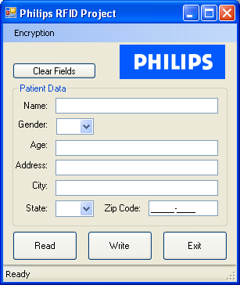

Figure 9: GUI Window of RFID Software

B. Encryption

First Design

After researching current encryption methods, the first design is the most secure way to implement security and privacy. This scheme includes both AES (Advanced Encryption Standard) and RSA encryption. Unlike early symmetric key algorithms, AES is the latest and hardest to break. It currently meets the encryption standards of the U.S. government for transmitting classified data and is ranked secure enough for Top Secret level government material. AES is also good for encrypting large amounts of data. As for RSA encryption, it is currently almost impossible to break and also known as a “strong” encryption algorithm. The down side is that it is used for small amounts of data, thus it is usually used to encrypt keys.
The AES key is used to encrypt the patient data. It is then stored along with the encrypted data onto the RFID tag. Unfortunately, this is similar to storing the lock with a key. Therefore the use of RSA is needed in this situation. Upon initial setup, the Ultrasound Machine will generate the public and private keys involved with RSA encryption. The public key is used to encrypt the AES key and the private key is used to decrypt the AES key. When these keys are made, the private key is stored safely in Microsoft Windows via Cryptographic Service Provider. The public key is exported to the front desk. Since the path that the RFID tag takes from the front desk to the Ultrasound Machine is at risk, a new AES key is generated for every patient. This way a hacker will not be able to see a pattern in thousands of encrypted patient data and also every patient data will have a unique AES key.
Finally, when the patient data is received at the Ultrasound Machine, the sonographer will be able to view this information, because the Ultrasound Machine holds the private key to decrypt the AES key, which can then be used to decrypt the patient data. This is ideal for Ultrasound facilities because we want to be able to control who can view patient information. This set up allows patient data to only be viewable at a secure Ultrasound Machine. This is also a very secure method because it combines the best of both AES and RSA encryption.

Second Design

In our first design, the use of RSA encryption method required us to save the encrypted AES key with the patient data file on the RFID tag. This took up extra space on the small storage capacity of 256 bytes on the RFID tags. Not only that, if a hacker gets access to enough encrypted keys, the encryption pattern could be derived and be used to access a patient’s confidential information.
To solve these problems, we implemented Microsoft’s DPAPI (Data Protection Application Programming Interface) into our encryption method. It is a set of system calls that can be used by any windows application to encrypt files. After the patient data is encrypted using the AES key, the function calls of DPAPI are used to encrypt the AES key and have it stored into the computer’s registry. Only specified Microsoft Windows user accounts have access to the file.
DPAPI met the requirements of the project because it is much more flexible than RSA. This algorithm allowed us to encrypt data of any size. Its malleability is what makes this algorithm more secure.

C. Serial Port Implementation

UART/Serial communications also need to be handled properly on the patient data software side. Just as parity and the number of stop bits had to be set on the microcontroller, the same has to be done here.
The Serial Port class in .Net Framework was used for all of the serial port communications on the PC. A wrapper class was implemented making the serial port class easier to use. In addition, this added some functionality such as: Receive command and Send Command. These features are necessary for interacting with the RFID reader. One reason for this is that the patient data application can disable the read button and only enable it when there is a tag nearby.

VI) PCB
The finished prototype is shown below in Figure 10. We had already adhered to project requirements through the bread-boarded prototype, but we wanted to eliminate any noise associated with the breadboard by transferring it onto a printed circuit board (PCB). In addition we also wanted a neater looking RFID reader/writer.

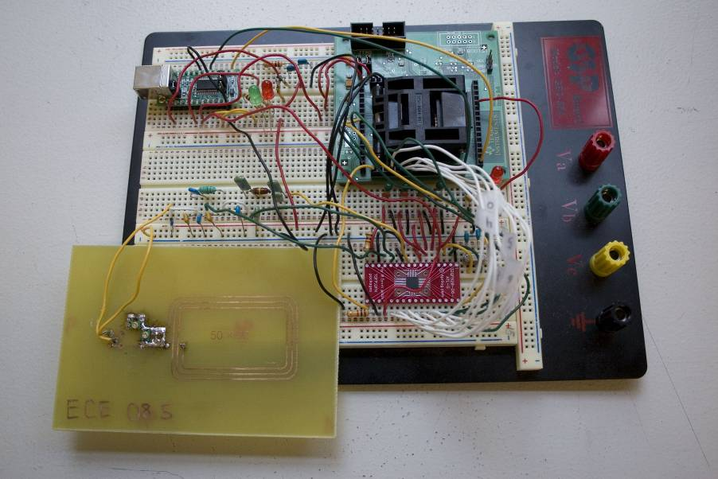

Figure 10: Finished Prototype

There are two main stages in making our PCB. The first part consisted of drawing our entire schematic in Allegro Design Entry CIS. This is the part where we had to include every component and connect all pins correctly. For debugging purposes, we also included test points via a test socket. For every component we needed to include the footprint which is a physical view of the component that includes the holes through the board or pads for surface mount components. Unfortunately some of our components were not included in the PCB Editor footprint library so we had to create them according to information on our datasheets. In our project we mainly used surface mount components. This was because they are smaller, more compact, and lighter. They have lower lead resistances and inductances which entails better performance for high frequency applications such as ours. Also fewer unwanted RF signals affect surface mount parts, yielding better predictability of component characteristics. After all the footprints were added, we created a netlist for the second stage of our PCB manufacturing process. The second stage included the preparation of the basic board parameters using Allegro PCB Design. We drew our board geometry and defined our layers. In our case we had a top layer, dielectric layer, and bottom layer. Then, we imported the netlist files and placed the components. After placing our components in our desired locations, we routed all wires and prepared the files for our PCB manufacturer.
For the final product, we actually omitted the antenna and its matching circuit from the PCB process. We continued ironing the Texas Instrument antenna of Figure 4 from the cookbook onto a copper board. This antenna would then be connected to the PCB using sockets. This was done to ensure that we could tune the antenna properly and possibly use different antennas should the need arise.

VII) Results

We successfully encrypted our patient data and were able to transmit it from the patient data application form to the RFID hospital bracelet, and back again. The antenna was designed and tuned accurately to specifications, and we were able to put the entire project onto a printed circuit board.

VIII) Conclusions

In conclusion, the project was a very educational experience. It put every member on the team in a situation in which they had to use all engineering knowledge acquired throughout the past four years. On top of that, we also needed to acquire new knowledge that could not have been obtained from our engineering education. It was equivalent to taking two to three electives classes.
When creating our Patient Data Application, thankfully we had a member who was proficient in the C# programming language. The rest of the team was proficient in the C programming language so adjusting to reading C# was not too strenuous. In addition, implementing the encryption algorithms proved to be not too difficult as these were provided within the .NET framework library.
The most strenuous part of the entire project was the design and testing of the antenna. By the middle of Seattle University’s Winter Quarter, we had successfully implemented encryption and had managed to transfer our patient data from our computer to the MSP430 microcontroller, and back again. We had also written code to communicate with the TRF7960. That was when progress stopped. It had taken us more than an entire quarter to get the antenna working. We even purchased an antenna from Texas Instruments priced at $550 dollars which was a huge hit to our budget. We had looked for other antennas available on the market but a majority of the ones we found were either way above our budget or didn’t have any specification sheets and reviews. We didn’t want to take the risk of purchasing an antenna that wasn’t suggested by Texas Instruments.
In hindsight, we should have bought the TRF7960 Evaluation Module from Texas Instruments earlier in the project. We could have used it for testing and comparing the results of its antenna test with the results of our made antennas. In addition, we should have invested more into the research of our antenna, not only in antenna theory but how antennas work in the real world. If we had read and understood more about the Q factor, tuning to resonant frequency, antenna 50 ohm impedance matching, we would have gotten farther along during the winter. Being able to tune the antenna and having it to test our code would have been a great help.

IX) References

- “MSP430x15x, MSP430x16x, MSP430x161x MIXED SIGNAL MICROCONTROLLER (Rev E)” Texas Instruments. 21 Aug 2006.
<http://www.ti.com/lit/gpn/msp430f169>
- “Multi-Standard Fully Integrated 13.56MHZ RFID & Data Framing Reading System (Rev. B)” Texas Instruments. 04 Apr 2007.
<http://www.ti.com/lit/gpn/trf7960>
- “TRF7960 EVM Schematic 8” Texas Instruments. 24 Aug 2006.
<http://www.ti.com/litv/zip/sloc086>
- “UM232R USB- Serial UART Development Module” Future Devices Technology International Ltd. 31 Jan 2006.
<http://www.ftdichip.com/Documents/DataSheets/Modules/DS_UM232R.pdf>
- Davis, Alex. “Safeguard Database Connection Strings and Other Sensitive Settings in Your Code” MSDN Magazine. Nov 2003. <http://msdn.microsoft.com/msdnmag/issues/03/11/ProtectYourData/>
- McCaffrey, James. “Encrypt It: Keep Your Data Secure with the New Advanced Encryption Standard” MSDN Magazine. Nov 2003. <http://msdn.microsoft.com/msdnmag/issues/03/11/AES>
- NAI Labs, Network Associates, Inc. “Windows Data Protection” MSDN. Oct 2001. <http://msdn2.microsoft.com/en-us/library/ms995355.aspx>

- Catsoulis, John. Designing Embedded Hardware. Sebastopol California: O’Reilly Media, Inc, 2005.

- Barr, Michael and Anthony Massa. Programming Embedded Systems with C and GNU Development Tools. Sebastopol California: O’Reilly Media, Inc, 2007.

- Nagy, Chris. Embedded Systems Design using the TI MSP430 Series. Burlington, MA: Elsevier Science, 2003.

- Axelson, Jan. Serial Port Complete Second Edition. Madison WI: Lakeview Research LLC, 2007.

- “Tag-it HF-I PLUS TRANSPONDER INLAYS MINIATURE RECTANGLE” Texas Instruments. 14 Nov 2007. <http://focus.ti.com/lit/ds/symlink/ri-i03-112a-03.pdf>

- “Tag-it HF-I Plus Transponder Inlays Reference Guide” Texas Instruments. December 2005. <http://focus.ti.com/lit/ug/scbu004/scbu004.pdf>

- “Tag-it HF-I Pro Transponder Chip/Inlays Extended Commands and Options” Texas Instruments. December 2005. < http://focus.ti.com/lit/ug/scbu003/scbu003.pdf>

- “Quick Start Manual for TRF7960 Evaluation Module User’s Guide (Rev. A)” Texas Instruments. June 2007. <http://focus.ti.com/lit/ug/slou193a/slou193a.pdf>

- “TRF7960EVM User’s Guide (Rev. B)” Texas Instruments. June 2007. <http://focus.ti.com/lit/ug/slou192b/slou192b.pdf>

- Carr, Joseph J. RF Components and Circuits. Woburn, MA. Elsevier Science Ltd, 2002.

- Losee, Ferril. RF Systems, Components, and Circuits Handbook. Norwood, MA. Artech House, Inc, 1997.

- The ARRL Handbook for Radio Amateurs. USA. The ARRL, Inc, 1999.

- “HF Antenna Cookbook Technical Application Report” Texas Instruments. Jan. 2004. http://www.ti.com/rfid/docs/manuals/appNotes/HFAntennaCookbook.pdf

- “HF Antenna Design Notes Technical Application Report” Texas Instruments. Sept. 2003. http://www.ti.com/rfid/docs/manuals/appNotes/HFAntennaDesignNotes.pdf

- “Tag- it Transponder Protocol Reference Manual” Texas Instruments. March 2000. http://rfidusa.com/superstore/pdf/rfid_trp_hf_rg_TagItProtocol.pdf

- “13.56 MHz RFID systems and antennas design guide” Melexis Microelectronic Integratd Systems. March 2004. <http://www.melexis.com/prodfiles/0003929_AN90121_7.pdf>

- Neto, P. Z. from http://mspgcc.sourceforge.net/baudrate.html.

IX) Appendix

Appendix A: Statement of Work

SCIENCE AND ENGINEERING PROJECT CENTER
MASTER PROJECT AGREEMENT
EXHIBIT A: COMMITMENT AND SCOPE OF PROJECT AGREEMENT

This Agreement is entered into by and between Seattle University, a Washington nonprofit corporation ("SU"), and the undersigned ("Sponsor").
1. Scope of Project. SU and Sponsor agree that the following Project will be jointly supervised by an SU faculty member and the Sponsor Liaison.

Sponsor Name: Philips Medical Systems

Sponsor Address: 22100 Bothell Everett Highway
P.O. Box 3003 98041-3003
Bothell, WA 98021-8431

Sponsor Liaison: Rob Trahms

Project Title: RFID technology project for Ultrasound

Project Description:
This project could address two potential Ultrasound scenarios
with different requirements. The first scenario involves conventional
asset tracking of small ultrasound devices such as transducers or
smaller form factor ultrasound machines. The second scenario
involves patient tracking with the potential of correlating ultrasound
data gathering with patient databases using RFID.
This project would take students through all the phases of a typical
R&D product development cycle.
The project would be to identify the requirements of these two
scenarios and explore the space of off-the-shelf chip solutions
to identify best fit solution candidates.
Based on this survey, the students would select a solution and implement the
HW and SW to develop a working prototype. This could involve
developing a board using an off-the-shelf RFID chip set and associated
components to interface to a laptop for example. Some interfacing
software would likely be required as well.
The project should evaluate the performance and validate the requirements
against the two above scenarios in terms of cost, power, size, range, etc. based
on a working prototype.
This would likely be a multi-disciplinary project in that it would involve electrical
hardware development, software and possibly aspects of human factors.
The benefit to Philips Ultrasound is that we would obtain a current snapshot of
the suitability of existing technology solutions for Ultrasound applications with a working
demonstrator.

Project Term: From September 26, 2007 to June 6, 2008.

2. Commitment

Sponsor hereby pledges the amount of $15,000 as a charitable contribution to the Science and Engineering Project Center of Seattle University, for use in connection with the Project defined in Section 1. This charitable contribution will be paid in accordance with one of the following selected payment schedules:

____ 1) In three payments:
Payment One: $___________ by ______________
Payment Two: $___________ by ______________
Payment Three: $___________ by ______________

____ 2) In two payments:
Payment One: $___________ by ______________
Payment Two: $___________ by ______________

____ 3) In one lump sum of $___________ by ______________

SPONSOR  Sponsor Name: __________________________  By: ____________________________________  Title: ___________________________________  Date: ___________________________________ | SEATTLE UNIVERSITY  By: ____________________________________  Title: Project Center Director  Date: ___________________________________

Checks payable to: Seattle University

Mail checks to: Attn: Amy Haedt, Corporate Relations Manager
Science and Engineering Project Center
Seattle University
901 12th Avenue
PO Box 222000
Seattle, WA 98122-1090

Appendix B: Student Resumes

Riley M. Higa

Andrew Kurniadi

Min Kyeong Lee

Mark John Garcia Merin

Robert W. Nguon






Appendix C

A) Hardware Components Used

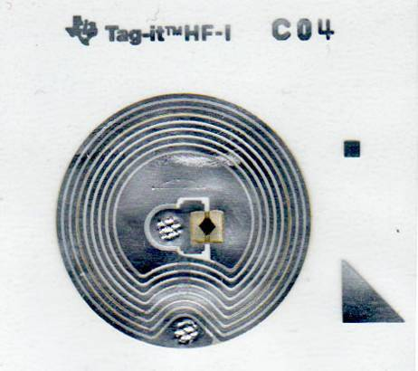

Figure 11: RFID tag for storing patient data

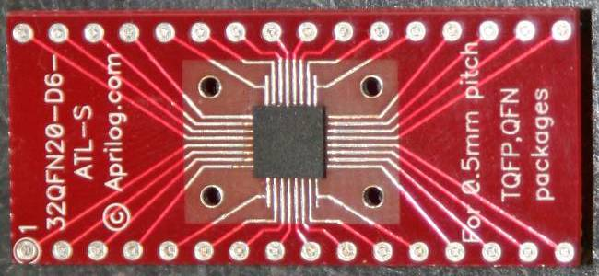

Figure 12: TRF7960 RFID Reader Chip

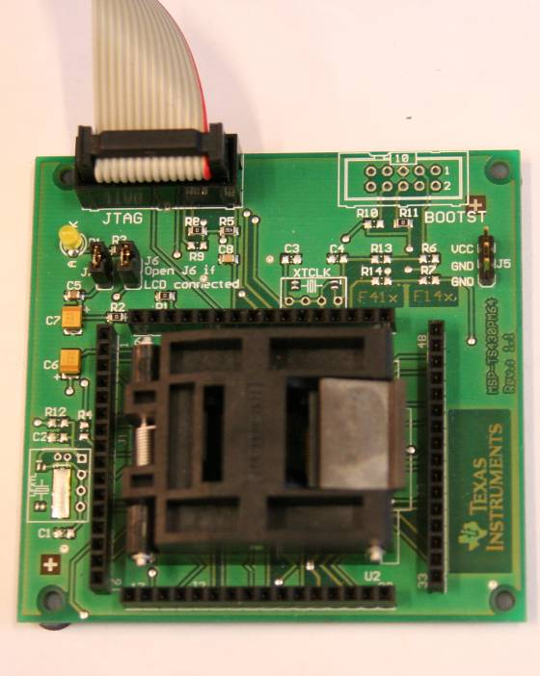

Figure 13: MSP430F169 Microcontroller Development Board

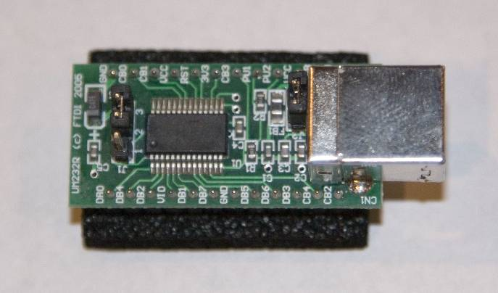

Figure 14: UM232R USB-to-Serial Conversion Device

B) Schematic of Current Design

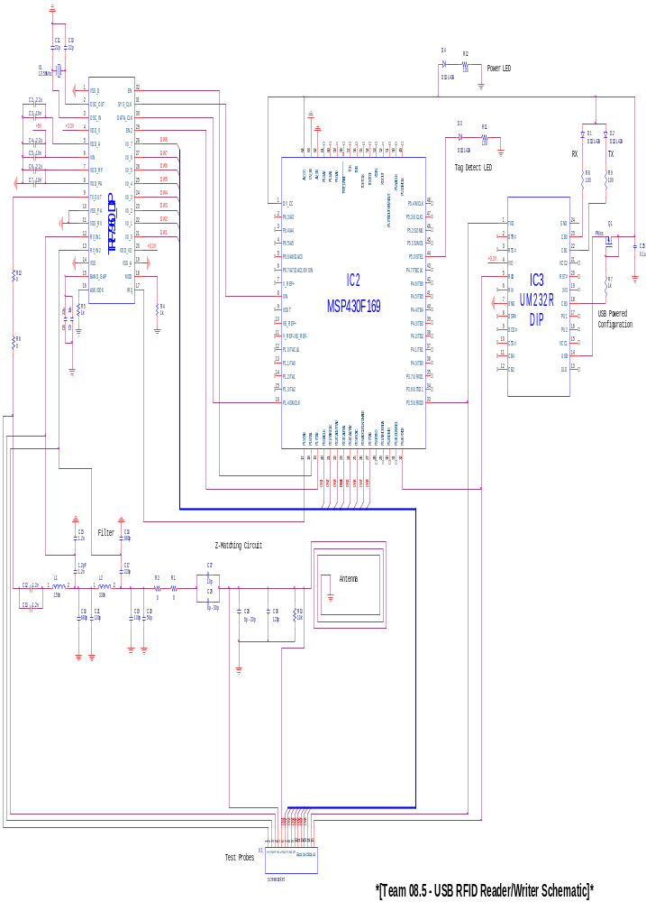

C) Encryption Algorithms Introduced

AES – Advanced Encryption Standard

AES was developed in response to the aging Data Encryption Standard (DES). DES had a small 56 bit key which was becoming vulnerable to attacks. In addition, DES was designed primarily for hardware and was very slow when implemented in software.
On January 2, 1997, the National Institute of Standards and Technology (NIST) announced that they wished to replace DES with a new standard known as AES. However rather than just creating a successor, the NIST asked for input on how the new standard should be chosen. The requirement was that any of the algorithms submitted were all to be block ciphers which supported block sizes of 128 bits and key sizes of 128, 192, and 256 bits.
In the nine months that followed, many algorithms were submitted from all over the world. The advantages and disadvantage of each of the designs were heavily debated upon. On October 2, 2000 NIST announced Rijndael had been selected as the proposed AES.
The AES algorithm is capable of using cryptographic keys of 128, 192 and 256 bits to encrypt data and decrypt data in blocks of 128 bits. AES is fast in both software and hardware, and is pretty easy to implement and requires very little memory. AES has a fixed block size of 128 bits and therefore must operate on a four by four array of bytes.

In June 2003, the US Government announced that AES may be used for classified information:

"The design and strength of all key lengths of the AES algorithm (i.e., 128, 192 and 256) are sufficient to protect classified information up to the SECRET level. TOP SECRET information will require use of either the 192 or 256 key lengths. The implementation of AES in products intended to protect national security systems and/or information must be reviewed and certified by NSA prior to their acquisition and use."

As of 2006, the only successful attack against AES has been side channel attacks.

RSA

RSA is from the initials of its co-inventors: Ron Rivest, Adi Shamir, and Len Adleman. This encryption algorithm was one of the first great advances in public key cryptography. It is primarily used for electronic commerce protocols and is believed to be secure enough given sufficiently long keys and the use of up to date implementations.
It is implemented by generating a pair of private key and a public key. The public key can be known to everyone and is used only for encrypting messages. Messages encrypted using a public key can only be decrypted using the generated private key.

DPAPI

The Data Protection Application Programming Interface (DPAPI) is a pair of function calls that provide OS-level data protection services to user and system processes as shown in Figure 1 below. Applications send data to DPAPI, and DPAPI sends its encrypted data back to the applications. DPAPI does not store any of the encrypted data, and applications calling DPAPI must implement their own storage of the encrypted data.

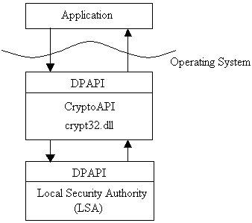

Figure 15: How DPAPI Exists Within the OS and How Data Gets Encrypted

D) Data Compression Introduced

Data Compression is used to reduce the number of bits required to represent data so that the storage space of the data is conserved. Data compression schemes can be divided into two broad classes, lossless and lossy. As the name implies, lossless compression techniques involve no loss of information, and the original data can be recovered exactly from the compressed data. Lossy compression techniques involve the loss of some information. Despite the lower compression ratio delivered by lossy compression, data, compressed using lossy techniques generally cannot be exactly recovered.
Since the project deals with the medical data of patients, the lossless compression has to be used to keep the original text data without any loss of information. In general, a technique called Bzip2 has the higher compression ratio, making it the more popular and more efficient compression used. However, Gzip is more efficient for small data sizes. Therefore, Gzip was chosen due to the small size of the patient data used in the project.

E) MSP430F169 Microcontroller Source Code

//******************************************************************************
// RFID Technology for Ultrasound
//
// MSP430F169
// -----------------
// /|\| XIN|-
// | | | 6.78 MHz
// --|RST XOUT|-
// | |
// | P3.4|------------>
// | | 4800 - 8O2
// | P3.5|<------------
//
//
// Riley Higa, Andrew Kurniadi, Min Kyeong Lee, Mark Merin, Robert Nguon.
// ECE 08.5: RFID Technology for Ultrasound
// Liason Engineer: Matthew Rieger
// Faculty Advisor: Dr. Robert Heeren
// Seattle University / Philips Healthcare
// Built with IAR Embedded Workbench IDE
//******************************************************************************

#include "msp430x16x.h"
#include <stdbool.h>
#include "uart_functions.h"
#include "rfid_functions.h"
#include "process_data.h"

void TRFInterruptHandler( unsigned char *reg );

void main( void )
{
WDTCTL = WDTPW + WDTHOLD; // Stop WDT

InitializeRFID();
InitializeUART();
InitializeFlags();

wait_ms(10);

__enable_interrupt(); // Enable interrupts

while(1)
{
if(DATA_IN_BUFFER)
{
ProcessData();
}
LPM0;
}
}

// UART0 RX interrupt service routine
#pragma vector=UART0RX_VECTOR
__interrupt void UART0RX (void)
{
DATA_IN_BUFFER = true;
__low_power_mode_off_on_exit();
}

// Timer A0 interrupt service routine
#pragma vector=TIMERA0_VECTOR
__interrupt void TimerAhandler(void)
{
unsigned char reg;
stopCounter;

reg = IRQStatus;
clearIRQ; //PORT2 interrupt flag clear
Read_Address(&reg); //IRQ status register has to be read
reg = reg & 0xF7; //set the parity flag to 0

if(reg == 0x00)
{
irq_reg = 0x00;
}
else
{
irq_reg = 0x01;
}
__low_power_mode_off_on_exit();
}

// TRF7960 IRQ interrupt service routine
#pragma vector=PORT1_VECTOR
__interrupt void TRF_IRQ (void)
{
unsigned char reg[2];
stopCounter;
do
{
clearIRQ; // Clear the IRQ
reg[0] = IRQStatus;
Read_Address(reg);
if(*reg == 0xA0)
{
goto FINISH;
}
TRFInterruptHandler(&reg[0]); // Send IRQ to ISR
} while((P1IN & BIT5) == BIT5);
FINISH:
__low_power_mode_off_on_exit();
}

/***************************************************************
* Description: Interrupt Service Routing
***************************************************************/
void TRFInterruptHandler( unsigned char *reg )
{
unsigned char len;

if(debug)
{
SendByte(*reg);
PutCharTX0(':');
}

if(*reg == 0xA0) // TX active and less than 4 bytes in FIFO
{
irq_reg = 0x00; // Say that TX is complete
}
else if(*reg == BIT7) // TX complete
{
irq_reg = 0x00; // Say that TX is complete
ResetFIFO; // Must reset FIFO after transmission
SendT("TX Done");
}
else if((*reg & BIT1) == BIT1) // Collision Error
{
irq_reg = 0x02; // Say that RX is complete
Write_Command(0x16); // Block Receivers
coll_pos = CollisionPos;
Read_Address(&coll_pos);
len = coll_pos - 0x20; // number of valid bits in FIFO

SendT("{");
if(debug) SendByte(coll_pos);
SendT("}");

if((len & 0x0F) != 0x00)
{
len = len + 0x10; // Add one byte if broken byte is received
}
len = len >> 4;

if(len != 0x00)
{
Read_AddressCont(FIFO, &buf[RXTXstate],len); // write the received bytes to the correct place in the buffer;
RXTXstate = RXTXstate + len;
}

ResetFIFO;
*reg = IRQStatus;
Read_Address(reg);
clearIRQ;
}
else if(*reg == BIT6) // RX active and that EOF has been received ... need to check FIFO for unread contents
{
if(RXErrorFlag == 0x02)
{
irq_reg = 0x02; // Say that CRC or Byte Framing Error (collission) Occured
return;
}
*reg = FIFOStatus;
Read_Address(reg);
*reg = (0x0F & *reg) + 0x01; // masking the fifo_status to determines number of bytes left in FIFO
Read_AddressCont(FIFO, &buf[RXTXstate], *reg);

RXTXstate = RXTXstate + *reg;

*reg = TXLength2;
Read_Address(reg); // reading from TXLengthByte2 to see if there are any broken bytes
if((*reg & BIT0) == BIT0) // found broken byte
{
*reg = (*reg >> 1) & 0x07;
*reg = 8 - *reg;
buf[RXTXstate - 1] &= (0xFF << *reg);
}
ResetFIFO;
irq_reg = 0xFF; // says that these are the last bytes

SendT("EOF Received 0x40");
}
else if(*reg == 0x60) // RX active and 9 bytes already in FIFO
{
irq_reg = 0x01;
Read_AddressCont(FIFO, &buf[RXTXstate],9); // Read 9 bytes from FIFO
RXTXstate = RXTXstate + 0x09;

SendT("FIFO Full");

if(P1IN & BIT5)
{
*reg = IRQStatus;
Read_Address(reg);
clearIRQ;
if(*reg == 0x40) // RX active and that EOF has been received ... need to check FIFO for unread contents
{
*reg = FIFOStatus;
Read_Address(reg);
*reg = 0x0F & (*reg + 0x01);

Read_AddressCont(FIFO, &buf[RXTXstate],*reg);
RXTXstate = RXTXstate + *reg;

*reg = TXLength2;
Read_Address(reg); // reading from TXLengthByte2 to see if there are any broken bytes
if((*reg & BIT0) == BIT0) // found broken byte
{
*reg = (*reg >> 1) & 0x07;
*reg = 8 - *reg;
buf[RXTXstate - 1] &= 0xFF << *reg;
}

ResetFIFO;
irq_reg = 0xFF;

SendT("EOF Received 0x60");
}
else if(*reg == 0x50) // RX EOF error
{
irq_reg = 0x02; // end of RX
SendT("EOF Received Error");
}
}
else
{
*reg = IRQStatus;
Read_Address(reg);
*(reg + 1) = FIFOStatus;
Read_Address(reg+1);
if((*reg == 0x00) && (*(reg+1) * BIT4) == BIT4)
SendT("FIFO Overflow Error");
else //if(*reg == 0x00)
irq_reg = 0xFF;
}
}
else if((*reg & BIT4) == BIT4) // CRC Error
{
if((*reg & BIT5) == BIT5) // FIFO is underflow or overflow
{
irq_reg = 0x01; //RX Active
RXErrorFlag = 0x02;
SendT("CRCE + RX Active");
}
else
irq_reg = 0x02; // End of RX
}
else if((*reg & BIT2) == BIT2) // Byte Framing Error
{
if((*reg & BIT5) == BIT5) // FIFO is underflow or overflow
{
irq_reg = 0x01; //RX Active
RXErrorFlag = 0x02;
}
else
irq_reg = 0x02; // End of RX
}
else if(*reg == BIT0) // No Response Interrupt
{
irq_reg = 0x00;
SendT("No Response Interrupt");
}
else // Interrupt Register not properly set
{
// say interrupt error
if(debug) SendByte(*reg);

irq_reg = 0x02;
Write_Command(0x16); // Block Receivers
ResetFIFO;
*reg = IRQStatus;
Read_Address(reg);
SendT("Unknown Interrupt Error");
clearIRQ;
}
}

// Riley Higa, Andrew Kurniadi, Min Kyeong Lee, Mark Merin, Robert Nguon.
// ECE 08.5: RFID Technology for Ultrasound
// Liason Engineer: Matthew Rieger
// Faculty Advisor: Dr. Robert Heeren
// Seattle University / Philips Healthcare
// Built with IAR Embedded Workbench IDE

#ifndef UART_FUNCTIONS_H
#define UART_FUNCTIONS_H

#include <stdbool.h>
#include "msp430x16x.h"
#include <string.h>
//#include "rfid_functions.h"

//Description: Initialize UART I/O pins, setting baud rate, and clock frequency
void InitializeUART( void );

//Description: Initialize the flags required for UART operation.
void InitializeFlags( void );

//Description:
void Send(const char *string_to_sent);

//Description: Puts character into the transmit buffer
bool PutCharTX0(unsigned char data);

//Description: Sends characters currently in the transmit buffer.
//void SendCharTX0(void);

//Description: Sends characters currently in the transmit buffer. terminal
void SendT(const char *string_to_sent);

//Description: Adds EOF character at the end of the output string
void AddEOF(void);

unsigned char Nibble2Ascii(unsigned char anibble);

void SendByte(unsigned char abyte);

////Description: Process data
//void ProcessData( void );

bool DATA_IN_BUFFER;
bool DATA_MODE;
unsigned int data_len;
unsigned int end_counter;

char patient_data[256];

char received_buffer[261];
unsigned int size;
char stats;
// Global Variables
bool debug = true;
// Counters

/***************************************************************
* Description:
* Initialize UART for baud rate and clock frequency
* Set number of characters, parity and stop bits.
***************************************************************/

void InitializeUART( void )
{

unsigned int ii1;

//Setup UART0
BCSCTL1 |= XTS + XT2OFF; // Set the LF clock to HF
BCSCTL1 &= ~(RSEL0 + RSEL1 + RSEL2);

// turn external oscillator on
do
{
IFG1 &= ~OFIFG; // Clear OSCFault flag
for (ii1 = 0xFF; ii1 > 0; ii1--); // Time delay for flag to set
}
while ((IFG1 & OFIFG) == OFIFG); // OSCFault flag still set?

BCSCTL2 |= SELM1 + SELM0 + SELS;
//BCSCTL2 |= SELM_3;// MCLK = LFXT1 (safe)

// Enable transmit module
U0CTL |= SWRST; /* disable UART */
ME1 |= (UTXE0 + URXE0); /* transmitter and receiver enable */
U0CTL &= ~SWRST; /* enable UART */

// Reset UART
U0CTL = (CHAR+PENA+SPB); //8 bit characters, Parity odd, 2 stop bits.
U0TCTL = (TXEPT+SSEL0); //SSEL0 = ACLK

// Setup 4800 baud with 6.78 mhz from TRF7960 SYS_CLK
U0BR0 = 0x84;
U0BR1 = 0x05;
U0MCTL = 0x55; //Modulation

IE1 |= (URXIE0); // Enable UART RX interrupts

// Enable module pin functions
P3DIR |= (BIT4); //Pin 3, bit 4 set to output direction
P3SEL |= (BIT4 + BIT5); //Pin 3, bit 4-5 set to UART mode
}

/***************************************************************
* Description:
* Initialize flags and counters.
***************************************************************/

void InitializeFlags( void )
{
// Initialize neccessary flags and counter
DATA_IN_BUFFER = false;

size = 0;
end_counter = 0;
// transmit_count = 0; transmit_in = 0; transmit_out = 0;
data_len = 0;
}

/***************************************************************
* Description: Sends a stream of characters through UART
***************************************************************/

void Send(const char *string_to_sent)
{

while(*string_to_sent != '\0')
{
PutCharTX0(*string_to_sent++);
}
//PutCharTX0('\r'); // Add Carriage Return
//PutCharTX0('\n'); // Start New Line

AddEOF();
}

/***************************************************************
* Description: Sends a stream of characters through UART to Terminal
***************************************************************/

void SendT(const char *string_to_sent)
{
if(debug)
{
while(*string_to_sent != '\0')
{
PutCharTX0(*string_to_sent++);
}
PutCharTX0('\r'); // Add Carriage Return
PutCharTX0('\n'); // Start New Line
}
}

/***************************************************************
* Description: Add EOF character
***************************************************************/

void AddEOF(void)
{
int j=0;
for(j = 0; j < 5; j++){
while(!PutCharTX0('\r'));
}
}

/***************************************************************
* Description: Puts characters into the UART transmit buffer
***************************************************************/

bool PutCharTX0(unsigned char data)
{
while(!(IFG1 & UTXIFG0)); /* Wait for TX flag to be empty */
TXBUF0 = data;
return true;
}

unsigned char Nibble2Ascii(unsigned char anibble)
{
unsigned char AsciiOut = anibble;
if(anibble > 9)
AsciiOut = AsciiOut + 0x07;
AsciiOut = AsciiOut + 0x30;
return(AsciiOut);
}

void SendByte(unsigned char abyte)
{
unsigned char temp1, temp2;

temp1 = (abyte >> 4) & 0x0F;
temp2 = Nibble2Ascii(temp1);
PutCharTX0(temp2);

temp1 = abyte & 0x0F;
temp2 = Nibble2Ascii(temp1);
PutCharTX0(temp2);
}

#endif

// Riley Higa, Andrew Kurniadi, Min Kyeong Lee, Mark Merin, Robert Nguon.
// ECE 08.5: RFID Technology for Ultrasound
// Liason Engineer: Matthew Rieger
// Faculty Advisor: Dr. Robert Heeren
// Seattle University / Philips Healthcare
// Built with IAR Embedded Workbench IDE

#ifndef RFID_FUNCTIONS_H
#define RFID_FUNCTIONS_H

#include "delay.h"
#include <stdbool.h>
#include "msp430x16x.h"
#include "uart_functions.h"

#define clearIRQ P1IFG = 0x00 // Clear IRQ Request
#define onIRQ P1IE |= BIT5 // Turn IRQ pin on; Pin P1.5
#define offIRQ P1IE &= ~BIT5 // Turn IRQ pin off; Pin P1.5

unsigned char RXErrorFlag;
signed char RXTXstate;
unsigned char buf[300];
unsigned char coll_pos;
unsigned char irq_reg;

// used for transmit receive byte count
unsigned char flags;
unsigned char uid[8];
bool found_tag;

/* Defining TRF7960 Aliases */
#define SetPinIO_OUT P2DIR = 0xFF;
#define SetPinIO_IN P2DIR = 0x00;
#define DataClockHigh P1OUT |= BIT4;
#define DataClockLow P1OUT &= ~BIT4;

// Defining TRF7960 Addresses
#define ChipStatControl 0x00
#define ISOControl 0x01
#define SYSCLKControl 0x09
#define IRQStatus 0x0C
#define CollisionPos 0x0E
#define InterruptMask 0x0D
#define RSSILevels 0x0F
#define RAM 0x10 // RAM is located at addresses 0x10 to 0x14
#define FIFOStatus 0x1C
#define TXLength 0x1D
#define TXLength2 0x1E
#define FIFO 0x1F

// TRF7960 Direct Commands
#define ResetFIFO Write_Command(0x0F);

//Counter-timer constants------------------------------------
#define countValue TACCR0 //counter register
#define startCounter TACTL |= (MC0 + MC1) //start counter in up mode
#define stopCounter TACTL &= ~(MC0 + MC1) //stops the counter
#define count1ms 847

// Function Headers

void StartCond( void ); // Description: Start data transmission to TRF7960
void StopCond( void ); // Description: Stop data transmission to TRF7960
void StopCond_Cont( void ); // Description: Stop data transmission to TRF7960 in continuuous mode
void Write_Command( unsigned char command ); // Description: Write command instruction
void Write_Address( unsigned char address, unsigned char command_str ); // Description: Write to address space
void Write_AddressCont( unsigned char address, unsigned char *dBuffer, unsigned int length ); // Description: Write to one address space continuously
void Read_Address( unsigned char *address ); // Description: Read from address space
void Read_AddressCont( unsigned char address, unsigned char rBuffer[], unsigned int length ); // Description: Read continuously from one address space
void CounterSet(void);
void InitializeRFID( void ); // Description: Initialize TRF7960 Chip
void Direct_Write( unsigned char buffer[], unsigned int length );
void CheckInventory();
unsigned char RequestCommand(unsigned char length, unsigned char brokenBits);
void EnableSlotCounter(void);
void DisableSlotCounter(void);

/***************************************************************
* Description: Start Condition consists of Pin A/D[7] going from
* low to high after the rising edge of Data_Clock.
* This starts transmission to the TRF7960
***************************************************************/
void StartCond( void )
{
P2OUT = 0x00; // A/D[7] is low
DataClockHigh;
P2OUT = 0xFF; // A/D[7] is high [Start Condition]
DataClockLow;
}

/***************************************************************
* Description: Stop Condition consists of Pin A/D[7] going from
* high to low after the rising edge of Data_Clock
***************************************************************/
void StopCond( void )
{
P2OUT |= 0x80; // A/D[7] is high
DataClockHigh;
P2OUT = 0x00; // A/D[7] is low [Stop Condition]
DataClockLow;
}

/***************************************************************
* Description: Stop Condition consists of Pin A/D[7] going from
* high to low after the rising edge of Data_Clock
* This stops transmission to the TRF7960
***************************************************************/
void StopCond_Cont( void )
{
P2OUT = 0x00; // A/D[7] is low
SetPinIO_OUT;
P2OUT = 0x80; // A/D[7] is high
__no_operation();
P2OUT = 0x00; // A/D[7] is low
}

/***************************************************************
* Description: Send a Direct Command to access built in functions
* in the TRF7960
***************************************************************/

void Write_Command( unsigned char command )
{
StartCond();
command |= 0x80; // Add "write this command" instruction
command &= 0x9F;//
P2OUT = command;
DataClockHigh;
DataClockLow;
StopCond();
}

/***************************************************************
* Description: Write to specified address space
***************************************************************/
void Write_Address( unsigned char address, unsigned char options )
{
StartCond();
address &= 0x1F;
P2OUT = address; // Specify address to write to
DataClockHigh;
DataClockLow;
P2OUT = options; // Writing data to the specified address
DataClockHigh;
DataClockLow;
StopCond();
}

/***************************************************************
* Description: Write data to starting address and continues to
* write data to each address after the previous
* address. Amount of addresses written to is
* determined by the length
***************************************************************/
void Write_AddressCont( unsigned char address, unsigned char *dBuffer, unsigned int length )
{
StartCond();
address |= 0x20;
address &= 0x3F;
P2OUT = address;
DataClockHigh;
DataClockLow;
while(length > 0)
{
P2OUT = *dBuffer;
DataClockHigh;
DataClockLow;
dBuffer++;
length--;
}
StopCond_Cont();
}

/***************************************************************
* Description: Read from one address space
***************************************************************/
void Read_Address( unsigned char *buffer )
{
StartCond();
*buffer |= 0x40; // Add "read from address" instruction
*buffer &= 0x5F;//
P2OUT = *buffer; // Specify address to read from
DataClockHigh;
DataClockLow;

SetPinIO_IN;
DataClockHigh;
__no_operation();
*buffer = P2IN; // Store read data from specified address
DataClockLow;
P2OUT = 0x00;
SetPinIO_OUT;

StopCond();
}

/***************************************************************
* Description: Read data from starting address and continues to
* read data from each address after the previous
* address. Amount of addresses read from is
* determined by the length
***************************************************************/
void Read_AddressCont( unsigned char address, unsigned char *rBuffer, unsigned int length )
{
StartCond();
address |= 0x60; // Specify that we want to "read from an address"
address &= 0x7F;
P2OUT = address; // Send address instruction across 8-bit parallel bus
DataClockHigh;
DataClockLow;

SetPinIO_IN;

while(length > 0)
{
DataClockHigh;
__no_operation();
*rBuffer = P2IN;
DataClockLow;
rBuffer++;
length--;
}
SetPinIO_OUT;
StopCond_Cont();
}

/***************************************************************
* Description: Initialize our TRF7960
***************************************************************/
void InitializeRFID( void )
{
// Power up TRF7960
P1SEL = 0x00; // Select all P1 ports as I/O
P1DIR = 0xFF; // Set all P1 ports as Output
P1DIR &= ~BIT5; // Set only P1.5 as input for IRQ from TRF7960
P1IES &= ~BIT5; // rising edge set
onIRQ; // Turn Interrupt On.

//Setting up pins for I/O
P2SEL = 0x00; // Set Port 2, Bit 0 - Bit 7 as I/O ports
SetPinIO_OUT;

//Setting up pins to light LEDs
P5SEL = 0x00; // Select all P5 ports as I/O
P5DIR = 0xFF; // Set all P5 ports as Output for LEDs
P5OUT = 0x00;

P1OUT = 0xC0; // Enable EN and EN2 for full power mode

Write_Address(SYSCLKControl, 0x21); // Address: Modulator/SYS_CLK Control; Option: Change clock rate to RF/2 (6.78 MHz) and 100% OOK Mod
Write_Address(ChipStatControl,0x21); // Address: Chip Status Control; Option: Specify the TRF7960 to run in full active mode in 5V operation (default)
//Write_Address(ISOControl,0x13); // Address: ISO Control address; Option: Select Tag-It Mode
Write_Address(ISOControl,0x02); // Address: ISO Control address; Option: Select ISO-15693 high bit rate mode
Write_Command(0x1A); // Command: Receiver Gain Adjust - reduce input sensitivity to noisy environment (make sure no tag is around)
//Write_Address(ChipStatControl,0x01); // Address: Chip Status Control; Deactivates RF field and receivers
ResetFIFO;
}

/***************************************************************
* Description: Write directly to the RFID Chip continously
***************************************************************/
void Direct_Write( unsigned char *buffer, unsigned int length )
{
StartCond();
while(length > 0)
{
P2OUT = *buffer; /* send command */
DataClockHigh;
DataClockLow;
buffer++;
length--;
}
StopCond_Cont();
}

/***************************************************************
* Description: Find the ID of the RFID Tag ISO15693
***************************************************************/
void CheckInventory()
{
/*~~~~~~~~~~~~~~~~~~~~~~~~~~~~~~~~~~~~~~~~~~~~~~~~~~~~~~*/
/* 010800030414(req.packet)[00ff] */
unsigned char i = 1, NoSlots, m = 0, found = 0;
unsigned char command;
int size;
unsigned int k = 0;
int count_tags;
/*~~~~~~~~~~~~~~~~~~~~~~~~~~~~~~~~~~~~~~~~~~~~~~~~~~~~~~*/

NoSlots = 17; /* 16 slots if bit is cleared */
EnableSlotCounter();

size = 3;

buf[0] = 0x8F;
buf[1] = 0x91; /* send with CRC */
buf[2] = 0x3D; /* write continous from 1D */
buf[3] = (char) (size >> 8);
buf[4] = (char) (size << 4);
buf[5] = 0x06; /* ISO15693 flags */
buf[6] = 0x01; /* anticollision command code */
buf[7] = 0x00; /* masklenght */

command = IRQStatus;
Read_Address(&command);

CounterSet(); /* TimerA set */
countValue = count1ms * 20; /* 20ms */
Direct_Write(&buf[0], 8); /* writing to FIFO */

clearIRQ; /* PORT2 interrupt flag clear */
onIRQ;

irq_reg = 0x01;
startCounter; /* start timer up mode */
LPM0; /* wait for end of TX interrupt */

for(i = 1; i < NoSlots; i++)
{
/* 1 or 16 available timeslots */
RXTXstate = 1; /* prepare the global counter */

/* the first UID will be stored from buf[1] upwards */
CounterSet(); /* TimerA set */
countValue = count1ms * 20; /* 20ms */
startCounter; /* start timer up mode */

LPM0;

PutCharTX0(i+0x40);
PutCharTX0('-');

k = 0;
while(irq_reg == 0x01)
{ /* wait for RX complete */
k++;
if(k == 0xFFF0)
{
irq_reg = 0x00;
RXErrorFlag = 0x00; // Reset RXErrorFlag
break;
}
}

command = RSSILevels;
Read_Address(&command); //read rssi levels

if(irq_reg == 0xFF)
{ /* recieved UID in buffer */
if(++count_tags == 1)
found = true;
else
found = false;
/* Output UID to terminal */
PutCharTX0(i+0x40);
PutCharTX0(':');
PutCharTX0(' ');
for(m = 10; m>=3; m--) //Put UID in output terminal
{
SendByte(buf[m]);
}
SendT(""); // add new line
}
else if(irq_reg == 0x02)
{ /* collision occured */
SendT("Collision Error");
}
else if(irq_reg == 0x00)
{ /* timer interrupt */
SendT("Timer Interrupt");
}
else
;

ResetFIFO;

if((NoSlots == 17) && (i < 16))
{
/* if 16 slots used send EOF(next slot) */
Write_Command(0x16);
Write_Command(0x17);
Write_Command(0x14);

}
else if((NoSlots == 17) && (i == 16))
{ /* at the end of slot 16 stop the slot counter */
DisableSlotCounter();
}
} /* for */

if(found)
{
P5OUT |= 0x01; // Light up LED at P5.0
}
else
{
P5OUT &= ~0x01; // Off LED
}

offIRQ;
}

/***************************************************************
* Description: Read
***************************************************************/
void CounterSet(void)
{
TACTL |= TACLR;
TACTL &= ~TACLR; //reset the timerA
TACTL |= TASSEL0 + ID1 + ID0; //ACLK, div 8, interrupt enable, timer stopped

TAR = 0x0000;
TACCTL0 |= CCIE; //compare interrupt enable
}

/***************************************************************
* Description: Read
***************************************************************/
void EnableSlotCounter(void)
{
buf[41] = InterruptMask; /* next slot counter */
buf[40] = InterruptMask;
Read_Address(&buf[41]);
buf[41] |= BIT0; /* set BIT0 in register 0x01 */
Write_Address(buf[40], buf[41] );
}

/***************************************************************
* Description: Read
***************************************************************/
void DisableSlotCounter(void)
{
buf[41] = InterruptMask; /* next slot counter */
buf[40] = InterruptMask;
Read_Address(&buf[41]);
buf[41] &= 0xfe; /* clear BIT0 in register 0x01 */
Write_Address(buf[40], buf[41]);
}

/***************************************************************
* Description: Read
***************************************************************/
unsigned char RequestCommand(unsigned char length, unsigned char brokenBits)
{
unsigned char j, command; //index

buf[0] = 0x8F; // reset FIFO
buf[1] = 0x91; // tx with crc
buf[2] = 0x3D; // tx length byte
buf[3] = length >> 4;
buf[4] = (length << 4) | brokenBits;

Direct_Write(&buf[0], length + 5); /* writing to FIFO */
clearIRQ; /* PORT2 interrupt flag clear */
onIRQ;

irq_reg = 0x01;
RXTXstate = 1; /* the response will be stored in buf[1] upwards */

/* wait for end of transmit */
while(irq_reg == 0x01)
{
CounterSet();
countValue = 0xF000; /* 60ms for TIMEOUT */
startCounter; /* start timer up mode */
LPM0;
}

if
(
(((buf[5] & BIT6) == BIT6) && ((buf[6] == 0x21) || (buf[6] == 0x24) || (buf[6] == 0x27) || (buf[6] == 0x29)))
|| (buf[5] == 0x00 && ((buf[6] & 0xF0) == 0x20 || (buf[6] & 0xF0) == 0x30 || (buf[6] & 0xF0) == 0x40))
)
{
wait_ms(20);
Write_Command(0x0F);
Write_Command(0x14);
}

//irq_reg = 0x01;

CounterSet();
countValue = 0xF000; /* 60ms for TIMEOUT */
startCounter; /* start timer up mode */

/* if */

while(irq_reg == 0x01)
{ /* wait for RX complete */
}

if(irq_reg == 0xFF)
{ /* received response */
PutCharTX0('[');
for(j = 1; j < RXTXstate; j++)
{
SendByte(buf[j]);
} /* for */

PutCharTX0(']');
return(0);
}
else if(irq_reg == 0x02)
{ /* collision occured */
SendT("Collision Occured");
// PutCharTX0('[');
// PutCharTX0('z');
// PutCharTX0(']');
return(0);
}
else if(irq_reg == 0x00)
{ /* timer interrupt */
SendT("Timer Interrupt");
//PutCharTX0('[');
//PutCharTX0(']');
return(1);
}
else
;

offIRQ;
return(1);
}

#endif

/***************************************************************
* Description: Process Commands sent to the uController
*
***************************************************************/

#ifndef PROCESS_DATA_H
#define PROCESS_DATA_H

#include "uart_functions.h"
#include "rfid_functions.h"

bool trfpower = 0; // 0 - full power, 1 - half power
bool trfagc = 0; // 0 - agc off, 1 - agc on

/* Function Declarations */
void ProcessData( void );
void WriteToTag( void );
void WriteBlock(unsigned char address, char *data);

/* Function Implementations */
void ProcessData( void )
{
char byIn;

byIn = RXBUF0;
received_buffer[size] = byIn;
size++;

// Check for 5 end delimeter '\r'
// We always assume all data or command will end with 5 \r's
if( byIn == '\r')
{
end_counter++;
// Check if it encounters multiple delimiters
if(end_counter == 5)
{
// Process Command
if(!DATA_MODE)
{
offIRQ;
RXErrorFlag = 0x00; // Reset trfRX error flag
received_buffer[size-5] = '\0'; // Remove \r's and make strcmp work
if(!strcmp("data",received_buffer))
{
int j;
for(j=0; j < data_len; j++)
{
while(!PutCharTX0(patient_data[j]));
}
AddEOF();
}
else if(!strcmp("sendd",received_buffer))
{
Send("OK");
DATA_MODE = true;
}
else if(!strcmp("write",received_buffer))
{
buf[5] = 0x42;
buf[6] = 0x21;
buf[7] = 0x02;
buf[8] = 0x12;
buf[9] = 0x34;
buf[10] = 0x56;
buf[11] = 0x78;
RequestCommand(7, 0x00);
}
else if(!strcmp("debug_on",received_buffer))
{
debug = true;
Send("Debug Mode: on");
}
else if(!strcmp("debug_off",received_buffer))
{
debug = false;
Send("Debug Mode: off");
}
else if(!strcmp("read",received_buffer))
{
buf[5] = 0x02;
buf[6] = 0x20;
buf[7] = 0x02;
RequestCommand(3, 0x00);
}
else if(!strcmp("sysinfo",received_buffer))
{
buf[5] = 0x02;
buf[6] = 0x2B;
RequestCommand(2, 0x00);
}
else if(!strcmp("inventory",received_buffer)) // HostCommand 0x14
{
SendT("\nISO 15693 Inventory Request\n");
CheckInventory();
SendT("\nDone\n");
}
Write_Address(ChipStatControl,(Read_Address(ChipStatControl) | 0x04));
Write_Address(ChipStatControl,(Read_Address(ChipStatControl) & ~0x04));
else
{
Send("Unsupported Command");
}
size = 0;
}
else // else DATA_MODE is true, Processing Patient Data
{
int i;
data_len = size - 5;
// Copy the buffer content to patient_data
for (i = 0; i < data_len; i++)
{
patient_data[i] = received_buffer[i];
}
size = 0;

//Write Data to the tag
WriteToTag();

DATA_MODE = false;
}
end_counter = 0; //Reset the \r counter
}
}
else
{
end_counter = 0;
//Check if command send is indeed a command.
//If it is a command, then reset all flags and output error message.
}

DATA_IN_BUFFER = false; //Reset FLAG
}

void WriteToTag( void )
{
int len = 0;
char *current_data = &patient_data[0];
unsigned char current_address = 0x00;

while ( len < data_len)
{
WriteBlock(current_address, current_data);
current_data += 4; //go to the next block of data
current_address++;
len++;
}
// Add padding if less than 256 bytes of data
if(data_len != 256)
{
int count = (256 - data_len) / 4;
while (count >= 0)
{
char pad[4] = {0x00,0x00,0x00,0x00};
WriteBlock(current_address, pad);
current_data += 4;
current_address++;
count--;
}
}
}

void WriteBlock(unsigned char address, char *data)
{
buf[5] = 0x42;
buf[6] = 0x21;
buf[7] = address; //Address
buf[8] = *(data); //Data from buf[8] to buf[11]
buf[9] = *(data+1);
buf[10] = *(data+2);
buf[11] = *(data+3);
RequestCommand(7, 0x00);
}
#endif

// Riley Higa, Andrew Kurniadi, Min Kyeong Lee, Mark Merin, Robert Nguon.
// ECE 08.5: RFID Technology for Ultrasound
// Liason Engineer: Matthew Rieger
// Faculty Advisor: Dr. Robert Heeren
// Seattle University / Philips Healthcare
// Built with IAR Embedded Workbench IDE

#ifndef DELAY_H
#define DELAY_H

void wait_ms(unsigned int n_ms);

void wait_ms(unsigned int n_ms) {
unsigned int ii1, ii0;
for(ii0=n_ms; ii0>0; ii0--) {
ii1 = 0x07FF; // Delay
do (ii1--);
while (ii1 != 0);
}
}

#endif

F) Software Source Code
using System;
using System.Collections.Generic;
using System.ComponentModel;
using System.Data;
using System.Drawing;
using System.Text;
using System.Windows.Forms;
using System.IO;
using System.Runtime.Serialization;
using System.Runtime.Serialization.Formatters.Binary;

namespace Philips_Ultrasound_Patient_Form
{
public partial class frmMain : Form
{
public frmMain()
{
InitializeComponent();
}

// Initialize the encryption and compression class
// needed for the sending and receiving data
private Encryption enc = new Encryption();
private Compression comp = new Compression();
Serial port;

// This method will run when the user clicks the read button
private void btnRead_Click(object sender, EventArgs e)
{
toolStripStatus.Text = "Reading...";

byte[] receivedData = port.TalkRFIDByte("data"); ; // Read data from the port

if (receivedData != null)
{

try
{
IFormatter formatter = new BinaryFormatter();

byte[] encryptedData = receivedData; // Store data received from port 5 into encrypted data.

// Decrypt the data
// MemoryStream decryptedStream = new MemoryStream(enc.Decrypt(encryptedData));
MemoryStream serializedData = new MemoryStream(comp.Decompress(enc.Decrypt(encryptedData)));
PatientData outputData = (PatientData)formatter.Deserialize(serializedData);

// Put the patient data to associated fields on the form.

txtName.Text = outputData.name;
cmbGender.Text = outputData.gender;
txtAge.Text = outputData.age.ToString();
txtAddress.Text = outputData.address;
txtCity.Text = outputData.city;
cmbState.Text = outputData.state;
txtZipcode.Text = outputData.zipcode;

// Close the streams used
serializedData.Close();

toolStripStatus.Text = "Reading Done!";
}
catch
{
toolStripStatus.Text = "Reading Error!";
}
}
else
{
toolStripStatus.Text = "RFID Reader is not responding!";
}
}

// This method will run when the user clicks the write button
private void btnWrite_Click(object sender, EventArgs e)
{
toolStripStatus.Text = "Writing...";

try
{
PatientData data = new PatientData(txtName.Text, cmbGender.Text, txtAge.Text, txtAddress.Text, txtCity.Text, cmbState.Text, txtZipcode.Text);
//PatientData data = new PatientData(txtName.Text, cmbGender.Text, txtAge.Text);
MemoryStream serializeData = new MemoryStream();
IFormatter formatter = new BinaryFormatter();

//Serialize the data
formatter.Serialize(serializeData, data);

//Compress the Data
MemoryStream compressedData = new MemoryStream();
comp.Compress(serializeData.ToArray(), compressedData);

//Encrypt the data
byte[] output = enc.Encrypt(compressedData.ToArray());
Stream fileStream = new FileStream("patient_data.bin", FileMode.Create, FileAccess.Write, FileShare.None);
fileStream.Write(output, 0, output.Length);

// Close the streams used
compressedData.Close();
fileStream.Close();
serializeData.Close();

port.Write(output);

FileInfo fileInfo = new FileInfo("patient_data.bin");
toolStripStatus.Text = "Writing Done! (" + fileInfo.Length.ToString() + " Bytes)";
}
catch
{
toolStripStatus.Text = "Writing Error!";
}
}

private void btnExit_Click(object sender, EventArgs e)
{
port.Close();
// Exit the application
Application.Exit();
}

private void btnClear_Click(object sender, EventArgs e)
{
// Clear the Form
txtName.Text = "";
cmbGender.Text = "";
txtAge.Text = "";
txtAddress.Text = "";
txtCity.Text = "";
cmbState.Text = "";
txtZipcode.Text = "";

toolStripStatus.Text = "Ready";
}

private void exportAESKeyToolStripMenuItem_Click(object sender, EventArgs e)
{
Stream keyDataStream = null;

// Open a Save File Dialog and get the file path for saving the AES key
SaveFileDialog saveFileDialog = new SaveFileDialog();
saveFileDialog.Filter = "AES key files (*.aes)|*.aes|All files (*.*)|*.*";
saveFileDialog.FilterIndex = 1;
saveFileDialog.RestoreDirectory = true;

if (saveFileDialog.ShowDialog() == DialogResult.OK)
{
if ((keyDataStream = saveFileDialog.OpenFile()) != null)
{
enc.ExportKey(keyDataStream);
keyDataStream.Close();
}
}
toolStripStatus.Text = "Public Key Exported!";
}

private void importAESKeyToolStripMenuItem_Click(object sender, EventArgs e)
{
Stream keyDataStream = null;

// Open an Open File Dialog and get the file path for reading the AES key
OpenFileDialog openFileDialog = new OpenFileDialog();
openFileDialog.InitialDirectory = Environment.GetFolderPath(Environment.SpecialFolder.MyComputer);
openFileDialog.Filter = "AES key files (*.aes)|*.aes|All files (*.*)|*.*";
openFileDialog.FilterIndex = 1;
openFileDialog.RestoreDirectory = true;

if (openFileDialog.ShowDialog() == DialogResult.OK)
{
try
{
if ((keyDataStream = openFileDialog.OpenFile()) != null)
{
using (keyDataStream)
{
enc.ImportKey(keyDataStream);
}
}
}
catch (Exception ex)
{
MessageBox.Show("Error: Could not read file from disk. Original error: " + ex.Message);
}
}
toolStripStatus.Text = "AES Key Sucessfully Imported!";
}

// This function will be removed on the final version
// for security reason.
private void viewKeysToolStripMenuItem_Click(object sender, EventArgs e)
{
// Show the AES Keys
MessageBox.Show(enc.GetEncryptionKey(), "Encryption Keys");
}

private void generateNewAESKeyToolStripMenuItem_Click(object sender, EventArgs e)
{
DialogResult result = MessageBox.Show("Are you sure you want to generate a new key? You will not be able to decrypt older data", "Generate New Key Confirmation", MessageBoxButtons.YesNo, MessageBoxIcon.Warning);
if(result == DialogResult.Yes)
enc.GenerateNewKey();
}

private void frmMain_Load(object sender, EventArgs e)
{
// Initialize the port needed for communications
string portNo = getComPort();
port = new Serial(portNo);

if (!port.Open())
MessageBox.Show("Cannot open" + portNo + "! Please change the COM Port settings.", "Port Error", MessageBoxButtons.OK, MessageBoxIcon.Error);
}

private void configureCOMPortToolStripMenuItem_Click(object sender, EventArgs e)
{

frmComPort frmComPort = new frmComPort();
frmComPort.ShowDialog();

string selectedPort = frmComPort.selectedComPort;

port.ComName = selectedPort;

//Save the ComName into application setting
Properties.Settings set = Properties.Settings.Default;
set.COMPort = selectedPort;
set.Save();
}

private string getComPort()
{
Properties.Settings set = Properties.Settings.Default;
return set.COMPort;
}

private void fillDataToolStripMenuItem_Click(object sender, EventArgs e)
{
txtName.Text = "Mark John Merin";
txtAge.Text = "3";
cmbGender.Text = "F";
txtAddress.Text = "1234 Somewhere Out There St";
txtCity.Text = "Unknown";
cmbState.Text = "WA";
txtZipcode.Text = "00911";
}

private void setProtocol()
{
////Initialize EVM
//toolStripStatus.Text = port.TalkRFIDString("010C00030410002101000000");
//toolStripStatus.Text = port.TalkRFIDString("0109000304F0000000");
//toolStripStatus.Text = port.TalkRFIDString("0109000304F1FF0000");
}

private void setProtocolToolStripMenuItem_Click(object sender, EventArgs e)
{
setProtocol();
}
}
}

using System;
using System.Collections.Generic;
using System.Text;
using System.IO;
using ICSharpCode.SharpZipLib.GZip;

namespace Philips_Ultrasound_Patient_Form
{
/* Compression Class
* This wrapper class provide support for Compressing data.
* Compression class uses the Gzip or GNU zip data compression program.
* It reduces the size of the named files using Lempel-Ziv(LZ77) and
* Huffman coding.
*/
class Compression
{
// Compress method
// This function has two parameters. The first one is the data
// That is being compressed and the second is for writing the
// compressed data into output stream.
public void Compress(byte[] data, Stream output)
{
//Initializes the stream needed to store the compressed data
GZipOutputStream zipStream = new GZipOutputStream(output);

//Compresses a block of bytes to this stream
zipStream.Write(data, 0, data.Length);

//Clears all buffers for this stream
zipStream.Flush();

//Closes and releases any resources associated with the stream
zipStream.Close();
}

// Decompress method
// This function will decompress the data inside the dataStream
// and return the decompressed data as an array of bytes
public byte[] Decompress(byte[] data)
{
//Convert the incoming data into a stream
Stream dataStream = new MemoryStream(data);
// Initializes a new MemoryStream to store the decompressed data
MemoryStream decompressData = new MemoryStream();

// Decompresses the data
using (GZipInputStream zipStream = new GZipInputStream(dataStream))
{
byte[] buffer = new byte[64];
int bytesRead;

while (true)
{
bytesRead = zipStream.Read(buffer, 0, buffer.Length);

if (bytesRead == 0)
break;
decompressData.Write(buffer, 0, bytesRead);
}

// Clears all buffers for this stream
zipStream.Flush();

// Closes and releases any resources associated with the stream
zipStream.Close();
}
// Close the stream
decompressData.Close();
dataStream.Close();

// Returns decompressed data as an array
return decompressData.ToArray();
}

}
}

using System;
using System.Collections.Generic;
using System.Text;
using System.Security.Cryptography;
using System.IO;

namespace Philips_Ultrasound_Patient_Form
{
/* Encryption Class
* This wrapper class provide support for encrypting data.
*/
class Encryption
{
// Initialize Global Variable

// Creates a Rijndael object for symmetric
// encryption of data
RijndaelManaged rjndl;

// Parameter for Encrypting and Decrypting Data
// keyName is used to determine entropy
const string keyName = "PhilipsKey";
// entropy is used as a scrambling factor in encryption
byte[] entropy = Encoding.Unicode.GetBytes(keyName);

// keySize and blockSize used for encryption
const int keySize = 256;
// blockSize is the basic unit of data that
// can be encrypted at one time
const int blockSize = 256;

//Default Constructor
public Encryption()
{
// Create new instance of Rijndael for symmetric
// encryption of the data. This creates a new key
// and initialization vector (IV)
rjndl = new RijndaelManaged();
rjndl.KeySize = keySize;
rjndl.BlockSize = blockSize;
// Uses Cipher Block Chaining for processing data block
rjndl.Mode = CipherMode.CBC;
// For the case that data to be encrypted is less than
// specified block size, ISO10126 adds random data to
// the end of the data block to fill it up.
rjndl.Padding = PaddingMode.ISO10126;
LoadKeyFromConfig();
}

// GenerateNewKey Method
// This function will generate a new AES key
// and IV for the AES encryption.
// It will also update the key stored in the application setting
public void GenerateNewKey()
{
rjndl.GenerateIV();
rjndl.GenerateKey();

//Save the new key and IV into
SaveKeyToConfig();
}

// Encrypt method
// This function accepts array of bytes containing the data to be encrypted
// and return the encrypted data as array of bytes
public byte[] Encrypt(byte[] inData)
{
// Create memorystream to hold the encrypted data.
MemoryStream outFs = new MemoryStream();

// Create encryption transform object
ICryptoTransform transform = rjndl.CreateEncryptor();

// Now write the cipher text using
// a CryptoStream for encrypting.
using (CryptoStream outStreamEncrypted = new CryptoStream(outFs, transform, CryptoStreamMode.Write))
{
int count = 0;
int offset = 0;

int blockSizeBytes = rjndl.BlockSize / 8;
byte[] data = new byte[blockSizeBytes];
int bytesRead = 0;

// Encrypts array of bytes and outputs an
// array of bytes to the output stream
using (MemoryStream dataStream = new MemoryStream(inData))
{
do
{
count = dataStream.Read(data, 0, blockSizeBytes);
offset += count;
outStreamEncrypted.Write(data, 0, count);
bytesRead += blockSizeBytes;
}
while (count > 0);
dataStream.Close();
}
outStreamEncrypted.FlushFinalBlock();
outStreamEncrypted.Close();
}

outFs.Close();
return outFs.ToArray();
}

// Decrypt method
// This function accepts array of bytes containing the data to be decrypted
// and return the decrypted data as array of bytes
public byte[] Decrypt(byte[] inData)
{
// Create Memory Stream to hold the decrypted
// and encrypted data
MemoryStream outFs = new MemoryStream();
MemoryStream inFs = new MemoryStream(inData);

// Create decryption transform object
ICryptoTransform transform = rjndl.CreateDecryptor();

// blockSizeBytes can be any arbitrary size.
int blockSizeBytes = rjndl.BlockSize / 8;
byte[] data = new byte[blockSizeBytes];

// Decrypt array of bytes and ouputs it as
// an array of bytes to output stream
using (CryptoStream outStreamDecrypted = new CryptoStream(outFs, transform, CryptoStreamMode.Write))
{
int count = 0;
int offset = 0;
do
{
count = inFs.Read(data, 0, blockSizeBytes);
offset += count;
outStreamDecrypted.Write(data, 0, count);
}
while (count > 0);

outStreamDecrypted.FlushFinalBlock();
outStreamDecrypted.Close();
}
outFs.Close();
inFs.Close();
return outFs.ToArray();
}

// ExportKey Method
// Will export the AES key from the Key Container
// into keyData stream
public void ExportKey(Stream keyData)
{
// StreamWriter is for character output in a
// particular encoding
StreamWriter sw = new StreamWriter(keyData);
sw.WriteLine(Convert.ToBase64String(rjndl.Key));
sw.WriteLine(Convert.ToBase64String(rjndl.IV));
sw.Close();
}

// ImportKey Method
// Will import the AES key in the input stream
// into the Key Container
public void ImportKey(Stream keyData)
{
// StreamReader is for character input in a
// particular encoding
StreamReader sr = new StreamReader(keyData);
rjndl.Key = Convert.FromBase64String(sr.ReadLine());
rjndl.IV = Convert.FromBase64String(sr.ReadLine());
sr.Close();
}

// LoadKeyFromConfig Method
// Load Key and Initialization Vectors (IV) for Encryption/Decryption
public void LoadKeyFromConfig()
{
Properties.Settings set = Properties.Settings.Default;
if (set.AESKey != "0" && set.AESIV != "0")
{
//Load key from the Setting File
rjndl.Key = DecryptKey(set.AESKey);
rjndl.IV = DecryptKey(set.AESIV);
}
else
GenerateNewKey();
}

// SaveKeyToConfig Method
// Save Key and Initialization Vectors (IV) for Encryption/Decryption
public void SaveKeyToConfig()
{
Properties.Settings set = Properties.Settings.Default;
set.AESKey = EncryptKey(rjndl.Key);
set.AESIV = EncryptKey(rjndl.IV);
set.Save(); //Save the keys into application setting
}

// EncryptKey Method
// Encrypt the AES key using DPAPI and returns the encrypted key
private string EncryptKey(byte[] key)
{
return Convert.ToBase64String(ProtectedData.Protect(key, entropy, DataProtectionScope.LocalMachine));
}

// DecryptKey Method
// Decrypts the AES key using DPAPI and returns the decrypted key
private byte[] DecryptKey(string key)
{
return ProtectedData.Unprotect(Convert.FromBase64String(key), entropy, DataProtectionScope.LocalMachine);
}

//WILL BE REMOVED ON THE FINAL VERSION
public string GetEncryptionKey()
{
return Convert.ToBase64String(rjndl.Key);
}
}
}

using System;
using System.Collections.Generic;
using System.Windows.Forms;

namespace Philips_Ultrasound_Patient_Form
{
static class Program
{
/// <summary>
/// The main entry point for the application.
/// </summary>
[STAThread]
static void Main()
{
Application.EnableVisualStyles();
Application.SetCompatibleTextRenderingDefault(false);
Application.Run(new frmMain());
}
}
}

using System;
using System.Collections.Generic;
using System.ComponentModel;
using System.Data;
using System.Drawing;
using System.Text;
using System.Windows.Forms;
using System.IO.Ports;

namespace Philips_Ultrasound_Patient_Form
{
public partial class frmComPort : Form
{
private string strComName;

public string selectedComPort
{
get { return strComName; }
}
public frmComPort()
{
InitializeComponent();
}

private void btnCancel_Click(object sender, EventArgs e)
{
this.Close();
}

private string LoadFromConfig()
{
Properties.Settings set = Properties.Settings.Default;
return set.COMPort;
}

private void frmComPort_Load(object sender, EventArgs e)
{
cmbPort.DataSource = SerialPort.GetPortNames();
cmbPort.Text = LoadFromConfig();
}

private void btnSave_Click(object sender, EventArgs e)
{
//Test Port

//If ok return
strComName = cmbPort.Text;
this.Close();
}
}
}

namespace Philips_Ultrasound_Patient_Form
{
partial class frmMain
{
/// <summary>
/// Required designer variable.
/// </summary>
private System.ComponentModel.IContainer components = null;

/// <summary>
/// Clean up any resources being used.
/// </summary>
/// <param name="disposing">true if managed resources should be disposed; otherwise, false.</param>
protected override void Dispose(bool disposing)
{
if (disposing && (components != null))
{
components.Dispose();
}
base.Dispose(disposing);
}

#region Windows Form Designer generated code

/// <summary>
/// Required method for Designer support - do not modify
/// the contents of this method with the code editor.
/// </summary>
private void InitializeComponent()
{
System.ComponentModel.ComponentResourceManager resources = new System.ComponentModel.ComponentResourceManager(typeof(frmMain));
this.btnRead = new System.Windows.Forms.Button();
this.btnWrite = new System.Windows.Forms.Button();
this.btnExit = new System.Windows.Forms.Button();
this.pictureBox1 = new System.Windows.Forms.PictureBox();
this.label8 = new System.Windows.Forms.Label();
this.groupBox1 = new System.Windows.Forms.GroupBox();
this.txtAge = new System.Windows.Forms.TextBox();
this.txtZipcode = new System.Windows.Forms.MaskedTextBox();
this.cmbGender = new System.Windows.Forms.ComboBox();
this.label7 = new System.Windows.Forms.Label();
this.cmbState = new System.Windows.Forms.ComboBox();
this.label6 = new System.Windows.Forms.Label();
this.txtCity = new System.Windows.Forms.TextBox();
this.label5 = new System.Windows.Forms.Label();
this.txtAddress = new System.Windows.Forms.TextBox();
this.txtName = new System.Windows.Forms.TextBox();
this.label4 = new System.Windows.Forms.Label();
this.label3 = new System.Windows.Forms.Label();
this.label2 = new System.Windows.Forms.Label();
this.label1 = new System.Windows.Forms.Label();
this.btnClear = new System.Windows.Forms.Button();
this.statusStrip1 = new System.Windows.Forms.StatusStrip();
this.toolStripStatus = new System.Windows.Forms.ToolStripStatusLabel();
this.menuStrip1 = new System.Windows.Forms.MenuStrip();
this.createKeyToolStripMenuItem = new System.Windows.Forms.ToolStripMenuItem();
this.exportAESKeyToolStripMenuItem = new System.Windows.Forms.ToolStripMenuItem();
this.importAESKeyToolStripMenuItem = new System.Windows.Forms.ToolStripMenuItem();
this.toolStripMenuItem2 = new System.Windows.Forms.ToolStripSeparator();
this.viewKeysToolStripMenuItem = new System.Windows.Forms.ToolStripMenuItem();
this.generateNewAESKeyToolStripMenuItem = new System.Windows.Forms.ToolStripMenuItem();
this.comPortToolStripMenuItem = new System.Windows.Forms.ToolStripMenuItem();
this.configureCOMPortToolStripMenuItem = new System.Windows.Forms.ToolStripMenuItem();
this.fillDataToolStripMenuItem = new System.Windows.Forms.ToolStripMenuItem();
this.findTagToolStripMenuItem = new System.Windows.Forms.ToolStripMenuItem();
this.setProtocolToolStripMenuItem = new System.Windows.Forms.ToolStripMenuItem();
((System.ComponentModel.ISupportInitialize)(this.pictureBox1)).BeginInit();
this.groupBox1.SuspendLayout();
this.statusStrip1.SuspendLayout();
this.menuStrip1.SuspendLayout();
this.SuspendLayout();
//
// btnRead
//
this.btnRead.Location = new System.Drawing.Point(12, 265);
this.btnRead.Name = "btnRead";
this.btnRead.Size = new System.Drawing.Size(83, 38);
this.btnRead.TabIndex = 9;
this.btnRead.Text = "Read";
this.btnRead.UseVisualStyleBackColor = true;
this.btnRead.Click += new System.EventHandler(this.btnRead_Click);
//
// btnWrite
//
this.btnWrite.Location = new System.Drawing.Point(108, 265);
this.btnWrite.Name = "btnWrite";
this.btnWrite.Size = new System.Drawing.Size(83, 38);
this.btnWrite.TabIndex = 10;
this.btnWrite.Text = "Write";
this.btnWrite.UseVisualStyleBackColor = true;
this.btnWrite.Click += new System.EventHandler(this.btnWrite_Click);
//
// btnExit
//
this.btnExit.Location = new System.Drawing.Point(204, 265);
this.btnExit.Name = "btnExit";
this.btnExit.Size = new System.Drawing.Size(83, 38);
this.btnExit.TabIndex = 11;
this.btnExit.Text = "Exit";
this.btnExit.UseVisualStyleBackColor = true;
this.btnExit.Click += new System.EventHandler(this.btnExit_Click);
//
// pictureBox1
//
this.pictureBox1.Image = ((System.Drawing.Image)(resources.GetObject("pictureBox1.Image")));
this.pictureBox1.Location = new System.Drawing.Point(149, 27);
this.pictureBox1.Name = "pictureBox1";
this.pictureBox1.Size = new System.Drawing.Size(138, 47);
this.pictureBox1.TabIndex = 17;
this.pictureBox1.TabStop = false;
//
// label8
//
this.label8.AutoSize = true;
this.label8.Font = new System.Drawing.Font("Microsoft Sans Serif", 24F, System.Drawing.FontStyle.Bold, System.Drawing.GraphicsUnit.Point, ((byte)(0)));
this.label8.Location = new System.Drawing.Point(12, 22);
this.label8.Name = "label8";
this.label8.Size = new System.Drawing.Size(0, 37);
this.label8.TabIndex = 19;
//
// groupBox1
//
this.groupBox1.Controls.Add(this.txtAge);
this.groupBox1.Controls.Add(this.txtZipcode);
this.groupBox1.Controls.Add(this.cmbGender);
this.groupBox1.Controls.Add(this.label7);
this.groupBox1.Controls.Add(this.cmbState);
this.groupBox1.Controls.Add(this.label6);
this.groupBox1.Controls.Add(this.txtCity);
this.groupBox1.Controls.Add(this.label5);
this.groupBox1.Controls.Add(this.txtAddress);
this.groupBox1.Controls.Add(this.txtName);
this.groupBox1.Controls.Add(this.label4);
this.groupBox1.Controls.Add(this.label3);
this.groupBox1.Controls.Add(this.label2);
this.groupBox1.Controls.Add(this.label1);
this.groupBox1.Location = new System.Drawing.Point(12, 76);
this.groupBox1.Name = "groupBox1";
this.groupBox1.Size = new System.Drawing.Size(275, 183);
this.groupBox1.TabIndex = 1;
this.groupBox1.TabStop = false;
this.groupBox1.Text = "Patient Data";
//
// txtAge
//
this.txtAge.Location = new System.Drawing.Point(55, 73);
this.txtAge.Name = "txtAge";
this.txtAge.Size = new System.Drawing.Size(208, 20);
this.txtAge.TabIndex = 4;
//
// txtZipcode
//
this.txtZipcode.Location = new System.Drawing.Point(174, 150);
this.txtZipcode.Mask = "00000-9999";
this.txtZipcode.Name = "txtZipcode";
this.txtZipcode.Size = new System.Drawing.Size(89, 20);
this.txtZipcode.TabIndex = 32;
//
// cmbGender
//
this.cmbGender.AutoCompleteMode = System.Windows.Forms.AutoCompleteMode.SuggestAppend;
this.cmbGender.AutoCompleteSource = System.Windows.Forms.AutoCompleteSource.ListItems;
this.cmbGender.FormattingEnabled = true;
this.cmbGender.Items.AddRange(new object[] {
"M",
"F"});
this.cmbGender.Location = new System.Drawing.Point(56, 45);
this.cmbGender.Name = "cmbGender";
this.cmbGender.Size = new System.Drawing.Size(48, 21);
this.cmbGender.TabIndex = 3;
//
// label7
//
this.label7.AutoSize = true;
this.label7.Location = new System.Drawing.Point(14, 153);
this.label7.Name = "label7";
this.label7.Size = new System.Drawing.Size(35, 13);
this.label7.TabIndex = 31;
this.label7.Text = "State:";
//
// cmbState
//
this.cmbState.AutoCompleteMode = System.Windows.Forms.AutoCompleteMode.SuggestAppend;
this.cmbState.AutoCompleteSource = System.Windows.Forms.AutoCompleteSource.ListItems;
this.cmbState.FormattingEnabled = true;
this.cmbState.Items.AddRange(new object[] {
"AA",
"AE",
"AK",
"AL",
"AP",
"AR",
"AS",
"AZ",
"CA",
"CO",
"CT",
"DC",
"DE",
"FL",
"FM",
"GA",
"GU",
"HI",
"IA",
"ID",
"IL",
"IN",
"KS",
"KY",
"LA",
"MA",
"MD",
"ME",
"MH",
"MI",
"MN",
"MO",
"MP",
"MS",
"MT",
"NC",
"ND",
"NE",
"NH",
"NJ",
"NM",
"NV",
"NY",
"OH",
"OK",
"OR",
"PA",
"PR",
"PW",
"RI",
"SC",
"SD",
"TN",
"TX",
"UT",
"VA",
"VI",
"VT",
"WA",
"WI",
"WV",
"WY"});
this.cmbState.Location = new System.Drawing.Point(55, 150);
this.cmbState.Name = "cmbState";
this.cmbState.Size = new System.Drawing.Size(49, 21);
this.cmbState.TabIndex = 7;
//
// label6
//
this.label6.AutoSize = true;
this.label6.Location = new System.Drawing.Point(115, 153);
this.label6.Name = "label6";
this.label6.Size = new System.Drawing.Size(53, 13);
this.label6.TabIndex = 28;
this.label6.Text = "Zip Code:";
//
// txtCity
//
this.txtCity.Location = new System.Drawing.Point(55, 124);
this.txtCity.Name = "txtCity";
this.txtCity.Size = new System.Drawing.Size(208, 20);
this.txtCity.TabIndex = 6;
//
// label5
//
this.label5.AutoSize = true;
this.label5.Location = new System.Drawing.Point(22, 124);
this.label5.Name = "label5";
this.label5.Size = new System.Drawing.Size(27, 13);
this.label5.TabIndex = 26;
this.label5.Text = "City:";
//
// txtAddress
//
this.txtAddress.Location = new System.Drawing.Point(55, 98);
this.txtAddress.Name = "txtAddress";
this.txtAddress.Size = new System.Drawing.Size(208, 20);
this.txtAddress.TabIndex = 5;
//
// txtName
//
this.txtName.Location = new System.Drawing.Point(55, 19);
this.txtName.Name = "txtName";
this.txtName.Size = new System.Drawing.Size(208, 20);
this.txtName.TabIndex = 2;
//
// label4
//
this.label4.AutoSize = true;
this.label4.Location = new System.Drawing.Point(1, 98);
this.label4.Name = "label4";
this.label4.Size = new System.Drawing.Size(48, 13);
this.label4.TabIndex = 22;
this.label4.Text = "Address:";
//
// label3
//
this.label3.AutoSize = true;
this.label3.Location = new System.Drawing.Point(20, 72);
this.label3.Name = "label3";
this.label3.Size = new System.Drawing.Size(29, 13);
this.label3.TabIndex = 21;
this.label3.Text = "Age:";
//
// label2
//
this.label2.AutoSize = true;
this.label2.Location = new System.Drawing.Point(4, 46);
this.label2.Name = "label2";
this.label2.Size = new System.Drawing.Size(45, 13);
this.label2.TabIndex = 20;
this.label2.Text = "Gender:";
//
// label1
//
this.label1.AutoSize = true;
this.label1.Location = new System.Drawing.Point(11, 22);
this.label1.Name = "label1";
this.label1.Size = new System.Drawing.Size(38, 13);
this.label1.TabIndex = 19;
this.label1.Text = "Name:";
//
// btnClear
//
this.btnClear.Location = new System.Drawing.Point(12, 50);
this.btnClear.Name = "btnClear";
this.btnClear.Size = new System.Drawing.Size(107, 21);
this.btnClear.TabIndex = 12;
this.btnClear.Text = "Clear Fields";
this.btnClear.UseVisualStyleBackColor = true;
this.btnClear.Click += new System.EventHandler(this.btnClear_Click);
//
// statusStrip1
//
this.statusStrip1.Items.AddRange(new System.Windows.Forms.ToolStripItem[] {
this.toolStripStatus});
this.statusStrip1.Location = new System.Drawing.Point(0, 308);
this.statusStrip1.Name = "statusStrip1";
this.statusStrip1.Size = new System.Drawing.Size(299, 22);
this.statusStrip1.TabIndex = 22;
this.statusStrip1.Text = "statusStrip1";
//
// toolStripStatus
//
this.toolStripStatus.Name = "toolStripStatus";
this.toolStripStatus.Size = new System.Drawing.Size(38, 17);
this.toolStripStatus.Text = "Ready";
//
// menuStrip1
//
this.menuStrip1.Items.AddRange(new System.Windows.Forms.ToolStripItem[] {
this.createKeyToolStripMenuItem,
this.comPortToolStripMenuItem,
this.fillDataToolStripMenuItem,
this.findTagToolStripMenuItem});
this.menuStrip1.Location = new System.Drawing.Point(0, 0);
this.menuStrip1.Name = "menuStrip1";
this.menuStrip1.Size = new System.Drawing.Size(299, 24);
this.menuStrip1.TabIndex = 23;
this.menuStrip1.Text = "menuStrip1";
//
// createKeyToolStripMenuItem
//
this.createKeyToolStripMenuItem.DropDownItems.AddRange(new System.Windows.Forms.ToolStripItem[] {
this.exportAESKeyToolStripMenuItem,
this.importAESKeyToolStripMenuItem,
this.toolStripMenuItem2,
this.viewKeysToolStripMenuItem,
this.generateNewAESKeyToolStripMenuItem});
this.createKeyToolStripMenuItem.Name = "createKeyToolStripMenuItem";
this.createKeyToolStripMenuItem.Size = new System.Drawing.Size(70, 20);
this.createKeyToolStripMenuItem.Text = "Encryption";
//
// exportAESKeyToolStripMenuItem
//
this.exportAESKeyToolStripMenuItem.Name = "exportAESKeyToolStripMenuItem";
this.exportAESKeyToolStripMenuItem.Size = new System.Drawing.Size(186, 22);
this.exportAESKeyToolStripMenuItem.Text = "Export AES Key";
this.exportAESKeyToolStripMenuItem.Click += new System.EventHandler(this.exportAESKeyToolStripMenuItem_Click);
//
// importAESKeyToolStripMenuItem
//
this.importAESKeyToolStripMenuItem.Name = "importAESKeyToolStripMenuItem";
this.importAESKeyToolStripMenuItem.Size = new System.Drawing.Size(186, 22);
this.importAESKeyToolStripMenuItem.Text = "Import AES Key";
this.importAESKeyToolStripMenuItem.Click += new System.EventHandler(this.importAESKeyToolStripMenuItem_Click);
//
// toolStripMenuItem2
//
this.toolStripMenuItem2.Name = "toolStripMenuItem2";
this.toolStripMenuItem2.Size = new System.Drawing.Size(183, 6);
//
// viewKeysToolStripMenuItem
//
this.viewKeysToolStripMenuItem.Name = "viewKeysToolStripMenuItem";
this.viewKeysToolStripMenuItem.Size = new System.Drawing.Size(186, 22);
this.viewKeysToolStripMenuItem.Text = "View AES Key";
this.viewKeysToolStripMenuItem.Click += new System.EventHandler(this.viewKeysToolStripMenuItem_Click);
//
// generateNewAESKeyToolStripMenuItem
//
this.generateNewAESKeyToolStripMenuItem.Name = "generateNewAESKeyToolStripMenuItem";
this.generateNewAESKeyToolStripMenuItem.Size = new System.Drawing.Size(186, 22);
this.generateNewAESKeyToolStripMenuItem.Text = "Generate New AES Key";
this.generateNewAESKeyToolStripMenuItem.Click += new System.EventHandler(this.generateNewAESKeyToolStripMenuItem_Click);
//
// comPortToolStripMenuItem
//
this.comPortToolStripMenuItem.DropDownItems.AddRange(new System.Windows.Forms.ToolStripItem[] {
this.configureCOMPortToolStripMenuItem});
this.comPortToolStripMenuItem.Name = "comPortToolStripMenuItem";
this.comPortToolStripMenuItem.Size = new System.Drawing.Size(68, 20);
this.comPortToolStripMenuItem.Text = "Serial Port";
//
// configureCOMPortToolStripMenuItem
//
this.configureCOMPortToolStripMenuItem.Name = "configureCOMPortToolStripMenuItem";
this.configureCOMPortToolStripMenuItem.Size = new System.Drawing.Size(170, 22);
this.configureCOMPortToolStripMenuItem.Text = "Configure COM Port";
this.configureCOMPortToolStripMenuItem.Click += new System.EventHandler(this.configureCOMPortToolStripMenuItem_Click);
//
// fillDataToolStripMenuItem
//
this.fillDataToolStripMenuItem.Name = "fillDataToolStripMenuItem";
this.fillDataToolStripMenuItem.Size = new System.Drawing.Size(57, 20);
this.fillDataToolStripMenuItem.Text = "Fill Data";
this.fillDataToolStripMenuItem.Click += new System.EventHandler(this.fillDataToolStripMenuItem_Click);
//
// findTagToolStripMenuItem
//
this.findTagToolStripMenuItem.DropDownItems.AddRange(new System.Windows.Forms.ToolStripItem[] {
this.setProtocolToolStripMenuItem});
this.findTagToolStripMenuItem.Name = "findTagToolStripMenuItem";
this.findTagToolStripMenuItem.Size = new System.Drawing.Size(43, 20);
this.findTagToolStripMenuItem.Text = "RFID";
//
// setProtocolToolStripMenuItem
//
this.setProtocolToolStripMenuItem.Name = "setProtocolToolStripMenuItem";
this.setProtocolToolStripMenuItem.Size = new System.Drawing.Size(152, 22);
this.setProtocolToolStripMenuItem.Text = "Set Protocol";
this.setProtocolToolStripMenuItem.Click += new System.EventHandler(this.setProtocolToolStripMenuItem_Click);
//
// frmMain
//
this.AutoScaleDimensions = new System.Drawing.SizeF(6F, 13F);
this.AutoScaleMode = System.Windows.Forms.AutoScaleMode.Font;
this.ClientSize = new System.Drawing.Size(299, 330);
this.Controls.Add(this.statusStrip1);
this.Controls.Add(this.menuStrip1);
this.Controls.Add(this.btnClear);
this.Controls.Add(this.groupBox1);
this.Controls.Add(this.label8);
this.Controls.Add(this.pictureBox1);
this.Controls.Add(this.btnExit);
this.Controls.Add(this.btnWrite);
this.Controls.Add(this.btnRead);
this.Icon = ((System.Drawing.Icon)(resources.GetObject("$this.Icon")));
this.MainMenuStrip = this.menuStrip1;
this.Name = "frmMain";
this.Text = "Philips RFID Project";
this.Load += new System.EventHandler(this.frmMain_Load);
((System.ComponentModel.ISupportInitialize)(this.pictureBox1)).EndInit();
this.groupBox1.ResumeLayout(false);
this.groupBox1.PerformLayout();
this.statusStrip1.ResumeLayout(false);
this.statusStrip1.PerformLayout();
this.menuStrip1.ResumeLayout(false);
this.menuStrip1.PerformLayout();
this.ResumeLayout(false);
this.PerformLayout();

}

#endregion

private System.Windows.Forms.Button btnRead;
private System.Windows.Forms.Button btnWrite;
private System.Windows.Forms.Button btnExit;
private System.Windows.Forms.PictureBox pictureBox1;
private System.Windows.Forms.Label label8;
private System.Windows.Forms.GroupBox groupBox1;
private System.Windows.Forms.ComboBox cmbGender;
private System.Windows.Forms.Label label7;
private System.Windows.Forms.ComboBox cmbState;
private System.Windows.Forms.Label label6;
private System.Windows.Forms.TextBox txtCity;
private System.Windows.Forms.Label label5;
private System.Windows.Forms.TextBox txtAddress;
private System.Windows.Forms.TextBox txtName;
private System.Windows.Forms.Label label4;
private System.Windows.Forms.Label label3;
private System.Windows.Forms.Label label2;
private System.Windows.Forms.Label label1;
private System.Windows.Forms.Button btnClear;
private System.Windows.Forms.StatusStrip statusStrip1;
private System.Windows.Forms.ToolStripStatusLabel toolStripStatus;
private System.Windows.Forms.MaskedTextBox txtZipcode;
private System.Windows.Forms.TextBox txtAge;
private System.Windows.Forms.MenuStrip menuStrip1;
private System.Windows.Forms.ToolStripMenuItem createKeyToolStripMenuItem;
private System.Windows.Forms.ToolStripMenuItem exportAESKeyToolStripMenuItem;
private System.Windows.Forms.ToolStripMenuItem importAESKeyToolStripMenuItem;
private System.Windows.Forms.ToolStripSeparator toolStripMenuItem2;
private System.Windows.Forms.ToolStripMenuItem viewKeysToolStripMenuItem;
private System.Windows.Forms.ToolStripMenuItem generateNewAESKeyToolStripMenuItem;
private System.Windows.Forms.ToolStripMenuItem comPortToolStripMenuItem;
private System.Windows.Forms.ToolStripMenuItem configureCOMPortToolStripMenuItem;
private System.Windows.Forms.ToolStripMenuItem fillDataToolStripMenuItem;
private System.Windows.Forms.ToolStripMenuItem findTagToolStripMenuItem;
private System.Windows.Forms.ToolStripMenuItem setProtocolToolStripMenuItem;
}
}

using System;

/// <summary>
/// Summary description for Class1
/// </summary>

[Serializable]
public class PatientData
{
//Patient Data properties
public string name;
public string gender;
public Int16 age;
public string address;
public string city;
public string state;
public string zipcode;

//Default Constructor
public PatientData()
{
// Default Values
name = "N/A";
gender = "M";
age = 0;
address = "N/A";
city = "N/A";
state = "N/A";
zipcode = "N/A";
}

public PatientData(string initName, string initGender, string initAge, string initAddress, string initCity, string initState, string initZipcode)
//public PatientData(string initName, string initGender, string initAge)
{
name = initName;
gender = initGender;
age = Int16.Parse(initAge);
address = initAddress;
city = initCity;
state = initState;
zipcode = initZipcode;
}
}

using System;
using System.Collections.Generic;
using System.Text;
using System.IO;
using System.IO.Ports;

namespace Philips_Ultrasound_Patient_Form
{
class Serial
{
private SerialPort comPort;
//public byte[] receivedData; //Creates an array of bytes good for 256 bytes
//private bool dataReceived = false;

public Serial(string portName)
{
//System.Text.UTF8Encoding utf8 = new System.Text.UTF8Encoding();
comPort = new SerialPort();
comPort.PortName = portName;
comPort.BaudRate = 4800;
//comPort.BaudRate = 115200;
comPort.Parity = Parity.Odd;
// comPort.Parity = Parity.None;
comPort.DataBits = 8;
comPort.StopBits = StopBits.Two;
//comPort.StopBits = StopBits.One;
comPort.Handshake = Handshake.None;
comPort.ReceivedBytesThreshold = 1;
comPort.DataReceived += new SerialDataReceivedEventHandler(DataReceived);
comPort.ReadTimeout = 500;//in ms
//comPort.Encoding = utf8;
}

public string ComName
{
get
{
return comPort.PortName;
}
set
{
Close();
comPort.PortName = value;
Open();
}
}
public bool Open()
{
try
{
comPort.Open();
TalkRFIDString("debug_off");
return true;
}
catch
{
return false;
}
}

public void Close()
{
comPort.Close();
}

public void Write(byte[] dataToSend)
{
string response = TalkRFIDString("sendd");
if ( response.Contains("OK"))
{
//Add the "end of transmission buffer" to the actual data to make a final data
byte[] final_data = PrepareData(dataToSend);

//Write this data through the comport
comPort.Write(final_data, 0, final_data.Length);
}
}

public void Write(string command)
{
char[] commandArray = command.ToCharArray();
byte[] dataToSend = new byte[commandArray.Length];

for (int i = 0; i < dataToSend.Length; i++)
{
dataToSend[i] = (byte)commandArray[i];
}
//Add the "end of transmission buffer" to the actual data to make a final data
byte[] final_data = PrepareData(dataToSend);

//Write this data through the comport
comPort.Write(final_data, 0, final_data.Length);

//comPort.Write(dataToSend, 0, dataToSend.Length);
}

public byte[] TalkRFIDByte(string command)
{
byte[] receivedBuffer = new byte[64];
Write(command); // Write the command array
int count = 0;

MemoryStream dataStream = new MemoryStream();
try
{
do
{
count = comPort.Read(receivedBuffer, 0, 64);
dataStream.Write(receivedBuffer, 0, count);
} while (count != 0);
}
catch
{
if (dataStream.Length == 0)
return null;
}

int dataLength = (int)(dataStream.Length - 5);
byte[] receivedData = new byte[dataLength];
dataStream.Position = 0;
dataStream.Read(receivedData, 0, dataLength);
return receivedData;
}

public string TalkRFIDString(string command)
{
Write(command);

string response;
try
{
//while (!dataReceived) ;
response = comPort.ReadTo("\r\r\r\r\r");
//response = comPort.ReadTo("\r\n");
}
catch
{
return null;
}

return response;
}

//ARGGHH I SHOULD HAVE WRITTEN THIS!!!!!!!!!!!!!!!
private byte[] PrepareData(byte[] data)
{
//Create a buffer of size 5
byte[] end_of_transmission = new byte[5] { 0x0D, 0x0D, 0x0D, 0x0D, 0x0D };

//Create an array named prepared data of type byte that can store the length of original data
//plus "end of transmission buffer"
byte[] preparedData = new byte[data.Length + end_of_transmission.Length];

//Copy the information from our data to the prepared data array
Buffer.BlockCopy(data, 0, preparedData, 0, data.Length);

//Copy the "end of transmission buffer" to the prepared data array after our original data.
Buffer.BlockCopy(end_of_transmission, 0, preparedData, data.Length, end_of_transmission.Length);

//Return the prepared data array.
return preparedData;
}

// Set the data received flag to true.
private void DataReceived( object sender, SerialDataReceivedEventArgs e )
{
//dataReceived = true;
}
}
}

namespace Philips_Ultrasound_Patient_Form
{
partial class frmComPort
{
/// <summary>
/// Required designer variable.
/// </summary>
private System.ComponentModel.IContainer components = null;

/// <summary>
/// Clean up any resources being used.
/// </summary>
/// <param name="disposing">true if managed resources should be disposed; otherwise, false.</param>
protected override void Dispose(bool disposing)
{
if (disposing && (components != null))
{
components.Dispose();
}
base.Dispose(disposing);
}

#region Windows Form Designer generated code

/// <summary>
/// Required method for Designer support - do not modify
/// the contents of this method with the code editor.
/// </summary>
private void InitializeComponent()
{
this.groupBox1 = new System.Windows.Forms.GroupBox();
this.cmbPort = new System.Windows.Forms.ComboBox();
this.label1 = new System.Windows.Forms.Label();
this.btnSave = new System.Windows.Forms.Button();
this.btnCancel = new System.Windows.Forms.Button();
this.groupBox1.SuspendLayout();
this.SuspendLayout();
//
// groupBox1
//
this.groupBox1.Controls.Add(this.label1);
this.groupBox1.Controls.Add(this.cmbPort);
this.groupBox1.Location = new System.Drawing.Point(11, 10);
this.groupBox1.Name = "groupBox1";
this.groupBox1.Size = new System.Drawing.Size(270, 59);
this.groupBox1.TabIndex = 0;
this.groupBox1.TabStop = false;
this.groupBox1.Text = "COM Port";
//
// cmbPort
//
this.cmbPort.FormattingEnabled = true;
this.cmbPort.Location = new System.Drawing.Point(63, 19);
this.cmbPort.Name = "cmbPort";
this.cmbPort.Size = new System.Drawing.Size(174, 21);
this.cmbPort.TabIndex = 0;
//
// label1
//
this.label1.AutoSize = true;
this.label1.Location = new System.Drawing.Point(28, 19);
this.label1.Name = "label1";
this.label1.Size = new System.Drawing.Size(29, 13);
this.label1.TabIndex = 1;
this.label1.Text = "Port:";
//
// btnSave
//
this.btnSave.Location = new System.Drawing.Point(190, 78);
this.btnSave.Name = "btnSave";
this.btnSave.Size = new System.Drawing.Size(90, 24);
this.btnSave.TabIndex = 1;
this.btnSave.Text = "Save Settings";
this.btnSave.UseVisualStyleBackColor = true;
this.btnSave.Click += new System.EventHandler(this.btnSave_Click);
//
// btnCancel
//
this.btnCancel.Location = new System.Drawing.Point(102, 78);
this.btnCancel.Name = "btnCancel";
this.btnCancel.Size = new System.Drawing.Size(82, 24);
this.btnCancel.TabIndex = 2;
this.btnCancel.Text = "Cancel";
this.btnCancel.UseVisualStyleBackColor = true;
this.btnCancel.Click += new System.EventHandler(this.btnCancel_Click);
//
// frmComPort
//
this.AutoScaleDimensions = new System.Drawing.SizeF(6F, 13F);
this.AutoScaleMode = System.Windows.Forms.AutoScaleMode.Font;
this.ClientSize = new System.Drawing.Size(292, 112);
this.Controls.Add(this.btnCancel);
this.Controls.Add(this.btnSave);
this.Controls.Add(this.groupBox1);
this.Name = "frmComPort";
this.Text = "Serial Port Configuration";
this.Load += new System.EventHandler(this.frmComPort_Load);
this.groupBox1.ResumeLayout(false);
this.groupBox1.PerformLayout();
this.ResumeLayout(false);

}

#endregion

private System.Windows.Forms.GroupBox groupBox1;
private System.Windows.Forms.Label label1;
private System.Windows.Forms.ComboBox cmbPort;
private System.Windows.Forms.Button btnSave;
private System.Windows.Forms.Button btnCancel;
}
}

namespace Philips_Ultrasound_Patient_Form.Properties {

// This class allows you to handle specific events on the settings class:
// The SettingChanging event is raised before a setting's value is changed.
// The PropertyChanged event is raised after a setting's value is changed.
// The SettingsLoaded event is raised after the setting values are loaded.
// The SettingsSaving event is raised before the setting values are saved.
internal sealed partial class Settings {

public Settings() {
// // To add event handlers for saving and changing settings, uncomment the lines below:
//
// this.SettingChanging += this.SettingChangingEventHandler;
//
// this.SettingsSaving += this.SettingsSavingEventHandler;
//
}

private void SettingChangingEventHandler(object sender, System.Configuration.SettingChangingEventArgs e) {
// Add code to handle the SettingChangingEvent event here.
}

private void SettingsSavingEventHandler(object sender, System.ComponentModel.CancelEventArgs e) {
// Add code to handle the SettingsSaving event here.
}
}
}

