Quality Control with R: Intuitive Example

Emilio L. Cano

31/01/2015

This is my first report of quality control using R. First, I will create the data I need from the example in the Book *Quality Control with R*. I also need to load the qcc library:

pdensity <- c(10.6817, 10.6040, 10.5709, 10.7858,   
 10.7668, 10.8101, 10.6905, 10.6079,   
 10.5724, 10.7736, 11.0921, 11.1023,   
 11.0934, 10.8530, 10.6774, 10.6712,   
 10.6935, 10.5669, 10.8002, 10.7607,   
 10.5470, 10.5555, 10.5705, 10.7723)  
library(qcc)

## Package 'qcc', version 2.6

## Type 'citation("qcc")' for citing this R package in publications.

And this is my first control chart using R:

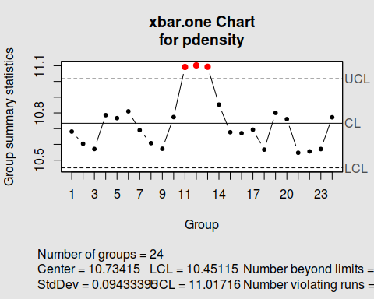

## List of 11  
## $ call : language qcc(data = pdensity, type = "xbar.one")  
## $ type : chr "xbar.one"  
## $ data.name : chr "pdensity"  
## $ data : num [1:24, 1] 10.7 10.6 10.6 10.8 10.8 ...  
## ..- attr(*, "dimnames")=List of 2  
## $ statistics: Named num [1:24] 10.7 10.6 10.6 10.8 10.8 ...  
## ..- attr(*, "names")= chr [1:24] "1" "2" "3" "4" ...  
## $ sizes : int [1:24] 1 1 1 1 1 1 1 1 1 1 ...  
## $ center : num 10.7  
## $ std.dev : num 0.0943  
## $ nsigmas : num 3  
## $ limits : num [1, 1:2] 10.5 11  
## ..- attr(*, "dimnames")=List of 2  
## $ violations:List of 2  
## - attr(*, "class")= chr "qcc"

It worked! Using R for quality control is great :)