**Potential Watermelon Cutting Mapping Project**

John K. Schueller *(schuejk@ufl.edu)*

Watermelon is an important crop and Florida is a leading producer. Watermelons are harvested manually in a two-stage process.

In the first stage, “cutters” go through the fields identifying ripe melons and cut the vine attachments from the melons.

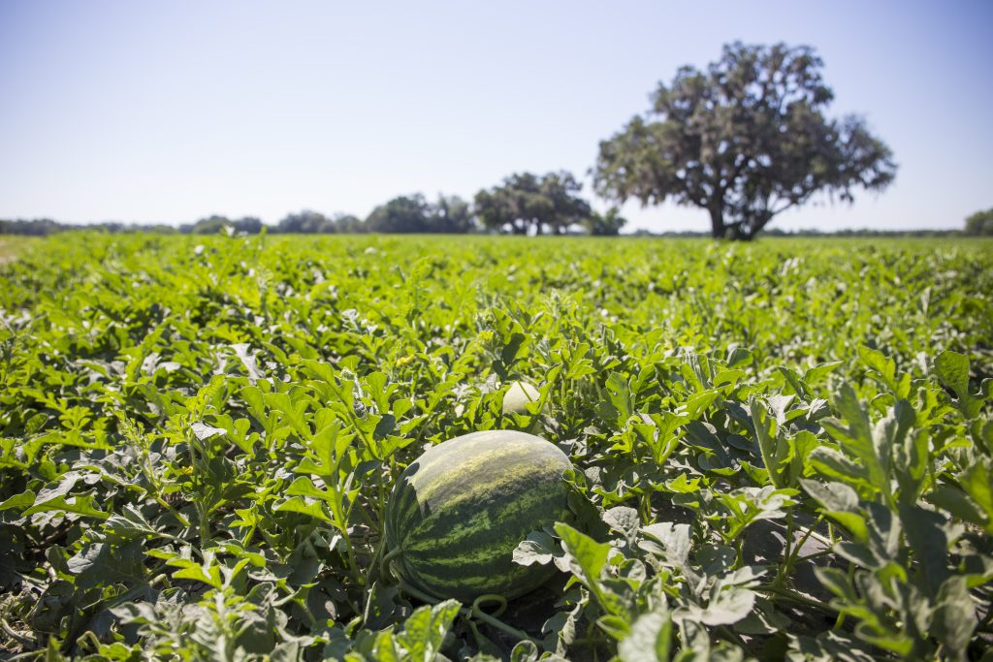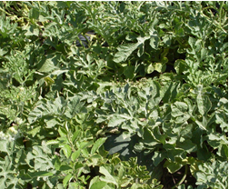

In the second stage “loaders” pick up the melons and pass them on to trucks or wagons.

We believe we can mechanize the loading process if we know which melons are ripe and where they are.

The project is to develop an instrumented shears and/or knife that will record the location of where each cut is made by the “cutters” so that the watermelon to be harvested are identified and mapped. It would also be helpful for horticultural reasons to know the force required to cut the vine.

The introduction to a patent (10,055,700) we were given says:

The georeferenced information (we will work on product characteristics later) of where watermelons are harvested would be very useful for such items as:

1. Aiding harvesting and marketing management
2. Guiding a mechanized harvesting system
3. Providing the farmer information for horticultural management

Your job is to develop a tool that will not significantly adversely affect the cutter or his/her work, but will provide an accurate map of where the watermelons have been cut. It would also be useful if the cutting force was included with the georeferenced location.

This map below (of a totally different situation) shows locations put on a map:

We would like something similar for the watermelon cutting.