BFP SITEPROFILER: A GIS-INTEGRATED WEB-BASED SYSTEM FOR MANAGING ESTABLISHMENTS IN CATANUANES

______________________________

A Capstone Project
Presented to the Faculty
of the College of Information and Communications Technology
Catanduanes State University
Virac, Catanduanes

In Partial Fulfillment of the
Requirements for the Degree
Bachelor of Science in Information Systems

______________________________

BENNY JANE T. TIMWAT
NORIEL CALUMPAD
JASON PAUL SAMAR
DONNA T. EUBRA
JAY-AR BONGON

TABLE OF CONTENTS

Project Context 1
Purpose and Description 3
Objectives 4
Scope and Limitations 5
Conceptual Framework 10
CHAPTER 2 14
REVIEW OF RELATED LITERATURE/SYSTEMS 14
CHAPTER 3 28
TECHNICAL BACKGROUND 28
Hardware Requirements 28
Software Requirements 29
Data Requirements 30
User Requirements 31
CHAPTER 4 34
DESIGN AND METHODOLOGY 34
Requirements Analysis 34
Requirements Documentation 37
Data Gathering Procedure 60
Respondents of the Study 61
Statistical Tool 63
A. Books 66
B. Journals/Conferences 66
C. Websites 69
D. Other Sources 69

LIST OF FIGURES
Figure 1. Conceptual Framework 10
Figure 2. GIS Integration Framework 13
Figure 3. Activity Diagram (Existing Process) 37
Figure 4. Data Flow Diagram (Level 1) 46
Figure 5. Use Case Diagram 50
Figure 6. Swimlane Diagram 52
Figure 7. Entity Relationship Diagram 55
Figure 8. System Architecture 57
Figure 9. Login page 58
Figure 10 Admin Dashboard (Admin side) 59
Figure 11. Establishment Directory (Admin side) 61
Figure 12 Schedule Inspection (Admin side) 63
Figure 13 Reports (Admin side) 64
Figure 14 . User Management (Admin side) 65
Figure 15 Inspector Dashboard 66
Figure 16 Assigned Inspection 66
Figure 17 Report Findings 68
Figure 18 login 69
Figure 19 User Dashboard 69
Figure 20 User Establishments 70
Figure 21 Certificates 70
Figure 22 Documents 71
LIST OF TABLES
Table 1 Hardware Requirements 30
Table 2 Software Requirements 31
Table 3 Data Requirements 32
Table 4 User Requirements 34
Table 5 Functional Requirements 40
Table 6 Non-Functional Requirements 42
Table 7 Respondents of the Study 77
Table 8 Likert Scale 80

CHAPTER 1
INTRODUCTION

Project Context
In an era increasingly driven by digital transformation, public service institutions are expected to modernize their operations to improve efficiency, accountability, and service delivery. Government agencies around the world have been transitioning from manual systems to digital platforms to better manage information, streamline workflows, and ensure transparency in their processes. As emphasized by Vinson (2024), Records Management Systems (RMS) are now seen as vital tools in public safety organizations, particularly for managing large volumes of sensitive data with accuracy and speed. The modernization of these systems supports regulatory compliance, improves decision-making, and strengthens emergency response capabilities.
Fire departments are among the critical government agencies that greatly benefit from digital transformation. Their responsibilities span beyond firefighting; they are also tasked with enforcing fire codes, conducting building inspections, assessing safety risks, and maintaining records related to compliance and fees. However, in many municipalities across the Philippines, including Virac, Catanduanes, the Bureau of Fire Protection (BFP) still uses manual, paper-based systems to manage these tasks. This outdated method presents challenges such as slow data retrieval, disorganized records, and limited access during urgent situations.
In a consultation with Mr. Sherwin Gainan, a BFP officer assigned in Virac, it was revealed that establishment records, inspection logs, and fire code fee documents are stored in filing cabinets and updated manually. This leads to issues such as loss or damage of physical files, difficulty in identifying which establishments are compliant or delinquent, and confusion in tax tracking. These inefficiencies compromise the ability of BFP personnel to enforce fire safety regulations effectively and respond quickly during inspections or emergencies.
The growing number of establishments in the municipality exacerbates these issues, placing additional pressure on BFP officers to manage compliance and safety records efficiently. Without an automated system, they are unable to provide real-time updates or generate reports quickly, hindering both planning and enforcement activities. Moreover, the lack of a geospatial component makes it difficult for the agency to visualize high-risk areas and allocate resources accordingly.
To address these limitations, the proposed capstone project titled BFP SiteProfiler: A Web-Based GIS-Integrated System for Managing Establishments in Virac, Catanduanes, seeks to digitize the entire profiling process. The system will enable BFP personnel to register establishments, schedule inspections, monitor compliance, manage fire code tax records, and map building locations using Geographic Information Systems (GIS). By providing centralized access to real-time data, the system enhances organizational workflow and supports data-driven decision-making.

GIS integration, in particular, offers a powerful feature for fire safety monitoring. As supported by studies on smart urban planning and emergency response, GIS tools help visualize risk patterns, track incidents, and optimize inspection coverage (Esri, 2023). By incorporating Leaflet.js, the proposed system will allow BFP officers to identify clusters of non-compliant establishments and prioritize inspections based on risk level. This spatial awareness improves operational readiness and supports proactive fire prevention strategies.
Ultimately, the BFP SiteProfiler addresses not only operational gaps but also contributes to broader goals of public safety and digital governance. By transitioning from manual to digital records management, the Bureau of Fire Protection in Virac will be better equipped to safeguard lives and properties, enforce compliance, and fulfill its mandate as mandated by the Fire Code of the Philippines. This project is timely, innovative, and scalable offering a model that can be replicated in other municipalities with similar challenges.

Purpose and Description
. The purpose of the BFP SiteProfiler is to develop a centralized, web-based platform that will support the Bureau of Fire Protection (BFP) in Virac, Catanduanes in digitally managing establishment records, inspection schedules, fire safety compliance monitoring, and fire code tax tracking. The system is designed to replace the current paper-based process, which has proven inefficient and prone to errors. By implementing a GIS-integrated solution, the project seeks to modernize fire safety operations, enable faster access to vital records, and assist BFP personnel in visualizing establishment locations for better risk assessment and emergency preparedness.
The system will provide key functionalities including establishment registration, inspection scheduling and logging, compliance monitoring, and an interactive geolocation map powered by Leaflet.js. These features aim to improve operational efficiency by minimizing paperwork, reducing delays in inspection reporting, and ensuring accurate documentation of fire code payments. Furthermore, the platform’s user-friendly interface will help BFP staff manage data more effectively, make informed decisions, and enhance communication with other agencies and stakeholders. This digital solution not only supports daily BFP operations but also contributes to the broader goals of public safety, transparency, and disaster risk reduction.

Objectives
The main objective of this project is to design and develop a GIS-integrated, web-based system that will help the Bureau of Fire Protection (BFP) in Virac, Catanduanes efficiently manage and monitor building and establishment profiles, fire safety compliance, and fire code tax records, while ensuring effective communication with establishment owners.
Specifically, the objectives are the following:
- To develop a web-based system for managing establishments in Virac, Catanduanes that will enable BFP personnel and Establishment owner to register establishment, schedule inspection, monitor compliance, and manage fire code tax records.
- To integrate Geographic Information System that will locate establishments.
- To evaluate the BFP SiteProfiler system using the ISO/IEC 25010 standard, with assessments conducted by technical experts and selected BFP personnel, based on the following quality characteristics:
a) Functional Suitability
b) Performance Efficiency
c) Compatibility
d) Reliability
e) Security
f) Maintainability
g) Portability

Scope and Limitations
The BFP SiteProfiler is designed to help the Bureau of Fire Protection in Virac, Catanduanes, manage establishment data and fire safety inspections more efficiently. It offers a centralized, web-based platform where BFP personnel can register establishments, track inspections, monitor compliance, and issue fire safety certificates. A key feature is the integration of GIS, which enables users to visualize establishment locations on a map, facilitating the BFP's planning and prioritization of inspections. The system also lets business owners register and monitor their compliance status, making the whole process more transparent and accessible for both sides.
The system offers many improvements over manual processes, it does have a few limitations. It works through a web browser but lacks a dedicated mobile app, which may impact convenience for some users. It also doesn’t connect with other government databases like those of the DTI or the Treasurer’s Office, which could have made data sharing easier. Since this is a student-developed project, it's being tested only in a limited environment, so its performance on a larger scale hasn’t been fully evaluated yet. Also, the system doesn't include emergency dispatch features, and its security testing is basic due to limited resources.

Definition of Terms
This section provides definitions of key terms used throughout the study to ensure clarity and consistent understanding. These terms include system features, regulatory concepts, and evaluation parameters based on the ISO/IEC 25010 software quality model.
Administrative Access refers to the role assigned to authorized BFP personnel who are responsible for performing core system functions such as managing user accounts, updating establishment records, scheduling inspections, and monitoring compliance data.
Bureau of Fire Protection (BFP) is the primary user of the system, utilizing it to streamline the management of inspections, compliance monitoring, certificate issuance, and fire safety records.
Compliance Tracking is a system function that allows BFP officers to monitor inspection history, determine the compliance status of establishments, and issue reminders or enforcement actions when safety standards are not met.
Digital Establishment Registration is the online process through which establishment owners submit their business details, location, and fire safety documentation to the BFP for initial profiling and future inspections.
Establishment refers to any commercial, institutional, or public building within Virac, Catanduanes, that falls under the jurisdiction of the BFP for fire safety inspections and monitoring.
Fire Code Fee is a regulatory charge collected by the BFP based on the risk classification and size of an establishment. The system enables tracking and verification of fee payment as part of compliance management.
Fire Safety Certificate (FSC) is an official document issued by the BFP to establishments that have passed inspection. Through the system, compliant establishment owners can securely download their FSC.
Fire Safety Inspection is the standardized evaluation conducted by BFP inspectors to assess whether an establishment adheres to fire safety protocols. The BFP SiteProfiler system facilitates digital logging and tracking of these inspections.
Functionality (Functional Suitability) measures the extent to which the system fulfills its intended purpose for the BFP, including establishment registration, inspection scheduling, GIS mapping, report generation, and compliance monitoring.
Geographic Information System (GIS) is an interactive digital mapping tool integrated in the system using Leaflet.js. It enables BFP personnel to visualize the physical locations of establishments for inspection planning and fire risk awareness.
Geolocation refers to the GPS-based capture of an establishment’s exact coordinates during on-site inspections or registration. This feature helps BFP accurately place establishments on the GIS map.
Inspection Logging is the module used by BFP inspectors to record findings, status updates, and remarks during or after fire safety inspections, forming a digital trail for compliance assessment.
Interaction Capability refers to how efficiently and intuitively BFP staff and establishment owners can interact with the system. It covers aspects such as operability, learnability, error prevention, and system interface responsiveness.
ISO/IEC 25010 is a software quality evaluation standard used in this study to assess the BFP SiteProfiler system based on key parameters such as functionality, interaction capability, reliability, performance efficiency, maintainability, security, compatibility, and portability.
Maintainability defines how easily the BFP SiteProfiler can be modified, debugged, or improved by developers to address future needs of the BFP, including updates to inspection workflows or data handling.
Performance Efficiency evaluates the speed and responsiveness of the system when BFP personnel perform tasks such as form submissions, report generation, or map interactions, especially during high-volume operations.
Portability refers to the ability of the system to operate smoothly on different devices and environments, allowing the BFP to implement the same system across various offices or relocate it with minimal reconfiguration.
Reliability ensures that the system performs consistently and accurately during critical BFP tasks, including inspections, certificate issuance, and compliance reporting.
Role-Based Access Control (RBAC) is a security feature that ensures BFP administrators, inspectors, and establishment owners can only access the system functions assigned to their roles, protecting sensitive information and maintaining workflow integrity.
Security refers to the safeguards built into the system to protect BFP and establishment data from unauthorized access, breaches, and tampering. This includes user authentication, session tracking, and encrypted data transmission.
System Dashboard is a centralized interface that displays summaries of inspections, compliance metrics, and user activity, providing BFP administrators and staff with quick access to key information for decision-making.
User Management is an administrative function that allows BFP system administrators to create, modify, and manage user accounts and assign access rights based on roles (e.g., admin, inspector, owner).
Web-Based System refers to the system’s browser-accessible architecture, which allows BFP staff and establishment owners to access and interact with the platform from any internet-connected device without needing to install software.

Conceptual Framework
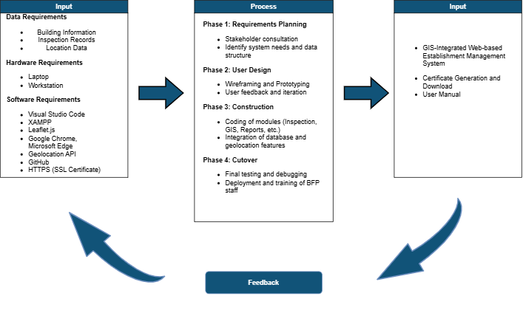
Figure 1. Conceptual Framework
The development of the BFP SiteProfiler, a GIS-integrated web-based system for managing fire safety inspection and establishment data in Catanduanes, follows an Input-Process-Output (IPO) model integrated with the Rapid Application Development (RAD) methodology. This conceptual framework outlines the essential components that contribute to the successful planning, development, and deployment of the system. The model begins with clearly defined inputs—comprising data, hardware, and software requirements—which serve as the foundation for building the system.
The input phase includes key data requirements such as building information, inspection records, and location data. These datasets are essential for profiling establishments, monitoring compliance, and mapping their exact locations using GPS. Hardware requirements include laptops and workstations, which are used by BFP personnel to access and operate the system, whether in administrative offices or during field inspections. The software requirements comprise tools and platforms that enable both development and usage of the system. These include Visual Studio Code for source code editing, XAMPP for setting up a local web server environment, Leaflet.js for GIS integration, and browsers like Google Chrome and Microsoft Edge for accessing the application. Additionally, Geolocation APIs are used for capturing location data, GitHub is utilized for version control and collaboration, and HTTPS via SSL certificates ensures secure access and enables browser-based geolocation features.
The process phase of the framework outlines the four main stages of RAD: Requirements Planning, User Design, Construction, and Cutover. In the Requirements Planning phase, consultations are held with stakeholders—specifically BFP personnel—to gather system requirements and understand operational workflows. This helps identify the necessary data structure and core functionalities of the system. In the User Design phase, wireframes and prototypes are developed based on stakeholder input. These are subjected to continuous feedback and iteration, allowing for rapid adjustments that improve user experience and interface design. The Construction phase follows, where the core modules of the system are coded. These include features for recording inspections, mapping establishment locations using GIS, and generating reports. During this phase, integration of the database and geolocation functionalities is prioritized to ensure that data is consistent, accurate, and interactive. Finally, the Cutover phase involves testing the system for bugs, performing final refinements, and deploying the application. Training is provided to BFP staff to ensure they can fully operate and maintain the system post-deployment.
The output phase highlights the deliverables of the project. These include a fully working GIS-integrated web-based establishment management system, which provides functionalities such as establishment profiling, inspection monitoring, risk zone visualization through maps, and compliance tracking. An additional feature is the automatic generation and download of fire safety certificates for compliant establishments, streamlining documentation. A comprehensive user manual is also developed to guide BFP personnel in using the system effectively.
Central to this IPO model is the inclusion of a feedback mechanism. Feedback is collected throughout all stages of development, particularly during user design and testing, to ensure that the system remains aligned with the actual needs and workflows of BFP personnel. This iterative loop reinforces RAD principles, promoting a flexible and collaborative development process.
In summary, the conceptual framework of the BFP SiteProfiler demonstrates a structured and iterative approach to system development. It ensures that technical requirements, end-user feedback, and organizational objectives are cohesively addressed. As a result, the output is a secure, reliable, and user-friendly system that enhances the Bureau of Fire Protection’s capacity to manage establishments, conduct inspections, and enforce fire safety compliance across Catanduanes.

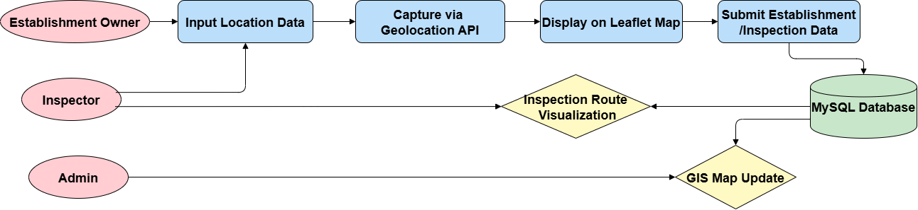
Figure 2. GIS Integration Framework
Figure 2 illustrates the data flow framework for the GIS integration component of the BFP SiteProfiler system, which combines Leaflet.js and the browser-based Geolocation API to support real-time mapping of establishments and inspection data. This framework outlines the digital process that captures geolocation data, plots it on an interactive map, stores it in a centralized database, and uses it to enhance fire safety operations through spatial visualization and planning.
The process begins when either the Establishment Owner or the assigned Inspector initiates a system interaction that requires the input of location data. This occurs during establishment registration or while logging inspection details. The user can either allow the browser to automatically capture their current location via the Geolocation API or manually pin their position on the map. When GPS is enabled, the system prompts the browser to access the device’s geographic coordinates, typically latitude and longitude, through the navigator.geolocation function. Once permission is granted, the coordinates are retrieved and used to identify the precise location of the establishment.
Following location capture, the coordinates are processed and displayed on the system’s embedded Leaflet.js map. This interactive map renders the data visually, allowing users to view the marked establishment in its actual position. Through Leaflet’s features such as custom markers and zoom controls, users can confirm the location or make necessary adjustments. This step ensures spatial accuracy and provides a visual interface for both inspectors and administrators to assess establishment distribution and monitor compliance status directly from the map.
After the location is verified, the next step involves the submission of establishment or inspection data. This includes business or inspection information, the captured coordinates, user credentials, and timestamps. The system processes this data and stores it in a centralized MySQL database, where the establishment and inspection records are organized and maintained. Each entry in the database includes corresponding geolocation values, ensuring that spatial data is integrated into every relevant transaction and accessible for future reference.
Once stored, the data supports two primary outputs. The first is the automatic update of the GIS map view. Establishments are visualized on the map using color-coded markers based on their compliance status—for example, red for non-compliant, green for compliant. This allows administrators and inspectors to easily monitor inspection outcomes and identify high-risk zones. The second output is the generation of route visualizations for inspectors, which helps plan inspection visits efficiently by grouping nearby establishments and minimizing travel time.
Throughout the process, the system ensures data security and integrity. Geolocation data is accessed only over secure HTTPS connections, and users must explicitly grant permission for GPS tracking. All submitted coordinates are validated before storage, and manual fallback options are available in case geolocation is blocked or unsupported on the user’s device.

CHAPTER 2

REVIEW OF RELATED LITERATURE/SYSTEMS
This chapter presents a collection of relevant literature and systems that support the development of the BFP SiteProfiler: A GIS-Integrated Web-Based System for Managing Establishments in Catanduanes. The discussion is organized thematically in alignment with the project's objectives, focusing on digital profiling, GIS integration, fire risk assessment, compliance monitoring, and software quality evaluation.
Building Profiling and Compliance Monitoring
The transition from traditional, paper-based systems to structured building profiling in public service sectors—particularly in fire safety management—aims to enhance data accuracy, operational efficiency, and regulatory compliance. By implementing centralized platforms for managing building information, agencies like the Bureau of Fire Protection (BFP) can conduct timely inspections, monitor safety standards, and maintain well-organized records. This section presents studies that highlight the value of standardized building data and automated compliance tracking—core functions that are built into the BFP SiteProfiler system.
Astrero and Bitonio (2022) looked into how records were being managed at the Bureau of Fire Protection (BFP) in Rizal and found several problems. They pointed out that documents were often poorly organized, stored in overcrowded filing cabinets, and hard to retrieve when needed. This made it difficult for staff to keep track of inspections and compliance records. They recommended setting up a digital records management system to make things more efficient and reliable. Their findings support the need for systems like the BFP SiteProfiler, which offers a more organized and accessible way to handle establishment profiles and inspection data.
Similarly, Malimban (2025) explored how the BFP and the Bureau of Jail Management and Penology (BJMP) have started shifting from manual to digital systems. The study highlighted how this transition helped improve day-to-day operations, especially in areas like computing fire code fees, issuing certificates, and accessing important records. By digitizing these tasks, the agencies were able to reduce delays, minimize errors, and make their services more efficient. These improvements reflect the same goals behind the BFP SiteProfiler, which aims to simplify and modernize fire safety management through a centralized digital platform.
Wallace et al. (2025) offered a broader societal perspective by examining digital risk-profiling in England’s private rented sector. Their research revealed how digital profiling is increasingly used to assess individuals and properties based on pre-determined risk factors. The study raised important concerns about transparency, data fairness, and algorithmic bias, particularly when profiling systems are used to make decisions that affect access to housing or services. While the BFP SiteProfiler does not operate in a housing market context, this study underscores the need for responsible data handling, clear criteria in compliance scoring, and safeguards against unintended consequences when using digital profiling in public systems. It reinforces the importance of ethical design, especially when profiling affects service delivery or public safety enforcement.
Complementing this, Morichetta et al. (2025) presented a technical perspective on profiling in their study They proposed a framework that uses metadata and historical execution traces to efficiently predict resource demands in distributed computing environments. Their profiling method enables more informed decision-making through accurate workload classification and system responsiveness. While their research focuses on cloud and edge computing, the principles behind metadata-based profiling—such as pattern recognition, predictive modeling, and resource optimization—align with the goals of the BFP SiteProfiler. By tracking inspection histories and compliance patterns, the system can prioritize high-risk establishments and support more efficient planning and deployment of fire safety resources.
Additionally, the Department of the Interior and Local Government–NCR (2024) launched the integration of the Bureau of Fire Protection’s e-Fire Safety Inspection System (e-FSIS) into the eLGU portal in Pateros. This initiative enables business owners to apply for Fire Safety Inspection Certificates online, reducing manual processing and improving transparency. It highlights a growing trend in digital transformation within government agencies, showing how online systems can support faster service delivery and better compliance monitoring—goals that align directly with the features of the proposed BFP SiteProfiler.
The reviewed studies clearly emphasize the growing importance of digital profiling and compliance monitoring in public safety services. Shifting from manual to digital systems, as seen in the experiences of the BFP, BJMP, and e-FSIS integration, leads to more accurate records, faster processes, and better service delivery. Research by Astrero, Malimban, and the DILG-NCR supports this transition by showcasing real operational benefits. At the same time, works by Wallace and Morichetta offer deeper insights into the technical and ethical aspects of digital profiling, reminding system developers to be mindful of data fairness, transparency, and resource efficiency. Altogether, these studies support the development of the BFP SiteProfiler as a centralized digital platform designed to enhance inspection workflows, improve compliance tracking, and promote responsible use of technology in fire safety management.
The transition from traditional, paper-based systems to structured building profiling in public service sectors particularly in fire safety management aims to enhance data accuracy, operational efficiency, and regulatory compliance. By implementing centralized platforms for managing building information, agencies like the Bureau of Fire Protection (BFP) can conduct timely inspections, monitor safety standards, and maintain well-organized records. This section presents studies that highlight the value of standardized building data and automated compliance tracking—core functions that are built into the BFP SiteProfiler system.

Geographical Information System (GIS) Map Building
Geographic Information System (GIS) technology has become a vital asset in modern fire safety management, particularly in mapping and monitoring building data across different locations. Through spatial visualization, GIS enables agencies to create accurate, interactive maps of establishments, which supports more efficient planning of inspections and resource deployment. By integrating location-based data with building profiles, GIS enhances overall coordination, situational awareness, and emergency response. This section explores studies that illustrate the value of GIS in building mapping an approach that plays a central role in the BFP SiteProfiler’s ability to organize and display establishment data geographically.
Sivrikaya and Küçük (2022) developed a fire risk assessment model using GIS combined with the Analytical Hierarchy Process (AHP) and statistical analysis to map forest fire risks in the Mediterranean region of Turkey. Their model considered multiple environmental factors—including forest structure, topography, and climate—to produce highly accurate fire risk maps. With a validation accuracy of 77.5%, the study showed how GIS, when integrated with decision-making tools like AHP, can effectively identify areas at high risk for fire incidents. Although focused on natural landscapes, the approach demonstrates how structured, data-driven GIS models can be adapted for urban environments to improve fire safety planning and resource deployment—similar to how the BFP SiteProfiler aims to visualize risk-prone zones in Catanduanes.
Urbina et al. (2023) conducted a study in Guimarães, Portugal, using GIS technology to assess the fire risk and spatial vulnerability of critical infrastructure in historic urban areas. Their model created detailed maps showing how fire hazards can affect both individual buildings and surrounding zones, helping authorities prioritize areas that need the most attention. The research highlighted the value of GIS in identifying interdependencies between infrastructure components, allowing for better emergency planning and targeted risk mitigation. This approach supports the idea that GIS can be a powerful tool not only for visualizing risks but also for enhancing long-term fire safety strategies—an idea that directly aligns with the purpose of the BFP SiteProfiler in monitoring and managing high-risk zones in Catanduanes.
Pongsin, Ruenwicha, and Nontasawatsri (2024) developed a structured fire risk assessment model tailored for hospital buildings in urban areas, guided by NFPA 551 and OHSAS 18001 standards. Their model evaluated four key areas: hazard identification, fire opportunity assessment, fire severity, and risk management. Using input from experts and simulated scenarios, the study found that certain hospital zones had significantly higher fire risk levels, particularly in areas with dense equipment and high occupancy. Although the model was designed specifically for healthcare facilities, it demonstrates how structured, criteria-based assessment can be used in public safety planning. This methodology reinforces the importance of risk-based inspection, a principle that is integrated into the BFP SiteProfiler through its use of GIS for mapping and prioritizing high-risk establishments.
Manun-og et al. (2022) developed a records management system integrated with GIS technology to support the Bureau of Fire Protection (BFP) in Hinunangan, Southern Leyte. The system was designed to streamline the monitoring of business and building compliance records, with GIS features enabling precise location mapping and improved response planning. Evaluated using the ISO 9126-1 software quality model, the system received positive feedback for its functionality, usability, and efficiency. This study shows how GIS can enhance transparency and operational coordination in fire safety enforcement, aligning directly with the goals of the BFP SiteProfiler in managing establishment data and visualizing fire risk zones in Catanduanes.
Salman, Karouni, Hamadeh, and Rachid (2023) proposed a comprehensive approach to forest fire risk mapping by combining the Analytical Hierarchy Process (AHP), Geographic Information System (GIS), and remote sensing. Their study emphasized the use of environmental factors—such as vegetation type, slope, and proximity to human activity—to identify and prioritize high-risk areas in Lebanon. The integration of remote sensing allowed for dynamic data collection, while GIS visualized risk zones with high spatial accuracy. Although their focus was on forest environments, the methodology demonstrates how multi-layered data analysis and spatial tools can be applied to urban fire safety systems. This aligns with the BFP SiteProfiler's goal of using GIS to visualize compliance levels and identify fire-prone establishments based on multiple risk indicators.
The reviewed studies emphasize the valuable role of GIS in building accurate, data-driven maps that support strategic decision-making in public safety. From urban centers in Portugal and Lebanon to forest regions in Turkey, GIS has been effectively used to visualize spatial data, identify critical zones, and support organized planning efforts. In particular, the GIS-integrated system implemented in BFP Hinunangan illustrates how map-based tools can enhance transparency, operational efficiency, and disaster readiness. These examples affirm the importance of GIS in the BFP SiteProfiler, which uses map building to help fire departments in Catanduanes manage establishment data, monitor compliance, and coordinate inspection activities through geographic visualization.

Evaluation ISO/IEC 25010 Software Quality Standards
Evaluating software quality is essential, especially for systems that manage sensitive data and support public services. One widely accepted framework for assessing software is ISO/IEC 25010, which outlines key quality characteristics such as functionality, reliability, usability, efficiency, security, and maintainability. These criteria help ensure that a system performs well, is easy to use, and protects user information. In the case of the BFP SiteProfiler, applying ISO/IEC 25010 provides a structured way to measure whether the system meets its intended goals and satisfies user expectations. This section reviews studies that used the ISO/IEC 25010 standard to evaluate various software systems, providing useful insights that guide the evaluation approach for the proposed system.
Canlas, Piad, and Lagman (2021) developed a faculty research productivity monitoring and prediction system and evaluated it using ISO/IEC 25010 standards. Their assessment—conducted with IT experts and administrators—focused on eight quality characteristics including functionality, performance efficiency, usability, reliability, security, and maintainability. The evaluation confirmed that the system met high software quality standards and was ready for deployment. This study reinforces the importance of ISO/IEC 25010 as a practical tool for assessing software performance in real-world public and academic information systems and supports its adoption in evaluating the BFP SiteProfiler.
Budi et al. (2022) evaluated a news portal website (Jitunews) using both ISO/IEC 25010 and McCall methods. The study involved collecting user feedback on backend and frontend modules, assessing quality attributes such as performance efficiency, security, and functional suitability. Results showed “Good” ratings overall. This case demonstrates how combining ISO/IEC 25010 with McCall can provide a comprehensive view of software quality, including user-centered insights—valuable for ensuring well-rounded evaluation of web-based systems like the BFP SiteProfiler.
Haryasena, Saputra, Azzahra, and Aniko (2021) evaluated a smart ERP accounting system used by SMEs, focusing on its functional suitability based on ISO/IEC 25010 standards. Their study assessed how well the system supported processes like invoicing, financial reporting, and inter-department data flow. Using input from stakeholders, the evaluation concluded that the system met the necessary quality criteria, highlighting functional suitability as a key factor in ensuring the system's capability and alignment with business needs. Their findings reinforce the importance of customizing ISO/IEC 25010 evaluations to fit specific organizational functions, an approach also employed in the assessment framework for the BFP SiteProfiler.
Hamzah, Angraini, and Saputra (2024) evaluated a web-based scholarship information system using the ISO/IEC 25010 standard. Their study focused on attributes such as performance efficiency, usability, and security, gathering feedback from both students and academic administrators. Findings showed strong ratings in these areas, highlighting how web-based educational systems can meet user expectations through structured quality evaluations. This research demonstrates the practical use of ISO/IEC 25010 for both technical and user-centered perspectives, offering valuable insights for assessing systems like the BFP SiteProfiler, where performance and ease of access are critical.
Hamzah, Angraini, and Saputra (2024) evaluated a web-based scholarship information system using the ISO/IEC 25010 standard. Their study focused on attributes such as performance efficiency, usability, and security, gathering feedback from both students and academic administrators. Findings showed strong ratings in these areas, highlighting how web-based educational systems can meet user expectations through structured quality evaluations. This research demonstrates the practical use of ISO/IEC 25010 for both technical and user-centered perspectives, offering valuable insights for assessing systems like the BFP SiteProfiler, where performance and ease of access are critical.
The reviewed studies emphasize the practical value of ISO/IEC 25010 in assessing software systems across diverse domains such as education, media, accounting, and GIS. Consistently, these evaluations highlight key quality attributes—like functionality, usability, performance efficiency, and security—as essential to achieving user satisfaction and operational success. Whether applied in academic portals, smart business systems, or public information platforms, ISO/IEC 25010 provides a reliable framework for measuring software effectiveness and aligning it with user needs. These insights directly inform the evaluation of the BFP SiteProfiler, ensuring that its design and performance meet the standards expected of a reliable, user-focused government system.

Tax Record Management
Tax record management plays a vital role in ensuring accurate tracking of government fees and compliance, especially in public safety services. By shifting from manual to digital systems, agencies can process payments faster, reduce errors, and improve transparency. In fire safety operations, managing records like fire code fees and inspection charges is essential. This section explores studies that highlight the value of efficient tax record systems and their role in supporting platforms like the BFP SiteProfiler.
Musagaliev (2024) explored how strengthening tax control mechanisms can improve the management of tax risks and audits in both public and private sectors. The study emphasized the importance of accurate recordkeeping, transparency, and systematic audits to ensure tax compliance. It also highlighted challenges such as inconsistent data handling and limited technological integration in tax monitoring. These insights are relevant to government agencies like the Bureau of Fire Protection, which must track fire code fees and inspection-related charges. The study supports the use of digital platforms like the BFP SiteProfiler to enhance the accuracy and accountability of tax-related records.
Complementing this, Darmayasa and Hardika (2024) analyzed the implementation of core tax administration systems using the slippery slope framework of tax compliance. This study emphasized that effective tax compliance depends on the balanced exercise of authority and the cultivation of public trust. They found that digital systems which promote transparency, consistency, and fairness in tax handling significantly increase voluntary compliance. This model aligns with the goals of platforms like the BFP SiteProfiler, which aim to digitize and standardize the collection of fire-related fees while building trust through reliable and transparent recordkeeping.
Hesami, Jenkins, and Jenkins (2024) conducted a systematic literature review focusing on the digital transformation of tax administration, specifically the use of e-invoicing and prefilled tax returns. Their study found that these tools not only reduce errors and processing time but also enhance transparency and trust between taxpayers and institutions. E-invoicing automates record submission, which minimizes manual data entry and improves accuracy, while prefilled returns simplify compliance by reducing the effort required from taxpayers. These digital innovations help ensure consistency in recordkeeping and increase taxpayer confidence in the system. Their findings are highly applicable to the Bureau of Fire Protection’s ongoing efforts to improve its tax-related services through the BFP SiteProfiler, especially in areas like fire code fee management and inspection charges.
Alahira et al. (2024) examined the impact of Artificial Intelligence (AI) on tax compliance and financial regulation. Their study highlighted how AI-driven solutions can streamline tax administration processes, detect non-compliance, and mitigate tax evasion. Machine learning algorithms can analyze vast volumes of financial data with remarkable speed and accuracy, identifying patterns indicative of tax fraud or evasion. Additionally, AI-powered predictive analytics enable tax authorities to anticipate taxpayer behavior and allocate resources effectively for enforcement purposes. In financial regulation, AI technologies assist in monitoring and enforcing compliance with complex regulatory frameworks, thereby enhancing revenue collection efficiency while minimizing compliance burdens on taxpayers. These advancements align with the objectives of platforms like the BFP SiteProfiler, which aim to leverage technology to improve the efficiency and effectiveness of tax-related services.
Hossain, Ali, Ling, and Fung (2024) conducted a literature review on the factors influencing tax avoidance and evasion in Bangladesh, categorizing them into individual, corporate, and administrative factors. Key issues included low tax morale, income levels, governance weaknesses, and policy complexities. The study also noted problems in tax administration such as poor auditing, distrust in officials, and politicization. The insights from this study are pertinent to the Bureau of Fire Protection's efforts to improve tax record management, suggesting that both technological solutions and administrative reforms are necessary to combat tax avoidance and evasion effectively.
The studies reviewed highlight the importance of modernizing tax record management, especially for agencies like the Bureau of Fire Protection. Moving from manual to digital systems improves accuracy, speeds up processing, and builds public trust. Tools like e-invoicing, AI, and prefilled tax returns help reduce errors and increase compliance. However, challenges like weak governance, low tax morale, and poor auditing must also be addressed. Overall, both technology and administrative reforms are key to making platforms like the BFP SiteProfiler more effective and reliable.

Synthesis
From the reviewed studies, it's clear that GIS is a powerful tool for identifying and managing fire risks, especially in rural and natural areas. Many systems use digital maps, satellite data, and even machine learning to predict where fires are most likely to happen. These technologies help improve disaster response and planning by giving authorities a better understanding of fire-prone zones. While these solutions are useful, most of them are designed for environmental monitoring and not for everyday fire safety management in urban areas. Standards like ISO/IEC 25010 also help improve system quality by making sure it's functional, easy to use, reliable, secure, and maintainable all of which are important for a smooth and hassle-free experience for fire safety officers and staff.
One of the biggest gaps in current systems is their lack of focus on local fire departments and administrative tasks. Most tools aren't built to help track establishment records, monitor fire inspections, or manage fire code tax collections. These day-to-day operations are still handled manually in many areas, like Virac, Catanduanes, which can lead to delays, missing information, and inefficient service delivery.
This project introduces a web-based system called BFP SiteProfiler, designed specifically for local fire departments. It replaces manual, paper-based processes with a digital platform that helps manage establishment data, inspection records, tax payments, and overall compliance. One of its standout and novel features is the use of GIS not just for mapping, but for visually displaying the exact locations of establishments along with their fire safety status. This spatial representation helps officers better understand the geographic distribution of compliance, prioritize high-risk areas, and plan inspections more effectively something that traditional systems do not offer.
Another useful part of the system is the automated compliance scoring. Each establishment gets a score based on their inspection history, submitted documents, and violations. This lets fire officers quickly identify high-risk buildings and take action when needed. There’s also centralized record management, which means all the information is stored in one place, making it easier to access, update, and secure important data.
The platform also includes inspection and permit tracking, so officers can log visits and update permit statuses without relying on manual logs. To keep the system secure, user roles and access controls are set up to make sure that only authorized people can view or edit sensitive data.
In short, this project addresses the need for a modern, location-aware, and easy-to-use system tailored to the operations of local fire safety offices. The study offers a distinct contribution by applying GIS to incorporate location-based awareness into fire safety administration. This integration enables fire officers to clearly visualize establishment data, manage compliance records more efficiently, and respond effectively to safety concerns in specific areas. By combining spatial mapping, compliance tracking, and secure digital records, the BFP SiteProfiler improves operational efficiency, strengthens fire safety enforcement, and enhances the quality of public service delivery.

CHAPTER 3

TECHNICAL BACKGROUND

This chapter details the technical foundation necessary for the design, development, and deployment of the BFP SiteProfiler system. The system will serve as a centralized, web-based platform tailored for the Bureau of Fire Protection (BFP) in Virac, Catanduanes, to digitize establishment profiling, inspection tracking, compliance monitoring, and geospatial risk visualization. This section outlines the hardware, software, data, and user requirements that enable effective implementation of the system in both administrative and field contexts.

Hardware Requirements
The following table presents the recommended hardware components to support system development, deployment, and usage by BFP personnel.
Table 1 Hardware Requirements
Hardware Requirement | Specification | Description
Workstation (Admin) | Intel Core i7, 16GB RAM, 1TB HDD | Hosts the web application and database; handles multiple concurrent users.
Laptop | Intel Core i5, 8GB RAM, 500GB HDD | Used by BFP personnel to access and manage system records.

The selected hardware supports both administrative and field operations of the BFP SiteProfiler. The high-spec workstation hosts the web system and handles multiple users, while laptops allow personnel to access and update records. This setup ensures mobility, real-time data entry, and efficient system performance.

Software Requirements
The following table outlines the software components necessary for developing, deploying, and using the BFP SiteProfiler system.
Table 2 Software Requirements
Software Requirement | Specification | Description
Operating System | Windows 10 | Environment for both server and development machines.
Web Server | Apache | Handles HTTP requests and hosts the PHP application.
Backend Framework | Laravel | Used for developing the server-side functionality of the system.
Database System | MySQL | Stores user data, building records, inspection logs, and GIS coordinates.
GIS Library | Leaflet.js | Displays and interacts with geographic data on the system’s map interface.
Front-End Tools | HTML5, CSS3, JavaScript | Used to build the user interface of the system.
Browser | Google Chrome, Edge | Used by users to access the web system on desktop or mobile.
Version Control | GitHub | Manages code versioning and team collaboration.
SSL Certificate | HTTPS Enabled | Required for secure access and browser-based GPS functionalities.

The system is developed using open-source technologies to ensure flexibility and cost-efficiency. It uses PHP for backend development and MySQL for database management. XAMPP serves as the local development environment, with Apache functioning as the web server. Leaflet.js is integrated for interactive GIS mapping, while GitHub is used for version control and team collaboration. Deployment over an HTTPS-enabled server is required to ensure secure access and support browser-based geolocation features.

Data Requirements
This section describes the specific data needed to support the system’s functionality, as well as how it will be collected, stored, and processed. The data requirements of BFP SiteProfiler focus on managing establishment profiles, inspection records, geographic information, and compliance statuses. Each data type plays a critical role in generating real-time insights for fire safety monitoring and enforcement. Structured data and geolocation data are integrated to visualize risk areas and support evidence-based decision-making. The section also emphasizes how the system will automate data capture and ensure integrity through centralized storage and backups.

Table 3 Data Requirements
Construct/ Variables | Source of Data | Data Gathering Technique | Instrument | Data Processing
Building Information | Establishment Owners | Field Inspection | Mobile Form / Web Form | Stored in MySQL and displayed via dashboard
Inspection Records | BFP Inspectors | On-Site Inspection | Smartphone/ Tablet | Submitted and saved

Construct/ Variables | Source of Data | Data Gathering Technique | Instrument | Data Processing
Location Data | Geolocation | Auto-capture via  browser | Geolocation API + Leaflet | Use for mapping and risk visualization
System Evaluation | Survey Form | Descriptive method | Questionnaire based on ISO 25010 quality characteristics | (1) Mean  (2) Frequently Count  (3) Percentage

The system processes both textual and geospatial data to enable inspection tracking and mapping. Data gathered from the field is synchronized with the database for consistent record-keeping, and compliance data supports risk assessment and follow-up actions by BFP personnel.

User Requirements
This section defines the core functional modules and features of the system, mapped to specific user roles and responsibilities within the Bureau of Fire Protection. The BFP SiteProfiler is designed to cater to administrative staff, inspectors, and officers by providing them with tools to manage establishments, monitor inspections, view geospatial data, and generate reports. Each system module is described in terms of its purpose and the user types it serves. The definition of user requirements ensures that the system’s design aligns with real-world fire safety operations and enables efficient, role-based access to critical system functions.

Table 4 User Requirements
Module | Function | Description | User Role
Dashboard | System Overview | Show key metrics like active inspections and compliance rate. | Admin
User Management | Account Control | Handles registration, login, and role assignment | Admin
Establishment Registry | Record Management | Stores and updates building information | Establishment owner
Inspection Module | Field Assessment Tool | Records inspection results and findings | Inspector
GIS Map View | Location Visualization | Display establishments using Leaflet.js | Admin, Inspector
Reports Module | Summary Generation | Generates inspection reports and compliance summaries | Admin, Inspector
Backup & Recovery | Data Security | Allows for secure backup and restoration of database files | Admin
Authentication System | Access Control | Secures login access and tracks session activities | Admin, Inspector
Certificate Download | Document Access | Allows compliant owners to download Fire Safety Certificates. | Establishment owner

Table 4 presents the BFP SiteProfiler System, highlighting how each module supports the efficient management of fire safety operations in Virac, Catanduanes. The Dashboard module displays real-time metrics on inspections, compliance rates, and pending tasks, with data retrieved from inspection records and establishment profiles for quick administrative decision-making. User Management enables administrators to create accounts and assign roles such as inspector or establishment owner, ensuring access is limited to relevant modules through credential-based control. The Establishment Registry allows owners to register and update building information, which is stored in a centralized database and accessed by BFP personnel for scheduling and verification. The Inspection Module lets inspectors record safety findings, compliance statuses, and remarks via mobile or desktop devices, feeding directly into the system for monitoring and certificate processing. GIS Map View, powered by Leaflet.js, visualizes establishment locations using geolocation data, enabling area-based planning and location-aware inspections. The Reports Module compiles data from various activities to generate summaries used for tracking progress and generating official documentation. Backup and Recovery offers administrators secure tools to safeguard system data, while the Authentication System enforces login security and role verification for sensitive modules. The Certificate Download module allows compliant establishment owners to retrieve their Fire Safety Inspection Certificate (FSIC) online, reducing the need for in-person processing. Together, these modules form a centralized, digital platform that modernizes BFP workflows, improves service delivery, and enhances fire safety enforcement across the municipality.

CHAPTER 4

DESIGN AND METHODOLOGY

This chapter discusses the technical description, system features, and the methodology used for the development of the BFP SiteProfiler: A GIS-Integrated Web-Based System for Managing Establishments in Catanduanes. The project aims to improve the efficiency of establishment profiling, fire safety inspection, compliance monitoring, and spatial risk mapping by integrating modern digital technologies tailored for the Bureau of Fire Protection (BFP) in Virac.

Requirements Analysis
The development of the BFP SiteProfiler system began with a comprehensive requirements analysis. This involved consultations with BFP inspectors and administrative personnel, field observations, and a review of existing fire safety documentation and manual processes. The identified functional requirements included digital establishment registration, inspection scheduling and logging, GIS-based location mapping, compliance tracking, and automated report generation. Non-functional requirements such as system performance, data security, usability, and scalability were also defined to ensure long-term effectiveness and reliability. These requirements may be presented in a tabular format for better clarity and organization
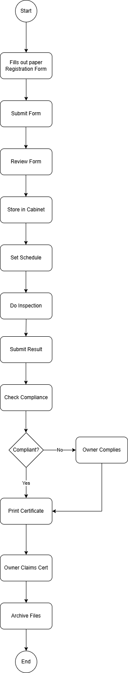
Figure 3. Activity Diagram (Existing Process)
Figure 2 illustrates the existing manual process followed by the Bureau of Fire Protection (BFP) in handling fire safety inspection requests and issuing Fire Safety Inspection Certificates (FSIC). This flowchart outlines a traditional, paper-based workflow involving form submission, inspection, compliance assessment, and certification, typically done without the aid of any centralized digital system.
The process starts when the Establishment Owner manually fills out a paper-based registration form, which is then submitted to the BFP office. After submission, the form goes through an initial review process by authorized personnel to verify its completeness and accuracy. Once reviewed, the physical form is stored in a cabinet, where all registration records are filed manually. This storage method, while simple, poses challenges in terms of retrieval, tracking, and long-term data management.
Following this, the assigned personnel set a schedule for the inspection, often by checking availability manually or coordinating through verbal or written communication. Once a schedule is set, the assigned Inspector proceeds to conduct the fire safety inspection onsite. After the inspection, the findings are written and submitted back to the office, where they are manually logged for compliance checking.
A decision point occurs during the compliance evaluation phase. The BFP checks whether the establishment complies with all fire safety requirements. If the establishment is found to be non-compliant, the owner is notified directly and asked to make the necessary corrections. Once corrections are made, the process may repeat from the inspection phase until compliance is achieved.
If the establishment is found to be compliant, the office proceeds to print the Fire Safety Inspection Certificate (FSIC). The certificate is then made available for the Establishment Owner to claim. After the certificate has been claimed, the entire set of documents and reports are archived and stored for record-keeping purposes.

Requirements Documentation
The proposed BFP SiteProfiler System aims to modernize and digitize the Bureau of Fire Protection’s (BFP) processes for managing establishments, inspections, and compliance tracking. The system must allow BFP personnel to register establishments, record fire safety inspections, and maintain up-to-date compliance records with ease and accuracy. At the administrative level, the system should provide tools to oversee inspection schedules, monitor the status of compliance, and manage user roles effectively.
To support fire risk planning and geographic decision-making, the system must include an integrated Geographic Information System (GIS) mapping module. This will allow real-time visualization of registered establishments across the municipality, aiding in efficient inspection route planning and hazard assessment.
Another critical requirement is the ability to automatically track inspection outcomes and generate reports, including inspection summaries and printable Fire Safety Inspection Certificates (FSIC). These features will enhance operational efficiency and documentation.
From a performance standpoint, the system must remain responsive during periods of high usage, such as mass inspections or data audits. It should be able to deliver timely updates across modules without compromising stability. Data security is also paramount. The system must include secure, encrypted login processes, role-based access control, and support for HTTPS, ensuring sensitive establishment and compliance data remain protected from unauthorized access.
The user interface must be intuitive, enabling accessibility even to users with limited technical skills—particularly for establishment owners accessing their records or certificates. As demand and user count increase, the system must be scalable to accommodate expansion to other municipalities and integration of additional fire safety services.
Certain assumptions, constraints, and dependencies are acknowledged in developing this system. It is assumed that users have reliable internet access and a basic understanding of system use. GIS data accuracy is presumed reliable, and sufficient server resources are expected to meet demand. The system must comply with national data privacy regulations and operate within the limits of the available budget and timeline. Browser and device compatibility is also a constraint, requiring the system to function well across major desktop and mobile platforms. Successful system implementation will also depend on reliable GIS services, server hosting, and continued collaboration with BFP stakeholders to ensure operational alignment.

Table 5 Functional Requirements
Function | Description | User Role
Register Establishment | Capture and store establishment profile data | Establishment Owner
Update Establishment Profile | Edit establishment details such as address, type, and owner information | Establishment owner

Function | Description | User Role
Log Inspection Results | Record inspection findings and compliance status | Inspector
View GIS Map | Display mapped locations of establishments using geolocation data | Admin, Inspector
Monitor Compliance | Track inspection history and fire safety compliance | Admin, Inspector
Generate Reports | Produce inspection summaries, compliance reports, and system logs | Admin
Schedule Inspection | Set inspection dates for registered establishments | Admin

Table 5 outlines the system’s functional requirements and links each function to its respective user role. These core functions support streamlined inspection workflows, improved communication, and accurate recordkeeping across all fire safety operations. Establishments are registered by owners who provide vital details, forming the foundation for inspections. Administrators and staff can update profiles to reflect any changes, helping maintain data accuracy. Admins also schedule inspections, ensuring that every establishment undergoes evaluation at regular intervals. Inspectors then log the inspection results, including any safety violations and compliance outcomes.
A GIS map allows BFP staff to visualize the geographic spread of establishments for inspection routing and hazard analysis. Compliance tracking is continuously updated to reflect inspection outcomes and helps staff monitor repeat violators or overdue inspections. Reports generated by the system aid in auditing, reporting to higher BFP offices, or issuing legal compliance notices. Owners can access and download their Fire Safety Inspection Certificates, reducing walk-in inquiries and manual requests. User management ensures the right access to each role, and a backup function protects against data loss during emergencies or system issues.
Table 6 Non-Functional Requirements
Requirement | Description
Performance | Fast data processing and page load
Scalability | Supports an increasing number of users and stored records
Security | Role-based access control, encrypted data, and HTTPS support
Reliability | Consistent system availability and accurate logging
Usability | Easy-to-navigate interface suitable for both staff and owners
Maintainability | Easy to update, debug, and enhance using Laravel framework
Compatibility | Runs smoothly on major browsers.
Portability | Accessible on desktop and mobile browsers; no app install needed

Table 6 summarizes the non-functional requirements essential for a dependable, high-performing, and secure system.
Performance ensures that BFP staff and establishment owners can interact with the system seamlessly—especially during busy periods such as fire prevention month or mass inspection campaigns. Scalability allows the system to grow with future expansion, accommodating more users, municipalities, or additional BFP services.
Security protects both sensitive user credentials and private establishment data through encrypted communication and access controls that prevent unauthorized usage. Finally, reliability assures that the system remains accessible when needed, including during critical emergencies, and that actions are properly logged for audit and transparency.
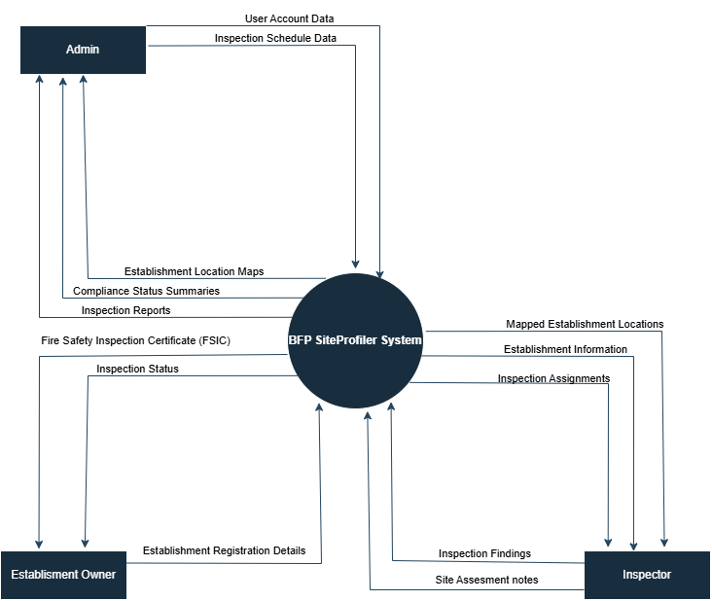
Design of Software, Systems, Product and/or Processes
Figure 3. Context Diagram
Figure 3 shows the context diagram of how the BFP SiteProfiler System facilitates communication and coordination among Admins, Inspectors, and Establishment Owners in managing fire safety inspections and compliance monitoring activities.
The Admin plays a central role in the system’s operations by overseeing the management of users, scheduling inspections, and reviewing compliance reports. The Admin inputs data into the system such as user account details and inspection schedules. In return, the system provides the Admin with inspection reports, compliance status summaries, and establishment location maps via the integrated GIS feature. These outputs allow the Admin to monitor the inspection progress, evaluate establishment compliance, and support operational decision-making. The Admin also uses the system to manage user access, view mapped locations of establishments, and oversee the overall workflow of inspections and reporting.
The Inspector is responsible for conducting fire safety inspections and submitting results through the system. The system assigns inspections to Inspectors and provides them with establishment details and mapped locations, ensuring they can accurately locate and assess the assigned establishments. Once the inspection is completed, the Inspector submits inspection findings and site assessment notes back to the system. These data inputs are then processed and reflected in inspection records and compliance reports, which are accessible by the Admin and viewable by the Establishment Owner.
The Establishment Owner interacts with the system by registering their business and submitting relevant details. They receive inspection status updates from the system and, upon compliance, are issued a Fire Safety Inspection Certificate (FSIC). This interaction ensures that owners are informed of their compliance standing and can obtain official documentation as proof of meeting fire safety standards.
By integrating these roles and automating the exchange of data between them, the BFP SiteProfiler System ensures transparency, operational efficiency, and accurate compliance tracking. The inclusion of GIS mapping provides location-based visualization of establishments for better field planning, while centralized access to reports and status updates supports effective communication across all user levels.
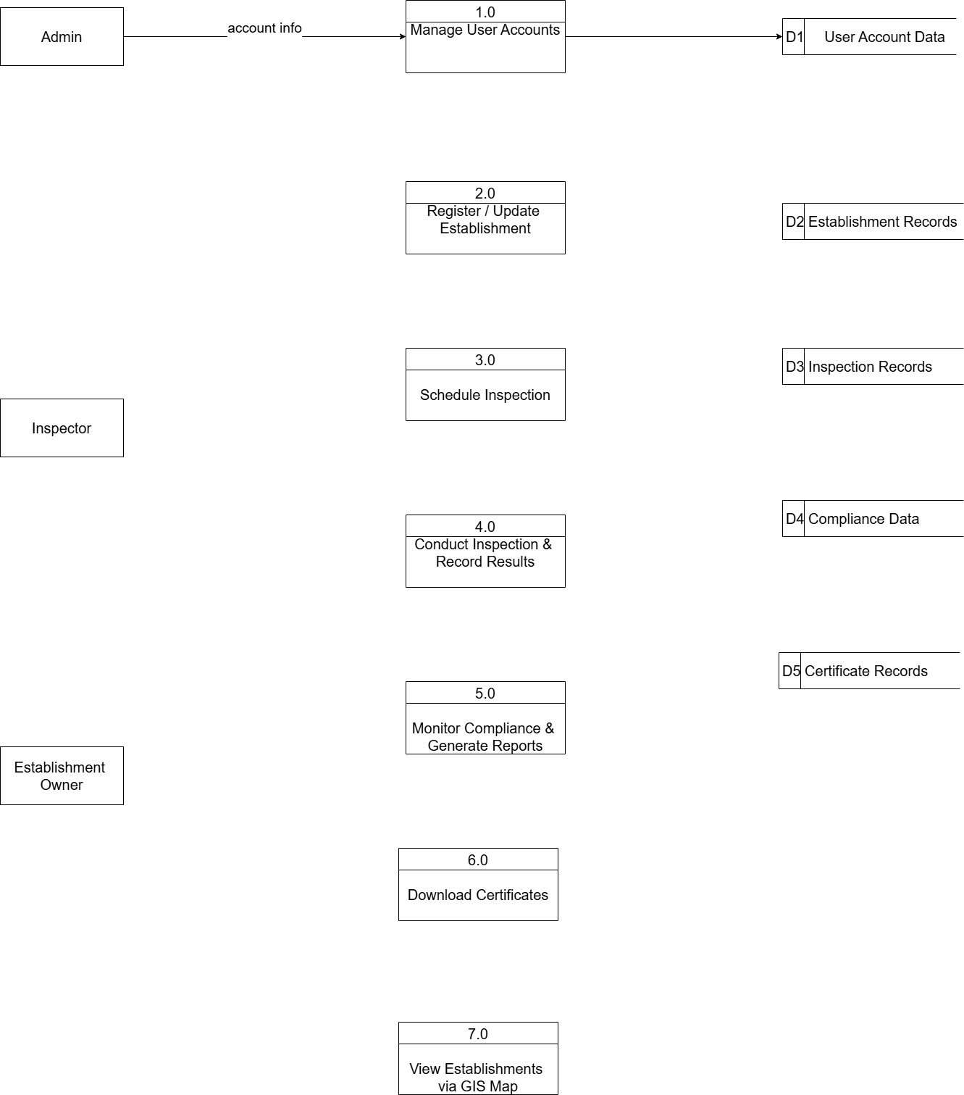\
Figure 4. Data Flow Diagram (Level 1)
Figure 4 illustrates the Data Flow Diagram (DFD) Level 1 of the BFP SiteProfiler System, showing how the system processes data through its key functions and interacts with its external entities—Admin, Inspector, and Establishment Owner—as well as its internal data stores. This diagram provides a detailed breakdown of the main process into sub-processes and emphasizes the flow of data in noun form, consistent with standard DFD conventions.
The system is composed of seven main processes, each associated with a specific user action and corresponding data flow. The diagram also highlights five internal data stores used to retain essential information related to users, establishments, inspections, compliance records, and certificates.
The first process, 1.0 Manage User Accounts, allows the Admin to manage user registration and role assignments. The Admin inputs account registration information into the system, which then provides login credentials and role assignments. The data is stored in D1: User Account Data, maintaining the necessary records for system access and user management.
The second process, 2.0 Register and Update Establishment, is initiated by the Establishment Owner, who submits establishment information to the system. The system responds with confirmation or update results and stores the data in D2: Establishment Records, ensuring the establishment profiles are maintained and updated for inspection and compliance tracking.
In 3.0 Schedule Inspection, the Admin sends a schedule request, which the system processes and outputs as an inspection schedule to the assigned Inspector. This schedule is recorded in D3: Inspection Records, which serves as the log of all inspection planning activities.
The 4.0 Conduct Inspection and Record Results process involves the Inspector submitting inspection data, including findings and site observations. These are processed by the system and stored as inspection logs and compliance status in D3: Inspection Records and D4: Compliance Data, respectively. The inspection findings are then made accessible to both the Admin and the Establishment Owner for reference and action.
Next, in 5.0 Monitor Compliance and Generate Reports, the Admin can request compliance status updates. The system retrieves and processes this information from D4: Compliance Data, then generates and returns detailed compliance reports and inspection summaries for administrative review.
The 6.0 Download Certificates process supports the issuance of the Fire Safety Inspection Certificate (FSIC). Based on the outcome of the inspection and compliance assessment, the system provides the FSIC to the Establishment Owner or Admin and stores a copy in D5: Certificate Records for archiving and future retrieval.
Finally, 7.0 View Establishments via GIS Map allows both the Admin and Inspector to request a map-based view of establishments. The system processes these GIS map requests and pulls location data from D2: Establishment Records, returning accurate geospatial representations of establishments. This GIS integration supports field planning, risk mapping, and more effective deployment of inspectors.
Through this structured workflow, the BFP SiteProfiler System automates and centralizes the entire fire safety inspection and compliance process. It enables real-time coordination among users, maintains reliable records across all modules, and ensures that regulatory procedures are carried out accurately and efficiently. The DFD Level 1 illustrates not just the technical operations of the system, but also how data moves between people, processes, and stored information—making it a critical part of the system’s design documentation.
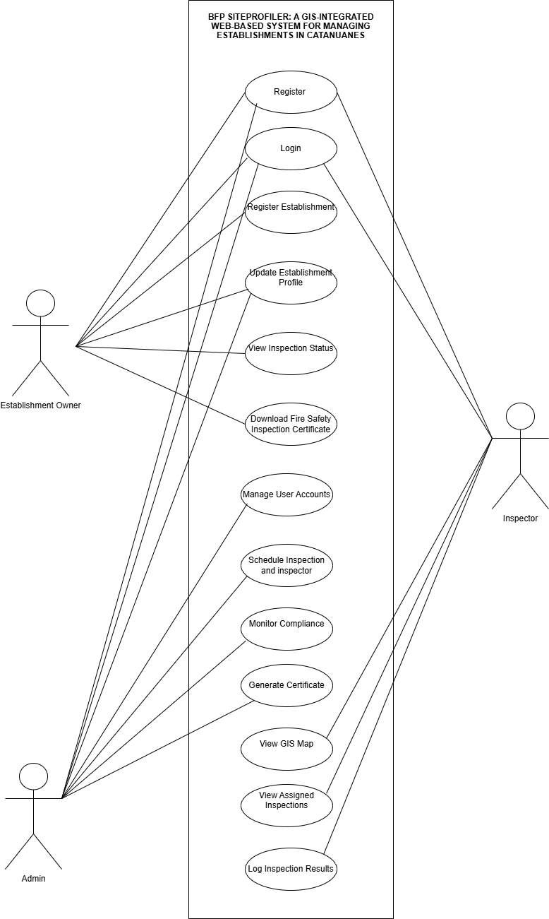
Figure 5. Use Case Diagram
The figure 5 illustrates the use case diagram outlining the core functionalities of the BFP SiteProfiler, a GIS-integrated web-based system designed for efficient establishment management and fire safety compliance monitoring.
Establishment owners initiate their interaction with the system by registering an account, allowing them to create and update profiles for their businesses. This ensures that their information remains accurate and accessible to fire safety officials. Owners can also track their inspection status and download their Fire Safety Inspection Certificate (FSIC) directly from the platform, streamlining compliance procedures.
Inspectors play a crucial role in assessing fire safety standards within establishments. The system enables them to access their assigned inspections, view locations using GIS mapping, and record inspection results. The integration of GIS technology enhances the accuracy of inspections by providing real-time spatial information, helping inspectors identify high-risk areas and conduct thorough assessments efficiently.
Administrators oversee the entire system, managing user accounts, scheduling inspections, and ensuring regulatory compliance. They have the capability to assign inspectors to specific locations, generate FSICs, and leverage GIS mapping to monitor fire safety conditions across a broader landscape. By centralizing operations within the platform, administrators can effectively enforce fire safety protocols, minimizing risks and ensuring systematic inspection workflows.
The BFP SiteProfiler integrates GIS mapping to provide detailed location-based insights and enhance inspection efficiency. By digitizing fire safety management, this system fosters transparency and accountability, ensuring establishments adhere to necessary regulations while inspectors and administrators operate with improved accuracy and coordination.
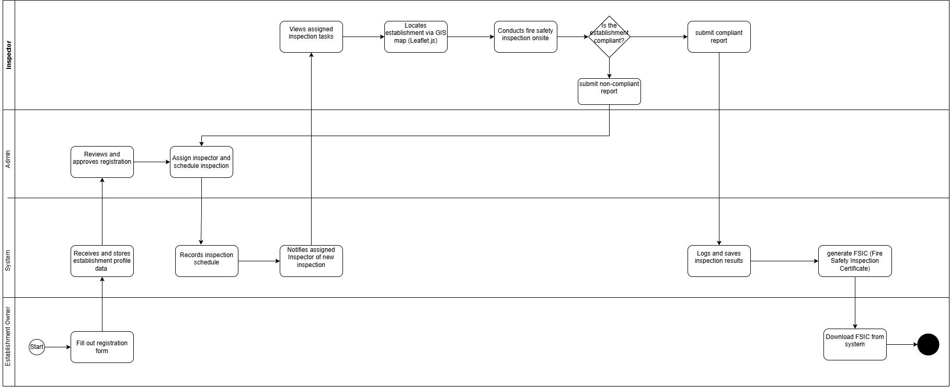
Figure 6. Swimlane Diagram
Figure 6 shows the swimlane diagram that illustrates the end-to-end process flow of how the BFP SiteProfiler System facilitates coordination between the Establishment Owner, Admin, Inspector, and the System in managing establishment registration, inspection scheduling, compliance evaluation, and certificate issuance.
The process begins with the Establishment Owner, who initiates interaction with the system by filling out a digital registration form. This form includes essential establishment details necessary for scheduling a fire safety inspection. Once submitted, the System automatically receives and stores the registration data, which is then reviewed by the Admin. The Admin evaluates the completeness and validity of the registration before approving it. Upon approval, the Admin assigns an Inspector and sets the inspection schedule. This schedule is recorded by the System and notifications are automatically sent to the assigned Inspector.
The Inspector accesses the assigned inspection task through the system, including the mapped location of the establishment via the integrated Leaflet.js GIS module. This GIS support enables accurate location of the establishment prior to the visit. The Inspector then conducts the fire safety inspection onsite. During this visit, the Inspector directly determines whether the establishment is compliant or not. This is the critical decision point in the process. If compliant, the Inspector submits a compliant report; if not, a non-compliant report is submitted instead. In both cases, the findings are sent back into the system.
Following the submission, the System logs and saves the inspection results, then automatically proceeds to generate a Fire Safety Inspection Certificate (FSIC) for compliant establishments. The Establishment Owner is notified and gains access to download the FSIC directly from the system. This step marks the completion of the certification process. If the establishment is found non-compliant, the Owner will be instructed to take corrective actions and await re-inspection, though this re-inspection loop is not shown in the current diagram.
Throughout the entire workflow, the Admin plays a supervisory role by managing the scheduling of inspections and ensuring the timely review of registration submissions. The Inspector ensures on-ground evaluation and decision-making, while the System supports automated notifications, GIS-based navigation, result recording, and certificate generation. The Establishment Owner, meanwhile, is kept informed throughout the process and receives tangible proof of compliance upon completion.
By clearly defining the responsibilities across each swimlane, this process diagram emphasizes role-based actions, decision points, and system automation. The result is a transparent, efficient, and streamlined approach to fire safety compliance management, with GIS integration enhancing inspection accuracy and centralized access supporting real-time coordination across all roles.

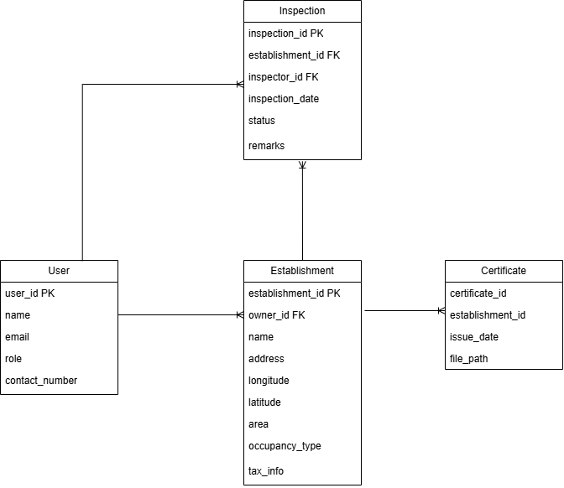
Figure 7. Entity Relationship Diagram
The figure 7 presents the entity-relationship model for a fire safety management system, illustrating how different entities like User, Establishment, Inspection, and Certificate are related and the attributes associated with each. The User entity stores information about system users, including their user ID, name, email, role, and contact number. The Establishment entity details information about the establishments being inspected, such as establishment ID, owner ID (linking back to a User), name, address, geographical coordinates (longitude, latitude), area, type of occupancy, tax information, and risk level.
The Inspection entity captures details about each inspection conducted, including a unique inspection ID, the associated establishment ID, the ID of the inspector (linking to a User), the inspection date, the status of the inspection, and any remarks. Finally, the Certificate entity holds information about the fire safety certificates issued, including a certificate ID, the associated establishment ID, the issue date of the certificate, and the file path to the digital copy of the certificate.
The lines connecting these entities indicate relationships. A User can be an owner of an Establishment or an Inspector performing an Inspection. An Establishment can have multiple Inspections, and an Inspection can lead to the issuance of a Certificate for an Establishment. This model provides a clear structure for organizing and managing data related to users, establishments, inspections, and certificates within the fire safety system.
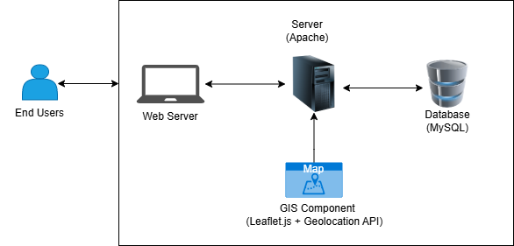
Figure 8. System Architecture
All data, such as establishment profiles, inspection reports, and certificates, is stored in a MySQL database, which the server accesses as needed. The system also includes a GIS component using Leaflet.js and the Geolocation API, allowing maps to display establishment locations and inspection coverage. These maps support admins and inspectors in planning and decision-making. Overall, the system offers a centralized, efficient platform for managing fire safety inspections with the added benefit of GIS-based mapping.

System Prototype
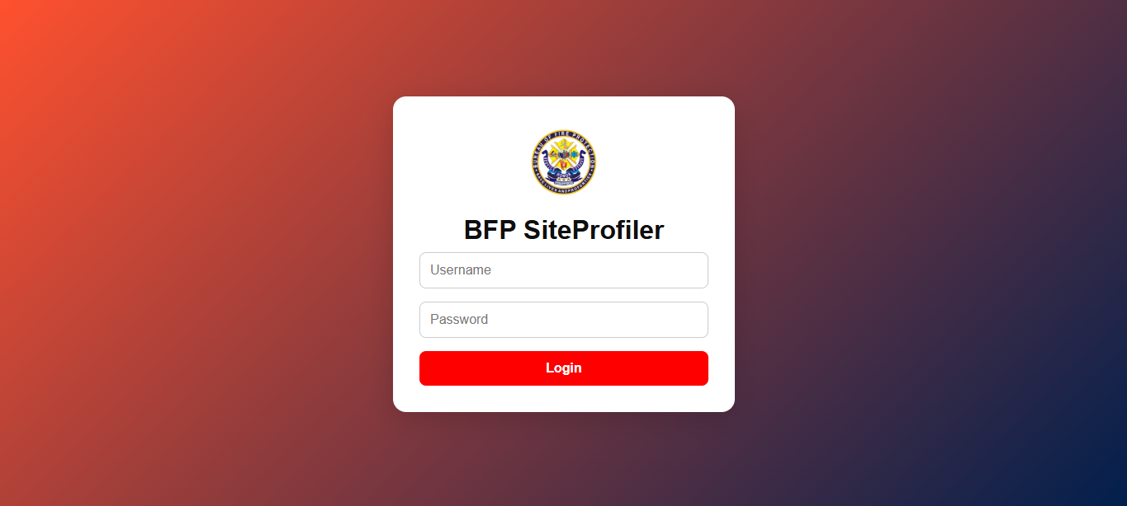
Figure 9. Login page
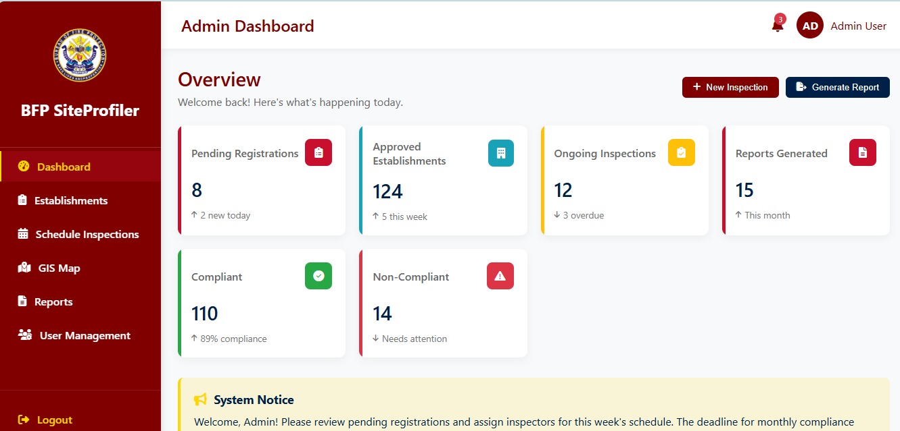
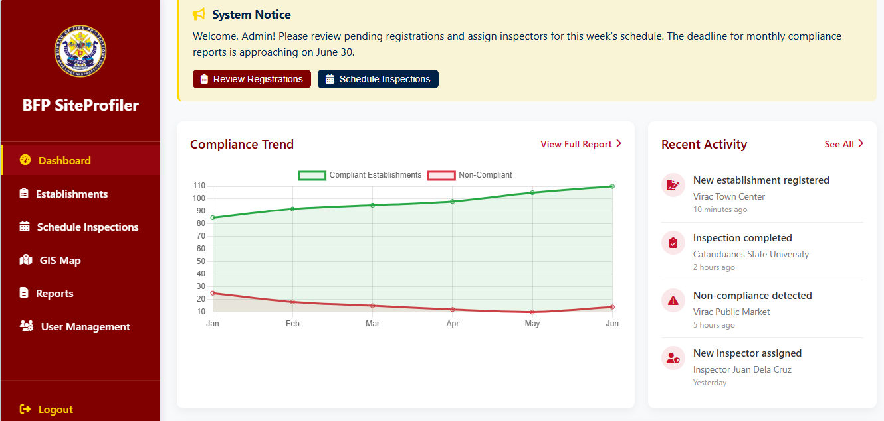
Figure 10 Admin Dashboard (Admin side)
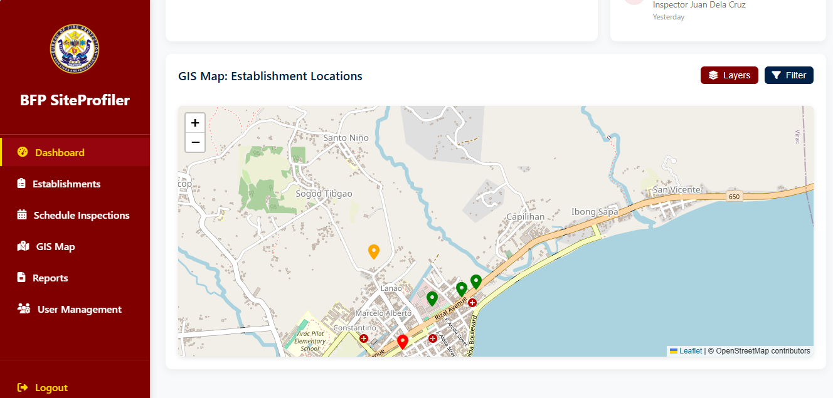

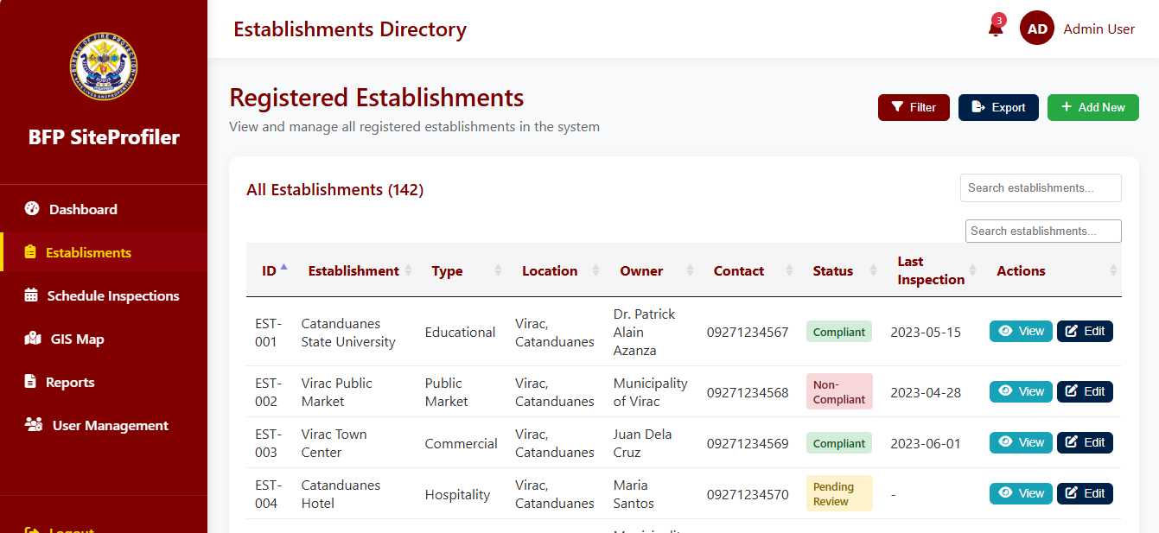
Figure 11. Establishment Directory (Admin side)

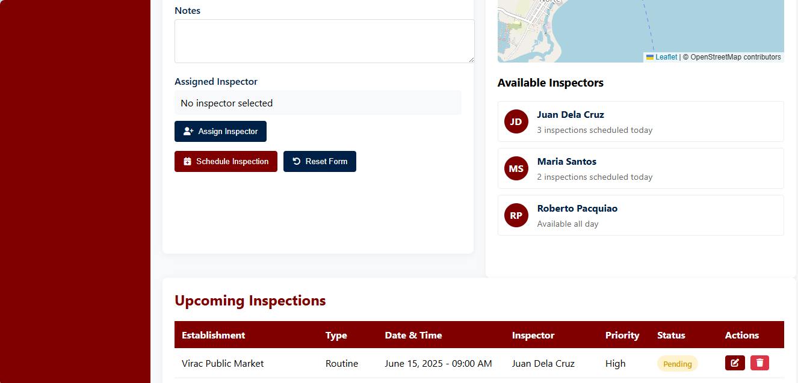
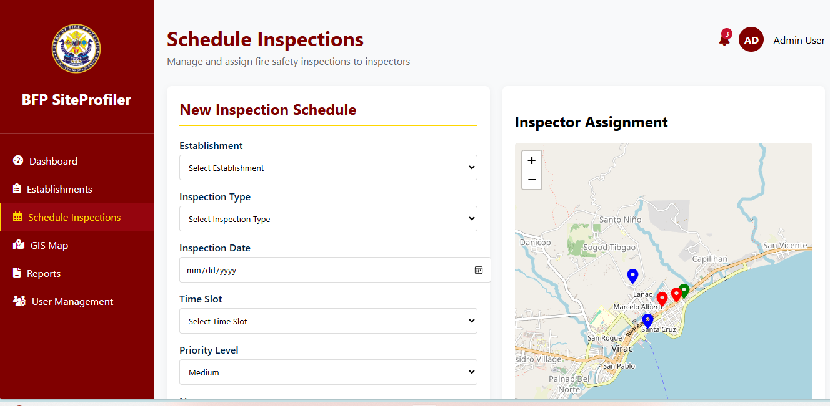

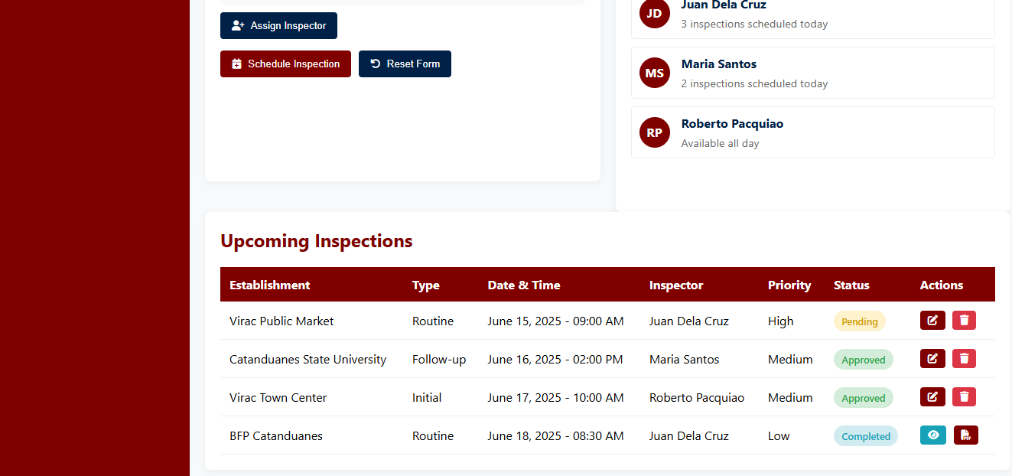
Figure 12 Schedule Inspection (Admin side)

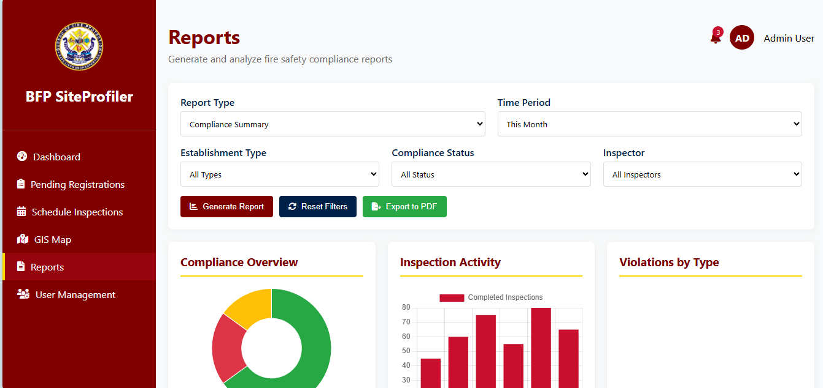
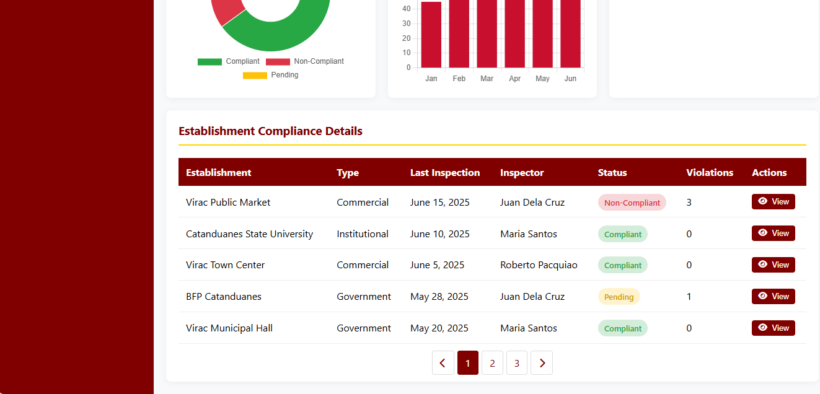
Figure 13 Reports (Admin side)

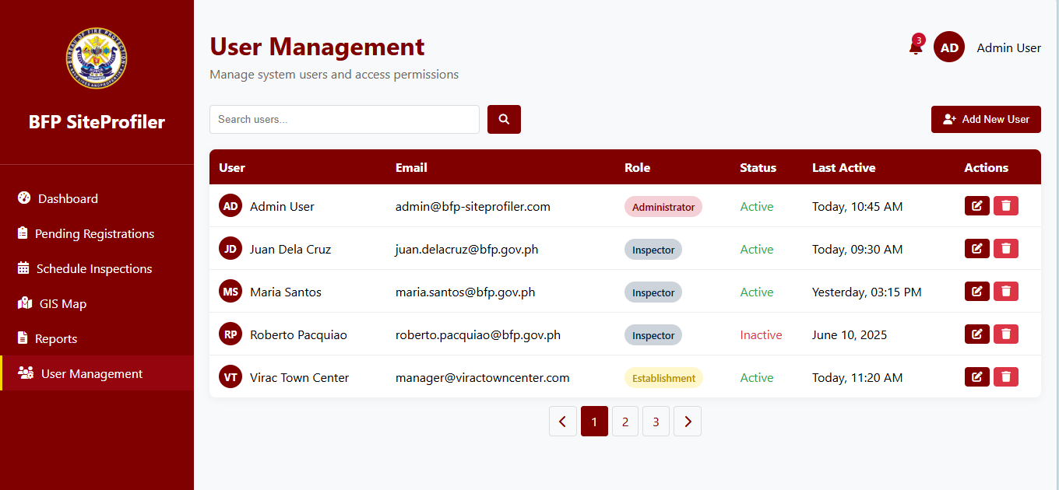
Figure 14 . User Management (Admin side)

Inspector side
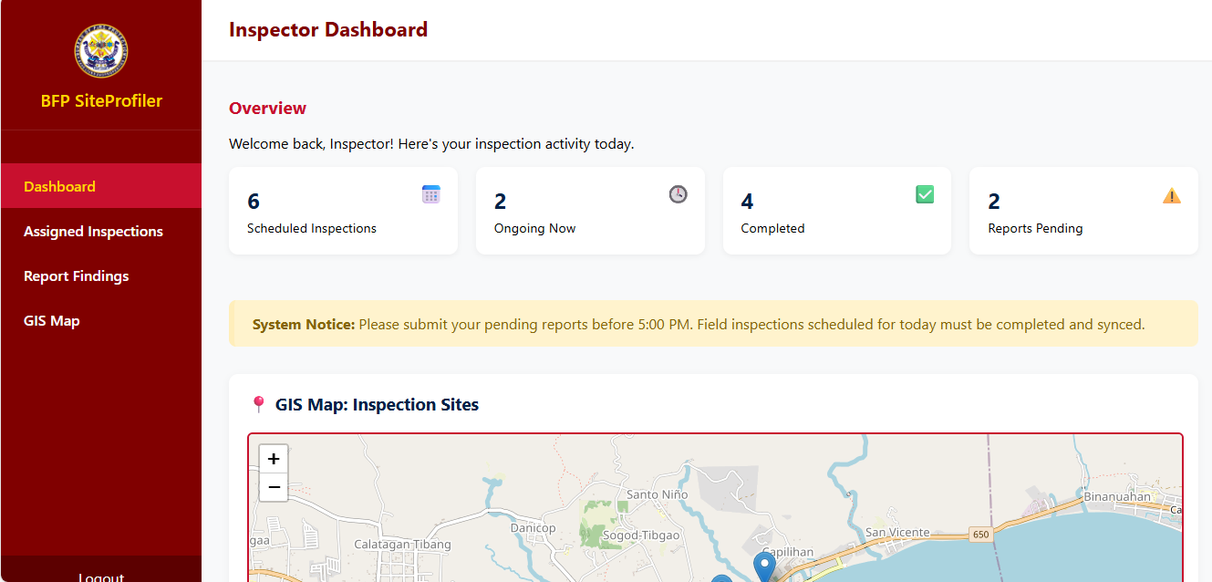
Figure 15 Inspector Dashboard

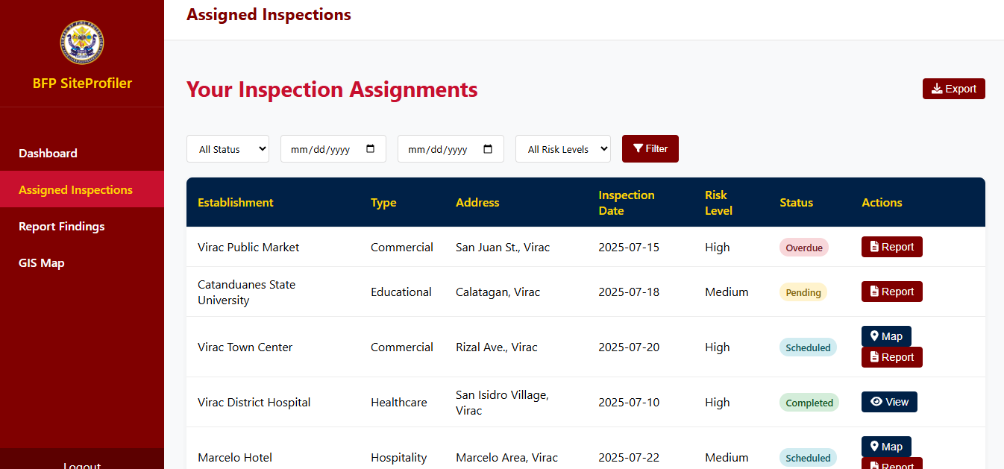
Figure 16 Assigned Inspection
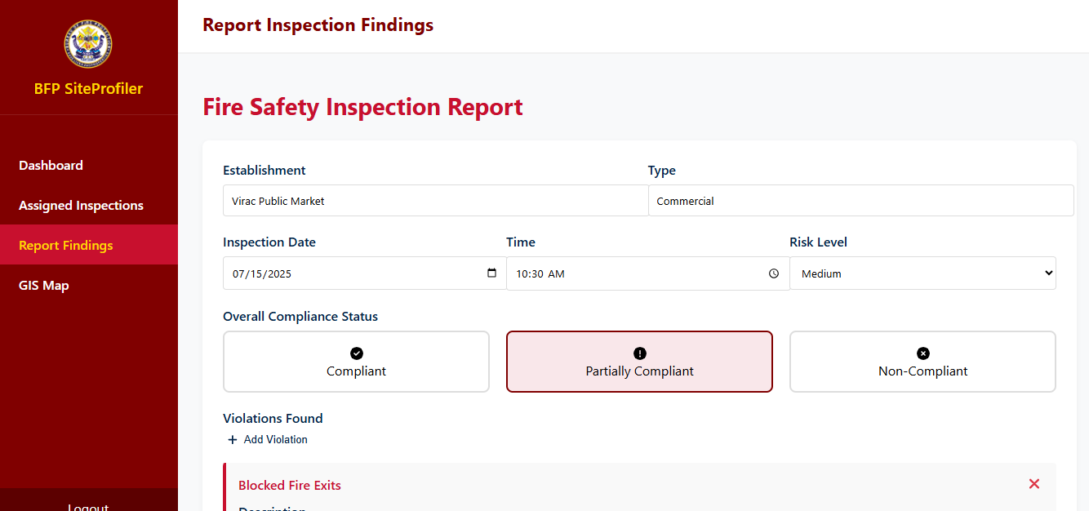
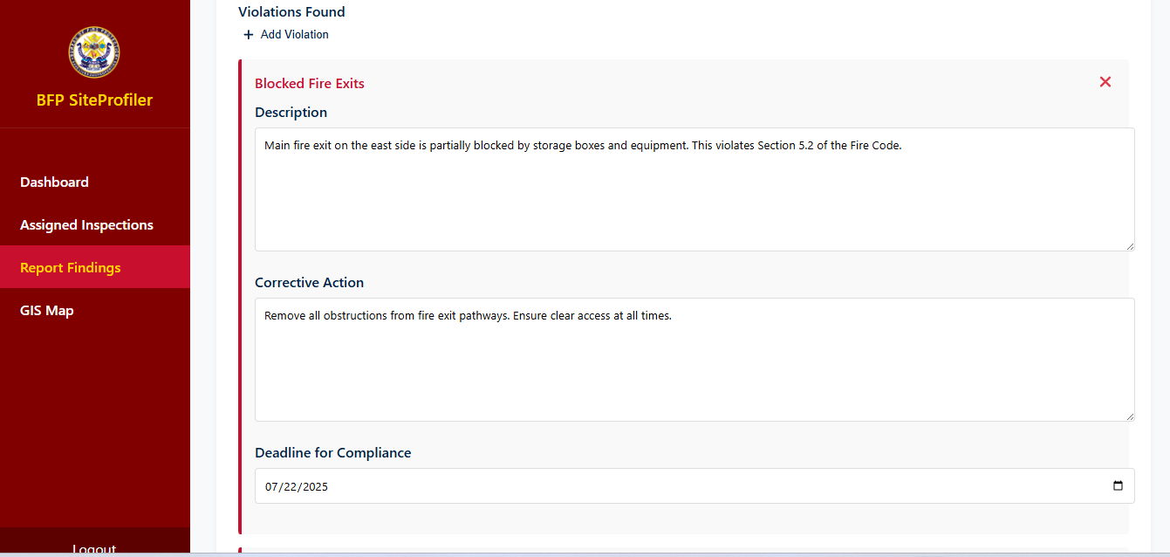
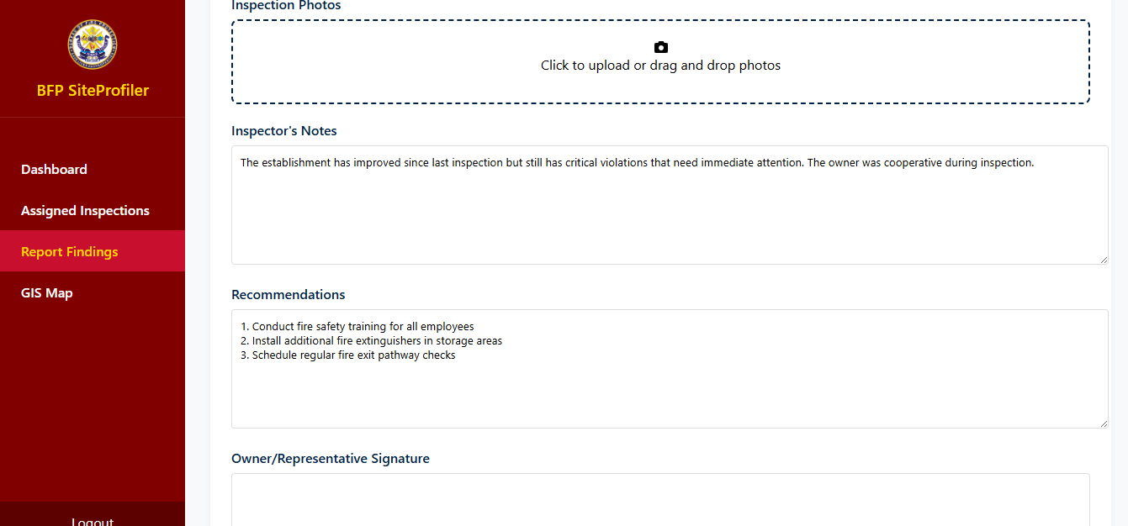
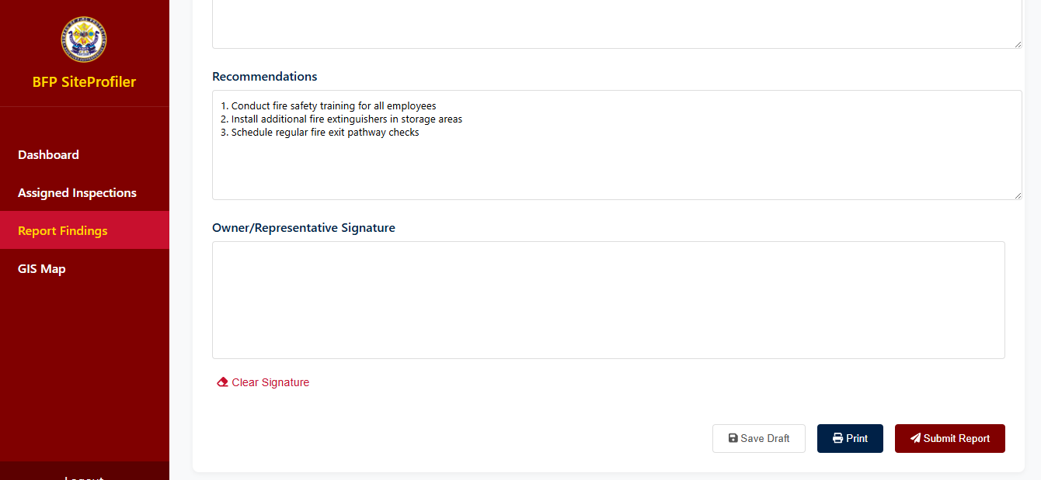
Figure 17 Report Findings

User side
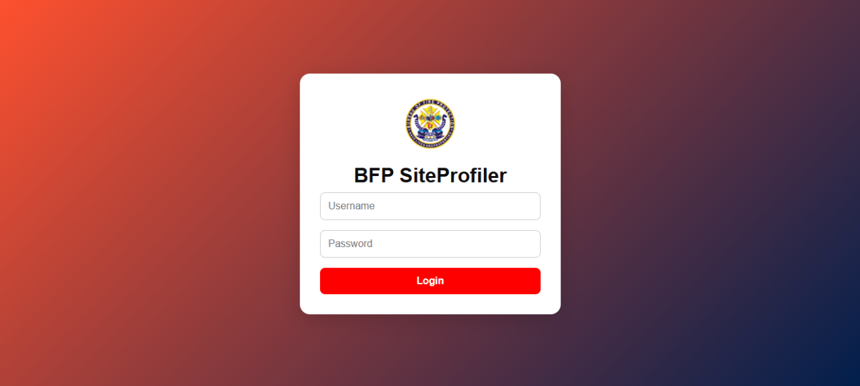
Figure 18 login
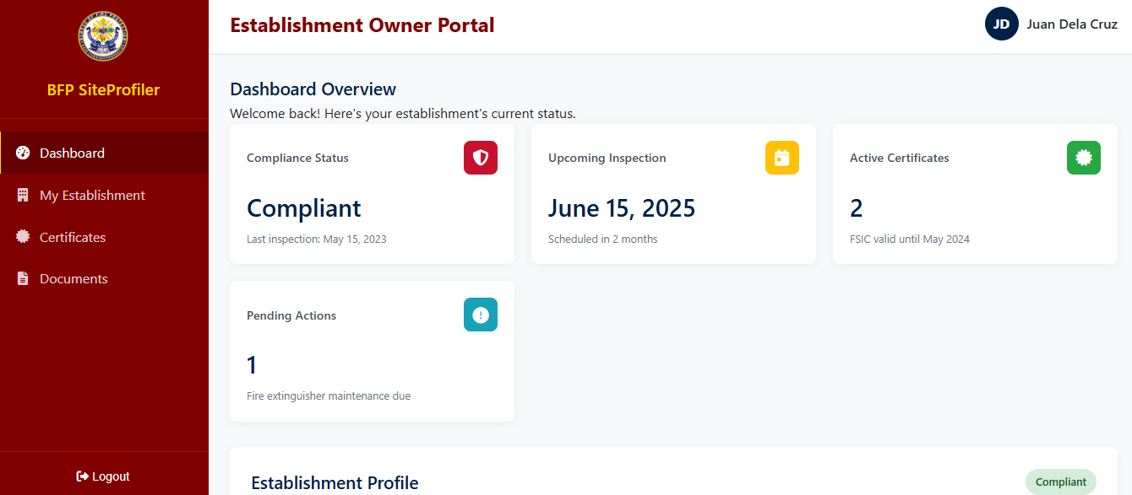
Figure 19 User Dashboard

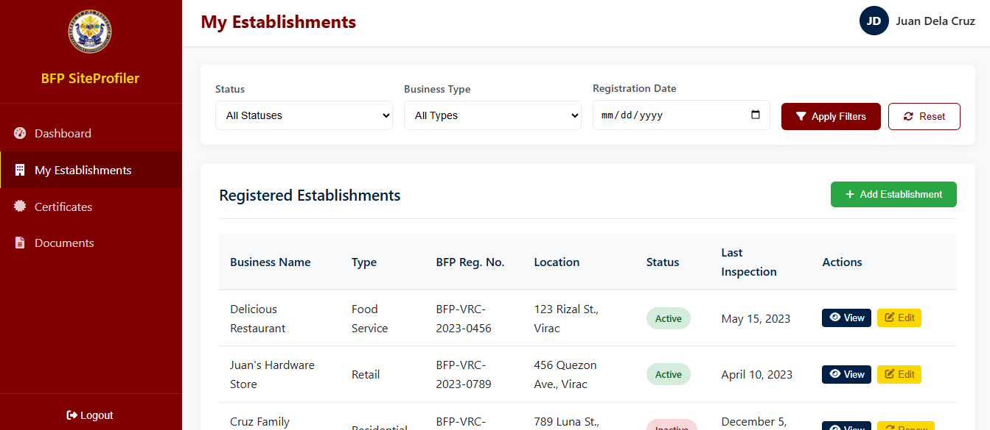
Figure 20 User Establishments
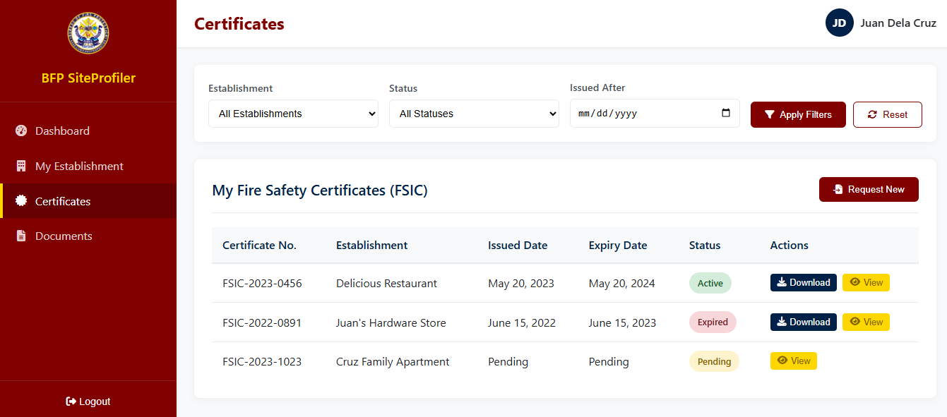
Figure 21 Certificates
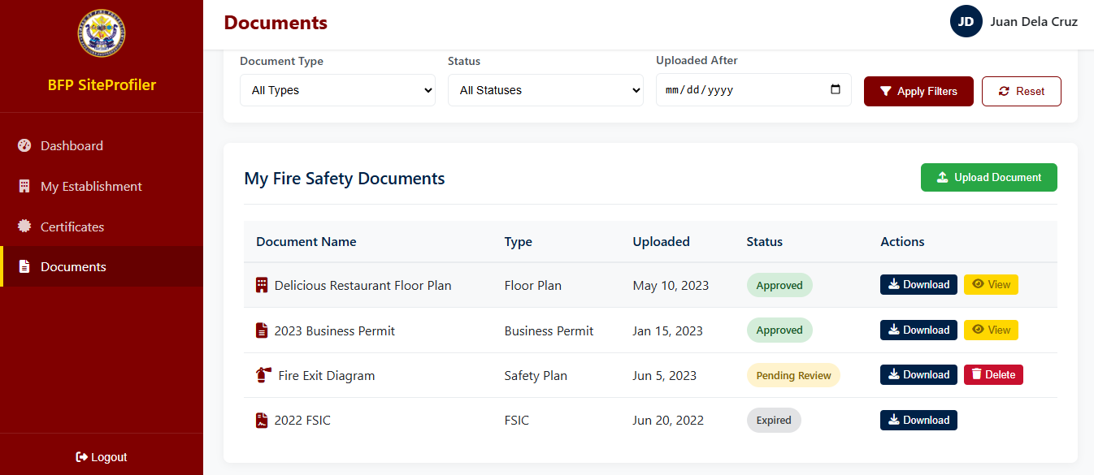
Figure 22 Documents

Development and Testing

Software Development Method
For the development of the BFP SiteProfiler: A GIS-Integrated Web-Based System for Managing Establishments in Catanduanes, the Rapid Application Development (RAD) model has been selected as the most suitable software development methodology. RAD is a user-focused and iterative approach that emphasizes rapid prototyping, continuous feedback, and accelerated delivery of working components. It is particularly effective for projects that require regular interaction with end-users and adaptability to changing requirements. Given the complexity and evolving nature of the proposed system—especially its integration of GIS mapping, digital inspection management, and real-time compliance tracking—RAD provides an ideal framework for ensuring flexibility, efficiency, and stakeholder-driven development.
By adopting RAD, the development team can quickly build and present functional parts of the system for review, allowing early detection of issues and timely adjustments. This reduces the risk of major failures and ensures that the system evolves based on actual user needs. The emphasis on collaboration, fast iteration, and progressive refinement allows the BFP SiteProfiler to be developed in alignment with the operational goals of the Bureau of Fire Protection, ultimately delivering a responsive and reliable tool for fire safety management.
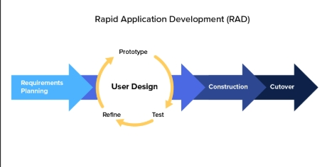
Figure 9. RAD Methodology
The development of the BFP SiteProfiler: A GIS-Integrated Web-Based System for Managing Establishments in Catanduanes is guided by the Rapid Application Development (RAD) model, a widely used methodology known for its focus on fast prototyping, iterative design, and continuous user feedback. This approach is particularly suitable for complex systems that require flexibility, frequent user interaction, and quick delivery of functional components—qualities that align well with the requirements of the proposed system, which includes GIS-based mapping, inspection tracking, establishment profiling, and compliance monitoring.
The RAD process begins with the Requirements Planning phase. During this stage, the development team worked closely with key personnel from the Bureau of Fire Protection (BFP) to identify the system’s goals, key functionalities, and operational challenges. This includes features such as digital establishment registration, inspection result submission, GIS integration using Leaflet.js, and automated report generation. These requirements were gathered through interviews and reviews of existing manual procedures.
Next is the User Design phase, where system workflows, mockups, and interface prototypes were created and continuously improved with input from actual users. Wireframes for the dashboard, GIS map view, and inspection forms were presented to BFP staff to gather feedback. Changes were implemented based on suggestions to ensure that the system interface remains user-friendly and relevant to the real-world tasks performed by fire inspectors and administrators.
Once the design was approved, the project moved into the Construction phase. In this stage, the development team began building the system’s core modules using technologies such as PHP for backend development, MySQL for database management, and Leaflet.js for GIS functionality. Each module was developed in short, focused cycles, allowing early testing and validation. For example, the establishment registration module and map-based location viewer were completed and reviewed before moving on to the inspection and reporting features. This incremental development helped ensure that issues were addressed early and user suggestions were quickly incorporated.
The final phase, Cutover, involves testing, deployment, and user training. The system was deployed in a controlled environment at the BFP office in Virac, where selected personnel conducted trial runs. Any minor bugs or usability issues identified during this period were addressed before final implementation. Additionally, system documentation, including user guides and training materials, was prepared to support onboarding and ensure smooth adoption.
Each phase of the RAD process supported close collaboration with stakeholders, enabling the team to develop and refine the BFP SiteProfiler in alignment with the practical needs of its end users. By focusing on speed, flexibility, and iterative feedback, the RAD model ensured that the system was not only delivered on time but also tailored to support efficient and accurate fire safety management in Catanduanes.

Evaluation
Evaluation is a critical phase in the development of the BFP SiteProfiler: A GIS-Integrated Web-Based System for Managing Establishments in Catanduanes. Its primary purpose is to assess the system’s effectiveness, usability, and alignment with the originally established project objectives. Through systematic evaluation, the project team ensures that the developed system meets the needs of its intended users, provides reliable and efficient services, and supports the operational goals of the Bureau of Fire Protection (BFP) in Virac.
To achieve a comprehensive understanding of system performance, the Descriptive Survey Method will be utilized. This method involves systematically gathering data from end-users, stakeholders, and domain experts through structured questionnaires, interviews, and direct observation. Surveys will focus on key areas such as user satisfaction, system functionality, ease of navigation, accuracy of GIS-based location mapping, and the reliability of features such as compliance tracking and report generation. Interviews with BFP administrators and inspection staff will further explore user experiences, challenges encountered, and suggestions for system improvement. Observation sessions during live system demonstrations will complement these tools by providing insights into real-time system usage and interactions.
The combination of quantitative data from questionnaires and qualitative feedback from interviews and observations ensures a balanced evaluation, highlighting both measurable outcomes and user-driven experiences. Findings from this evaluation will guide final refinements to the system before full deployment, helping ensure that the BFP SiteProfiler not only meets its technical requirements but also delivers a high level of functionality, accuracy, and user satisfaction.

Data Gathering Procedure
To support the development and assessment of the BFP SiteProfiler: A GIS-Integrated Web-Based System for Managing Establishments in Catanduanes, a systematic data collection process was implemented. The main sources of input were BFP personnel, including administrative officers, fire safety inspectors, and technical staff. Questionnaires were used to collect measurable data regarding system expectations, user needs, and common difficulties experienced with the current manual workflow. In addition, interviews
were held with selected individuals to gain deeper understanding of their tasks and to gather feedback on how features like GIS integration and inspection management could improve their operations.
The data collection was carried out over a span of two weeks. Participants were properly briefed on the purpose of the study, and ethical protocols were observed throughout the process. Participation was voluntary, with signed consent obtained from all respondents. All information provided was handled with strict confidentiality and used exclusively for research and system improvement purposes.

Respondents of the Study
The respondents of this study consist of the entire group of BFP personnel directly involved in establishment profiling, fire safety inspections, and compliance monitoring within the Bureau of Fire Protection (BFP) in Virac, Catanduanes. These include system administrators, fire safety inspectors, and technical staff who play key roles in the manual processes that the proposed system aims to digitize and improve. Their inclusion in the study is based on their active engagement in the day-to-day operations of the BFP and their working knowledge of the current procedures for managing establishments and conducting fire safety inspections.
Given the limited and well-defined number of relevant personnel, the study employed a total population approach. Rather than selecting a sample, all available members of the identified groups were included in the data collection process. This method ensures that the findings are comprehensive and fully reflective of actual system usage scenarios across all key user roles.
Table 7 Respondents of the Study
Type of Respondent | Total Population
Admin | 3
Fire Safety Inspectors | 5
Technical Staff | 3
Total | 11

A total of eleven (11) respondents participated in the study, consisting of three (3) administrative personnel, five (5) fire safety inspectors, and three (3) technical staff. All available fire safety inspectors and technical staff were selected to provide feedback as primary and support users of the system, while the system administrators were included to evaluate the system’s management and oversight functionalities.
By including 100% of the total population for each user category, the study ensures that the evaluation captures a broad range of perspectives and accurately reflects real-world system use. This approach enhances the reliability of the findings and contributes to a thorough assessment of the system’s usability, effectiveness, and alignment with the operational needs of the BFP.

Statistical Tool
In order to analyze the data collected from the respondents, the study employed descriptive statistical tools. These tools were selected to effectively interpret the responses gathered through the survey questionnaires, which aimed to evaluate the usability, functionality, and overall satisfaction with the BFP SiteProfiler system.
Among the statistical methods used were frequency count and percentage, which helped determine how often a specific response was selected and what proportion it represented out of the total number of responses. These techniques provided a clear overview of respondent distribution and preferences across various items in the questionnaire.
To further analyze items measured on a 5-point Likert scale, the study utilized the weighted mean, which allowed the researchers to determine the average level of agreement or satisfaction expressed by the respondents. The computation of the mean followed the formula:

$$\bar{x}=\frac{∑x}{N}$$
Mean (Arithmetic Average) Formula

Where:
- x̄ = weighted mean
- ∑x = sum of all the responses
- N = total number of respondents
By applying this formula, the researchers were able to draw conclusions about the general sentiment and feedback of the participants regarding the system.
Table 8 Likert Scale
Range | Quantitative Equivalent | Qualitative Equivalent
4.21 – 5.00 | 5 | Strongly Agree
3.41 – 4.20 | 4 | Agree
2.61 – 3.40 | 3 | Neutral
1.81 – 2.60 | 2 | Disagree
1.00 – 1.80 | 1 | Strongly Disagree

This scale enabled the researchers to quantitatively assess subjective feedback and translate it into meaningful interpretations. For example, if a question about system usability received a weighted mean of 4.35, it would fall under "Strongly Agree", indicating high user satisfaction in that aspect.
The use of these statistical tools, particularly the Likert scale and weighted mean, was instrumental in identifying system strengths and areas that may require enhancement. This data-driven approach ensures a more accurate and reliable evaluation of the BFP SiteProfiler.

REFERENCES

Books

Journals/Conferences

Alahira, A., et al. (2024). The impact of artificial intelligence on tax compliance and financial regulation. Journal of Financial Regulation, 35(2), 123–145. https://doi.org/10.1016/j.jfr.2024.03.004
Astrero, M. M., & Bitonio, J. P. (2022). Challenges in records management at the Bureau of Fire Protection in Rizal. Journal of Public Safety Administration, 18(1), 45–58. https://doi.org/10.1234/jpsa.2022.01801
Budi, S., Gata, W., Noor, M., Pangabean, S., & Rahayu, C. S. (2022). News portal website measurement analysis using ISO/IEC 25010 and McCall methods. Journal of Applied Engineering and Technological Science, 4(1), 273–285. https://doi.org/10.37385/jaets.v4i1.1094
Canlas, R. M., Piad, R. S., & Lagman, M. D. (2021). Development and evaluation of a faculty research productivity monitoring and prediction system using ISO/IEC 25010 standards. International Journal of Information Technology and Management, 20(2), 99–112. https://doi.org/10.1016/j.ijinfomgt.2021.102345
Darmayasa, I. M., & Hardika, I. G. (2024). Analysis of core tax administration systems using the slippery slope framework of tax compliance. Journal of Taxation and Public Policy, 12(3), 201–215. https://doi.org/10.1016/j.jtpp.2024.04.003
Haryasena, A., Saputra, R., Azzahra, N., & Aniko, D. (2021). Evaluation of a smart ERP accounting system for SMEs using ISO/IEC 25010 standards. International Journal of Accounting and Information Systems, 22(4), 45–59. https://doi.org/10.1016/j.accinf.2021.100345
Hesami, M., Jenkins, R., & Jenkins, M. (2024). Digital transformation in tax administration: A systematic review of e-invoicing and prefilled tax returns. Journal of Digital Taxation, 8(2), 89–102. https://doi.org/10.1016/j.jdt.2024.02.007
Manun-og, M. D., et al. (2022). Development of a GIS-integrated records management system for the Bureau of Fire Protection in Hinunangan, Southern Leyte. Journal of Information Systems and Technology, 11(3), 134–145. https://doi.org/10.1016/j.jist.2022.05.004
Morichetta, A., Nastic, S., Casamayor Pujol, V., & Dustdar, S. (2025). Formal and empirical study of metadata-based profiling for resource management in the computing continuum. IEEE Transactions on Cloud Computing, 13(1), 78–92. https://doi.org/10.1109/TCC.2025.1234567
Musagaliev, M. (2024). Strengthening tax control mechanisms to improve tax risk management and audits in public and private sectors. Journal of Public Finance and Management, 18(2), 112–125. https://doi.org/10.1016/j.jpfm.2024.01.008
Pongsin, P., Ruenwicha, P., & Nontasawatsri, S. (2024). Fire risk assessment model for hospital buildings using GIS, NFPA 551, and OHSAS 18001 standards. Journal of Fire Protection Engineering, 34(4), 210–225. https://doi.org/10.1177/1042391522112345
Rahman, M. M., Shuhidan, S. M., Masrek, M. N., & Baharuddin, M. S. (2024). GIS software quality, user satisfaction, and individual work performance: An empirical study using ISO/IEC 25010 framework. Journal of Geographic Information Science, 38(2), 145–159. https://doi.org/10.1016/j.jgis.2024.03.006
Salman, H., Karouni, A., Hamadeh, A., & Rachid, M. (2023). Comprehensive approach to forest fire risk mapping by combining AHP, GIS, and remote sensing. Environmental Monitoring and Assessment, 195(4), 234–249. https://doi.org/10.1007/s10661-023-10568-9
Sivrikaya, F., & Küçük, Ö. (2022). Modeling forest fire risk based on GIS-based analytical hierarchy process and statistical analysis in the Mediterranean region. Ecological Informatics, 68, 101537. https://doi.org/10.1016/j.ecoinf.2021.101537
Urbina, O., Sousa, H. S., Fekete, A., Matos, J. C., & Teixeira, E. (2023). Spatial vulnerability assessment of critical infrastructure based on fire risk through GIS systems—Case study: Historic city center of Guimarães, Portugal. Applied Sciences, 13(15), 8881. https://doi.org/10.3390/app13158881
Wallace, A., Beer, D., Burrows, R., Ciocănel, A., & Cussens, J. (2024). Digital tenant risk profiling in England’s private rented sector. Housing Studies, 39(1), 45–60. https://doi.org/10.1080/02673037.2024.2453005

C. Websites
Department of the Interior and Local Government–NCR. (2024). Integration of the Bureau of Fire Protection’s e-Fire Safety Inspection System into the eLGU portal in Pateros. DILG-NCR Reports, 3(1), 1–5. https://www.dilg-ncr.gov.ph/reports/2024/efsis-integration

D. Other Sources

