QR Code-enabled Student Organization Event Management System for Catanduanes State University

______________________________

A Capstone Project
Presented to the Faculty
of the College of Information and Communications Technology
Catanduanes State University
Virac, Catanduanes

In Partial Fulfillment of the
Requirements for the Degree
Bachelor of Science in Information Systems

______________________________

ALBERT DQ. SABENIANO
JAMES MARTY C. TERROBIAS
NATASHA MAE Y. DE QUIROZ
JORAINE N. BRIZO

March 16, 2026
TABLE OF CONTENTS
CHAPTER 1 | 1
Project Context | 1
Purpose and Description | 3
Objectives | 4
Scope and Limitations | 5
Definition of Terms | 6
Conceptual Framework | 9
CHAPTER 2 | 12
CHAPTER 3 | 26
Hardware Requirements | 26
Software Requirements | 28
Data Requirements | 30
User Requirements | 33
CHAPTER 4 | 37
Requirements Analysis | 37
Requirements Documentation | 38
Design of Software, Systems, Product and/or Processes | 48
Development and Testing | 65
Data Gathering Procedure | 76
Respondents of the Study | 77
Statistical Tool | 79
REFERENCES | 82

LIST OF FIGURES
Figure 1. Conceptual Framework | 10
Figure 2. Use Case Diagram | 48
Figure 3. Context Diagram | 50
Figure 4. Swimlane Diagram | 53
Figure 5. Data Flow Diagram Level 1 for Students | 56
Figure 6. Data Flow Diagram Level 1 for Organization Officers | 58
Figure 7. Data Flow Diagram Level 1 for Admin | 60
Figure 8. Entity Relationship Diagram | 62
Figure 9. System Architecture | 63
Figure 10. Login Interface | 65
Figure 11. Dashboard Interface | 66
Figure 12. Create New Event Interface | 67
Figure 13. QR Code Generation Interface | 68
Figure 14. Student Registration and Check-In Interface | 69
Figure 15. QR Code Scanning Interface | 70
Figure 16. Certificate Generation Interface | 71
Figure 17. Event Evaluation Form Interface | 72
Figure 18. Attendance Monitoring Dashboard | 73
Figure 19. RAD Methodology | 74

LIST OF TABLES
Table 1. Hardware Requirements | 27
Table 2. Software Requirements | 29
Table 3. Data Requirements | 31
Table 4. User Requirements | 34
Table 5. Functional Requirements | 37
Table 6. Non-Functional Requirements | 43
Table 7. Respondents of the Study | 78
Table 8. Likert Scale Interpretation | 79

CHAPTER 1
INTRODUCTION

Project Context
Event management systems are widely used in educational institutions to improve the organization, monitoring, and documentation of academic and extracurricular activities. These systems help automate processes such as participant registration, attendance monitoring, event scheduling, report generation, and record management. According to Rajendran and Hamzah (2022), digital event management systems improve operational efficiency by reducing manual workloads and enhancing coordination among organizers through centralized platforms. Similarly, Selvam and Harun (2023) stated that integrating QR code technology into event management systems improves attendance accuracy, minimizes human error, and strengthens data security during event operations.
In universities, student organizations regularly conduct seminars, meetings, outreach programs, orientations, competitions, leadership activities, and other institutional events that require proper coordination and monitoring. These activities contribute to student engagement, leadership development, organizational participation, and academic collaboration within the institution. To manage these activities efficiently, universities increasingly adopt digital event management systems capable of automating attendance verification, participant monitoring, and report generation.
Despite the availability of digital technologies, student organizations in Catanduanes State University still commonly use manual processes in managing organizational events and attendance. Existing procedures often involve paper-based registration, handwritten attendance sheets, manual participant verification, and physical preparation of reports and certificates. These manual practices may result in inaccurate attendance records, duplication of participant information, delayed report generation, misplaced documents, and difficulty in monitoring event participation.
Managing large numbers of participants during university-wide activities may also increase the workload of organization officers and administrators, resulting in inefficient coordination and time-consuming processing of records. In addition, manual handling of event information may affect the accessibility, security, organization, and reliability of student records and event documentation.
The proposed QR Code-Enabled Student Organization Event Management System supports Sustainable Development Goal (SDG) 4: Quality Education, SDG 9: Industry, Innovation and Infrastructure, and SDG 16: Peace, Justice and Strong Institutions. The system promotes quality education by supporting organized student activities and improving accessibility of event-related information. It also promotes innovation through the integration of QR code technology and web-based automation while strengthening transparency and accountability through organized attendance monitoring and report management.
Because of these challenges, there is a need to develop a centralized and web-based QR Code-Enabled Student Organization Event Management System for Catanduanes State University. The proposed system is intended to automate attendance verification, improve participant monitoring, centralize event records, generate real-time reports, and enhance the efficiency, accuracy, and reliability of student organization event management within the university.

Purpose and Description
The purpose of this study is to improve the management of student organization events and attendance at Catanduanes State University through a web-based system with QR code technology. The study, titled “QR Code-Enabled Student Organization Event and Attendance Management System for Catanduanes State University,” aims to reduce manual processes in event posting, participant registration, attendance checking, certificate generation, and report preparation. The system allows Organization Officers to create and manage events, post announcements, generate QR codes, monitor participants, validate attendance, send notifications, generate certificates, and produce event reports. It also allows the Admin to manage user accounts, monitor student organizations, process event approvals, review reports, and maintain the system, while Students can view posted events, register for events, scan or present QR codes for attendance, check attendance status, submit evaluations, and receive certificates when qualified.
This system is designed to provide a centralized and organized platform for event coordination, attendance verification, and record management within the university. It helps minimize delays and errors caused by manual registration and attendance tracking while improving the accuracy of event records and reports. The QR code feature supports faster attendance validation during events, while the certificate and report generation features help reduce the workload of organization officers and administrators. Overall, the system benefits the Admin, Organization Officers, and Students by making student organization event management more efficient, accessible, and reliable.

Objectives
The main objective of this study is to develop and evaluate a web-based QR Code-Enabled Student Organization Event Management System for Catanduanes State University that will support the management of student organization events, attendance monitoring, participant registration, and report generation.
Specifically, this study aims to:
- To develop a web-based student organization event management system for recognized student organizations in Catanduanes State University.
- To integrate QR code technology for automated attendance verification during student organization events.
- To implement digital event scheduling, participant registration, and event monitoring features for student organizations.
- To generate automated attendance records and event reports in real time.
- To evaluate the developed system using the ISO/IEC 25010 software quality model in terms of:
a.) Functional Suitability
b.) Performance Efficiency
c.) Compatibility
d.) Interaction Capability
e.) Reliability
f.) Security
g.) Maintainability
h.) Flexibility
i.) Safety

Scope and Limitations
The study focuses on the development of a web-based QR Code-Enabled Student Organization Event Management System for recognized student organizations in Catanduanes State University. The system provides a centralized platform for event posting, event scheduling, participant registration, QR code generation, QR code scanning, attendance monitoring, notification management, certificate generation, evaluation submission, and automated report generation. It allows Admin to manage users, recognized student organizations, event approvals, and reports, while Organization Officers can create and manage events, monitor attendance, generate QR codes, send notifications, issue certificates, and generate event-related reports. Students can view posted events, register for activities, scan or present QR codes for attendance verification, submit evaluations, receive certificates, and update their profiles.
The study is limited to student organization events conducted within Catanduanes State University and does not cover external organizations, commercial event management services, or activities outside the university setting. The system does not include online payment integration, financial management, biometric authentication, or fully offline functionality. Its QR code scanning performance may depend on the quality of the device camera and the availability of a stable internet connection. Access to the system is limited only to registered users such as Admin, Organization Officers, and Students, and the system’s performance may vary depending on available hardware, browser compatibility, and network resources.

Definition of Terms
To ensure clarity and consistency throughout the study, the following terms are operationally defined based on their use in the proposed QR Code-Enabled Student Organization Event Management System for Catanduanes State University.
Administrator The authorized user responsible for managing system accounts, monitoring activities, maintaining records, and controlling access to the system database.
Attendance Monitoring The process of recording, tracking, and reviewing the attendance of participants during student organization events through the system.
Attendance Verification The process of validating participant attendance through QR code scanning and automated system confirmation.
Automated Certificate Generation A system feature that automatically creates digital certificates for qualified event participants after attendance validation.
Automated Report Generation A system function that automatically produces downloadable event reports, attendance summaries, and participant records.
Compatibility The ability of the system to operate properly across supported devices, browsers, and web-based environments used by administrators, organization officers, and students.
Event Management System A centralized web-based platform designed to organize, schedule, monitor, and manage student organization events digitally.
Event Monitoring The process of tracking event activities, participant involvement, attendance records, and event progress using digital technologies.
Event Scheduling The process of creating and organizing event details such as event title, date, time, venue, participants, and assigned organization through the system.
Functional Suitability The ability of the system to provide the necessary functions needed for managing student organization events, attendance verification, participant registration, and report generation.
InteractionCapability The ability of users to interact with the system clearly and effectively when performing event management and attendance-related tasks.
ISO/IEC 25010 Software Quality Model A software quality standard used in this study to evaluate the quality and acceptability of the QR Code-Enabled Student Organization Event Management System as a web-based platform for event management, attendance monitoring, and report generation.
Maintainability The ability of the system to be corrected, updated, or improved when changes in user needs, event management processes, or system functions are required.
OrganizationOfficer An authorized student organization representative responsible for creating events, managing participant registration, monitoring attendance, and generating event-related reports.
Participant Registration The digital process of collecting and storing participant information before joining a student organization event.
Performance Efficiency The ability of the system to process event-related tasks quickly and efficiently, including QR code scanning, attendance recording, data updating, and report generation.
Portability The ability of the system to be accessed and used in different supported web-based environments without affecting its main functions.
QR Code A machine-readable two-dimensional barcode used to store event or participant data that can be scanned and validated using digital devices.
QR Code Scanning The process of scanning a generated QR code using a mobile device or scanner to verify attendance and record participation.
Reliability The ability of the system to perform its functions consistently and accurately, especially in recording attendance, storing event data, and producing reports.
Security The ability of the system to protect user accounts, event records, attendance data, and other stored information from unauthorized access or misuse.
Student Organization A recognized university-based group that conducts academic, social, cultural, leadership, and extracurricular activities for students.
Student Participant A student who registers for and attends student organization events managed through the system.
System Evaluation The process of assessing the developed system to determine whether it meets the needs of its intended users and supports the objectives of the study.
Usability The ability of the system to be easily understood and used by administrators, organization officers, and students in managing events and attendance-related processes.
User Authentication The security process of verifying authorized users through usernames, passwords, and system credentials before allowing access to the platform.

Conceptual Framework
Presents the Input-Process-Output (IPO) Model with a feedback mechanism used as the conceptual framework of the study. The framework serves as the foundation for the development of the proposed QR Code-Enabled Student Organization Event Management System by identifying the required inputs, system processes, and expected outputs necessary for efficient event management within Catanduanes State University.
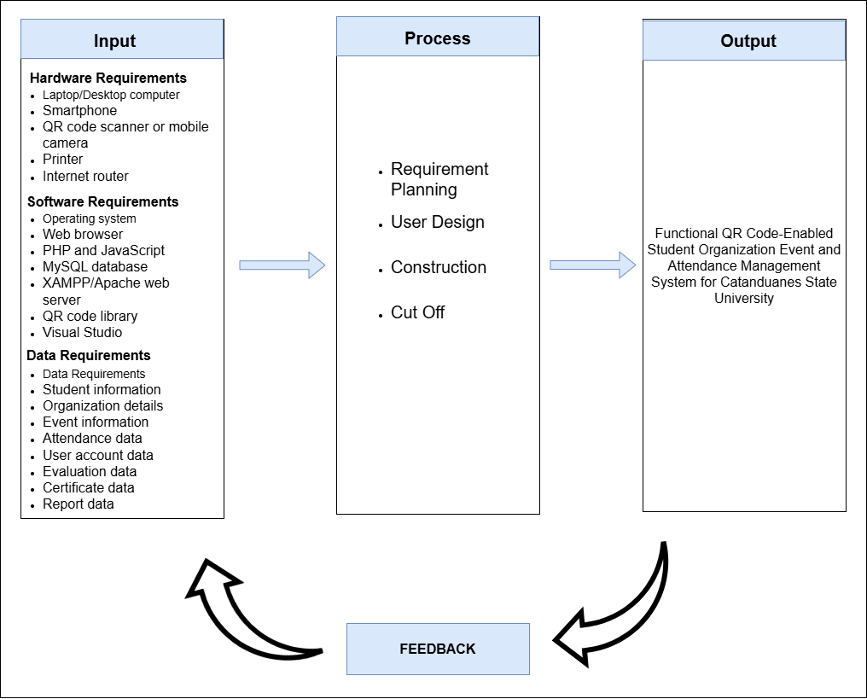
Figure 1. Conceptual Framework
Figure 1. Conceptual Framework presents the structured development of the QR Code-Enabled Student Organization Event and Attendance Management System for Catanduanes State University using the Input-Process-Output model with feedback. The input includes the necessary hardware requirements such as laptop or desktop computer, smartphone, QR code scanner or mobile camera, printer, and internet router; software requirements such as operating system, web browser, PHP and JavaScript, MySQL database, XAMPP/Apache web server, QR code library, and Visual Studio; and data requirements such as student information, organization details, event information, attendance data, user account data, evaluation data, certificate data, and report data. The process follows the Rapid Application Development (RAD) methodology, which includes Requirement Planning, User Design, Construction, and Cutover. Through these stages, the system is planned, designed, developed, tested, and prepared for actual use. The output is a functional QR Code-Enabled Student Organization Event and Attendance Management System that supports event posting, participant registration, QR code attendance verification, certificate generation, and report management. The feedback component allows users and evaluators to provide comments and suggestions that can be used to improve the system’s functionality, usability, and overall performance.

CHAPTER 2
REVIEW OF RELATED LITERATURE AND SYSTEMS

This chapter presents the review of related literature and systems relevant to the development of the proposed QR Code-Enabled Student Organization Event Management System for Catanduanes State University. The discussion focuses on recent studies published from 2022 to 2026 related to event management systems, QR code-based attendance monitoring, web-based information systems, cloud and database technologies, and system evaluation standards. The reviewed studies provide theoretical and technical support for the development of the proposed system.

Event Management Systems in Educational Institutions
Event management systems are widely used in educational institutions because they improve the organization, scheduling, monitoring, and documentation of academic and extracurricular activities. These systems help automate participant registration, attendance recording, report generation, and event coordination through centralized digital platforms. In universities, event management systems are important because they help administrators and organization officers reduce manual workloads and improve monitoring efficiency.
Rajendran and Hamzah (2022) explained that digital event management systems improve operational efficiency by reducing manual workloads and enhancing coordination among event organizers. Their study emphasized that centralized systems help institutions organize event information more effectively while improving communication and monitoring processes. This supports the proposed system because it also aims to centralize event records, participant monitoring, and attendance management.
Selvam and Harun (2023) stated that educational institutions benefit from event management systems because these systems simplify participant monitoring and automate documentation processes. Their findings showed that digital systems minimize paperwork and improve accessibility of records. This is relevant to the proposed system because student organizations in Catanduanes State University still rely on paper-based registration and attendance monitoring.
Chaturvedi et al. (2024) developed a university event management platform capable of handling participant registration, event scheduling, attendance monitoring, and report generation through a centralized database. Their study revealed that institutions using automated systems experienced improved administrative productivity and reduced processing time. This supports the proposed system because it also includes automated registration, attendance monitoring, and report generation features.
Gonzales and Reyes (2022) found that many universities in the Philippines continue to experience difficulties in managing student organization activities because of manual event documentation and attendance processes. Their study emphasized that digital systems improve organization, transparency, and monitoring efficiency. This is connected to the proposed study because the system aims to address similar problems experienced in Catanduanes State University.
Lee and Kim (2025) explained that centralized event management systems improve real-time coordination and reduce duplication of records during university events. Their findings showed that automation contributes to faster processing and more organized event handling. This supports the proposed system because it aims to reduce duplicate participant information and improve the accuracy of event records.
Ramos et al. (2024) emphasized that event management platforms improve collaboration among administrators, organization officers, and participants through centralized access to event information. Their findings also showed that automated systems support better decision-making through real-time monitoring and reporting features. This relates to the proposed system because it allows organization officers and administrators to monitor attendance and generate reports efficiently.
Dela Cruz and Santos (2023) reported that event systems integrated with automated attendance features significantly reduce administrative errors and improve event documentation accuracy within academic institutions. This study supports the proposed system because attendance monitoring through QR code scanning is one of its major functions.
The reviewed studies show that event management systems improve efficiency, coordination, documentation, and monitoring within educational institutions. These systems reduce manual workloads, minimize errors, and provide centralized access to event-related information. The reviewed literature supports the development of the proposed QR Code-Enabled Student Organization Event Management System as a centralized platform for managing student organization events, attendance, and participant records.

QR Code-Based Attendance Monitoring Systems
QR code technology has become an effective solution for automating attendance monitoring because of its speed, reliability, and accuracy. QR code-based systems are widely used in educational institutions to improve attendance verification, minimize manual errors, and strengthen data security. These systems help automate participant validation and improve attendance recording efficiency during events and academic activities.
Rahman et al. (2022) explained that QR code attendance systems significantly reduce attendance processing time while improving data accuracy and security. Their findings showed that QR codes eliminate duplicate attendance entries and reduce manual errors during attendance recording. This is relevant to the proposed system because it also uses QR code technology for automated attendance verification.
Garcia and Lopez (2022) found that QR code-based attendance systems improve participant verification and simplify attendance management during university events. Their study revealed that automated attendance logs are more accurate compared to paper-based systems. This supports the proposed system because it aims to replace manual attendance sheets with QR code-based attendance monitoring.
Dizon and Mendoza (2023) reported that QR code scanning systems improve efficiency in academic attendance monitoring by reducing long queues and minimizing physical contact during event participation. This study is connected to the proposed system because QR code scanning will also be used to simplify attendance recording during university activities.
Patel et al. (2024) emphasized that QR code attendance systems provide secure authentication mechanisms that help prevent proxy attendance and unauthorized participation. Their study highlighted the importance of real-time attendance verification during events. This supports the proposed system because it also validates participant attendance through QR code scanning and automated system confirmation.
Lee et al. (2025) explained that mobile QR code scanning technologies improve accessibility and user convenience in attendance monitoring systems. Their findings showed that QR code integration strengthens attendance reliability and monitoring efficiency. This relates to the proposed system because it uses mobile-compatible QR code scanning for attendance monitoring.
Chua and Ramos (2023) stated that automated QR attendance systems improve record consolidation and simplify report generation processes for administrators and organization officers. This is relevant because the proposed system also generates attendance summaries and downloadable reports automatically.
Villanueva and Torres (2026) revealed that integrating QR codes with web-based event systems improves real-time attendance monitoring and enhances organizational productivity within educational institutions. This supports the proposed study because the proposed system integrates QR code technology into a web-based event management platform.
The reviewed studies show that QR code-based attendance systems improve attendance accuracy, security, efficiency, and monitoring reliability. These systems reduce manual errors, improve participant verification, and strengthen automated attendance management. The reviewed literature strongly supports the integration of QR code technology into the proposed event management system.

Web-Based Information Systems and Database Technologies
Web-based information systems are commonly used in academic institutions because they provide accessibility, scalability, centralized data management, and real-time processing. These systems allow users to access information using internet-connected devices, making them suitable for event monitoring, participant management, and report generation.
Kumar and Singh (2022) explained that web-based applications improve organizational efficiency by allowing users to access information anytime through internet-enabled devices. This supports the proposed system because it is designed as a web-based platform accessible to administrators, organization officers, and students.
Pressman and Maxim (2023) stated that modern web systems support multi-user access, centralized databases, and real-time processing, making them suitable for institutional operations and information management. This relates to the proposed system because it also supports centralized event management and attendance monitoring.
Mendoza et al. (2022) found that web-based systems simplify information dissemination and reduce manual documentation within educational institutions. Their findings showed that browser-based platforms improve accessibility and usability for administrators and students. This supports the proposed system because it reduces manual event documentation and improves accessibility of event records.
Torres and Rivera (2024) explained that centralized web-based databases improve data organization and retrieval efficiency within academic organizations. Their study showed that centralized systems reduce duplication and improve record consistency. This relates to the proposed system because it stores attendance records, participant information, and event details in a centralized database.
Gonzales et al. (2025) highlighted that cloud-integrated web systems improve data backup, accessibility, and system reliability for academic institutions. This supports the proposed system because centralized storage improves accessibility and management of event records.
Navarro and Cruz (2023) emphasized that responsive web technologies improve compatibility across smartphones, tablets, and desktop computers. This is relevant because the proposed system is intended to function across different supported devices and browsers.
Lee and Park (2026) explained that web-based management systems improve operational efficiency through real-time synchronization and centralized data processing. This supports the proposed study because the proposed system also processes attendance and event records in real time.
The reviewed studies show that web-based systems improve accessibility, scalability, centralized data storage, and operational efficiency. These findings support the development of the proposed QR Code-Enabled Student Organization Event Management System as a web-based platform for event and attendance management.

Agile Software Development and System Development Methodologies
Software development methodologies are important in ensuring that systems are reliable, flexible, and responsive to user requirements. Agile methodologies are commonly used in system development because they support continuous improvement, iterative development, and user feedback integration.
Sommerville (2022) explained that Agile methodology supports iterative development and continuous improvement throughout the software development lifecycle. This supports the proposed study because the system development process requires continuous refinement and testing.
Pressman and Maxim (2023) stated that Agile development improves software quality because developers continuously evaluate system performance and implement modifications based on user feedback. This is relevant because the proposed system also requires feedback from users during development and testing.
Cruz and Fernandez (2022) found that Agile methodology improves adaptability and project management efficiency in academic information systems. Their study showed that iterative testing helps developers identify and resolve issues earlier. This supports the proposed system because iterative testing is necessary in improving QR code scanning and attendance monitoring features.
VersionOne (2023) reported that Agile-based projects achieve higher success rates because of frequent communication, evaluation, and incremental improvements during development. This supports the proposed system because stakeholder feedback is important during system refinement.
Ramos et al. (2024) emphasized that Agile methodologies improve collaboration among developers, administrators, and end-users during system implementation. This is connected to the proposed study because administrators and organization officers are involved during development and testing.
Villaflor and Garcia (2025) explained that Agile software development improves usability and system reliability because user feedback is integrated throughout the development process. This supports the proposed study because the system must remain user-friendly and reliable.
Lee and Santos (2026) stated that Agile frameworks improve deployment efficiency and reduce software maintenance challenges in educational systems. This is relevant because the proposed system also requires continuous maintenance and future improvements.
The reviewed literature shows that Agile methodology improves adaptability, collaboration, usability, software quality, and system reliability. These findings support the use of Agile methodology in developing the proposed QR Code-Enabled Student Organization Event Management System.

System Evaluation, Usability, and Software Quality Standards
System evaluation is essential in determining software effectiveness, usability, security, efficiency, and reliability. Software quality standards help ensure that developed systems meet acceptable levels of functionality and user satisfaction.
ISO/IEC 25010 (2023) explained that software quality standards focus on important characteristics such as functionality, usability, reliability, security, maintainability, compatibility, and performance efficiency. This supports the proposed study because the developed system will also be evaluated using the ISO/IEC 25010 Software Quality Model.
Lewis and Sauro (2022) explained that usability testing measures how effectively users interact with software systems. Their findings showed that user-friendly systems improve user satisfaction and operational productivity. This relates to the proposed system because administrators, organization officers, and students are the primary users of the platform.
Nielsen (2023) emphasized that usability is an important factor influencing system acceptance and software success. Their study explained that systems with simple navigation and efficient interfaces improve user experience significantly. This supports the proposed system because usability is important in event registration, attendance scanning, and report generation.
Ramos and Dela Cruz (2024) found that applying ISO software quality standards improves reliability and security of academic information systems. This supports the proposed study because attendance records and participant information require secure and reliable management.
Gonzales et al. (2025) emphasized that descriptive surveys and weighted mean analysis are effective in measuring user satisfaction and system performance. This supports the evaluation process of the proposed system.
Chua and Fernandez (2024) explained that system evaluation processes help developers identify usability issues and improve software functionality. This relates to the proposed system because evaluation results will be used for future improvements.
Villanueva et al. (2026) emphasized that evaluating systems based on usability, efficiency, and reliability improves the long-term effectiveness of digital platforms within universities. This supports the proposed study because the developed system is intended for long-term use within Catanduanes State University.
The reviewed studies show that system evaluation is important in ensuring software quality, usability, security, and reliability. These studies support the use of ISO/IEC 25010 and descriptive evaluation methods in assessing the quality and acceptability of the proposed QR Code-Enabled Student Organization Event Management System.

Synthesis
The reviewed literature and related studies show that digital technologies significantly improve the efficiency, reliability, organization, and accessibility of event management and attendance monitoring systems within educational institutions. Studies on event management systems emphasized that centralized digital platforms simplify event scheduling, participant registration, attendance monitoring, and report generation while reducing manual workloads and documentation errors.
The reviewed studies on QR code-based attendance systems highlighted that QR code technology improves attendance accuracy, participant verification, security, and monitoring efficiency. These systems reduce manual attendance recording, minimize errors, and strengthen real-time attendance validation during events.
The reviewed literature on web-based information systems also emphasized that centralized web-based platforms improve accessibility, scalability, real-time processing, and organized record management. These systems support multi-user access and centralized data storage, making them suitable for academic institutions and student organization operations.
The reviewed studies on Agile software development methodologies showed that Agile improves collaboration, adaptability, usability, and software quality through iterative development and continuous user feedback. These findings support the use of Agile methodology in developing the proposed system.
The reviewed literature on system evaluation and software quality standards revealed that ISO/IEC 25010 is an effective framework for evaluating software quality, usability, reliability, security, and system performance. These studies support the evaluation approach of the proposed system using recognized software quality standards.
Despite these technological advancements, many educational institutions still rely on manual event management and attendance monitoring processes, resulting in delays, inaccuracies, duplicate records, and inefficient documentation. Existing systems also commonly focus on only one functionality without integrating event management, attendance monitoring, QR code verification, and report generation into a single platform.
To address these gaps, the proposed QR Code-Enabled Student Organization Event Management System integrates event management, QR code-based attendance verification, participant registration, automated report generation, and centralized data management into one web-based platform. Overall, the reviewed literature and related studies provide strong theoretical and technical support for the development and evaluation of the proposed system.

CHAPTER 3
TECHNICAL BACKGROUND

This chapter presents the technical requirements needed to develop and implement the QR Code-enabled Student Organization Event Management System for Catanduanes State University. It includes the hardware, software, and data requirements necessary for the system to function efficiently.

Hardware Requirements
These are the physical devices and equipment needed for the development, implementation, and operation of the QR Code-Enabled Student Organization Event Management System. The hardware components ensure that the system performs efficiently, supports attendance monitoring, and allows smooth access to system functions and data processing.

Table 1. Hardware Requirements
Hardware Requirement | Specification | Description
Laptop/Desktop Computer | Intel Core i3 or higher, 4GB RAM | Used for system development, administration, data management, testing, and report generation.
Smartphone (Android) | Android 8.0 and above ith camera | Used to access the system and scan QR codes during student organization events.
QR Code Scanner (Mobile Camera) | Built-in smartphone camera | Captures QR codes for automated attendance recording during events..
Printer | Inkjet/ Laser printer | Used for printing reports, attendance summaries, certificates, and related documents.
Internet Router | 10 Mbps or higher | The internet router provides stable connectivity for accessing the web-based system, enabling real-time data processing and online attendance monitoring.

Table 1 shows the Hardware Requirements needed for the development, testing, and operation of the QR Code-Enabled Student Organization Event Management System for Catanduanes State University. The laptop or desktop computer will be used by USC/OSADS and Organization Officers for system administration, event management, attendance monitoring, report generation, and data processing. With a minimum specification of an Intel Core i3 processor and 4GB RAM, the device is capable of supporting the web-based functions and administrative operations of the system.
Smartphones running on Android 8.0 or higher with built-in cameras will serve as mobile devices for accessing the system and scanning QR codes during student organization events. These devices allow Organization Officers and Students to monitor attendance conveniently and support real-time event participation and verification. The built-in smartphone camera functions as the QR code scanner, enabling automated attendance recording and faster participant validation during events.
Printers, specifically inkjet or laser printers, will be used for printing attendance summaries, certificates, reports, and other event-related documents generated by the system. Meanwhile, an internet router with at least 10 Mbps connectivity is necessary to provide stable internet access for the web-based platform. This allows real-time data processing, attendance synchronization, and continuous access to event records and system functions.
These hardware components were selected based on their availability, reliability, compatibility, and capability to support the proposed system’s operational requirements. The identified hardware ensures that the QR Code-Enabled Student Organization Event Management System can function efficiently in managing student organization events, attendance monitoring, and report generation within Catanduanes State University.

Software Requirements
These are the software applications and tools required for the development, implementation, and operation of the QR Code-Enabled Student Organization Event Management System. The software components provide the necessary environment for coding, database management, QR code generation, system testing, and web-based access.

Table 2. Software Requirements
Software Requirement | Specification | Description
Operating System | Windows 10 or higher | Provides the primary environment for system development, testing, and administration.
Web Browser | Google chrome, firefox | Used to access and operate the web-based event management system.
Programming Language | PHP / JavaScript | Used for developing the  system interface, functions, and database connectivity.
Database | MySQL | Stores and manages event records, participant information, attendance logs, and reports.
Web Server | XAMPP / Apache | Provides local server and  database services during  system development and  testing.
QR Code Generator | PHP QR Code Library | Used for coding, debugging  , and modifying the system  source code.
Code Editor | Visual Studio Code | Used for coding, debugging, and modifying the system source code.
Reporting Tool | PDF/Excel Export Tool | Generates downloadable attendance summaries and event reports.

Table 2 shows the Software Requirements needed for the development, testing, and operation of the QR Code-Enabled Student Organization Event Management System for Catanduanes State University. The operating system, specifically Windows 10 or higher, provides the primary environment for system development, administration, and testing. Web browsers such as Google Chrome and Mozilla Firefox will be used to access and operate the web-based platform.
The system will be developed using PHP and JavaScript for creating the interface, system functions, and database connectivity. MySQL will serve as the database for storing and managing event records, participant information, attendance logs, user accounts, and generated reports. XAMPP or Apache will be used as the local web server during development and testing to support system execution and database services.
The PHP QR Code Library will be used to generate QR codes for attendance verification during student organization events. Visual Studio Code will serve as the code editor for writing, debugging, and modifying the system source code. Lastly, the PDF/Excel Export Tool will be used to generate downloadable attendance summaries and event reports.
These software tools were selected because they are compatible with web-based system development and can support the major functions of the proposed system, including event management, QR code attendance monitoring, data storage, and report generation.

Data Requirements
These are the data and information required for the operation of the QR Code-Enabled Student Organization Event Management System. The data components support student registration, organization management, event scheduling, QR code attendance monitoring, system evaluation, certificate generation, and report production.

Table 3. Data Requirements
Construct/ Variables | Source of Data | Data Gathering Technique | Instrument | Data Processing
Student Information | Student participants | Registration Form | Online Registration Form | Store and manage in the database
Organization Details | Student Organizations | Interview / Survey | Questionnaire | Encoded and validated
Event Information | Event organizers | Data Entry | System Form | Saved and updated in the database
Attendance Data | QR Code Scan | QR Scanner | Mobile Camera | Automatically record attendance
User Accounts | System Admin | Manual Input | Admin Panel | Authentication & secured data storage
Evaluation Data | Student participants | Online evaluation | Evaluation form / questionnaire | Collected and summarized for system or event assessment
Certificate Data | Attendance and event records | Automated generation | Certificate module | Generated for qualified participants
Reports Data | System Generated | Automated process | System | Export to PDF/Excel

Table 3 shows the Data Requirements needed by the QR Code-Enabled Student Organization Event Management System for Catanduanes State University. These data are necessary for participant registration, organization management, event scheduling, attendance monitoring, system access, evaluation, certificate generation, and report production.
Student information will be collected from student participants through an online registration form and will be stored and managed in the system database. Organization details will be gathered from student organizations through interviews or surveys using questionnaires, then encoded and validated to ensure that only recognized organizations are included in the system. Event information will be provided by event organizers through data entry using the system form, allowing event records to be saved and updated in the database.
Attendance data will be collected through QR code scanning using a mobile camera and will be automatically recorded by the system. User account data will be entered by the system administrator through the admin panel and will be processed through authentication and secured data storage. Evaluation data will be collected from student participants through online evaluation forms or questionnaires and summarized for system or event assessment.
Certificate data will be generated based on attendance and event records through the certificate module, allowing qualified participants to receive certificates. Lastly, report data will be automatically processed by the system and exported into PDF or Excel format. These data requirements ensure that the system can properly manage records, verify attendance, generate documents, and support the overall operation of student organization events.

User Requirements
The user requirements of the QR Code-Enabled Student Organization Event Management System for Catanduanes State University identify the functional features and user roles necessary for the effective operation of the proposed system.

Table 4. User Requirements
Module | Function | Description | User Role
Dashboard | View system overview | Displays total events, participants, attendance records, and recent activities | Admin, Organization Officers
User Management | Manage users | Allows Admin to add,  update, manage accounts, and  assign user roles. | Admin
Event Posting | Post Event Announcements | Allows organization officers to publish event details, schedules, and announcements. | Admin, Organization Officers
Organization Management | Manage organizations | Allows the administrator to register, update, and monitor recognized student organizations. | Admin
Event Calendar | View scheduled events | Enable students to register for events online | Students, Organization Officers, Admin
Event Management | Create and manage events | Allows organization officers to create, update, and monitor student organization events. | Organization Officer
Participant Registration | Register for events | Allows students to register for available student organization events. | Students
QR Code Generation | Generate QR codes | Creates unique QR codes for event attendance verification. | Organization Officers
QR Code Scanning | Scan QR codes | Records and verifies student attendance through QR code scanning. | Students, Organization Officers
Attendance Monitoring | Monitor attendance records | Tracks and displays student attendance during events. | Organization Officers, Admin
Evaluation Management | Submit event evaluation | Allows students to answer event evaluation forms after attending events. | Students
Certificate Generation | Generate certificates | Creates digital certificates for qualified students after attendance validation. | Organization Officers, Admin
Reports Management | Generate reports | Produces downloadable  attendance summaries,  participant records, and  event reports. | Organization Officers, Admin
Notification Management | Send notifications | Sends event announcements, reminders, and updates to users. | Organization Officers, Admin
Authentication Module | Login and logout | Provides secure access to the system based on user credentials and assigned roles. | Students, Organization Officers, Admin
Profile Management | Update profile | Allows users to view and update their personal account information. | Students, Organization Officers, Admin

Table 4 shows the User Requirements of the QR Code-Enabled Student Organization Event Management System for Catanduanes State University. It identifies the major system modules, their functions, descriptions, and the intended end users who will access and use each feature. The end users of the system are Students, Organization Officers, and Admin.
The dashboard provides Admin and Organization Officers with an overview of total events, registered participants, attendance records, and recent system activities. The user management module allows Admin to add, update, manage accounts, and assign user roles. The organization management module also supports Admin in registering, updating, and monitoring recognized student organizations.
For event-related functions, the event posting module allows Admin and Organization Officers to publish event details, schedules, and announcements, while the event calendar allows Students, Organization Officers, and Admin to view scheduled events. The event management module enables Organization Officers to create, update, and monitor student organization events. Students can use the participant registration module to register for available events.
The QR code generation module creates unique QR codes for event attendance verification, while the QR code scanning module records and verifies student attendance. Attendance monitoring allows Organization Officers and Admin to track and review student attendance during events. The evaluation management module enables Students to submit evaluations after attending events, while certificate generation allows Organization Officers and Admin to generate digital certificates for qualified students.
The reports management module produces downloadable attendance summaries, participant records, and event reports. Notification management sends event announcements, reminders, and updates to users. Lastly, the authentication and profile management modules provide secure access and allow users to manage their personal account information. Overall, these user requirements ensure that the system supports organized event management, accurate attendance monitoring, efficient communication, and proper documentation of student organization events.

CHAPTER 4
DESIGN AND METHODOLOGY

This chapter presents the design, methodology, and system features of the proposed system. It includes requirements analysis, system design, development process, and evaluation of the system

Requirements Analysis
This section presents the analysis of the system requirements based on the needs of the stakeholders and the objectives of the study. It identifies both the functional and non-functional requirements that define what the system should do and how it should perform. These requirements serve as the foundation for the system design and development process.

Table 5. Functional Requirements
Actor | Functional Requirements | Description
Admin | User Login | Allows the admin to securely access the system using authorized credentials.
 | View Dashboard | Displays an overview of system information such as total events, registered students, attendance records, organizations, and recent activities.
 | Manage User Accounts | Enables the admin to create, update, manage user accounts, and assign user roles based on system access privileges.
 | Manage Student Organizations | Allows the admin to register, update, and monitor recognized student organizations in the university.
 | Monitor Events | Allows the admin to view posted events, schedules, participant records, and attendance summaries.
 | Process Event Approvals | Enables the admin to review and approve event-related requests submitted by organization officers.
 | Generate Reports | Allows the admin to generate downloadable reports such as event records, attendance summaries, participant lists, and organization-related reports.
 | Maintain System | Enables the admin to manage system data, monitor system activities, and ensure proper operation of the platform.
Organization Officers | User Login | Allows organization officers to securely access the system using authorized credentials.
 | View Dashboard | Displays event-related information such as posted events, registered participants, attendance records, and recent activities.
 | Post Event Announcements | Allows organization officers to publish event details, schedules, and announcements for students.
 | Create and Manage Events | Enables organization officers to create, update, and monitor student organization events.
 | Generate QR Codes | Allows organization officers to generate QR codes used for event attendance verification.
 | Generate QR Codes | Allows organization officers to scan participant QR codes to record and verify attendance during events.
 | Monitor Attendance | Enables organization officers to view and track student attendance records during and after events.
 | Generate Certificates | Allows organization officers to generate digital certificates for qualified participants after attendance validation.
 | Generate Reports | Enables organization officers to produce attendance summaries, participant records, and event reports.
 | Send Notifications | Allows organization officers to send event announcements, reminders, and updates to students.
Students | User Login | Allows students to securely access the system using their registered credentials.
 | View Event Calendar | Allows students to view scheduled events posted by student organizations.
 | Register for Events | Enables students to register for available student organization events through the system.
 | Scan QR Codes | Allows students to scan or present QR codes for attendance verification during events.
 | View Attendance Status | Allows students to check their attendance records and event participation status.
 | Submit Event Evaluation | Enables students to answer evaluation forms after attending events.
 | Receive Certificates | Allows students to access or receive digital certificates after completing event attendance requirements.
 | Update Profile | Enables students to view and update their personal account information.

Table 5 presents the Functional Requirements of the QR Code-Enabled Student Organization Event Management System for Catanduanes State University. It identifies the major functions of the system according to its three main actors: Admin, Organization Officers, and Students. These requirements define the specific tasks that each actor can perform to support event management, attendance monitoring, participant registration, QR code verification, certificate generation, and report production.
The Admin is responsible for managing the overall operation of the system. This includes secure login, viewing the dashboard, managing user accounts, monitoring recognized student organizations, reviewing event requests, generating reports, and maintaining system records. These functions allow the Admin to oversee system activities and ensure that event-related processes are properly managed.
Organization Officers are given access to the event management functions of the system. They can log in, view the dashboard, post event announcements, create and manage events, generate QR codes, scan QR codes, monitor attendance, generate certificates, produce reports, and send notifications to students. These functions help organization officers handle student organization events more efficiently and reduce manual work in attendance recording and documentation.
Students can use the system to access event-related services. They can log in, view the event calendar, register for events, scan or present QR codes for attendance verification, view their attendance status, submit event evaluations, receive certificates, and update their profiles. These functions allow students to participate in organization events through a more organized and accessible digital process.
Overall, the functional requirements show how the proposed system supports role-based access and organized system operations. Each actor is assigned specific functions that contribute to the efficient management of student organization events, accurate attendance monitoring, secure system access, and reliable generation of event-related records and reports.

Table 6. Non-Functional Requirements
Non-Functional Requirements | Description
Performance Efficiency | The system shall ensure efficient processing and consistent performance by delivering timely responses for core functions such as event posting, participant registration, QR code scanning, attendance monitoring, certificate generation, and report production, even when multiple users access the system at the same time.
Compatibility | The system shall ensure compatibility with commonly used web browsers, devices, and web-based environments to allow Students, Organization Officers, and Admin to access the system properly and perform their assigned tasks without major technical issues.
Interaction Capability | The system shall provide clear and effective interaction between users and system modules, allowing smooth use of features such as event registration, QR code attendance verification, event monitoring, evaluation submission, and report viewing.
Reliability | The system shall ensure consistent and accurate operation by properly recording attendance, storing event data, generating reports, and maintaining access to important system functions with minimal errors or interruptions.
Security | The system shall implement secure login, role-based access control, and data protection measures to protect user accounts, student information, event records, attendance logs, certificates, and generated reports from unauthorized access or misuse.
Maintainability | The system shall be designed with organized and manageable components that allow easy correction, updating, troubleshooting, and improvement of system features without affecting the overall operation of the platform.
Flexibility | The system shall be flexible enough to support future modifications, additional event management features, user role adjustments, and possible system enhancements based on the changing needs of student organizations and university event management.
Safety | The system shall support safe operation by providing proper validation, confirmation prompts, controlled access, and backup procedures to help prevent data loss, incorrect record processing, and unauthorized changes to event and attendance records.

Table 6 presents the Non-Functional Requirements of the QR Code-Enabled Student Organization Event Management System for Catanduanes State University. These requirements describe the quality attributes that the system must possess to ensure efficient, secure, reliable, and user-friendly operation. Unlike functional requirements, which focus on what the system does, non-functional requirements focus on how well the system performs its functions.
Performance efficiency ensures that the system can process major functions such as event posting, participant registration, QR code scanning, attendance monitoring, certificate generation, and report production with timely responses. Compatibility allows the system to operate properly across commonly used browsers, devices, and web-based environments. Interaction capability ensures that users can smoothly interact with system modules, especially in registration, attendance verification, evaluation submission, and report viewing.
Reliability ensures that the system can consistently record attendance, store event data, and generate reports with minimal errors or interruptions. Security protects user accounts, student information, event records, attendance logs, certificates, and reports through secure login, role-based access, and controlled permissions. Maintainability allows the system to be corrected, updated, and improved without affecting its overall operation.
Flexibility ensures that the system can support future changes, additional features, and adjustments based on the needs of student organizations and university event management. Safety supports proper validation, confirmation prompts, controlled access, and backup procedures to prevent data loss, incorrect processing, and unauthorized changes. Overall, these non-functional requirements ensure that the system remains efficient, secure, reliable, adaptable, and suitable for managing student organization events.

Requirements Documentation
The requirements gathered during analysis were documented to serve as a guide for system development. The documentation includes system features, user roles, input and output specifications, and constraints. This ensures that all stakeholders have a clear understanding of the system’s functions and objectives. The system has three main users: Administrator, Organization Officer, and Student. The Administrator manages the system, the Organization Officer creates events, and the Student scans QR codes to mark.
attendance. The documentation also outlines assumptions such as internet availability and QR code scanning capability of mobile devices.

Design of Software, Systems, Product and/or Processes
This section presents the overall design of the QR Code-Enabled Student Organization Event Management System for Catanduanes State University. It explains how the system was structured to meet the identified functional and non-functional requirements based on the needs of Students, Organization Officers, and Admin. The design focuses on major system processes such as event posting, event scheduling, participant registration, QR code generation, QR code scanning, attendance monitoring, evaluation submission, certificate generation, notification management, and report production. The development and design process followed the Rapid Application Development (RAD) methodology, which allowed the researchers to create prototypes, gather feedback, and refine the system based on user requirements. The design includes diagrams and models that show how users interact with the system, how data flows between modules, and how each process supports efficient event management and attendance monitoring. Each component, from the user interface to the database and system logic, was carefully planned to ensure that the platform is reliable, accessible, secure, and suitable for managing student organization events within Catanduanes State University.

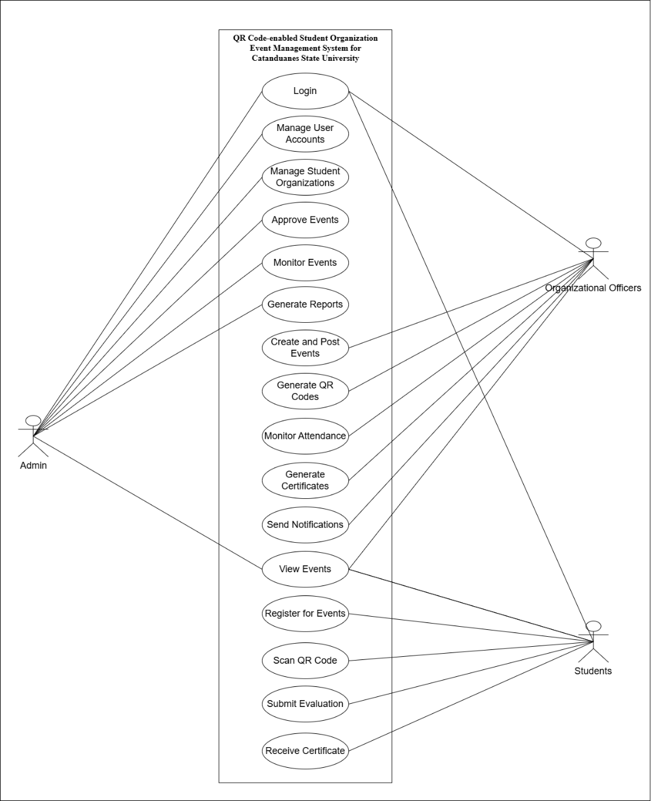
Figure 2. Use Case Diagram
Figure 2 shows the Use Case Diagram of the QR Code-Enabled Student Organization Event Management System for Catanduanes State University. The diagram presents the main interactions between the system and its three end users: Admin, Organization Officers, and Students. It is designed to organize how student organization events are created, posted, monitored, and documented through a role-based system structure.
At the core of the system is the Admin, who has access to major administrative functions. The Admin is responsible for logging in, viewing events, managing user accounts, managing student organizations, approving event requests, and generating reports. Through these functions, the Admin ensures that only authorized users and recognized student organizations can access and use the system properly. The Admin also monitors event-related records to support accurate documentation and system oversight.
Organization Officers are responsible for managing the actual event-related activities in the system. They can log in, view events, create and post events, generate QR codes for attendance verification, monitor attendance records, generate certificates, send notifications, and generate reports. These functions allow organization officers to manage student organization events more efficiently and reduce manual processes in registration, attendance checking, and report preparation.
Students interact with the system by logging in, viewing posted events, registering for available events, scanning or presenting QR codes for attendance verification, submitting event evaluations, and receiving certificates after completing event requirements. These functions allow students to participate in organization events through a more accessible and organized digital process.
Through this role-based structure, the system supports efficient event management, accurate attendance monitoring, secure user access, and organized report generation. Overall, the Use Case Diagram illustrates how the proposed system improves the management of student organization events by assigning specific functions to each end user.

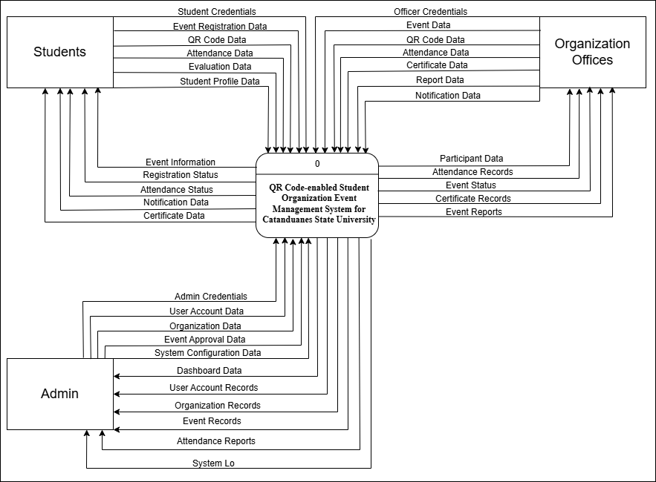
Figure 3. Context Diagram
Figure 3 presents the Context Diagram of the QR Code-Enabled Student Organization Event Management System for Catanduanes State University. The diagram shows the interaction between the system and its three main external entities: Students, Organization Officers, and Admin. Students provide student credentials, event registration data, QR code data, attendance data, evaluation data, and student profile data to the system. In return, the system provides event information, registration status, attendance status, notification data, and certificate data, allowing students to participate in events, monitor their attendance, receive updates, and access certificates after completing the required event participation.
Organization Officers interact with the system by providing officer credentials, event data, QR code data, attendance data, certificate data, report data, and notification data. These data support the creation and management of student organization events, QR code-based attendance monitoring, certificate generation, report preparation, and event-related notifications. The system then returns participant data, attendance records, event status, certificate records, and event reports, enabling organization officers to properly monitor event participation and manage event records.
The Admin provides admin credentials, user account data, organization data, event approval data, and system configuration data to manage and control the overall operation of the platform. The system sends back dashboard data, user account records, organization records, event records, attendance reports, and system logs. Through these data flows, the Admin can monitor system activities, manage users and organizations, process event approvals, and maintain accurate records. Overall, the context diagram illustrates how the system serves as the central platform for managing student organization events, attendance verification, reports, certificates, and communication among users.

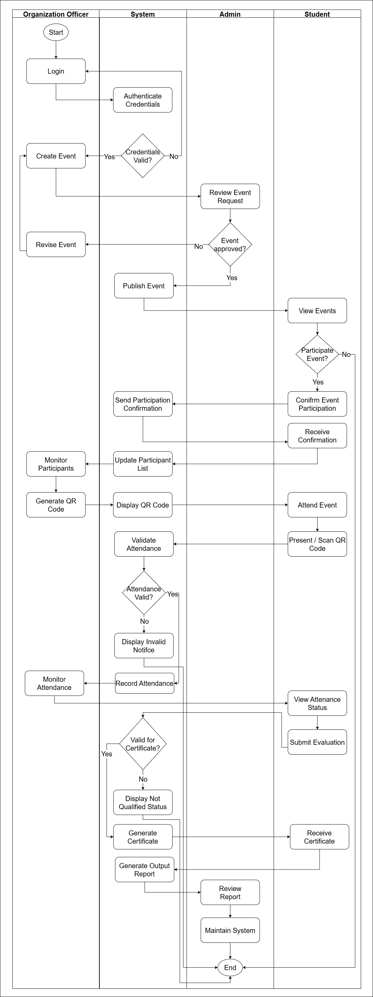
Figure 4. Swimlane Diagram
Figure 4 illustrates the Swimlane Diagram of the QR Code-Enabled Student Organization Event and Attendance Management System for Catanduanes State University. It shows the step-by-step interaction among the Organization Officer, System, Admin, and Student in managing student organization events, participant registration, QR code attendance, certificate generation, and reporting. The diagram presents how each user role performs specific tasks while the system supports authentication, event publishing, registration confirmation, QR code display, attendance validation, certificate processing, and report generation.
The process begins with the Organization Officer logging in to the system. The system authenticates the credentials and verifies whether the login is valid. If the credentials are invalid, the user is redirected back to the login process. If valid, the Organization Officer proceeds to create an event request, which is then forwarded to the Admin for review. The Admin checks the event details and decides whether the event will be approved or not. If the event is not approved, the Organization Officer revises the event and resubmits it for review. Once approved, the system publishes the event and makes it available for students to view.
After the event is published, students can view the available events and decide whether to participate. If the student chooses not to participate, the process ends for that student. If the student confirms participation, the system sends a participation confirmation and updates the participant list. The Organization Officer can then monitor the registered participants and generate QR codes through the system. The system displays the QR code, which students use when attending the event.
During the event, students present or scan their QR codes for attendance verification. The system validates the attendance record and checks whether the attendance is valid. If the attendance is invalid, the system displays an invalid notice. If valid, the system records the attendance, and the Organization Officer can monitor the attendance records. Students may also view their attendance status and submit an event evaluation after attending the event.
After attendance validation and evaluation, the system checks whether the student is qualified to receive a certificate. If the student is not qualified, the system displays a not qualified status. If qualified, the system generates the certificate, and the student receives it. The system also generates the output report, which is reviewed by the Admin. Lastly, the Admin maintains the system to ensure that records, reports, and system processes are properly managed. Overall, the swimlane diagram shows a clear and organized flow of responsibilities among users and demonstrates how the system supports efficient event management, attendance monitoring, and certificate generation.

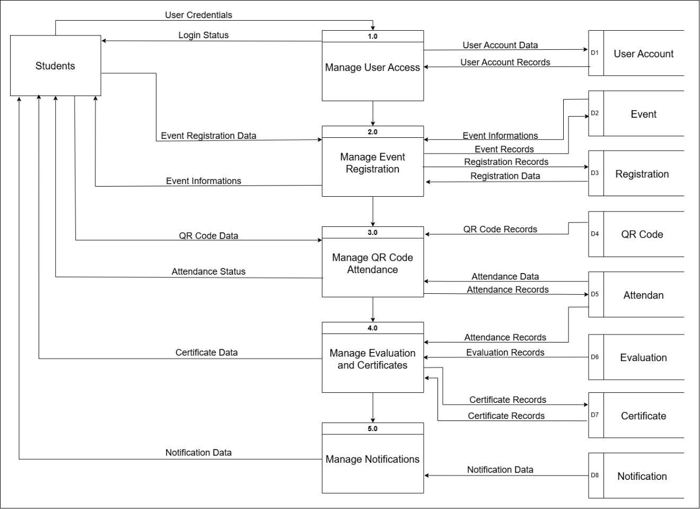
Figure 5. Data Flow Diagram level 1 (Students)
Figure 5 illustrates the Data Flow Diagram Level 1 for Students, showing how student users interact with the QR Code-Enabled Student Organization Event and Attendance Management System. The process begins when students submit their user credentials to Manage User Access (Process 1.0). The system validates the credentials using the User Account data store (D1), where user account data and user account records are managed. After verification, the system returns the login status to the student, allowing access to the student-related features of the platform.
After gaining access, students proceed to Manage Event Registration (Process 2.0). In this process, students can view available event information and submit event registration data for the events they want to join. The system retrieves event information from the Event data store (D2) and stores registration details in the Registration data store (D3). This ensures that student participation is properly recorded and that registration records are available for monitoring and confirmation.
The next process is Manage QR Code Attendance (Process 3.0), where students use their QR code data for attendance verification during events. The system checks QR code records from the QR Code data store (D4) and records the attendance data in the Attendance data store (D5). After validation, the system provides the student with an updated attendance status, confirming whether the attendance was successfully recorded.
Students then proceed to Manage Evaluation and Certificates (Process 4.0). This process handles the submission of evaluation records and the generation of certificate data for qualified students. The system retrieves attendance records from the Attendance data store (D5), stores evaluation records in the Evaluation data store (D6), and manages certificate records through the Certificate data store (D7). Once the requirements are met, the system provides the student with the corresponding certificate data.
Lastly, Manage Notifications (Process 5.0) handles the notification data received by students. The system retrieves and processes notification data from the Notification data store (D8), allowing students to receive updates related to events, registration status, attendance, evaluations, and certificates. Overall, the DFD shows the organized flow of student-related data from login, event registration, QR code attendance, evaluation, certificate processing, and notification management within the system.
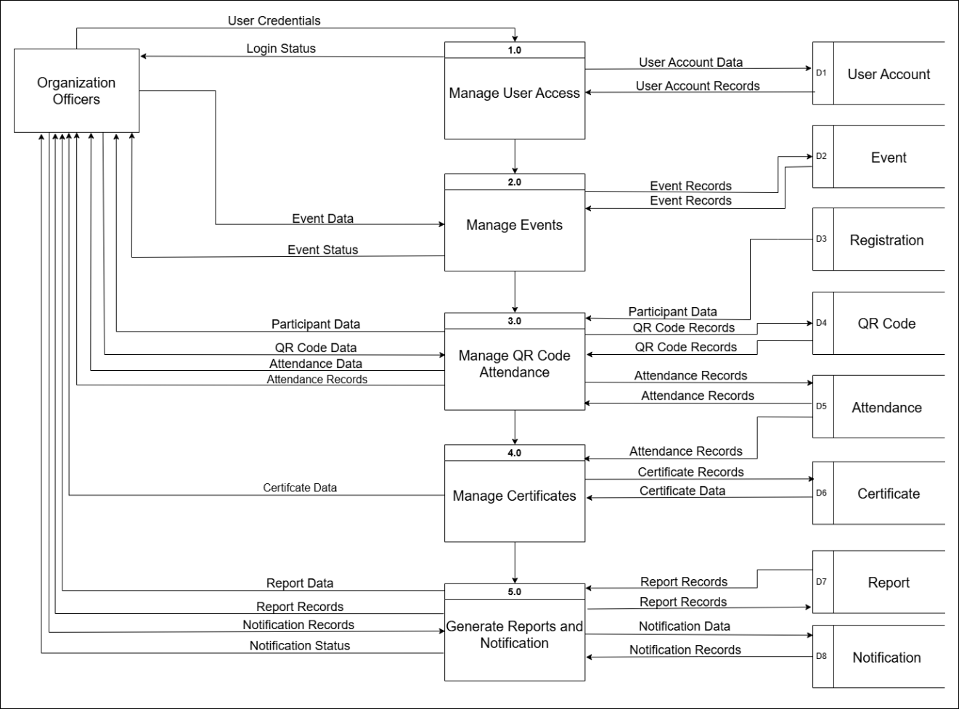
Figure 6. Data Flow Diagram level 1 (Organization Officer)
Figure 6 illustrates the Data Flow Diagram Level 1 for Organization Officers, showing how organization officers interact with the system in managing student organization events and attendance-related processes. The process begins with Manage User Access (Process 1.0), where organization officers submit their user credentials to access the system. The system verifies the credentials using the User Account datastore (D1) and returns the login status to determine whether access is granted.
After successful login, organization officers proceed to Manage Events (Process 2.0), where they create, update, and monitor event information. The event data submitted by the organization officers is stored and retrieved from the Event datastore (D2), while the system provides event status updates for monitoring purposes. The next process is Manage QR Code Attendance (Process 3.0), which handles participant data, QR code data, and attendance data. This process retrieves participant information from the Registration datastore (D3), uses QR code records from the QR Code datastore (D4), and records verified attendance in the Attendance datastore (D5).
The diagram also shows Manage Certificates (Process 4.0), where attendance records are used as the basis for generating certificates for qualified participants. Certificate data and records are stored in the Certificate datastore (D6) and may be accessed by organization officers when needed. Lastly, Generate Reports and Notification (Process 5.0) allows organization officers to produce report data and send notification-related information. Report records are stored in the Report datastore (D7), while notification data and records are managed through the Notification datastore (D8). Overall, the DFD shows that organization officers play an important role in event management, QR code attendance monitoring, certificate generation, report production, and communication with participants through the system.

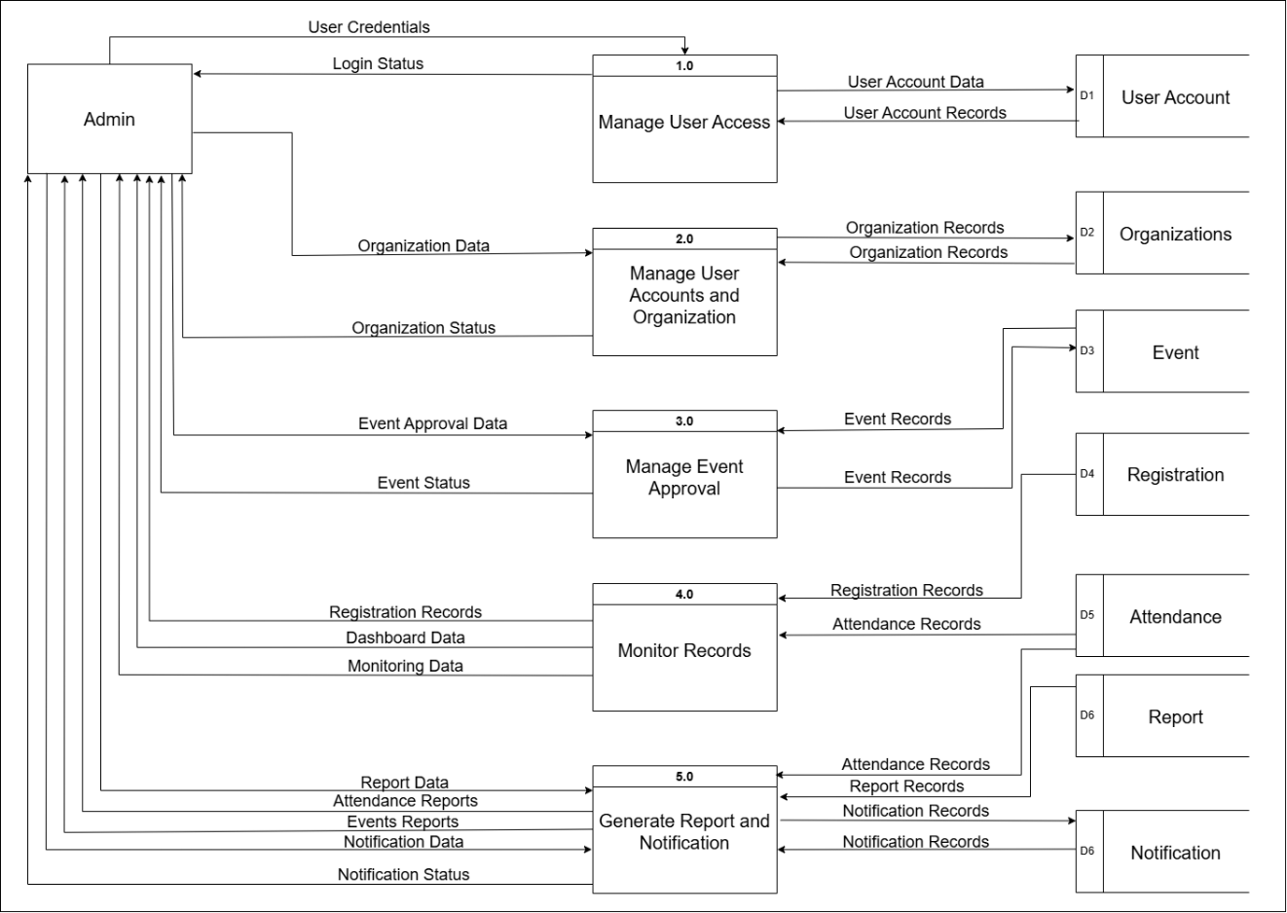
Figure 7. Data Flow Diagram level 1 (Admin)
Figure 7 illustrates the Data Flow Diagram Level 1 for the Admin, showing how the admin manages user access, organizations, event approvals, records, reports, and notifications within the QR Code-Enabled Student Organization Event and Attendance Management System. The process begins with Manage User Access (Process 1.0), where the admin provides user credentials to access the system. The system verifies these credentials using the User Account data store (D1), and once validated, the admin receives the login status.
The admin can also manage user accounts and student organizations through Manage User Accounts and Organization (Process 2.0). In this process, organization data and user-related information are processed and connected to the Organizations data store (D2). This allows the admin to monitor recognized student organizations and maintain updated organization records.
For event-related requests, Manage Event Approval (Process 3.0) handles event approval data submitted through the system. The process retrieves and updates event records from the Event data store (D3), allowing the admin to approve, reject, or monitor the status of events created by organization officers. After approval, the event status is returned to the user side of the system.
The admin also performs monitoring tasks through Monitor Records (Process 4.0). This process uses registration records, attendance records, dashboard data, and monitoring data to provide an overview of system activities. It connects to the Registration data store (D4) and Attendance data store (D5), helping the admin track event participation, attendance summaries, and overall system activity.
Lastly, Generate Report and Notification (Process 5.0) allows the admin to produce reports and manage notification-related data. This process uses attendance records, event reports, report data, and notification data to generate useful summaries and updates. The generated records are connected to the Report data store (D6) and Notification data store. Overall, the DFD shows how the admin supervises the system by managing accounts, monitoring organizations and events, reviewing records, generating reports, and maintaining proper communication through notifications.
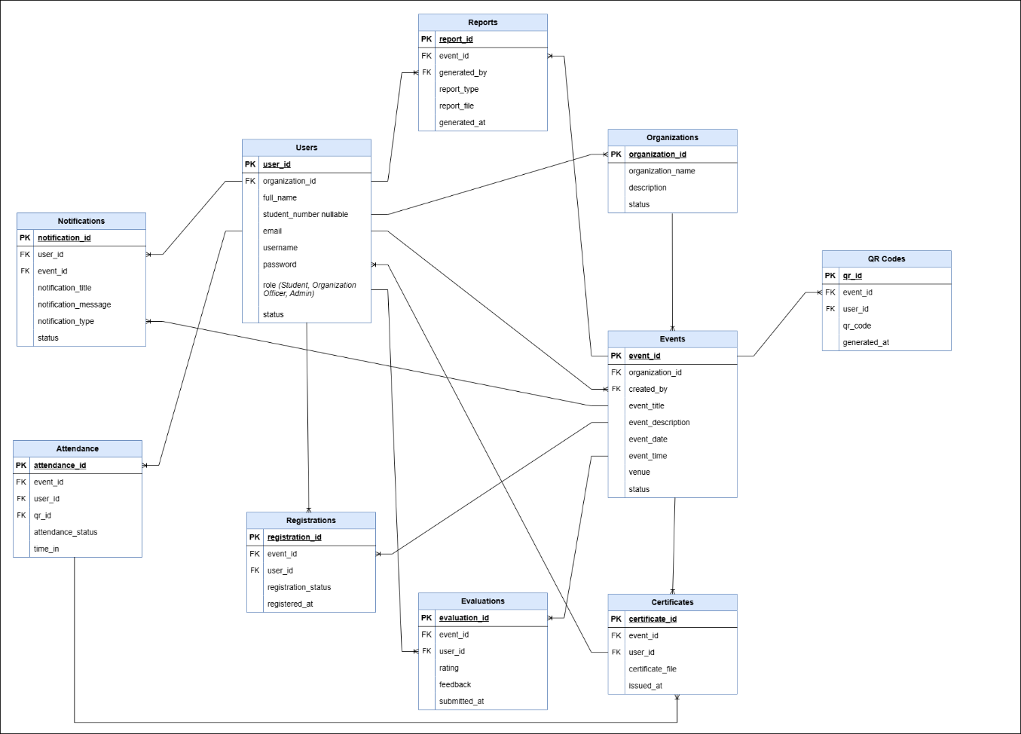
Figure 8. Entity Relationship Diagram
The Entity Relationship Diagram (ERD) presented illustrates the structural relationships among the main entities of the QR Code-enabled Event and Attendance Management System. It defines how data is organized, stored, and connected across different roles and system components. The diagram identifies four key entities: Student, Organization Officer, Admin, and USC/OSADS Admin, each interacting with central data elements such as Event Data, QR Code Data, and Attendance Log. The Student entity is linked to the QR Code Data, representing the process of scanning and recording attendance during events. The Organization Officer manages Event Data, ensuring that event details are properly encoded and validated. The Admin serves as the system’s central controller, maintaining connections with all data entities—event, QR code, and attendance—to monitor activities and generate reports. Finally, the USC/OSADS Admin oversees the Attendance Log, ensuring institutional compliance and record accuracy. Overall, this ERD demonstrates a hierarchical and relational structure where each entity performs a distinct role but remains interconnected through shared data flows. It emphasizes data integrity, role-based access, and efficient event tracking, forming the backbone of a transparent and automated attendance management system.

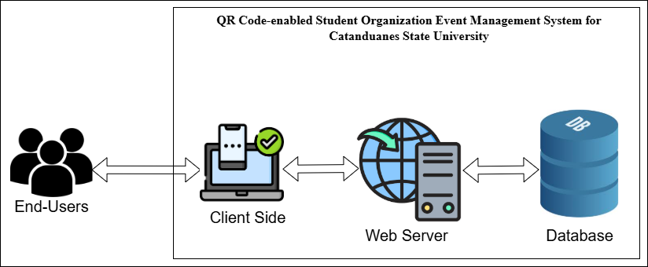
Figure 9. System Architecture
Figure 9 presents the System Architecture of the QR Code-enabled Student Organization Event Management System for Catanduanes State University. The architecture shows the basic interaction among the end-users, client side, web server, and database. The end-users, which include Students, Organization Officers, and Admin, access the system through the client side using a web browser or supported device. The client side serves as the user interface where users can perform actions such as viewing events, registering for events, managing event records, scanning or presenting QR codes, monitoring attendance, and generating reports. These requests are then sent to the web server, which processes the system functions, handles business logic, validates user actions, and connects the client side to the database. The database stores and manages important records such as user accounts, event information, registration data, QR code records, attendance logs, evaluation responses, certificates, notifications, and reports. Overall, the architecture illustrates a simple client-server structure that supports smooth communication between users and the system, ensuring that data is properly processed, stored, and retrieved for efficient event and attendance management.

STORY BOARD
The storyboard illustrates the complete workflow of the QR Code‑enabled Event and Attendance Management System, showcasing how each process unfolds from event creation to report generation. It visually narrates the interaction between the admin and students, emphasizing automation, efficiency, and real‑time data handling. Each scene represents a distinct system function — from login and QR code scanning to attendance monitoring, evaluation, certificate generation, and report export — forming a cohesive sequence that demonstrates the system’s capability to streamline university event management. This storyboard serves as both a visual guide and a conceptual framework, bridging the technical design with user experience for academic presentation and defense.

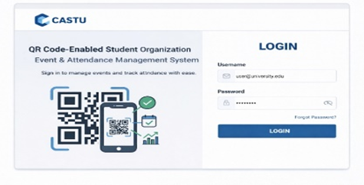
Figure 10. Login Interface
Figure 10 presents the login interface of the QR Code-Enabled Student Organization Event and Attendance Management System. This page allows authorized users such as students, organization officers, and admin to enter their username and password to securely access the system.

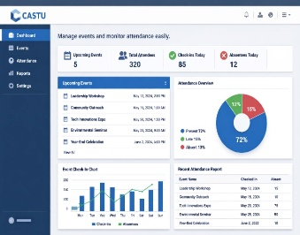
Figure 11. Dashboard Interface
Figure 11 shows the dashboard interface, which provides an overview of important system information such as upcoming events, total attendees, check-ins, absences, attendance overview, and recent attendance reports. This allows users to monitor event and attendance activities in one centralized page.
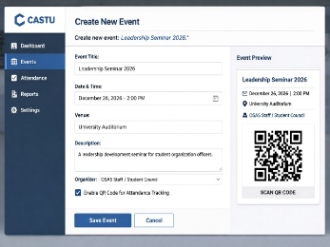
Figure 12. Create New Event Interface
Figure 12 presents the create new event interface used by organization officers or authorized users to input event details such as event title, date and time, venue, description, and organization. The interface also includes an event preview and QR code option for attendance tracking.
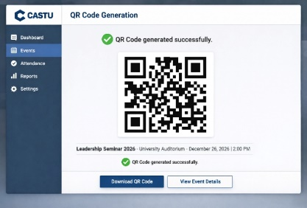
Figure 13. QR Code Generation Interface
Figure 13 shows the QR code generation interface where the system generates a unique QR code for a specific event. This feature allows organization officers to download the QR code or view event details for attendance verification.

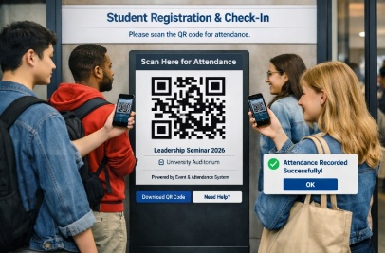
Figure 14. Student Registration and Check-In Interface
Figure 14 illustrates the student registration and check-in interface where students scan the displayed QR code to record their attendance. Once scanned successfully, the system provides a confirmation message indicating that the attendance has been recorded.
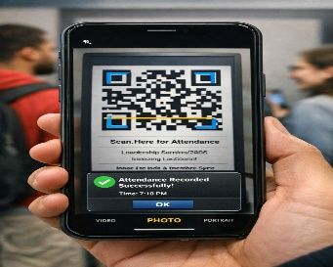
Figure 15. QR Code Scanning Interface
Figure 15 presents the QR code scanning process using a mobile device. This interface allows students or authorized users to scan the event QR code and receive an attendance confirmation once the QR code is successfully validated.
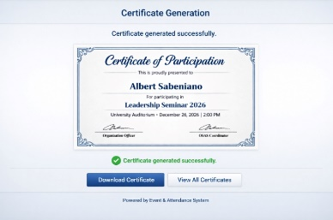
Figure 16. Certificate Generation Interface
Figure 16 shows the certificate generation interface where the system creates a digital certificate for qualified participants. Students can download their certificate after completing the required attendance or event participation process.
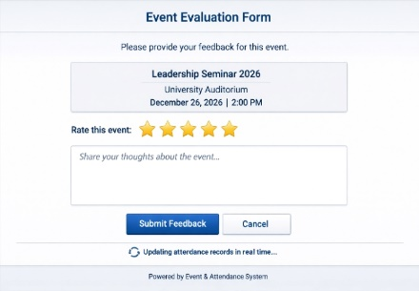
Figure 17. Event Evaluation Form Interface
Figure 17 presents the event evaluation form where students can provide feedback after attending an event. The form allows students to rate the event and submit comments that may help improve future student organization activities.
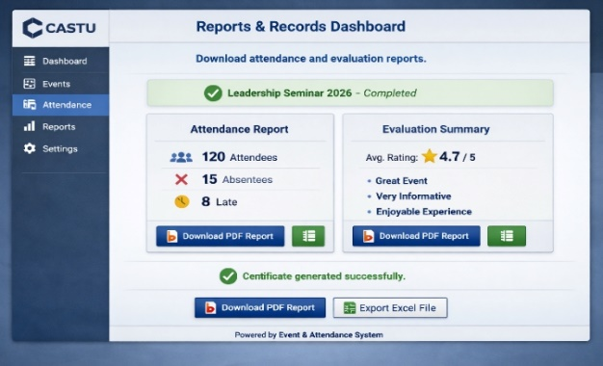

Figure 18. Attendance Monitoring Dashboard

Figure 18 shows the attendance monitoring dashboard, which displays the list of students who have checked in, including their student ID, time-in, and attendance status. This helps organization officers monitor attendance records in real time.

Development and Testing
Software Development Method
The study will use the Rapid Application Development (RAD) Methodology in developing the proposed QR Code-enabled Student Organization Event and Attendance Management System for Catanduanes State University. RAD emphasizes quick prototyping and iterative development, allowing the researchers to rapidly design, build, and refine system components based on continuous user feedback. This approach ensures that the system evolves efficiently to meet the functional and operational needs of the university’s student organizations.
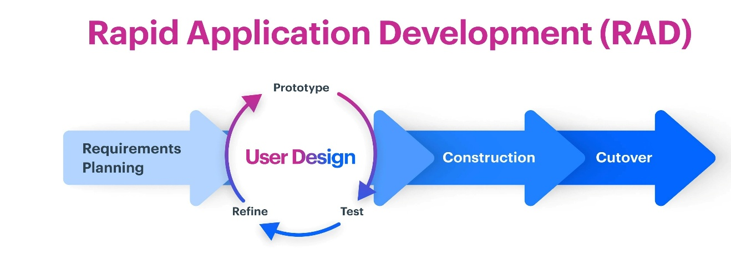
source: https://kissflow.com/application-development/rad/rapid-application-development/
Figure 19. RAD Methodology
Figure 19 illustrates the development of the QR Code-Enabled Student Organization Event and Attendance Management System for Catanduanes State University using the Rapid Application Development (RAD) methodology. This methodology guides the researchers in developing the system through a fast, flexible, and iterative process where requirements, design, construction, testing, and implementation are continuously refined based on user needs and feedback. Instead of following a long and rigid development process, RAD allows the researchers to focus on quick prototyping and improvement of the system features, including event creation, participant registration, QR code generation, attendance validation, evaluation submission, certificate generation, report generation, notification management, and user account management. Through this approach, the system is developed in a structured manner while ensuring that the final output addresses the needs of Students, Organization Officers, and Admin users.
a. Requirements Planning. The development process begins with the requirements planning phase. During this phase, the researchers identify the problems related to manual event registration, attendance tracking, certificate preparation, and report generation in student organization activities. The needed hardware, software, data, and user requirements are also determined. The researchers identify the major users of the system, including Students, Organization Officers, and Admin, together with their expected functions such as viewing events, registering for events, managing event records, generating QR codes, monitoring attendance, and producing reports. This phase serves as the foundation for defining the scope, objectives, and required features of the proposed system.
b. User Design. After identifying the requirements, the researchers proceed to the user design phase. In this phase, the structure, interface, database design, and system flow are planned and improved through continuous review and refinement. The researchers prepare system models such as the use case diagram, context diagram, data flow diagrams, entity relationship diagram, swimlane diagram, system architecture, conceptual framework, and storyboard screens. These models help show how users interact with the system, how data moves between processes, and how records are stored and retrieved. The user design phase also allows the researchers to refine the prototype based on feedback to ensure that the system will be clear, organized, and easy to use.
c. Construction. During the construction phase, the researchers develop the actual system based on the approved design and requirements. The main modules are implemented, including user login, dashboard, event management, participant registration, QR code generation, attendance monitoring, evaluation management, certificate generation, notification management, and report generation. The system is developed as a web-based platform where authorized users can access their assigned functions through a client-side interface, while the web server processes requests and communicates with the database. This phase focuses on converting the planned design into a functional system.
d. Cutover. The cutover phase involves final testing, correction, and preparation of the system for actual use. The researchers check whether the system features work properly, including login access, event posting, registration processing, QR code scanning, attendance recording, certificate generation, and report export. Errors and inconsistencies are corrected before finalizing the system. This phase ensures that the completed QR Code-Enabled Student Organization Event and Attendance Management System is ready for evaluation and can support the event and attendance management needs of Catanduanes State University.
Evaluation. The evaluation of the developed system is conducted to determine its effectiveness, usability, and alignment with the objectives of the study. The evaluation focuses on assessing whether the system can properly support event management, participant registration, QR code attendance verification, certificate generation, notification handling, and report generation. Feedback from the intended users and evaluators is gathered using a survey questionnaire based on software quality criteria. The results help determine the quality, performance, reliability, security, maintainability, and overall acceptability of the system.

Data Gathering Procedure
The data gathering procedure involved collecting information necessary for evaluating the system. First, the researchers identified the respondents who are actual users of the system. Second, questionnaires were prepared based on system usability, functionality, and performance. Third, the questionnaires were distributed to respondents after they used the system. Fourth, responses were collected and organized for analysis. Ethical considerations such as voluntary participation, consent, and confidentiality of responses were strictly followed during the data collection process.

Respondents of the Study
The respondents of the study include students, organization officers, and administrators from Catanduanes State University. These respondents were selected because they are the primary users of the QR Code-Enabled Student Organization Event Management System. The sampling technique used in this study is purposive sampling, where participants were selected based on their involvement in student organization events.

Table 7. Respondents of the Study
Type of Respondent | Sample
OSADS Staff | 3
Student Council Executives | 15
General Student Evaluators | 30
Total | 48

Statistical Tool
This part presented the statistical tools and techniques utilized to process data in the QR Code-enabled Student Organization Event and Attendance Management System for Catanduanes State University. Descriptive statistics were applied to summarize and describe the principal characteristics of the gathered data, like user satisfaction scores and scanning processing duration. Frequency counts were applied to tally responses for categorical variables like student organizations and frequency of attendance-related offenses. Percentages were utilized to calculate the proportion of respondents who chose certain options in surveys.
The mean range was calculated using the formula as shown below:
$$\frac{\overline{x}= ∑fx}{n}$$

Whereas:
x̄ = Weighted Mean
F = Frequency
W = Weighted Assigned
N = Total number of participants
The mean range is a statistical measure used to understand the average response within a group. It was calculated by first determining the total rate, which is the sum of each respondent's chosen scale value multiplied by its corresponding frequency. This total rate was then divided by the total number of respondents, resulting in the mean range. This value represents the average response or satisfaction level of the evaluators toward the developed system.
The study will use a five-point Likert Scale to interpret the responses of the respondents during system evaluation.
Table 8. Likert Scale Interpretation
Scale | Range | Verbal Interpretation
5 | 4.21 – 5.00 | Strongly Agree
4 | 3.41 – 4.20 | Agree
3 | 2.61 – 3.40 | Neutral
2 | 1.81 – 2.60 | Disagree
1 | 1.00 – 1.80 | Strongly Disagree

The weighted mean of the responses will be interpreted based on the given scale to determine the overall evaluation and acceptability of the proposed system.

REFERENCES
Yourdon, E., & DeMarco, T. (1979). Structured analysis and system specification. Prentice Hall.
Lucid Software Inc. (2023). What is a context diagram? Lucidchart. https://www.lucidchart.com/pages/examples/context-diagram-software
Bentley University Library. (2024). APA figure examples for images, charts, and diagrams. https://libguides.bentley.edu/citingsources-apa/figures
Wikipedia contributors. (2024). Use case diagram. Wikipedia. https://en.wikipedia.org/wiki/Use_case_diagram
Denso Wave Incorporated. (2020). QR code essentials. https://www.qrcode.com/en/
University of California. (2022). Student organization management guidelines. https://www.universityofcalifornia.edu/
Chaturvedi, R., Sharma, P., & Singh, V. (2024). Centralized university event management systems and administrative efficiency. International Journal of Information Systems, 14(2), 45–57.
Chua, M., & Fernandez, L. (2024). Software evaluation methods in academic information systems. Philippine Journal of Computing Studies, 11(1), 20–31.
Chua, R., & Ramos, D. (2023). QR code attendance systems in educational institutions. Journal of Educational Technology, 9(2), 66–74.
Cruz, M., & Fernandez, J. (2022). Agile software development in academic information systems. Philippine IT Research Journal, 7(1), 15–24.
Dela Cruz, R., & Santos, P. (2023). Digital event systems in universities. Asian Journal of Educational Technology, 10(2), 51–63.
Dizon, P., & Mendoza, J. (2023). QR code attendance systems for higher education institutions. Philippine Computing Journal, 8(1), 33–42.
Garcia, L., & Lopez, M. (2022). Automated attendance systems using QR code technology. Journal of Information Systems, 12(3), 28–40.
Gonzales, A., & Reyes, T. (2022). Event management challenges in Philippine universities. Journal of Educational Administration, 6(2), 40–50.
Gonzales, M., Cruz, P., & Ramos, J. (2025). Cloud-based academic information systems. International Journal of Web Technologies, 13(1), 70–82.
Gonzales, R., Torres, J., & Santos, M. (2025). User satisfaction evaluation in academic systems. Philippine Journal of Information Technology, 15(1), 55–68.
ISO/IEC 25010. (2023). Systems and software quality requirements and evaluation. International Organization for Standardization.
Kumar, R., & Singh, P. (2022). Web-based information systems in educational management. International Journal of Computer Applications, 15(4), 44–52.
Lee, H., & Kim, J. (2025). Centralized event systems for academic institutions. International Journal of Educational Technology, 17(2), 60–73.
Lee, J., Kim, H., & Park, S. (2025). Mobile QR code attendance monitoring systems. Journal of Smart Systems, 16(1), 81–94.
Lee, S., & Park, Y. (2026). Real-time web-based management systems in universities. International Journal of Web Engineering, 18(1), 25–39.\
Lee, T., & Santos, M. (2026). Agile framework implementation in educational software systems. Journal of Software Engineering Studies, 12(2), 41–55.
Lewis, J., & Sauro, J. (2022). Measuring software usability and user satisfaction. Usability Research Journal, 5(1), 11–20.
Mendoza, J., Ramos, K., & Cruz, L. (2022). Web-based systems in academic organizations. Philippine Journal of ICT Research, 9(2), 31–45.
Navarro, P., & Cruz, D. (2023). Responsive web technologies for educational systems. Journal of Web Computing, 10(3), 56–69.
Nielsen, J. (2023). Usability principles for modern software systems. Nielsen Norman Group.
Patel, R., Sharma, A., & Jain, V. (2024). Secure QR code authentication systems. International Journal of Security Systems, 11(2), 72–84.
Pressman, R., & Maxim, B. (2023). Software engineering: A practitioner’s approach (10th ed.). McGraw-Hill.
Rahman, M., Hasan, K., & Ali, S. (2022). QR code-based attendance monitoring system. Journal of Computing Technologies, 14(2), 85–96.
Rajendran, S., & Hamzah, N. (2022). Event management automation in academic institutions. International Journal of Event Technologies, 8(1), 18–30.
Ramos, D., Reyes, M., & Cruz, P. (2024). Agile collaboration in software development projects. Journal of Information Technology Management, 13(1), 48–60.
Ramos, P., & Dela Cruz, R. (2024). ISO-based evaluation of educational systems. Philippine Journal of Systems Evaluation, 6(1), 14–26.
Selvam, R., & Harun, M. (2023). Digital event systems and participant monitoring. Asian Journal of Information Systems, 11(2), 34–47.
Sommerville, I. (2022). Software engineering (11th ed.). Pearson Education.
VersionOne. (2023). State of Agile report. VersionOne Inc.
Villaflor, M., & Garcia, R. (2025). Agile software usability improvement methods. Journal of Computing Innovation, 7(2), 36–49.
Villanueva, J., Ramos, A., & Torres, P. (2026). Evaluation of university digital platforms using ISO standards. International Journal of Information Quality, 9(1), 50–64.
Villanueva, M., & Torres, J. (2026). QR code integration in web-based event systems. Journal of Educational Computing, 14(1), 77–89.
None.

