Mick O’Hanlon

Week 7 Lab Report

mjo4rk

**Lab Setup**

* Installed Vagrant
* Set up WPDistillery
  + I was having lots of trouble at first accessing <http://wpdistillery.vm/>
* Edited Configurations in
* Downloaded Kali
  + Lots of issues with this step
  + Spent a while dealing with an issue where I did not have enough disk space. I finally was able to move some of the larger applications on my computer over to my hard drive so that I could download Kali to complete the assignment
  + Issues with copying and pasting into Kali
  + Computer would slow down or even shut down very frequently while I was following the steps to set up Kali. Fixed this through trial and error.
* Pinged the IP of WD Distillery
  + I had a lot of trouble accessing the [http://wpdistillery.vm](http://wpdistillery.vm/) link in my host computer browser and in Kali. I brought my issue to office hours on Sunday where I Chris fixed in issue with Vagrant on my computer.
* Challenge 3
  + Logged in using username: admin, password: admin
  + Created a post:
    - 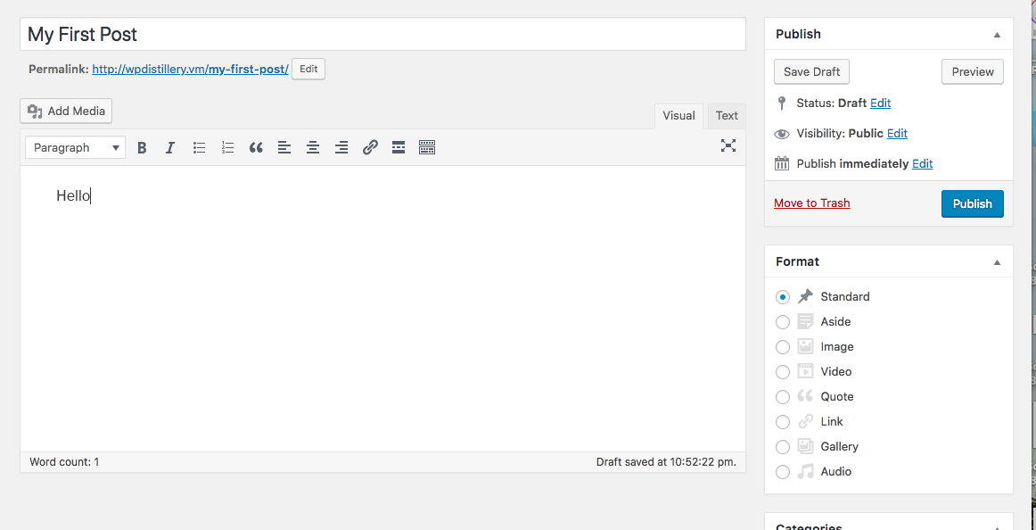
  + Created a page:
    - 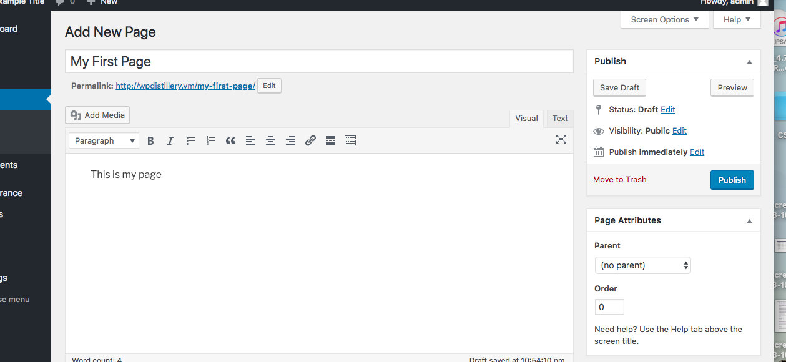
  + Created an attachment:
    - 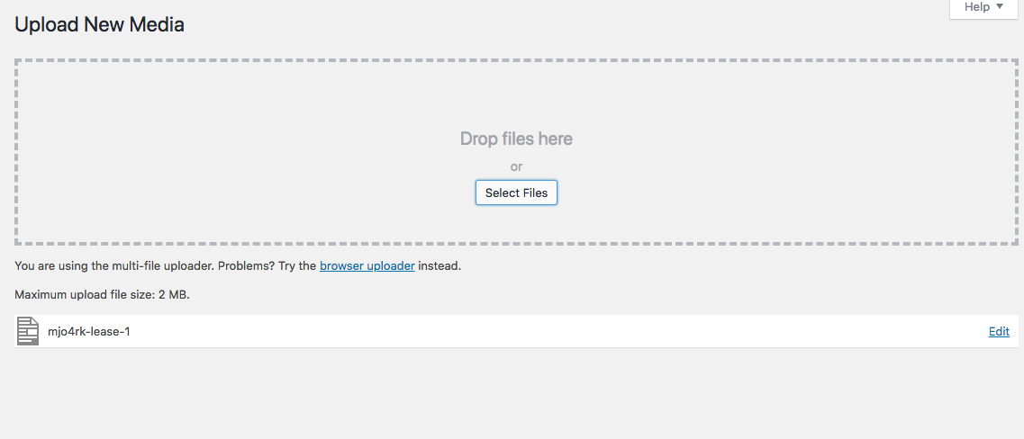
  + Challenge 5
    - Updated WP Scan
      * 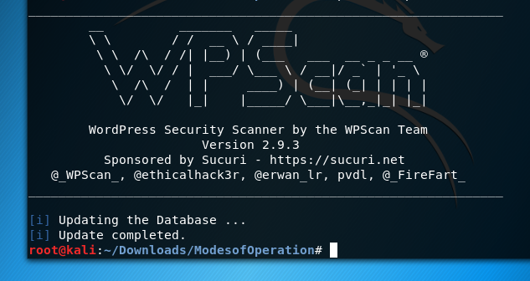
  + Challenge 6
    - Followed terminal commands for removing vagrant.
    - Changed config file:
      * 
    - Issues running vagrant up after deleting the current version of wordpress

**Challenge 7 - wpscan vs. WP 4.2**

* Ran WPScan command in Kali Terminal
  + I had a major issue running vagrant up in order to download the older version of wordpress. Because of this when I ran the WPScan command in Kali, I was still receiving the same amount of output as I had received before.

**Note:**

I spend about 10 hours total trying to trouble shoot various parts of this lab. My largest issue was that I was not able to access the wordpress.vm page. After posting in Piazza, I was instructed to go to office hours Sunday night. My problem was resolved at office hours, however, since I had to wait until the office hour time at Sunday night, and I also had to work for my job on Sunday night, I was not able to finish challenge 7. I have documented all the steps that I took to set up this lab, including areas where I ran into troubleshooting issues. Although I did not finish challenge 7, I hope that I will be able to receive some partial credit due to the extensive amount of time I took working on the lab and the unfortunate circumstance of having to wait until Sunday evening office hours to fix my issue with accessing the WordPress site.

**References**