---
title: "invasive plant data preparation"
format: html
---

```{r setup-prep}
#| echo: false
#| message: false
library(dplyr)
library(readr)
library(stringr)
library(ggplot2)
library(tidyverse)
library(tidyr)
```

```{r load-data}
# Load and prepare data
locations_clean <- Locations|>
drop_na(Field_Species)
# Save processed data
write_csv(locations_clean, "data/locations_clean.csv")
```

```{r bargraph}
#create bar graph of counts of different invasive species found by name and add color to each species
bar_chart_v1 <- locations_clean |>
ggplot(aes(x= Field_Species)) +
geom_bar( )

bar_chart_v1
```
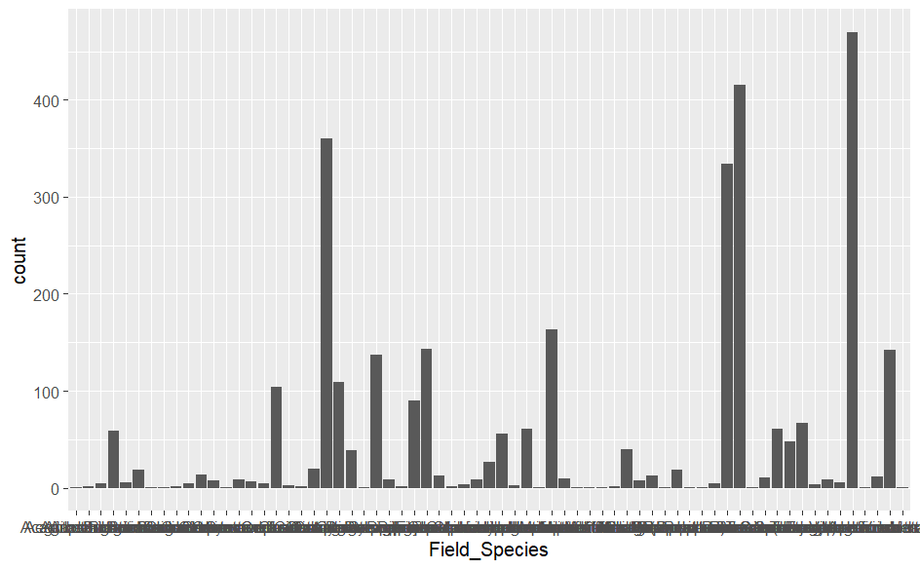
```{r bargraph}
#flipping and labeling axes and titling plot
bar_graph_v2 <- locations_clean |>
ggplot (aes(x = Field_Species)) +
geom_bar() +
coord_flip() +
labs(
title = "Count of Each Invasive Species Found",
x = "Invasive Species",
y = "Count"
)

bar_graph_v2
```
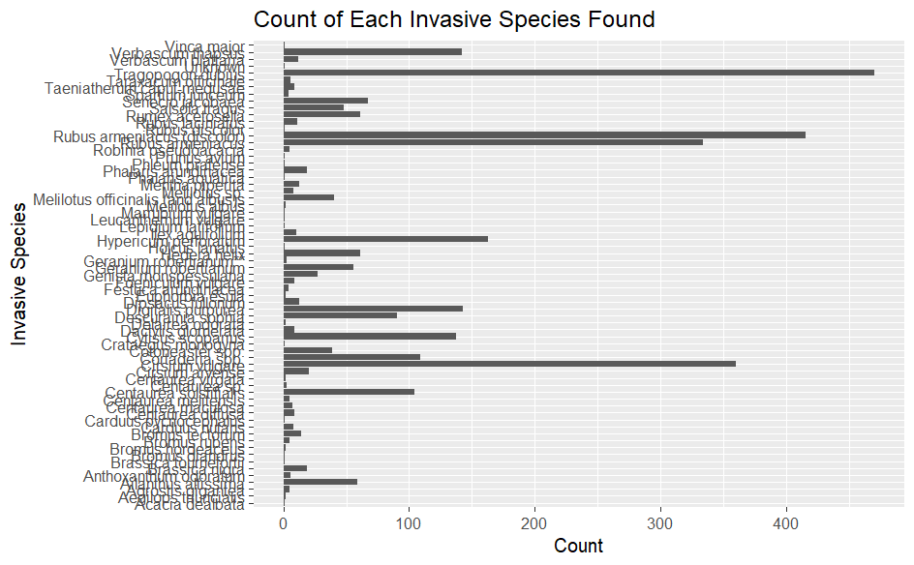
```{r bargraph}
# sorting by count and making bars narrower
bar_graph_v3 <- locations_clean |>
count(Field_Species) |>
mutate(Field_Species = fct_reorder(Field_Species, n)) |>
ggplot(aes(x = Field_Species, y = n)) +
geom_bar(stat = "identity", width = 0.2) +
coord_flip() +
theme_minimal() +
labs(
title = "Number of Each Invasive Species Found",
x = "Invasive Species",
y = "Count"
)

bar_graph_v3
```

```{r bargaph}
#changing font size on labels
bar_graph_v4 <- locations_clean |>
count(Field_Species) |>
mutate(Field_Species = fct_reorder(Field_Species, n)) |>
ggplot(aes(x = Field_Species, y = n)) +
geom_bar(stat = "identity", width = 0.2) +
theme_grey(base_size = 8) +
coord_flip() +
labs(
title = "Number of Each Invasive Species Found",
x = "Invasive Species",
y = "Count"
)

bar_graph_v4
```
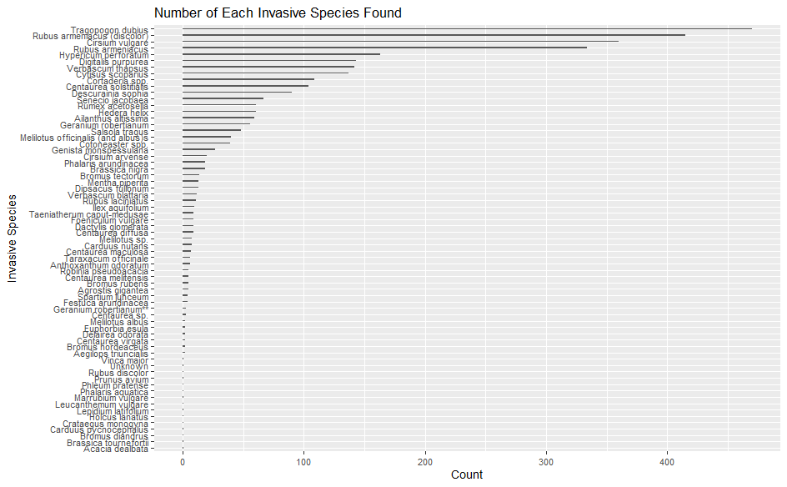
```{r prepare-data}
#load and prepare data
elevation_clean <- Locations |>
drop_na(Elevation_m)

#save cleaned data
write_csv(elevation_clean, "data/elevation_clean.csv")
```

```{r histogram}
#histogram of elevations at which invasive specimens were found with bin and axes scale adjustments and colored title
histogram_v1 <- elevation_clean |>
ggplot(aes(x = Elevation_m)) +
geom_histogram(binwidth = 100) +
scale_y_continuous(name = "Number of Specimens", breaks = c(0,100,200,300,400,500,600,700,800,900,1000),limits=(c(0,1000))) +
scale_x_continuous(name = "Elevation (meters)", breaks = c(0,200,400,600,800,1000,1200,1400,1600,1800,2000,2200,2400,2600,2800,3000)) +
ggtitle("Distribution of Elevations At Which Invasive Specimens Were Identified") +
theme(plot.title=element_text(face='bold', colour='blue', size=14))

histogram_v1
```
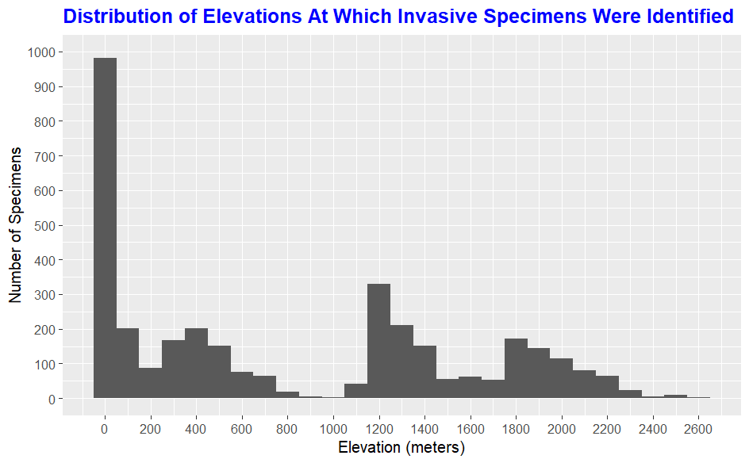
```{r clean data}
elevation_location_clean <- Locations |>
drop_na(Elevation_m,Field_Species)

# Save processed data
write_csv(locations_clean, "data/elevation_location_clean.csv")
```

```{r subsetting data}
# filtering data to spp Tragopogon dubius and asspciated elevations

filtered_spp <- elevation_location_clean[ which (elevation_location_clean$Field_Species=='Tragopogon dubius'),]

view(filtered_spp)

# Save processed data
write_csv(filtered_spp, "data/filtered_spp.csv")
```

```{r scatterplot}
#scatterplot of elevations that Trgopogon dubius was found
scatter_plot <- filtered_spp |>
ggplot(aes(x = Elevation_m, y = Field_Species)) +
geom_point()

scatter_plot
```
