Clock Model: Vilar et al 2002, PNAS. Mechanisms of Noise-resistance in genetic oscillators.

Circadian Clock Oscillator Model:

|  |  |  |  |  |  |  |
| --- | --- | --- | --- | --- | --- | --- |
|  | Reaction | kon (or kf) | koff | ka3D (or kf) | kb | 𝜎 |
| 1 | PmrA⟶PrmA+mRNA_A | 50s-1 | - | 50s-1 | - | - |
| 2ab | PrmA+A⇌PrmA_bound | 602μM-1s-1 | 50s-1 | 4888.6nm3μs-1 | 244.5s-1 | 5nm |
| 3 | PrmA_bound ⟶PrmA_bound+mRNA_A | 500s-1 | - | 500s-1 | - | - |
| 4 | PrmR⟶PrmR+mRNA_R | 0.01s-1 | - | 0.01s-1 | - | - |
| 5ab | PrmR+A⇌PrmR_bound | 602μM-1s-1 | 100s-1 | 4888.6nm3μs-1 | 489s-1 | 5nm |
| 6 | PrmR_bound ⟶PrmR_bound+mRNA_R | 50s-1 | - | 50s-1 | - | - |
| 7 | mRNA_A⟶mRNA_A+A | 50s-1 | - | 50s-1 | - | - |
| 8 | mRNA_R⟶mRNA_R+R | 5s-1 | - | 5s-1 | - | - |
| 9 | A+R⟶C | 1204μM-1s-1 | - | 356263nm3μs-1 | - | 8nm |
| 10 | C⟶R | 1s-1 | - | 1s-1 | - | - |
| 11 | A⟶Null | 1s-1 | - | 1s-1 | - | - |
| 12 | R⟶Null | 0.2s-1 | - | 0.2s-1 | - | - |
| 13 | mRNA_A⟶Null | 10s-1 | - | 10s-1 | - | - |
| 14 | mRNA_R⟶Null | 0.5s-1 | - | 0.5s-1 | - | - |

For all species Dt=10μm2/s, and DR=0.

V=4.188 μm3

Initial copies are 0 except for prmA=1 and prmR=1.

Use ∆t=10μs, density can get high and 50μs is above suggested max time-step.

**DATA FILES:**

This directory contains A(t) R(t) for NERDSS trajectory. First column is Iteration, time=Itr*50us.

ar_iter_regDecay_NERDSS.dat

And for slower decay: ar_iter_slowDecay_NERDSS.dat

Files for ODE from Virtual Cell: ARode_vstime.dat

Files from PDE from Virtual Cell: ARpde_vstime.dat

**ANALYSIS FILES:** Read in trajectory [t, A(t), R(t)], calculate periods of oscillations and lag times.

findOscillationPeriodFFTZeroPad.m

calc_peak_sepsAR.m

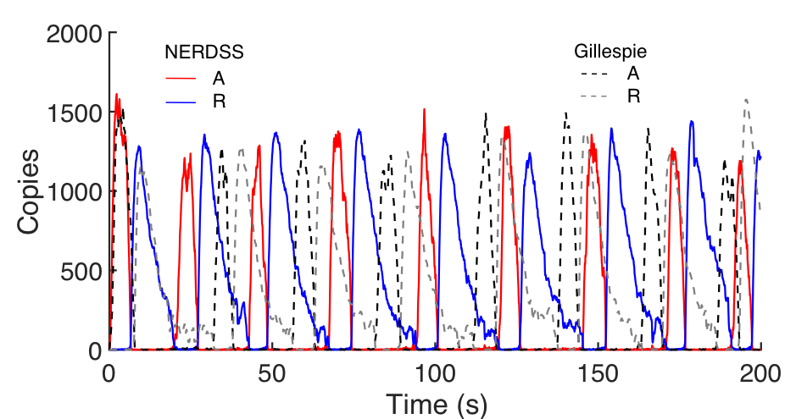

**Fig 1**. NERDSS simulations give periods of 24.5s, 24.75, 6.45s lag. ODE/PDE is 25.12, 25.12 and 6.55s. Based on FFt with zeropad to 5000s.



**Fig 2**. FFT of NERDSS A/R oscillations vs time, after zero padding to 500s. Largest amplitude is for oscillations at a period of 24.2658s, from this trajectory.



**Fig 3.** With slow R decay, (reaction #12, we drop the rate from 0.2 to 0.05 s-1) oscillations disappear in deterministic solution but persist in stochastic simulations. Here, the single-particle NERDSS simulations were run for 1000s, producing oscillations with periods of 63.3 and 64.1s, or about twice as slow as the original model. The lag between A and R slowed to 7.95s.