**Graded Unit Stage 1A: Inception Report**

Michael Johnston

(1800329)

Contents

Introduction 3

Client Brief and Background 3

Researching functional and non-functional requirements 5

Discussion of Possible Software Solutions to the Problem 13

A Discussion on User Groups 13

Functional and Non-Functional Requirements 14

Aims of the Project 15

Use-Case Model 15

Required Resources 15

Conclusion 16

References 16

# Introduction

In this report we shall detail the steps taken in the inception phase of the development of the software that we have been commissioned to make. These steps are largely split into the sections of this report and cover the following topics:

* Client Background and background subject information
* Researching the client’s needs from the software
* Researching similar software
* A “brief” statement from the client
* Discussion of possible solutions to the client’s request
* The functional and non-functional requirements we have decided to implement in this iteration
* A statement of the aims of this project
* A top-level use-case model
* A list of know resources required to complete the project

Client Brief and Background

Wayne Walker of Walker Vapor Group LLC has commissioned this developer to produce a piece of software to solve problems Mr. Walker and other figures within the vaping community have identified. He has provided the following brief describing the features he is looking for in a software solution:

"I would like to have a software platform in which I can mix an e-liquid recipe, save it locally to an account privately and have the option to publicly share it to a pool of recipes, which other users can do the same. I should be able to add notes to at least my recipes. It must have a means of listing these public recipes in a fashion such that the list can be filtered or show what’s popular this week, this year etc., being able to specify any given time frame would be nice. Recipes should be able to be rated by users. I should be able to take a public recipe and take it into the mixing calculator part of the software so I can mix however much I want of it without me having to type it all out myself. It should have a list of the flavours I have and I should be able to add new ones. I want to mix e-liquid by weight though by volume would be nice too.

This should be done by the 30th of April 2020. The software should run on Windows 10, should be beginner friendly and easy to navigate."

Wayne Walker is a prominent figure in the vaping community (that is, those who utilise e-cigarette technology to meet their nicotine dependence), he produces videos and podcasts on vaping related topics on YouTube (with a following of 54.8 thousand at the time of this writing) (Walker Vapor Group LLC, n.d.), publishes articles and videos on his own website(https://diyordievaping.com/) (Walker Vapor Group LLC, n.d.), and constructs e-juice recipes for public and commercial usage-selling oneshot flavourings for use by those who make their own e-juice. Many of his commercial and public recipes have seen extreme popularity in the past and sell on many websites that cater to the vaping community such as Chefs Flavours (Chefs Flavours, n.d.), Sluice Juice (Sluice Juice, n.d.), and Liquid Barn (Liquid Barn, n.d.) to name a few.

Before we go any further, I should first explain the composition of e-juice, how it is mixed and some other things.

The liquids that are vaporised in e-cigarette devices are commonly referred to as e-juice, e-liquid or sometimes vape-juice. It is composed of four main parts: vegetable glycerine, propylene glycol, nicotine (in a propylene glycol solution) and flavourings (also usually in a propylene glycol solution) (Misthub, 2015). The flavourings used in e-liquid are typically food grade flavourings safe for vaping or are made specifically for it (DaveX, 2019).

When e-liquid is made (by companies or private users) these four components are mixed at proportions that the user desires. This may depend on the type of device they use, how strong they want the flavour to be, the strength of the nicotine concentration desired etc. The flavouring component of the liquid can be composed of a single flavour, multiple flavours or a "oneshot" which is a cocktail of flavourings in specific proportions making mixing the liquid easier and more convenient. This is how we arrive at the idea of a recipe: the specific flavourings and their proportion in each e-liquid defines a recipe. Many bottles can be made to the specification of a recipe. Those who construct original recipes are sometimes referred to as "mixers". People who make their own e-liquid with single flavourings find recipes for them from websites like alltheflavors.com or e-liquid-recipes.com.

Researching functional and non-functional requirements

I recently sat down with Wayne Walker to discuss the current crop of software available to the vaping community.

**Q**: So what do you think of the current software available to people who want to mix their own e-liquid?

**A**: I would describe it as adequate. It is very useful in what it does offer, lots of recipes for a beginner to make, tools that make your life easier like flavour stashes and searching by flavour, though I think it could certainly be improved upon.

**Q**: How could it be improved?

**A**: Well the problem for someone like me, someone who’s mixed a lot of recipes, makes a lot recipes, is that it’s very difficult to find popular recipes that have come out from, say, this week or this year or this month. ELR (e-liquid-recipes.com) and alltheflavors (alltheflavors.com) just don’t show that or allow for that. If you want to find a specific popular recipe from this week you need to know the name of it. Of course, that doesn't help the recipe's visibility in the DIY community.

**Q**: People can't find recipes to make?

**A**: No, they can find plenty of recipes to make, it's just that the list of recipes that they are looking through are static and unchanging. These lists are dominated by recipes that got popular years ago, got rated very highly, and they are stuck there at the top.

**Q**: How do people currently deal with that?

**A**: They will typically hang out on forums like the ELR forum, diy-ejuice on Reddit (www.reddit.com/r/DIY_eJuice/), ECF (www.e-cigarette-forum.com)and just see what other people are vaping. Not an efficient solution. Either that or they'll just have to wade through ELR's list to find something that they like the look of that they haven't mixed a hundred times before.

**Q**: So, a good solution will involve getting good new recipes in front of people's eyes?

**A**: Exactly

**Q**: What about desktop software?

**A**: Those programs usually focus on letting people calculate proportions of the juice they're mixing they don't allow for sharing recipes or the like. Oh, and they're ugly and buggy. ELR and such also have calculators that a lot of people use.

Mr Walker's frustrations centre around the lack of ability to find recipes that have been popular this month or this year or this week etc. This is because popular e-juice recipe sites like alltheflavors.com or e-liquid-recipes.com either don't have options to filter recipes by date or have poor methods of doing so. For example, e-liquid-recipes maintains a list of all public recipes on their platform with the date and time of the recipe's posting but only allows the user to sort by descending or ascending post-date. The list can be sorted by user rating which is the main way that people evaluate the quality of a recipe. This has resulted in a list which is essentially a list which describes "the best recipes of all time" where new and surely popular recipes cannot make it to the top of the list and remain in obscurity for those who don't know the name of the recipe.

The same is largely true of alltheflavors.com which offers the same gargantuan and unchanging list. They also offer on their front page a section called "popular new recipes" with 8 links to recipes though this section has no utility and no functionality beyond this.

Both of these websites offer the facility to follow "mixers"(anyone with an account posting recipes), the ability to search for recipes using keywords, the ability to store the flavours you currently have and check these against the flavours used in recipes you are viewing, the ability to search by single flavour usage in public recipes, the facility to allow the user to be presented with only recipes they have complete flavours for(they aren't missing ingredients), the ability for anyone with an account to post a public recipe or keep it private, facility to calculate the proportions required to make any amount of e-juice using a given recipe or user-created one, e-liquid-recipes also has a forum and many other features.

These websites are very feature rich though have failed in the basic task of allowing the user to find good recipes that have been made in a specific time frame.

Shown below are screenshots of the websites in question and screenshots of desktop mixing software:

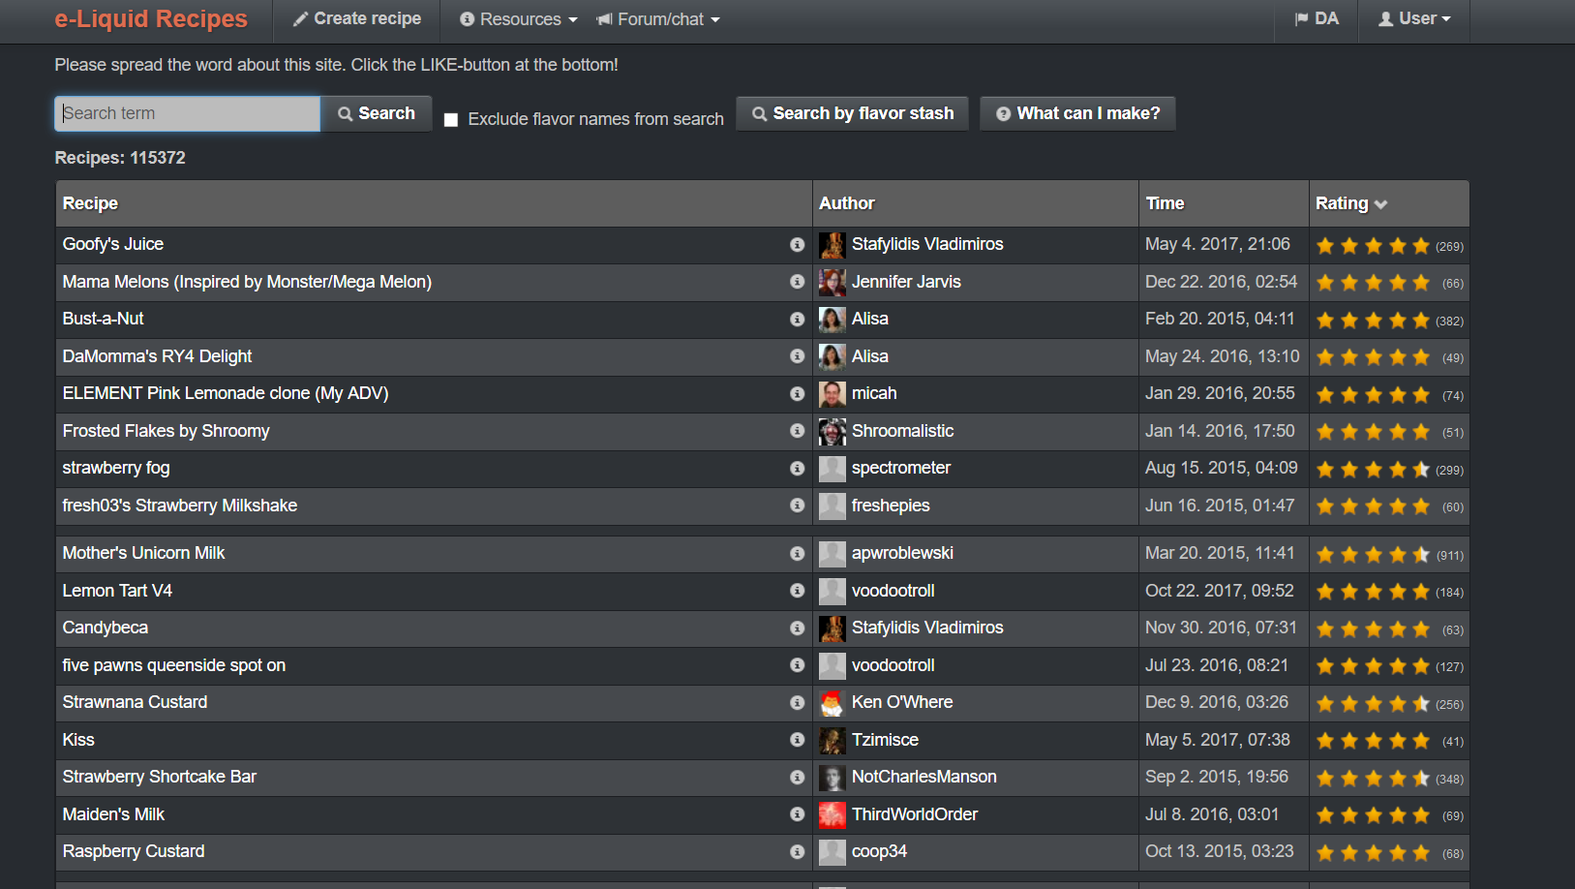

Figure 1: e-liquid-recipes' recipe list sorted by rating.

(E-Liquid-Recipes, n.d.)

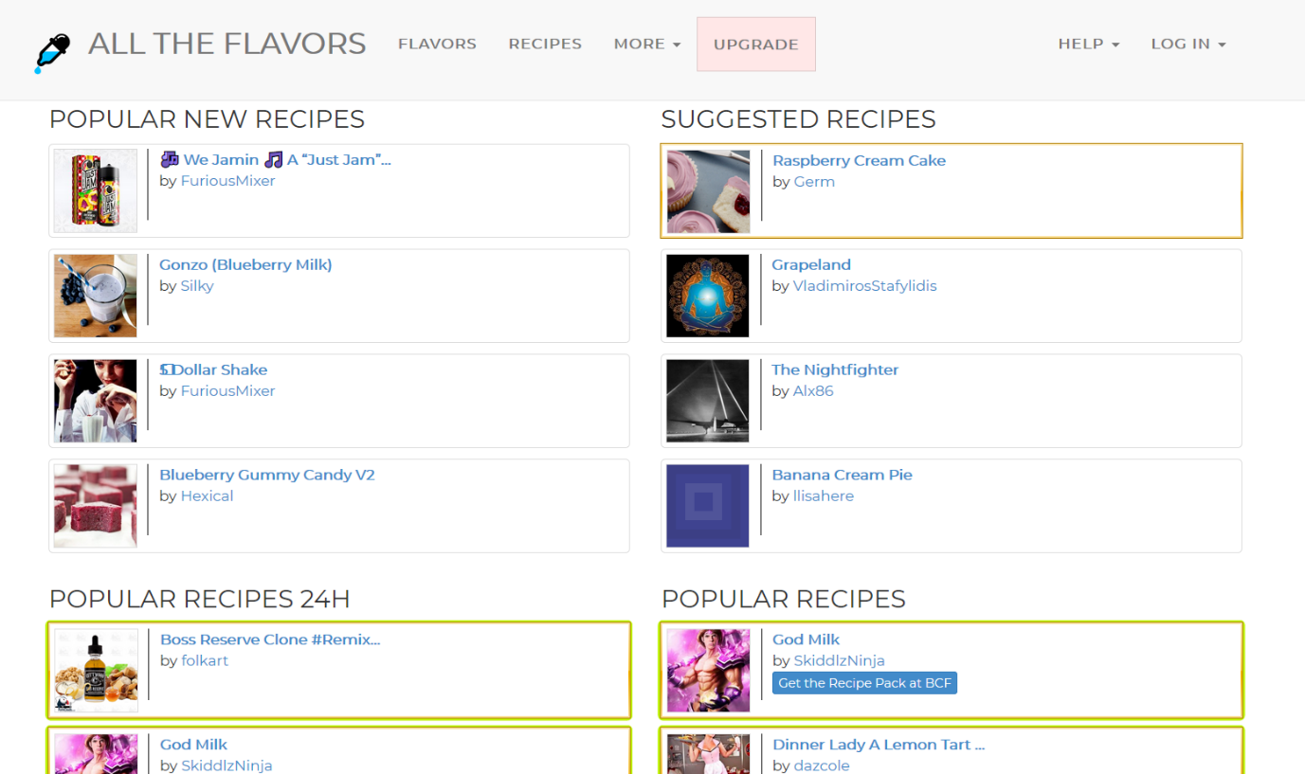

Figure 2: All the Flavors website front page.

(All The Flavors, n.d.)

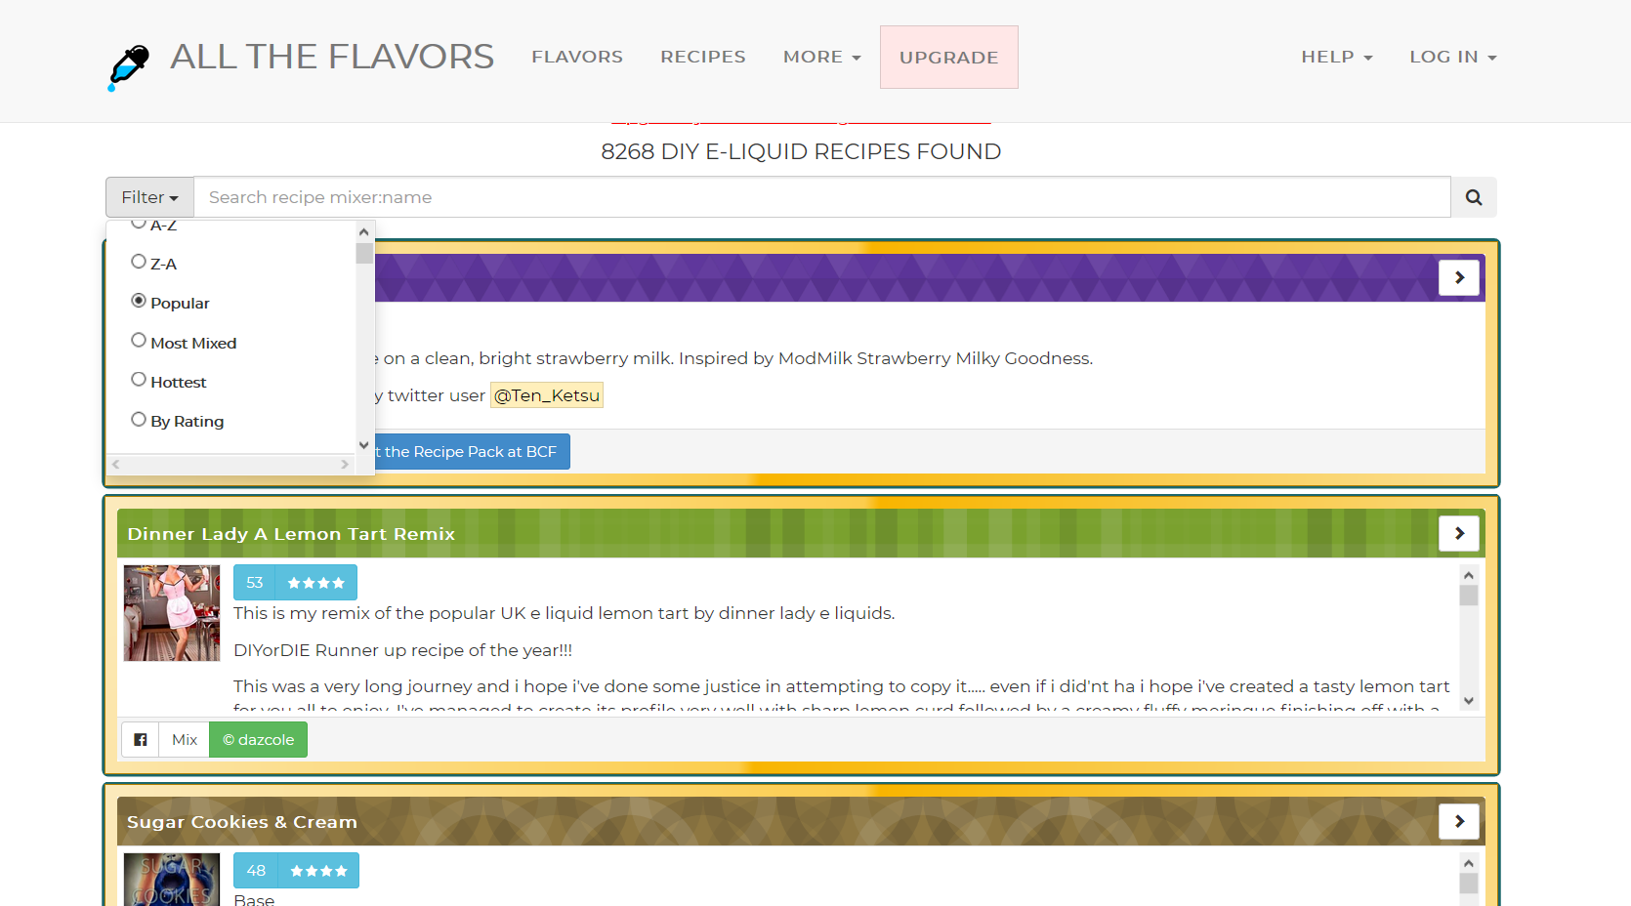

Figure 3: All the Flavors' recipe list with filter options.

(All The Flavors, n.d.)

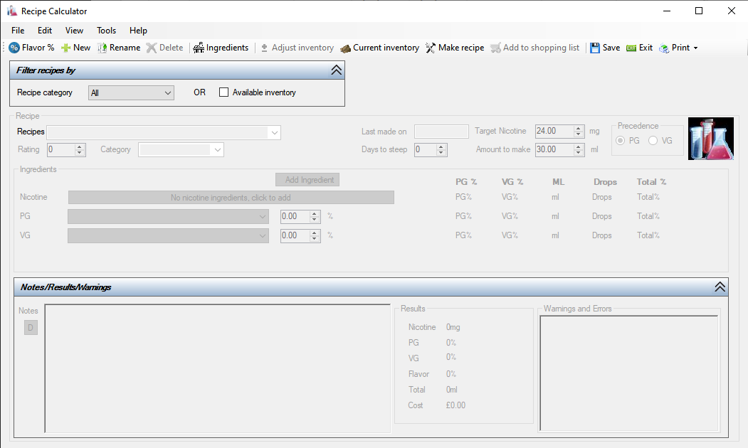

Figure 4: Juice Calculator App Screenshot.

(diy juice calculator, n.d.)

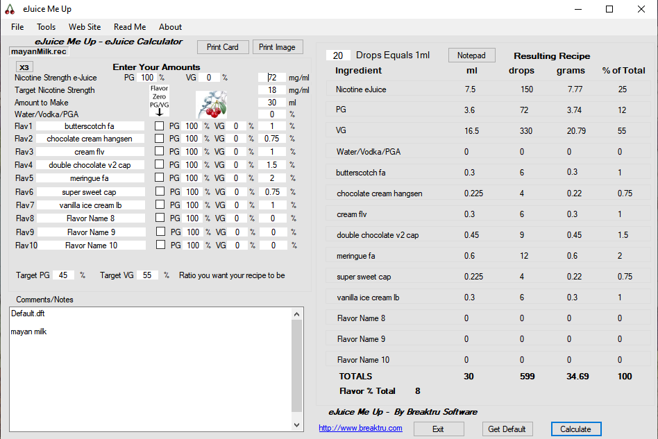

Figure 5: eJuice Me Up App Screenshot.

(eJuice Me Up, n.d.)

Additionally, here is what a recipe looks like on e-liquid-recipes.com:

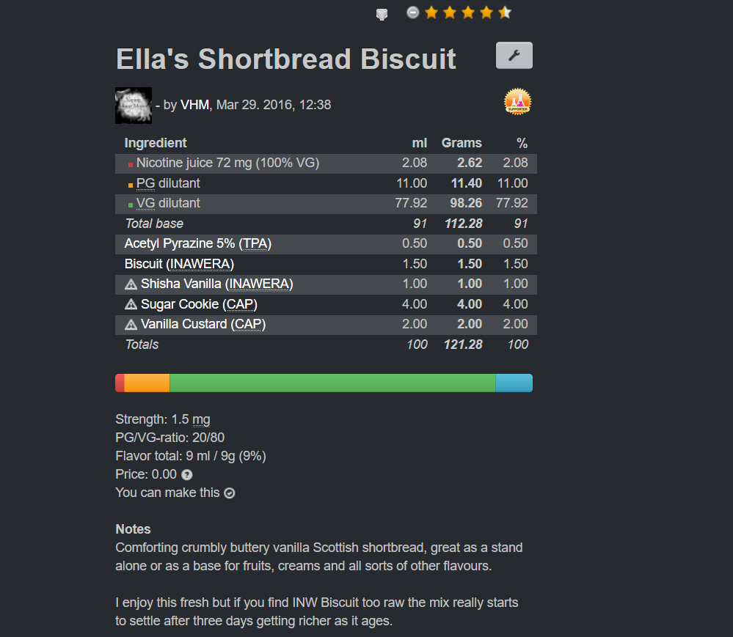

Figure 6: Recipe page on e-liquid-recipes.com.

(Ella's Shortbread Biscuit, 2016)

And its built-in calculator:

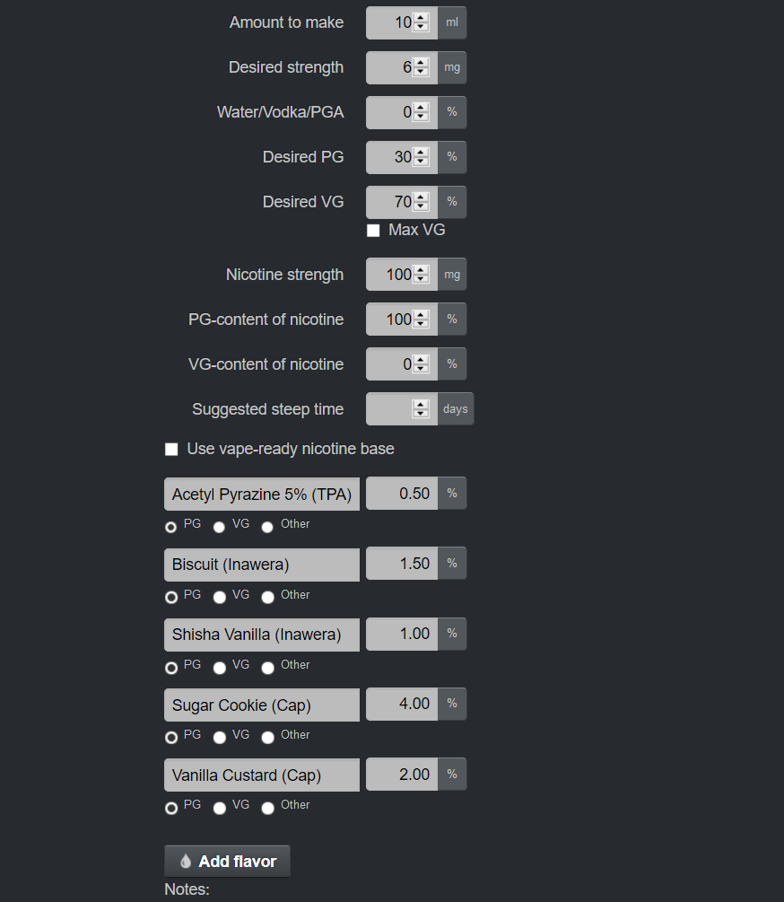

Figure 7: E-Liquid-Recipes' built in calculator.

(Ella's Shortbread Biscuit, 2016)

# Discussion of Possible Software Solutions to the Problem

The software outlined in Wayne Walker's brief could be achieved in many forms. It could be achieved by means of a website or web app. It could be achieved by a desktop application or mobile application. This software would best be served by having a database external to the software (to hold the public user-generated recipes) which does the mixing calculations and displaying of recipes. This is to make the public recipes visible to all users of the software. The software may need a database integrated with it for saving user data in an organised fashion. The recipes the user creates is highly structured data so could benefit from being saved in a database.

The software should have several "pages" to delineate the different functionalities described in the brief. The software could allow the user to enter flavour names themselves or use drop-down elements. Drop-downs could also be used for flavour percentages. The software could save the recipes as some kind of file on their computer or in an integrated database or both.

# A Discussion on User Groups

We have so far not mentioned possible user groups for the proposed software. This is due largely due to the direction of this software developer’s intention with the software. The software we intend to create is not educational and assumes knowledge of certain things such as: how e-liquid is mixed, its main components, the purpose of a mixing calculator, familiarity with e-liquid flavourings and at least passing familiarity with the company’s that make them or where they are sold. Thus, there is a knowledge barrier to using the software and educating those who are unfamiliar with the concepts is outside the scope of this software. As such, even users of the software who use less of its features than others have roughly the same knowledge so it wouldn’t be helpful to differentiate them.

Users who do not vape will find no utility in the software. Neither will users who do vape but don’t mix their own e-liquid. Thus, there is only one user group for this software and a profile for them is outlined below.

**Demographic:**

* User is any age between 18(due to nicotine restriction laws) and 100
* Has experience with one or many e-cigarette devices
* Has experience mixing their own e-liquid
* Is familiar with the contents of e-liquid and the user logistics of mixing it (measurement scales etc.)
* Knows what a mixing calculator is for

**Frequency of use:**

This demographic will demographic will probably use the software once a week or more, whether to look at public recipes or use the mixing calculator or share their own recipes.

**Environment:**

They will likely use this software at home or in “standard-European-office” conditions. They will use the software on a PC, laptop, or tablet device.

# Functional and Non-Functional Requirements

The functional and non-functional requirements of the app will now be detailed below in what we intend to develop in this first iteration of the app. Future versions of this app will be able to satisfy the clients brief even more accurately and this first iteration should be thought of as a proof of concept. This is for several reasons: this developer cannot implement an external database in this iteration though it should be easy enough to integrate later if the proper software foundation is laid, also this developer is bound to using C# as a programming language and must make the software a desktop app.

The functional requirements are:

* The user must be able to calculate the weights of each necessary ingredient in a recipe to make a complete e-liquid (like in the screenshot figure 5).
* The user must be able to browse a list of stock recipes (which will come with the app) and filter and display them for a given range of post-dates (i.e. past month, past year, past week etc).
* The user must be able to sort the recipe list by recipe rating
* The user must be able to maintain a list of the flavours they have (stock flavours will come with the app) and add new ones.
* The user must be able to save their own recipes and add it to the recipe pool if they wish to do so.
* The app must be easy to navigate.

The non-functional requirements are:

* The app must be completed and delivered along with an evaluation by the 30th of April 2020.
* The app must store data in a local database.
* The app must run on Windows 10.

If we have time during development, we may add in some feature to allow administrators to more flavours/recipes to the database.

# Aims of the Project

The aim of this project is to develop the software as previously outlined in this document to the specified functional and non-functional requirements. This is a prototype application which will be improved upon in later iterations.

# Use-Case Model

Included along with this report is a top-level use-case diagram of the proposed software in the file called “stage1ATopLevelUseCase”.

# Required Resources

The resources required for this project include (but may not be limited to):

* A PC or laptop with the requisite specifications to run development and utility software
* Windows 10 operating system to develop and test on
* Microsoft Visual Studio Community edition
* Microsoft Office (specifically Word, Project, Visio, PowerPoint)
* Text editing software (Sublime Text, Notepad++ etc)
* An internet connection
* Stack Overflow websites for troubleshooting software problems (Stack Overflow, n.d.)
* C# 7.0 In a Nutshell (Joseph Albahari, 2017)
* Microsoft's documentation concerning UWP (Microsoft, n.d.)
* Information on how e-liquids are mixed (how the calculation is done). (Will find a source during Stage 1B: Solution Planning)
* Information on the most commonly used e-liquid flavourings (the flavourings which can make the most recipes) (Scottes777, 2018)
* Sources for public e-liquid recipes (e-liquid-recipes.com and alltheflavors.com) (E-Liquid-Recipes, n.d.), (All The Flavors, n.d.)

# Conclusion

In summary, this developer will undertake a development project requested by the client, Wayne Walker of Walker Vapor Group LLC, in which a partial software system (desktop app) will be developed in C# and Universal Windows Platform. This software will allow the user to mix e-liquids and do the calculation themselves, allow them to browse pre-loaded recipes in an integrated database and allow them to keep track of their own flavours too (some coming pre-loaded). This app and its accompanying evaluation report will be delivered on the 30th of April 2020 and have the provisional title of “The Mixing Desk” or “Mixing Desk”.

# References

All The Flavors. (n.d.). *All The Flavors*. Retrieved from All The Flavors: https://alltheflavors.com/

All The Flavors. (n.d.). *Recipes*. Retrieved from All The Flavors: https://alltheflavors.com/recipes?sort_order=popular&name_like=

Chefs Flavours. (n.d.). *DIY OR DIE*. Retrieved from Chefs Flavours: https://chefsflavours.co.uk/one-shots/diy-or-die/

DaveX. (2019, January 25). *What’s Really in Your E-liquid? | Ingredients & Myths Surrounding Vape Juice*. Retrieved from ecigclick: https://www.ecigclick.co.uk/whats-really-in-your-e-liquid/

diy juice calculator. (n.d.). *diy juice calculator*. Retrieved from diy juice calculator: http://diyjuicecalculator.com/

eJuice Me Up. (n.d.). *e-juice calculator*. Retrieved from eJuice Me Up: http://www.ejuice.breaktru.com/

E-Liquid-Recipes. (n.d.). *Recipes*. Retrieved from E-Liquid-Recipes: https://e-liquid-recipes.com/list?q=&missing=0&recipesonly=0&adaptedfrom=&sort=score&direction=desc

*Ella's Shortbread Biscuit*. (2016, March 29). Retrieved from E-Liquid-Recipes: https://e-liquid-recipes.com/recipe/550035/Ella%27s%20Shortbread%20Biscuit

Joseph Albahari, B. A. (2017). *C# 7.0 in a Nutshell.* Sebastapol: O'Reilly Media.

Liquid Barn. (n.d.). *DIY or DIE*. Retrieved from Liquid Barn: https://www.liquidbarn.com/pages/diy-or-die

Microsoft. (n.d.). *Universal Windows Platform documentation*. Retrieved from Microsoft Docs: https://docs.microsoft.com/en-us/windows/uwp/

Misthub. (2015, November 18). *Tutorial: Beginner's E-Juice Guide*. Retrieved from Misthub: https://www.misthub.com/blogs/vape-tutorials/76790021-tutorial-beginners-e-juice-guide

Scottes777. (2018, November 10). *Analyzing The 100 Top-Rated Recipes*. Retrieved from E-Liquid-Recipes: https://forum.e-liquid-recipes.com/t/analyzing-the-100-top-rated-recipes/83979

Sluice Juice. (n.d.). *DIY or DIE Concentrates*. Retrieved from Sluice Juice: https://sluicejuice.co.uk/products/diy-or-die-concentrates

Stack Overflow. (n.d.). *Stack OverFlow*. Retrieved from Stack Overflow: https://stackoverflow.com/

Walker Vapor Group LLC. (n.d.). *DIY or DIE*. Retrieved from YouTube: https://www.youtube.com/channel/UCFoe3PEb1_7sAY1ZgehNP3A

Walker Vapor Group LLC. (n.d.). *DIY or DIE Vaping*. Retrieved from DIY or DIE Vaping: https://diyordievaping.com/