**Mixing Desk User Guide**

Michael Johnston

(1800329)

Table of Contents

Introduction 3

Navigation 3

Personal Stash Page 4

Recipe Pages 5

Recipe Pages Functionality 7

Specific Recipe Page 9

Mixing Calculator Page 10

Saving and Loading Recipes 12

# Introduction

This document is designed to give the first-time user of the Mixing Desk app an overview of its functions and instruction on the basic operation of the app. We will proceed through the application in sequence which this developer believes is easiest to understand and illustrates the functionality of the app best.

# Navigation

When first opening the app, you will be presented with the first page of the app the Mixing Calculator page. You will also see in the navigation bar to the left (this bar is present on all pages) three links to other pages and a back arrow (Figure 1 below shows the Mixing Calculator page).

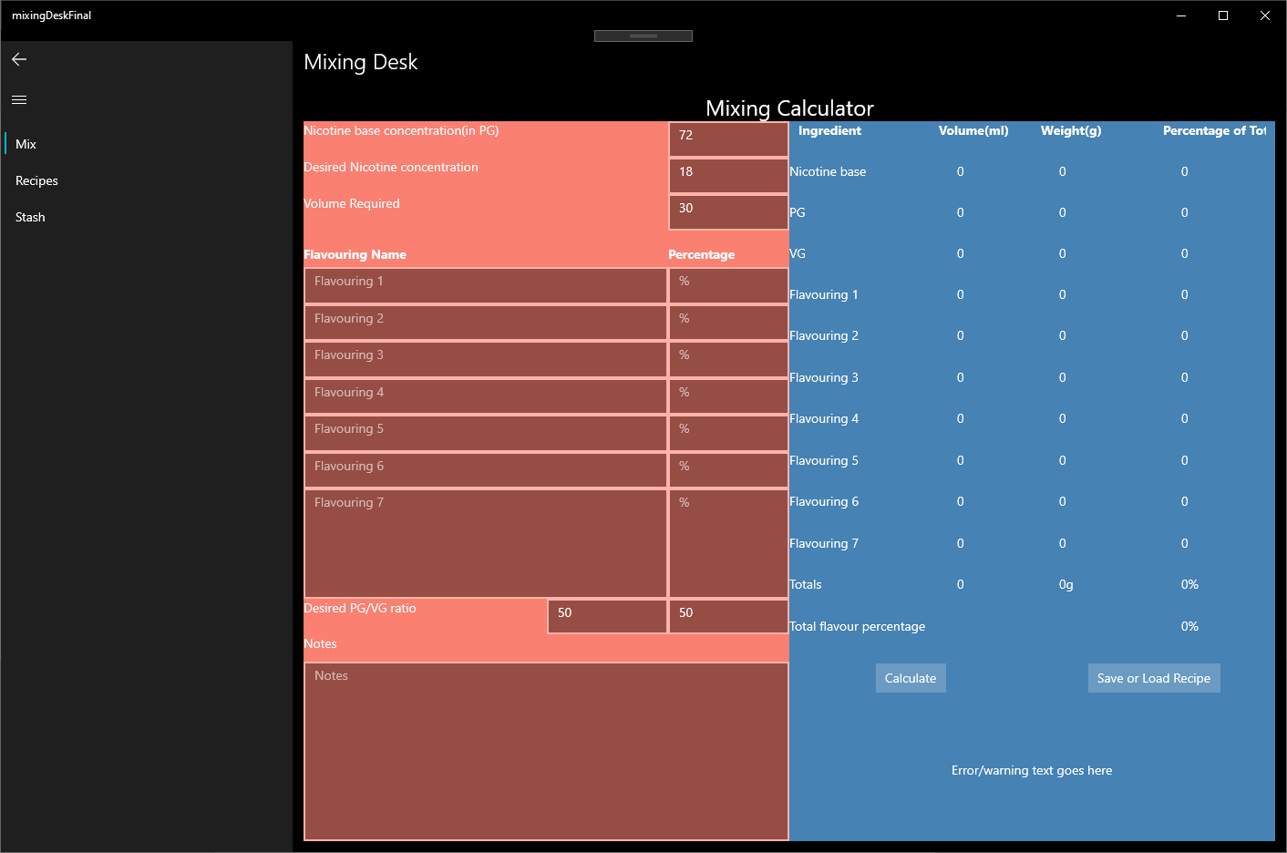

Figure 1: Mixing Calculator page

The links on the left: “Mix”, “Recipes” and “Stash”, will navigate you to the Mixing Calculator, Recipes, and Personal Stash Pages respectively no matter where you are in the app. The back arrow in the top left will navigate you to the previous page you were on, no matter where you are in the app, if it can. There is on more element to navigation, the pages for specific recipes, which we will cover in the Recipe Pages Section.

# Personal Stash Page

The Personal Stash Page (shown below in figure 2) is one of the simplest in functionality.

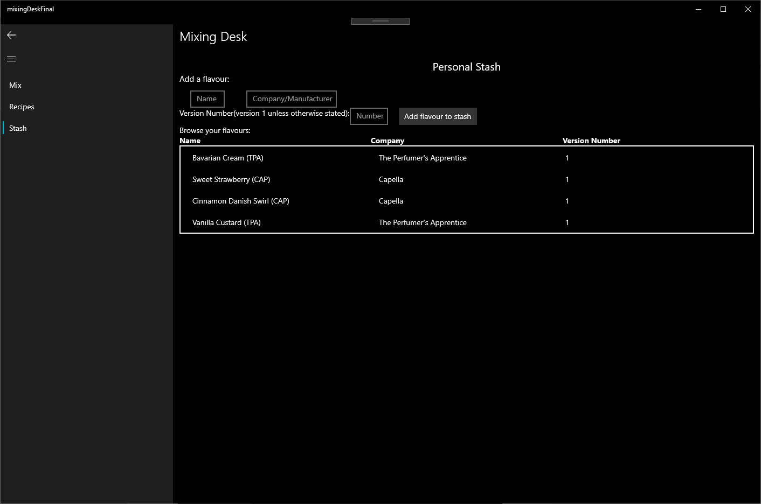

Figure 2: Personal Stash page

This page is intended as a store for the user to keep track of the flavourings that they have. Here the user can enter the name of the flavouring they have, the name of the company that makes it and its version number in the given text boxes. The user then clicks the “Add flavour to stash” button and this new flavouring will now appear in the list below the text boxes.

The user can also remove a flavouring from this list by right-clicking one of the flavourings listed and selecting the “Remove flavouring” option from the given context menu. The flavouring listing will then be removed from the list immediately (using this remove feature occasionally throws an exception (i.e. breaks the app and it must be restarted)).

Currently any items added to or removed from this list is not persistent across restarts of the app.

# Recipe Pages

Having navigated to the Recipes section you will be presented with the first page of the Recipes section, that is the Recipes This Week page (shown below in figure 3). Clicking the “Recipes” link in the navigation bar will always direct you to this page.

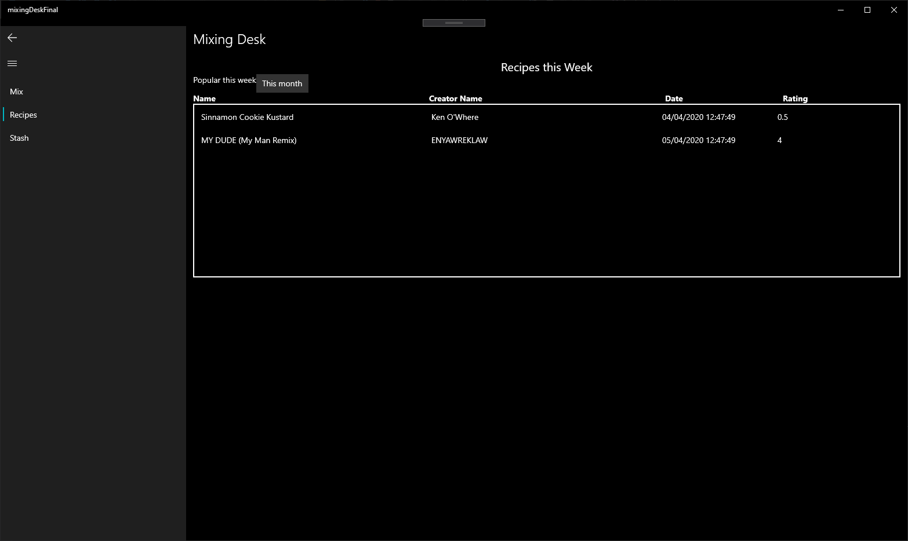

Figure 3: Recipes This Week page

Here you will see a list of recipes with their names, creator names, date of posting and rating. This list contains recipes links which were posted any time up to one week prior to your opening of the app.

You will also notice a button labelled “This month” above the list. This button navigates the app to the page Recipes This Month (as shown in figure 4 below)

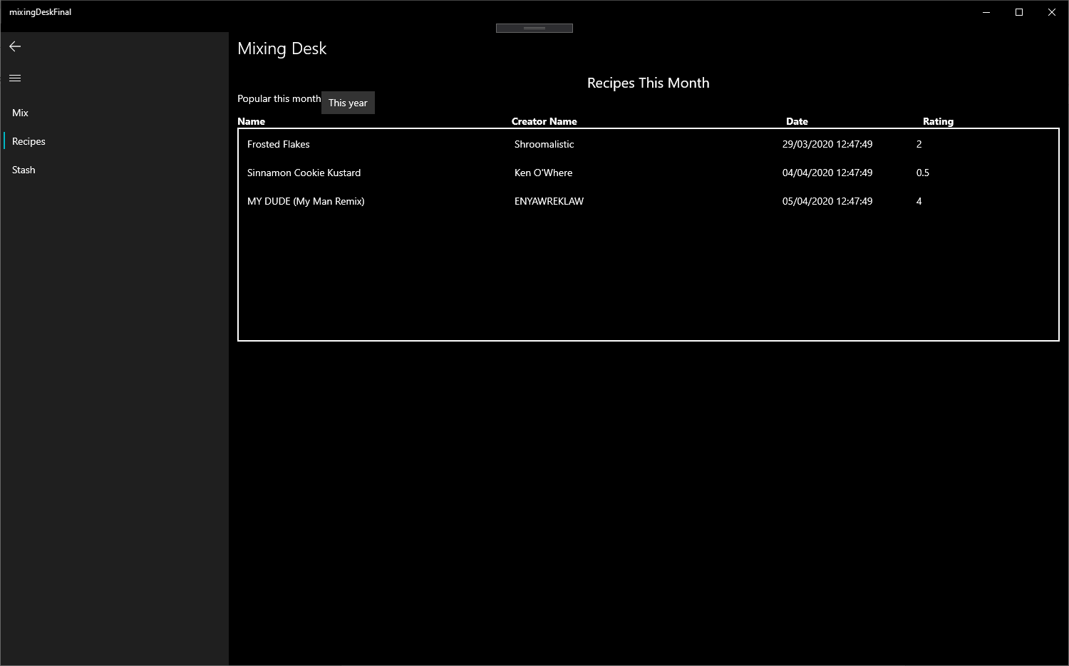

Figure 4: Recipes This Month

In this page we have the same functionality as the previous page (now showing a list of recipe listings posted any time up to one month prior to your opening of the app) and button labelled “This year”. Clicking this button will take you to the page Recipes This Year (as shown in figure 5 below)

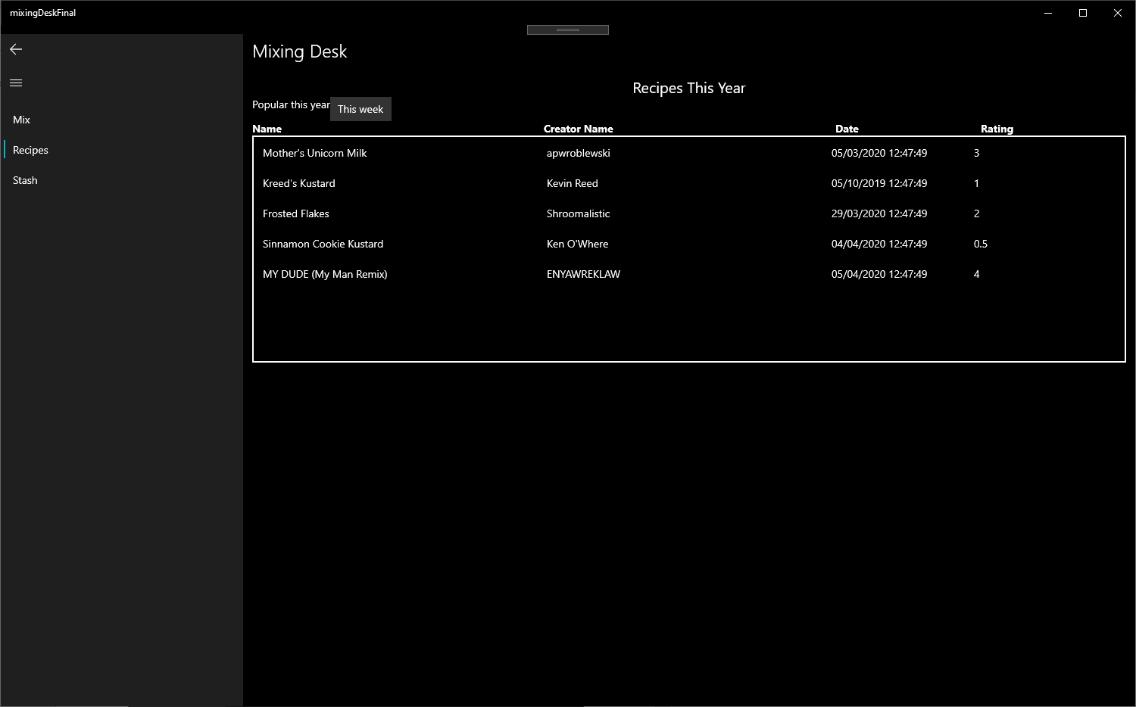

Figure 5: Recipes This Year page

Again, this page has the same functionality as the previous two pages (now showing a list of recipe listings posted any time up to one year prior to your opening of the app) and has a button labelled “This week” to navigate the user back to the page Recipes This Week.

## Recipe Pages Functionality

On each of the three recipe pages the list of recipe links can be sorted by date or by rating (shown in figures 6 and 7 below).

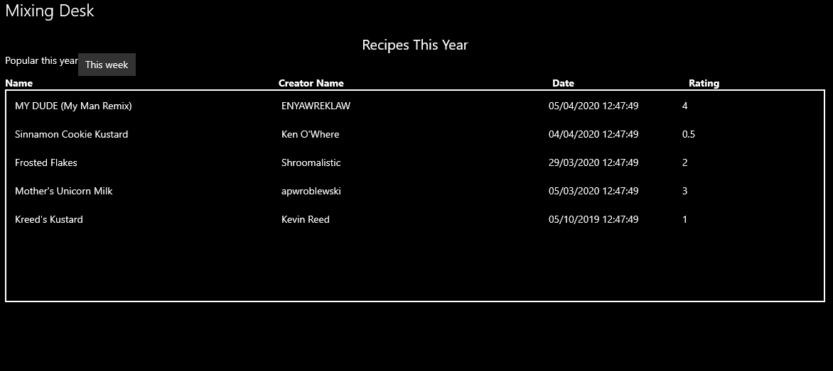

Figure 6: Recipes This Year page sorted by Date

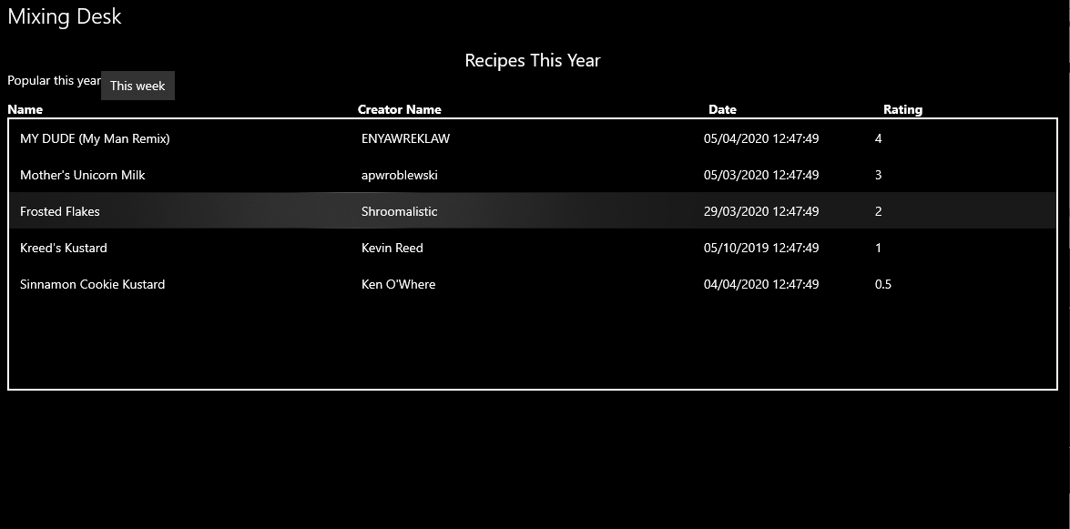

Figure 7: Recipes This Year page sorted by Rating

This is achieved by clicking the either of the Date or Rating column headers above the list. The app attempts to give the user some indication of this by changing the colour of these words to the user’s system highlight colour when the mouse cursor moves over these words (shown in figure 8 below).

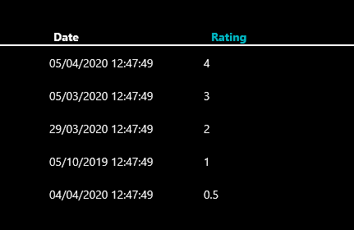

Figure 8: Recipes This Year page Rating text highlighting

## Specific Recipe Page

When you want to see the full details of a recipe you simply click once on one of the recipe list elements any of the Recipe pages and you will be navigated to a page showing the details of the recipe you have selected. Shown below in figure 9, is the page for the recipe called “MY DUDE” by ENYAWRECKLAW.

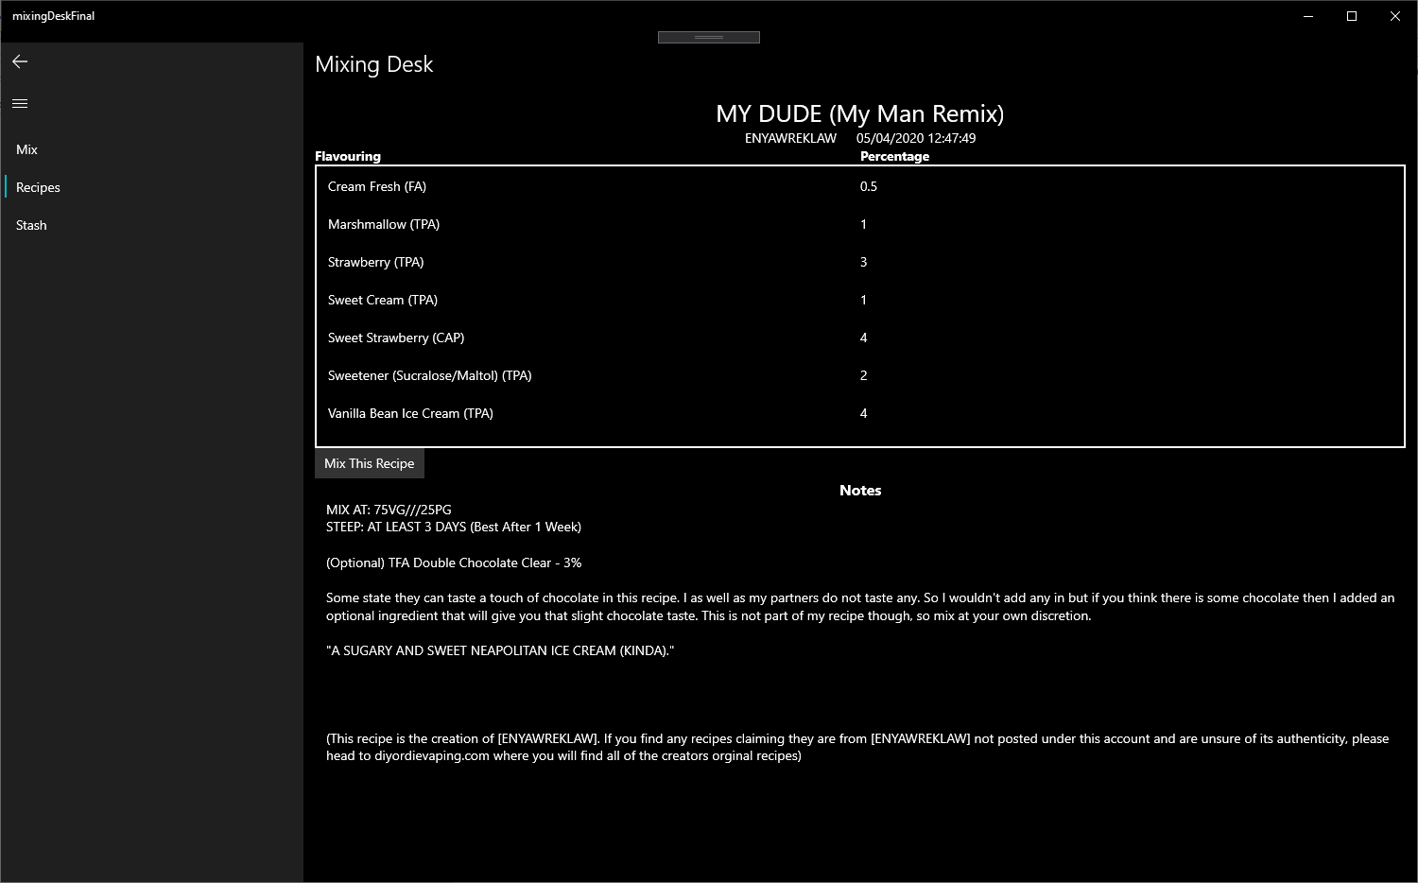

Figure 9: MY DUDE recipe page

On the page for any given recipe in the database you will see the recipe’s title, creator name, posting date, a list of the flavourings used and the percentage they are used at in this recipe. There may also be notes or comments about the recipe by the creator. There is also a button below the list labelled “Mix This Recipe” which will navigate you to the Mixing Calculator page taking the flavouring names and their usage percentages with you (shown in figure 10 below in the next section).

# Mixing Calculator Page

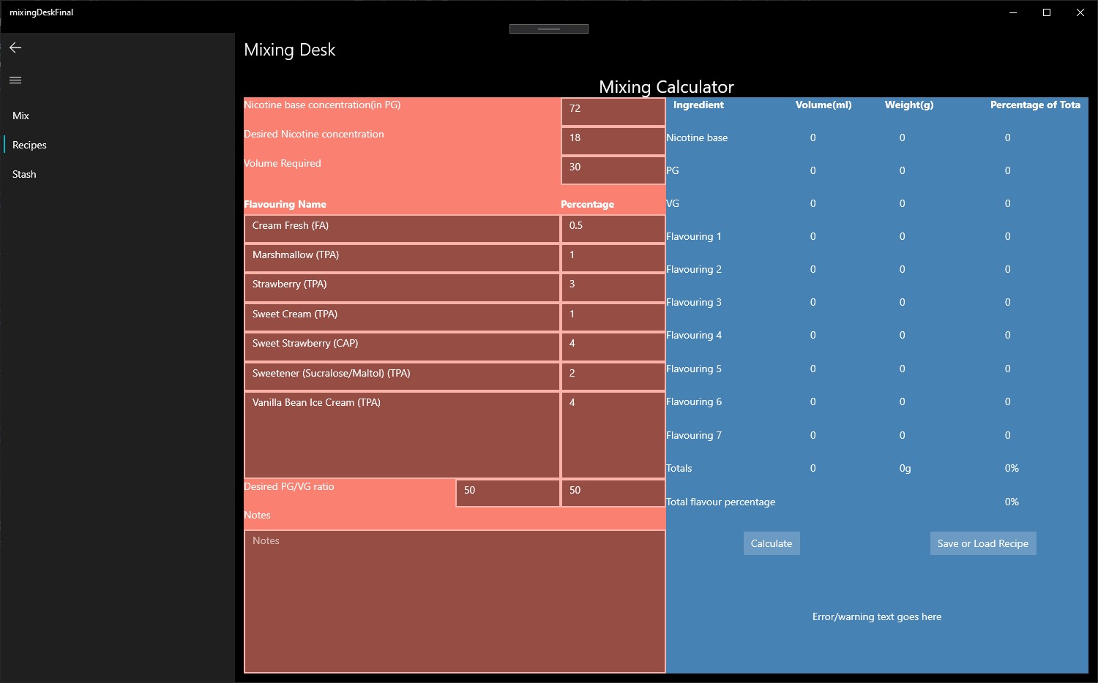

Figure 10: Mixing Calculator page with transferred data

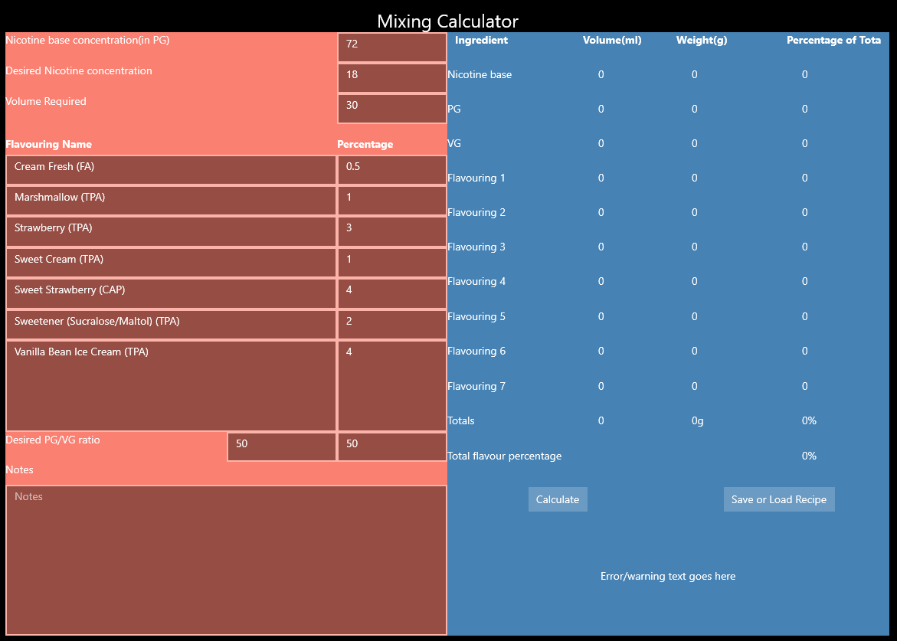

Figure 11: Mixing Calculator page with transferred data

In figures 10 and 11 we have now navigated to the Mixing Calculator page of the app and brought with us the flavouring names and usage percentages from the recipe called “MY DUDE” we were previously viewing. The flavouring names populate the flavouring name fields and the percentages populate the percentage fields.

This page is split into two sections. An input section on the left side and an output section on the right side.

On the left side (see figure 11) you can see there are fields for inputting the concentration of your nicotine base, the desired nicotine strength in the finished liquid, the volume of liquid you want to mix, the names of flavourings you are using and the percentage they represent of the total finished liquid, the desired propylene glycol vegetable glycerin ratio and input for notes on your mix. All fields which expect a number will only take numbers and all other fields will take any characters. Some of the number fields have standard values inserted into them upon loading this page for ease of use.

On the right side is the output section. If we take the recipe called “MY DUDE” as it is without altering it (the recipe could be completely changed, have new flavourings used in it etc.) and attempt to mix it by clicking the “Calculate” button the output will be as shown in figure 12 below.

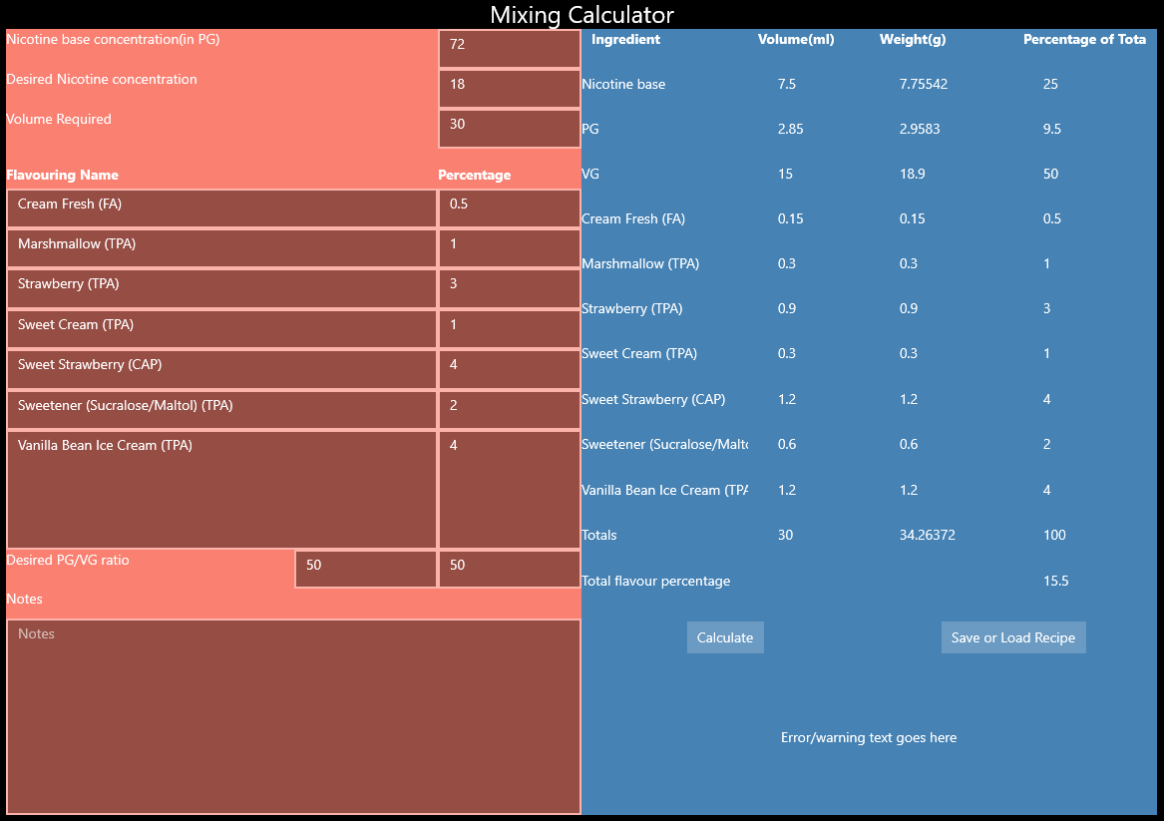

Figure 12: Mixing Calculator page with ingredient proportions calculated

Here we can see that the volume, weight and percentage have been calculated for each ingredient which will now allow the user to make their e-liquid using scales (by weight) or syringes (by volume). This section also shows totals for each column along with a total percentage of flavouring relative to the entire liquid.

Additionally, there is text on the bottom right which will indicate to the user errors in the calculation when they attempt to mix liquid with mathematically incorrect proportions etc.

## Saving and Loading Recipes

There is also a button on the Mixing Calculator page labelled “Save or Load Recipe”. Upon clicking this it will produce a flyout menu with the options “Save Recipe” or “Load Recipe”. Clicking either of these will open a file dialog box in which you can save a recipe you have made, or you can load one. Files are saved in .txt format and currently only store basic information about the recipe, they currently do not store notes.