Analyze_transmission

# Preamble

Title: *Script B for Objective 2: effects of seasonal network differences on pathogen transmission*  
Author: Marie Gilbertson  
Date: “08/30/2020”

**What this code does:**  
1. Analyzes differences between wet and dry season epidemics

#### Clear Environment ####  
remove(list=ls())  
  
#### Load libraries ####  
library(ggplot2)  
library(dplyr)  
library(stringr) # for "str_split"  
library(viridis)  
library(ggpubr)  
  
#### Set seed ####  
set.seed(3268)

# Load data

Start by loading parameter sets and preparing to load data of interest.

# load parameter sets  
param.sets <- get(load("../Data/simulation_paramsets.Rdata"))  
  
# set which parameter sets to analyze  
param.ids <- c(1:420)  
  
# empty dataframe to store results  
all.results <- NULL  
summ.stats <- data.frame(matrix(nrow = length(param.ids), ncol = 7))  
colnames(summ.stats) <- c("param.set", "m.dur.time", "m.total.i", "m.final.i",   
 "m.max.i", "m.max.it_s", "prop.fail")

Next, loop through parameter sets of interest, loading those simulation results.

# loop through and load all results  
for(i in 1:length(param.ids)){  
 param.set.num <- param.ids[i]  
   
 full.name <- paste("../Output/Simulation_Results/full set results_paramset ", param.set.num, ".Rdata", sep = "")  
 set_results <- get(load(full.name))  
   
 all.results <- rbind(all.results, set_results)  
   
 #### store summary stats ####  
 summ.stats$param.set[i] <- set_results$param.set[1]  
   
 # proportion failed epidemics; if only 1 individual is ever infected, consider it a "failed" epidemic  
 bad.draws <- sum(set_results$num.failed)  
 only.1 <- nrow(set_results[set_results$total.i<=(1/33),])  
 # number of bad draws + number only infecting 1 / simulations + number of bad draws  
 summ.stats$prop.fail[i] <- (bad.draws + only.1)/(nrow(set_results) + bad.draws)  
   
 ## now, of only the "successful" epidemics:  
 set_results_succ <- set_results[set_results$total.i>(1/33),]  
 # mean duration  
 summ.stats$m.dur.time[i] <- mean(set_results_succ$dur.time)  
 # mean total ever infected  
 summ.stats$m.total.i[i] <- mean(set_results_succ$total.i)  
 # mean final infected  
 summ.stats$m.final.i[i] <- mean(set_results_succ$final.i)  
 # mean max infected  
 summ.stats$m.max.i[i] <- mean(set_results_succ$max.i)  
 # mean start point of max infected  
 summ.stats$m.max.it_s[i] <- mean(set_results_succ$max.it_s)  
}

Update formatting, subset, and save for ease in plotting later.

# assign appropriate model type and gamma labeling for plotting  
param.sets$model.type <- NA  
param.sets$gamma <- NA  
for(i in 1:nrow(param.sets)){  
 temp.params <- param.sets[i,]  
 model.type_gamma <- unlist(str_split(temp.params$model.type_gamma, "_"))  
 param.sets$model.type[i] <- model.type_gamma[1] # type of disease process; options are "SI", "SIR", or "SIS"  
   
 if(model.type_gamma[1]=="SI"){  
 param.sets$gamma[i] <- 0  
 }else{  
 param.sets$gamma[i] <- as.numeric(model.type_gamma[2])  
 }  
}  
  
param.sets$param.set <- paste("set_", param.sets$set.num, sep = "")  
summ.stats <- left_join(summ.stats, param.sets, by = "param.set")  
all.results <- left_join(all.results, param.sets, by = "param.set")  
  
# split data and save as subsets of interest  
weight.data <- subset(summ.stats, summ.stats$weights==T)  
binary.data <- subset(summ.stats, summ.stats$weights==F)  
  
w.si <- subset(weight.data, weight.data$model.type=="SI")  
b.si <- subset(binary.data, binary.data$model.type=="SI")  
  
w.sis <- subset(weight.data, weight.data$model.type=="SIS")  
b.sis <- subset(binary.data, binary.data$model.type=="SIS")  
   
w.sir <- subset(weight.data, weight.data$model.type=="SIR")  
b.sir <- subset(binary.data, binary.data$model.type=="SIR")  
  
### save these datasets for making manuscript figures ###  
# save(w.si, file = "../Output/Manuscript_Figures/data_for_plotting/w.si.Rdata")  
# save(b.si, file = "../Output/Manuscript_Figures/data_for_plotting/b.si.Rdata")  
# save(w.sis, file = "../Output/Manuscript_Figures/data_for_plotting/w.sis.Rdata")  
# save(b.sis, file = "../Output/Manuscript_Figures/data_for_plotting/b.sis.Rdata")  
# save(w.sir, file = "../Output/Manuscript_Figures/data_for_plotting/w.sir.Rdata")  
# save(b.sir, file = "../Output/Manuscript_Figures/data_for_plotting/b.sir.Rdata")

# Automated generation of results heatmaps

Loop through all model types, generating results heatmaps for epidemic outcomes of interest.

model.types <- c("w.si", "b.si" , "w.sir", "b.sir", "w.sis", "b.sis")  
  
for(i in 1:length(model.types)){  
   
 temp.model <- model.types[i]  
 print(temp.model)  
   
   
 # read in data  
 name <- paste("../Output/Manuscript_Figures/data_for_plotting/", temp.model, ".Rdata", sep = "")  
 temp.data <- get(load(name))  
   
 temp.data.d <- subset(temp.data, temp.data$season=="Dry")  
 temp.data.w <- subset(temp.data, temp.data$season=="Wet")  
 temp.data_diff <- temp.data.d  
 temp.data_diff[,c("m.dur.time", "m.total.i","prop.fail")] <- temp.data.d[,c("m.dur.time", "m.total.i","prop.fail")] - temp.data.w[,c("m.dur.time", "m.total.i","prop.fail")]  
   
   
   
 #### MEAN DURATION ####  
 if(temp.model %in% c("w.sir", "b.sir", "w.sis", "b.sis")){  
  
 g1_st <- ggplot(temp.data, aes(x = c.rate, y = prob)) + geom_tile(aes(fill = m.dur.time), colour = "white") +  
 scale_fill_viridis(discrete=F, option = "B", direction = 1, limits = c(1, 26)) +   
 ylab("Probability of transmission") +  
 xlab("Edge weight scaling")   
   
   
 gg1_st <- g1_st + facet_grid(gamma ~ season) +  
 theme(text = element_text(size=15)) +   
 theme(axis.text.x = element_text(size = 10),  
 legend.position = "bottom") +  
 labs(fill = "Mean duration (weeks)")  
 gg1_st  
   
 # differences  
 g2_st <- ggplot(temp.data_diff, aes(x = c.rate, y = prob)) + geom_tile(aes(fill = m.dur.time), colour = "white") +  
 scale_fill_gradient2(low = "blue", mid = "white", high = "red", midpoint = 0, breaks = c(-2, 0, 2, 4), limits = c(-2.6, 4.4)) +  
 ylab("Probability of transmission") +  
 xlab("Edge weight scaling")   
   
   
 gg2_st <- g2_st + facet_grid(gamma~.) +  
 theme(text = element_text(size=15)) +   
 theme(axis.text.x = element_text(size = 10),  
 legend.position = "bottom") +  
 labs(fill = "Dry mean difference (weeks)")  
 gg2_st  
   
   
 g <- ggarrange(gg1_st, gg2_st, labels = c("A", "B"), nrow = 1, widths = c(1.5, 1))  
 g  
   
 dur.name <- paste("../Output/Manuscript_Figures/", temp.model,"_duration_full figure.jpeg", sep = "")  
 ggsave(g, file = dur.name, width = 11, height = 11, units = "in", dpi = 300)  
 }  
   
 #### MEAN TOTAL INFECTED ####  
 g1_st <- ggplot(temp.data, aes(x = c.rate, y = prob)) + geom_tile(aes(fill = m.total.i), colour = "white") +  
 scale_fill_viridis(discrete=F, option = "B", direction = 1, limits = c(0.06, 1)) +   
 ylab("Probability of transmission") +  
 xlab("Edge weight scaling")   
   
 gg1_st <- g1_st + facet_grid(gamma ~ season) +  
 theme(text = element_text(size=15)) +   
 theme(axis.text.x = element_text(size = 10),  
 legend.position = "bottom", legend.key.width = unit(1, "cm")) +  
 labs(fill = "Mean total proportion infected")  
 gg1_st  
   
   
 g2_st <- ggplot(temp.data_diff, aes(x = c.rate, y = prob)) + geom_tile(aes(fill = m.total.i), colour = "white") +  
 scale_fill_gradient2(low = "blue", mid = "white", high = "red", midpoint = 0, breaks = c(-0.08, 0, 0.08, 0.16), limits = c(-0.08, 0.2)) +  
 ylab("Probability of transmission") +  
 xlab("Edge weight scaling")   
   
 gg2_st <- g2_st + facet_grid(gamma~.) +  
 theme(text = element_text(size=15)) +   
 theme(axis.text.x = element_text(size = 10),  
 legend.position = "bottom", legend.key.width = unit(1, "cm")) +  
 labs(fill = "Dry mean difference")  
 gg2_st  
   
 g <- ggarrange(gg1_st, gg2_st, labels = c("A", "B"), nrow = 1, widths = c(1.5, 1))  
 g  
   
   
 if(temp.model %in% c("w.si", "b.si")){  
 total.name <- paste("../Output/Manuscript_Figures/", temp.model,"_total infected_full figure.jpeg", sep = "")  
 ggsave(g, file = total.name, width = 11, height = 5, units = "in", dpi = 300)  
 }else{  
 total.name <- paste("../Output/Manuscript_Figures/", temp.model,"_total infected_full figure.jpeg", sep = "")  
 ggsave(g, file = total.name, width = 11, height = 11, units = "in", dpi = 300)  
 }  
   
   
 #### MEAN PROPORTION FAILED ####  
   
 g1_st <- ggplot(temp.data, aes(x = c.rate, y = prob)) + geom_tile(aes(fill = prop.fail), colour = "white") +  
 scale_fill_viridis(discrete=F, option = "B", direction = -1, limits = c(0, 1)) +   
 ylab("Probability of transmission") +  
 xlab("Edge weight scaling")   
   
 gg1_st <- g1_st + facet_grid(gamma ~ season) +  
 theme(text = element_text(size=15)) +   
 theme(axis.text.x = element_text(size = 10),  
 legend.position = "bottom", legend.key.width = unit(1, "cm")) +  
 labs(fill = "Proportion failed")  
 gg1_st  
   
   
   
   
 g2_st <- ggplot(temp.data_diff, aes(x = c.rate, y = prob)) + geom_tile(aes(fill = prop.fail), colour = "white") +  
 scale_fill_gradient2(low = "red", mid = "white", high = "blue", midpoint = 0, breaks = c(-0.2, -0.1, 0, 0.1), limits = c(-0.22, 0.12)) +  
 ylab("Probability of transmission") +  
 xlab("Edge weight scaling")   
   
 gg2_st <- g2_st + facet_grid(gamma~.) +  
 theme(text = element_text(size=15)) +   
 theme(axis.text.x = element_text(size = 10),  
 legend.position = "bottom") +   
 labs(fill = "Dry difference")  
 gg2_st  
   
   
 g <- ggarrange(gg1_st, gg2_st, labels = c("A", "B"), nrow = 1, widths = c(1.5, 1))  
 g  
   
 if(temp.model %in% c("w.si", "b.si")){  
 fail.name <- paste("../Output/Manuscript_Figures/", temp.model,"_prop failed_full figure.jpeg", sep = "")  
 ggsave(g, file = fail.name, width = 11, height = 5, units = "in", dpi = 300)  
 }else{  
 fail.name <- paste("../Output/Manuscript_Figures/", temp.model,"_prop failed_full figure.jpeg", sep = "")  
 ggsave(g, file = fail.name, width = 11, height = 11, units = "in", dpi = 300)  
 }  
   
}

## [1] "w.si"

## [1] "b.si"

## [1] "w.sir"

## [1] "b.sir"

## [1] "w.sis"

## [1] "b.sis"

For illustration purposes, view example output.

print(g)

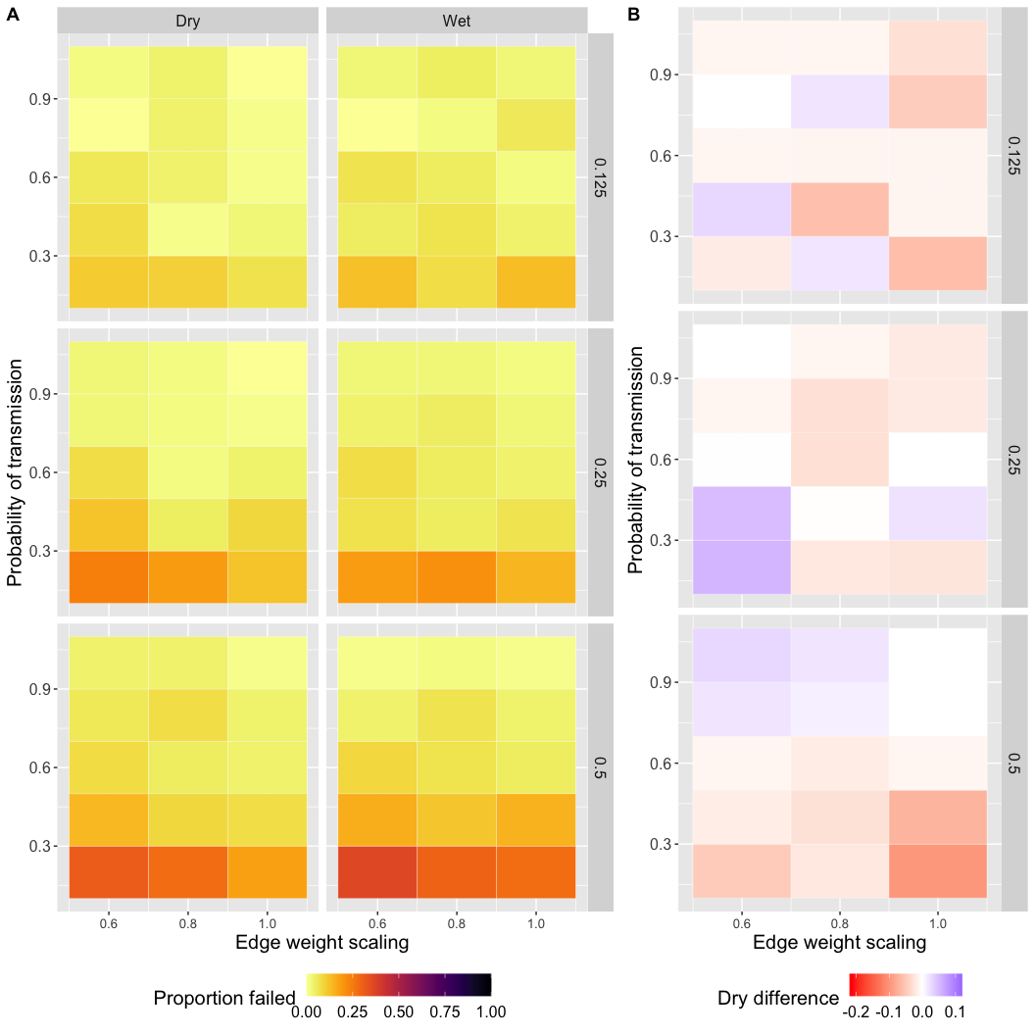

For reproducibility, view session info.

sessionInfo()

## R version 3.6.3 (2020-02-29)  
## Platform: x86_64-apple-darwin15.6.0 (64-bit)  
## Running under: macOS 10.16  
##   
## Matrix products: default  
## BLAS: /Library/Frameworks/R.framework/Versions/3.6/Resources/lib/libRblas.0.dylib  
## LAPACK: /Library/Frameworks/R.framework/Versions/3.6/Resources/lib/libRlapack.dylib  
##   
## locale:  
## [1] en_US.UTF-8/en_US.UTF-8/en_US.UTF-8/C/en_US.UTF-8/en_US.UTF-8  
##   
## attached base packages:  
## [1] stats graphics grDevices utils datasets methods base   
##   
## other attached packages:  
## [1] ggpubr_0.4.0 viridis_0.5.1 viridisLite_0.3.0 stringr_1.4.0   
## [5] dplyr_1.0.4 ggplot2_3.3.3   
##   
## loaded via a namespace (and not attached):  
## [1] tidyselect_1.1.0 xfun_0.24 purrr_0.3.4 haven_2.2.0   
## [5] carData_3.0-4 colorspace_2.0-0 vctrs_0.3.6 generics_0.1.0   
## [9] htmltools_0.5.1.1 yaml_2.2.1 rlang_0.4.10 pillar_1.4.7   
## [13] foreign_0.8-76 glue_1.4.2 withr_2.4.1 DBI_1.1.1   
## [17] readxl_1.3.1 lifecycle_1.0.0 munsell_0.5.0 ggsignif_0.6.0   
## [21] gtable_0.3.0 cellranger_1.1.0 zip_2.1.0 evaluate_0.14   
## [25] labeling_0.4.2 knitr_1.28 rio_0.5.16 forcats_0.5.0   
## [29] curl_4.3 broom_0.7.2 Rcpp_1.0.6 scales_1.1.1   
## [33] backports_1.1.6 abind_1.4-5 farver_2.0.3 gridExtra_2.3   
## [37] hms_1.0.0 digest_0.6.27 stringi_1.5.3 openxlsx_4.1.5   
## [41] rstatix_0.6.0 cowplot_1.1.0 grid_3.6.3 tools_3.6.3   
## [45] magrittr_2.0.1 tibble_3.0.6 crayon_1.4.1 tidyr_1.0.2   
## [49] car_3.0-9 pkgconfig_2.0.3 ellipsis_0.3.1 data.table_1.12.8  
## [53] rmarkdown_2.9 R6_2.5.0 compiler_3.6.3