Continuity and Change in Rice Cultivation-Based Methane Output in 22 Countries

Marie Jordan

For this investigation, I used the ClimateTRACE methane estimates dataset to investigate how methane produced by rice cultivation might change over time and across countries. I also looked at how outputs varied between countries with relatively low change in methane output and those with relatively high change.

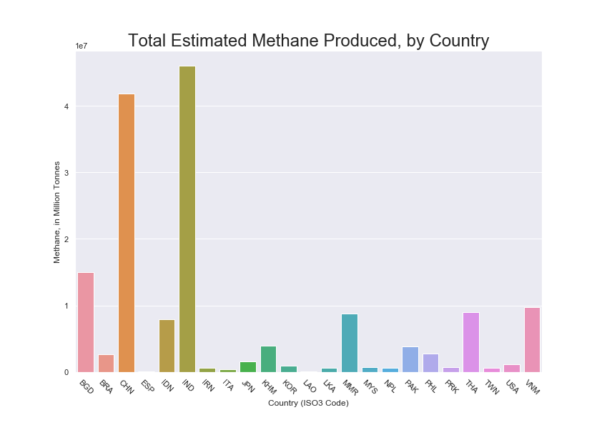
Fig 1: Methane Output from 2015-2021

I started very simply, by just looking at the sum total tonnes of methane produced over the full time range, broken down by country (Fig. 1). This lets us see quite a wide range of methane outputs; countries really differ from each other! Notably, more countries seem to be clustered at the minimum end with significantly less than one million tonnes of methane produced.
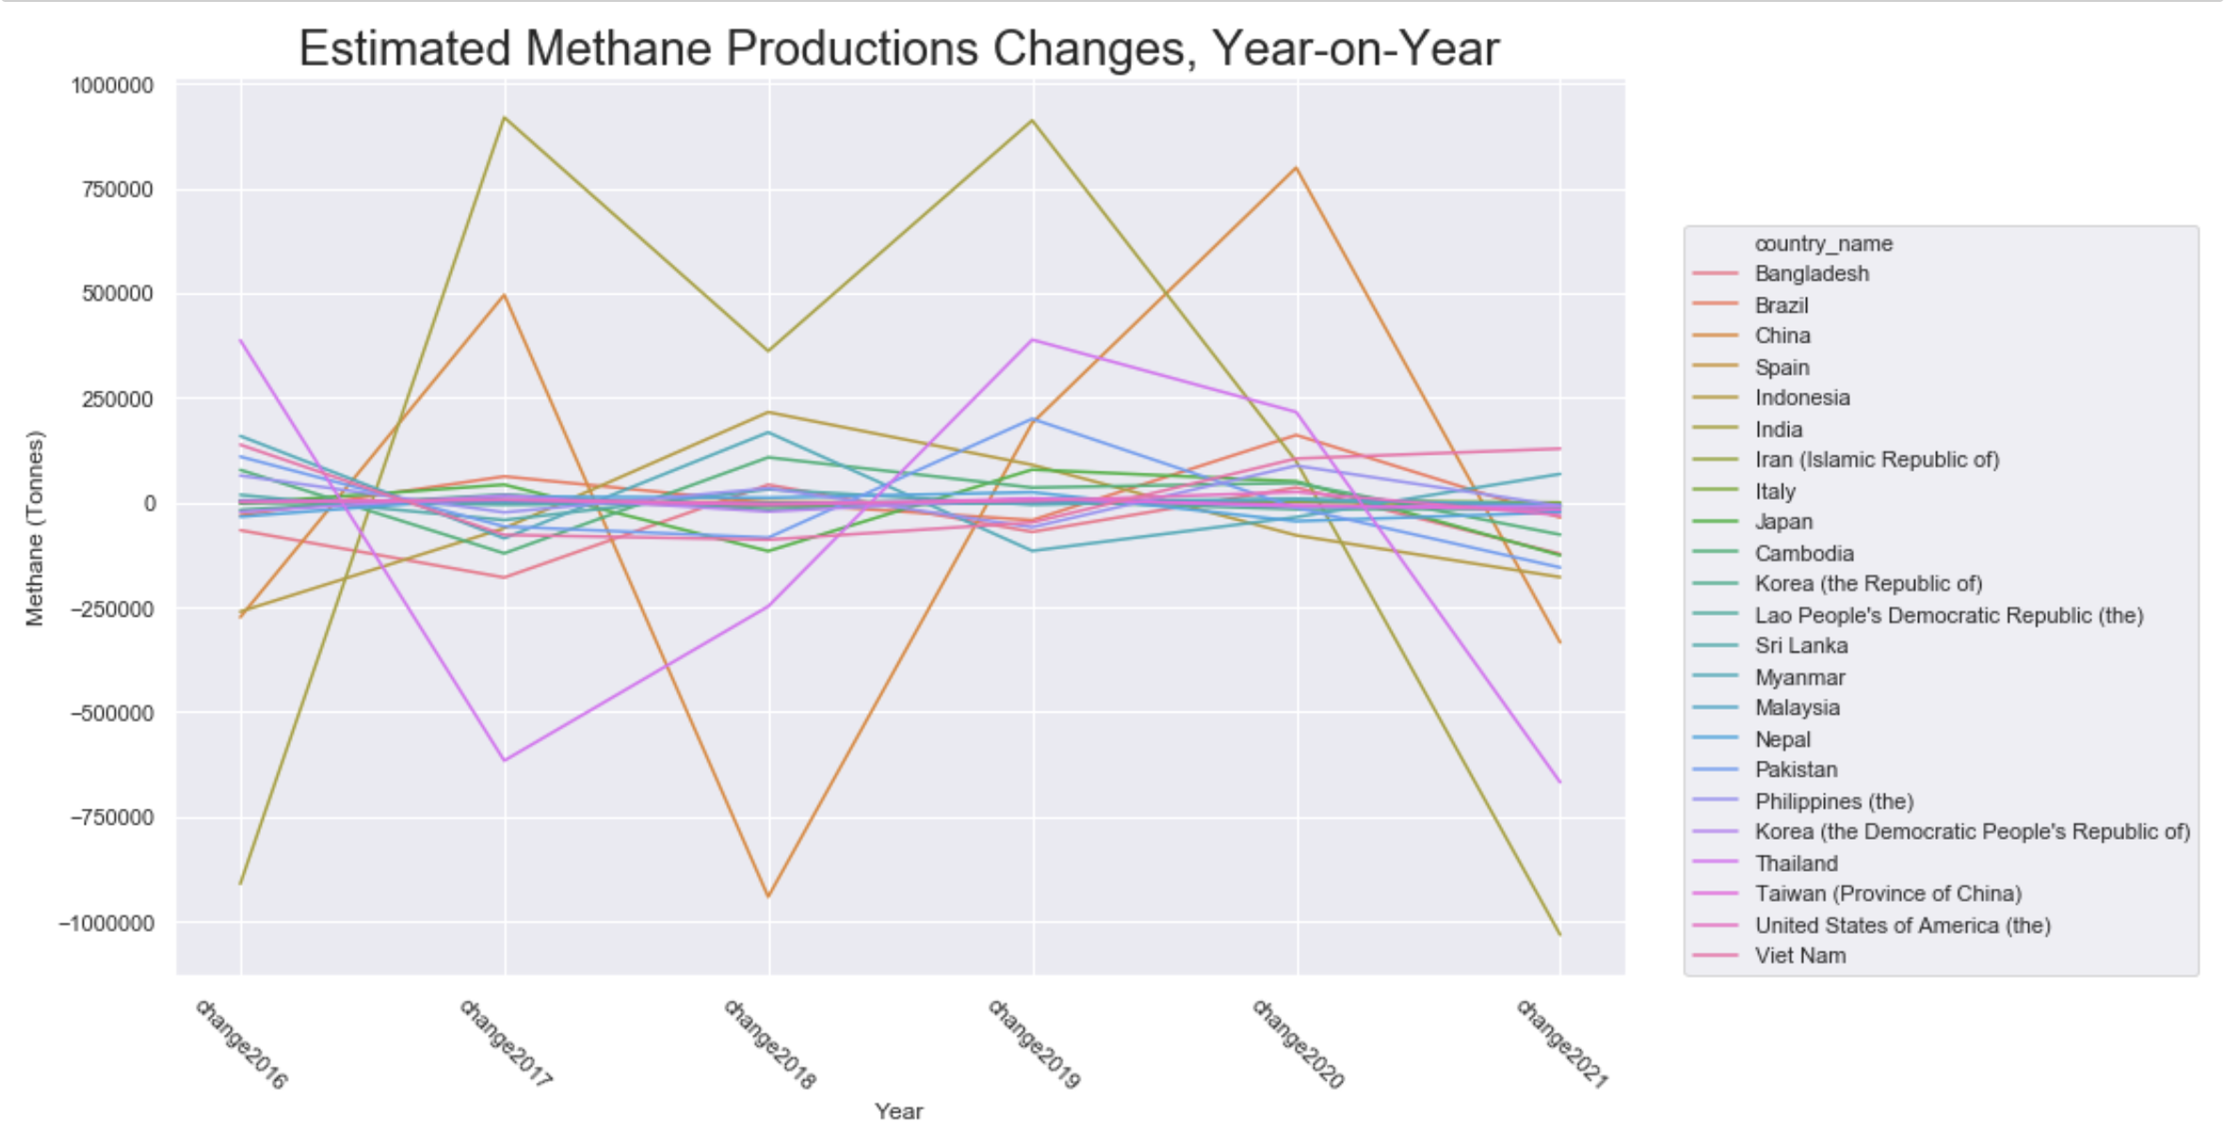
Fig 2: Actual year-on-year changes in methane production.

I then looked at year-on-year (YOY) changes in methane output, as the sum totals can mask activity that more granular analysis reveals (Fig.2). This shows that countries do not necessarily trend lower or higher over time, but may be putting out less methane one year, and then more the next.
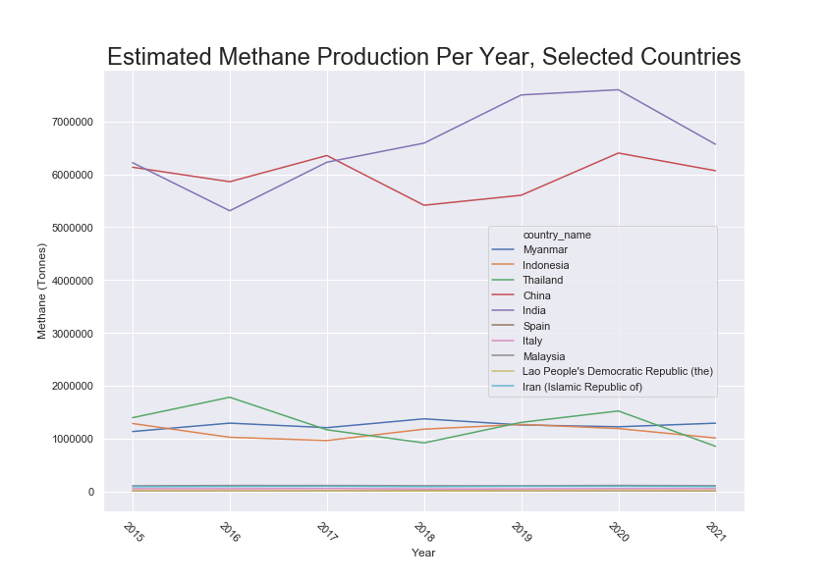
Fig 3: Methane outputs each year. See Fig. 4 for the countries at the very bottom of the chart.
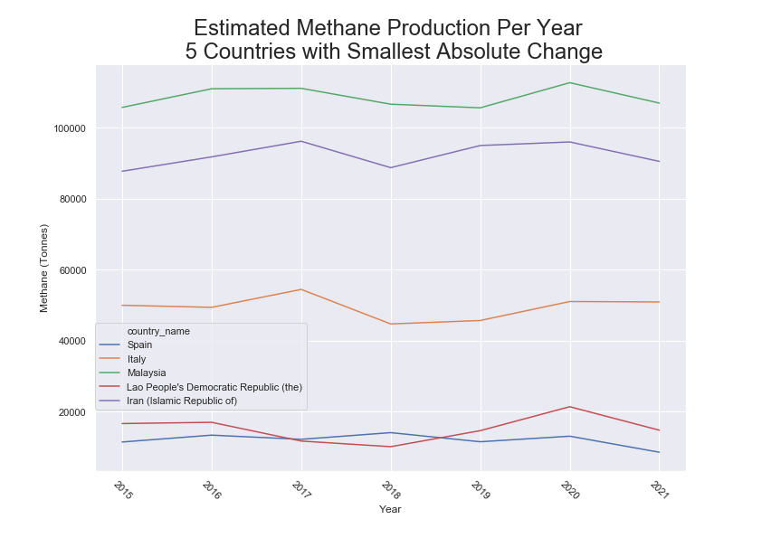
Fig. 4: Methane outputs each year for only those 5 countries with the least change over time. This data is obscured in Fig. 3.

Next, I created a rough metric to measure the amount of change (relative to the dataset) in a given country's methane output. To do this, I took the absolute value of every country's YOY change and added it together. I then looked at actual methane outputs among the 5 countries with the highest metric of change, and the 5 with the lowest. I found that those countries with a smaller metric of change also had smaller total outputs, and vice-versa. (Fig. 3 and 4.)

I admit here that I would have liked to examine change as a percentage of overall methane output, but I feel that this is a good first step, providing solid confirmation of the relationship between change in absolute terms and methane output.

We can see a rough relationship, but I wanted to see if or how it was statistically significant, and applied a linear model.

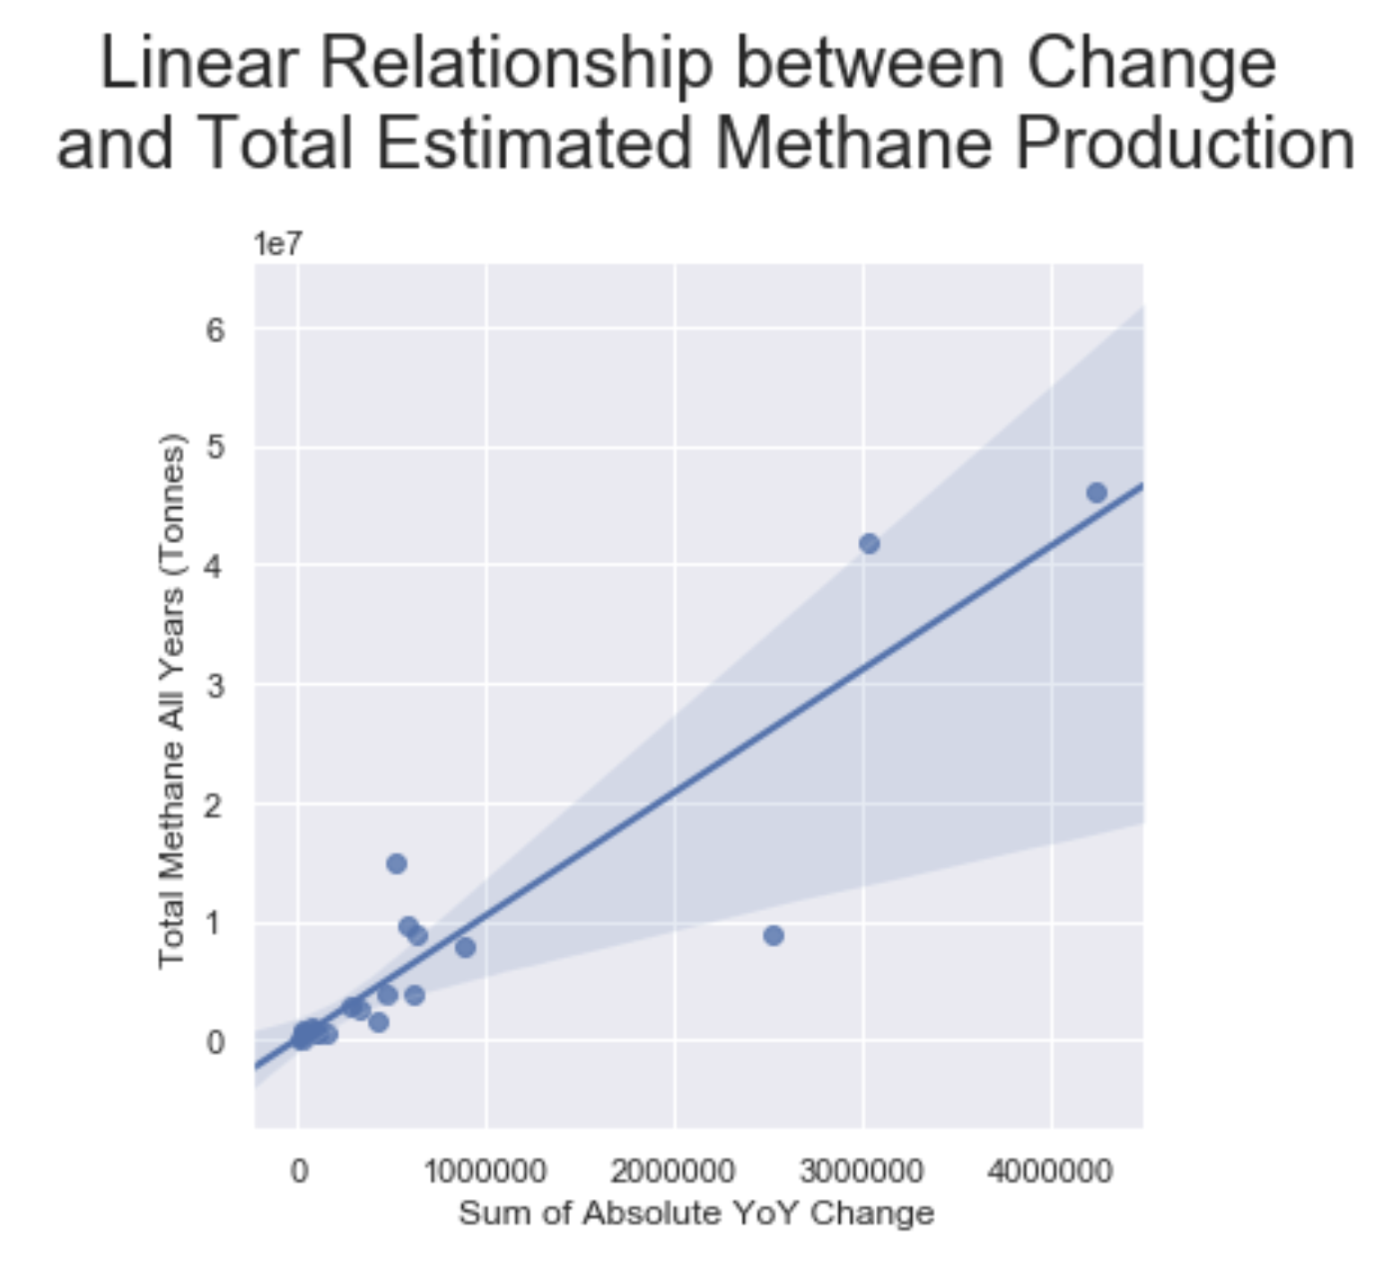
Fig 5: Change vs Total Methane Output

The relationship is probably real, with an R2 of .88 and a statistically significant p-value. From the visualization (Fig.5), though, we see this relationship changes as the metric of change increases. There is much greater variability in those countries with a higher metric of change. This is notable especially because the greater number of relatively low methane-outputting/low-change countries means the statistics alone can mask what the visualization shows.

As a result of this analysis, we now know that countries don't change in the same way year-on-year, and therefore can contextualize those changes when we see them in future years; a decrease in one year doesn't necessarily predict a decrease the next year. It would be interesting to more closely investigate how long it takes to be clear that methane outputs are generally falling in a country.

Finally, my analysis shows that in countries with lower metrics of change, the total methane outputs from rice cultivation are also relatively low. However, countries with higher metrics of change do not behave as predictably; some may have a large total methane output, and others much less than would be predicted by the model as built.

