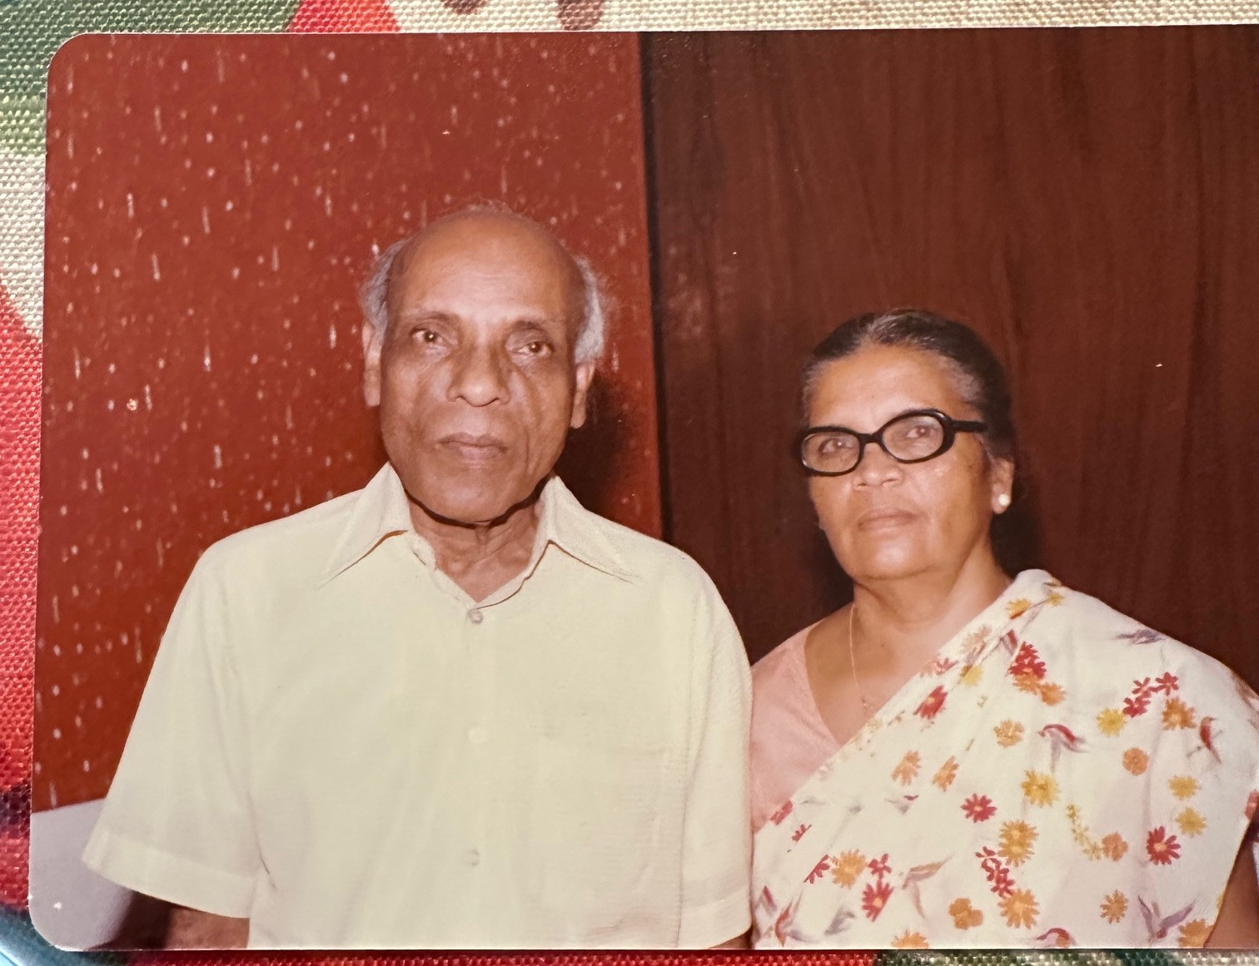

P. K. Abraham and Annamma of Pattasseril, Puthupally
Remembering the Love and Sacrifices they made
Korah, Mani and Dr. George Abraham and families
Grandchildren and Great Grandchildren

