Ideation Phase
Brainstorm & Idea Prioritization Template
Date | 7 July 2026
Team ID | SWTID-2026-1094
Project Name | Voice Based Concept Understanding Analyser
Maximum Marks | 4 Marks

Brainstorm & Idea Prioritization Template:
The team came together to brainstorm solutions for building a Voice Based Concept Understanding Analyser — a system that listens to a learner explain a concept out loud and evaluates how well they actually understand it. Ideas were generated across environment and API setup, speech-to-text processing, concept extraction and understanding-scoring models, the feedback and guidance engine, the learner-facing interface, and testing, before being grouped and prioritized to define the project roadmap.
Team ID SWTID-2026-1094 used this process to move from an open problem statement — how do we tell the difference between a learner who truly understands a concept and one who has only memorized the words for it — to a prioritized set of epics that form the foundation for building the Voice Based Concept Understanding Analyser.
Key Outcomes of the Session:
The session produced six prioritized work areas: Environment & API Setup, Speech Processing (speech-to-text and audio handling), the NLP & Understanding Model (concept extraction and scoring), the Feedback & Guidance Engine, the Learner-Facing User Interface, and Testing & Deployment. Quick wins such as Environment Setup and an early UI wireframe were separated from major, high-impact efforts such as Speech-to-Text Integration and the Concept Extraction & Scoring Model, giving the team a clear, prioritized roadmap to execute against rather than an unordered idea list.
Step-1: Team Gathering, Collaboration and Select the Problem Statement
The team assembled for a structured session that began with a recap of the problem statement, followed by a short round of individual, silent brainstorming so that every member's ideas were captured before group discussion could anchor everyone to the loudest voice in the room. Ideas were then shared openly on a shared board, clustered by theme, and dot-voted on impact versus effort before the team converged on a prioritized roadmap. The flow of this collaboration session is shown below.
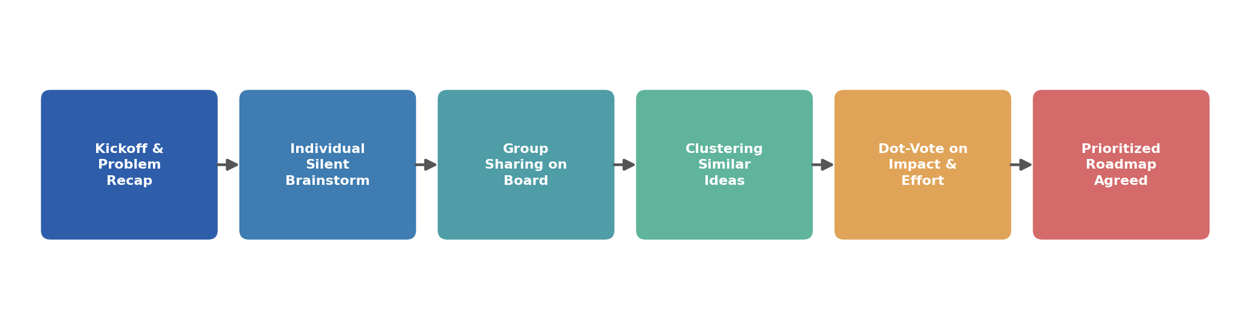
Fig 1: Team collaboration flow for selecting and prioritizing ideas
Step-2: Brainstorm, Idea Listing and Grouping
Individual ideas were listed on sticky notes and then grouped into six natural clusters that map directly onto the system's architecture: getting the environment and speech APIs ready, processing raw audio into usable speech data, extracting concepts and scoring genuine understanding, generating feedback that actually helps a learner, building an interface a learner would want to use daily, and testing the system end to end before deployment. Grouping the raw ideas this way, instead of leaving them as a flat table, made it easy to see where the real complexity of the project sits.
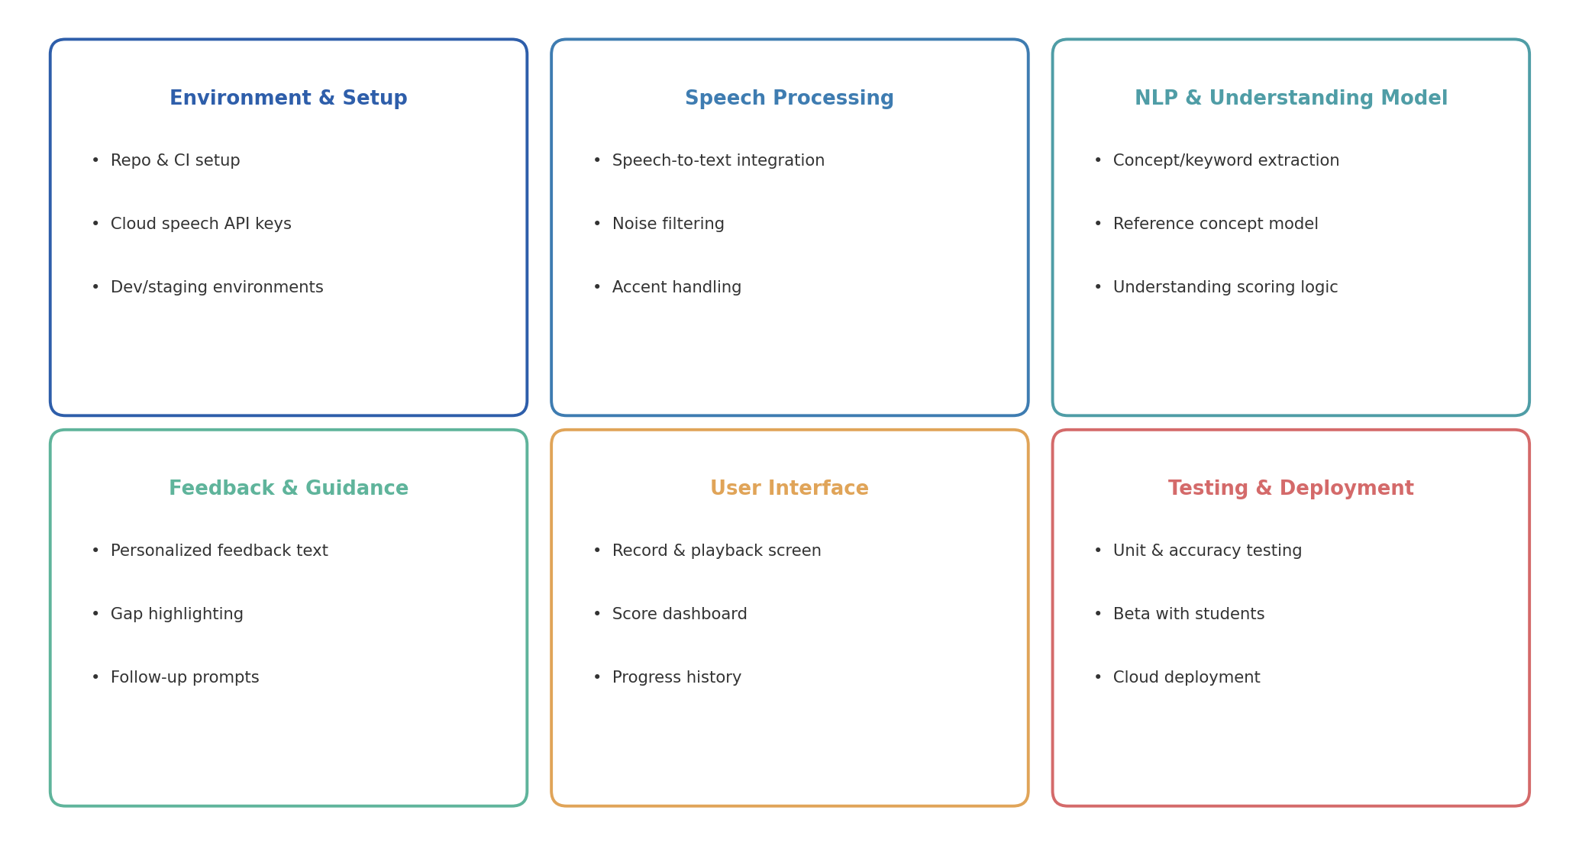
Fig 2: Brainstormed ideas grouped into six work clusters
Step-3: Idea Prioritization
Every clustered idea was then plotted on an impact-versus-effort matrix so the team could agree on sequencing rather than debate it repeatedly later. Environment setup and an early UI wireframe emerged as quick wins that could be started immediately and would unblock other work. Speech-to-text integration and the concept extraction and scoring model were flagged as major projects: high impact, but requiring dedicated research and iteration, so they were scheduled early with enough runway. Automated testing and a progress-history screen were treated as useful fill-in work for slower sprints, while lower-priority ideas like multi-language voice support and gamified badges were pushed to a later release so they would not distract the team from the core understanding-detection problem.
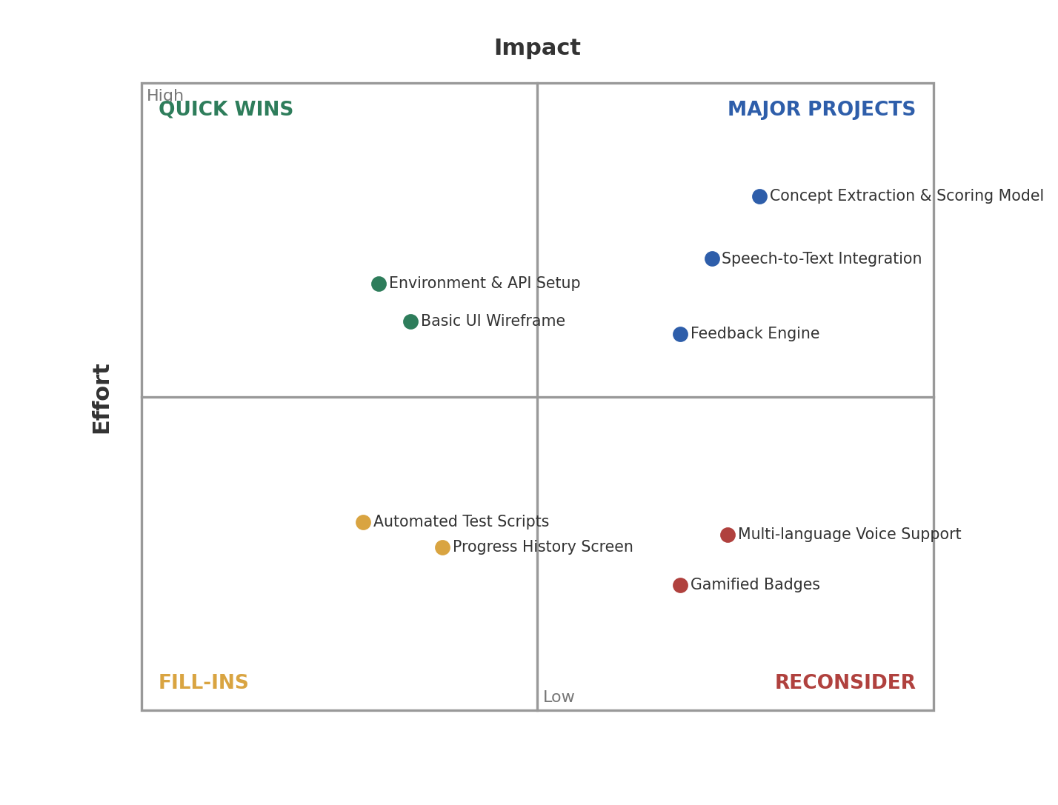
Fig 3: Impact vs. Effort prioritization matrix for brainstormed ideas

