Project Design Phase-II
Data Flow Diagram & User Stories
Date | 07 July 2026
Team ID | SWTID-2026-1094
Project Name | Voice Based Concept Understanding Analyser
Maximum Marks | 4 Marks

Data Flow Diagrams:
A Data Flow Diagram (DFD) shows how information moves through the Voice Based Concept Understanding Analyser — how a learner's spoken explanation enters the system, what transforms it into an understanding score, and where the resulting data is stored. Below are the Level 0 (context) and Level 1 (detailed) diagrams for the system.
Level 0 — Context Diagram
At the highest level, the system sits between three external entities — the Learner, the Instructor, and the Administrator — plus the cloud speech and storage services it depends on. The learner sends a voice recording and topic selection in and receives an understanding score and feedback back; the instructor supplies reference material and receives class-level analytics; the administrator manages users and scoring thresholds.
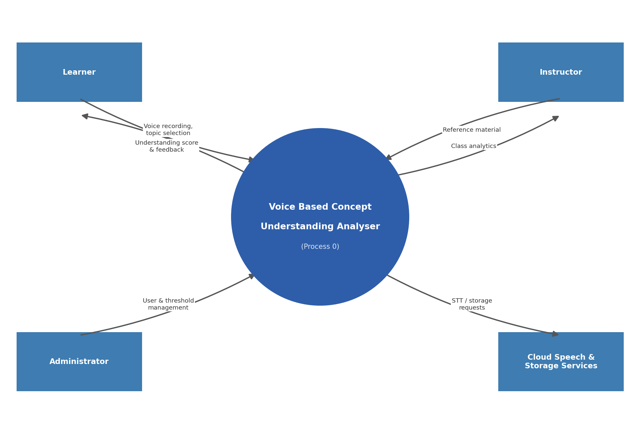
Fig 1: Level 0 — Context diagram for the Voice Based Concept Understanding Analyser
Level 1 — Detailed Data Flow Diagram
At the next level of detail, the system is broken into six processes: registering and authenticating users, capturing the learner's voice explanation, converting speech to text, extracting concepts and scoring understanding against a reference model, generating feedback, and producing analytics for instructors and administrators. Four data stores support these processes — the user store, the recording store, the reference concept store, and the scores & feedback store.
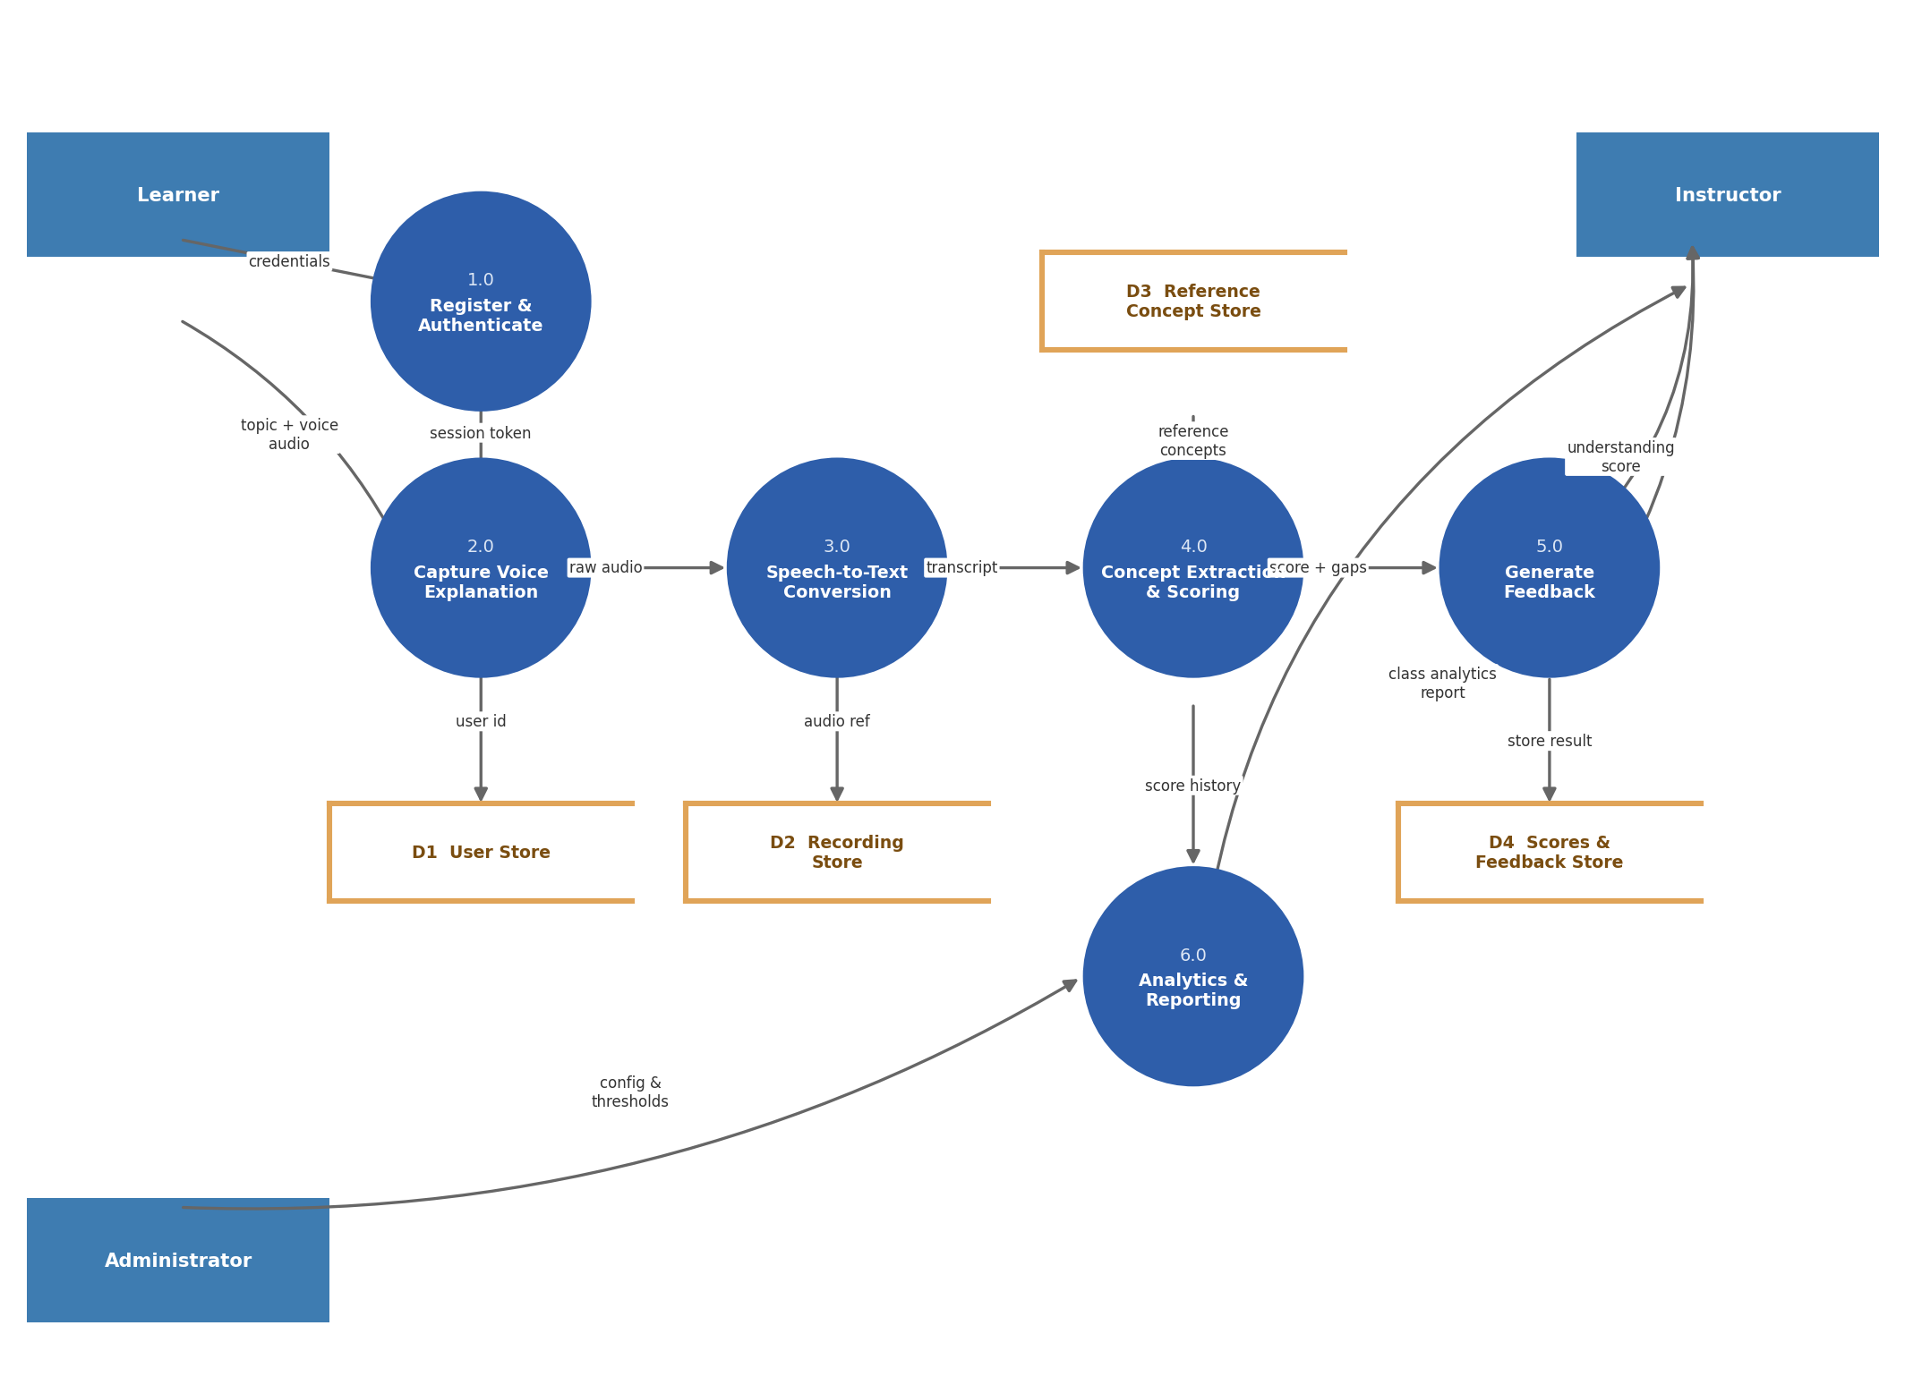
Fig 2: Level 1 — Detailed data flow diagram for the Voice Based Concept Understanding Analyser
User Stories:
The user stories below cover the Student (Learner), Instructor, Administrator, and the System (AI Engine) itself, expressed as narrative story cards rather than a flat table so that the intent behind each requirement stays easy to read.
Student (Learner)
USN-1 — Registration
User Story: As a learner, I can register by entering my name, email, password, and confirming my password.
Acceptance Criteria: I can create an account and land on my personalized dashboard.
Priority / Release: High • Sprint-1
USN-2 — Registration
User Story: As a learner, I receive a confirmation email once I register.
Acceptance Criteria: I receive an email and can confirm my account via a verification link.
Priority / Release: High • Sprint-1
USN-3 — Registration
User Story: As a learner, I can register or log in using Google or institutional SSO.
Acceptance Criteria: I can access my dashboard using Google/SSO login.
Priority / Release: Medium • Sprint-2
USN-4 — Login & Consent
User Story: As a learner, I can log in with my email and password.
Acceptance Criteria: I am authenticated and redirected to my dashboard.
Priority / Release: High • Sprint-1
USN-5 — Login & Consent
User Story: As a learner, I am asked for explicit consent before my microphone is used to record my voice explanation.
Acceptance Criteria: I see a clear consent prompt and can opt in/out before any recording begins.
Priority / Release: High • Sprint-1
USN-6 — Voice Explanation Capture
User Story: As a learner, I can select a concept or topic and record myself explaining it out loud.
Acceptance Criteria: Recording starts and stops correctly and the audio is saved against the selected topic.
Priority / Release: High • Sprint-2
USN-7 — Voice Explanation Capture
User Story: As a learner, I can re-record my explanation if I'm not satisfied before submitting it.
Acceptance Criteria: The previous recording is discarded and replaced with the new one.
Priority / Release: Medium • Sprint-2
USN-8 — Understanding Feedback
User Story: As a learner, I receive an understanding score after submitting my spoken explanation.
Acceptance Criteria: A score is generated within about 30 seconds, with a defined minimum accuracy in testing.
Priority / Release: High • Sprint-3
USN-9 — Understanding Feedback
User Story: As a learner, I receive specific feedback on which parts of the concept I explained well or missed.
Acceptance Criteria: Feedback clearly highlights correctly covered and missing sub-concepts.
Priority / Release: High • Sprint-3
USN-10 — Understanding Feedback
User Story: As a learner, I can view my understanding-score trends over time.
Acceptance Criteria: I can see a simple chart of my scores across past topics and sessions.
Priority / Release: Low • Sprint-4
USN-11 — Dashboard
User Story: As a learner, I can view my practiced topics, scores, and pending topics on one dashboard.
Acceptance Criteria: Dashboard loads with accurate topic list, scores, and pending items.
Priority / Release: Medium • Sprint-2
Instructor
USN-12 — Topic & Reference Management
User Story: As an instructor, I can upload reference concept material (notes or model answers) that the analyser uses to score explanations.
Acceptance Criteria: Uploaded content is correctly linked to the right topic.
Priority / Release: High • Sprint-1
USN-13 — Class Insights
User Story: As an instructor, I receive a real-time alert when multiple students score low understanding on the same topic.
Acceptance Criteria: An alert appears on my dashboard within seconds of the threshold being crossed.
Priority / Release: High • Sprint-3
USN-14 — Class Insights
User Story: As an instructor, I can see which specific sub-concept most students are missing.
Acceptance Criteria: The alert links directly to the specific gap area within the topic.
Priority / Release: Medium • Sprint-3
USN-15 — Class Analytics
User Story: As an instructor, I can view a class-level analytics dashboard showing average understanding scores per topic.
Acceptance Criteria: Dashboard shows engagement/score graphs updated after each submission batch.
Priority / Release: High • Sprint-4
USN-16 — Class Analytics
User Story: As an instructor, I can export understanding reports as PDF or Excel.
Acceptance Criteria: I can download a correctly formatted report for any selected topic.
Priority / Release: Low • Sprint-4
Administrator
USN-17 — User Management
User Story: As an administrator, I can create, edit, and deactivate learner and instructor accounts.
Acceptance Criteria: Account changes are saved and reflected immediately in the system.
Priority / Release: High • Sprint-1
USN-18 — System Configuration
User Story: As an administrator, I can configure the understanding-score threshold and scoring sensitivity.
Acceptance Criteria: Changed thresholds take effect for all new submissions without a restart.
Priority / Release: Medium • Sprint-3
USN-19 — Data Privacy
User Story: As an administrator, I can review and manage retention and deletion settings for stored voice recordings.
Acceptance Criteria: I can set a retention period and trigger deletion in compliance with policy.
Priority / Release: High • Sprint-2
System (AI Engine)
USN-20 — Model Monitoring
User Story: As the system, I log confidence scores for every understanding prediction for later review.
Acceptance Criteria: Every prediction is logged with a confidence score and timestamp.
Priority / Release: Medium • Sprint-3
USN-21 — Failover
User Story: As the system, I fall back to a "manual review needed" state if the concept-scoring service is unavailable.
Acceptance Criteria: Learners are notified and their session is not lost even if scoring fails.
Priority / Release: High • Sprint-2

