Ideation Phase
Define the Problem Statements
Date | 7 July 2026
Team ID | SWTID-2026-1094
Project Name | Voice Based Concept Understanding Analyser
Maximum Marks | 2 Marks

Customer Problem Statement Template:
This template is used to define the core problem statements for the Voice Based Concept Understanding Analyser, capturing the learner's point of view before designing the speech-driven concept assessment and feedback features. The Voice Based Concept Understanding Analyser is envisioned as a system that listens to a learner explaining a concept out loud, analyses the spoken explanation using speech and language processing, and determines how well the underlying concept has actually been understood, rather than merely recalled.
A well-articulated customer problem statement allows the team to find the ideal solution for the challenges learners, educators, and professionals face when trying to verify and demonstrate genuine conceptual understanding. Throughout this process, the team empathizes with these users, which helps in designing a voice-based understanding-assessment experience that listens carefully, evaluates fairly, and responds with guidance that feels personal rather than generic.
Why This Matters:
Without a clearly defined problem statement, teams risk building a voice analysis engine that transcribes speech accurately but fails to judge conceptual depth, missing the actual pain point users have. For a concept-understanding system in particular, it is critical to understand exactly who the learner is, what they are trying to prove to themselves or to others, and what gap exists between saying the right words and truly grasping the idea. This understanding is what shapes accurate speech-to-concept mapping, meaningful understanding scores, and a genuinely supportive feedback experience, instead of just another quiz app with a microphone bolted on.
The diagram below illustrates, at a high level, how a spoken explanation moves through the analyser: from capturing the learner's voice, to extracting the concepts discussed, to comparing them against a reference model of the topic, and finally to generating a personalized understanding score and feedback.
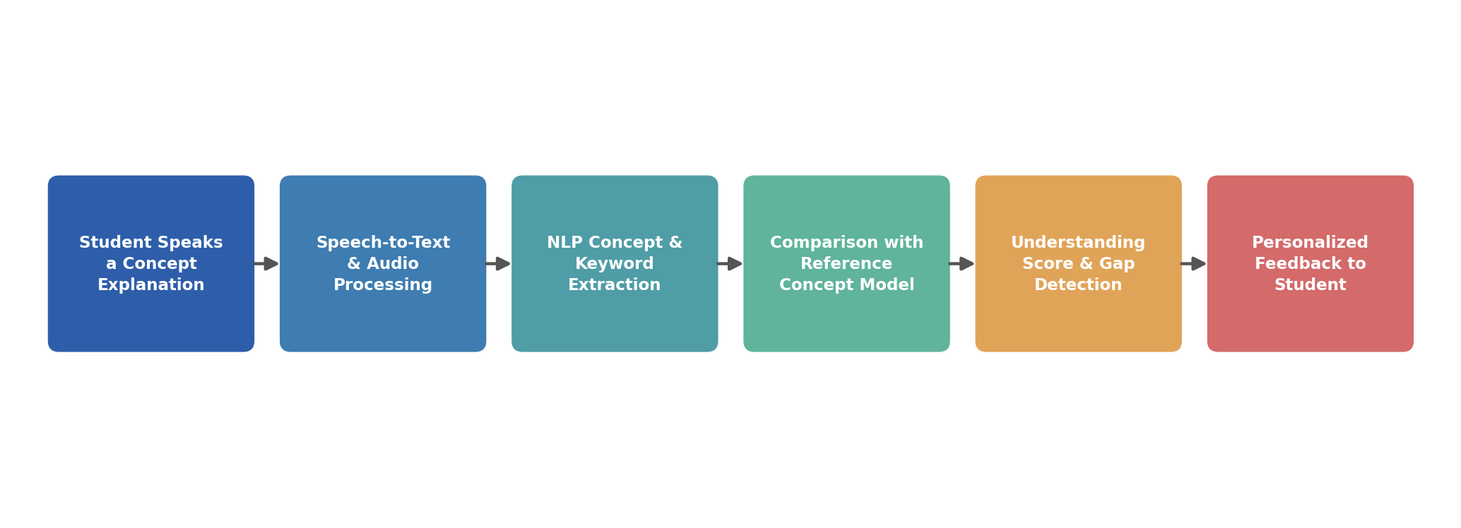
Fig 1: How the Voice Based Concept Understanding Analyser processes a spoken explanation
Problem Statements:
The following problem statements describe, in the customer's own voice, the real-world situations that the Voice Based Concept Understanding Analyser needs to solve. Each statement captures who the user is, what they are trying to do, what is blocking them today, why that block exists, and how it makes them feel — the same logic a table would hold, expressed here as narrative so the human context is not lost in rows and columns.
PS-1: The Exam-Prep Student
I am: a college student juggling multiple subjects and constant academic pressure
I'm trying to: confirm that I actually understand a concept, not just memorize it, before my exam
But: I have no one available at 11 p.m. to listen to me explain the concept and tell me if I'm right
Because: self-assessment tools today are limited to text-based MCQs that reward recall, not spoken reasoning
Which makes me feel: unsure and unprepared, despite having spent hours revising the material
PS-2: The Overloaded Educator
I am: a teacher or trainer responsible for a large classroom of learners
I'm trying to: identify which students have genuinely grasped a topic versus those who have simply memorized answers
But: I don't have the time to individually question every student through oral explanation
Because: manual oral assessment is slow, inconsistent, and difficult to scale across dozens of students
Which makes me feel: overwhelmed, and unable to give each learner the personalized attention they need
PS-3: The Upskilling Professional
I am: a working professional learning a new technical concept through an online course
I'm trying to: make sure I can clearly articulate the concept before I have to apply it at work
But: there is no way for me to practice explaining it out loud and receive structured, honest feedback
Because: most e-learning platforms only test recall through multiple-choice questions, not the ability to explain
Which makes me feel: anxious and underprepared about applying the knowledge in a real, high-stakes situation

Together, these three problem statements show a common thread: the moment of speaking a concept aloud is where real understanding is revealed, yet it is also the moment that is least supported by existing tools. The gap this creates for each of these users is summarized visually below.
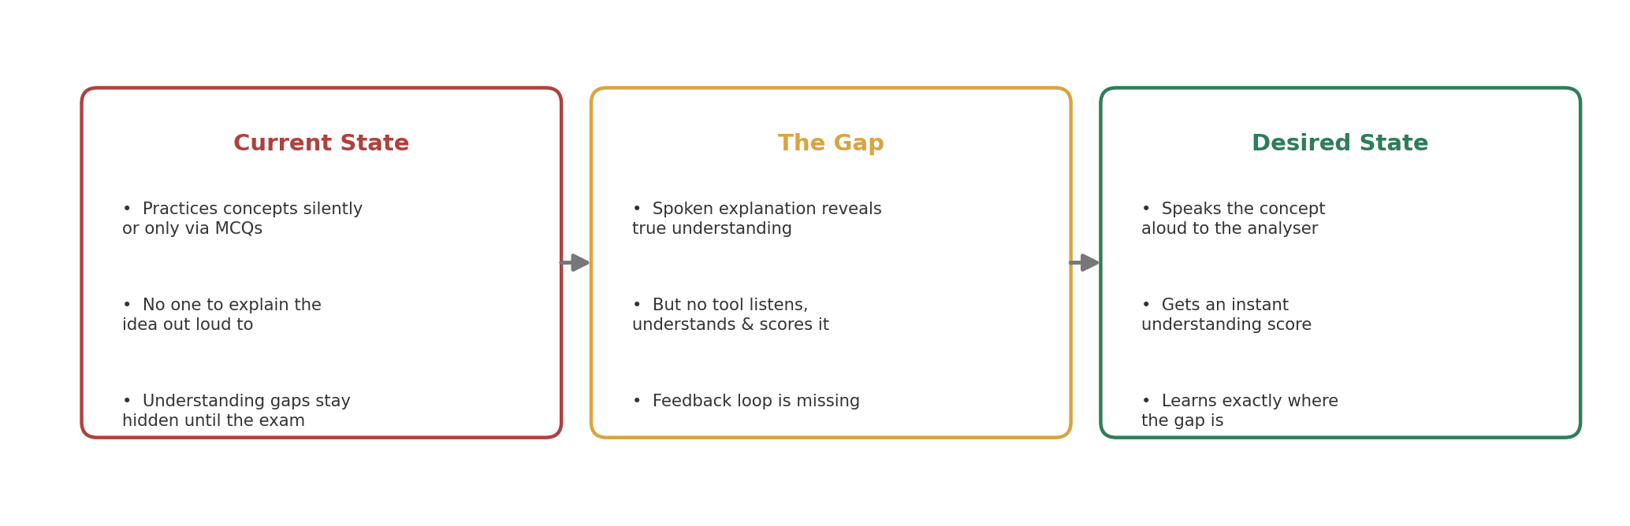
Fig 2: The understanding gap the Voice Based Concept Understanding Analyser is designed to close

