Ideation Phase
Empathize & Discover
Date | 07 July 2026
Team ID | SWTID-2026-1094
Project Name | Voice Based Concept Understanding Analyser
Maximum Marks | 4 Marks

Empathy Map Canvas:
An empathy map is a simple, easy-to-digest visual that captures what a user thinks, feels, says, does, sees, and hears in their day-to-day context. It pushes a team beyond assumptions and requirement lists into the lived experience of the person they are actually designing for, which is essential when the product itself is meant to interpret something as personal as a learner's spoken understanding of a concept.
Creating an effective solution requires understanding the true problem and the person experiencing it. For the Voice Based Concept Understanding Analyser, that person is a learner who is preparing for an exam, an interview, or a real-world application of what they have studied, and who has no reliable way today to test whether they can explain a concept out loud, not just recognize it on a page. The map below considers this learner's perspective, along with their goals, doubts, and everyday behaviours, to ground the design of the analyser in a real emotional and practical context rather than in guesswork.
Building this empathy map before writing any requirements ensured the team designed for the learner's actual moment of struggle — the gap between silently feeling confident and being unable to prove that understanding out loud — rather than simply building a feature list around speech recognition technology.
Empathy Map: Voice Based Concept Understanding Analyser
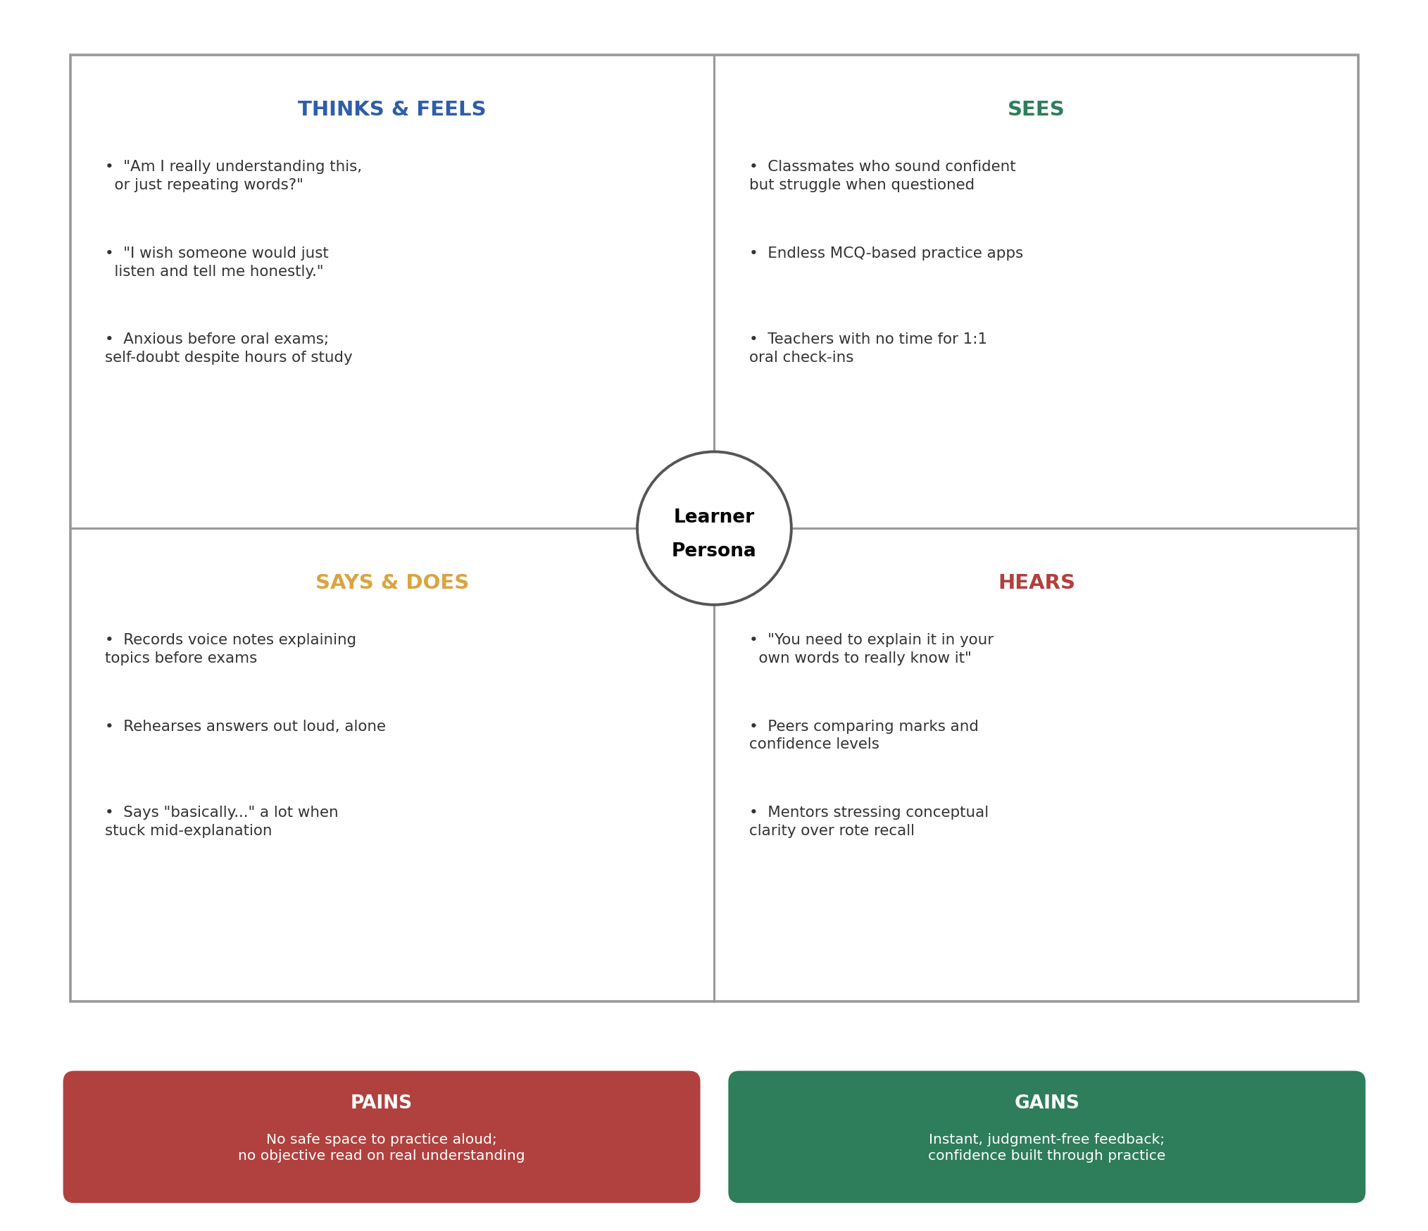
Fig 1: Empathy map for the primary learner persona of the Voice Based Concept Understanding Analyser

